Dancer Guide
For: UM Dancesport Club dancers.
Website: https://umdsc-dance-class.umdancesportc.workers.dev
Use it to see your class schedule, watch class recap videos, practise with the class music, and check your attendance.
💻 Tip: The calendar works well on a phone. For the Studio (practising with music and video), a laptop or PC is much easier: a bigger screen, a keyboard, and voice commands work best in Chrome.

1. Log in
1. Open the website.
2. Enter your Matric Number, for example 22001234.
3. Enter your Full Name exactly as you wrote it on the registration form. Every word of your name is needed, but capital letters and the order of the words don't matter.
4. Tap ENTER.
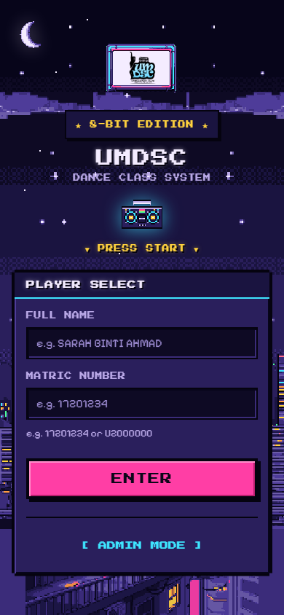
Dancer login
Can't log in? You will see "Matric number and name don't match a registered dancer." Check that:
- you registered for this month's class through the club's Google Form, and
- your name matches the form, including every word, for example binti/bin parts are optional but other words are not.
Still stuck? Contact your class lead or the club admin.
Make it an app: in Safari tap Share › Add to Home Screen; in Chrome tap ⋮ › Add to Home screen.

2. Your calendar
Home shows a calendar of your classes. Each coloured mark is one of your dance styles.
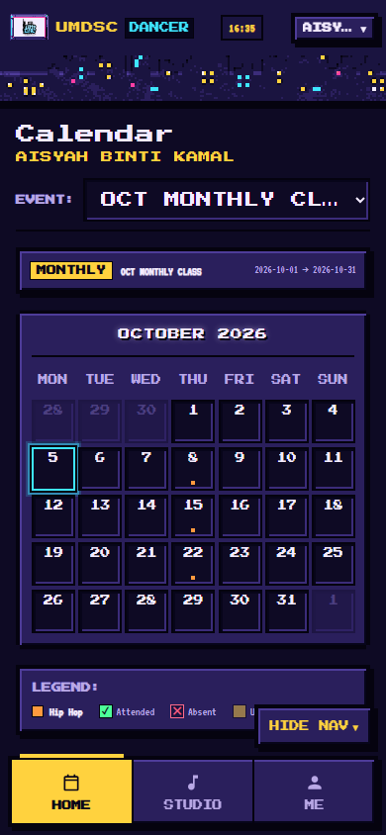
Calendar
Tap a day with a class to see the details: time, venue, instructor, and that class's recap videos and music.
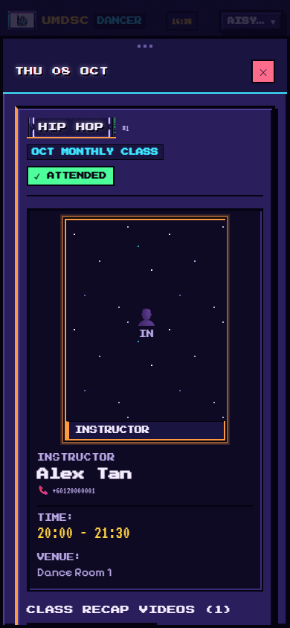
Class day
If you're in more than one event (for example a monthly class and a workshop), choose it with EVENT: at the top.

3. Studio: practise with music and video 💻
Open Studio from the menu.
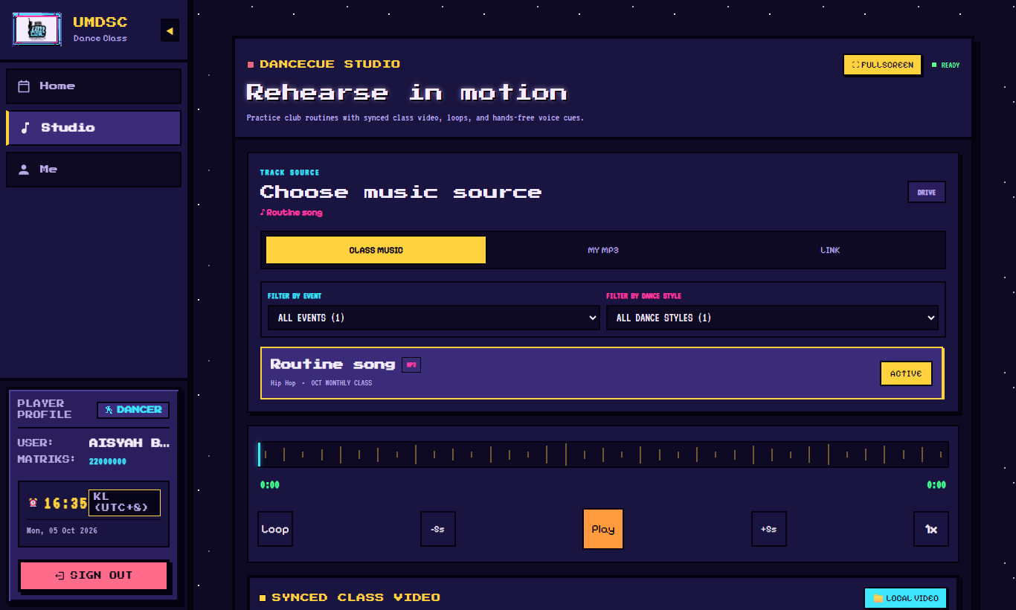
Studio
1. Choose music under Choose music source:
- CLASS MUSIC: the songs your class lead added. Filter by event and dance style.
- MY MP3: play a music file from your own device.
- LINK: paste a YouTube or SoundCloud link.
2. Play controls: Play, -5s / +5s, Loop, and speed (1x; slow it down to learn steps).
3. Loops: the class lead's Class Sections (for example Chorus part A) appear in Markers. Tap one to loop it. Tap Add Loop to make your own.
4. SYNCED CLASS VIDEO: choose the class recap video to play in time with the music, or LOCAL VIDEO to use a video from your device. SET START HERE lines the video up with the music.
5. FULLSCREEN: big video with the controls on top. Tap EXIT to leave.
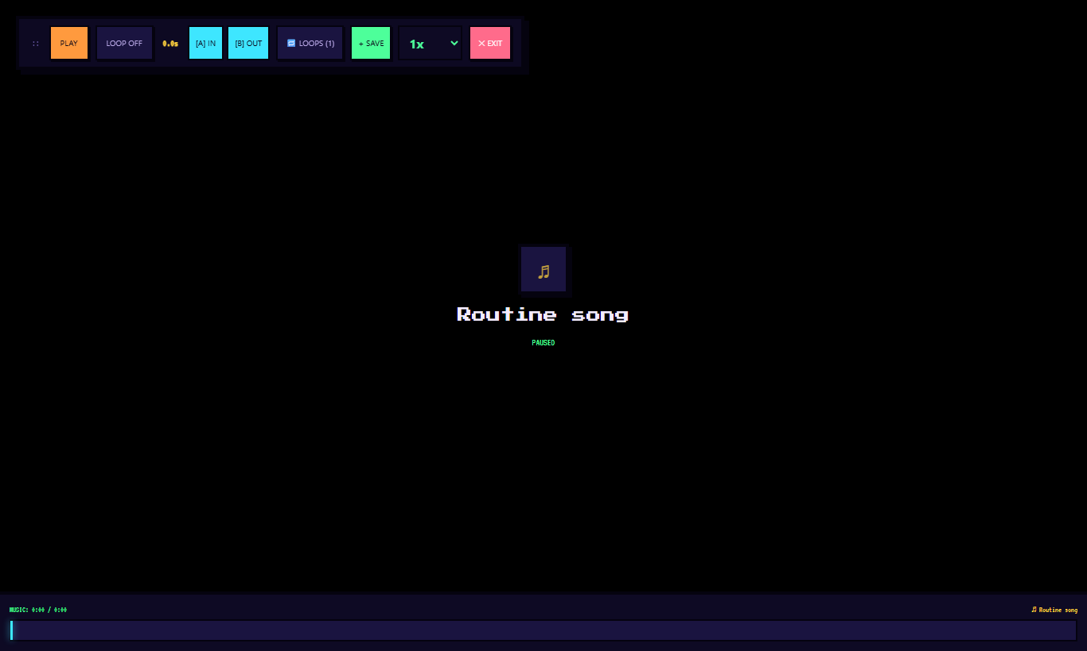
Fullscreen practice

Voice Cue (hands-free)
Under Voice Cue, press the microphone and say commands like "Play", "Pause", "Loop chorus", "Back 5 seconds" or "Restart". Voice control works best in Chrome on a laptop/PC. If your browser doesn't support it, use the buttons shown instead.

4. Me: your attendance
Open Me to see your matric number, registered events and total attendance.
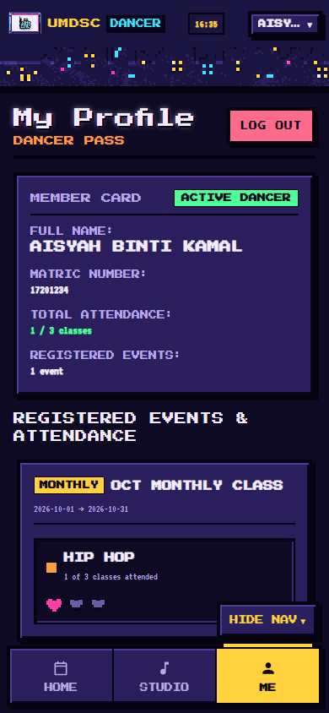
Me page
Tap LOG OUT when you're using a shared computer.

Questions
Problem | What to do
A video won't play | Try again on Wi-Fi. Some iPhone videos open in the Google Drive player instead.
My attendance looks wrong | Tell your class lead; they can correct it.
The website looks old after an update | Close the tab and open it again.

