Shopping Mall Sales Management System
A Single-Shop Java Swing Desktop POS & Inventory Application

01 Executive Summary
Small shop counters often rely on manual registers or spreadsheets for billing and stock tracking. This proposal describes a Shopping Mall Sales Management System (SMSMS) — a Java Swing desktop application backed by a MySQL database — that lets a single shop record product sales, keep stock counts accurate, and review a simple sales history, all from one role-secured application.
In one line: a simple, offline desktop POS and inventory tool that replaces manual billing and stock tracking for a single shop.

02 Background & Motivation
Many small shops still bill customers by hand or with basic spreadsheets, with no automatic link between a sale and the stock it should reduce. This leads to stock counts that drift from reality and no easy way to see how much was sold on a given day.
This project is motivated by the gap between expensive commercial POS software and what a beginner-friendly, learning-focused project can realistically deliver in one semester: a small but complete, correctly-built system rather than a large, half-finished one.

03 Problem Statement
- Manual billing: sales are written down or tracked in a spreadsheet with no automatic stock update.
- Manual inventory: stock counts drift because sales and stock aren't linked.
- No shared login/roles: anyone can access all functions of whatever tool is currently used.
- No quick sales overview: no simple way to see today's total sales at a glance.

04 Aim & Objectives
Aim: To design and implement a simple, role-based desktop application that lets a single shop record sales and manage product inventory using Java Swing and MySQL.

Specific Objectives
- Design a small, normalized MySQL schema for products, sales, and sale items.
- Implement a POS billing screen that always updates stock correctly using a JDBC transaction.
- Implement basic role-based access for Admin and Cashier.
- Provide a simple sales history screen and a "today's total" figure.
- Package the system as a runnable desktop application requiring no internet dependency.

05 Scope of the Project

In Scope
- Product management (add, edit, delete, view).
- POS billing: cart, one tax rate, one bill-level discount, payment mode selection, receipt.
- Automatic, transaction-safe stock reduction on sale.
- Sales history with a simple daily total.
- Admin and Cashier login with role-based screens.

Out of Scope (Future Work)
- Multi-shop / multi-branch support.
- Barcode scanning and label printing.
- Customer records, loyalty points, and coupons.
- Supplier and purchase-order tracking.
- Employee attendance tracking.
- Returns and refunds.
- Charts, dashboards, and PDF/Excel export.
- Cloud backup or remote access.

06 Development Methodology
The project will be built incrementally: each milestone adds one working, end-to-end feature (e.g., "products can be added and listed") rather than building all screens partially at once. This keeps a demoable version available from an early stage.

07 Proposed System Architecture
Layer | Responsibility
Presentation (Swing) | Login, Products, POS, Sales History, and User screens; input validation
DAO | All SQL via PreparedStatement (ProductDAO, SaleDAO, UserDAO); business checks like stock validation live in the form's event-handler methods
MySQL Database | Single-shop schema: users, products, sales, sale_items
This is a 3-layer version of the original 5-layer MVC design (Presentation / Controller / Service / DAO / Database). Splitting out Controller and Service layers is a good next step once the simplified version works.

08 Data Flow Diagram
The Level 1 Data Flow Diagram below shows how information moves between the two user roles, the five core processes, and the four data stores in the simplified system.
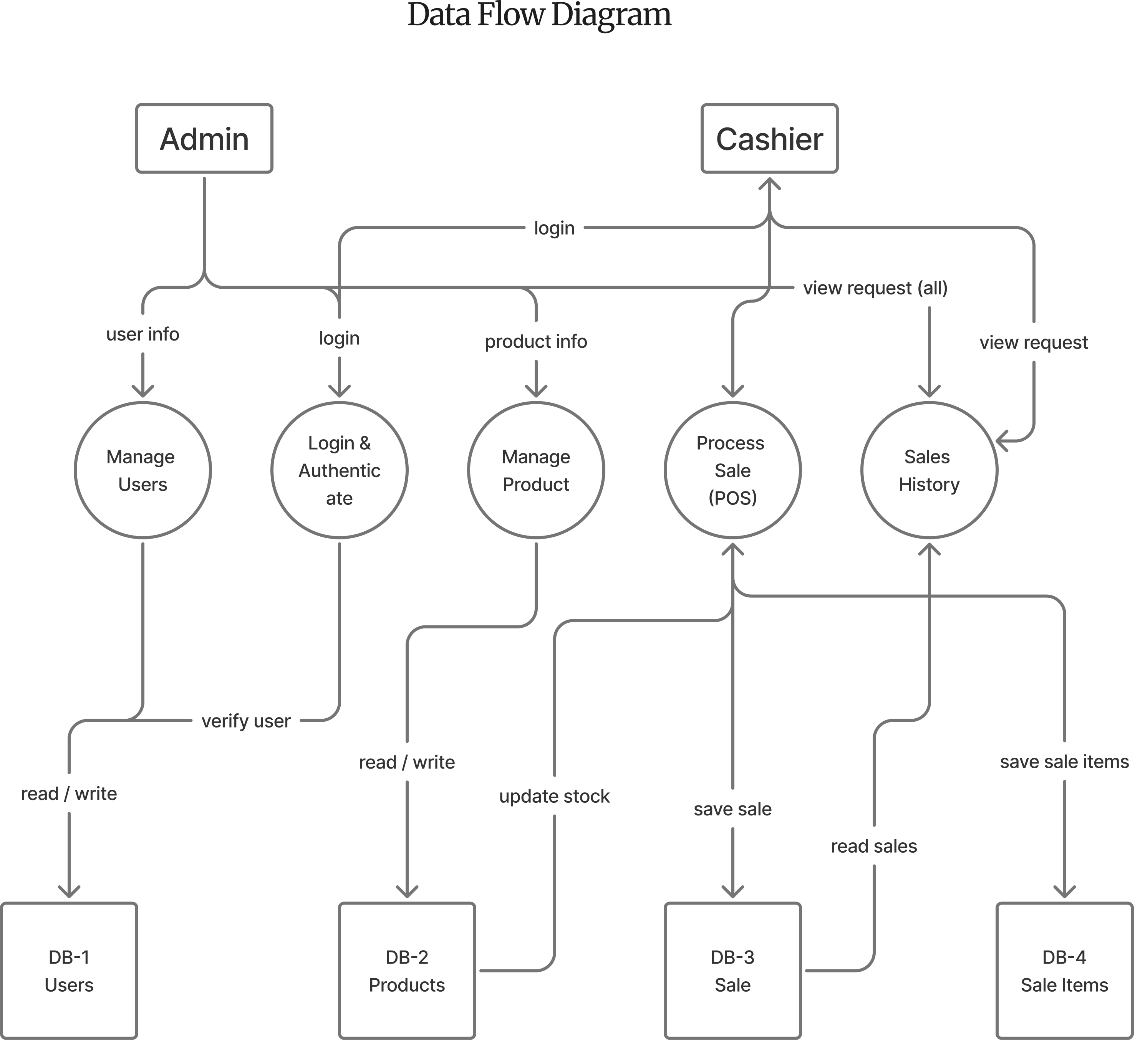
Figure 1 — Level 1 Data Flow Diagram

9 UML Class Diagram
The class diagram below shows the four core domain classes used by the simplified system, their key attributes and methods, and how they relate to one another.
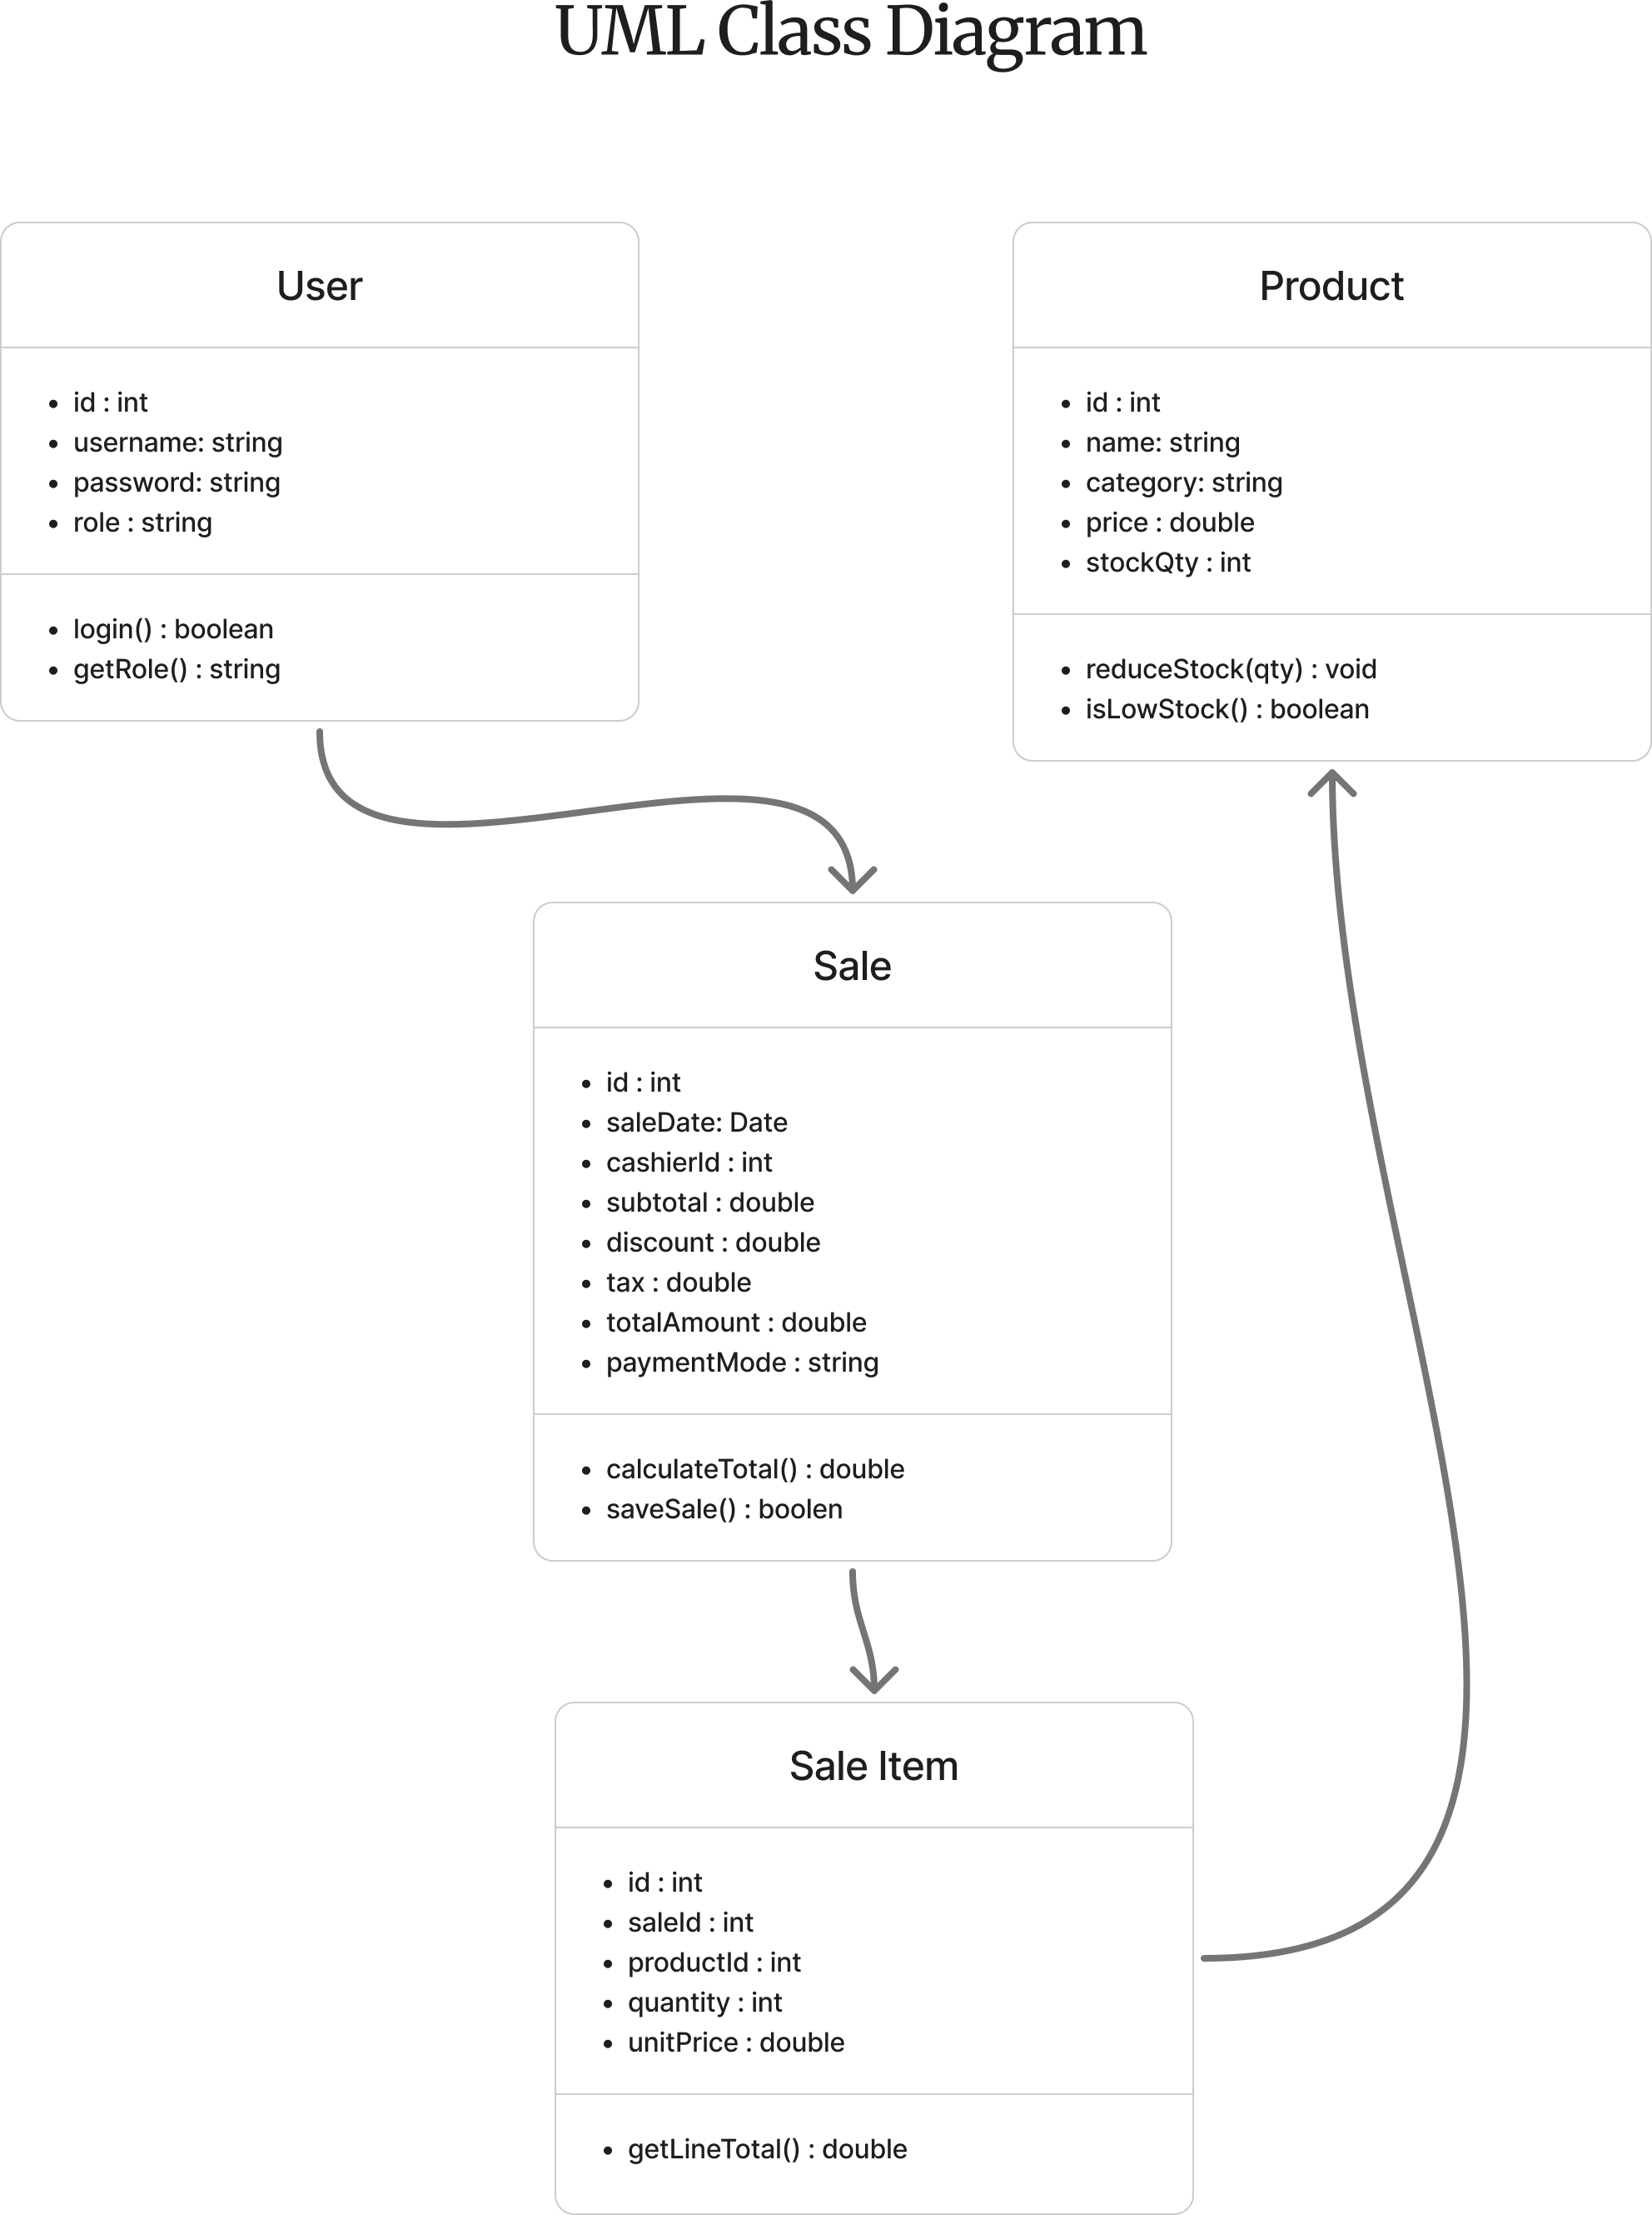
Figure 2 — UML Class Diagram (Core Domain Model)
- A User (cashier) can process many Sales, but each Sale is processed by exactly one User.
- A Sale is composed of one or more SaleItem records — if a Sale is deleted, its SaleItem rows go with it (composition).
- Each SaleItem refers to exactly one Product, but a Product can appear in many SaleItem records over time.

10 Database Structure
The simplified schema has four tables: one for logins, one for the product catalog, and two that record a completed sale and its line items. All money columns use DECIMAL(10,2) and all tables use the InnoDB engine so multi-step operations (like completing a sale) can be committed or rolled back as one unit.

users
Column | Data Type | Constraints | Description
id | INT | PRIMARY KEY, AUTO_INCREMENT | Unique user ID
username | VARCHAR(50) | UNIQUE, NOT NULL | Login username
password | VARCHAR(255) | NOT NULL | Login password
role | VARCHAR(20) | NOT NULL | 'Admin' or 'Cashier'

products
Column | Data Type | Constraints | Description
id | INT | PRIMARY KEY, AUTO_INCREMENT | Unique product ID
name | VARCHAR(100) | NOT NULL | Product name
category | VARCHAR(50) | — | Simple plain-text category label
price | DECIMAL(10,2) | NOT NULL | Selling price per unit
stock_qty | INT | NOT NULL, DEFAULT 0 | Current stock on hand

sales
Column | Data Type | Constraints | Description
id | INT | PRIMARY KEY, AUTO_INCREMENT | Unique sale / invoice ID
sale_date | DATETIME | NOT NULL, DEFAULT CURRENT_TIMESTAMP | Date and time of the sale
cashier_id | INT | FOREIGN KEY → users(id), NOT NULL | Cashier who processed the sale
subtotal | DECIMAL(10,2) | NOT NULL | Sum of line items before discount/tax
discount | DECIMAL(10,2) | DEFAULT 0 | Bill-level discount applied
tax | DECIMAL(10,2) | DEFAULT 0 | Tax amount applied
total_amount | DECIMAL(10,2) | NOT NULL | Final payable amount
payment_mode | VARCHAR(20) | NOT NULL | 'Cash' or 'Card'

sale_items
Column | Data Type | Constraints | Description
id | INT | PRIMARY KEY, AUTO_INCREMENT | Unique line-item ID
sale_id | INT | FOREIGN KEY → sales(id), NOT NULL | Parent sale/invoice
product_id | INT | FOREIGN KEY → products(id), NOT NULL | Product sold
quantity | INT | NOT NULL | Quantity sold
unit_price | DECIMAL(10,2) | NOT NULL | Price per unit at time of sale (copied from product, so later price changes don't rewrite history)

11 Proposed Timeline
Estimated over an 8-week development cycle:
Phase | Duration
Requirements & DB Design | Week 1
Core Setup & Login | Week 1 – 2
Product Management | Week 2 – 3
POS / Billing Module | Week 3 – 5
Sales History & User Management | Week 5 – 6
Testing & Polish | Week 6 – 7
Documentation & Defense Prep | Week 7 – 8

12 Tools & Technologies
Java 17+ · Java Swing · MySQL 8 · JDBC (MySQL Connector)

13 Feasibility Study
Aspect | Assessment
Technical | Uses only core Java, Swing, and JDBC — all well-documented and appropriate for a beginner.
Economic | Fully open-source toolchain; zero licensing cost.
Operational | Runs locally with no internet dependency.
Schedule | Reduced scope comfortably fits an 8-week timeline, leaving buffer for testing and writing the report.

14 Expected Outcomes
- A working, installable desktop POS and inventory application for a single shop.
- A small, correctly normalized MySQL schema with an ER diagram.
- A demo showing a full sale: search product → add to cart → complete sale → stock updates → receipt shown.
- A written report covering design decisions and testing, suitable for academic submission.

15 Future Scope
- Multi-shop support.
- Barcode scanning.
- Charts/dashboard (JFreeChart).
- PDF/Excel export.
- Returns/refunds, customer loyalty, supplier tracking, employee attendance, and an audit log.
- Password hashing and a connection pool for production-readiness.

16 Conclusion
This revised proposal keeps the core, defensible idea of the original — a transaction-safe POS and inventory system with real-time stock accuracy — while sizing the feature list to what a beginner in Java and Swing can build, test, and fully understand within a single term. It is intentionally left room to grow: every feature removed here is listed as a clear, achievable next step.
“Start with a system that correctly sells one product to one customer — everything else is an extension of that.”

