Major Assignment

Name: Chandan Khare

Email : [ckhare@deloitte.com](mailto:ckhare@deloitte.com)

* At the beginning I have added all the CSV files into the tables of Database.

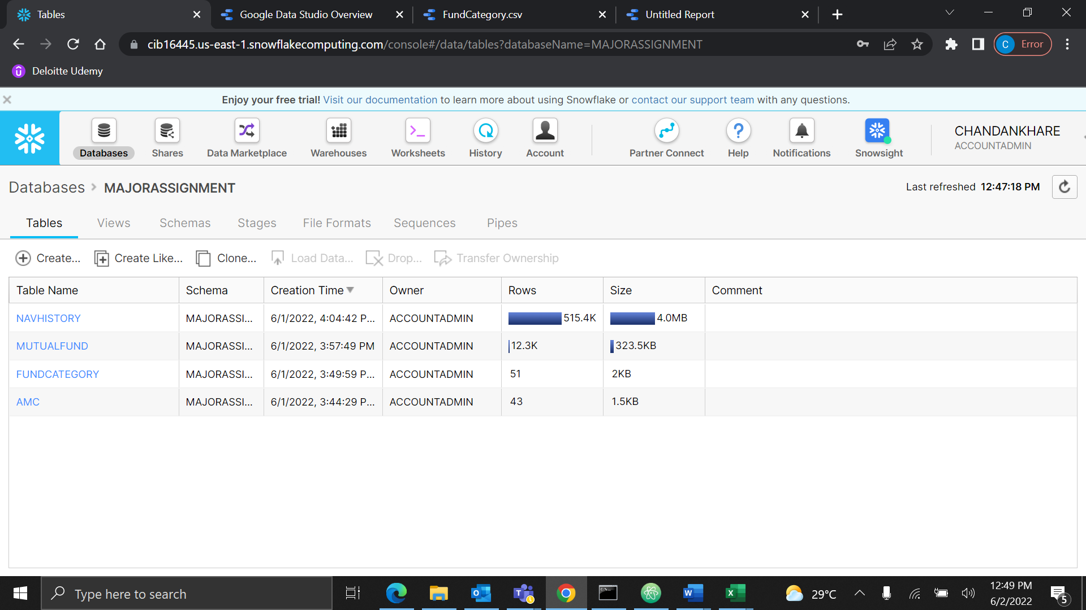

* Then I have completed the 1st question from Milestone 1.

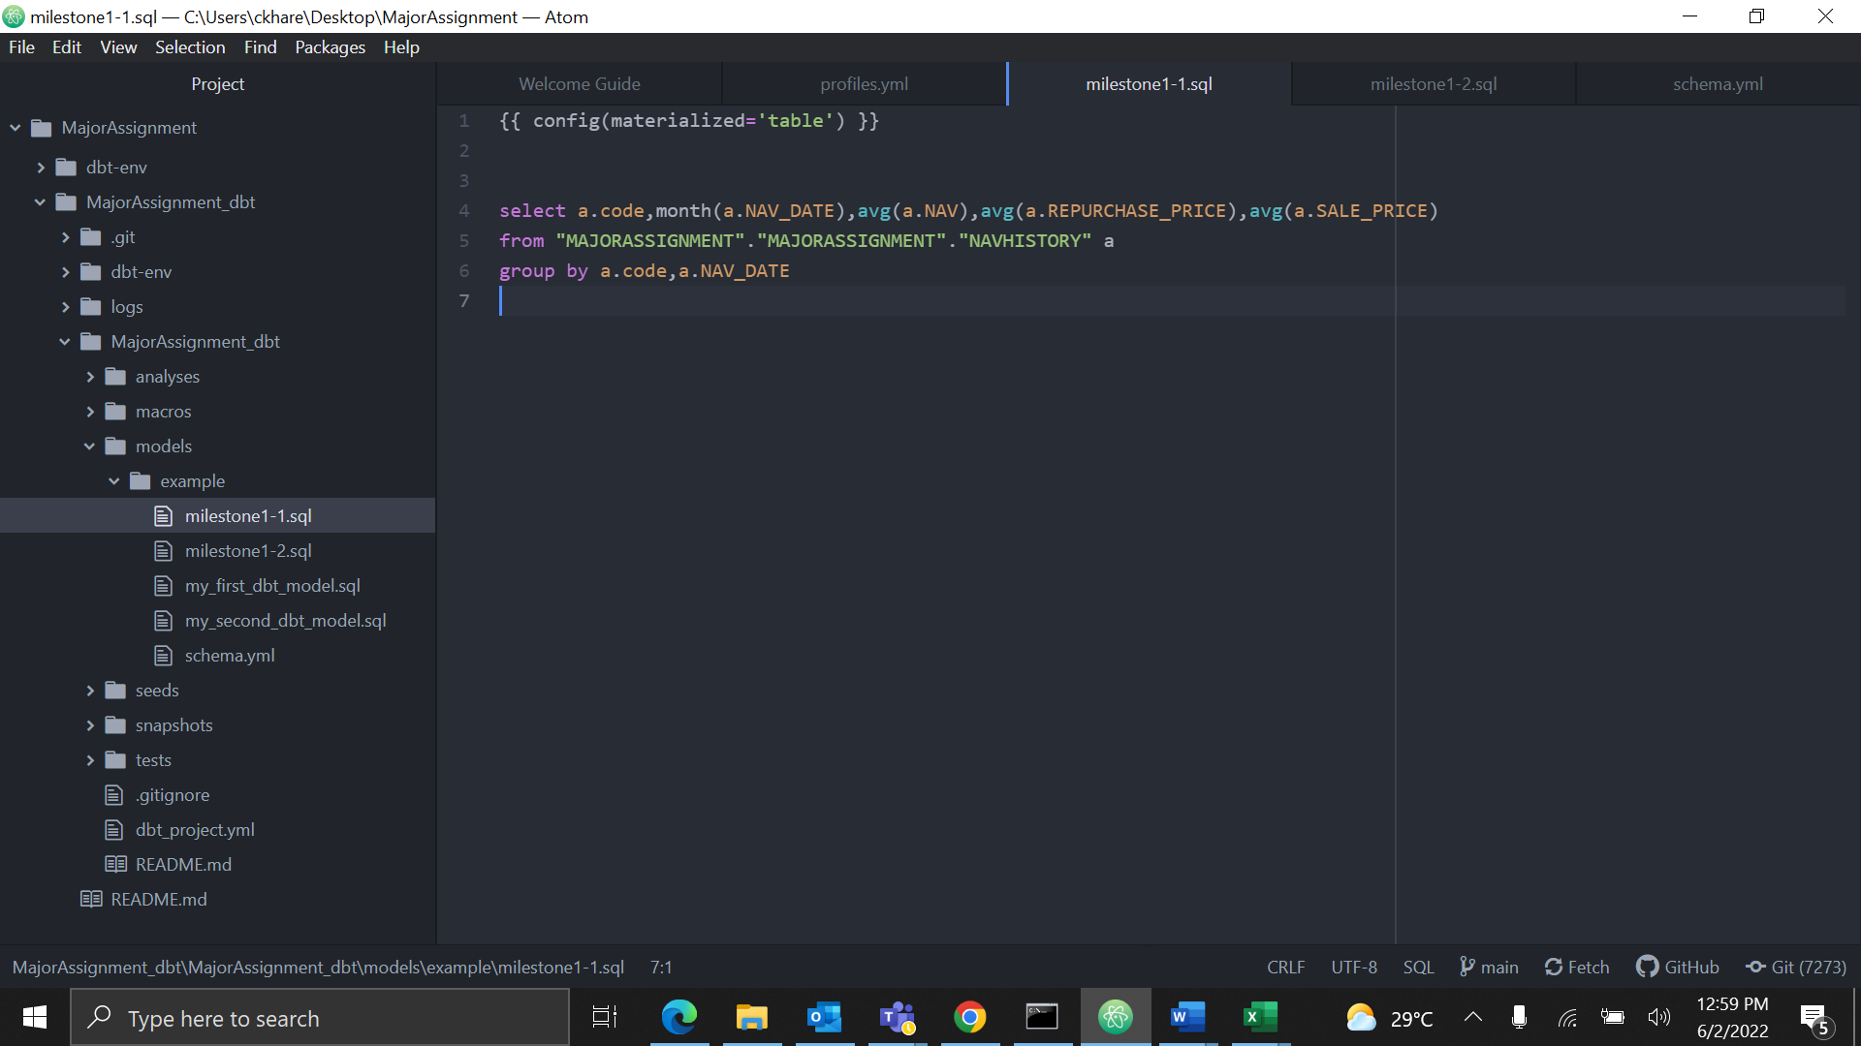

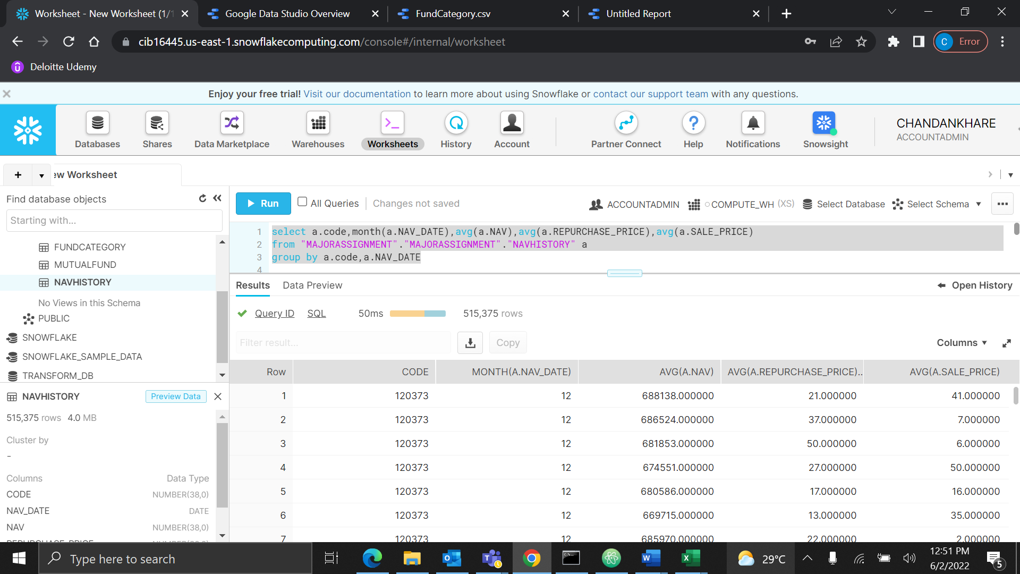

* Then I have completed the 2nd question from Milestone 1.

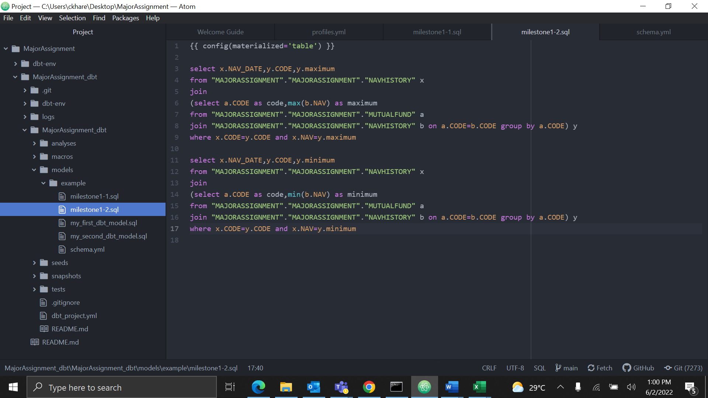

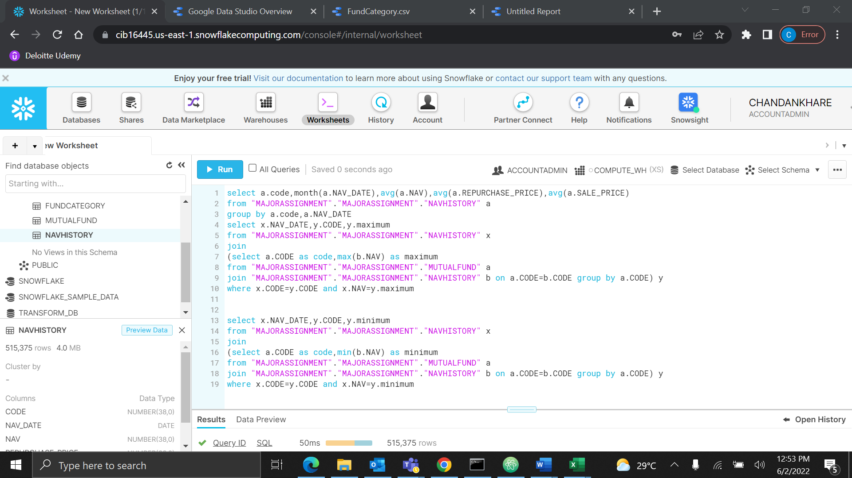

* While Debugging and running I encounters an error.

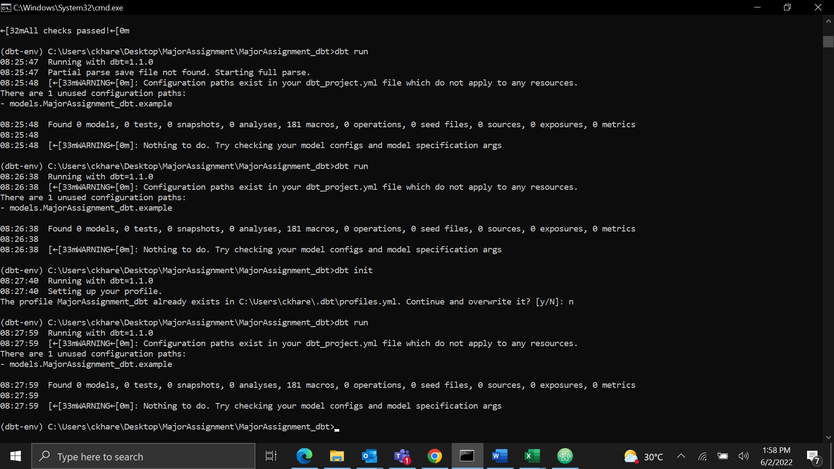

Milestone3:

Question 3:

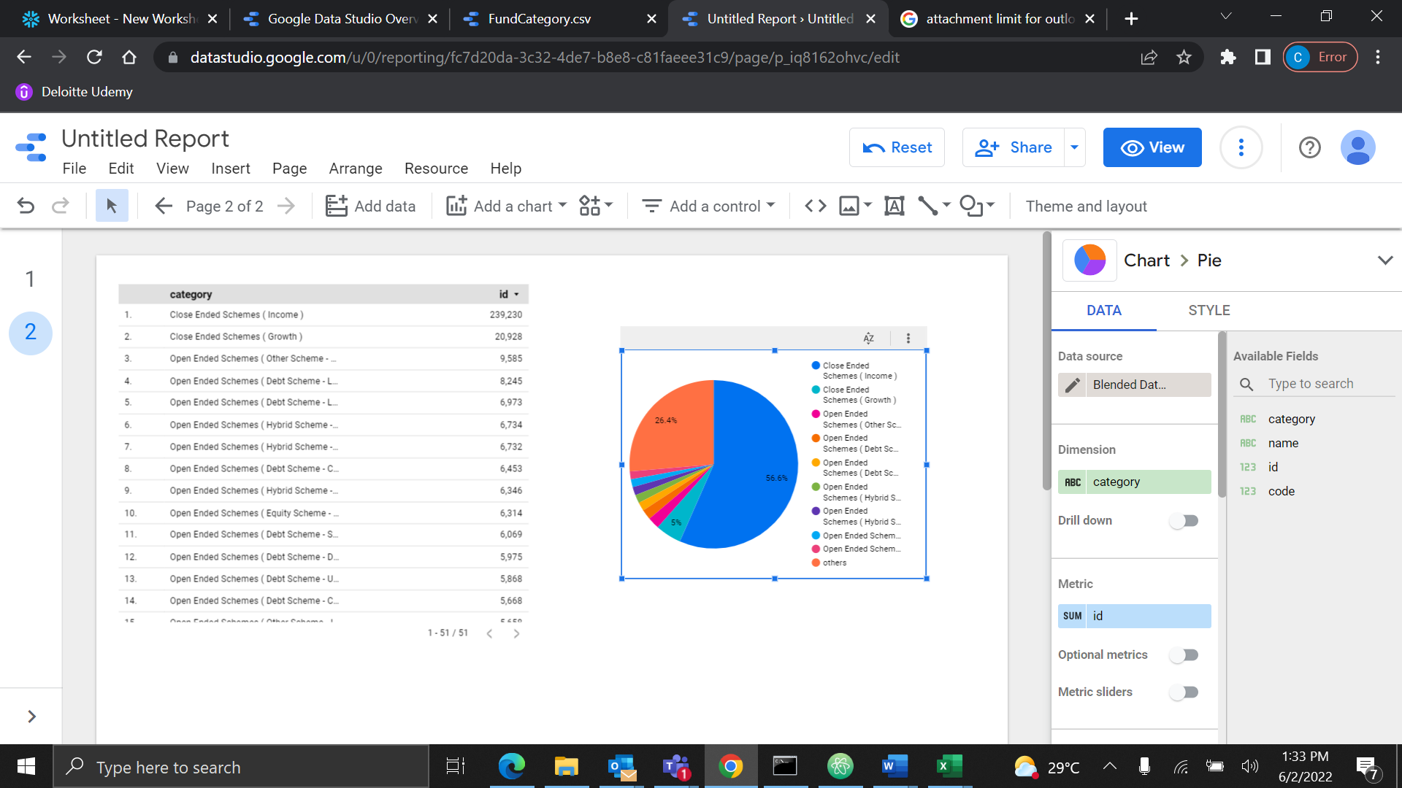

Question 4:

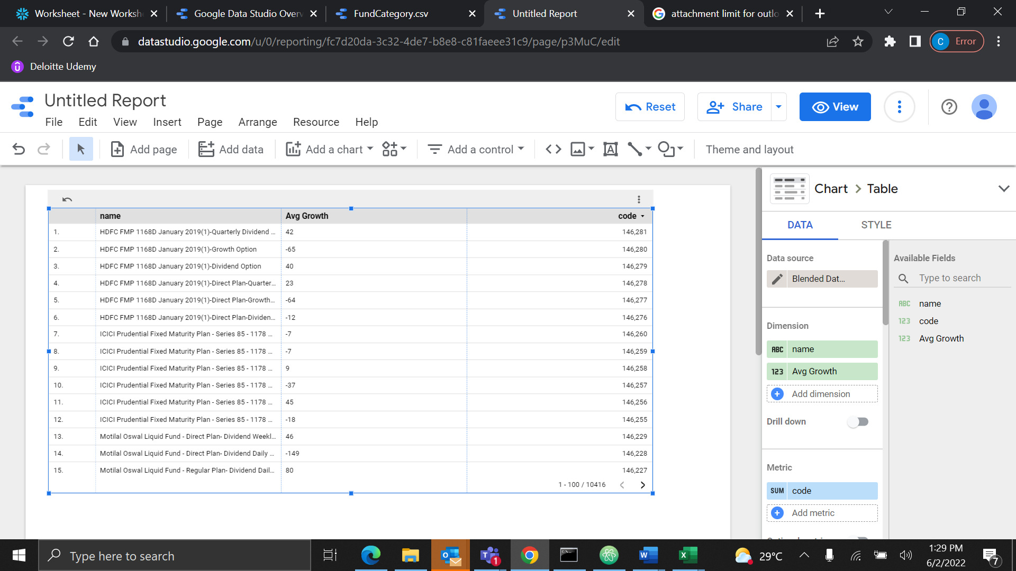

* The link for Data Studio.

https://datastudio.google.com/s/v-ElBSm4CGE