Mini Assignment

Name: Chandan Khare

Email: [ckhare@deloitte.com](mailto:ckhare@deloitte.com)

Approach Used in the Assignment:

* At the beginning we have downloaded the dataset and extracted that zip file into a folder. That file contains xml files different types of information.
* Many XML files were so big that they could not be able to upload to the snowflake as the maximum limit is 16MB.
* So I tried to slice down the large files into smaller chunks.
* I went through several articles and videos and tried querying in snowsql to slice the files.
* But I could not able to slice it. So, I manual sliced the files into a file with some thousands of records in it.
* Then I loaded all those manually sliced XML files into the snowflake.
* And I created a table for each file and loaded the data into those tables.

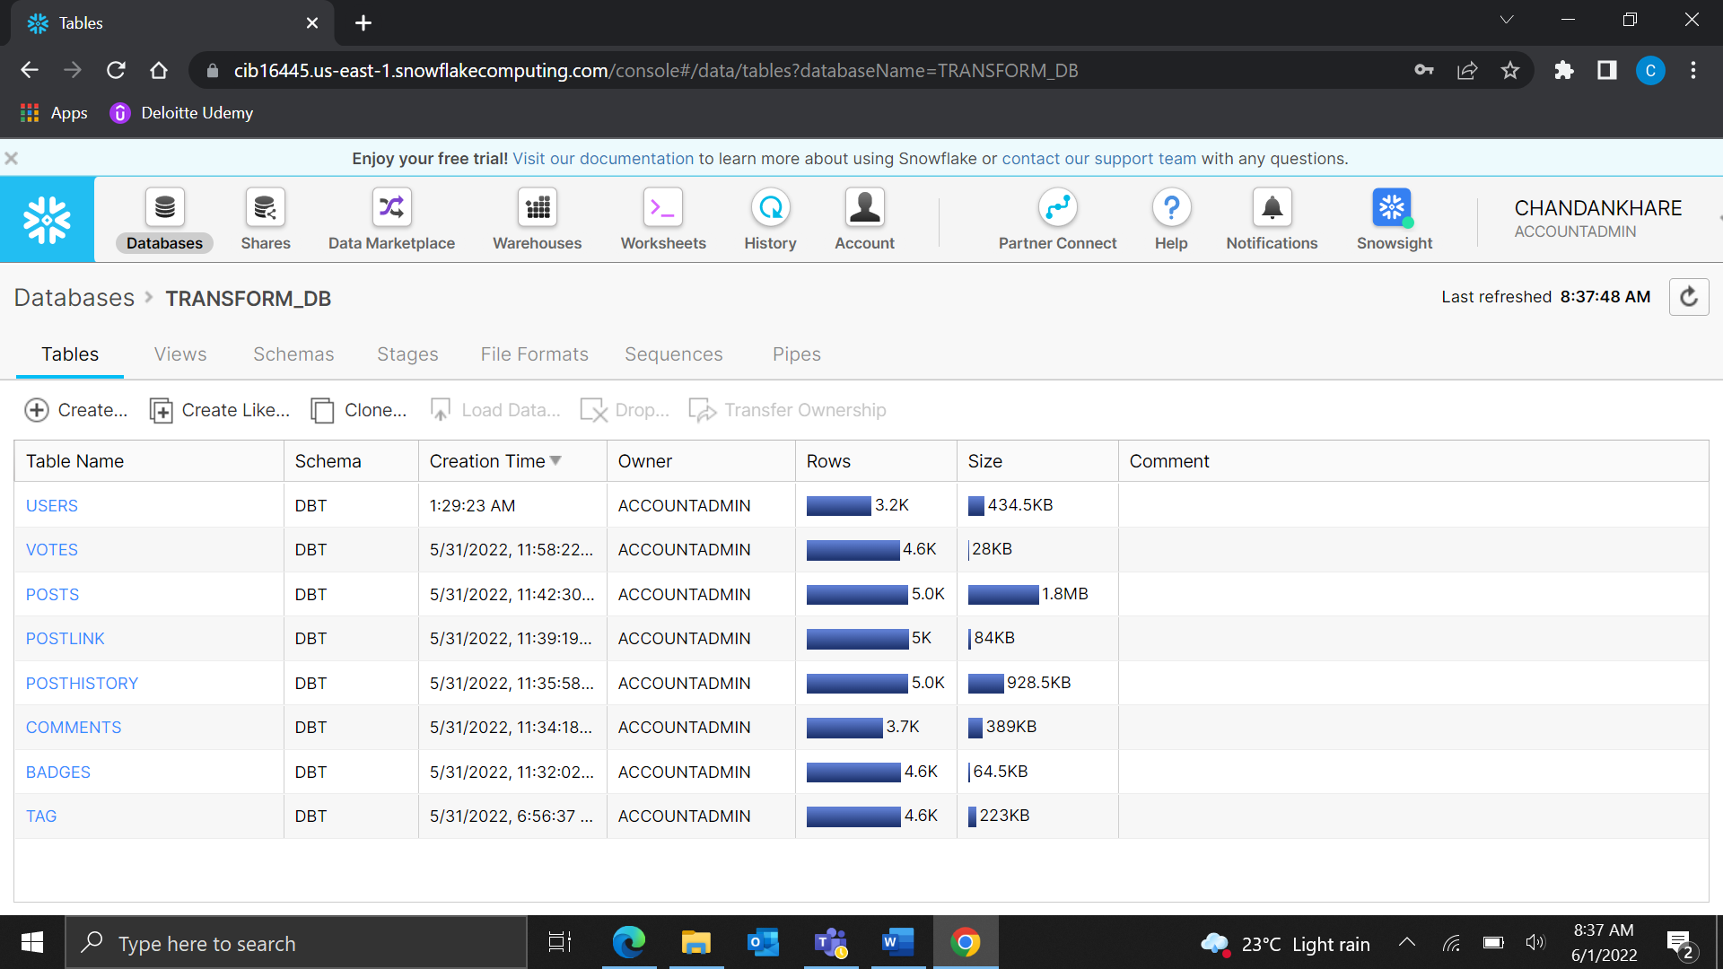

* After creating the tables I have Wrote Some queries to fetch the data from the tables.

