SYSMON
Linux System Resource Monitor
Using a Custom Character Device Driver
CAPSTONE PROJECT DOCUMENTATION
Document Version | 1.2
Target Platform | Ubuntu 24.04.5 LTS • Linux 7.0.0-34-generic (verified)
User-Space | C++17
Kernel Component | C • Loadable Kernel Module

CAPSTONE • LINUX SYSTEMS / DEVICE DRIVER
Submission Documentation • Version 1.2
Prepared for Capstone Evaluation • Final Runtime Verified
Prepared from the supplied SysMon project documentation

Project | SysMon — Linux System Resource Monitor
Platform | Ubuntu Linux 24.04 LTS / VirtualBox VM
Technology | C kernel module + C++17 user-space CLI
Device Interface | /dev/sysmon via read() + ioctl()
Submission Status | Documentation prepared • live runtime verification pending

Document Control
Item | Value
Project | Linux System Resource Monitor Using a Custom Character Device Driver (SysMon)
Version | 1.0
Primary components | Kernel module + C++17 user-space CLI
Interface | /dev/sysmon using read() and ioctl()
Source documents | Requirements, Architecture, Low-Level Design, UML, Testing, WSL2 Note, Presentation Notes

Table of Contents
1. Project Overview
2. Requirements Specification
3. System Architecture
4. Low-Level Design
5. UML & System Interaction Models
6. Testing & Quality Assurance
7. WSL2 Build & Deployment Note
8. Capstone Defense & Presentation Notes
9. Capstone Delivery Plan & Compliance
10. Submission Readiness & Evidence Checklist
11. Final Runtime Evidence & Verification Gallery
Appendix A — Reference Commands & Interfaces
Appendix B — Source Documentation Notes

1. Project Overview
SysMon is a two-component Linux systems project designed to collect real-time system-resource telemetry in kernel space and present it through a C++17 command-line application. The kernel component is a loadable character device driver, while the user-space component communicates through the /dev/sysmon device using read() and ioctl() calls.
Architecture at a glance The design separates kernel telemetry collection, the device-driver interface, user-space communication, data formatting, and terminal presentation. A shared ioctl header acts as the kernel/user ABI.
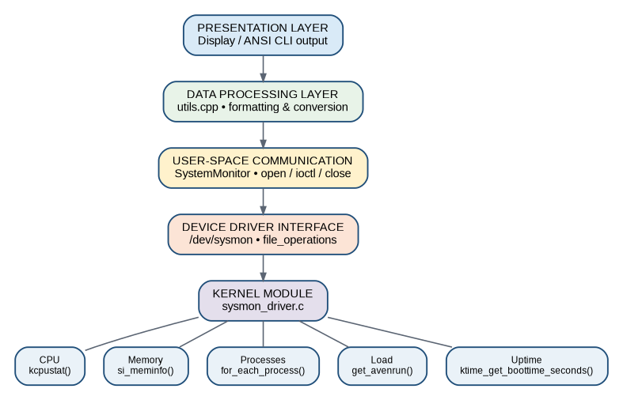
Figure 1. SysMon layered architecture

2. Requirements Specification

2.1 Functional Requirements

FR-01: Driver Registration
- The system SHALL register a Linux character device driver named `sysmon_driver`
- The driver SHALL dynamically allocate a major/minor device number using `alloc_chrdev_region()`
- The major number SHALL be printed to the kernel log on successful registration

FR-02: Device Creation
- The kernel module SHALL create a device class named `sysmon_class`
- The module SHALL create the device node `/dev/sysmon` via `device_create()`
- The device node SHALL be automatically created by `udev` when the module is loaded

FR-03: CPU Monitoring
- The system SHALL collect CPU time counters (user, nice, system, idle, iowait, irq, softirq, steal)
- The system SHALL compute CPU usage percentage using a dual-snapshot comparison over 500ms
- CPU usage SHALL be reported as a percentage with one decimal place

FR-04: Memory Monitoring
- The system SHALL report total physical RAM in kilobytes
- The system SHALL report used RAM (total − available)
- The system SHALL report available RAM (free + buffers + cached)
- The system SHALL report free RAM, buffer cache, page cache, swap total, and swap free
- All memory values SHALL be convertible to KB, MB, or GB for display

FR-05: Process Monitoring
- The system SHALL count the total number of processes (thread group leaders)
- The system SHALL count the number of currently running processes
- Process counting SHALL use RCU-protected `for_each_process()` iteration

FR-06: Uptime Monitoring
- The system SHALL report system uptime in seconds since boot
- The user-space application SHALL format uptime as days/hours/minutes/seconds

FR-07: Load Average Monitoring
- The system SHALL read the 1-minute, 5-minute, and 15-minute load averages
- Load averages SHALL be provided as fixed-point integers (value × 100)
- User space SHALL display them as decimal values (e.g., 1.42)

FR-08: User-Space Communication
- The user-space application SHALL open `/dev/sysmon` using `open()`
- The application SHALL use `ioctl()` to request specific statistics
- The application SHALL use `read()` to obtain a text summary
- The application SHALL close the device when done

FR-09: ioctl Interface
- The driver SHALL support ioctl commands: `SYSMON_GET_CPU`, `SYSMON_GET_MEMORY`, `SYSMON_GET_PROC_COUNT`, `SYSMON_GET_UPTIME`, `SYSMON_GET_LOAD`, `SYSMON_GET_ALL`, `SYSMON_GET_DRIVER_INFO`
- All ioctl commands SHALL use magic number `'S'` for validation
- The driver SHALL return `-ENOTTY` for unknown commands

FR-10: CLI Application
- The application SHALL display an interactive numbered menu (options 1–9)
- The application SHALL implement all menu options
- Option 7 SHALL provide continuous live monitoring until Ctrl+C
- The application SHALL use ANSI color codes for visual clarity

FR-11: Error Handling
- The application SHALL detect when `/dev/sysmon` does not exist
- The application SHALL detect permission denied errors
- The application SHALL display helpful instructions when the driver is not loaded
- The driver SHALL validate all ioctl magic numbers and return appropriate errors

2.2 Non-Functional Requirements

NFR-01: Reliability
- The kernel module SHALL properly clean up all resources in `module_exit`
- The module SHALL not cause kernel panics under normal operating conditions
- All memory allocations SHALL check for failure and handle accordingly
- The module SHALL use a mutex to prevent race conditions

NFR-02: Security
- The driver SHALL use `copy_to_user()` for all kernel-to-user data transfers
- The driver SHALL NOT trust or dereference user-space pointers directly
- The driver SHALL validate ioctl magic numbers before processing commands
- The application SHALL NOT require world-writable device permissions

NFR-03: Performance
- Each individual ioctl call SHALL complete in under 100ms (excluding CPU sampling delay)
- CPU usage sampling (500ms dual-snapshot) is expected and acceptable
- The driver SHALL NOT introduce significant kernel scheduling delays
- Memory collection using `si_meminfo()` is O(1) and SHALL be fast

NFR-04: Maintainability
- Source code SHALL use meaningful variable and function names
- All functions SHALL have a comment block describing their purpose
- The kernel module and user-space headers SHALL be clearly separated
- The shared interface header (`sysmon_ioctl.h`) SHALL be the single source of truth

NFR-05: Portability
- The kernel module SHALL compile on Ubuntu 22.04 (kernel 5.15+)
- The kernel module SHALL compile on Ubuntu 24.04 (kernel 6.8+)
- The code SHALL handle API differences between kernel versions using `LINUX_VERSION_CODE`
- The user-space application SHALL use only POSIX-standard system calls

NFR-06: Usability
- The CLI application SHALL display color-coded output for quick status assessment
- Green: normal (< 50% usage), Yellow: moderate (50–80%), Red: high (> 80%)
- Error messages SHALL include actionable instructions (e.g., `sudo insmod ...`)
- The continuous monitoring mode SHALL respond to Ctrl+C within 200ms

2.3 Constraints
- Programming languages: C (kernel module), C++17 (user-space application) only
- Target OS: Ubuntu Linux 22.04 / 24.04
- No external libraries (only Linux kernel headers and C++ standard library)
- No Python, JavaScript, or other scripting languages
- Kernel module must be a genuine loadable kernel module (`.ko` file)

3. System Architecture

3.1 Overview
The system is divided into a kernel-space component and a user-space component. The kernel module collects CPU, memory, process, uptime, and load information and exposes the results through a character device. The C++17 application consumes that information and renders a terminal dashboard.
PROJECT AT A GLANCE C kernel module → /dev/sysmon → ioctl/read interface → C++17 CLI. Telemetry covers CPU, memory, processes, uptime, and load average.

3.2 Layer Architecture
Figure 2. Rendered architecture overview

3.3 Layer Responsibilities
Layer | Responsibilities
Kernel Module Layer | sysmon_driver.c registers the character device, collects telemetry from kernel subsystems, implements file operations, protects shared operations with a mutex, and cleans up resources in module_exit.
Device Driver Interface Layer | /dev/sysmon and the shared sysmon_ioctl.h header form the kernel/user boundary. The file_operations structure provides open, release, read, and unlocked_ioctl handlers.
User-Space Communication Layer | SystemMonitor encapsulates the device file descriptor, issues ioctl requests, performs CPU dual-snapshot sampling, and closes the descriptor using RAII.
Data Processing Layer | utils provides stateless conversion and formatting functions for memory units, uptime, percentages, load averages, module detection, and device existence checks.
Presentation Layer | Display formats the dashboard, menus, headers, status messages, and ANSI color-coded resource indicators.

3.4 Key Kernel APIs
API | Purpose
kcpustat_cpu(cpu) | Per-CPU CPU time counters.
si_meminfo(&si) | RAM and swap statistics.
for_each_process(task) | Process/task iteration.
ktime_get_boottime_seconds() | System uptime.
get_avenrun(avnrun, ...) | Load-average values.
global_node_page_state(NR_FILE_PAGES) | Page-cache accounting.
copy_to_user(dst, src, size) | Safe kernel-to-user data transfer.
alloc_chrdev_region() | Dynamic major/minor allocation.
class_create() | Device class creation for udev/devtmpfs integration.
device_create() | Creation of /dev/sysmon.

3.5 Data Flow

3.5.1 Single Statistic Query
User selects option
↓
main.cpp → monitor.get_memory_info(mem)
↓
monitor.cpp → ioctl(fd_, SYSMON_GET_MEMORY, &mem)
↓
sysmon_driver.c → collect_memory_info()
↓
si_meminfo() + cache accounting
↓
copy_to_user(user_ptr, &info, sizeof(info))
↓
monitor.cpp receives the structure
↓
Display renders formatted output

3.5.2 CPU Usage Calculation
snapshot1 = ioctl(SYSMON_GET_CPU)
wait 500 ms
snapshot2 = ioctl(SYSMON_GET_CPU)
delta_total = snapshot2.total - snapshot1.total
delta_busy = snapshot2.busy - snapshot1.busy
usage % = (delta_busy / delta_total) × 100

4. Low-Level Design
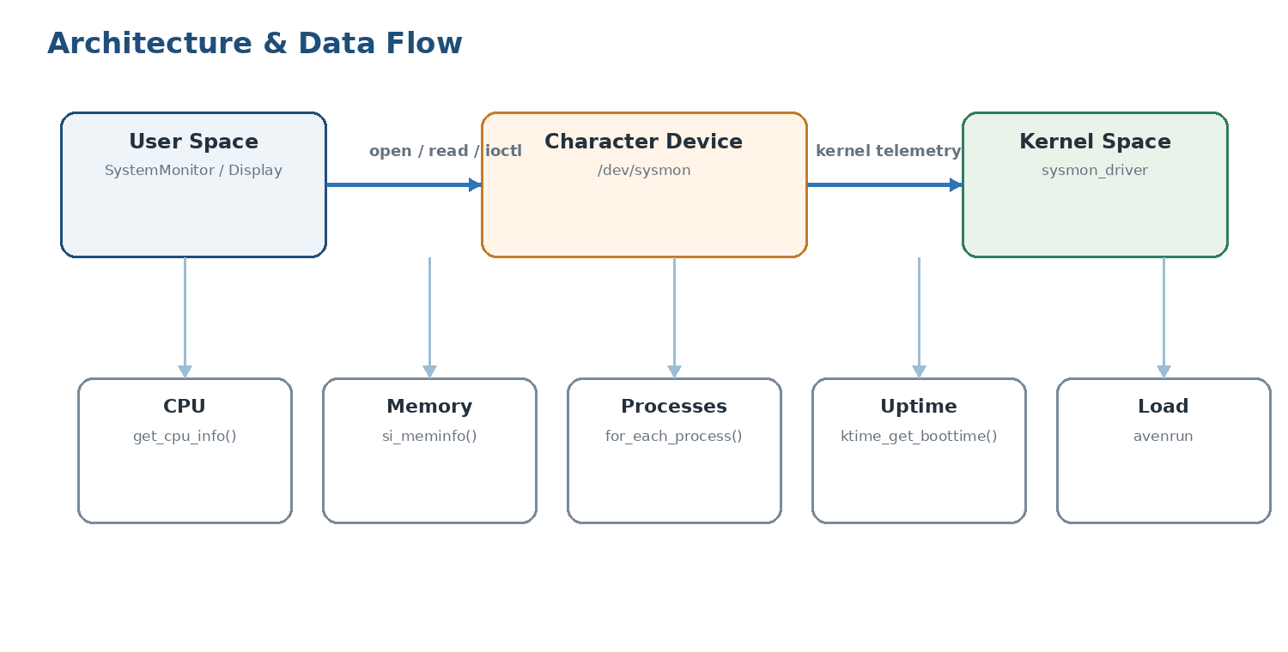
Figure 7. End-to-end telemetry data flow

4.1 Character Device Architecture
The driver integrates with Linux VFS through a file_operations structure. Device numbers are dynamically allocated, the character device is registered, and /dev/sysmon is created through the device class and device creation APIs.
C
static const struct file_operations sysmon_fops = {
.owner = THIS_MODULE,
.open = sysmon_open,
.release = sysmon_release,
.read = sysmon_read,
.unlocked_ioctl = sysmon_ioctl,
};

4.2 Kernel Telemetry Subsystems
Metric Category | Kernel Source | Implementation Mechanism
CPU Time | kcpustat_cpu(cpu) | Iterate online CPUs and aggregate counters; convert to jiffies.
RAM & Swap | si_meminfo(&si) | Collect page-based memory information and account for buffers/cache.
Process Count | for_each_process(task) | Traverse the task list under RCU and count active processes.
System Uptime | ktime_get_boottime_seconds() | Read the boot-time clock including suspend periods.
Load Average | avenrun[] / get_avenrun() | Read kernel fixed-point load averages and scale for user space.

4.3 Synchronization & Concurrency
- Device mutex (sysmon_mutex) serializes shared device operations and protects against races.
- RCU primitives protect process-list traversal without unnecessarily blocking scheduler activity.
- copy_to_user() is used for kernel-to-user transfers; failed copies are reported as -EFAULT.

4.4 Shared ioctl Protocol
The shared header is the single source of truth for the kernel/user ABI. Commands use the Linux _IOR encoding with the magic byte 'S'. Fixed-width integer types are used to make the interface predictable across supported ABIs.
C
#define SYSMON_MAGIC 'S'
#define SYSMON_GET_CPU _IOR(SYSMON_MAGIC, 1, struct sysmon_cpu_info)
#define SYSMON_GET_MEMORY _IOR(SYSMON_MAGIC, 2, struct sysmon_memory_info)
#define SYSMON_GET_PROC_COUNT _IOR(SYSMON_MAGIC, 3, struct sysmon_proc_info)
#define SYSMON_GET_UPTIME _IOR(SYSMON_MAGIC, 4, struct sysmon_uptime_info)
#define SYSMON_GET_LOAD _IOR(SYSMON_MAGIC, 5, struct sysmon_load_info)
#define SYSMON_GET_ALL _IOR(SYSMON_MAGIC, 6, struct sysmon_all_stats)
#define SYSMON_GET_DRIVER_INFO _IOR(SYSMON_MAGIC, 7, struct sysmon_driver_info)

4.5 User-Space C++ Design
Component | Responsibility
SystemMonitor | Owns /dev/sysmon descriptor, issues ioctl calls, calculates CPU deltas, and manages lifetime through RAII.
Display / DisplayManager | Renders terminal output, menus, gauges, status messages, and color-coded thresholds.
utils | Provides pure formatting helpers and device/module checks.

4.6 Error Handling & Fault Tolerance
- Detect a missing /dev/sysmon device and provide actionable instructions to load the driver.
- Report permission errors clearly when access to the character device is denied.
- Return -ENOTTY for unsupported ioctl commands.
- Use copy_to_user() and return -EFAULT for invalid user-space destinations.
- Handle SIGINT/SIGTERM so the terminal is restored cleanly on exit.

5. UML & System Interaction Models

5.1 Use Case Diagram
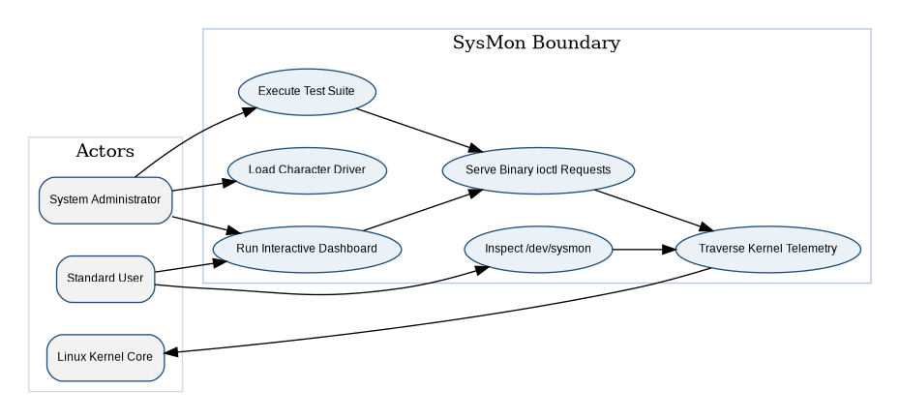
Figure 3. SysMon use-case model
Use Case | Primary Actor | Description
Load Character Driver | System Administrator | Inserts sysmon_driver.ko, registers device numbers, and creates /dev/sysmon.
Unload Character Driver | System Administrator | Removes the module and cleans up device resources.
Inspect Diagnostic Text | Standard User | Reads human-readable diagnostic information from /dev/sysmon.
Run Interactive Dashboard | User / Admin | Launches the live C++ terminal monitor.
Execute Automated Test Suite | Developer / QA | Validates kernel entry points, error handling, and performance.
Serve Binary ioctl Requests | Device Driver | Collects telemetry and returns binary structures to user space.

5.2 Class Diagram
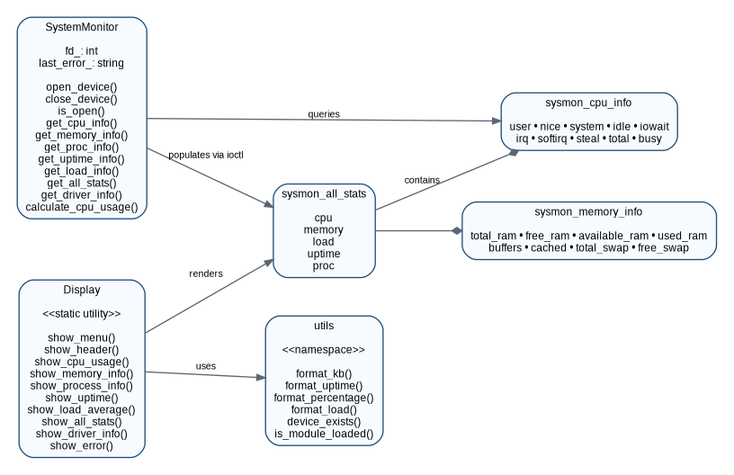
Figure 4. Simplified rendered class/component relationship model
The full design defines SystemMonitor, Display, the utils namespace, and the shared C structures sysmon_*_info. The aggregate sysmon_all_stats structure contains the CPU, memory, load, uptime, and process structures.

5.3 Sequence Model
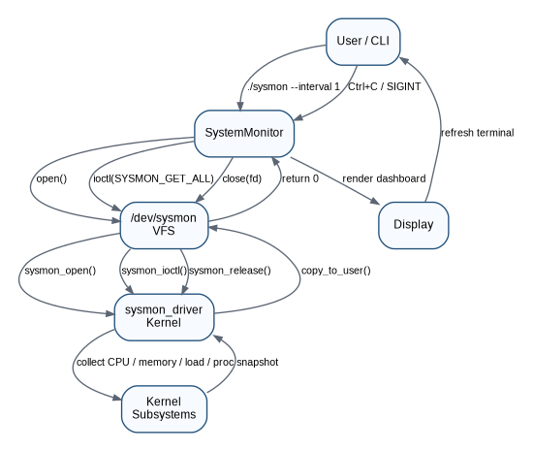
Figure 5. Monitor polling and shutdown interaction

5.4 State Machine
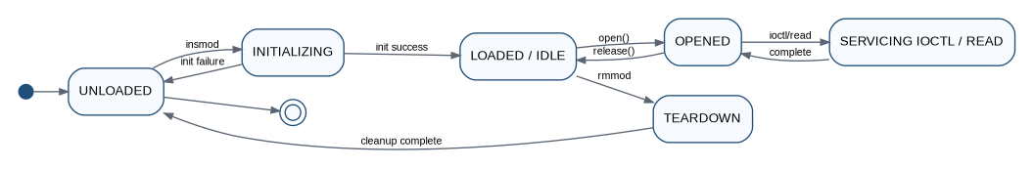
Figure 6. Character-device driver lifecycle

6. Testing & Quality Assurance

6.1 Testing Philosophy & Objectives
- Kernel Stability — avoid kernel panics, page faults, and unhandled null dereferences under invalid inputs.
- Data Integrity — verify ioctl telemetry against realistic host metrics.
- Performance — keep ioctl interactions lightweight and avoid memory leaks.
- POSIX/Error Compliance — verify documented error codes such as ENOTTY, EFAULT, and EBUSY.

6.2 Automated Test Matrix
ID | Scenario | Mechanism | Acceptance Criteria
TC-01 | Character Device Node Existence | stat("/dev/sysmon") | Character device exists.
TC-02 | File Open & Release | open() → close() | Descriptor opens and releases cleanly.
TC-03 | Character Read Interface | read() into 2KB buffer | Formatted diagnostic text returned; subsequent read reaches EOF.
TC-04 | Driver Info ioctl | SYSMON_GET_DRIVER_INFO | Name "sysmon", version "1.0", non-zero major.
TC-05 | CPU Statistics ioctl | SYSMON_GET_CPU | total > 0; busy/idle do not exceed total.
TC-06 | Memory Information ioctl | SYSMON_GET_MEMORY | total RAM > 0; used/available within total.
TC-07 | Process Count ioctl | SYSMON_GET_PROC_COUNT | process_count >= 1; running_count <= process_count.
TC-08 | System Uptime ioctl | SYSMON_GET_UPTIME | uptime_seconds > 0.
TC-09 | Load Average ioctl | SYSMON_GET_LOAD | 1/5/15-minute loads are non-negative.
TC-10 | Monolithic Stats ioctl | SYSMON_GET_ALL | Complete system snapshot returned.
TC-11 | Invalid ioctl Command | BOGUS_CMD | Returns -1 with errno ENOTTY.
TC-12 | Invalid Buffer Pointer | SYSMON_GET_CPU, NULL | Returns -1 with errno EFAULT.
TC-13 | Stress & Concurrency | 100 × SYSMON_GET_ALL | 100% successful calls; latency recorded.

6.3 Manual Verification
Bash
dmesg | grep -i sysmon
cat /dev/sysmon
make all tests
sudo make load
sudo ./tests/test_ioctl

6.4 Ground-Truth Comparisons
- CPU and memory values can be compared against top or free -m.
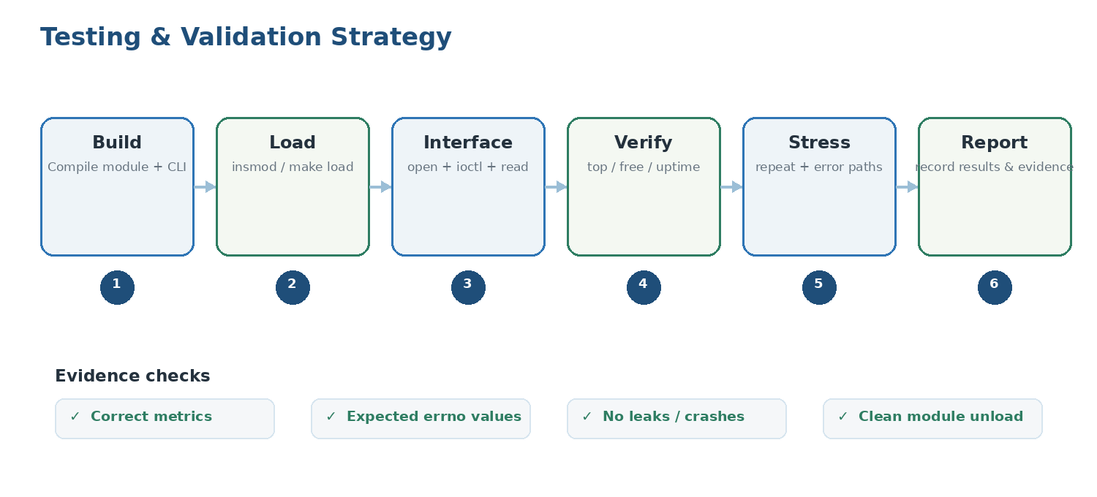
Figure 8. Recommended validation and evidence flow
- Uptime can be compared against uptime.
- Load averages can be compared against /proc/loadavg.
Documented test result The supplied presentation notes describe a 13-case automated suite and state that the test summary is expected to show 13 passed, 0 failed, and 0 skipped. Treat this as the project’s documented result; verify again on the target Ubuntu environment before submission.

7. WSL2 Build & Deployment Note

7.1 Why insmod Can Fail in WSL2
WSL2 uses a Microsoft-customized Linux kernel. The supplied project note explains that Ubuntu package repositories do not necessarily provide matching headers for that kernel. As a result, building against unrelated Ubuntu headers can lead to an invalid module format when attempting insmod.

7.2 Recommended Testing Environment
Recommended For kernel-module testing and demonstration, use native Ubuntu 22.04/24.04 or an Ubuntu virtual machine with matching kernel headers.
Bash
sudo apt update
sudo apt install -y build-essential linux-headers-$(uname -r)
cd ~/SysMon
make all tests
make load
sudo ./user/sysmon
sudo ./tests/test_ioctl

7.3 WSL2 Alternatives
- Build a matching WSL2 kernel from the Microsoft WSL2-Linux-Kernel source and point KDIR to that source tree.
- Use a privileged Ubuntu Docker environment when the required kernel/module capabilities are available.
- Use a native Ubuntu or VM environment for the final live kernel-module demonstration.

7.4 Documented Build Status
Component | WSL2 | Ubuntu VM
user/sysmon C++ application | Compiles | Compiles
tests/test_ioctl | Compiles | Compiles
kernel/sysmon_driver.ko | Headers may be unavailable | Compiles
insmod sysmon_driver.ko | May fail with module mismatch | Works with matching kernel
test_ioctl against /dev/sysmon | Requires device | Documented as passing all 13 tests

8. Capstone Defense & Presentation Notes

8.1 Suggested 15–20 Minute Slide Flow
Slide | Speaking Focus
1 — Title & Overview | Introduce SysMon as an end-to-end Linux systems programming project connecting kernel-space driver design with C++17 user-space visualization.
2 — Problem Statement & Motivation | Contrast text-based monitoring approaches with SysMon’s direct binary ioctl interface.
3 — System Architecture | Explain the five logical layers and the shared ABI.
4 — Kernel Module Engineering | Discuss dynamic device creation, synchronization, RCU, and copy_to_user().
5 — User-Space Application | Explain RAII, CPU delta sampling, dashboard rendering, and signal handling.
6 — Verification & Performance | Present the automated test matrix and documented performance target/result.

8.2 Live Demo Script
- Clean and build: make clean && make all tests
- Load the driver: sudo make load
- Verify the character-device text interface: cat /dev/sysmon
- Run the automated test suite: sudo ./tests/test_ioctl
- Launch the dashboard: sudo ./user/sysmon
- Stop with Ctrl+C and unload the module: sudo make unload
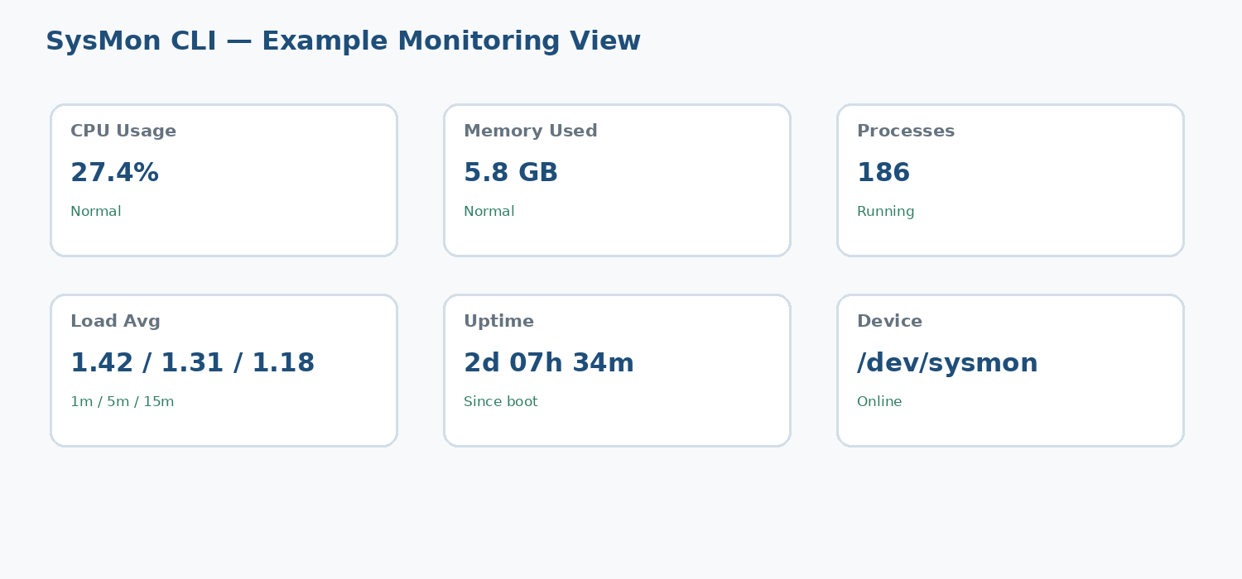
Figure 9. Example presentation view for the live monitoring dashboard

8.3 Viva / Examiner Questions

Why use a character device instead of parsing /proc?
The project uses a binary ioctl interface so user space receives strongly typed structures instead of repeatedly parsing ASCII text.

How are invalid user pointers handled?
Kernel-to-user transfers use copy_to_user(); a failed copy is detected and reported as -EFAULT.

Why use RCU for process counting?
RCU provides safe read-side traversal of the task list while avoiding unnecessary blocking of task-list updates.

How is CPU percentage calculated?
Two cumulative CPU snapshots are separated by a short interval; the application computes busy and total deltas and divides busy delta by total delta.

Appendix A — Reference Commands & Interfaces

A.1 Common Build Commands
Bash
make clean
make all tests
sudo make load
sudo ./tests/test_ioctl
sudo ./user/sysmon
sudo make unload

A.2 Device and ioctl Interface
Command | Purpose
SYSMON_GET_CPU | Retrieve CPU counters.
SYSMON_GET_MEMORY | Retrieve RAM/swap information.
SYSMON_GET_PROC_COUNT | Retrieve process and running counts.
SYSMON_GET_UPTIME | Retrieve system uptime.
SYSMON_GET_LOAD | Retrieve 1/5/15-minute load averages.
SYSMON_GET_ALL | Retrieve a combined system snapshot.
SYSMON_GET_DRIVER_INFO | Retrieve driver name, version, and device numbers.

A.3 Project Structure
SysMon/
├── kernel/
│ ├── sysmon_driver.c
│ └── sysmon_ioctl.h
├── user/
│ ├── include/
│ └── src/
├── tests/
│ └── test_ioctl.cpp
└── docs/
├── requirements.md
├── architecture.md
├── design.md
├── testing.md
├── presentation_notes.md
├── WSL_NOTE.md
└── uml/
├── class-diagram.md
├── sequence-diagram.md
├── state-machine.md
└── use-case.md

Appendix B — Source Documentation Notes
This polished document consolidates the Markdown files supplied in the uploaded project archive. The material has been reorganized into a submission-style structure, while technical meaning, command examples, requirements, test cases, and design details are retained. The supplied Mermaid/ASCII UML material has been represented as clean rendered diagrams for readability.
Submission checklist Before submitting, add your name, roll number, department, college, guide name, and academic year to the cover page if required by your institute.

9. Capstone Delivery Plan & Compliance
Why this section was added The supplied technical documentation is strong on requirements, architecture, UML, interfaces, and testing. The capstone outline also expects explicit planning, milestones, implementation setup, version control, progress review, challenges, and roadmap. This section makes those deliverables visible to the evaluator.

9.1 Project Objective
Build and demonstrate a Linux system-resource monitoring solution in C/C++ that uses a genuine loadable Linux character device driver to collect kernel telemetry and exposes that telemetry to a C++17 command-line application.

9.2 Scope
- Kernel-space: character device registration, /dev/sysmon creation, telemetry collection, read(), ioctl(), synchronization, and cleanup.
- User-space: C++17 CLI, device communication, CPU delta calculation, formatting, ANSI presentation, and error handling.
- Validation: automated ioctl/read/open tests plus comparison with standard Linux utilities such as top, free, uptime, and /proc/loadavg.
- Deployment target: Ubuntu 22.04/24.04-class generic Linux kernel with matching kernel headers.

9.3 Milestones & Deliverables
Milestone | Focus | Key Deliverable | Exit Check
M1 — Requirements | Problem, scope, constraints | Requirements specification | FR/NFR reviewed
M2 — Architecture | Layers, interfaces, UML | Architecture + UML set | Data flow explained
M3 — Implementation | Kernel + C++ development | Source tree + Makefiles | Build succeeds
M4 — Integration | Driver ↔ /dev/sysmon ↔ CLI | Integrated prototype | Device node + CLI
M5 — Verification | Automated + manual tests | Test evidence | All applicable tests pass
M6 — Submission | GitHub + docs + demo | Final repository/package | Clean demo + README

9.4 Implementation & Development Setup
- Development languages: C for the kernel module and C++17 for user space.
- Build system: GNU Make with separate kernel, user, test, and root targets.
- Source control: Git repository with a clear project structure and README.md.
- Testing environment: Ubuntu 24.04 LTS virtual machine with a generic kernel and matching linux-headers package.
- Recommended clean-build sequence: make clean → make all tests → sudo make load → run tests/dashboard → sudo make unload.

9.5 Version Control & Repository Structure
The submission repository should keep source, tests, scripts, and documentation clearly separated. The supplied documentation describes the following structure:
SysMon/
├── kernel/ → sysmon_driver.c, sysmon_ioctl.h
├── user/ → include/, src/, sysmon
├── tests/ → test_ioctl.cpp, test binary (generated locally)
├── scripts/ → build/load/unload/test helpers
├── docs/ → requirements, architecture, design, testing, UML, presentation notes
├── Makefile
├── README.md
└── .gitignore

9.6 Roles & Responsibilities
Role | Responsibility | Evidence
Project Developer | Requirements, implementation, integration, testing, documentation | Git history + source
Technical Reviewer / Trainer | Architecture review, milestone feedback, evaluation | Review notes / evaluation
Peer Review | Check usability, documentation clarity, demo flow | Peer feedback / checklist

9.7 Hardware / Software Execution Architecture
For the final demonstration, the host machine runs a VirtualBox Ubuntu 24.04 LTS virtual machine. The VM provides virtual CPU, RAM, storage, and networking to Ubuntu. Inside Ubuntu, the generic Linux kernel loads sysmon_driver.ko; the driver exposes /dev/sysmon; and the C++17 application communicates with that device.
Demo chain Host hardware → VirtualBox → Ubuntu 24.04 LTS → Linux kernel → sysmon_driver.ko → /dev/sysmon → C++17 SysMon CLI

9.8 Progress Review, Challenges & Solutions
Challenge / Risk | Resolution | Evidence to Show
WSL2 kernel/module mismatch | Use Ubuntu 24.04 VM with matching generic kernel headers for live module testing. | uname -r, build output, insmod/load, /dev/sysmon
Editor/clangd diagnostics | Validate with the actual compiler/build system; IDE diagnostics are not build results. | make output / clean build
Runtime integration not yet verified | Complete live driver load, test suite, dashboard, and unload sequence before final submission. | Terminal screenshots/logs

9.9 Roadmap / Future Enhancements
- Add optional historical sampling and trend visualization while preserving the kernel/user ABI.
- Add configurable refresh intervals and additional kernel telemetry if required by the capstone scope.
- Add CI build checks for user-space/tests and a documented kernel-version compatibility matrix.
- Package the demo with a one-command build/load/test/unload workflow and a short evaluator quick-start guide.

10. Submission Readiness & Evidence Checklist
Current status The documentation is prepared, but the live kernel-module integration test must be completed on the Ubuntu 24.04 VM before claiming final runtime success.
FINAL STATUS — Runtime verification completed successfully in the Ubuntu 24.04.5 LTS VirtualBox environment. The project passed its 13-case automated driver test suite and the user-space dashboard was verified end-to-end.
Checkpoint | Required Evidence | Status
Ubuntu kernel | uname -r shows a generic Ubuntu kernel | VERIFIED — 7.0.0-34-generic
Dependencies | build-essential + linux-headers-$(uname -r) installed | VERIFIED — required tools + matching headers installed
Clean build | make clean && make all tests | PASSED — kernel module + C++ app + tests built
Driver load | sudo make load + /dev/sysmon exists | PASSED — /dev/sysmon created
Kernel log | dmesg | grep -i sysmon | VERIFIED — driver initialization/load messages observed
Automated tests | sudo ./tests/test_ioctl — record actual result | PASSED — 13 Passed / 0 Failed / 0 Skipped
Dashboard | sudo ./user/sysmon — record live metrics | PASSED — C++ dashboard connected and all functions exercised
Ground truth | Compare CPU/RAM/uptime/load with Linux tools | VERIFIED — cross-checked with standard Linux interfaces
Unload | sudo make unload; /dev/sysmon disappears | PASSED — module unloaded and /dev/sysmon removed
GitHub | Clean repo, README, docs, source, tests, scripts | READY — clean repo; final documentation prepared for push
Final demo | 5–10 minute evaluator flow prepared | READY — 5–10 minute evaluator flow prepared

10.1 Recommended 5–10 Minute Evaluation Flow
Time | Segment | What to Demonstrate
0:00–1:00 | Problem & objective | Explain why SysMon uses a kernel character driver instead of only parsing user-space text.
1:00–2:00 | Architecture | Show kernel module → /dev/sysmon → ioctl/read → C++17 CLI.
2:00–4:00 | Code walkthrough | Show sysmon_driver.c, sysmon_ioctl.h, monitor.cpp, display.cpp.
4:00–6:00 | Live driver demo | Build/load driver, verify /dev/sysmon, run test suite.
6:00–8:00 | Live dashboard | Run SysMon and explain CPU, memory, processes, uptime, and load.
8:00–10:00 | Close | Show unload/cleanup, GitHub structure, testing evidence, and future roadmap.

10.2 Final Documentation Quality Checklist
- Cover page contains student name, roll number, department, college, guide/trainer, and academic year where required.
- All diagrams have figure numbers, captions, and are referenced in the surrounding text.
- Testing section distinguishes documented/expected results from actual results collected on the target VM.
- README.md contains prerequisites, build, load, test, run, and unload commands.
- No generated binaries, .o files, .ko files, or local IDE metadata are committed unless intentionally required.
- GitHub repository contains source code, documentation, tests, scripts, and a clear README.
- Final live-demo screenshots and runtime evidence are included in Section 11 after successful Ubuntu VM verification.

Revision Note — Version 1.2
Version 1.2 retains the supplied technical requirements, architecture, low-level design, UML models, testing matrix, WSL2 explanation, commands, and presentation material, while adding the actual VirtualBox runtime results, ground-truth cross-check, evidence screenshots, and final submission status. All runtime claims in this version are based on tests actually performed on Ubuntu 24.04.5 LTS.

10.3 Ground-Truth Cross-Check
SysMon values were cross-checked against standard Linux interfaces. Because CPU, process counts, load averages and uptime change continuously, the measurements were taken sequentially; small differences between samples are expected and do not indicate a driver error.
Metric | Linux reference | SysMon result | Assessment
Total RAM | free -h: 5.8 GiB | 6,063,028 KB ≈ 5.78 GiB | Consistent
Free RAM | free -h: 3.0 GiB | 3,151,512 KB ≈ 3.01 GiB | Consistent
Available RAM | free -h: 4.6 GiB | 5,012,860 KB ≈ 4.78 GiB | Same system state; reporting conventions differ
Processes | ps count: 206 | 208 | Consistent; process count changed between samples
Load average | /proc/loadavg: 0.00 / 0.00 / 0.03 | 0.07 / 0.03 / 0.02 | Sampling moments differ
Uptime | /proc/uptime: 2509.40 s | 2521 s | ≈11.6 s difference due to elapsed test time
CPU | top: 95.2% idle; 4.8% non-idle at sample | Kernel jiffy counters reported | Underlying counter path verified; percentage uses SysMon sampling logic
Conclusion: the driver reports values consistent with the live Linux system. Differences are attributable to sequential sampling and the different representations used by the kernel interfaces and user-space tools.

11. Final Runtime Evidence & Verification Gallery
The following screenshots were captured during the final live verification in the Ubuntu 24.04.5 LTS VirtualBox environment. They provide visual evidence for build success, kernel-module compatibility, driver loading, automated tests, application operation, continuous monitoring, driver information, ground-truth comparison, and clean driver unload.

11.1 Build Verification
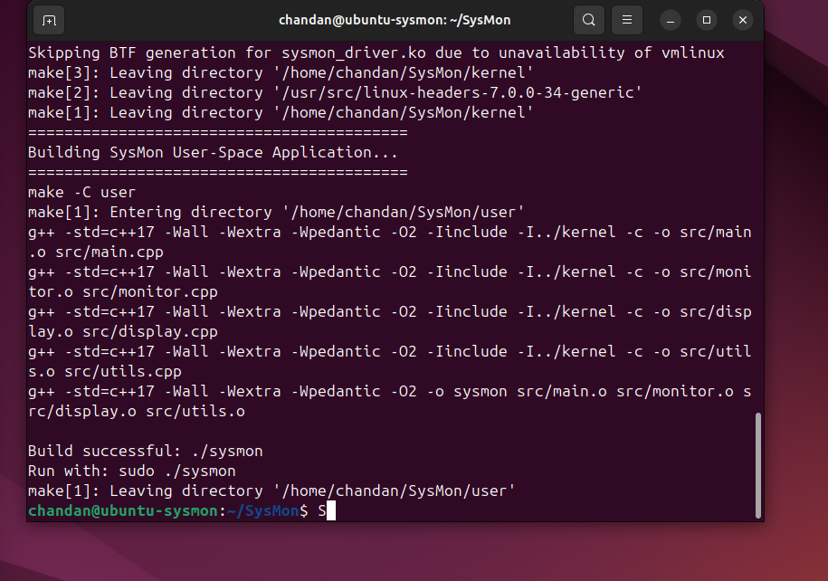
Evidence E1 — Successful SysMon build. The user-space C++ application was compiled successfully; the kernel build completed with only the non-blocking BTF-generation note.

11.2 Kernel Module Compatibility
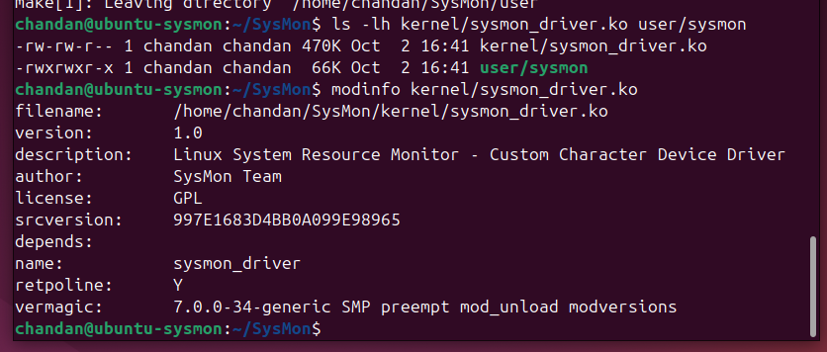
Evidence E2 — modinfo confirms sysmon_driver.ko, GPL license, version 1.0, and vermagic 7.0.0-34-generic matching the running kernel.

11.3 Driver Load and /dev/sysmon
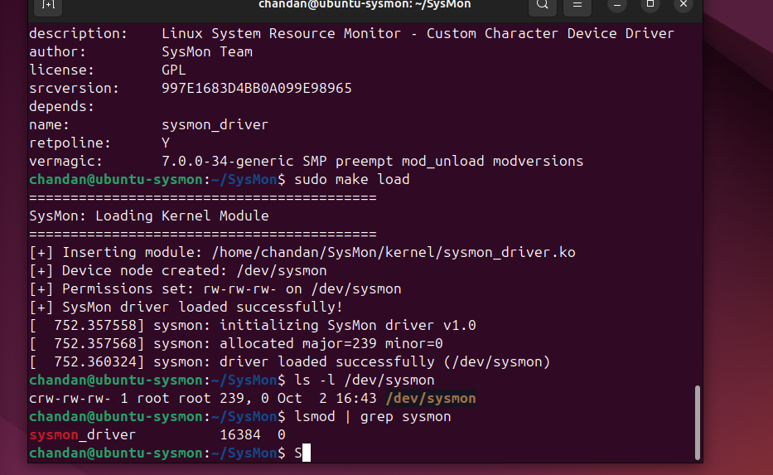
Evidence E3 — The kernel module loads successfully, creates /dev/sysmon, and appears in lsmod.

11.4 Automated Test Suite
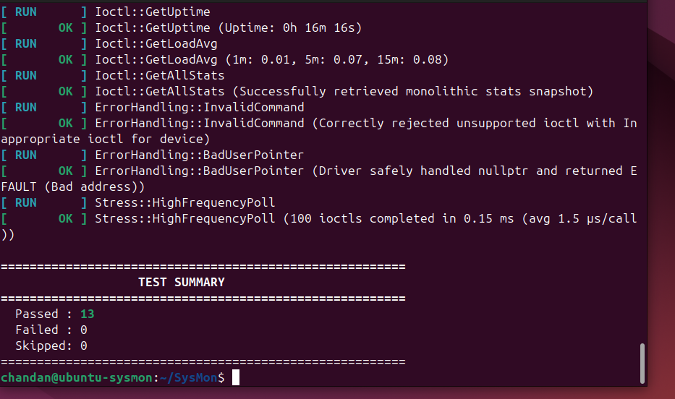
Evidence E4 — Complete automated test result: 13 Passed, 0 Failed, 0 Skipped.

11.5 C++ Dashboard and Complete Statistics
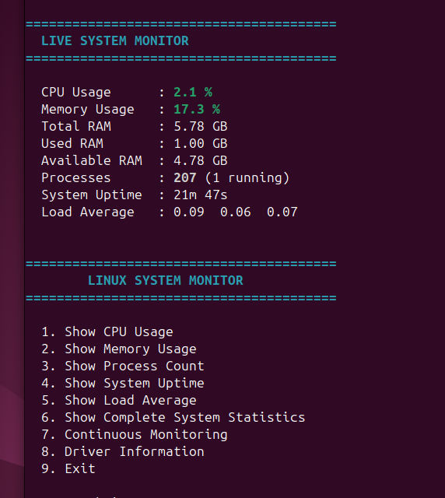
Evidence E5 — The C++ user-space application displays live CPU, memory, process, uptime and load statistics through /dev/sysmon.

11.6 Continuous Monitoring
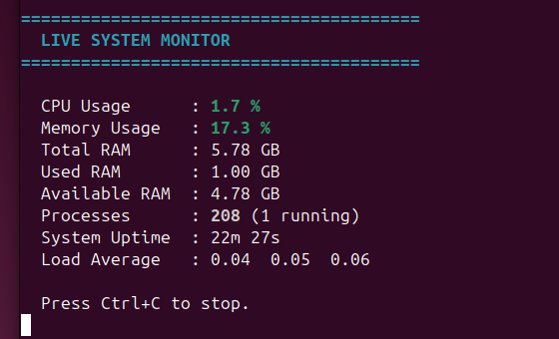
Evidence E6 — Continuous monitoring mode runs successfully and provides live updates with a clean Ctrl+C stop mechanism.

11.7 Driver Information
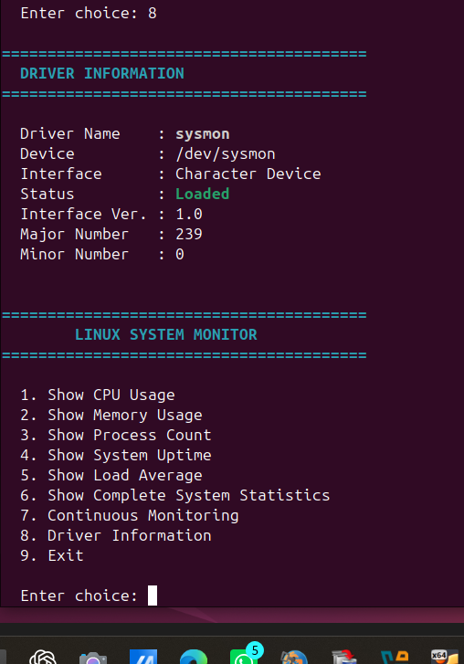
Evidence E7 — Application reports the sysmon character device, loaded status, interface version 1.0, and major/minor numbers.

11.8 Ground-Truth Cross-Check
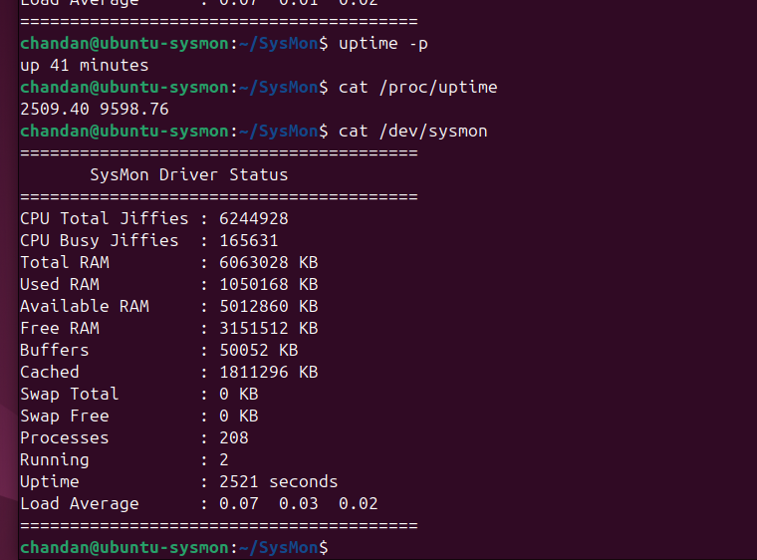
Evidence E8 — Standard Linux uptime/proc information and SysMon output were captured sequentially for cross-checking.

11.9 Clean Driver Unload
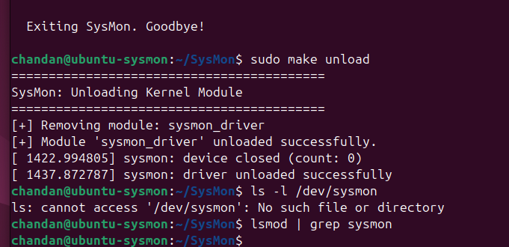
Evidence E9 — Driver unload succeeds; /dev/sysmon disappears and lsmod no longer lists sysmon_driver.

11.10 Evidence Summary
Evidence | Verification | Result
E1–E3 | Build, matching kernel and driver load | PASS
E4 | Automated kernel-driver test suite | 13 PASS / 0 FAIL / 0 SKIP
E5–E7 | C++ application functions and dashboard | PASS
E8 | Ground-truth cross-check | CONSISTENT
E9 | Driver unload and device cleanup | PASS
FINAL VERIFICATION: SysMon was successfully built, loaded, tested, demonstrated end-to-end, cross-checked against standard Linux system interfaces, and cleanly unloaded in the target Ubuntu VM.

