

Project Report

“Campus Network Design - Medical Grade Network”

Advanced Computer Networks

Under the guidance of

**Prof. Sivaraman E**

**January - May 2019**

DEPARTMENT OF COMPUTER SCIENCE AND ENGINEERING

Team

**Monish Reddy - PES1201701666**

**Chandan N Bhat - PES1201701593**

**Khamaroddin Sheikh - PES1201701017**

**(Section H)**

Scope of the Project:

Paramount health care is a health care enterprise founded in 2015. The health care company was founded with the primary goal of providing advanced and affordable health care to stuntmen from the entertainment industry.

The hospital has 5 doctors specializing in different fields. Each doctor has his/her own cabin (all cabins are on different floors) with a standalone physical desktop and printer through which they would require to access the intranet work as well as the internet. They have recently heard about OpenMRS, an electronic medical record system and would like the same to be implemented. The 4 operating rooms of the health care unit also have standalone desktops through which the staff primarily accesses SaaS-based medical imaging software and patient records. The administration staff of the company is 3 in number and the company also has 2 employees who manage the financial affairs. All these employees also have standalone physical desktops and dedicated printers. Note that the finance department deals with sensitive data. The enterprise has 2 servers where they host their internal applications and data.

It was noted in the past that the admitted patients primarily wanted to stream content from Netflix or YouTube. However, they all complained that “My videos always keep buffering”. The hospital staff has also complained that while they were always able to access the intranet, they always faced issues when accessing the internet. Since the enterprise is primarily concerned with providing affordable health care, they are looking for a solution that is affordable and a five 9’s availability medical-grade network.

Current Network

The current network design of Paramount health care is a simple flat network design that mainly aims to reduce cost, maintenance and administration. Their network is designed to reduce the number of routers and switches on a computer network without network segmentation and modularity, thus making the network difficult to manage, less secure, hard to administer and affecting the network performance. The current network is less scalable, poor traffic management thus leading to the issues faced by the community. It lacks redundant resources due to which availability criteria of 99999 is not possible.

Analyzing the existing network and its issue we seek to design an Affordable, Scalable and Highly Available Converged Hierarchical Network in order to solve the problems they are facing and also to meet the requirements requested by Paramount Health Care.

The topology of the current Network at Paramount Health Care is as shown below. Summarising the current situation: A flat network topology with on-premise servers and difficulty managing internet and intranet.

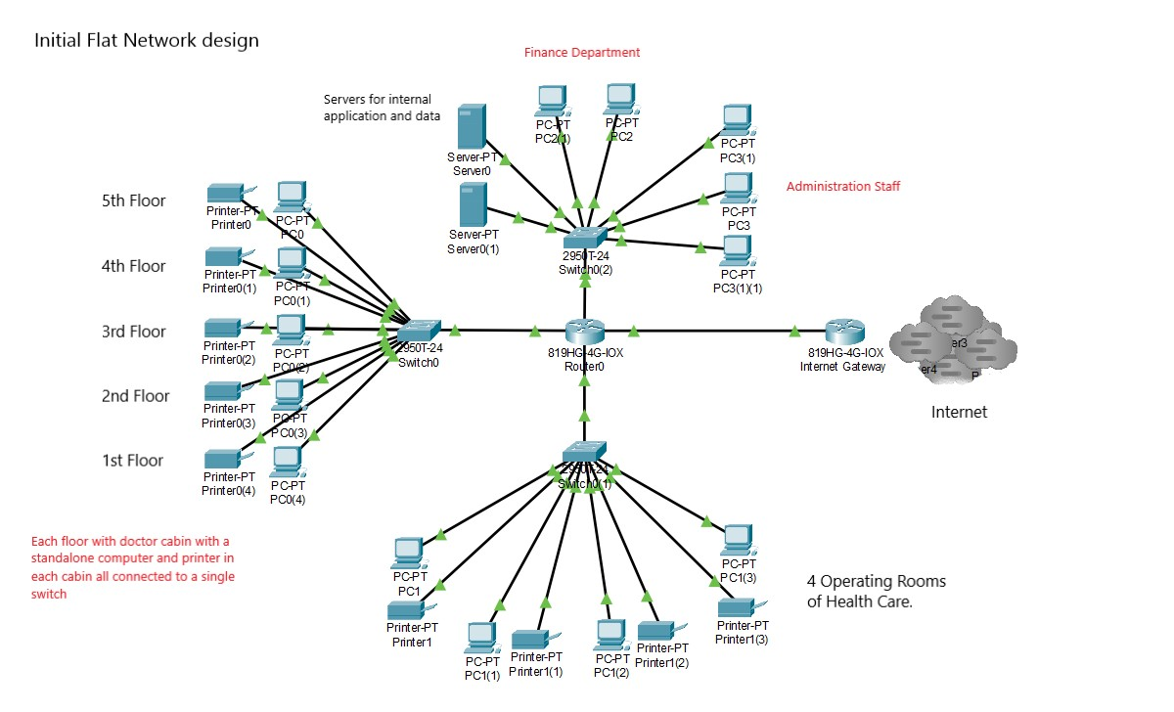

Business Goals

1. Advanced and Affordable health care for the stuntmen of the Entertainment Industry.
2. Faster Internet access to the staff, doctors and other departments of Paramount.
3. Faster Internet and streaming (Youtube, Netflix) for patients.
4. Implement OpenMRS.
5. Providing security from intruders.

Technical Goals

Technical goals include the need of a **Highly Available, Advanced, Secure and Scalable network** for an improved network performance and better experience for the user community. Also streamlining network management.

* Redesigning the existing Flat Network to Hierarchical Network.
* Availability of five 9, which is about 5-6 minutes a year.
* A Scalable network for advanced healthcare services.
* An affordable network design with efficient use of resources.
* Solve buffering problems in streaming applications and problems accessing the internet.
* Streamlining the network to manage both internet and intranet traffic.
* A secured network to prevent security breaches and intruders.
* No single point of failure with redundancy for backup.
* Reduce Network Traffic and Congestion.
* Identifying the core layers and taking proper security measurements.

Data Stores

* The enterprise has 2 servers where they host their internal applications and data

Network Applications

* OpenMRS - , an electronic medical record system and would like the same to be implemented.
* SaaS based medical imaging software and patient records.
* Other internal applications used by the staff, administrative and finance department.

User Communities

* Specialised Doctors in respective floors - 5
* Finance department staff - 2
* Administrative staff - 3
* Staff at the 4 operating rooms of the health care unit.
* Patients (stuntmen from entertainment industries)

Network Design Objectives

* Since Flat networks are not **scalable** and highly available, in order to achieve the requirements we need to redesign the existing network to a scalable, **reliable**, **highly available** and **affordable** network, **Hierarchical Network Design**.
* A good bandwidth connection for all the floors
* Cost of implementation should be as minimum as possible and optimal use of components and resources.
* Should have higher availability, security, false tolerance, latency
* Identify the relevant network applications, their logical connectivity requirements, and the services required.
* Identifying the core layers and taking proper security measurements.

Network Design Solution

Health care organizations have a network infrastructure - often there are several physically separate networks, supporting clinical data, non-clinical data, voice, research, and departmental staff.

For several reasons (manageability, efficiency, costs), there is a desire to converge these separate networks into one physical infrastructure, while still providing the isolation, security, and responsiveness needed by the organization.

We propose a network design of the converged network infrastructure for the healthcare organization based on the **hierarchical, three-layer model: core, distribution, and access layers.** This hierarchy establishes the foundation and connectivity for the entire network, as shown below. It is a **resilient network** that is easy to understand and easy to troubleshoot meeting the **high-availability and segmented network**. It is an industry wide adopted model for designing a reliable, scalable, and cost-efficient internetwork.

Our network design involves dividing the network into discrete layers. Each layer, or tier, in the hierarchy provides specific functions that define its role within the overall network. This helps the network designer and architect to optimize and select the right network hardware, software, and features to perform specific roles for that network layer. The network design proposed consists of a modular design with redundant components to achieve Availability, Reliability and Scalability.

**The benefit of dividing the existing flat network into smaller, more manageable blocks is that local traffic remains local. Only traffic that is destined for other networks is moved to a higher layer. Thus solving the prime problem faced by Paramount.**

How our network design met Technical Goals

* **Availability** : With redundant switches in each of the Hierarchical Layers we guarantee High Availability. Hence the 5’9s checklist is guaranteed with our design.
* **Scalability** : The Hierarchical 3 layered model guarantees a scalable network. The different layers are isolated and future scaling of the network becomes easy. Usage of multi-layer switches also guarantees scalability.
* **Security** : Our network consists of a firewall (Network based) to make the network more secure as it deals with Financial data and critical clinical data which are highly sensitive and prevents from falling into the hands of the wrong people.
* **Network and Internet Performance:** We configure VLANs in the access layers to separate traffic from different departments and reduce congestion. Dividing the network into smaller network segments also improves the network performance and guarantees faster internet connectivity which was an issue with older networks. Also multilayer switch enhances the network routing performance.
* **Streamlining Network Management:** Managing internet and intranet network traffic is achieved with policy based routing.

Converged Hierarchical Network Design

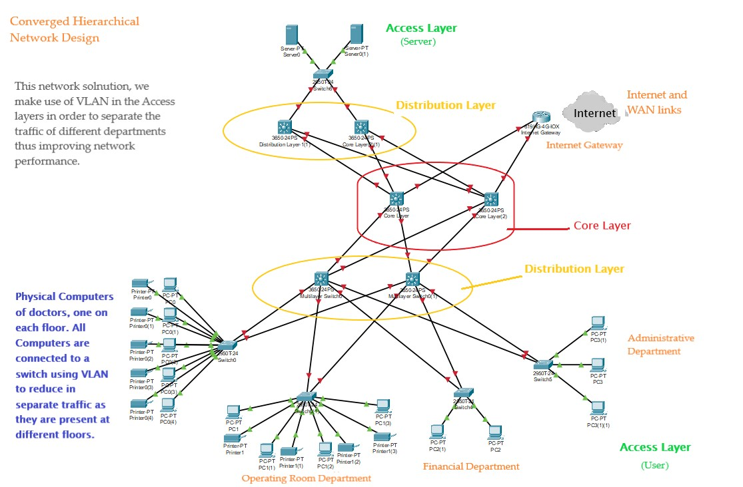

An affordable alternative solution is shown below

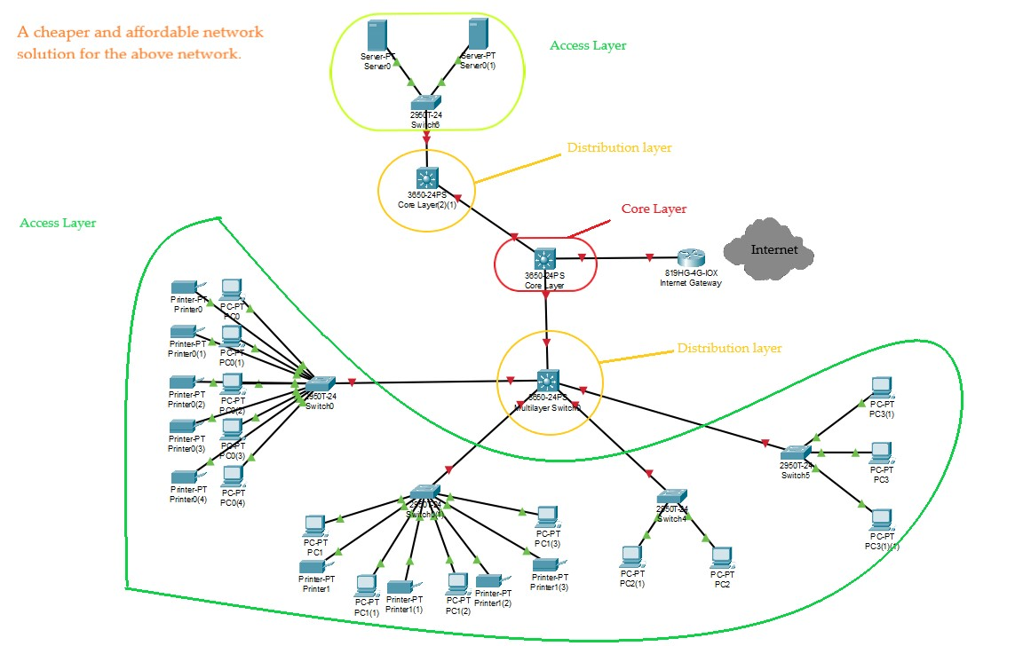

The hierarchy allows changes or upgrades to be performed at one layer in the hierarchy without disruption or significant changes to the other layers.End-to-end connectivity uses the ISO network model’s network layer (also called the routing layer or Layer 3), which provides network stability, fault isolation, fast response to failures, and maximizes redundant path utilization.

To implement high availability throughout the network infrastructure, we design with redundant pairs of devices, especially for the core and distribution layer. We find that replicating a standard redundant design, based on pairs, is predictable, easy to implement, scalable, and relatively simple to maintain.

Security is a crucial part of the health care network designs. In addition to standard infrastructure security practices, our designs include a security module to control all communication between the global network and the virtual networks. IPS/IDS devices and firewalls customized with organization specific policies and rules comprise the nucleus of the security module. All traffic that passes between the virtual networks and the global network travels through these network security devices. In addition, the perimeter network is secured to meet appropriate health care policies and regulations.

**Cost:**

|  |  |
| --- | --- |
| **Name** | **Cost** |
| 5 layer 2 switches | 550/- each |
| 6 cisco 6500 catalyst switch | 20000/-each |
| Fibre cable | 66/- per meter |
| Service Charges | 5,000/- |
| Network based enterprise Firewall installation | 2500/- |
| Consulting Fees | 10,000/- |
| Installation Fee | 5,000/- |

QOS

**The generalized QoS design, as shown in the figure below, is flexible, easily extending to support new service.**

|  |  |
| --- | --- |
| **QOS applications** | **Network priority** |
| Routing and switching protocols | high |
| Clinical life critical | high |
| Streaming video | high |
| data | medium |
| Transaction data | low |

**How our design meets the QOS services:**

**\***Routing and switching protocols are both handled by the multilayer switch. We opt to use OSPF routing protocol for routing of traffic. Our choice of routing protocol is considering that OSPF summarisation occurs only on change of topology and the broadcast traffic is also less thus facilitating our objective.

**\***Streaming video is given high preference as we will manage internet traffic from the intranet traffic using policy based routing. We also prioritize applications with QOS, thus streaming for patients can be of high priority as the Health care is service oriented.

**\***Clinical life critical is also assured as we have installed a firewall to secure the clinical section data as it is sensitive data, thus preventing it from the hands of the wrong people.

Since the major concern was to solve the internet issues and “difficulty of the patients on streaming netflix or youtube”, we try to seperate and manage the internet traffic from the intranet traffic using **Policy Based Routing.**

**Policy based routing**

With the help Policy based routing you can set different next hop for different traffic based on the destination or source of the traffic.In this way we can seperate the internet and Intranet traffic from interfering by directing the Intranet traffic to different router/network and internet traffic to another.This can solve the difficulty streaming netflix and youtube. Since our topology is a three layer model , This can be done easily but changing the required routers without affecting the other components of the network.

**In addition we follow few practices to improve the network performance.**

1. Monitor the entire network traffic to find insights of possible issues in the network.
2. Network Segmentation.
3. Use a content Delivery network.
4. Reconfigure TCP/IP Settings.
5. Prioritize Network Traffic.
6. Redundancy in the network.
7. A range extender may be useful.

**Another software solution:**

**Forefront UAG Direct Access** is a proprietary software solution which is used to separate and manage the internet traffic from the intranet. This is available in the form of a CD which can be easily installed in the End devices.

**We choose multilayer switch for the design due to:**

1. Multilayer switches not only can do all the job that Layer 2 switches do, it has a routing function as well, including static routing and dynamic routing.
2. Routers typically use software to route. While multilayer switches route packets on ASCI (Application Specific Integrated Circuit) hardware.
3. Multilayer switches route packets faster than routers.
4. Easy for use – Multilayer switches are configured automatically and its Layer 3 flow cache is set up autonomously. And there is no need to learn new IP switching technologies for its “plug-and-play” design.
5. Faster connectivity – With multilayer switches, you gain the benefits of both switching and routing on the same platform. Therefore, it can meet the higher-performance need for the connectivity of intranets and multimedia applications.

**Configuration**

You can start configuring the multilayer switch after making preparations.

1. Enable routing on the switch with the IP routing command.
2. Log into multilayer switch management interface.
3. Create the VLANs on the multilayer switch and assign ports to each VLAN.