Implement Snowflake Streams for Sales Data Processing

Task 1: Create Database
Create a transient database named:
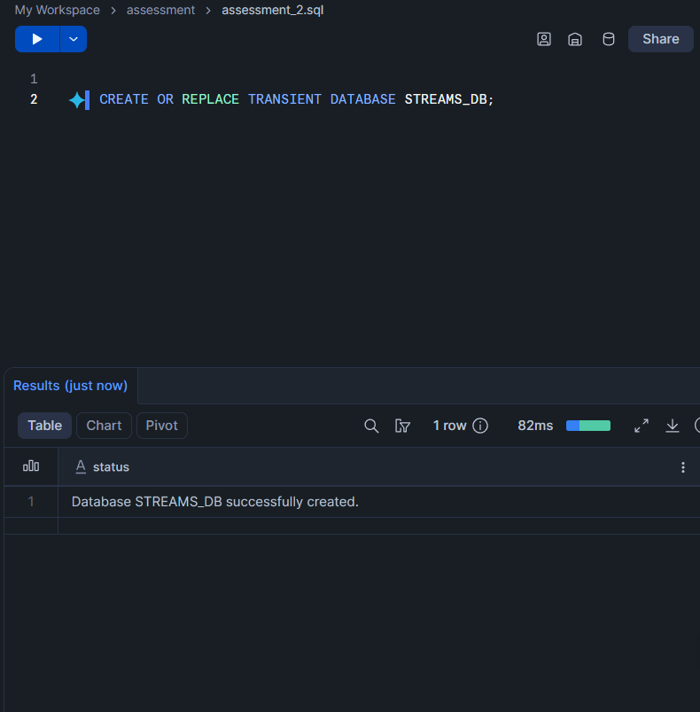
STREAMS_DB

Task 2: Create Raw Sales Staging Table
Create a table named:
SALES_RAW_STAGING
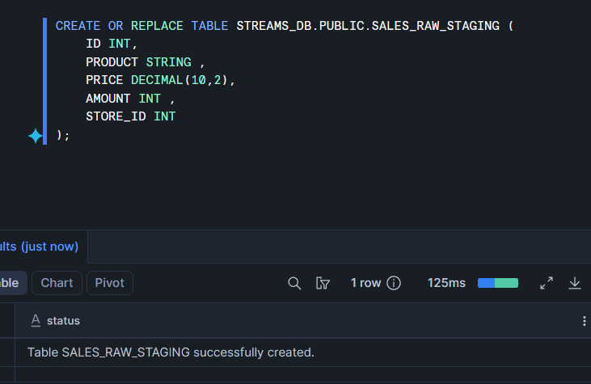

Task 3: Insert Initial Sales Data

Insert the following five records into SALES_RAW_STAGING:

id product price amount store_id
1 Banana 1.99 1 1
2 Lemon 0.99 1 1
3 Apple 1.79 1 2
4 Orange Juice 1.89 1 1
5 Cereals 5.98 2 1

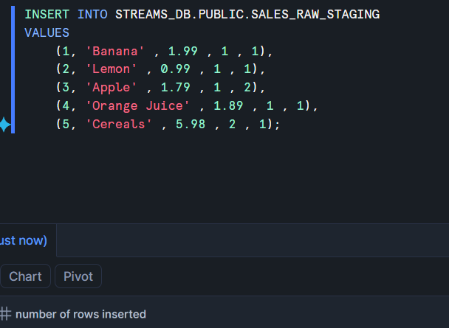

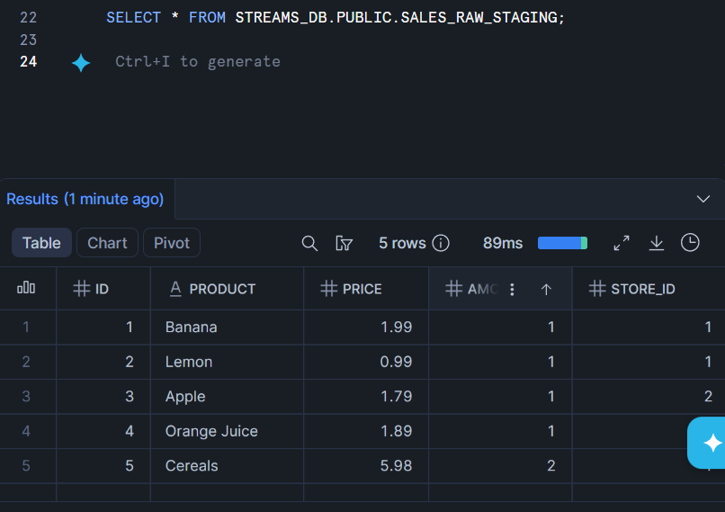
Task 4: Create Store Table
Create a table named:
STORE_TABLE
The table should contain:
store_id
location
employees

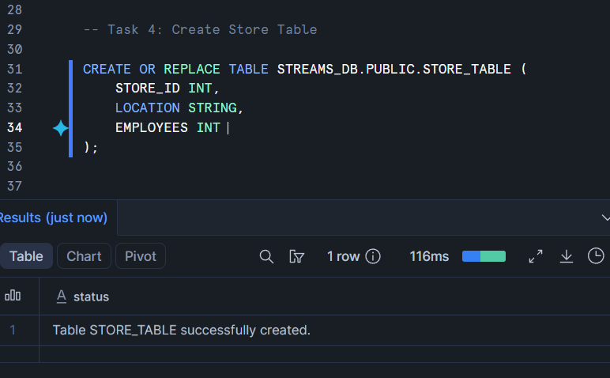

Task 5: Insert Store Data
Insert the following records into STORE_TABLE:
store_id location employees
1 Chicago 33
2 London 12

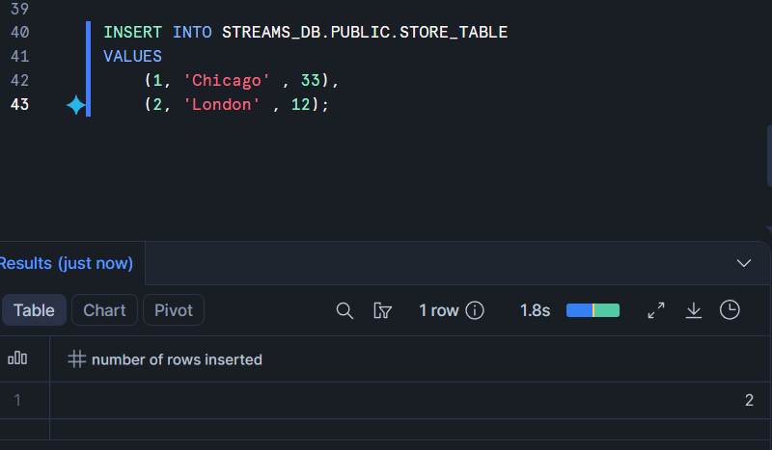
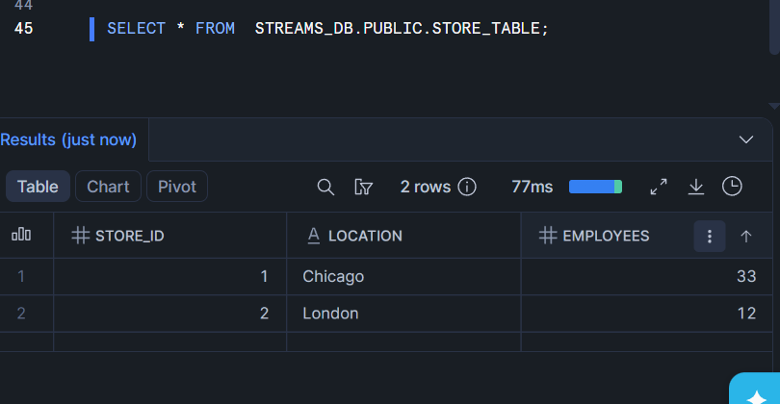

Task 6: Create Final Sales Table

Create a table named:
SALES_FINAL_TABLE
The table should contain:
id
product
price
amount
store_id
location
employees

This table will store sales data along with store location and employee details.
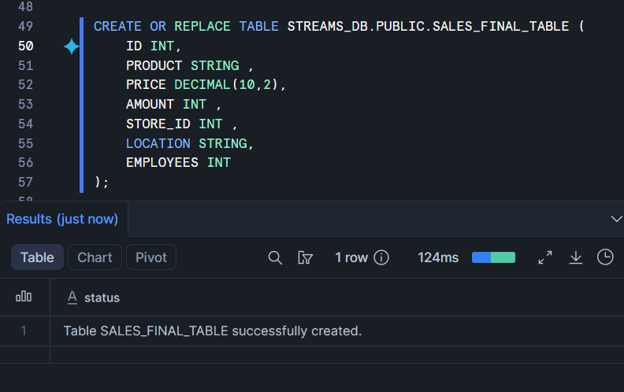

Task 7: Perform Initial Full Load

Load data from SALES_RAW_STAGING into SALES_FINAL_TABLE.
While loading, join:
SALES_RAW_STAGING
with:

STORE_TABLE
using STORE_ID.

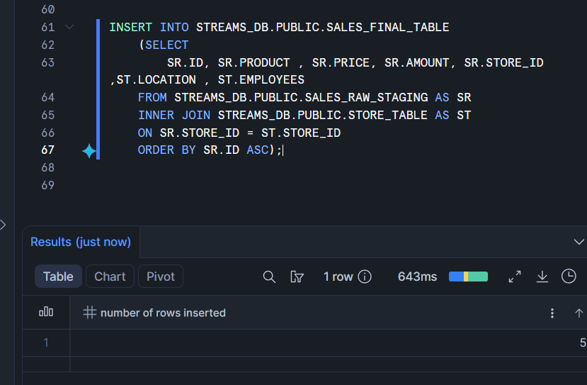

Task 8: Verify Initial Load
Display data from:

SALES_RAW_STAGING;
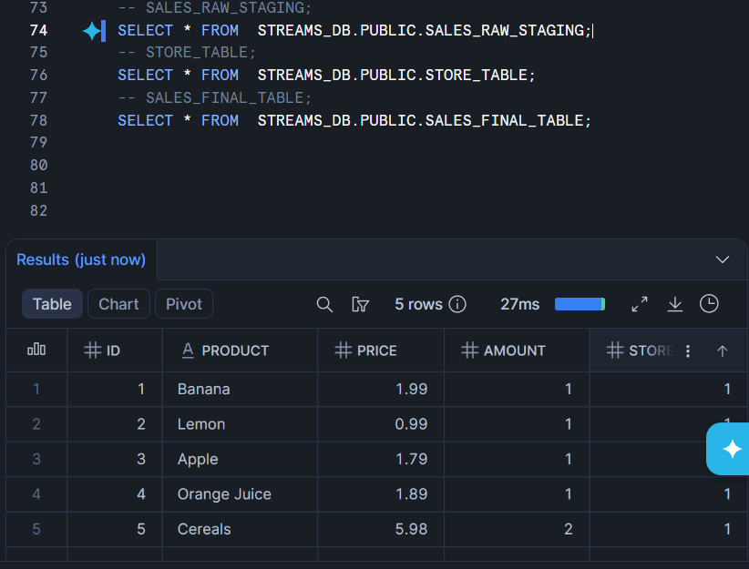
STORE_TABLE;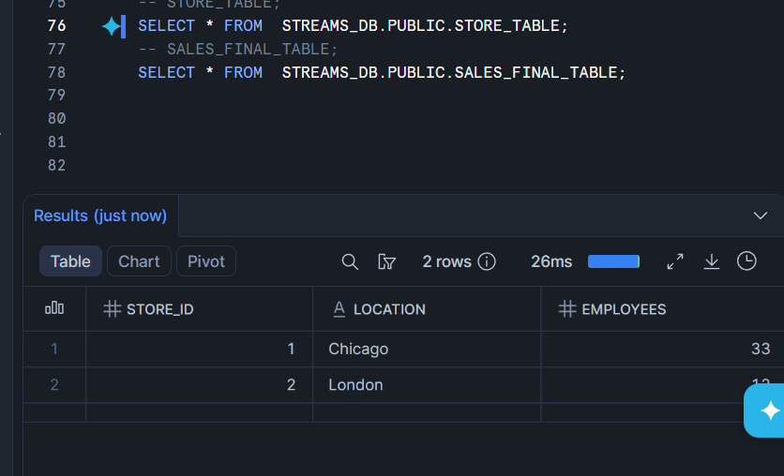

SALES_FINAL_TABLE;
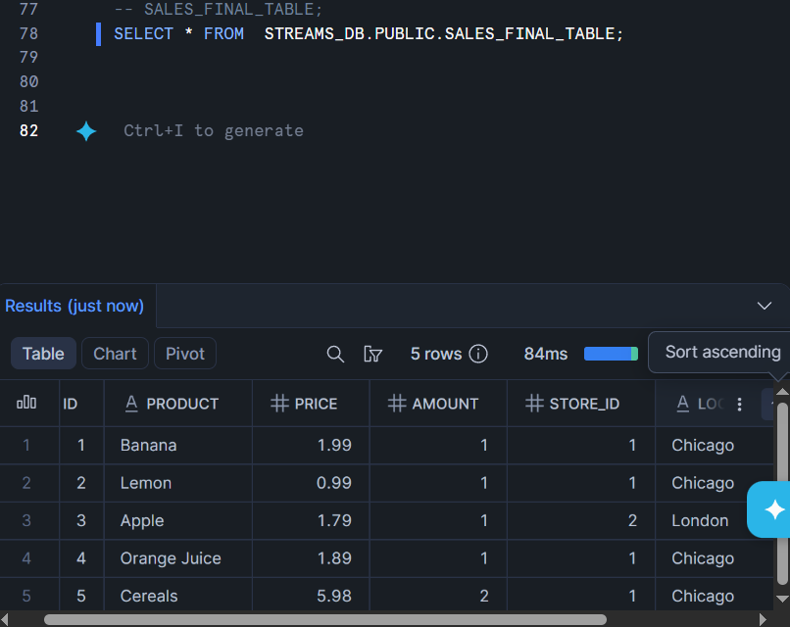
Confirm that SALES_FINAL_TABLE contains 5 records.

Stream Implementation
Task 9: Create Stream Object

Create a stream named:
SALES_STREAM
on top of:
SALES_RAW_STAGING

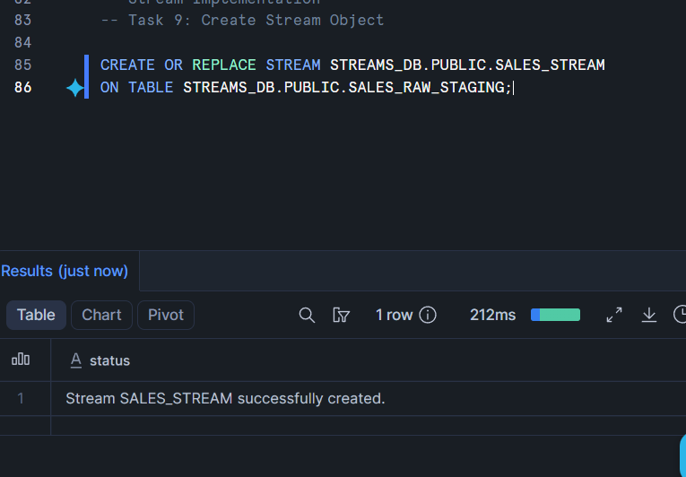

Task 10: View Stream Information

Execute commands to:
Show all streams.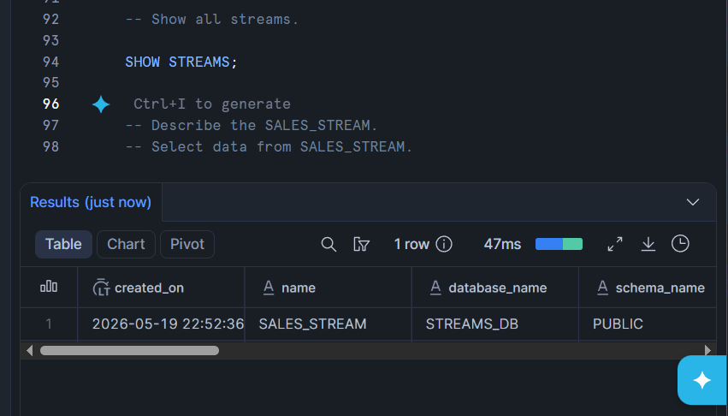
Describe the SALES_STREAM.
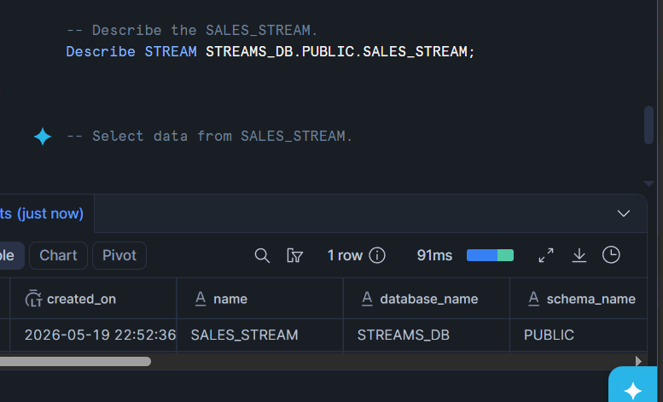

Select data from SALES_STREAM.
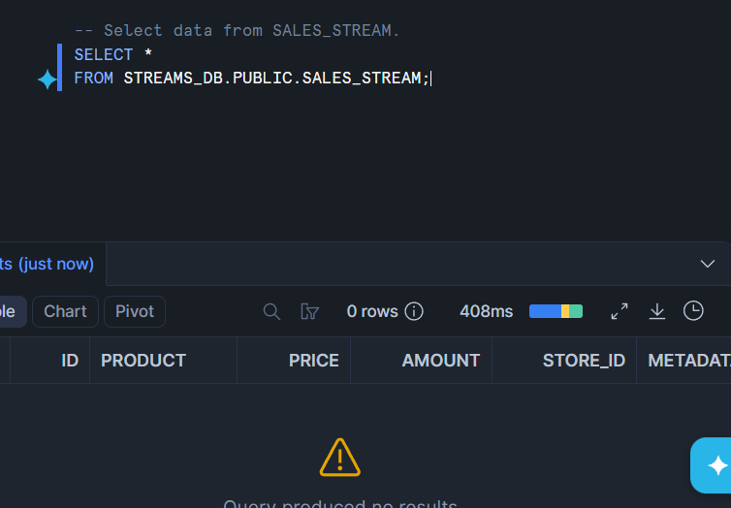

Answer this question:
Why is SALES_STREAM empty immediately after creation?
ANS : SALES_STREAM is empty immediately after creation because a stream only tracks changes made after the stream is created.

Task 11: Insert New Sales Records

Insert the following two records into SALES_RAW_STAGING:

Id product price amount store_id
6 Mango 1.99 1 2
7 Garlic 0.99 1 1

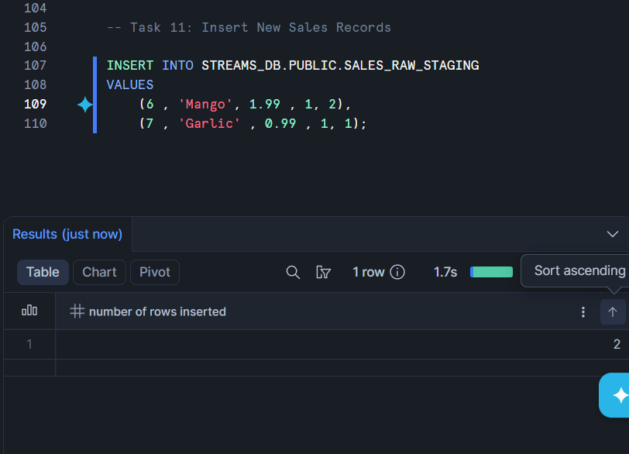

Task 12: Check Stream Data

Query SALES_STREAM.
Observe the new records and metadata columns:
METADATA$ACTION
METADATA$ISUPDATE
METADATA$ROW_ID

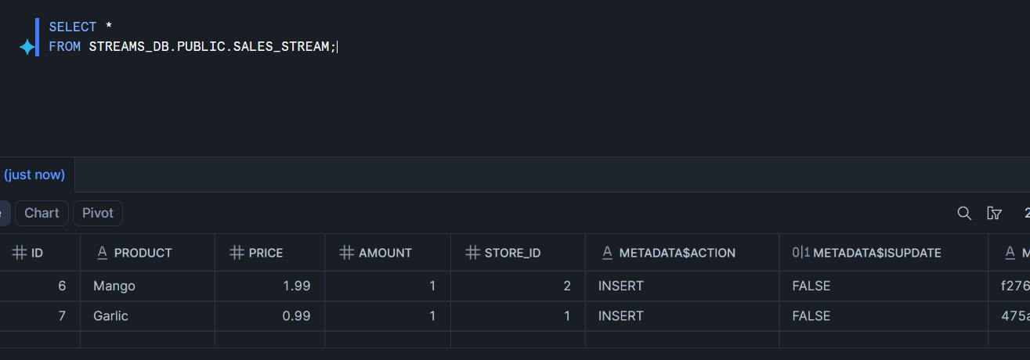

Answer this question:
What value do you see in METADATA$ACTION for newly inserted records?
Ans: INSERT VALUE SEE IN METADATA$ACTION For newly inserted records.

Task 13: Verify Source and Target Tables

Check data in:
SALES_RAW_STAGING;
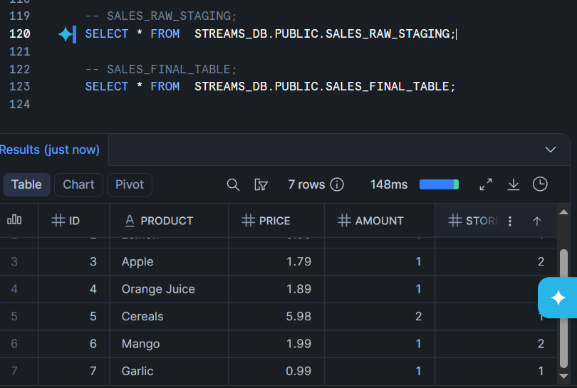

SALES_FINAL_TABLE;
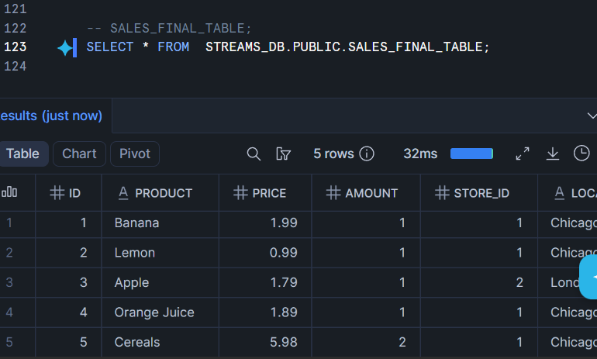

Answer this question:
Are the new records available in SALES_FINAL_TABLE before consuming the stream?
Ans : no new records available in SALES_FINAL_TABLE before consuming the stream.

Task 14: Consume Stream Data

Insert new records from SALES_STREAM into SALES_FINAL_TABLE.
While inserting, join the stream with STORE_TABLE using STORE_ID.

MERGE INTO STREAMS_DB.PUBLIC.SALES_FINAL_TABLE AS T
USING (
SELECT
SS.ID ,
SS.PRODUCT,
SS.PRICE ,
SS.AMOUNT ,
SS.STORE_ID ,
ST.LOCATION ,
ST.EMPLOYEES
FROM STREAMS_DB.PUBLIC.SALES_STREAM AS SS
INNER JOIN STREAMS_DB.PUBLIC.STORE_TABLE AS ST
ON SS.STORE_ID = ST.STORE_ID
) AS S
ON T.ID = S.ID

WHEN MATCHED THEN UPDATE SET
T.PRODUCT = S.PRODUCT,
T.PRICE = S.PRICE,
T.AMOUNT = S.AMOUNT ,
T.STORE_ID = S.STORE_ID,
T.LOCATION = S.LOCATION,
T.EMPLOYEES = S.EMPLOYEES

WHEN NOT MATCHED THEN INSERT
(
ID,
PRODUCT,
PRICE,
AMOUNT ,
STORE_ID,
LOCATION,
EMPLOYEES
)
VALUES(
S.ID,
S.PRODUCT,
S.PRICE,
S.AMOUNT ,
S.STORE_ID,
S.LOCATION,
S.EMPLOYEES
);

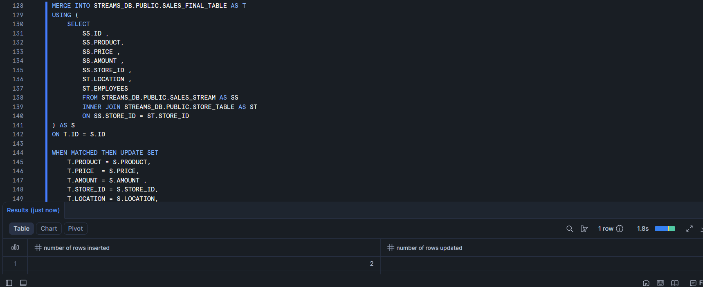

Task 15: Verify Stream After Consumption

Query:
SELECT * FROM SALES_STREAM;
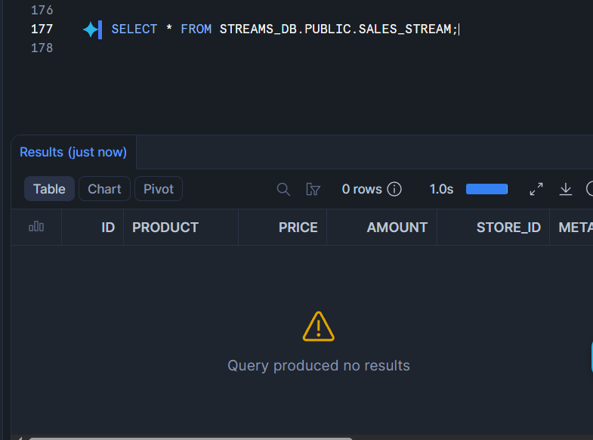

Answer this question:
Why did the stream become empty after inserting data into SALES_FINAL_TABLE?
ANS: Because stream is consumed by final table or targeted table.

Second Insert Change Capture
Task 16: Insert More Sales Records
Insert the following two records into SALES_RAW_STAGING:

id product price amount store_id
8 Paprika 4.99 1 2
9 Tomato 3.99 1 2

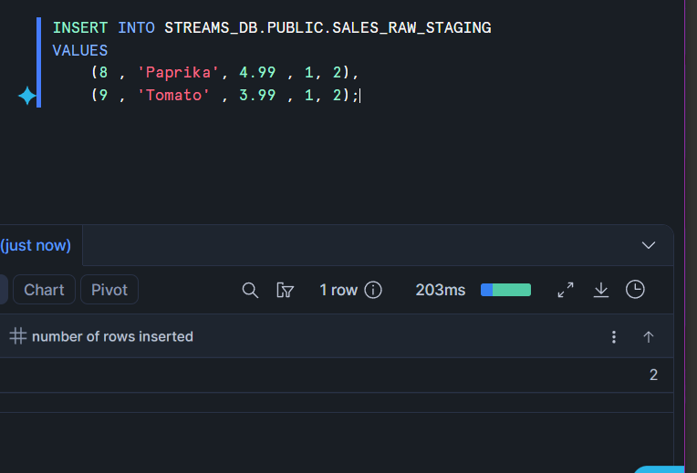

Task 17: Consume Second Stream Data

Consume the newly captured stream records and insert them into SALES_FINAL_TABLE.

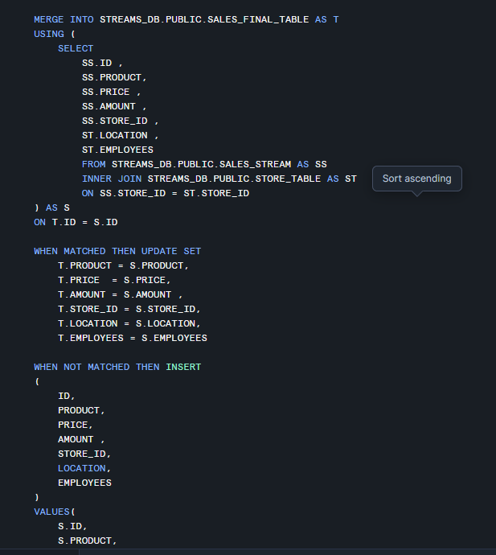
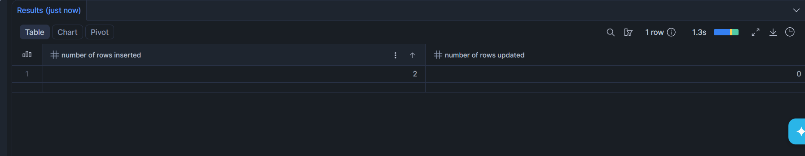

Task 18: Verify Final Insert Output

Display data from:

SALES_FINAL_TABLE;
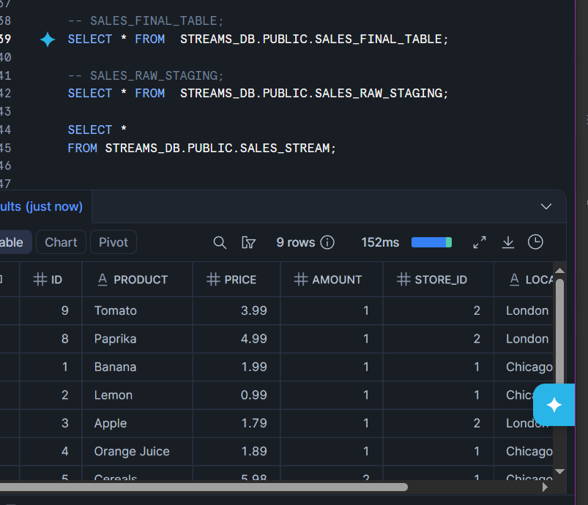

SALES_RAW_STAGING;
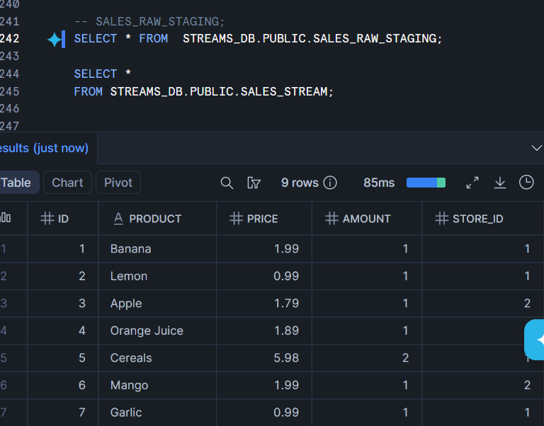

SALES_STREAM;
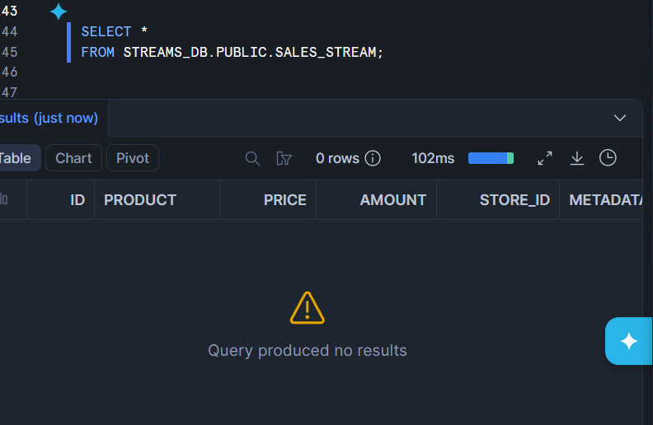

Answer:

How many records are now available in SALES_FINAL_TABLE?
Ans : 9 records available in SALES_FINAL_TABLE.

Update Change Capture
Task 19: Check Existing Data Before Update

Display records from:

SALES_RAW_STAGING;
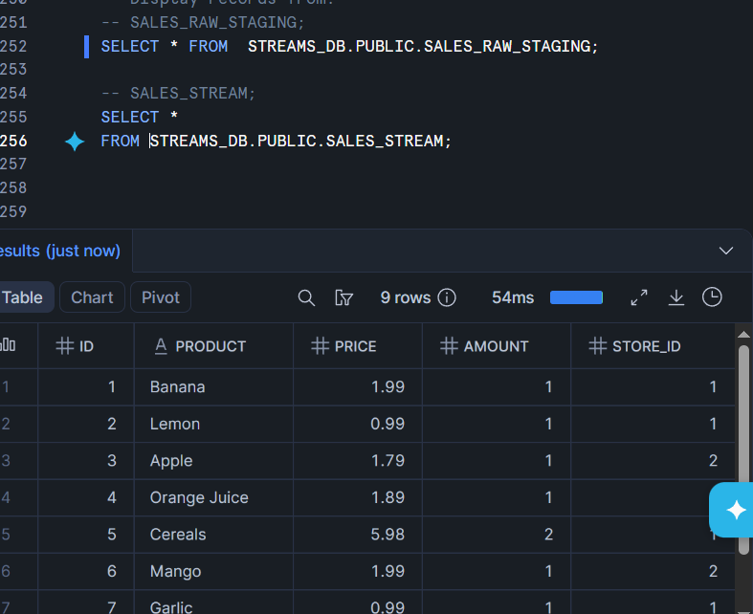

SALES_STREAM;
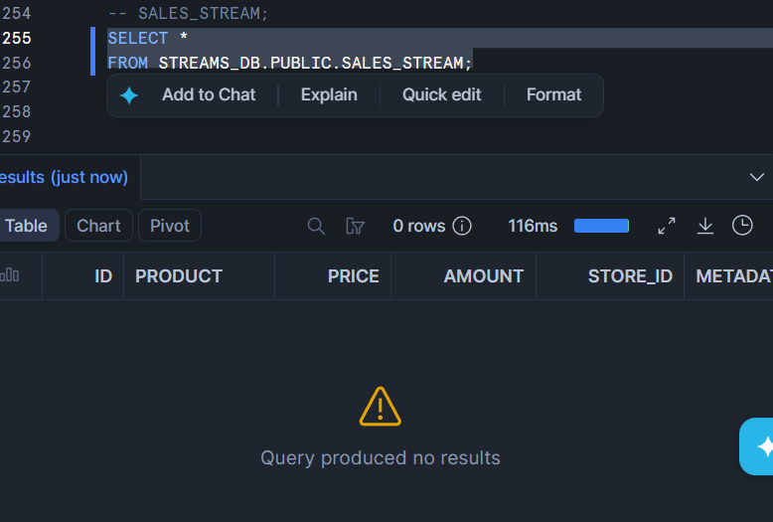

Task 20: Perform First Update

Update the product name:
Banana
to:
Potato
in SALES_RAW_STAGING.
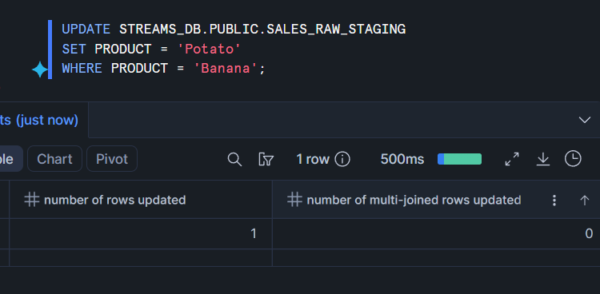

Task 21: Check Stream After Update

Query:
SELECT * FROM SALES_STREAM;
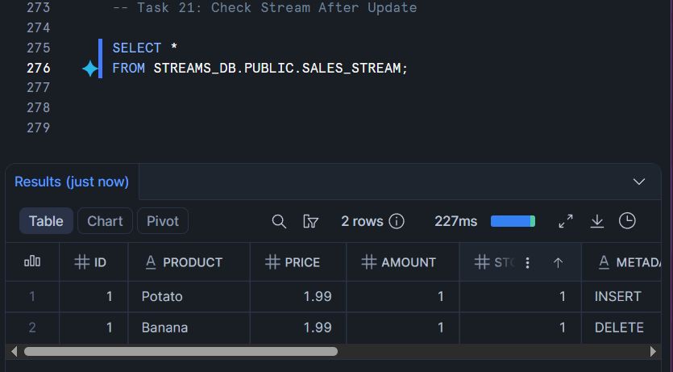

How does Snowflake represent an UPDATE operation inside a stream?
ANS : In Snowflake, an UPDATE operation inside a stream is represented as two records:
- A DELETE record (old row)
- An INSERT record (new updated row)

Task 22: Consume Update Using MERGE

Use a MERGE statement to update the corresponding record in SALES_FINAL_TABLE.

Condition:

Match records using ID
Update only records where METADATA$ACTION = 'INSERT'
and METADATA$ISUPDATE = TRUE

Update the following columns:
product
price
amount
store_id

MERGE INTO STREAMS_DB.PUBLIC.SALES_FINAL_TABLE AS T
USING (
SELECT
SS.ID ,
SS.PRODUCT,
SS.PRICE ,
SS.AMOUNT ,
SS.STORE_ID ,
ST.LOCATION ,
ST.EMPLOYEES ,
SS.METADATA$ACTION ,
SS.METADATA$ISUPDATE
FROM STREAMS_DB.PUBLIC.SALES_STREAM AS SS
INNER JOIN STREAMS_DB.PUBLIC.STORE_TABLE AS ST
ON SS.STORE_ID = ST.STORE_ID
) AS S
ON T.ID = S.ID

WHEN MATCHED
AND S.METADATA$ACTION = 'INSERT'
AND S.METADATA$ISUPDATE = TRUE
THEN UPDATE SET
T.PRODUCT = S.PRODUCT,
T.PRICE = S.PRICE,
T.AMOUNT = S.AMOUNT ,
T.STORE_ID = S.STORE_ID;

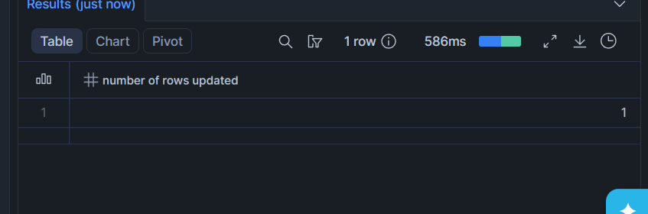

Task 23: Verify First Update

Display data from:

SALES_FINAL_TABLE;
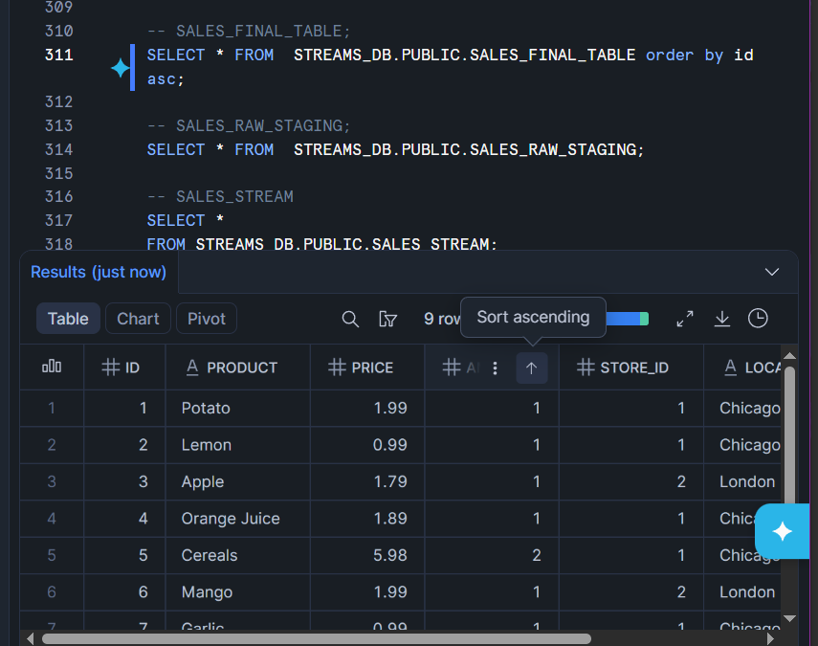

SALES_RAW_STAGING;
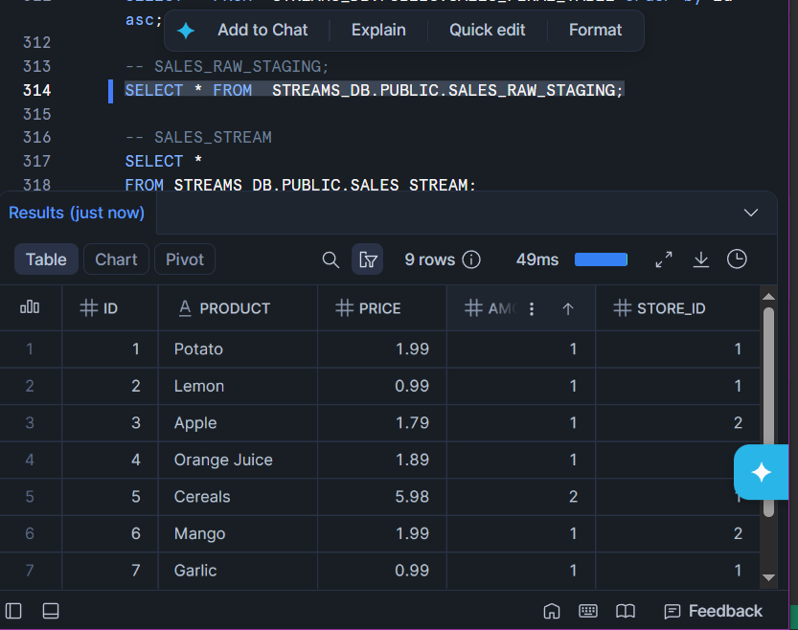

SALES_STREAM;
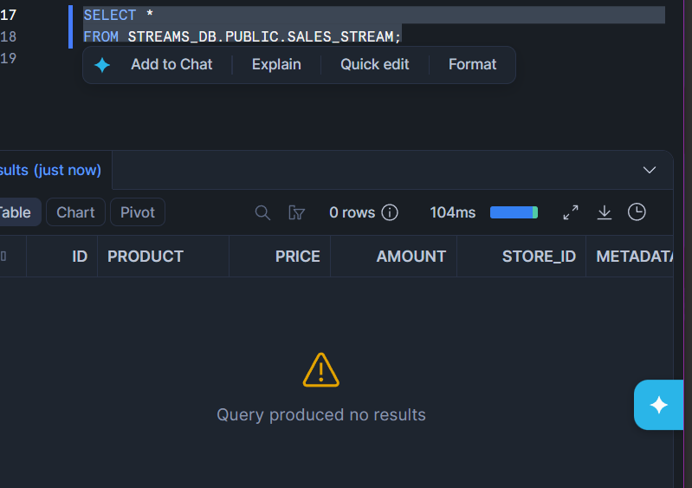

Answer:

Is Banana changed to Potato in SALES_FINAL_TABLE?
ANS: Yes Banana changed to Potato in SALES_FINAL_TABLE.

Second Update Change Capture
Task 24: Perform Second Update

Update the product name:
Apple
to:
Green apple
in SALES_RAW_STAGING.

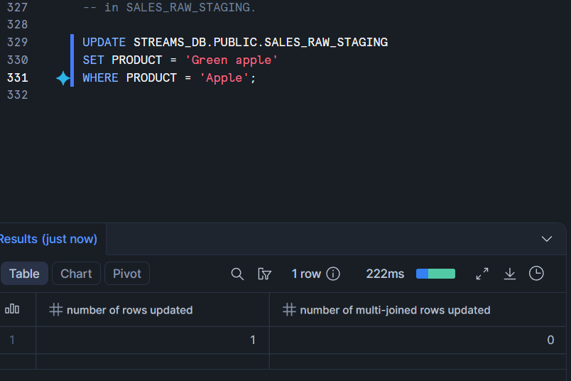

Task 25: Consume Second Update Using MERGE
Use a MERGE statement to update the changed record in SALES_FINAL_TABLE.

MERGE INTO STREAMS_DB.PUBLIC.SALES_FINAL_TABLE AS T
USING (
SELECT
SS.ID ,
SS.PRODUCT,
SS.PRICE ,
SS.AMOUNT ,
SS.STORE_ID ,
ST.LOCATION ,
ST.EMPLOYEES ,
SS.METADATA$ACTION ,
SS.METADATA$ISUPDATE
FROM STREAMS_DB.PUBLIC.SALES_STREAM AS SS
INNER JOIN STREAMS_DB.PUBLIC.STORE_TABLE AS ST
ON SS.STORE_ID = ST.STORE_ID
) AS S
ON T.ID = S.ID

WHEN MATCHED
AND S.METADATA$ACTION = 'INSERT'
AND S.METADATA$ISUPDATE = TRUE
THEN UPDATE SET
T.PRODUCT = S.PRODUCT,
T.PRICE = S.PRICE,
T.AMOUNT = S.AMOUNT ,
T.STORE_ID = S.STORE_ID;

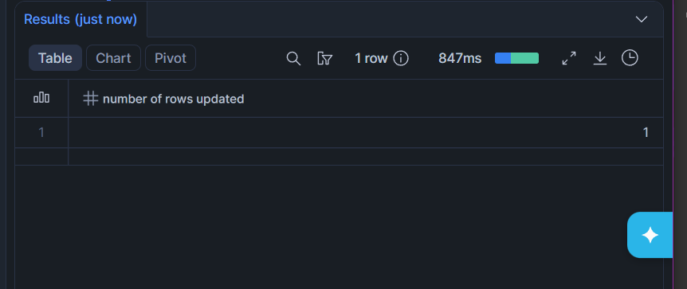

Task 26: Verify Final Output

Display data from:
SALES_FINAL_TABLE;
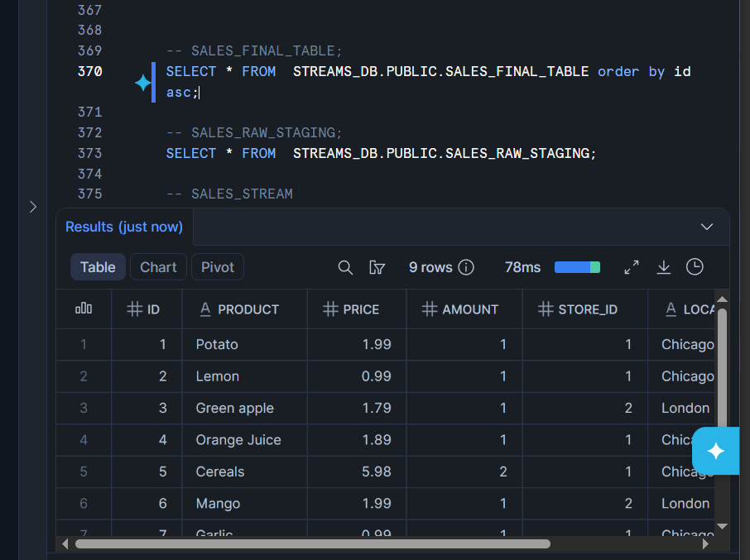

SALES_RAW_STAGING;
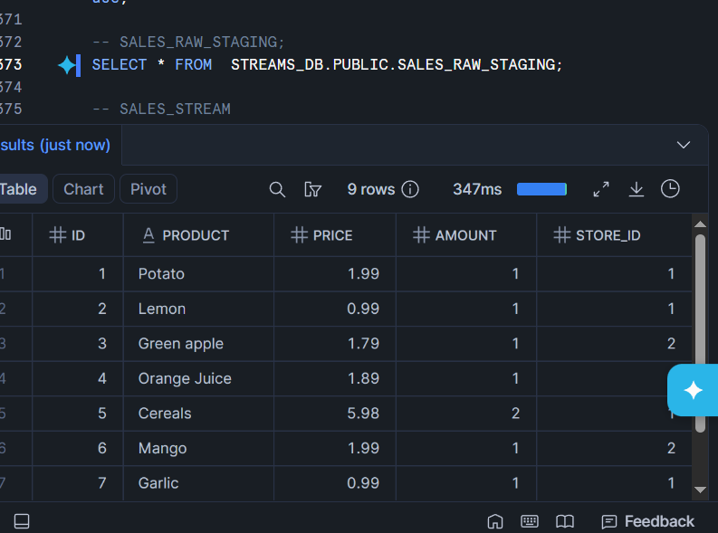

SALES_STREAM;
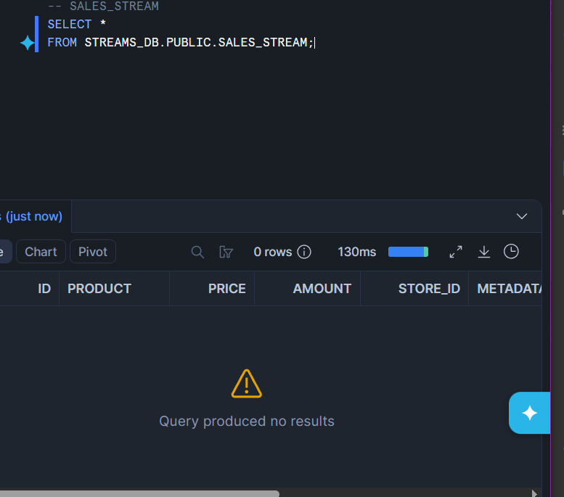

Answer:
Is Apple changed to Green apple in SALES_FINAL_TABLE?
Ans : yes Apple changed to Green apple in SALES_FINAL_TABLE.

