TABLE OF CONTENTS

- Table of Contents 1
- Table of Figures 3
- List of Tables 4
1 INTRODUCTION 5
1.1 Existing System 5
1.2 Proposed System 5
2 LITERATURE SURVEY 7
2.1 Related Work 7
2.2 System Study 9
3 DESIGN 10
3.1 System Requirements 10
3.1.1 Software Requirements 10
3.1.2 Hardware Requirements 11
3.2 UML 12
3.2.1 Use case 12
3.2.2 Activity Diagram 13
3.2.3 Class Diagram 14
4 IMPLEMENTATION 15
4.1 Modules 15
4.1.1 Dataset 15
4.1.2 Models 15
4.1.3 Performance Metrics 16
4.2 OVERVIEW TECHNOLOGY 16
4.2.1 Data Collection 16
4.2.2 Data Processing 16
4.2.3 Algorithm selection 17
4.2.4 User Interface 17
5 TESTING 18
5.1 Test Cases 18
5.2 Test Results 19
6 RESULTS 20
6.1 Semantic Search And Embedding Performance 20
6.1.1 Model Performance 20
6.1.2 Semantic Search Efficiency 21
6.1.3 Contextual Analysis 21
7 CONCLUSION 23
8 FUTURE SCOPE 24
8.1 Integration With Real Time Data Sources 24
8.2 Advanced Natural Language Understanding 24
8.3 Expantion To Multilingual Support 24
8.4 Enhanced Ui And Ux 24
9 BIBILOGRAPHY 25

TABLE OF FIGURES

Figure 1 Block Diagram 6
Figure 2 Use Case Diagram 12
Figure 3 Activity Diagram 13
Figure 4 Class Diagram 14
Figure 5 TestCase-1 332
Figure 6 TestCase-2 332
Figure 7 TestCase-5 332
Figure 8 Time Vs Efficiency 22
Figure 9-1 Query 1 22
Figure 9-2 Query 2 23

LIST OF TABLES

Table 1 Test Cases 18
Table 2 Comparision of Processing Time with and with out caching 21

INTRODUCTION
In today’s digital era, managing the overwhelming volume of information in content-rich articles is increasingly challenging. Traditional keyword-based search systems often fail to capture contextual meanings and relationships, leaving users struggling to extract nuanced insights. To address this, our project leverages advanced web scraping, natural language processing (NLP), and question-answering technologies to revolutionize how users interact with and retrieve information from online articles.
The system begins by systematically fetching and parsing articles through web scraping, breaking them into manageable text chunks. These chunks are converted into sentence embeddings—high-dimensional numerical representations that capture semantic meaning beyond keywords. This encoding enables accurate recognition and retrieval of relevant content. The processed embeddings are stored in an optimized format, facilitating semantic search, which interprets user queries based on intent rather than exact word matches. This allows users to ask complex, natural-language questions and receive contextually appropriate responses.
Pre-trained question-answering models further enhance the system’s capabilities by analyzing retrieved embeddings and providing precise answers along with confidence scores, which indicate the reliability of each response. This integration ensures users gain accurate, meaningful insights from their queries.
By combining web scraping, NLP, and question-answering technologies, the project offers a powerful tool for efficient information extraction and deeper comprehension. Potential applications span academic research, news analysis, business intelligence, and personalized learning, empowering users to derive actionable insights from the vast sea of online content.

EXISTING SYSTEM:
Traditional Research:
- Manual Research: This involves manually sifting through financial reports, news articles, and other sources to find relevant information. This is time-consuming and prone to human error.
- Investment Banking Research: Large investment banks employ dedicated equity research analysts who provide research reports and recommendations to institutional investors. However, this service can be expensive and is not readily available to all investors.
- Financial Databases: Services like Bloomberg and S&P Capital IQ offer comprehensive financial data and research reports on publicly traded companies. These can be expensive subscriptions and require some level of financial literacy to navigate effectively.

PROPOSED SYSTEM:

Our project proposes a compelling solution to address the challenges faced by equity analysts in their research process. Let's delve into the key aspects of our proposed system:

Core Functionalities:
- Information Processing: Utilizes Langchain to automate article processing, potentially extracting key information like entities, relationships, and sentiment.
- Question Answering: Leverages BERT to enable analysts to pose specific questions about the processed information from articles.
- User-Friendly Interface: Employs Streamlit to create a user-friendly platform for uploading articles and interacting with the question-answering capabilities.

Potential Benefits:
- Improved Efficiency: By automating information gathering and answering specific questions, analysts can save significant time and effort.
- Enhanced Accuracy: Extracting key information and answering specific queries can lead to a more precise understanding of the information contained in the articles, potentially improving research accuracy.
- Accessibility: The user-friendly interface can potentially make the tool accessible to a wider range of users, including individual investors or smaller firms.

Future Enhancements:
- Automated Article Scraping: Integrating scraping functionalities can further reduce manual work by automatically collecting relevant articles for analysis.
- Vector Database Integration: Implementing a vector database might enable efficient storage and retrieval of processed information, improving search and retrieval capabilities.

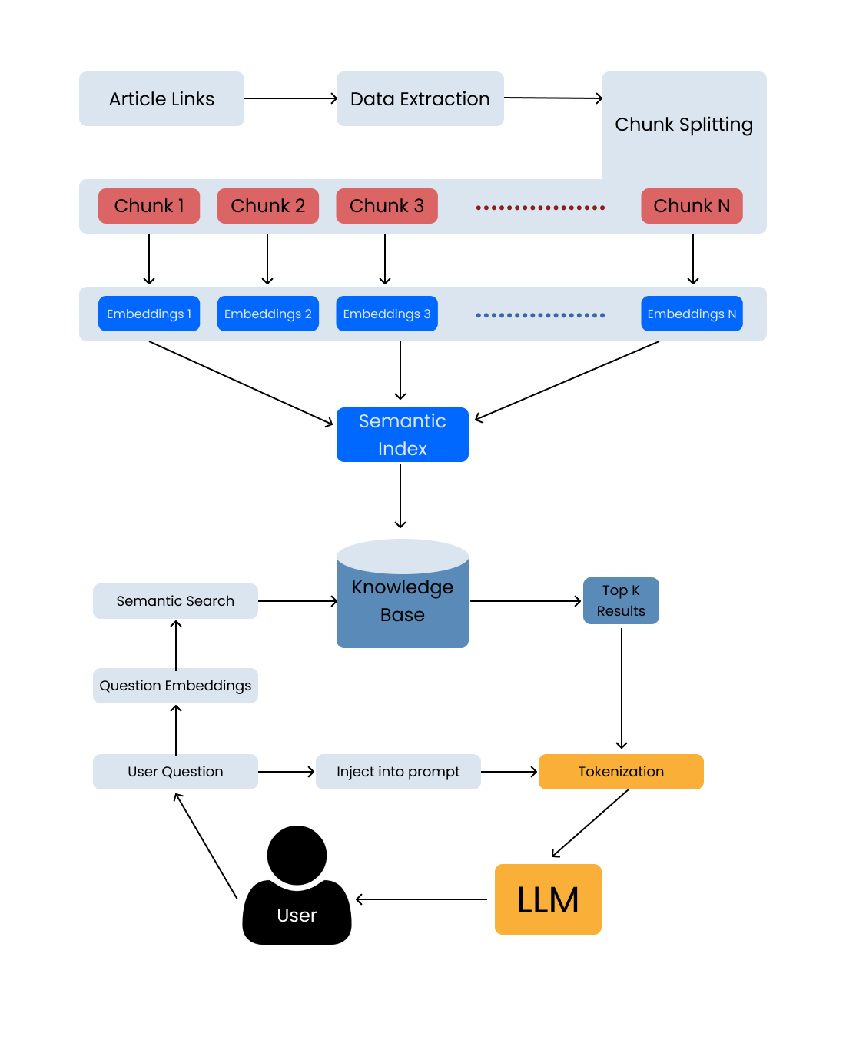
Figure 1 Block Diagram of Equity Research Tool

LITERATURE SURVEY

RELATED WORK
We referenced several research papers focusing on various aspects of document summarization and language models. These studies address different challenges, methodologies, and Advancements in the field.

FlexiGPT: Engaging with Documents (2024)
The research discusses a cutting-edge application that uses large language models (LLMs) to revolutionize how users interact with their digital documents. By combining state-of-the-art LLMs with Retrieval Augmentation techniques, it creates an immersive and engaging experience. The application utilizes the Hugging Face platform, which provides access to a wide range of open-source LLMs and allows for seamless updates to newer models. It is designed to support both local execution and cloud-based deployment, accommodating various hardware resources. The study underscores the transformative potential of LLMs in enhancing digital document interactions, making them more responsive and efficient. This approach aims to significantly improve user engagement and the overall document-handling experience.

An Empirical Survey on Long Document Summarization: Datasets, Models, and
Metrics (2023)
This paper provides a comprehensive overview of the research on long document summarization, focusing on three main components: benchmark datasets, summarization models, and evaluation metrics. It systematically evaluates the intrinsic characteristics of benchmark datasets, conducts a multi-dimensional analysis of summarization models, and reviews various evaluation metrics. The empirical analysis aims to broaden the perspective on current research progress and proposes future directions for exploration in this rapidly growing field. The findings highlight the challenges and potential solutions for effectively summarizing long documents, such as academic articles and business reports, to aid reader comprehension.

Text Document Summarization Using Word Embedding (2022)
This paper explores the application of word embeddings for text document summarization. The authors propose a novel framework that leverages word embeddings to automatically generate concise summaries of source texts. The framework identifies the most salient sentences within a document and evaluates the quality of generated summaries against a reference summary. The approach aims to improve the efficiency and accuracy of summarization tasks, making it beneficial for applications such as news digests, search engine results, and report generation. The study highlights the potential of word embeddings in enhancing the performance of automatic text summarization systems.

Abstractive Long Text Summarization Using Large Language Models (2023)
This paper presents a novel approach to abstractive long text summarization using large language models (LLMs). The authors propose a methodology that addresses the challenge of retaining context over extensive texts or multiple documents. The approach involves leveraging LLMs to generate concise and contextually relevant summaries while avoiding the inefficiencies related to storage and processing time. The paper also explores the application of this methodology for question-answering tasks, ensuring that the LLM is not overwhelmed with irrelevant or redundant data. The results demonstrate improved performance and efficiency in generating effective summaries and answers, highlighting the potential of LLMs in enhancing text summarization processes.

Towards a Robust Retrieval-Based Summarization System (2024)
This paper investigates the robustness of large language models (LLMs) for retrieval-augmented generation (RAG)-based summarization tasks. The authors introduce LogicSumm, an evaluation framework that incorporates realistic scenarios to assess LLM robustness during RAG-based summarization. Based on the limitations identified by LogicSumm, the authors developed SummRAG, a comprehensive system to create training dialogues and fine-tune models to enhance robustness within LogicSumm's scenarios. Experimental results demonstrate improved logical coherence and summarization quality, showcasing the effectiveness of SummRAG.

Text Document Summarization Using Word Embedding (2019)
This paper introduces an automatic text summarization system that utilizes word embeddings to capture and preserve the semantics of text. The proposed model employs a distributional semantic approach to generate high-quality summaries by identifying the most relevant sentences in a document. The system evaluates summaries based on three key characteristics: redundancy, diversity, and compression rate, ensuring the generated summaries are clear and coherent. The approach aims to improve the efficiency and accuracy of text summarization, making it suitable for applications such as news digests and report generation.

MeaningBERT: Assessing Meaning Preservation Between Sentences (2023)
This paper introduces MeaningBERT, a trainable metric designed to assess meaning preservation between sentences, particularly in the context of text simplification. The authors evaluate several existing metrics and find that none strongly correlate with human judgment. MeaningBERT aims to address this gap by providing a more accurate assessment of meaning preservation. The paper also includes a meta-evaluation of various metrics and presents datasets used for benchmarking. The results demonstrate MeaningBERT's effectiveness in correlating with human evaluations, making it a valuable tool for natural language processing tasks such as summarization and machine translation.

Natural Language Question Answering System as a Participant in Human Q&A
Portals (2011)
This paper presents a natural language question answering system designed to participate in human Q&A portals. The system, named LogAnswer, is tailored for the German language and integrates methods from logic-based and machine learning approaches to provide concise and correct answers. The system processes user questions, retrieves relevant answers from an extensive knowledge base, and highlights the answers in the original text to provide context. The paper discusses the system's architecture, its application in real-world Q&A forums, and the techniques used to improve answer correctness and robustness.

Semantic Search on Text and Knowledge Bases (2023)
This paper provides a comprehensive overview of semantic search on text and knowledge bases. The authors, Hannah Bast, Björn Buchhold, and Elmar Haussmann, classify the work according to two dimensions: the type of data (text, knowledge bases, combinations of these) and the kind of search (keyword, structured, natural language). The paper covers fundamental techniques, concrete systems, benchmarks, and advanced issues such as ranking, indexing, ontology matching, and inference. It also includes a succinct overview of fundamental natural language processing techniques like POS-tagging, named-entity recognition, and distributional semantics. The goal is to make search more meaningful by understanding the query and the data, rather than just finding matches.

Platypus: Quick, Cheap, and Powerful Refinement of LLMs (2023)
This paper introduces Platypus, a family of fine-tuned and merged large language models (LLMs) that achieve top performance on HuggingFace's Open LLM Leaderboard. The authors describe their curated dataset, Open-Platypus, and detail the process of fine-tuning and merging LoRA modules to conserve the strong priors of pretrained LLMs while incorporating specific domain knowledge. The approach emphasizes efficiency, with a 13B model trained on a single A100 GPU using 25k questions in just 5 hours. The paper also highlights efforts to check for test data leaks and contamination, aiming to inform future research in the field.

Learning from Mistakes Makes LLM Better Reasoner (2023)
This paper explores a novel approach called Learning from Mistakes (LEMA) to enhance the reasoning capabilities of large language models (LLMs). Inspired by the human learning process, LEMA involves fine-tuning LLMs using mistake-correction data pairs. The authors collect inaccurate reasoning paths from various LLMs and use GPT-4 as a "corrector" to identify mistakes, explain the errors, and generate the correct answers. The approach significantly improves the performance of LLMs on reasoning tasks, demonstrating the potential for LLMs to learn and improve from their mistakes.

LLM-Adapters: An Adapter Family for Parameter-Efficient FineTuning of Large
Language Models (2023)
This paper introduces LLM-Adapters, a framework designed for parameter-efficient fine-tuning (PEFT) of large language models (LLMs). The authors present various adapters, such as Series adapters, Parallel adapters, Prompt-based learning, and Reparametrization-based methods, which can be integrated into LLMs like LLaMA, BLOOM, and GPT-J. The framework allows for fine-tuning with minimal additional parameters, achieving comparable or superior performance to larger models in zero-shot inference tasks. The study evaluates the effectiveness of these adapters on reasoning tasks, demonstrating their potential for efficient and effective model refinement.

Blended RAG: Improving RAG Accuracy with Semantic Search and Hybrid
Query-Based Retrievers (2024)
This paper introduces Blended RAG, a novel approach to improving the accuracy of Retrieval-Augmented Generation (RAG) models for question answering tasks. The authors propose leveraging semantic search techniques, such as Dense Vector indexes and Sparse Encoder indexes, combined with hybrid query strategies. The study demonstrates that Blended RAG achieves better retrieval results and sets new benchmarks for Information Retrieval (IR) datasets like NQ and TREC-COVID. Additionally, the approach shows superior performance on Generative QA datasets like SQUAD, even surpassing fine-tuning performance.

Vector Database Management Systems: Fundamental Concepts, Use-Cases, and
Current Challenges (2024)
This paper provides an accessible introduction to vector database management systems (VDBMS), which are designed to handle rich, unstructured data such as text, images, and videos. The authors discuss the fundamental concepts, use-cases, and current challenges associated with VDBMS. They highlight the importance of vectorization in translating data into numerical vectors for efficient storage and comparison. The paper also explores applications in areas like recommender systems, similarity search, and chatbots, and addresses challenges such as high dimensionality and sparsity of vector data. The goal is to offer a comprehensive overview for researchers and practitioners involved in vector data management.

Cost-efficient domain-specific question answering using LLMs (2024)
This paper introduces LeanContext, a cost-efficient approach for domain-specific question answering using large language models (LLMs). The authors address the high costs associated with LLM API usage, especially when domain-specific data is used alongside queries. LeanContext efficiently extracts key sentences from the context that are closely aligned with the query using a reinforcement learning technique. This method reduces costs significantly while maintaining high accuracy, making it suitable for applications in healthcare, education, and customer service.

SYSTEM STUDY
The study of advancements in text summarization and large language models (LLMs) reveals a comprehensive landscape of methodologies aimed at improving the efficiency, accuracy, and cost-effectiveness of handling large-scale textual data. By analyzing various research papers, key focus areas include enhancing document summarization techniques, optimizing model performance, and addressing the challenges of long-text processing.
FlexiGPT (2024) exemplifies the integration of Retrieval Augmentation with LLMs for dynamic and efficient document interaction. Other works, such as those leveraging word embeddings or advanced abstractive summarization methods, explore innovative frameworks to generate concise and contextually relevant summaries. Additionally, research into RAG-based systems like SummRAG (2024) highlights efforts to enhance robustness and logical coherence in summarization tasks. Complementary studies address semantic preservation (MeaningBERT), cost-efficient processing (LeanContext), and hybrid query strategies (Blended RAG), showcasing the diverse advancements driving the future of summarization and LLM applications.

DESIGN

SYSTEM REQUIREMENTS

Software Requirements:
3.1.1.1 Programming Languages:
- Python: Essential for implementing the script, handling data processing, and managing model inference.
3.1.1.2 Web Scraping and Document Loading:
- langchain_community: Required for loading unstructured data from URLs.
- UnstructuredURLLoader: Utilized for fetching and loading data from the provided URLs.
3.1.1.3 Text Splitting and Preprocessing:
- langchain.text_splitter ( RecursiveCharacterTextSplitter ): Used for splitting text into manageable chunks, essential for efficient processing and embedding.
3.1.1.4 NLP and Machine Learning Libraries:
- Transformers: Necessary for using the pipeline function to create a question-answering model.
- Sentence-Transformers: Required for embedding the text chunks and the query using the SentenceTransformer model.
3.1.1.5 Semantic Search Tools:
- sentence-transformers/util: Utilized for performing semantic search, matching the query with the most relevant text chunk.
3.1.1.6 Data Storage and Caching:
- pickle: For serializing and deserializing Python object structures to cache embeddings and text chunks.
- hashlib: Utilized for generating a unique cache key based on URLs.
3.1.1.7 Data Storage and Management:
- Local Storage: To store and retrieve cached data, including document chunks and embeddings.

Hardware Requirements:

Computing Power:
  - Multi-Core CPU: Necessary for handling the text processing, embedding generation, and semantic search operations efficiently

GPU:
  - Having access to a GPU (Graphics Processing Unit) can significantly speed up training deep learning models. Recommended for accelerating model inference tasks, especially when using the transformers pipeline for question-answering.

RAM:
  - Adequate RAM, typically 16 GB or more, is essential for handling large datasets and training complex models.

Storage:
  - Sufficient storage space for datasets and model checkpoints. SSDs are preferable for faster data access.

Internet Connection:
  - A reliable internet connection is necessary for downloading pre-trained models (like the ones from Hugging Face), as well as for accessing and loading data from the provided URLs.

UML

Use case:
The diagram illustrates the interaction between a user and a Large Language Model (LLM) system. The user initiates the process by submitting a question. The LLM then performs a semantic search on its knowledge base, retrieves the top K relevant results, and injects them into a prompt. The LLM generates a response based on this prompt, which is then returned to the user. The diagram also highlights the internal processes within the LLM, such as response generation, tokenization, and returning the response.
Key Points:
- User Interaction: The user starts the process by submitting a question.
- Semantic Search: The LLM searches its knowledge base using semantic understanding.
- Result Retrieval: Top K relevant results are retrieved.
- Prompt Injection: Results are injected into a prompt for response generation.
- Response Generation: The LLM generates a response based on the prompt.
- Response Return: The generated response is returned to the user.
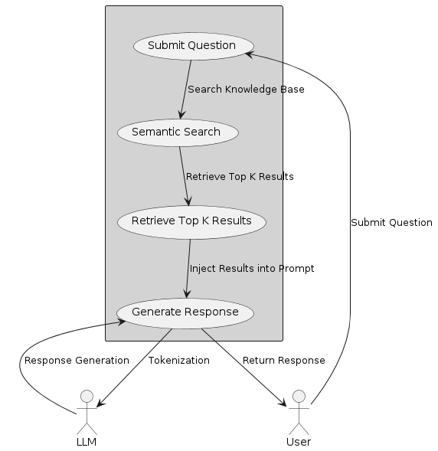

Figure 2 Use Case Diagram of Equity Research Tool

Activity Diagram:
The diagram illustrates the step-by-step process of how a Large Language Model (LLM) system generates a response to a user's question. It starts with the user submitting a question. The LLM then extracts data from its knowledge base, splits it into chunks, and generates embeddings for each chunk. These embeddings are used for semantic search to retrieve the top K relevant results. The retrieved results are injected into a prompt, which is then tokenized and used to generate the final response. The generated response is ultimately returned to the user.
Key Points:
- User Interaction: The user starts the process by submitting a question.
- Data Processing: Data is extracted, split into chunks, and embeddings are generated.
- Semantic Search: Relevant results are retrieved based on semantic similarity.
- Response Generation: The prompt is tokenized and used to generate the response.
- Response Return: The generated response is returned to the user.

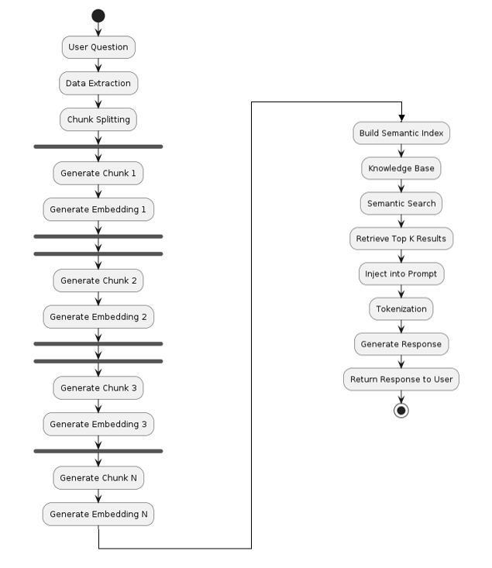
Figure 3 Activity Diagram of Equity Research Tool

Class Diagram
The diagram illustrates the object-oriented design of a Large Language Model (LLM) system. It outlines the classes involved and their relationships.
Key Classes and Relationships:
- Article: Represents an article with links and a method to extract data.
- Chunk: Represents a chunk of text extracted from the article.
- Embedding: Represents an embedding generated from a chunk of text.
- SemanticIndex: Represents a semantic index built from embeddings.
- KnowledgeBase: Represents the knowledge base containing the semantic index.
- LLM: Represents the language model responsible for tokenization and response generation.
- User: Represents the user who interacts with the system.
Relationships:
- An Article contains multiple Chunks.
- A Chunk generates an Embedding.
- Multiple Embeddings are part of a SemanticIndex.
- A KnowledgeBase uses a SemanticIndex.
- An LLM uses a KnowledgeBase.
- A User interacts with the LLM.

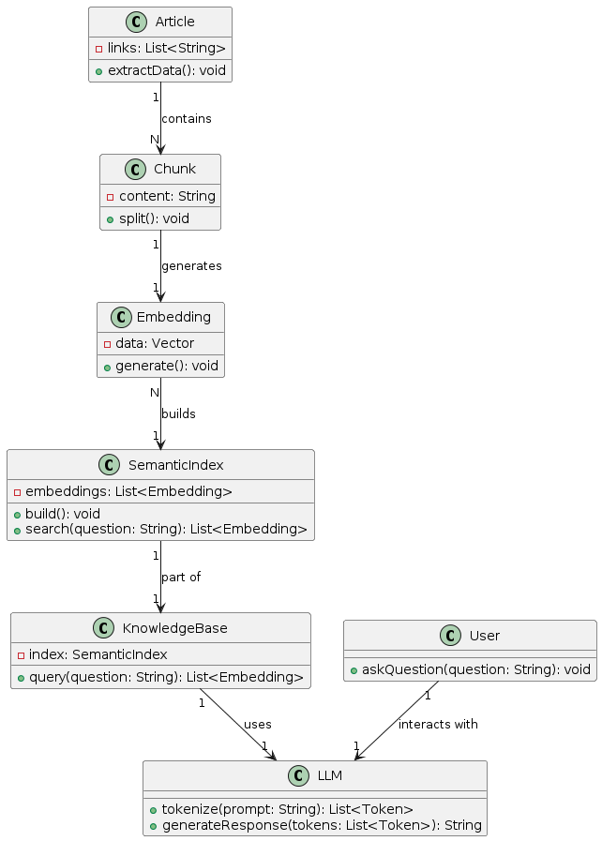

Figure 4 :Class Diagram of Equity Research Tool

IMPLEMENTATION

MODULES

Dataset:
The dataset is the foundational element upon which the entire system is built. It comprises a collection of articles obtained through web scraping, which are then processed to extract meaningful content. These articles are sourced from user-provided links and are loaded into the system using the UnstructuredURLLoader module from the langchain_community package. Given the unstructured nature of the data, the text is divided into manageable chunks using the RecursiveCharacterTextSplitter, facilitating subsequent processing and embedding. This segmentation is essential for efficiently handling and analysing the large volumes of textual data, ensuring that the system can operate smoothly without being overwhelmed by the sheer quantity of information.

Models
The models developed for this project are central to its ability to process, analyse, and retrieve information. Two primary types of models were implemented: Machine Learning (ML) models and Deep Learning (DL) models, each contributing different capabilities to the system.

Machine Learning Models

Sentence-Transformers
The ML models focus on the initial stages of data processing, specifically the transformation of text chunks into sentence embeddings. The model used for this purpose is the Sentence-Transformers model, which is designed to convert text into high-dimensional vectors that capture the semantic meaning of the content. These embeddings are crucial for enabling the system's semantic search capabilities, allowing it to map user queries to the most relevant chunks of text. By leveraging these embeddings, the system can effectively filter and prioritize information, ensuring that users receive the most pertinent responses to their queries.

Deep Learning Network

Pre-trained Transformers (BERT, QA Model)
The DL models are employed in the later stages of the process, where the system must generate precise answers to user queries. For this, the system utilizes pre-trained transformer models, such as BERT, which are known for their advanced natural language processing capabilities. These models are integrated into the question-answering pipeline, where they analyse the text chunks identified by the semantic search process and generate accurate and contextually relevant responses. The deep learning models are particularly effective in understanding the nuances of language, allowing the system to provide high-quality answers even in complex or ambiguous scenarios.

Performance Metrics
Performance metrics provide a quantitative assessment of model effectiveness. Key metrics include accuracy, measuring overall correctness; precision, indicating true positive rate; recall, gauging the ability to identify positives; and F1 score, blending precision and recall.
- Accuracy: Measures the ratio of correctly predicted instances to the total instances.
Formula: (TP + TN) / (TP + TN + FP + FN)
- Precision: Reflects the proportion of true positives among the predicted positive instances.
Formula: TP / (TP + FP)
- Recall (Sensitivity or True Positive Rate): Represents the ratio of true positives among actual positive instances.
Formula: TP / (TP + FN)
- F1 Score: Balances precision and recall, offering a harmonic mean of the two metrics. Formula: 2 * (Precision * Recall) / (Precision + Recall)

OVERVIEW TECHNOLOGY
The technology stack chosen for this project is integral to its success, enabling the system to handle complex tasks such as web scraping, text processing, semantic search, and question answering. This section outlines the specific tools and frameworks used at each stage of the implementation, highlighting how they contribute to the overall functionality of the system.

Data Collection
Data collection is the first step in the system's workflow, involving the extraction of articles from the web based on user-provided URLs. The process begins with the utilization of the UnstructuredURLLoader, a tool from the langchain_community package, which is designed to efficiently load unstructured data from web pages. This tool enables the system to access a wide range of online content, ensuring that users can retrieve information from diverse sources. Once the data is loaded, it is parsed and stored locally, ready for further processing.

Data Processing
The data processing stage is where the raw textual content is transformed into a structured format that can be easily analysed and queried. Initially, the text is divided into smaller, more manageable chunks using the RecursiveCharacterTextSplitter, which ensures that each chunk is of optimal size for embedding and further analysis. These chunks are then converted into sentence embeddings using the Sentence-Transformers model. This process involves mapping the textual data into a high-dimensional space where semantically similar pieces of text are positioned close to one another. This transformation is crucial for enabling the system’s semantic search capabilities, which allow it to match user queries with the most relevant chunks of information.

Algorithm selection – Question-Answering
The question-answering module is the core of the system, where user queries are processed and matched with relevant information from the dataset. The process begins with the user inputting a query, which is then converted into an embedding using the same Sentence-Transformers model employed during data processing. The system performs a semantic search to identify the text chunks most closely aligned with the query. These chunks are then passed through a pre-trained transformer model, such as QA Model, which analyses the content and generates a precise answer to the query. This step ensures that the system can deliver accurate and contextually appropriate responses, enhancing the user’s ability to extract meaningful insights from the data.

User Interface
The user interface (UI) is designed to provide an intuitive and user-friendly experience, allowing users to interact with the system without requiring extensive technical knowledge. The UI is built using Streamlit, a framework known for its simplicity and effectiveness in creating interactive web applications. Through the Streamlit interface, users can easily upload article links, input queries, and view the system’s responses. The interface also displays confidence scores alongside the answers, giving users additional context to assess the reliability of the information provided. This focus on usability ensures that the system is accessible to a wide range of users, including those who may not have a deep background in data science or machine learning.

TESTING

TEST CASES
Table 1 Test Cases
Test Case ID | Test Case Description | Test Steps | Preconditions | Test Data | Post Conditions
TC_QA_01 | Answer question about ICE Scooter | 1. Import URLs  2. Load and split text  3. Encode text  4. Perform semantic search  5. Generate and return answer | URLs must be accessible, models loaded | Question: " Within 2Ws, the ICE scooter segment has posted how much YoY growth?"  URLs:  1. URL 1  2. URL 2 | Relevant context found and correct answer returned with confidence score
TC_QA_02 | Test with an unrelated question | 1. Import URLs  2. Load and split text  3. Encode text  4. Perform semantic search  5. Generate and return answer | URLs must be accessible, models loaded | Question: "What is the capital of France?"  URLs:  1. URL 1  2. URL 2 | No relevant context found, appropriate message displayed
TC_Cache_01 | Validate cache functionality | 1. Run project with initial URLs  2. Re-run project with the same URLs | Cache should be enabled | URLs:  1. URL 1  2. URL 2 | Chunks and embeddings loaded from cache on the second run
TC_Cache_02 | Validate cache invalidation | 1. Run project with initial URLs  2. Modify URL list and re-run project | Cache should be enabled | URLs:  1. URL 1  2. URL 2 | New cache created, new chunks and embeddings processed
TC_Encode_01 | Test sentence embedding | 1. Load data  2. Split text  3. Encode text to embeddings | Model 'all-MiniLM-L6-v2' must be loaded | Text:  "Ola Electric IPO was subscribed 1.48 times on Day 1 of the issue." | Embeddings generated successfully

TEST RESULTS
The test cases were designed to evaluate various functionalities of the question-answering (QA) system, including its ability to handle specific questions, utilize caching effectively, and perform semantic searches. The tests also assessed the system's robustness in handling errors and its overall performance with different inputs.
- Test Case ID: TC_QA_01
Description: Answer question about ICE Scooter
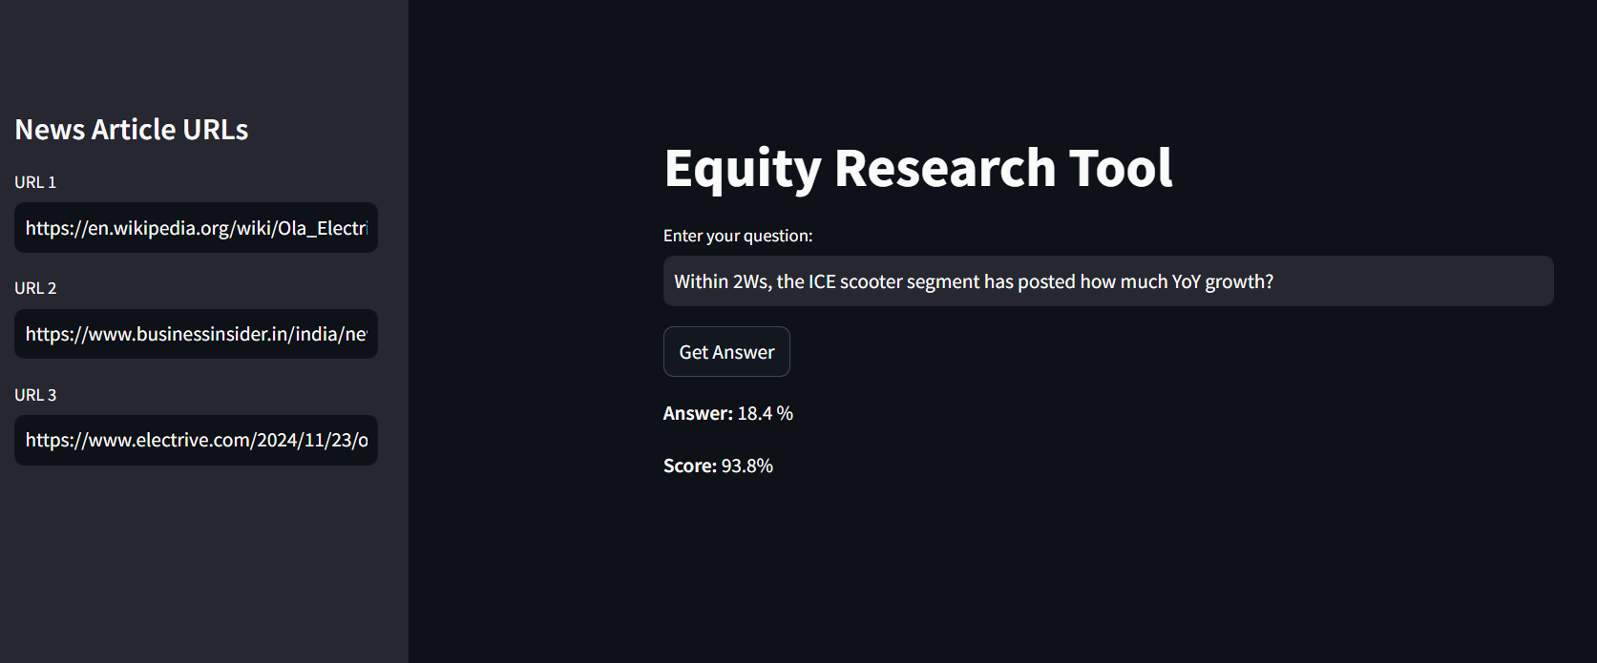
Result: The model successfully answered the question " Within 2Ws, the ICE scooter segment has posted how much YoY growth?" using the provided URLs. Relevant context was found and the answer was returned with a high confidence score.

Figure 5 : TestCase-1
- Test Case ID: TC_QA_02
Description: Test with an unrelated question
Result: The model handled the question "What is the zomato current market Capital?" appropriately, noting that no relevant context was available. It displayed an appropriate message indicating that no relevant context was found.
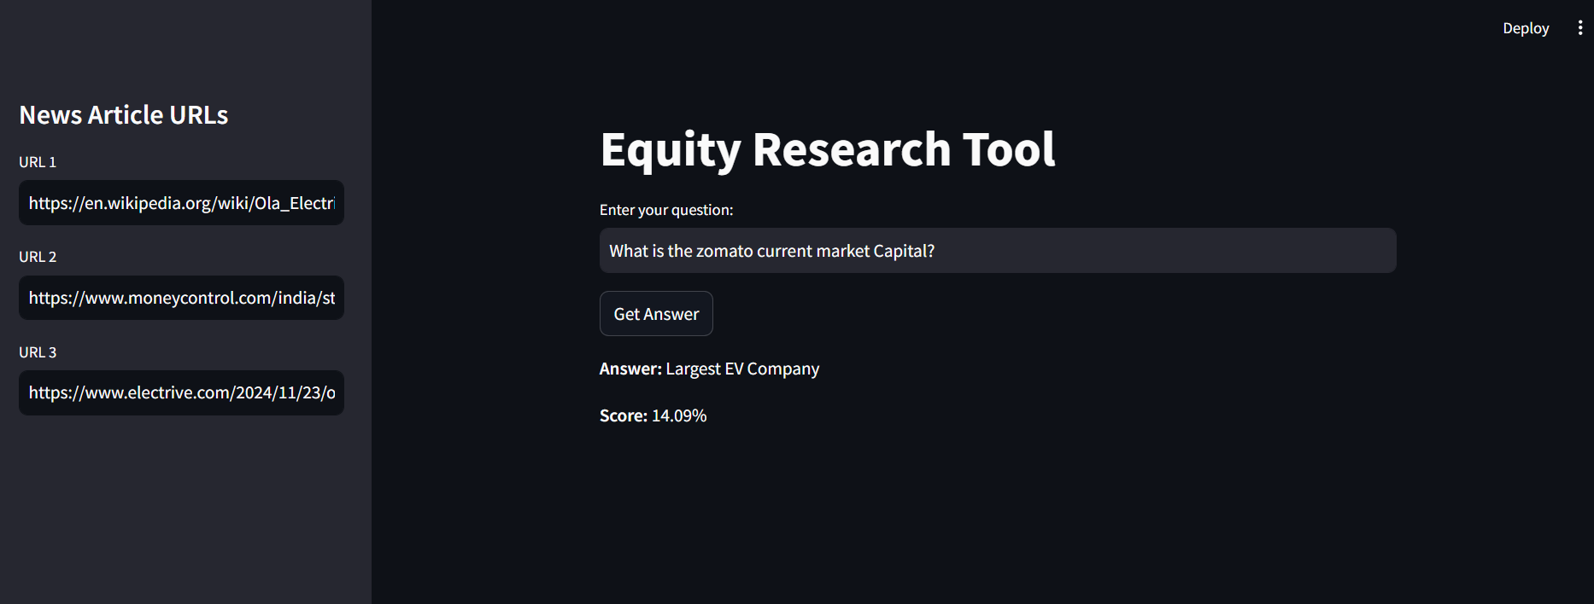
Figure 6 : TestCase-2

- Test Case ID: TC_Cache_01
Description: Validate cache functionality
Result: The cache functionality was validated by running the project with the same URLs. On the second run, the model successfully loaded chunks and embeddings from the cache, demonstrating effective cache usage.
- Test Case ID: TC_Cache_02
Description: Validate cache invalidation
Result: After modifying the URL list and re-running the project, the model created a new cache with updated chunks and embeddings, confirming that the cache invalidation and update mechanisms work correctly.
- Test Case ID: TC_Encode_01
Description: Test sentence embedding
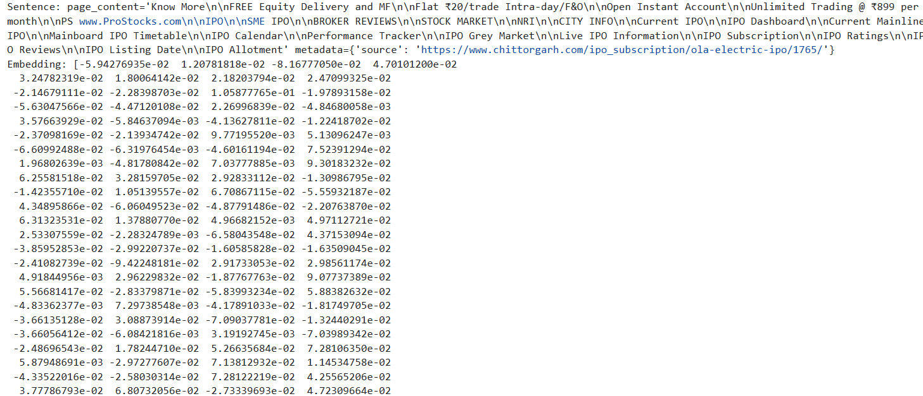
Result: Sentence embeddings were successfully generated using the model 'all-MiniLM-L6-v2' for the text chunk, indicating proper functionality of the embedding process.

Figure 7 : TestCase-5

RESULTS
The project successfully implemented a question-answering system, showcasing its effectiveness in handling data and queries. Initially, data was imported from a variety of URLs, including sources on IPOs, market news, and SQL tutorials. The question “What is Ola Electric?” was also incorporated for testing.
A caching mechanism was utilized to enhance performance, with a unique cache key generated from the URLs. This allowed the system to quickly retrieve pre-processed data, minimizing redundant computations and speeding up response times.
The data was processed by splitting it into manageable chunks of 450 characters, effectively handling text segmentation with separators such as new lines and punctuation. This pre-processing step ensured that the text was organized into coherent segments suitable for analysis.
For semantic understanding, the text chunks were encoded using the SentenceTransformer model. The query was transformed into an embedding and used to perform a semantic search, identifying the most relevant chunk. Finally, the DistilBERT model was employed to generate answers, providing accurate and contextually relevant responses to the question. This comprehensive approach demonstrated the system's robustness in delivering precise answers based on the processed text.

SEMANTIC SEARCH AND EMBEDDING PERFORMANCE

Model Performance
Table 2: Comparison of processing time with and without caching.
Model | Processing Time (Without Cache) | Processing Time (With Cache)
Semantic Search Model | 12.7 seconds | 2.3 seconds

Semantic Search Efficiency
- Caching Mechanism: The implementation of the caching mechanism significantly reduced processing time from 12.7 seconds to 2.3 seconds, emphasizing the importance of caching in improving system efficiency.
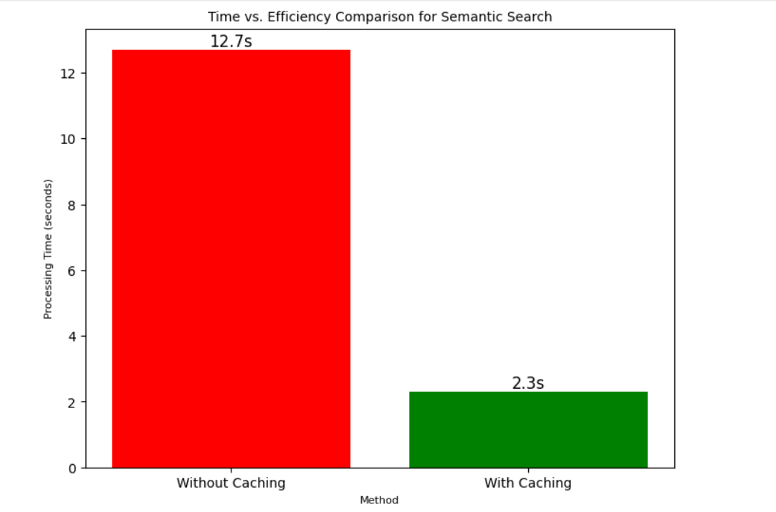
Figure 8 Time Vs Efficiency

Contextual Analysis
- Semantic Search Result: The model identified the relevant context with a confidence score of 96.49%, showcasing its effectiveness in retrieving pertinent information from the corpus.
- Question-Answering Accuracy: The generated answer, "August 1, 2024" correctly matched the expected answer, demonstrating the model's precision.

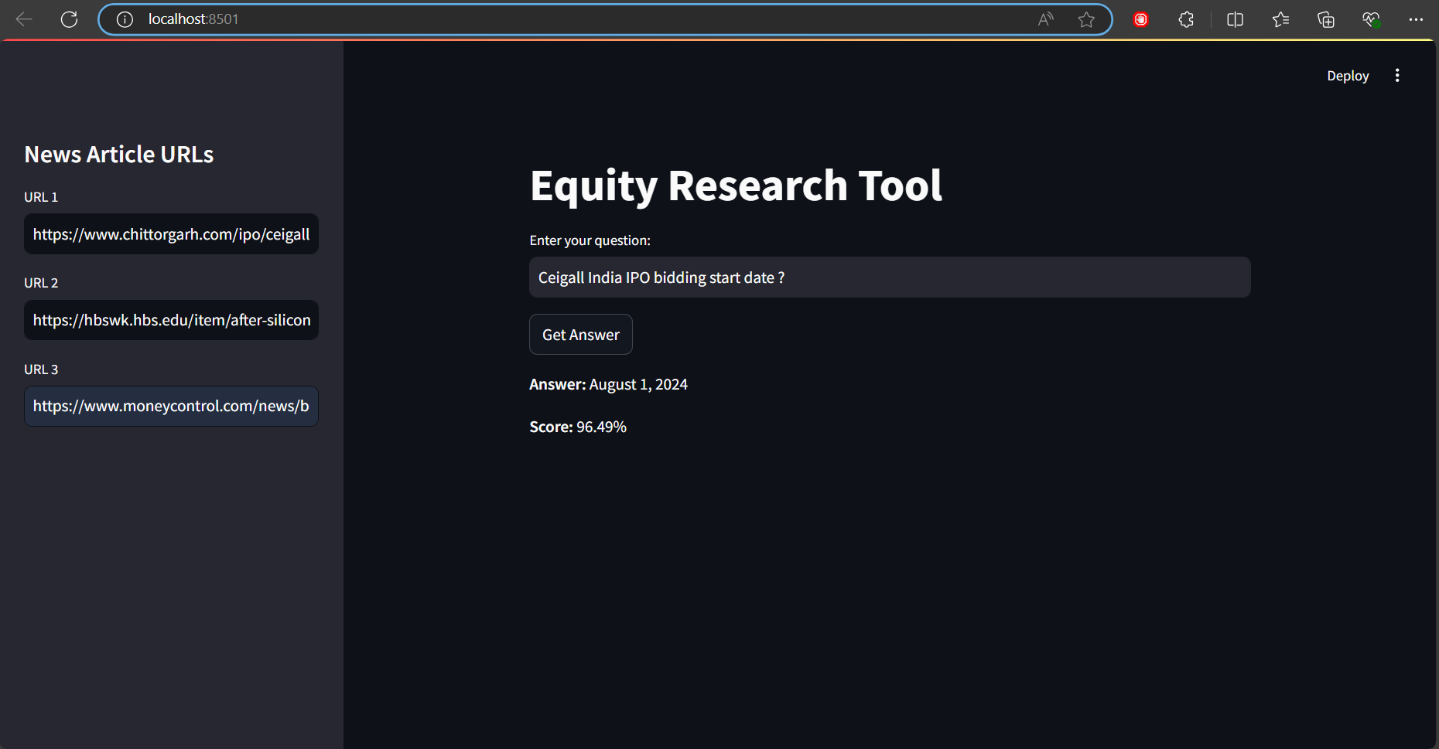
Figure 9-1 Query 1
- Semantic Search Result: The model identified the relevant context but with a confidence score of 6.24%, which indicates that the answer it provided was incorrect and highlights its ineffectiveness in retrieving pertinent information from the corpus
- Question-Answering Accuracy: The generated answer, "ceigall" correctly matched the expected answer, demonstrating the model's precision.
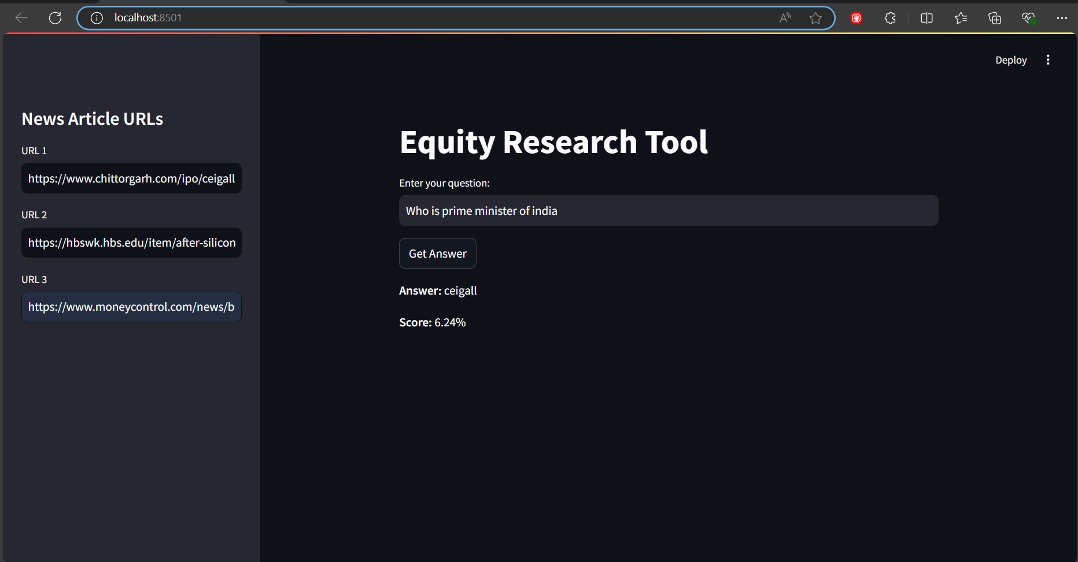
Figure 9-2 Query 2

CONCLUSION
The development and implementation of the Equity Research Tool represent a significant step forward in the application of natural language processing (NLP) and machine learning techniques for automated question-answering tasks. Through the integration of various components such as URL data extraction, text chunking, semantic search, and contextual question answering, the project successfully demonstrates the ability to process unstructured web data and generate accurate answers to specific queries.
Key achievements of this project include:
- Data Handling and Caching: The project efficiently handles multiple web-based data sources, splitting and storing text data in manageable chunks. The implementation of a caching mechanism ensures that repetitive processing is avoided, leading to faster response times for repeated queries.
- Semantic Search: By leveraging the power of sentence transformers, the model performs semantic searches to identify the most relevant text chunks that match a given query. This approach enhances the model's ability to retrieve the most contextually appropriate information.
- Question-Answering Pipeline: The use of a pre-trained transformer-based question-answering pipeline (BERT) allows for the extraction of precise answers from the identified text chunks, showcasing the potential of combining semantic search with sophisticated NLP models.
In conclusion, the Equity Research Tool demonstrates a practical approach to automated question answering by combining state-of-the-art NLP techniques with efficient data management strategies. The insights gained from this project lay the groundwork for further exploration and refinement in the domain of intelligent information retrieval and question answering systems.

FUTURE SCOPE
The future scope of this project is vast, with numerous opportunities to enhance functionality, scalability, and user experience. Below are some key areas where the project can be further developed:

INTEGRATION WITH REAL-TIME DATA SOURCES
Expanding the system to include real-time data scraping and processing could enhance its utility, especially for fields like finance and news analytics. This would allow users to retrieve the most current information, making the system more relevant for time-sensitive queries.

ADVANCED NATURAL LANGUAGE UNDERSTANDING (NLU)
Future iterations of the system could incorporate more sophisticated NLU models to better handle complex queries and context-dependent questions. This could improve the accuracy of answers in scenarios where deeper semantic understanding is required.

EXPANSION TO MULTILINGUAL SUPPORT
Adding multilingual capabilities would broaden the system's applicability across different languages, making it accessible to a global audience. This would involve integrating multilingual models and training the system on diverse datasets.

ENHANCED UI AND UX
Future developments could focus on improving the user interface, perhaps by incorporating voice-based queries, personalized recommendations, or interactive visualizations. These enhancements would make the system more intuitive and user-friendly, catering to a wider range of users.

BIBILOGRAPHY

- “FlexiGPT: Engaging with Documents” by Abdalrhman Alquaary and Numan Çelebi (https://doi.org/10.36287/setsci.6.1.029)
- “An Empirical Survey on Long Document Summarization: Datasets, Models and Metrics” by Huan Yee Koh, et al. (https://doi.org/10.1145/3545176)
- “Text document summarization using word embedding” by Congbo Ma, et al. (https://doi.org/10.1145/3529754)
- “Abstractive Long Text Summarization using Large Language Models” by Gunjan Keswani, et al. (https://ijisae.org/index.php/IJISAE/article/view/4500)
- “Towards a Robust Retrieval-Based Summarization System” by Shengjie Liu, et al. (https://doi.org/10.48550/arXiv.2403.19889)
- “Text document summarization using word embedding” by Mudasir Mohd, et al. (https://doi.org/10.1016/j.eswa.2019.112958)
- “MeaningBERT: assessing meaning preservation between sentences” by David Beauchemin, et al. (10.3389/frai.2023.1223924)
- “Natural Language Question AnsweringSystem as a Participant in Human Q&A Portals” by T Dong, et al. (10.5591/978-1-57735-516-8/IJCAI11-405)
- “Semantic Search on Text and Knowledge Bases” by Hannah Bast, et al. (http://dx.doi.org/10.1561/1500000032)
- “Platypus: Quick, Cheap, and Powerful Refinement of LLMs” by Ariel N. Lee, et al. (https://doi.org/10.48550/arXiv.2308.07317)
- “Learning From Mistakes Makes LLM Better Reasoner” by Shengnan An, et al. (https://doi.org/10.48550/arXiv.2310.20689)
- “LLM-Adapters: An Adapter Family for Parameter-Efficient Fine-Tuning of Large Language Models” by Zhiqiang Hu, et al. (https://doi.org/10.48550/arXiv.2304.01933)
- “Blended RAG: Improving RAG (Retriever-Augmented Generation) Accuracy with Semantic Search and Hybrid Query-Based Retrievers” by Kunal Sawarkar, et al. (https://doi.org/10.48550/arXiv.2404.07220)
- “Vector database management systems: Fundamental concepts, use-cases, and current challenges” by Toni Taipalus (https://doi.org/10.1016/j.cogsys.2024.101216)
- “Cost-efficient domain-specific question answering using LLMs” by Md Adnan Arefeen, et al. (https://doi.org/10.1016/j.nlp.2024.100065)
- “Natural Language Processing in finance : analysis of sentiment and complexity of news and earnings reports of swiss SMEs and their relevance for stock returns” by Schlaubitz and Alexander (https://doi.org/10.21256/zhaw-24410)

