G PULLA REDDY ENGINEERING COLLEGE
(gprec.ac.in)

GPREC COLLEGE PORTAL
Project Report

A Role-Based ERP Web Portal for Students, Faculty, Administration,
Parents, Alumni, Non-Teaching Staff, and Campus Fest Management

Static HTML / CSS / JavaScript frontend · Python backend · PostgreSQL database

Table of Contents
1. Introduction
2. Objectives
3. System Architecture
4. Technology Stack
5. Roles & Modules Overview
6. Public Website
7. Role-Based Login System
8. Student Portal
9. Faculty Portal
10. Admin Console
11. Department / Hostel / Exam Cell / Placement Dashboards
12. College Fest & Event Management System
13. Database Design
14. Security & Access Control
15. Notable Recent Enhancements
16. Deployment & Running Locally
17. Conclusion & Future Scope

1. Introduction
The GPREC College Portal is a full role-based ERP-style web application built for G Pulla Reddy Engineering College (gprec.ac.in). It combines the college's public-facing website with a complete internal portal covering ten distinct user roles - Student, Faculty, College/Department Admin, Hostel Warden, Exam Cell Officer, Placement Cell Officer, Parent, Alumni, Non-Teaching Staff, and public Event/Fest visitors.
The system is built with plain HTML, CSS, and JavaScript on the frontend (no framework dependency), backed by a Python HTTP server layer and a PostgreSQL database for all persistent academic, administrative, and event data. It is designed to run entirely locally for development, and is deployable to a real production environment as documented in PRODUCTION.md.

2. Objectives
- Digitize day-to-day academic and administrative workflows across every stakeholder of the college.
- Provide each role with a purpose-built dashboard showing exactly the data and actions relevant to them.
- Centralize student records, attendance, grades, fees, hostel allocation, placements, and examinations.
- Give the college admin a single console to manage users, content, notices, and integrations.
- Support the annual College Fest end-to-end - activity publishing, volunteer duty assignment, public visitor registration, digital passes, and gate check-in.
- Keep the stack simple and dependency-light (static HTML/CSS/JS + Python + PostgreSQL) so it is easy to run, audit, and extend.

3. System Architecture
The application follows a three-tier architecture: a static frontend, a set of lightweight Python HTTP servers acting as the API/service layer, and a PostgreSQL database for storage.
Layer | Responsibility
Frontend | 116 static HTML pages (public site, 25 login/service pages, 25 role dashboards), one shared script.js (~30,000 lines) and styles.css driving every page's behaviour and design.
static_server.py | Serves the static site at http://127.0.0.1:8080.
portal_db_server.py | Postgres-backed REST-style API at http://127.0.0.1:8766 - authentication, bootstrap data, and every read/write operation used by the dashboards.
admin_config_server.py | Handles admin-config.json and file uploads (profile photos, notices, media) at http://127.0.0.1:8765.
pdf_render_server.py | Optional Playwright-based HTML-to-PDF rendering (falls back to client-side html2canvas rendering when not running).
PostgreSQL (gprec_erp schema) | 78 tables covering students, faculty, admins, attendance, grades, fees, hostel, placements, examinations, campus events, and more.

Every dashboard requires a real, role-matched session issued at login. Session tokens and the active role are kept in the browser's local storage and cleared on logout; all portal records live in PostgreSQL when the backend is connected.

4. Technology Stack
Layer | Technology
Frontend | HTML5, CSS3, vanilla JavaScript (ES6+), no build step or framework
Client-side libraries | qrcode-generator.js (QR codes), html2canvas.min.js (client-side PDF/image rendering)
Backend | Python 3 (built-in http.server based tools, no web framework dependency)
Database | PostgreSQL (schema: gprec_erp)
PDF rendering | Playwright (headless Chromium) via pdf_render_server.py, optional
Payments | PayU payment gateway integration
Auth | Session tokens, salted/hashed passwords, math CAPTCHA, login throttling

5. Roles & Modules Overview
Role | Login Page | Dashboard
College Admin | admin-login.html | admin-dashboard.html
Department Admin | admin-login.html | department-dashboard.html
Hostel Warden (Boys/Girls) | admin-login.html | hostel-dashboard.html
Exam Cell Officer | admin-login.html | exam-cell-dashboard.html
Placement Cell Officer | admin-login.html | placement-dashboard.html
Student | student-login.html | student-dashboard.html
Faculty | faculty-login.html | faculty-dashboard.html
Parent | parent-login.html | parent-dashboard.html
Alumni | alumni-login.html | alumni-dashboard.html
Non-Teaching Staff | non-teaching-login.html | non-teaching-dashboard.html
Event Visitor (public) | self-service on the page | event-visitor-dashboard.html

6. Public Website
The public-facing site introduces the college to prospective students, parents, and visitors: homepage, About Us, Admissions, Campus Life, Fee Structure, Contact Us, Careers, Mandatory Disclosures, Research & Development, and Scholarships, among others.
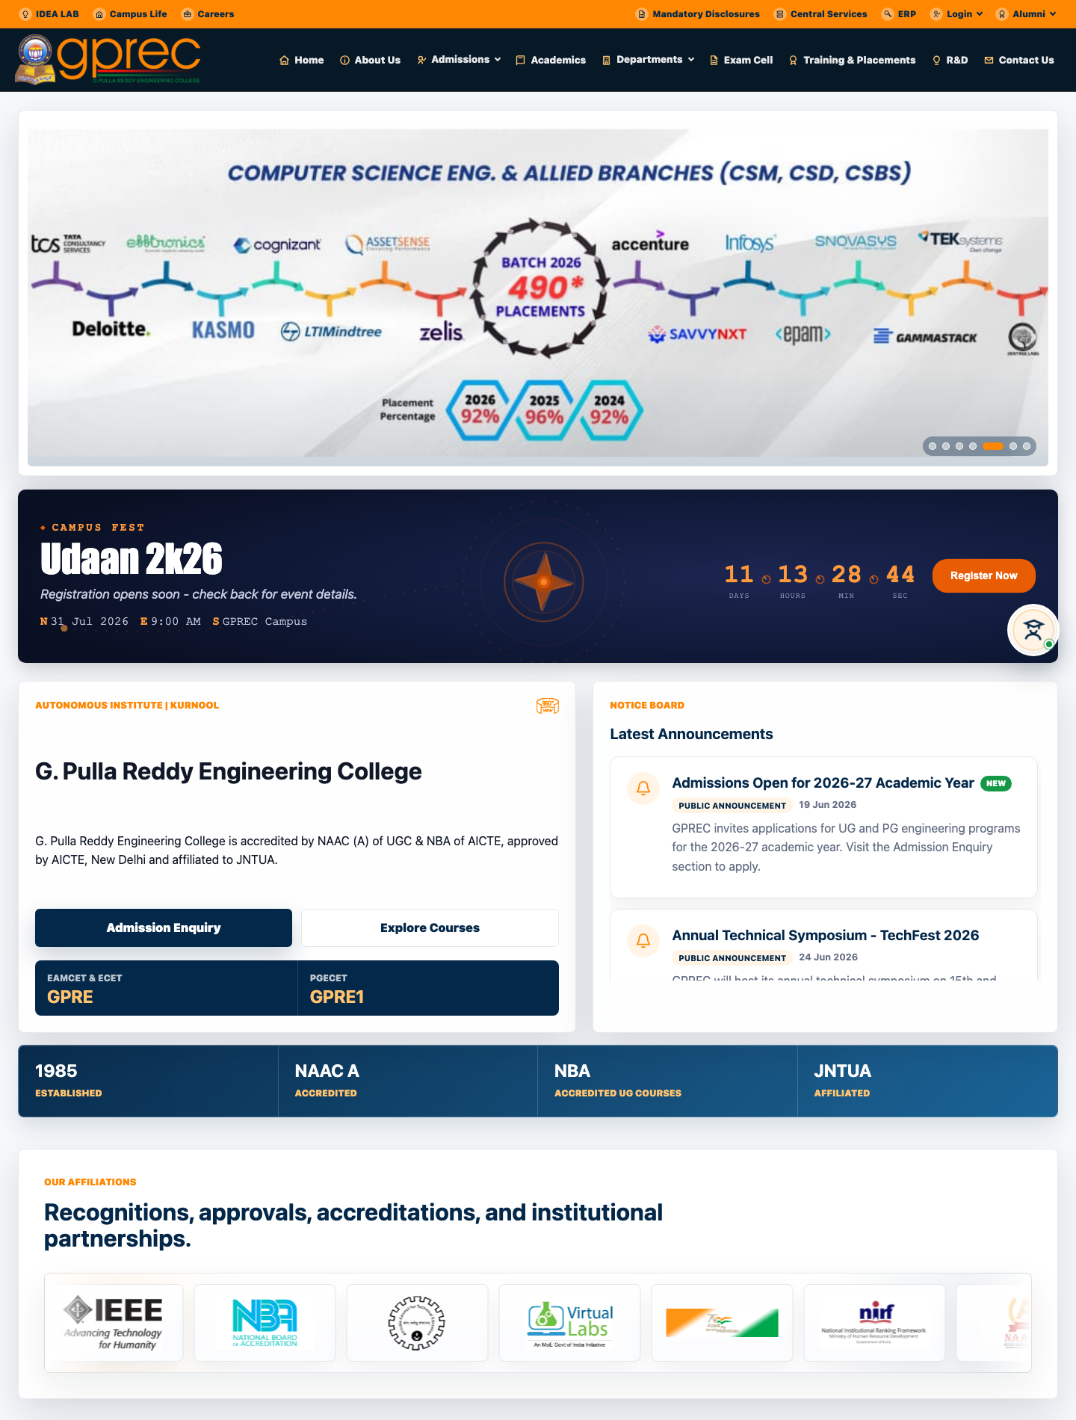
Figure: Public homepage

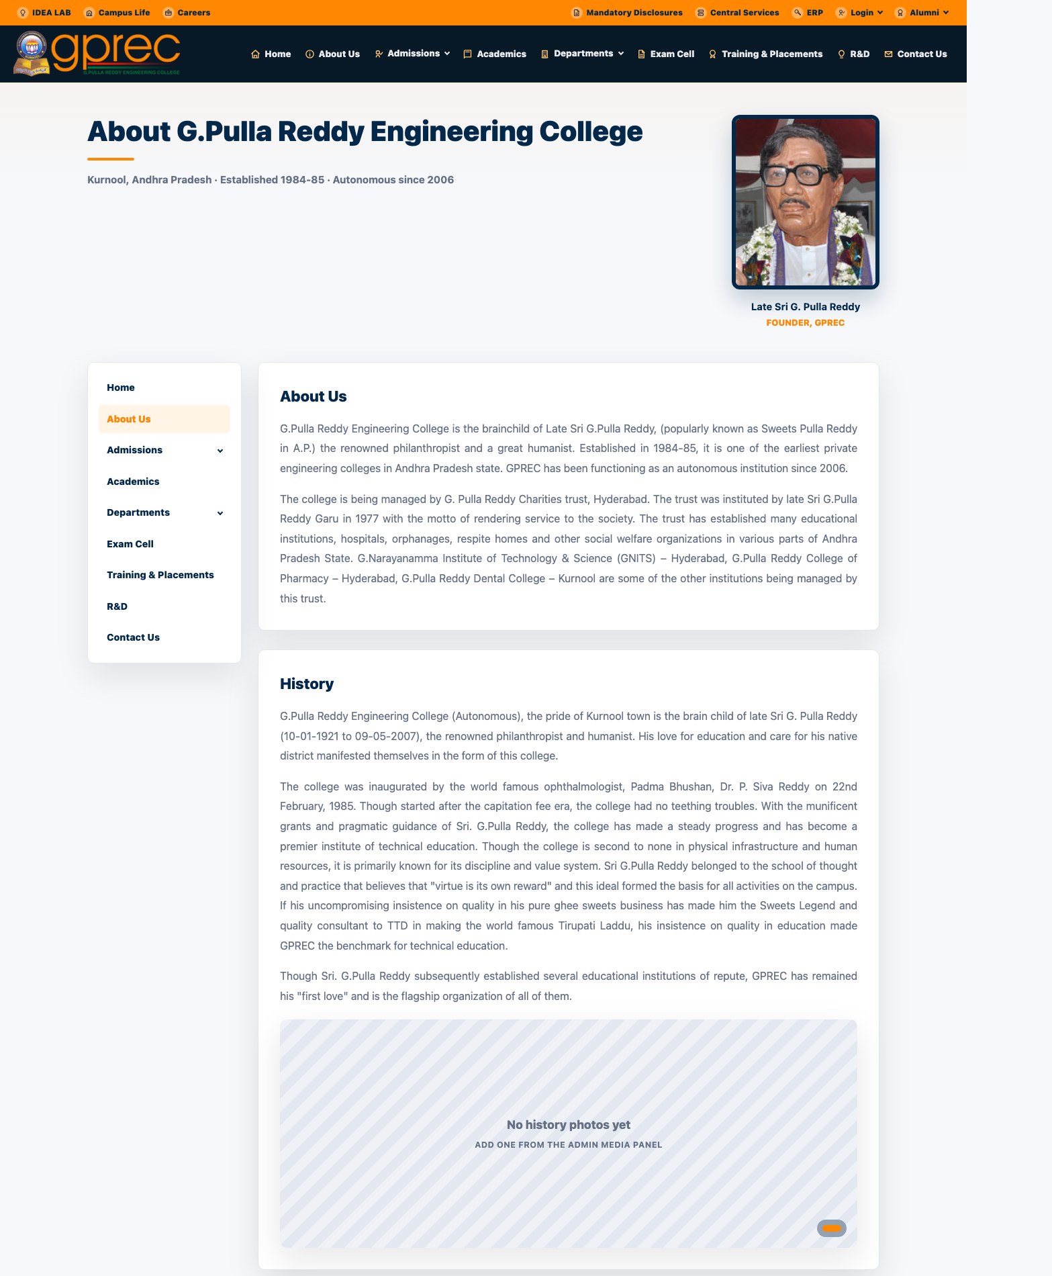
Figure: About Us page

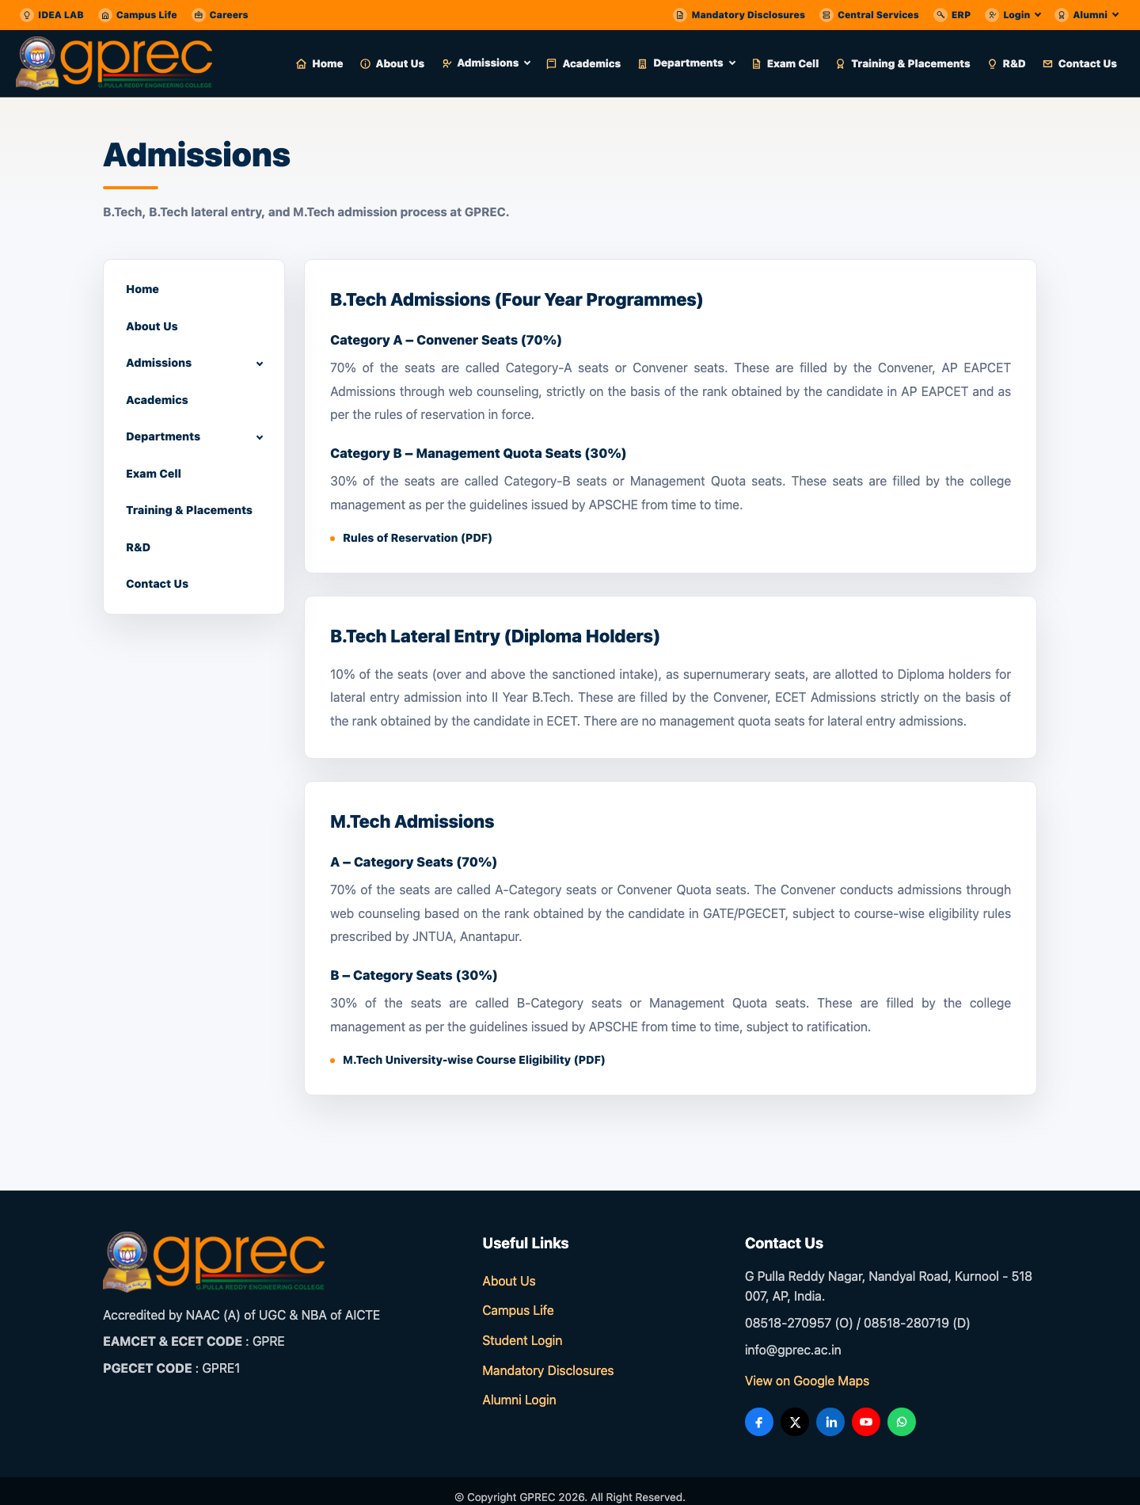
Figure: Admissions page

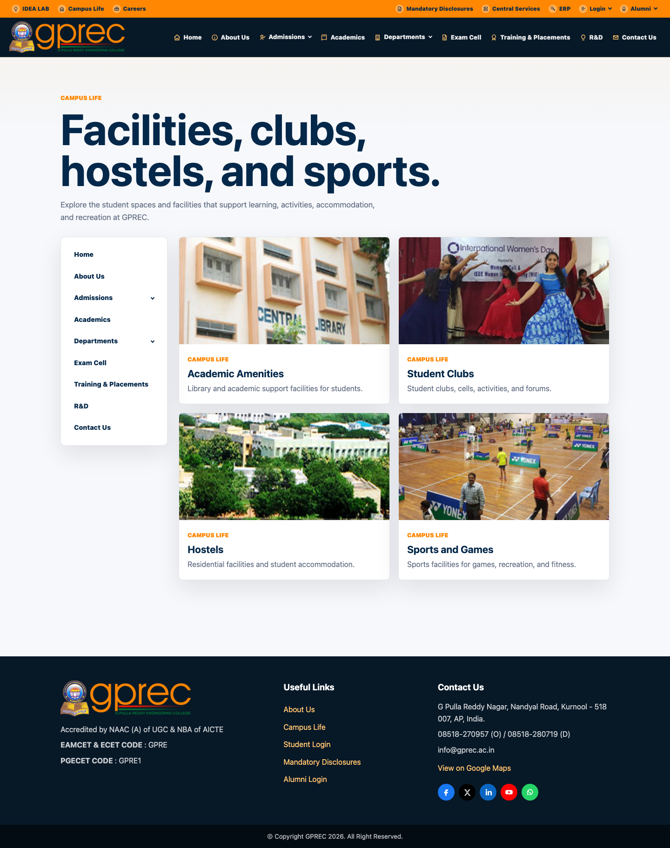
Figure: Campus Life page

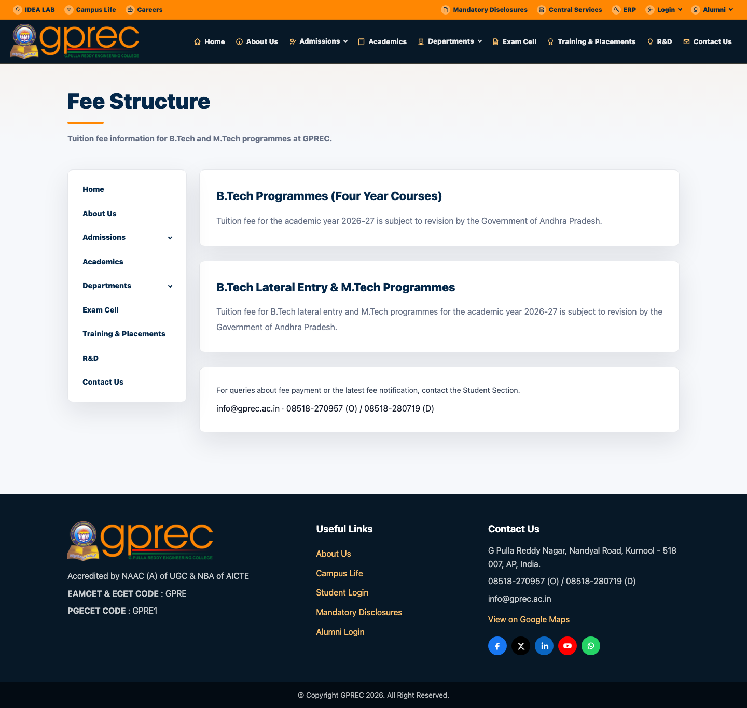
Figure: Fee Structure page

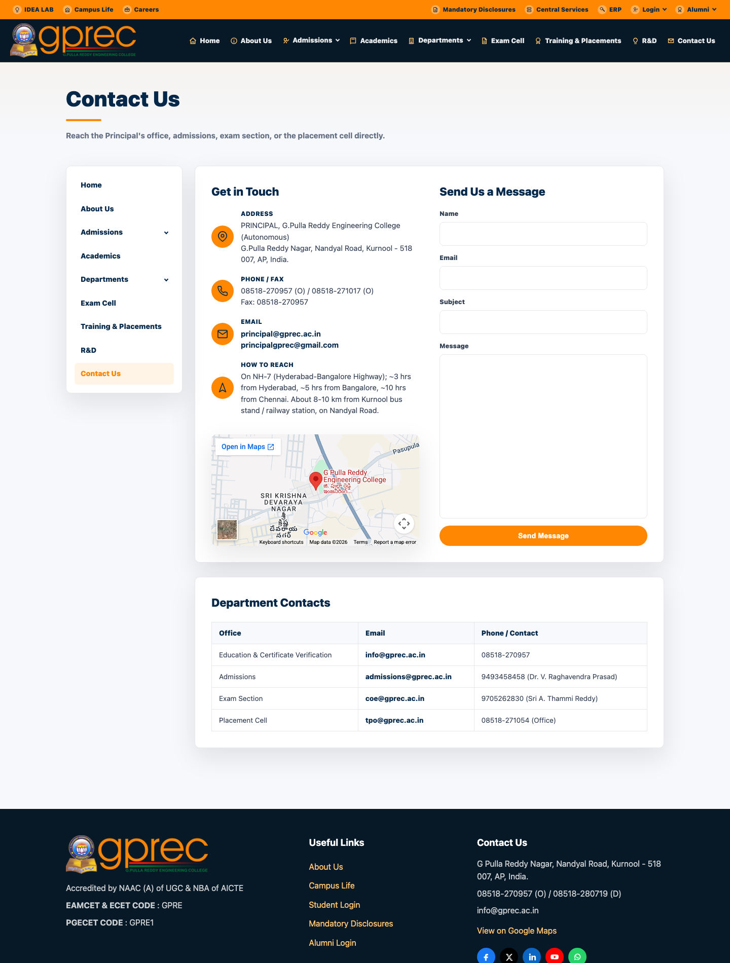
Figure: Contact Us page

7. Role-Based Login System
Every role signs in through its own dedicated login page. Students authenticate with roll number + date of birth (server-verified), staff and admin roles with email + password, and parents via a mobile-number OTP flow. Every form includes a self-hosted math CAPTCHA, and repeated failed attempts are rate-limited server-side.
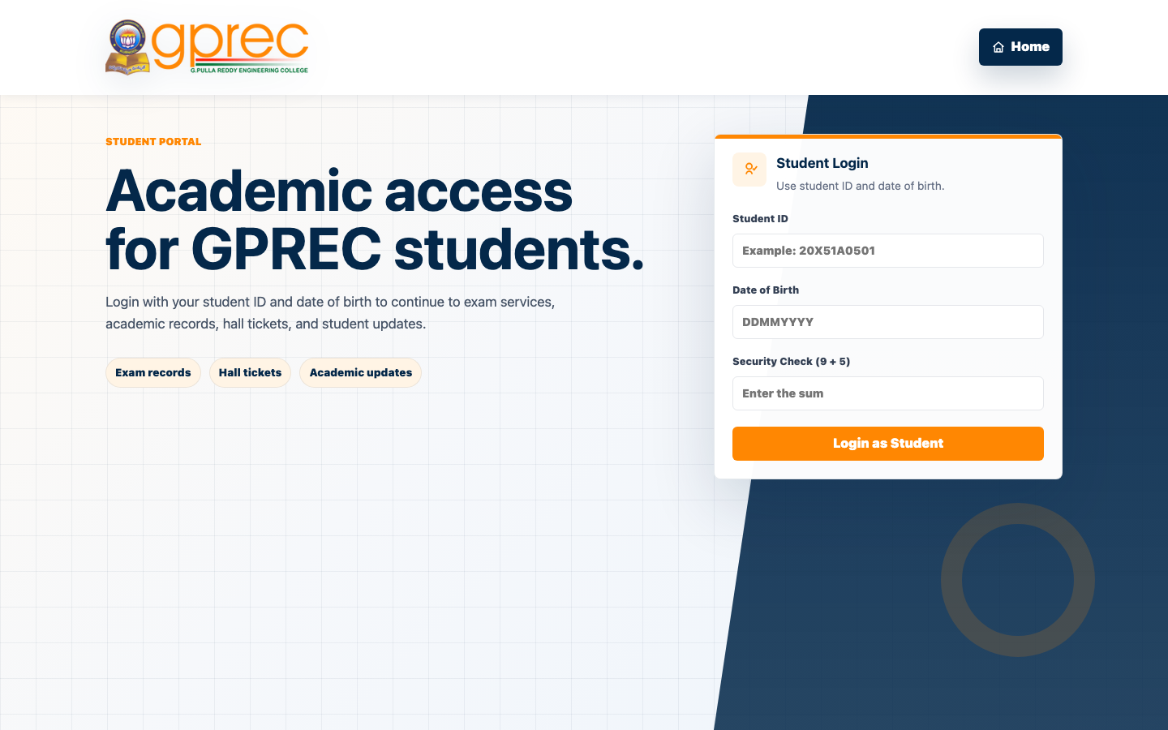 | 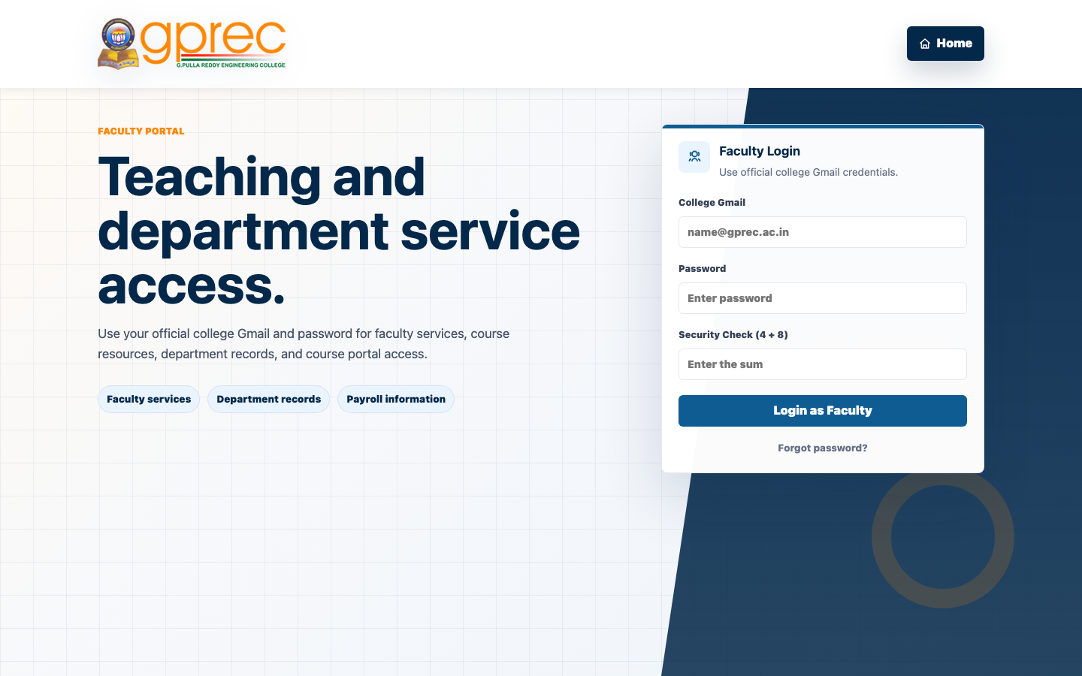
Student Login | Faculty Login

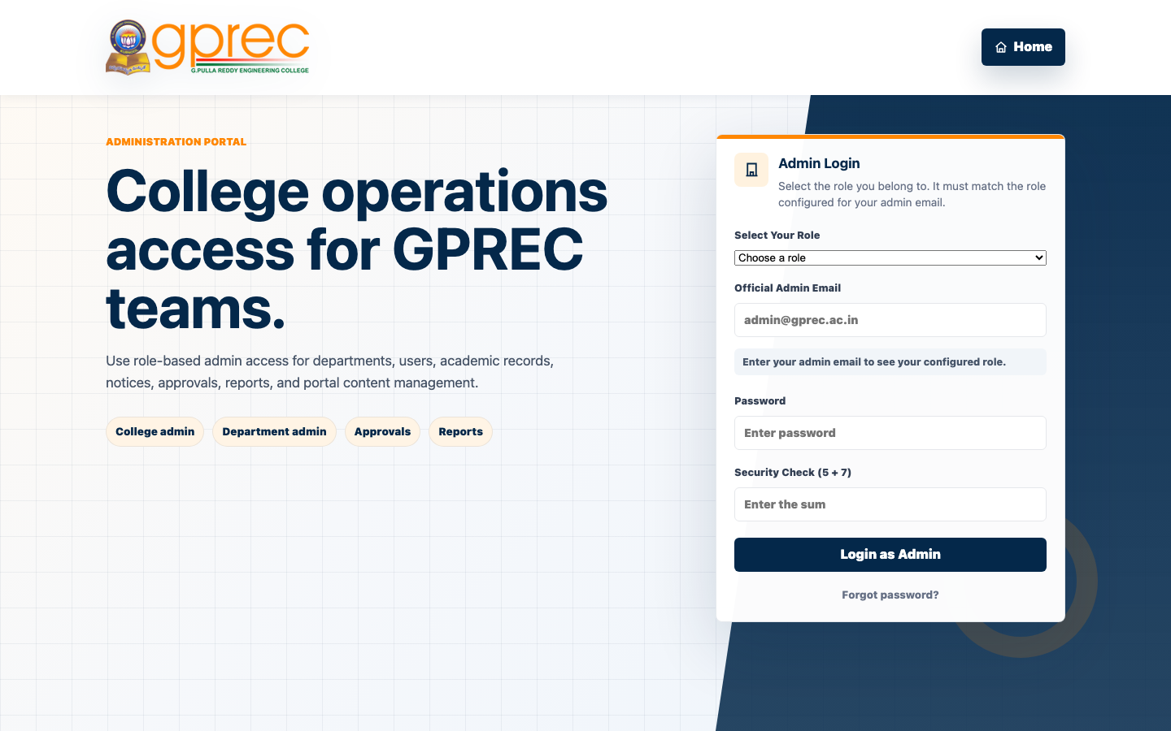 | 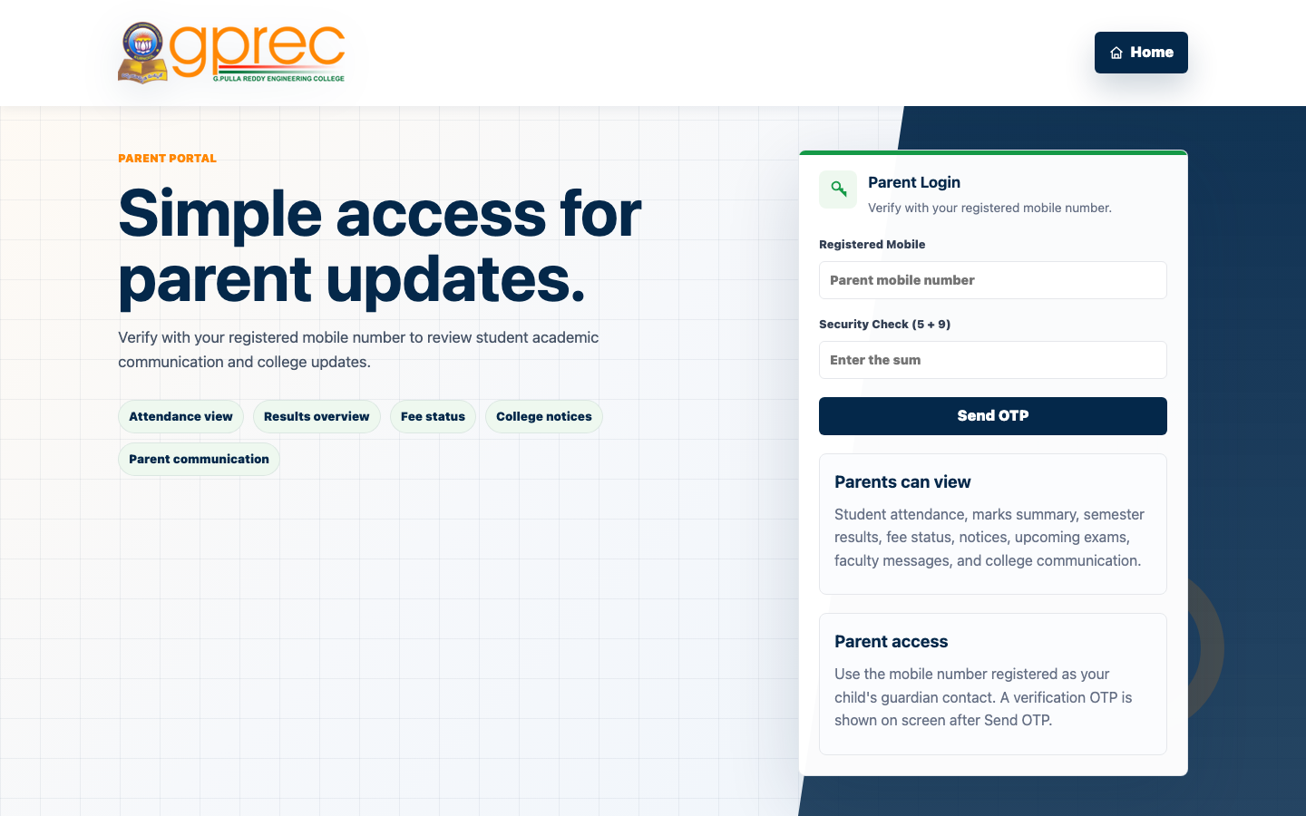
Admin Login (role-aware) | Parent Login (OTP)

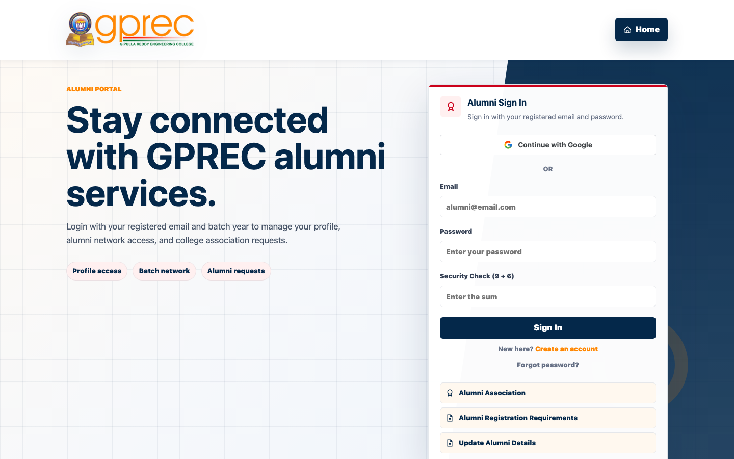 | 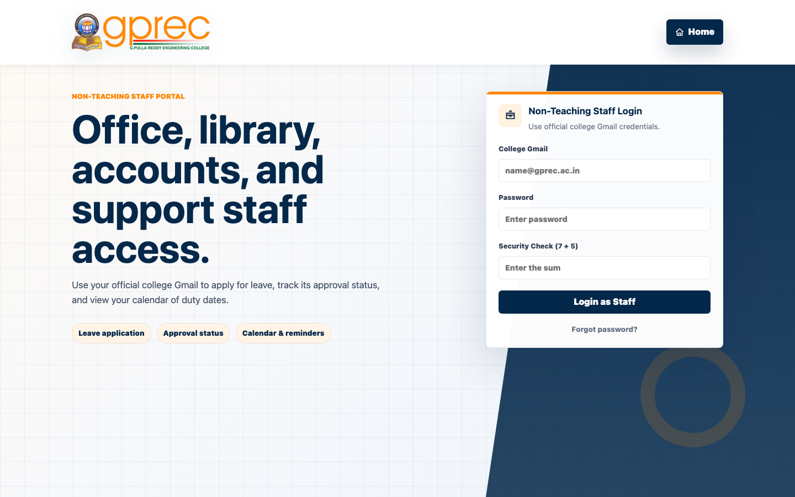
Alumni Login / Sign-up | Non-Teaching Staff Login

8. Student Portal
The Student Dashboard is the richest role in the portal, covering academics, attendance, grades, fees, hostel, library, placements, campus events, complaints, and more, organised into a collapsible sidebar menu.
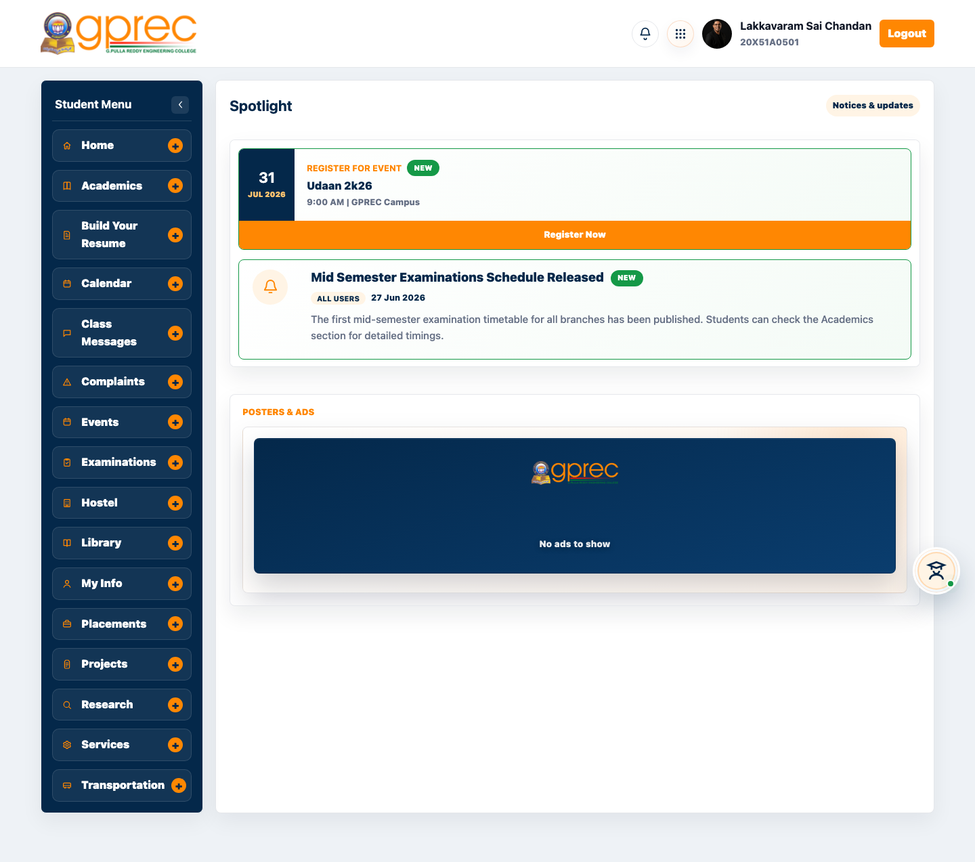
Figure: Student Dashboard - Home

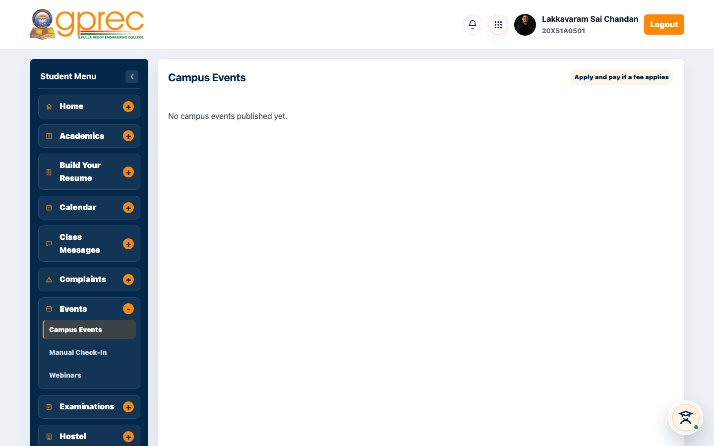
Figure: Campus Events - browse and register for open events

Manual Check-In (new): a volunteer signed in as a student can check an attendee into a fest event by roll number or outside-visitor email, without needing to scan a QR pass - useful when a phone camera is unavailable or a pass will not scan.
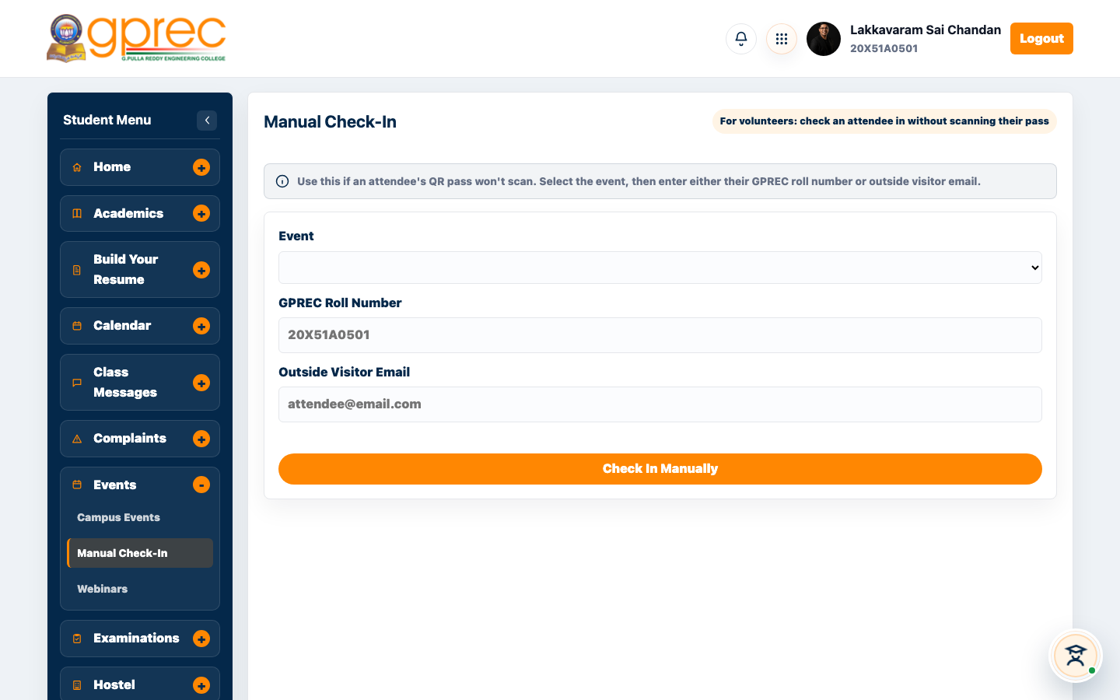
Figure: Manual Check-In panel

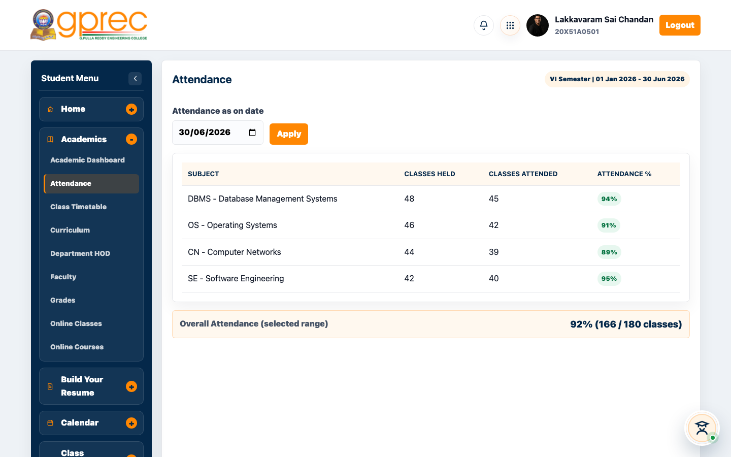
Figure: Attendance tracking

9. Faculty Portal
Faculty manage classes, assignments, attendance, timetables, leave requests, payroll documents, student research/projects supervision, and (for assigned Event Heads) their own campus events.
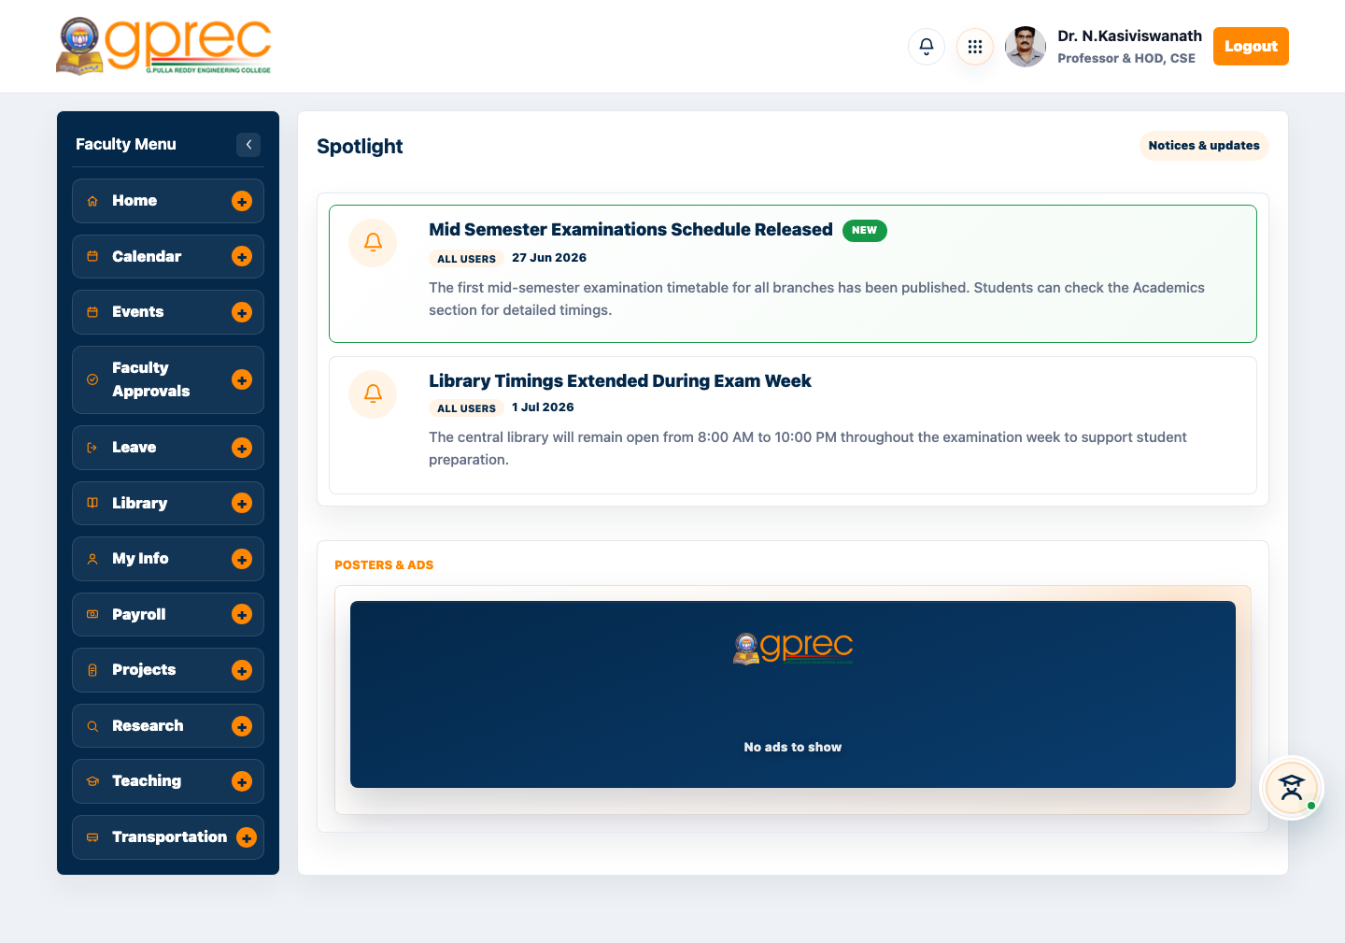
Figure: Faculty Dashboard - Home

Register for Event (new): faculty can now browse open campus/fest events and register themselves as an attendee - separate from creating or managing an event - and download a scannable digital event pass, the same flow students already had.
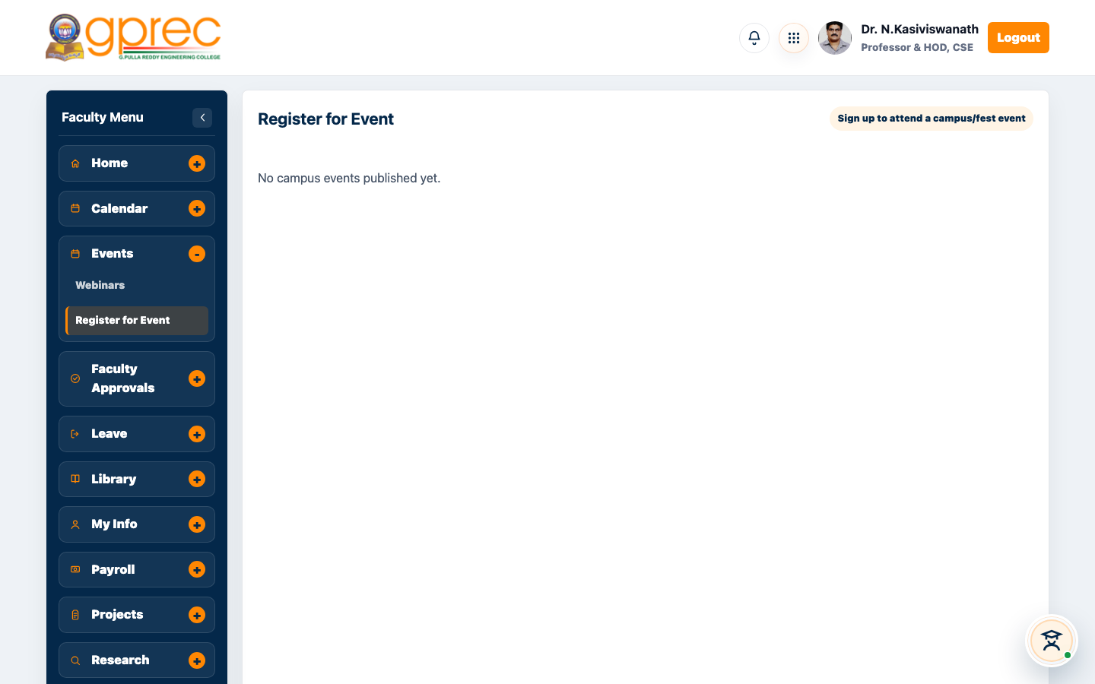
Figure: Register for Event panel (Faculty)

10. Admin Console
The College Admin dashboard is the operational nerve centre of the portal: a single console for departments, notices, student records, users, integrations, reports, and site maintenance.
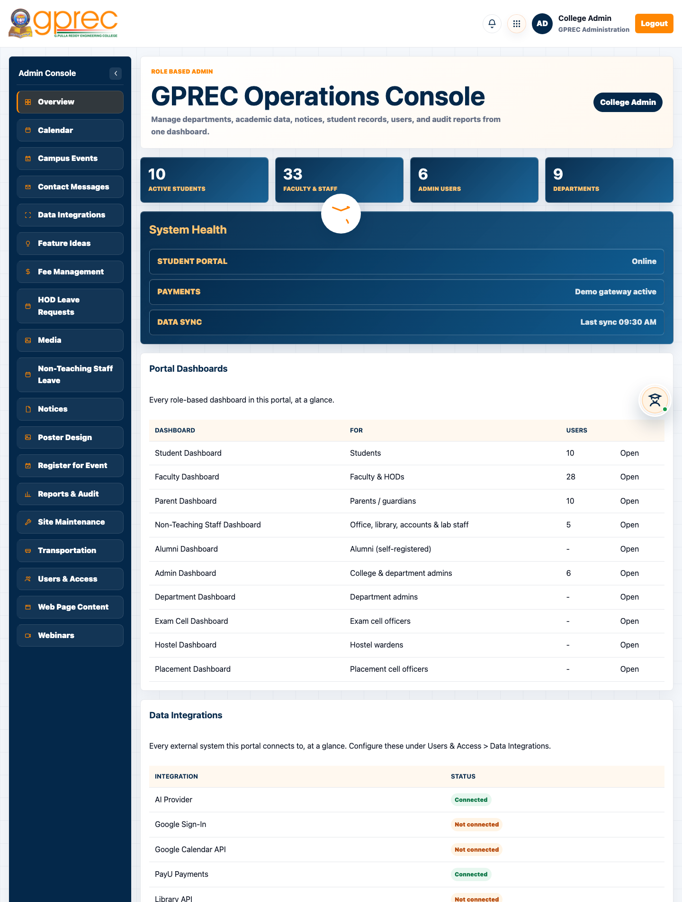
Figure: Admin Console - Overview

Module | What it's for
Overview | Portal-wide counts, system health, and a directory of every dashboard and integration.
Calendar | Academic dates and reminders shown on the student and faculty dashboards.
Campus Events | Fest and activity listings shown on the public Campus Life page.
Contact Messages | Submissions from the public Contact Us form.
Data Integrations | Google, PayU, AI, library, database, and SMS/KYC connection settings.
Fee Management | Student fee structures, dues, and payment tracking.
HOD Leave Requests | Leave approvals routed to department HODs.
Media | Photos and media used across the public site and dashboards.
Notices | Notices published to students, faculty, and other dashboards.
Poster Design | Event poster builder for campus events.
Register for Event (new) | Admin can register themselves as an attendee for a campus/fest event.
Reports & Audit | Academic/financial report exports, the admin audit trail, and data retention policy.
Site Maintenance | Take the public site or individual dashboards offline, with an advance-warning banner.
Transportation | Bus routes and transportation records.
Users & Access | Admin directory - who has access, at what role, in which department.
Web Page Content | Editable content blocks on the public website.
Webinars | Webinar listings shown on the public site.

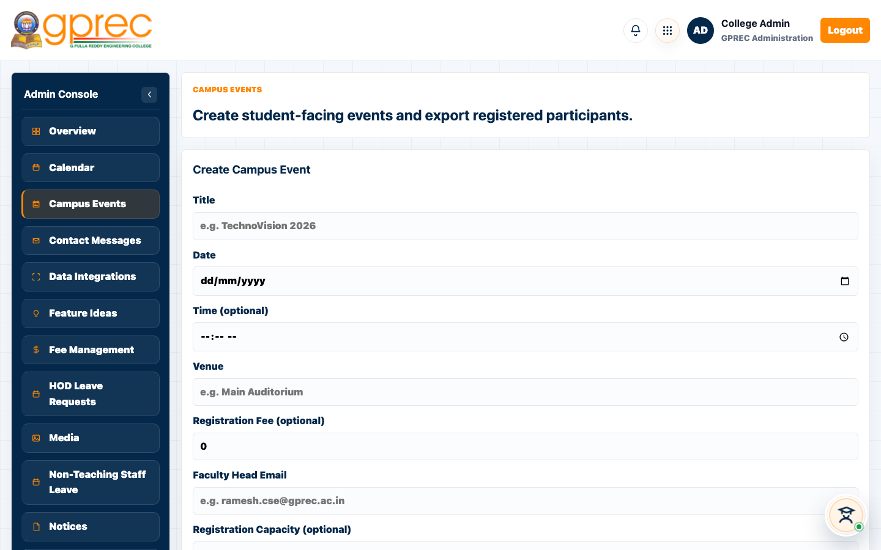
Figure: Campus Events - publish events, export check-ins

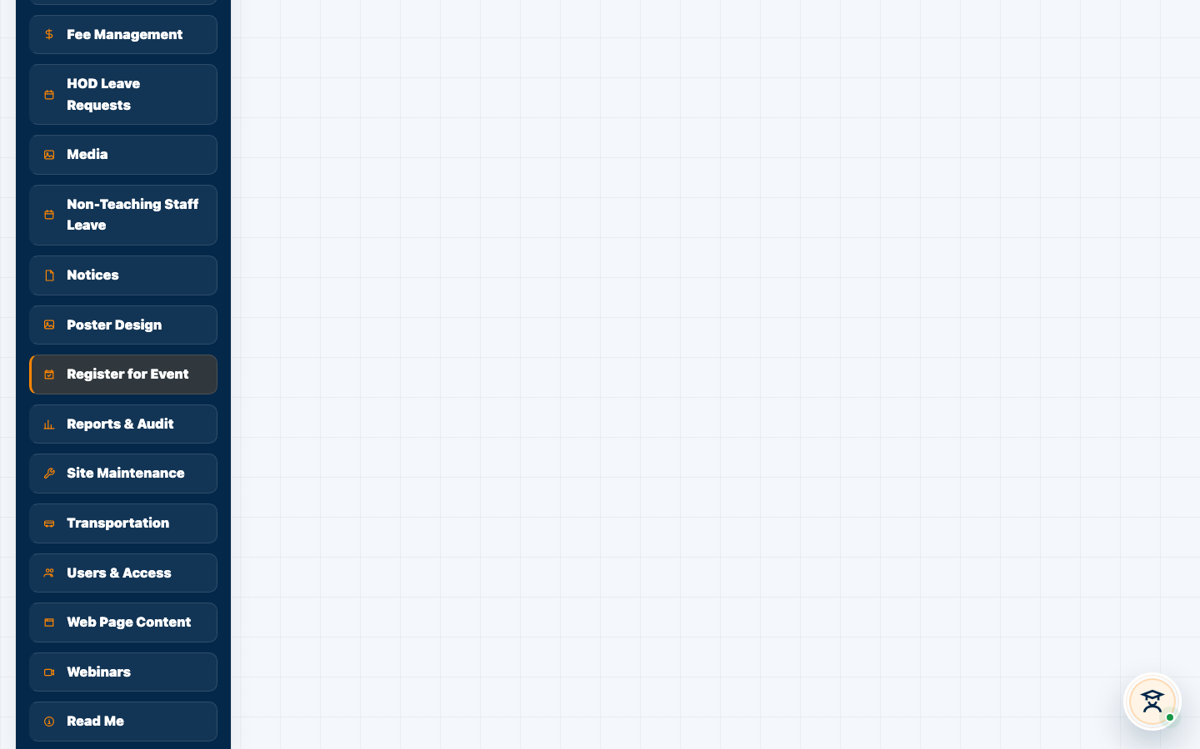
Figure: Register for Event panel (Admin)

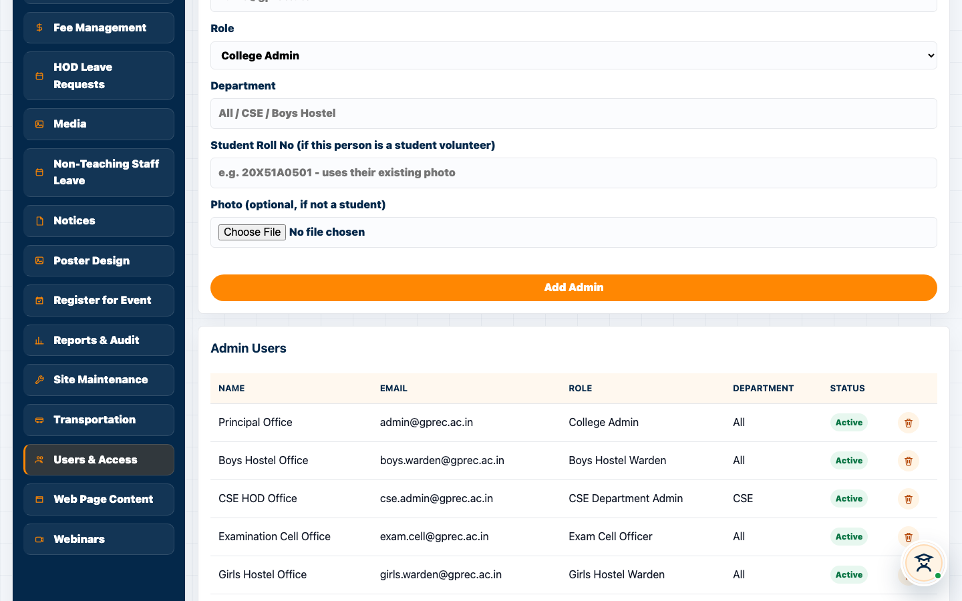
Figure: Users & Access - admin directory

11. Department / Hostel / Exam Cell / Placement Dashboards
These four dashboards share the admin-family login (admin-login.html) but scope every view to their own function - a department admin only sees their department's data, a hostel warden manages allocations and outings/leaves, the exam cell manages schedules and applications, and the placement cell manages drives and applicants.
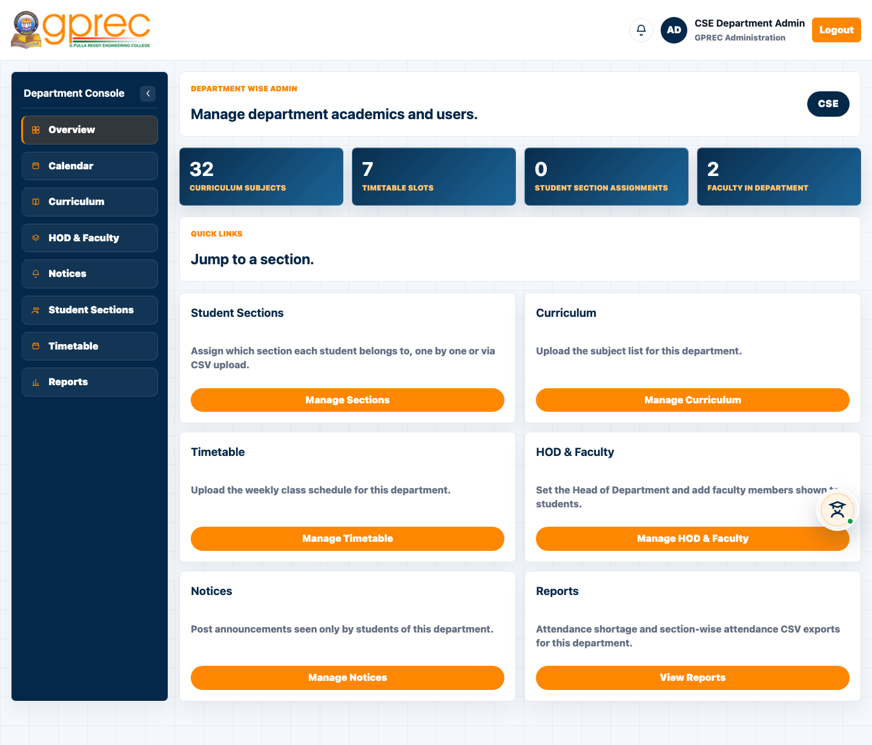
Figure: Department Admin Dashboard (CSE)

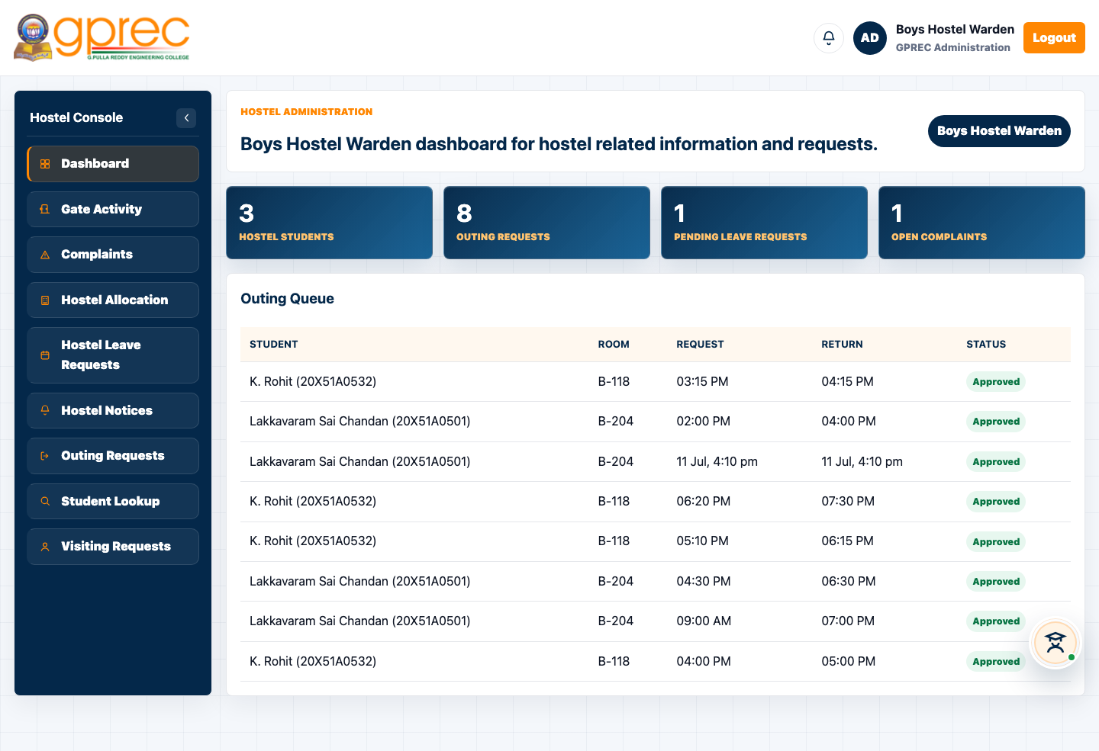
Figure: Hostel Warden Dashboard

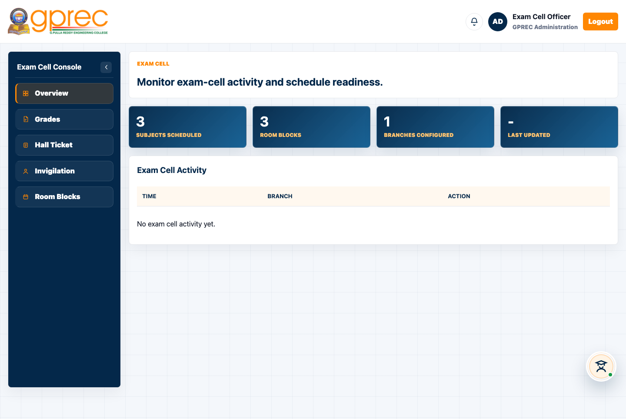
Figure: Exam Cell Dashboard

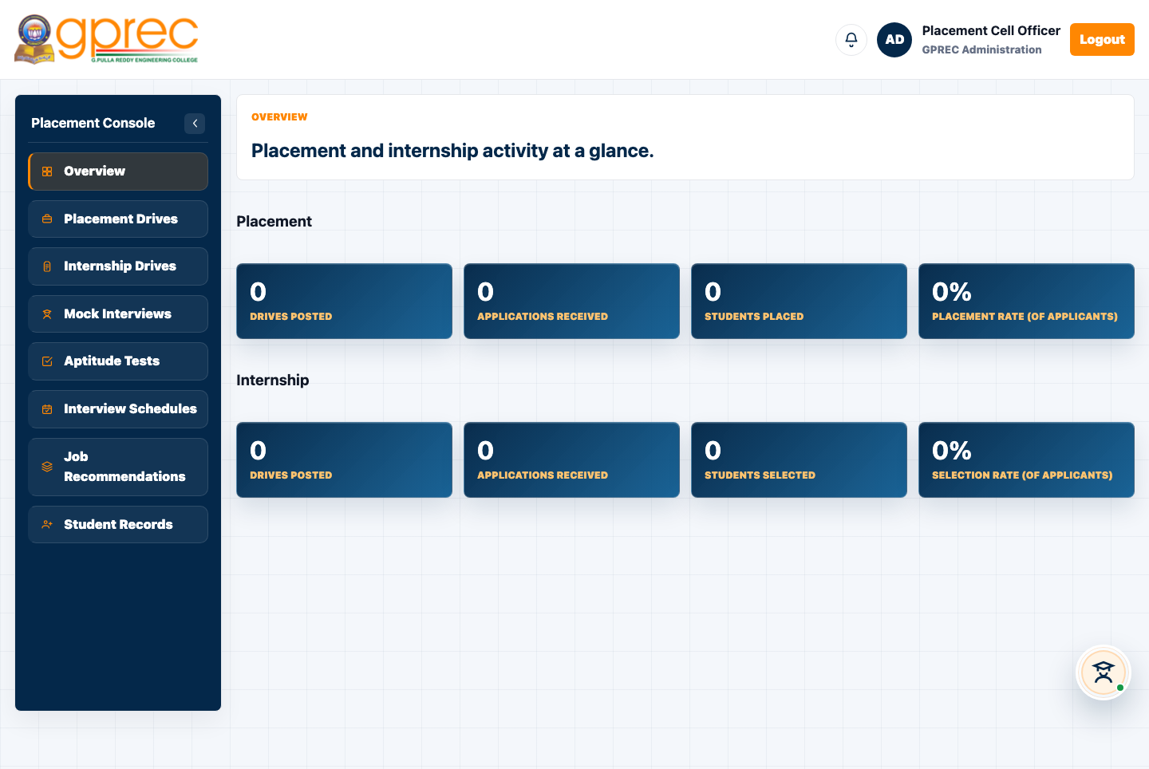
Figure: Placement Cell Dashboard

12. College Fest & Event Management System
A full sub-system for running the annual College Fest: admins publish fest activities and approve faculty coordinators, faculty manage their own activities and assign student volunteers, volunteers check attendees in at the gate (QR scan or manual fallback), and the public event-visitor page lets outside guests create an account, register for open events, and download a digital pass - all themed around a compass/travel motif with an admin-editable ticker, zone map, announcements, schedule, sponsors, gallery, and section copy.
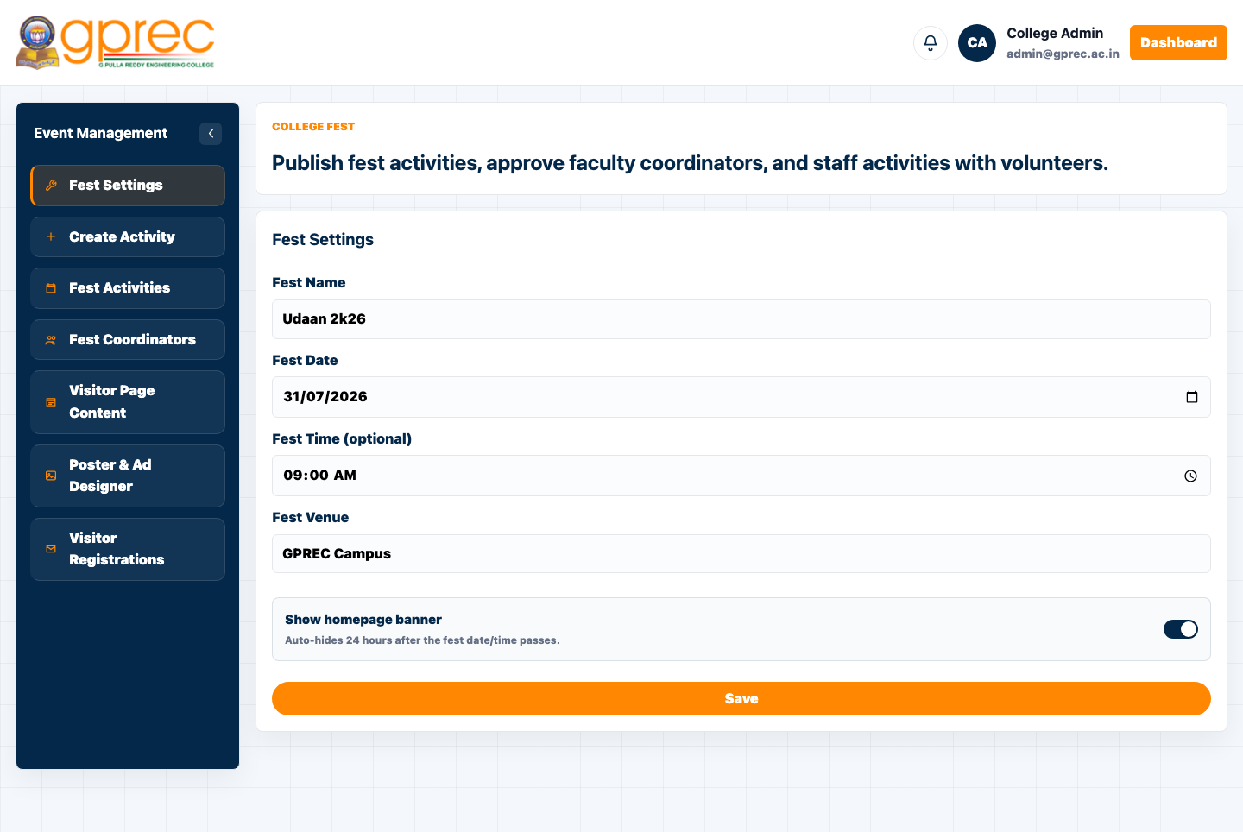
Figure: Event Management Dashboard (Fest Settings)

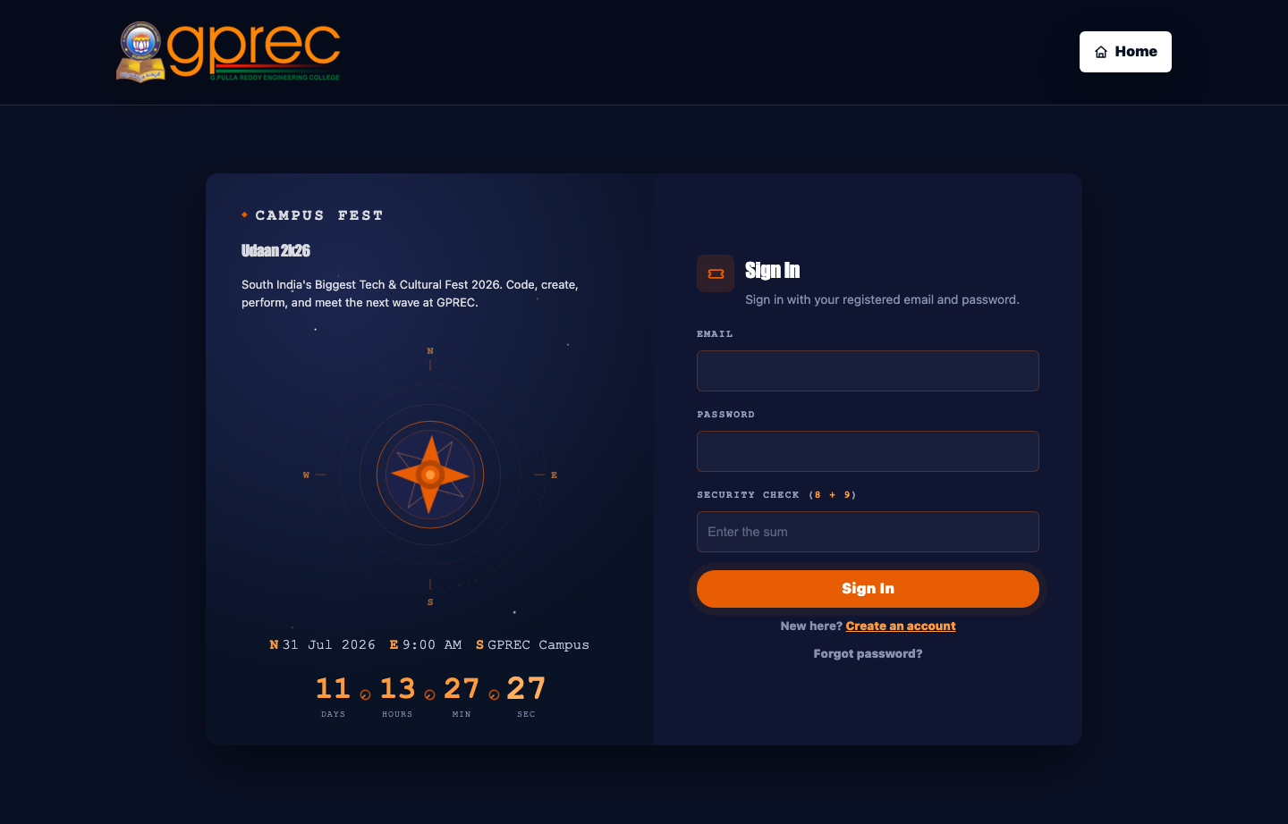
Figure: Public Event Visitor page - sign in / register

13. Database Design
All portal data lives in PostgreSQL under the gprec_erp schema, currently 78 tables. Key table groups include:
Group | Representative tables
Identity & Auth | admins, faculty, students, guardians, alumni_accounts, non_teaching_staff, event_visitor_accounts, user_credentials, login_throttle
Academics | attendance_records, attendance_entries, student_grades, internal_marks, curriculum, class_timetable, assignments, assignment_submissions, course_materials
Fees & Payroll | fee_dues, fee_amount_overrides, bank_details
Hostel | hostel_allocations, hostel_outing_requests, hostel_leave_requests, hostel_visiting_requests
Placements | interview_schedules, invigilation_duties (exam), online_class_viewers
Campus Events / Fest | campus_event_registrations, event_visitor_accounts, activity_log
Content & Comms | notices, notifications, contact_messages, calendar_reminders, site_content
Library | library_books, library_issues, book_favorites

A generic site_content key/value table backs every admin-editable content block across the portal (fest settings, poster/ad designs, ticker messages, and more), read via a single getSiteContent(key, fallback) helper on the frontend and written through one admin-only /api/site-content endpoint on the backend.

14. Security & Access Control
- Every dashboard requires a real, server-issued session token matched against the exact role it was issued for.
- Passwords are stored salted and hashed (user_credentials table) - never in plain text.
- A one-time First-Time Setup flow lets the very first admin generate a password without an existing session, then locks itself once any admin has a password.
- Self-hosted math CAPTCHAs on every login/signup form, verified server-side for the public event-visitor flow.
- Server-side login throttling blocks repeated failed attempts per identity.
- Role-scoped API authorization on the backend (allowed_types checks) independent of what the frontend shows or hides.
- Uploaded files are written under a dedicated uploads/ directory, separate from application code.

15. Notable Recent Enhancements
Dynamic Fest Content (Event Visitor page)
The event-visitor-dashboard.html page's live ticker, zone map, announcements, schedule, sponsors, gallery labels, and six section blurbs (Workshops, Competitions, Celebrity Night, Accommodation, FAQs, Contact) were all previously hardcoded. They are now admin-editable from a new "Visitor Page Content" card in the Event Management Dashboard, backed by the existing generic site_content API, with every field falling back to its original placeholder copy until an admin saves something.
Register for Event - Faculty & Admin
Previously only students (and public visitors) could register themselves as an attendee for a campus event. The registration flow (browse events, submit registration, download a digital pass/receipt) was generalised behind a single getCampusEventRegistrant() identity resolver that keys the registration by roll number for students or by login email for faculty/admin, then surfaced as a new "Register for Event" section on both the Faculty and Admin dashboards.
Manual Check-In - Student Dashboard
Event volunteers (who sign in through the student login) previously had to open a separate mobile-oriented QR scanner page to check attendees in manually. A desktop-friendly Manual Check-In section was added directly to the Student Dashboard's own navigation, reusing the existing /campus-event/manual-checkin endpoint - no camera required.

16. Deployment & Running Locally
The site can be opened directly via file:// for a static preview, but full functionality (uploads, the admin config API, and PostgreSQL-backed portal data) requires the local server stack:
- ./backend/tools/start_servers.sh - starts static_server.py (port 8080), portal_db_server.py (port 8766), and pdf_render_server.py (port 8767).
- admin_config_server.py (port 8765) - handles admin-config and upload writes.
- ./backend/tools/stop_servers.sh - stops all of the above.
- backend/database/postgres/schema.sql and seed.sql set up the gprec_erp schema and demo data.
For a real production deployment (not local development), see PRODUCTION.md in the project root.

17. Conclusion & Future Scope
The GPREC College Portal delivers a complete, role-aware digital front door for the college - from a public marketing site through to a full academic and administrative ERP, plus a purpose-built system for running the annual fest. Its dependency-light stack keeps it easy to run, audit, and extend without a framework build pipeline.
Potential future directions include:
- Native mobile apps (or a PWA wrapper) for the student and volunteer QR check-in flows.
- Deeper analytics/reporting dashboards for placements, attendance trends, and fee collection.
- Real Google/PayU/SMS integrations wired end-to-end in production (currently configurable, demo-gated locally).
- Automated test coverage for the authentication and registration flows.

