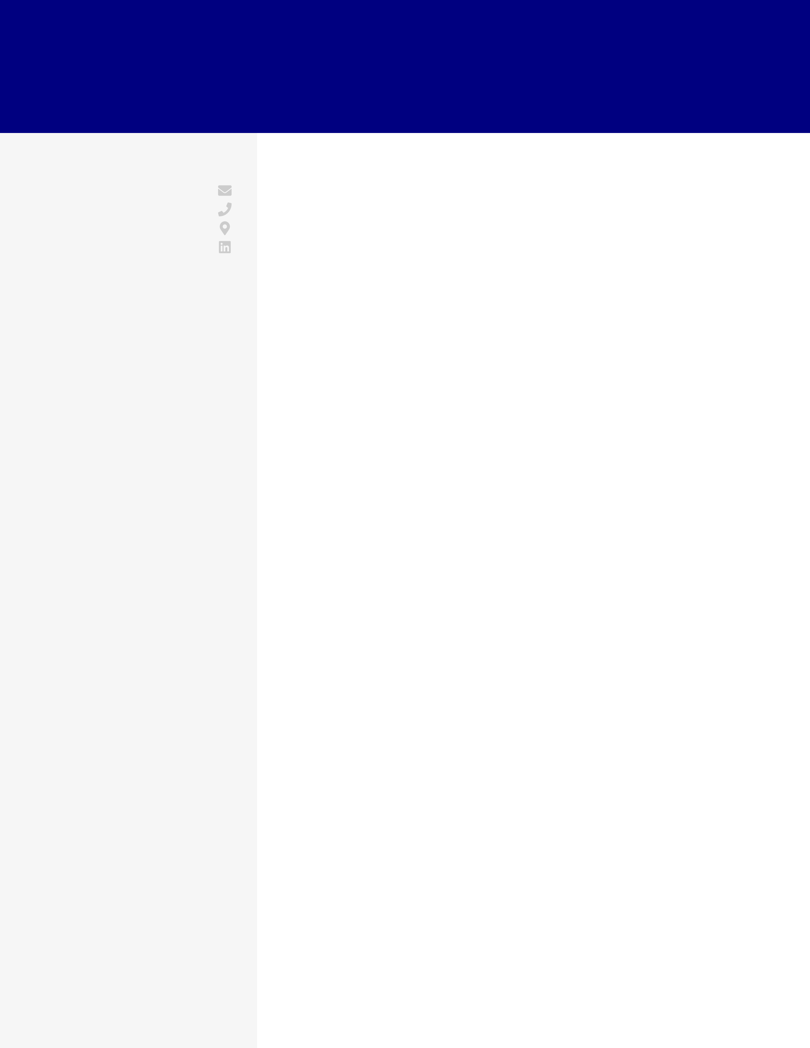

FARAH MARTIN DATA ANALYST

|  |  |
| --- | --- |
| **CONTACT** farahmartin@email.com   (123) 456-7890   Brooklyn, NY   [LinkedIn](http://linkedin.com/in/farahmartin)  **EDUCATION** B.S.  Mathematics and  Economics  University of Pittsburgh September 2010 - April 2014 Pittsburgh, PA  **SKILLS**  SQL  Excel/ Google Sheets  A/B Testing &  Experimentation  Tableau  Python (Pandas, Scikit-learn) Google Analytics  Leadership Experience | **WORK EXPERIENCE**  Data Analyst  Fountain House  May 2018 - current / New York, NY  ·Built out the data and reporting infrastructure from the ground up using Tableau and SQL to provide real-time insights  into the product, marketing funnels, and business KPIs·Designed and implemented A/B experiments for products to improve the conversion rate by 19 basis points and reduce  churn by 12 basis points ·Implemented long-term pricing experiment that improved customer value by 25% ·Built operational reporting in Tableau to find areas of improvement for contractors resulting in $250K in annual  incremental revenue ·Led a team of 2 full-time employees and 4 contractors  Data Analyst  Wavely  August 2016 - May 2018 / New York, NY  ·Partnered directly with the executive team as the first data hire to formulate and report on KPIs across their web properties  that received 225M visitors annually using SQL and Google  Sheets ·Built a logistic regression model to help the SEO team decide which keywords to target, resulting in a 15% lift in YoY site  visitors in 2018 ·Collaborated with product managers to perform cohort   analysis that identified an opportunity to reduce pricing by 22%  for a segment of users to boost yearly revenue by $730K·Developed root cause reports to address problems with customer conversions, successfully revealing insights that  boosted conversions by 32% |

Product Modeling Analyst   
Geico   
August 2014 - August 2016 / Washington D.C.

·Developed and owned reporting for a nationwide retention program with Python, SQL, and Excel, saving ~90 hours of monthly labor  
·Identified procedural areas of improvement through customer data, using SQL to help improve the profitability of a   
 nationwide retention program by 8%  
·Applied models and data to understand and predict repair costs for vehicles on the market, and presented findings to stakeholders