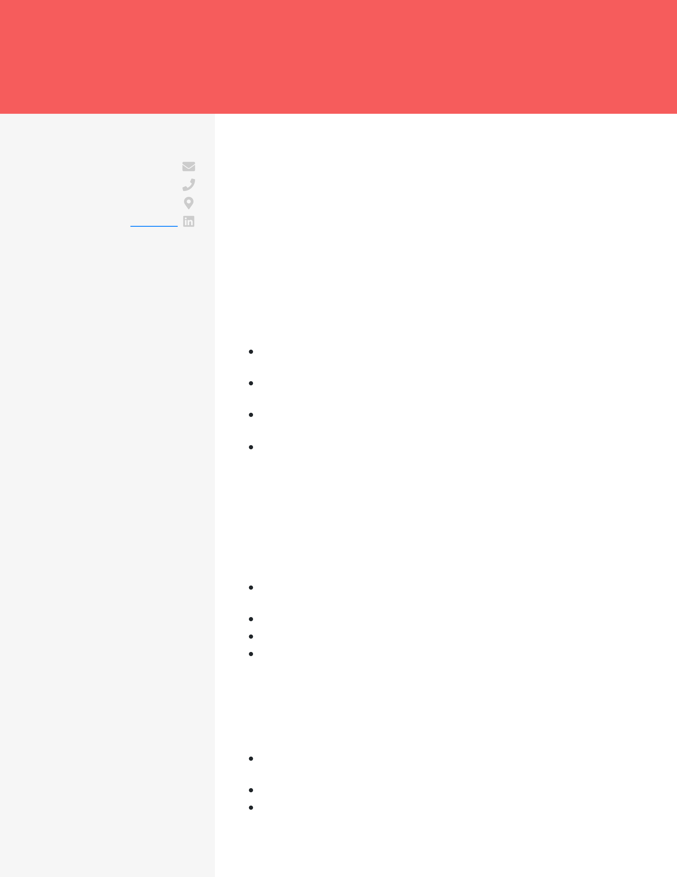

CHARLA SWAIN   
ENTRY-LEVEL RISK ADJUSTMENT DATA ANALYST

|  |  |
| --- | --- |
| **CONTACT** charla_swain@email.com   (123) 456-7890  San Francisco, CA   [LinkedIn](https://linkedin.com/)  **EDUCATION**  Bachelor's of Science  Data Science  University of California, San Francisco  2010 - 2014  San Francisco, CA | **CAREER OBJECTIVE**  Driven and curious data analyst with experience working with Python, SQL, R, Tableau, and several more programming languages. With a passion for creative innovation and solving complex problems, I am eager to further implement my skills and improve my data analysis experience with a detail-driven data team like Amazon's.  **WORK EXPERIENCE**  Risk Adjustment Data Analyst Intern  Blue Shield of California  2014 - current / Oakland, CA  Developed 6 methods to support the access, storage, and reporting of data sets that result from project initiatives  Visualized and communicated the insights, patterns, and trends from |

complex data sets

|  |  |
| --- | --- |
| **SKILLS**  Python  SQL | Performed data scrubbing, troubleshooting, quality checking, and usability analysis to identify 24 anomalies  Developed knowledge of the top 33 KPIs related to Medicare Risk Adjustment and Hierarchical Condition Categories (HCCs) |

R

|  |  |
| --- | --- |
| Tableau  Microsoft Excel Azure  SciPy  Data Preparation | **PROJECTS**  Toxic Mushroom Website - Biology Course Project Created a website to provide a singular resource for identifying and learning about toxic mushrooms |

Pulled data from a 2021 mushroom study to craft a 6,800-line JSON file to accompany data from the 1980s and provide a D3.js chart

Designed an interactive Sunburst chart using observables and D3.js

Led a team of 3 engineers to complete 10 Git Pull Requests

Drafted and wrote documentation of code complete with Machine Learning charts and hyperlinks to the web pages and data resources

Stock Analysis - Internship

Utilized stock market KPIs to determine the state of the tech sector of the stock market

Maintained a working knowledge of Data ETL, visualization, API frameworks, and statistical methods in Python

Cleaned data and accessed JSON endpoints for 15+ companies

Conducted a regression analysis to determine the correlation between the NASDAQ's price-to-earning ratio to revenue growth