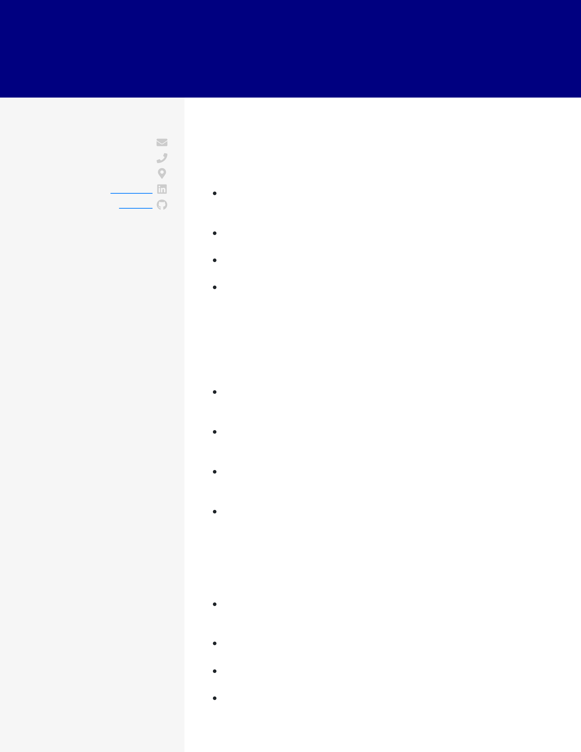

KANDACE LOUDOR

DATA SCIENTIST

|  |  |
| --- | --- |
| **CONTACT**  kloudor@email.com (123) 456-7890  Mount Laurel, NJ  [LinkedIn](https://linkedin.com/)  [Github](https://github.com/)  **EDUCATION**  B.S.  Statistics  Rutgers University  September 2011 - April 2015 New Brunswick, NJ  **SKILLS**  Python (NumPy, Pandas, Scikit-learn, Keras, Flask) SQL (MySQL, Postgres)  Git  Time Series Forecasting Productionizing Models Recommendation Engines Customer Segmentation AWS | **WORK EXPERIENCE**  Data Scientist  Grubhub  June 2018 - current / Princeton, NJ  Deployed a recommendation engine to production to  conditionally recommend other menu items based on past order history, increasing average order size by 7%  Implemented various time series forecasting techniques to predict surge in orders, lowering customer wait by 10 minutes  Designed a model in a pilot to increase incentives for drivers during peak hours, increasing driver availability by 22%  Led a team of 3 data scientist to model the ordering process 5 unique ways, reported results, and made recommendations to increase order output by 9%  Data Scientist  Spectrix Analytical Services  March 2016 - June 2018 / Princeton, NJ  Built a customer attrition random forest model that improved monthly retention by 12 basis points for clients likely to opt-out by providing relevant product features for them  Coordinated with the product and marketing teams to determine what kind of client interactions resulted in maximized service opt-ins, increasing conversions by 18%  Partnered with product team to create a production  recommendation engine in Python that improved the length on-page for users with $225K in incremental annual revenue  Compiled and analyzed data surrounding the prototypes for a prosthesis, which saved over $1M in its creation |

Entry-Level Data Analyst

Avenica

April 2015 - March 2016 / Mount Laurel, NJ

Collaborated with product managers to perform cohort analysis that identified an opportunity to reduce pricing by 21% for a segment of users to boost yearly revenue by $560,000

Constructed operational reporting in Tableau to improve scheduling contractors, saving $90,000 in the annual budget

Implemented a long-term pricing experiment that improved customer lifetime value by 23%

Ran, submitted, and reported on monthly client enrollments, services opted in for, and the employees assigned to clients