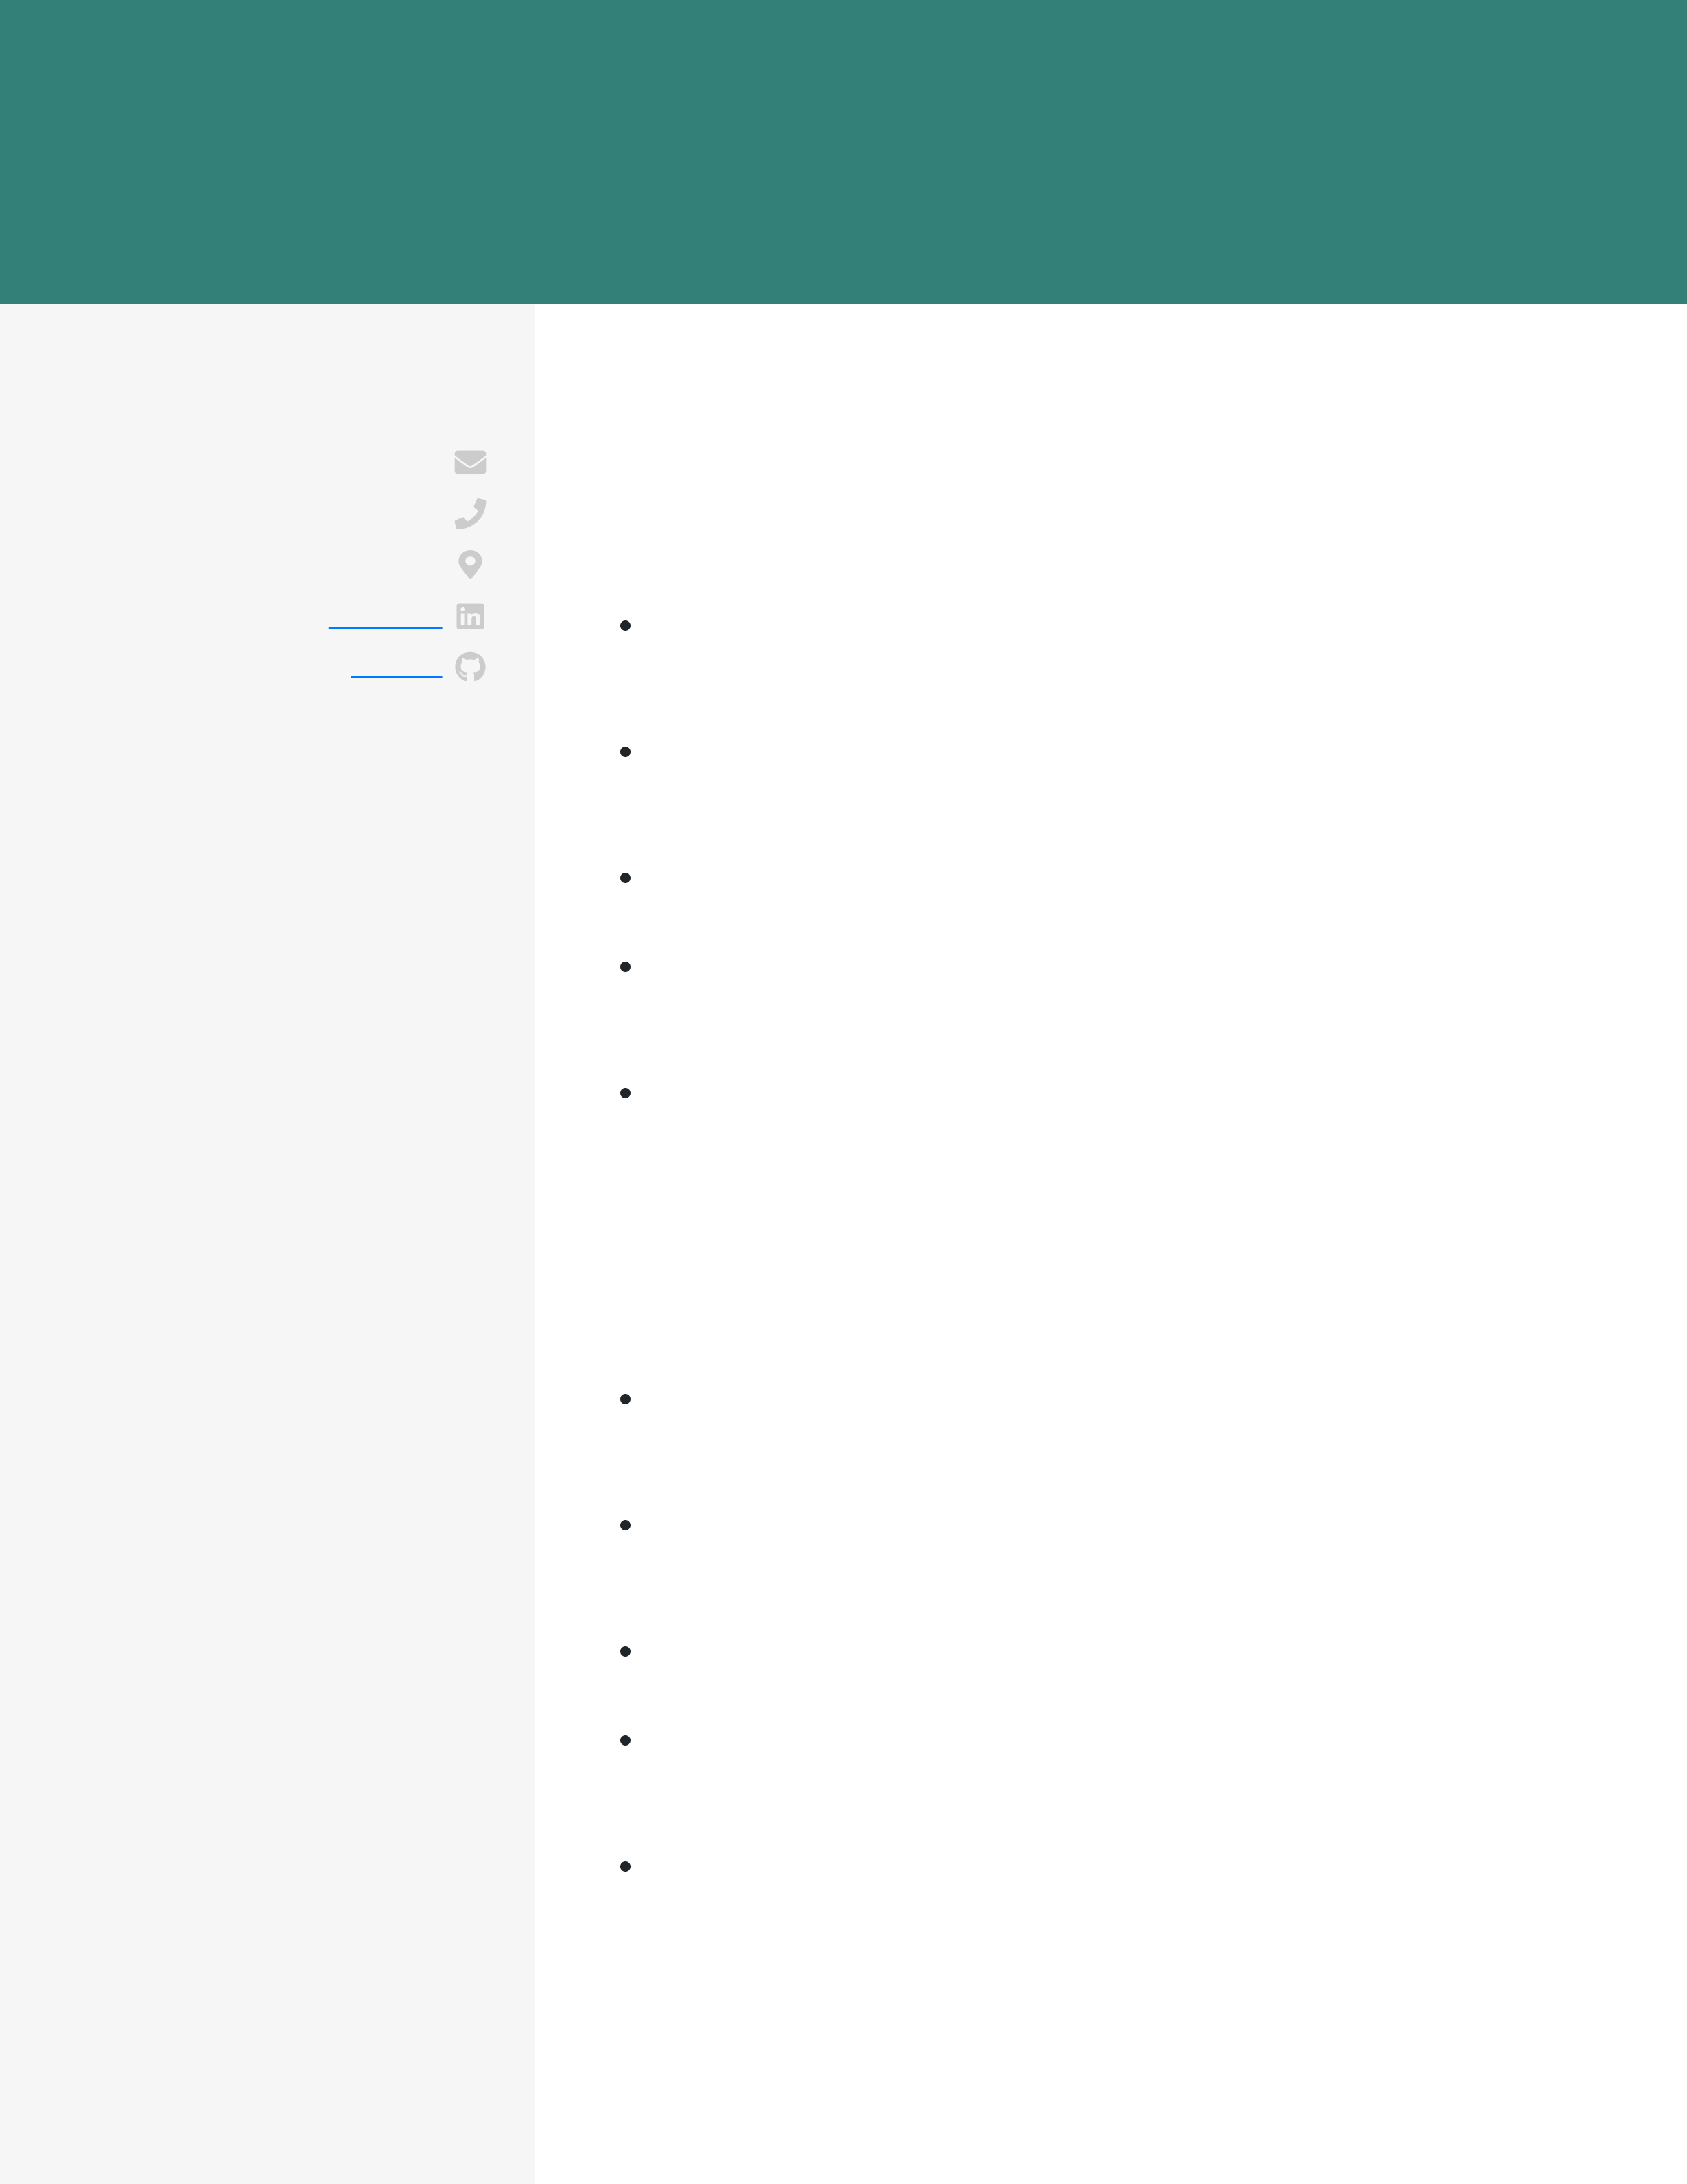

GIULIA GONZALEZ PYTHON DEVELOPER

|  |  |
| --- | --- |
| **CONTACT**  ggonzalez@email.com (123) 456-7890  Detroit, MI  [LinkedIn](http://linkedin.com/in/john-g)  [Github](http://github.com/john-gonzalez) | **WORK EXPERIENCE**  Python Developer  DoorDash  September 2017 - current / Detroit, MI  Worked on building new Angular components for the customer-facing web app, which improved the time on page for the average user by 2 |

minutes

Collaborated with an agile team of 6, and helped prioritize and scope

|  |  |
| --- | --- |
| **EDUCATION** M.S.  Computer Science  University of Chicago 2014 - 2016  Chicago, IL | feature requests to ensure that the biggest impact features were worked on first  Built extensive test coverage for all new features, which reduced the number of customer complaints by 23%  Acquired and ingested data to build and maintain data pipelines that led to discovering an opportunity for a new site feature, boosting revenue by 6%  Communicated with internal teams and stakeholders, working to |

determine solutions for the user experience B.S.

|  |  |
| --- | --- |
| Computer Science  University of Pittsburgh 2010 - 2014  Pittsburgh, PA | Python Developer Intern  Knewton  April 2016 - April 2017 / Chicago, IL  Worked alongside another developer to implement RESTful APIs in |

Django that enabled internal analytics team to increase reporting

|  |  |
| --- | --- |
| **SKILLS**  HTML/ CSS  SQL (PostgreSQL, Oracle) JavaScript (Angular)  Python (Django)  REST APIs (GraphQL)  AWS (Redshift, S3)  Git | speed by 24%  Using Selenium, built out a unit testing infrastructure for a client web application that reduced the number of bugs reported by the client by 11% month over month  Provided project updates to leadership team of 3, and offered recommendations for design  Diagnosed issues causing slow speeds in applications, and  documented the process to making the database query system more robust  Participated in writing scalable code with a team of 4 interns and 1 |

developer for applications for a math course