**Virtual Classroom**

This is **NetBeans and MySQL Project**

1. Open this Project on NetBeans IDE.
2. Create database named ‘login.
3. Create two tables named ‘Student’ and ‘Teacher’.

Tables description: (For both tables)

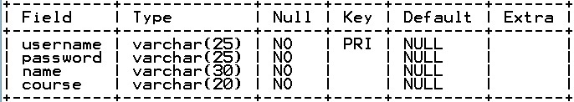

1. Userid for admin is ‘chandan’ and Password is ‘Chandan123’
2. Enjoy Project.