Rajat Agarwaal

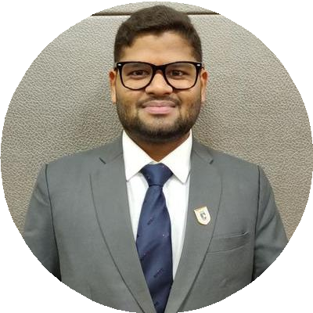

### Data Scientist

**Skilled Data Scientist with 2.5 years of experience executing data driven solutions to increase eﬃciency, accuracy and utility of internal data processing. Experienced at creating regression models, classiﬁcation models using predictive modelling, Computer Vision and analyzing data mining algorithms to deliver insights and implement action oriented solutions to complex business problems.**

# WORK EXPERIENCE



[rajatagarwaal30@gmail.com](mailto:rajatagarwaal30@gmail.com)

09958168687

Ghaziabad (NCR Region), India

30 March, 1994

[linkedin.com/in/rajat-agarwaal](https://www.linkedin.com/in/rajat-agarwaal/)

## Machine Learning Engineer

### AgEYE Technologies

*01/2021 - Present*, *Bangalore, India*

*Achievements/Tasks*

Undertaking data collection, preprocessing and analysis Building models to address business problems

Propose solutions and strategies to business challenges Worked on Machine Learning, Python and Computer Vision

**Decision Science Analytics Intern**

NiYO Solutions

*12/2019 - 06/2020*, *Bangalore, India*

*Achievements/Tasks*

Built machine learning solutions to solve important business problems

Worked with Data Scientists and Engineers to deploy solutions to a production environment

Collaborated with business leaders, subject matter experts, and decision makers to develop success criteria and optimize new products, features and models

Communicated key results to senior management in verbal, visual, and written media

**Engineer**

Ericsson Global India Pvt. Ltd.

*10/2016 - 04/2018*, *Noida, Uttar Pradesh Achievements/Tasks*

Built predictive models helpful to gain business insights to take

important business decisions

Applied ML techniques on the Telecom Customers data so to get a deeper understanding of the customers behavior and using those insights to improvise the products and offerings by the company to its customers

Worked on Python, ECMS, Machine Learning and SQL

**EDUCATION**

**M. Tech in Data Science and Business Analytics** Narsee Monjee Institute of Management Studies (NMIMS)

*07/2018 - 07/2020*, *Mumbai, Maharashtra*

## B. Tech in Computer Science and Engineering

### Amity University

*07/2012 - 07/2016*, *Greater Noida, Uttar Pradesh*

# SKILLS

#### 

Python



C

Machine Learning

Deep Learning

Computer Vision

Natural Language Processing

SQL

Pig

Hive

Basics of HDFS

Statistical Analysis

Gitlab

Tableau

**PROJECTS**

Instance and Semantic Segmentation Using UNET (04/2021 - Present)

The task is to categorize the multiple plants in the same image using Instance Segmentation

Also, Edge detection was performed on Leaf Edges of Basil and Lettuce plants so as to get the plant area and the leaf count, this task is also performed using UNET as it was giving the good results

#### Basil, Lettuce and Hemp Image Classiﬁcation (03/2021 - 03/2021)

Here the task was to identify which plant is in the image

By doing so, the corresponding pipeline of actions will be triggered so as to get the tasks done, this is also a part of the product being developed for the farmers

This task is accomplished with 95% accuracy using Custom CNN Architecture

#### Classiﬁcation and Regression Models on the Multiple Plants Data (02/2021 - 03/2021)

Here the task was to predict plant parameters like Stem Girth, Plant Height, Fresh Weight, Dry Weight and Leaf Count using previous data

The above regression tasks were achieved successfully with an Adjusted R-Squared value of 0.98

Another task was to classify between Basil and Lettuce Classes based on the numerical data collected, this task was successfully done with an accuracy of 94% using Stacking

#### Customer Churn Analysis for Salary Advance Product and Segmentation Model for Targeted Marketing (01/2020 - 04/2020)

Objective was to identify factors leading to Customer Churning. The aim was to predict whether the NiYO Bharat Customer will churn or not in future, the task was accomplished with an accuracy of 91% using Random Forests

The utility of Customer Segmentation project is for the Marketing Team who wanted to launch a Targeted and Marketing Campaign by dividing the Customers into four distinct segments, this task was achieved with a good Silhouette Score of 0.87

# ACHIEVEMENTS

#### TCS iON ProCert “Analytics” Certiﬁed

Gold Badge for both Python and Sql on Hacker Rank