# Background

User Modelling Inc is a society that   organizes conferences which mainly focuses on researches in the field of user adaptive systems and providing personalized experiences through those systems.

In order to organize their different annual conferences which includes the researchers as well as industry practitioners for present their work and meet or publish their works. For the development of the proposed conference management system the ASP.NET MVC architecture will be used. The development tools to be used in the development will be Visual studio 2019 and the SQL server 2012. The MVC architecture is verry helpful in order to secure the application through low coupling and high cohesion.

The MVC stands for Model View and Controller. The model is basically an C# class that can be accessible by both the components controller as well as view. The models are used in order to pass data which is collected from the Controller to view in order to present to user. Retrieved data is used by the view through model so that it can display those data in page.

On the other hand, the View is a ASPX web page that does not contains any code behind file in the solution folder. Different kind of page specific HTML generation as well as formatting can be easily carried out inside a view in a MVC project. It is also possible to utilize Inline codes such as the server tags in order to develop the data driven dynamic pages. Any request in order to view different ASPX pages can be created only from any controllers specified action method.

Finally the Controller is mainly a C# class that inherits the properties of system.mvc.controller. The Controller can be considered as the heart or main component of the complete MVC framework or architecture for websites. In the C# Controller’s classes the action methods are implemented. These actions methods are responsible for responding against the requests coming from the browser OR views. The Controller classes are capable of accessing as well as using the model classes so that it can pass data to different views according to the requests to the views

# Database design

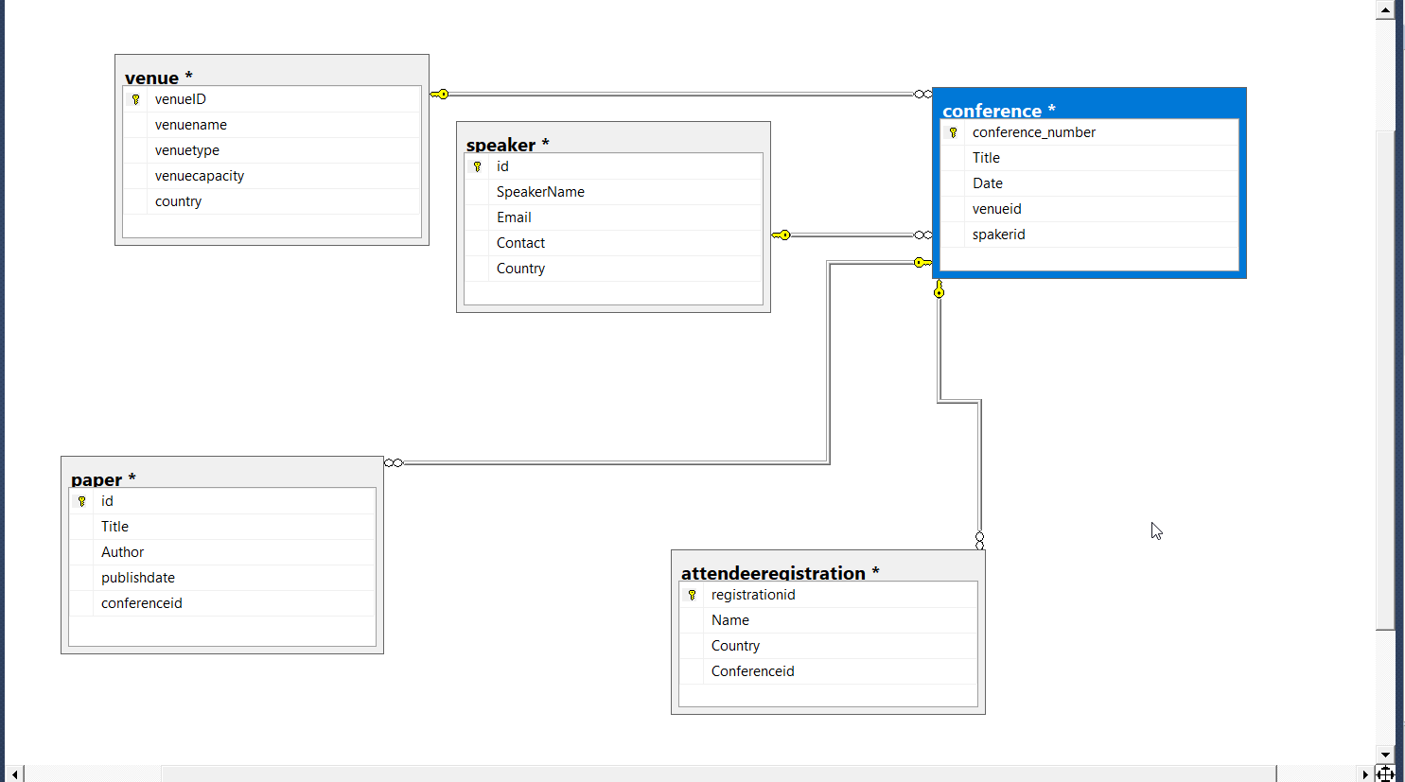

Provided above is the database design for the developed website which is used as the back end. There are multiple relationships among the tables, one-to-one relationship between the papers and speaker tables entities. This kind of relationship exists when some specific entity record exists in one database table, and there is only one associated entity record in the given another table. For the papers there can be only one speaker for a paper. The conference and attendeeregistration table have one to many relationships. As there can be multiple attendees for a specific conference at a given date.

# Documentation

In order to develop and connect with the database the Entity Framework is used in this Website development project. This framework is very helpful in the development of the data-oriented/driven applications utilizing ADO.NET. This Entity Framework is helpful in resolving issues with the entity models, entity relationships as well as execution of the implemented business logic. Furthermore, it also works for different data engines.

The Entity Framework provides Object-Relational Mapping (ORM) framework for the developed application. Any ORM structure is helpful in providing database engine accessibility as well as data operation process.

With ADO.NET Entity Framework, the entity relationship modelling process in an executable process. This is achieved through a blend of XML documents as well as code generation using the .NET objects in the project. The ADO.NET Entity Framework APIs. Different schema documents are utilized in order to characterize a calculated layer, in order to expose data store's in this project the SQL Server database engine. In order to make map between the two. The ADO.NET Entity Framework permits developer in order to compose the project against classes that are produced from the calculated pattern. The Framework at that point deals with the entirety of the database transactions.

# Test instruction

In order to test the application, it is important to deploy the website on the local host while connecting to the database as the operations to be carried out on the different pages needs retrieval and submission of data to the SQL server database engine.

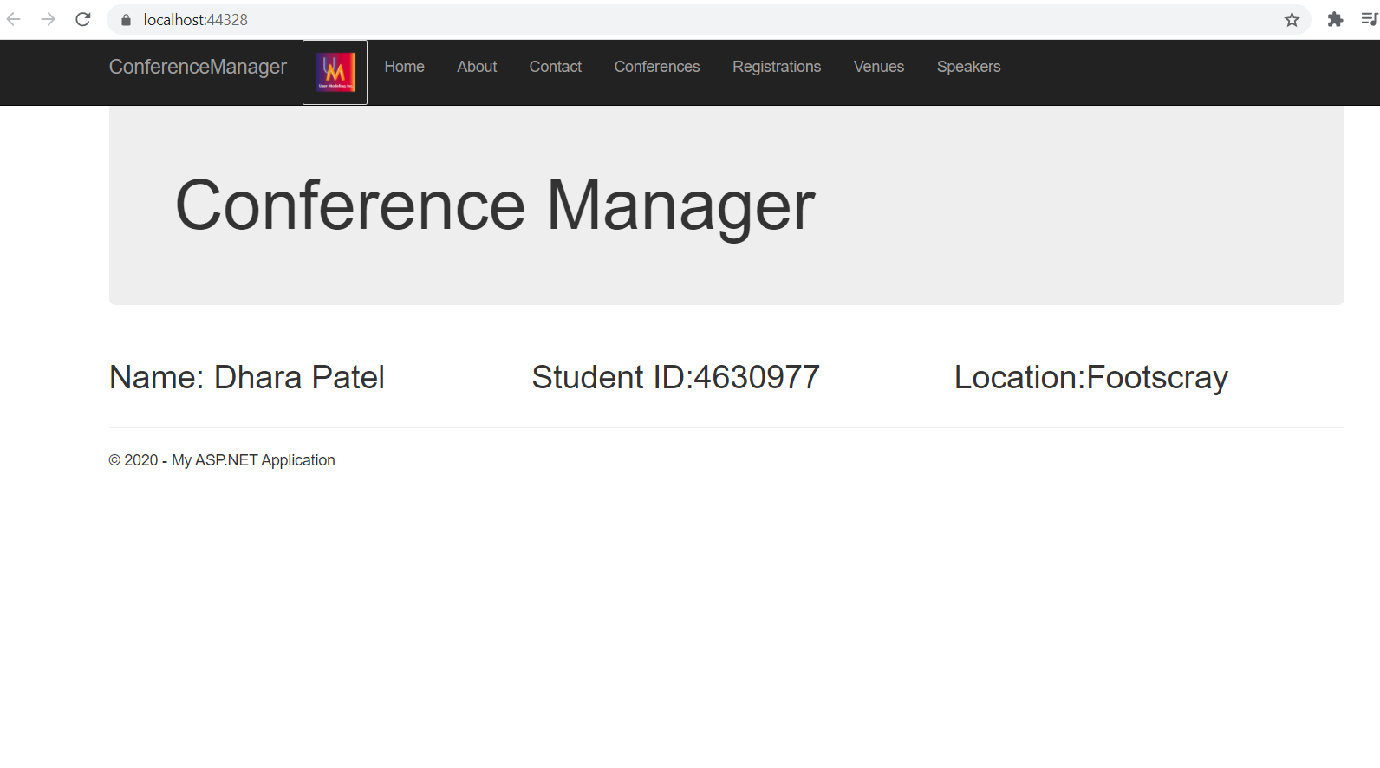

Speaker

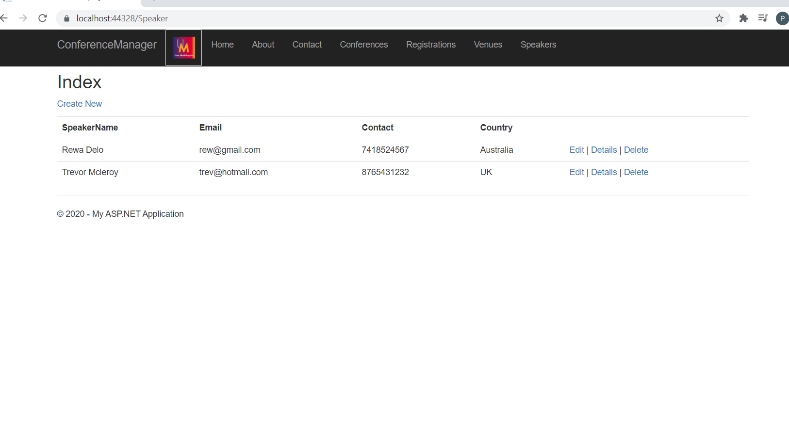

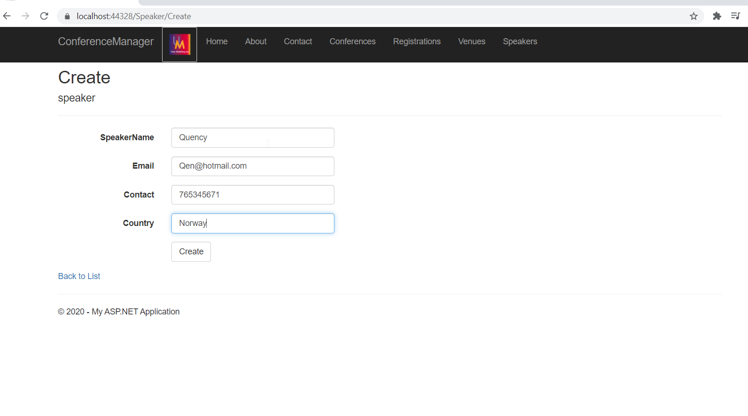

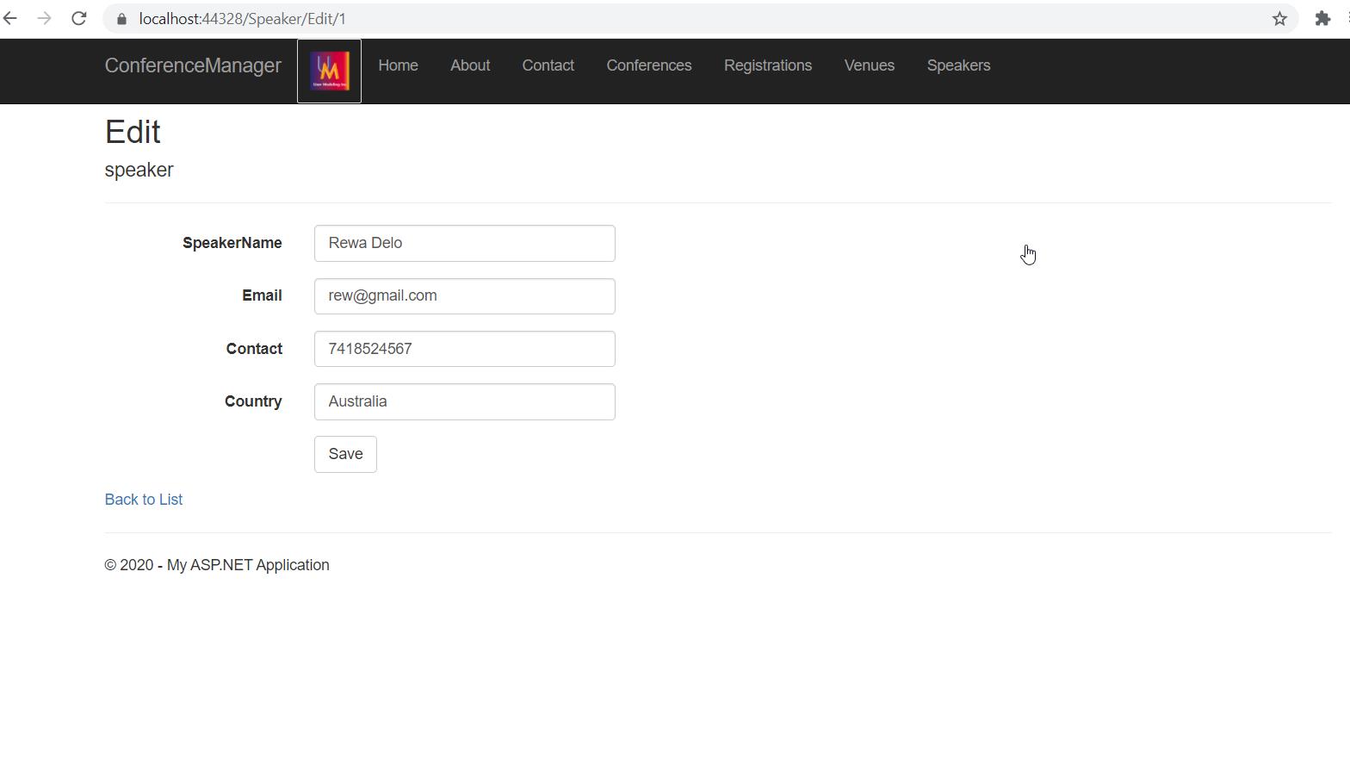

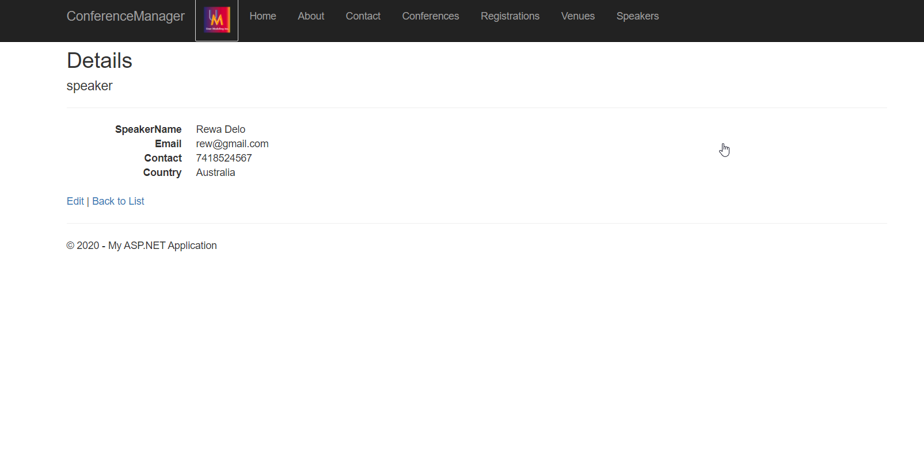

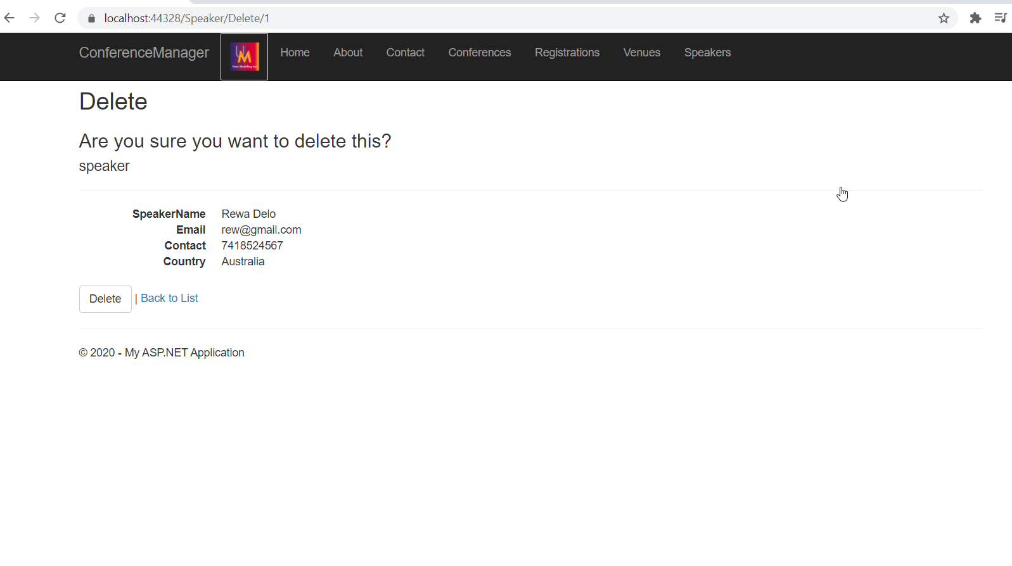

Venue

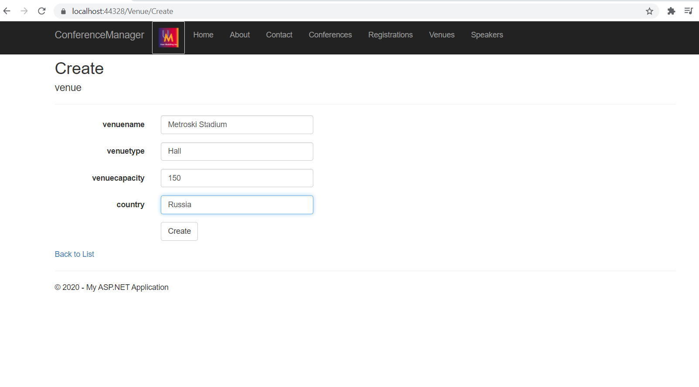

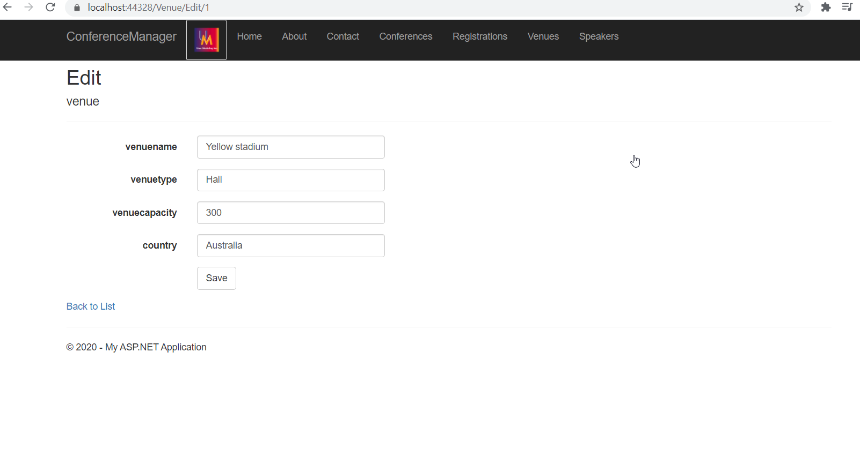

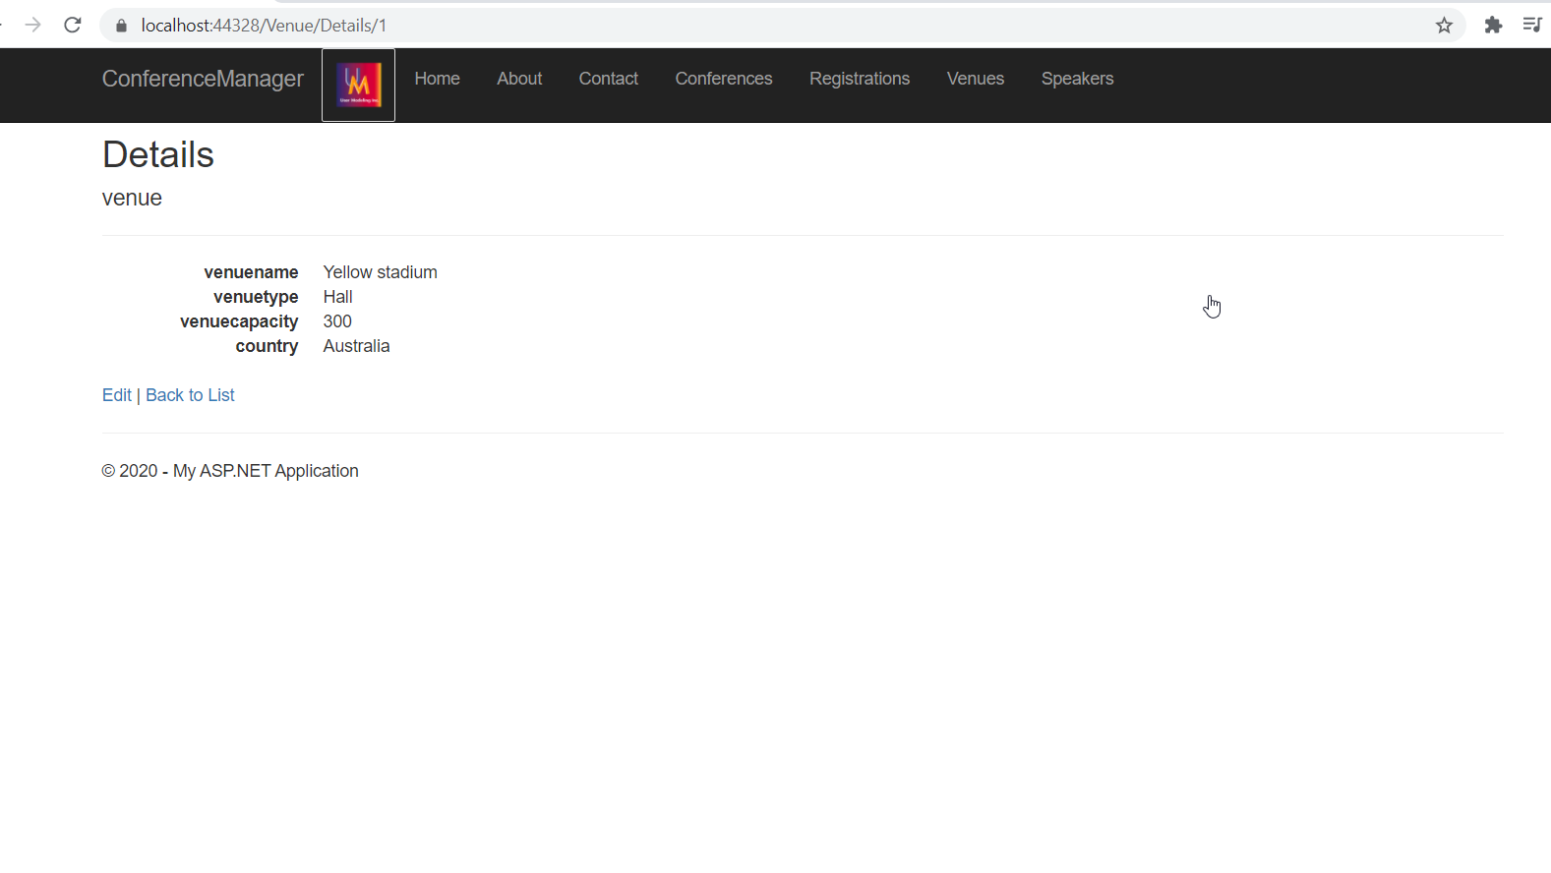

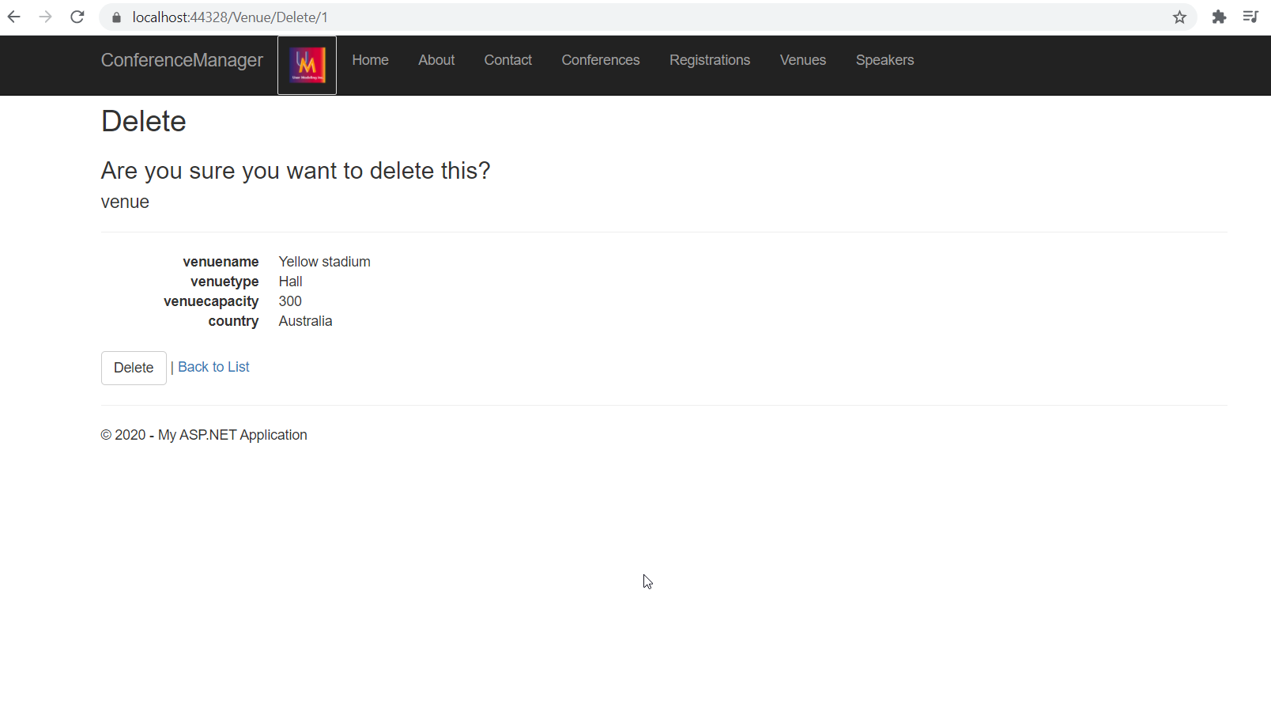

Conference

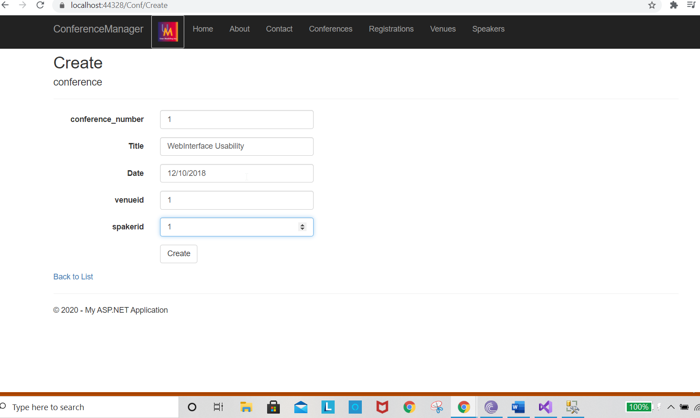

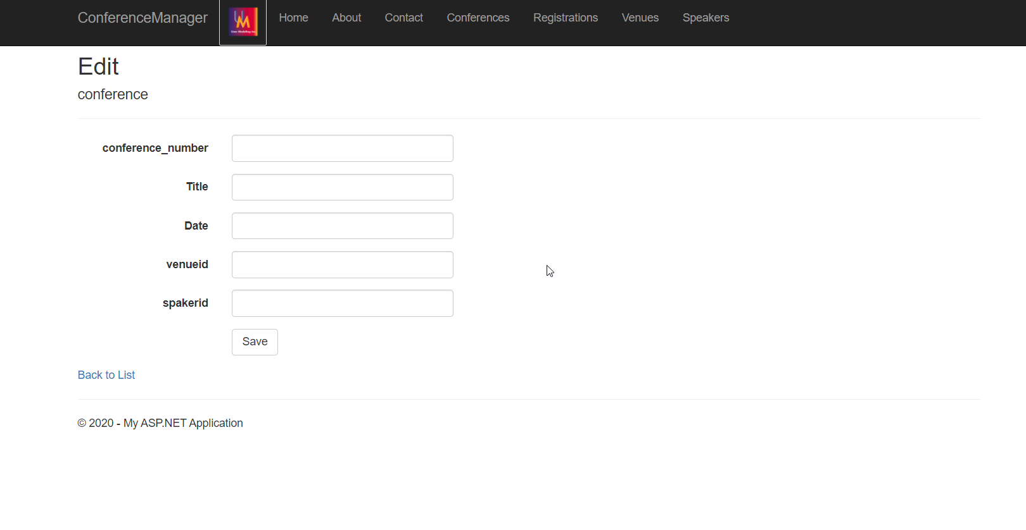

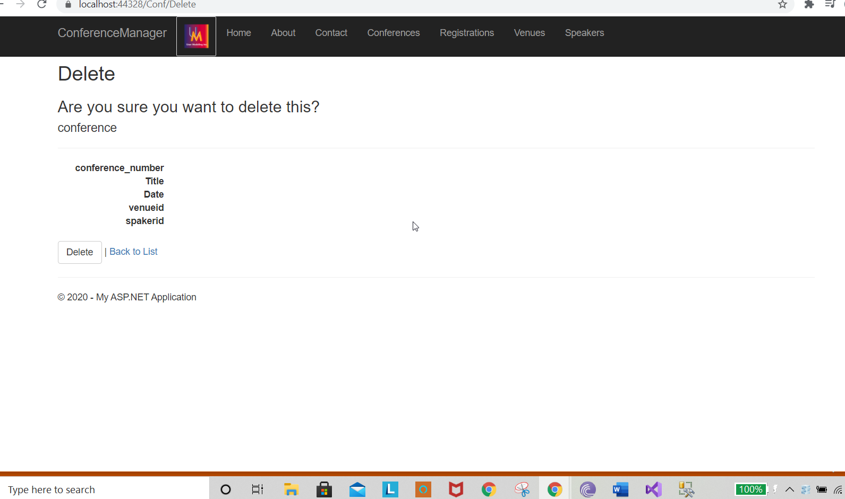

Attendee reords

