**Asg 4: Report on Debugging or Sample Debugging**

Details of Version Control

|  |  |  |  |
| --- | --- | --- | --- |
| Author | Username | Password | Link |
| [NAME] |  |  |  |

**Task 1: Replication Test Scenario**

**Test Script of UAT**

|  |  |
| --- | --- |
| **Script #1: Bug 1** | |
| **Name of the Script** | Whenever a client borrows a textbook, as well as a penalty at the moment of delivery, the status of the product is not adjusted until the next client. |
| **Utilised Case Examined:** | The status of all the books must be modified at the moment of delivery, as well as the penalty is imposed for additional weeks. |
| **Description of the Examination:** | If a customer delivers the books due after a mentioned time frame, the penalty will be reported during the penalty transaction procedure, however the books will not be made publicly accessible. |
| **Pre-state** | Return of the books is overdue  Penalty is given |
| **Post-state** | Given penalty is recorded |

**Bug 1: Before Addressing the Bug**

|  |  |  |  |
| --- | --- | --- | --- |
|  | Phases of the Tests | Estimated Outcomes of the Tests | Test Grade |
| *1* | Chose full penalty amount from menu | Stimulate for the sum of penalty | **PASS** |
| 2 | Examine the Book properly | Condition of the book after penalty collection: ACCESSIBLE | **Fail** |

|  |  |
| --- | --- |
| **Script #2: Bug 2** | |
| **Name of the Script** | Whenever the times are raised utilising the choices more than once, the penalty sum stays nil after 3 days of delay. |
| **Utilised Case Examined:** | The penalty is to be adjusted from the day after the estimated return time frame is over. |
| **Description of the Examination ption:** | When a consumer fails to deliver the borrowed books after the estimated date, a specific amount of penalty must be reported for the delayed delivery. |
| **Pre-state** | Book delivery is Over dated  The sum of the penalty shall be measured against the client. |
| **Post-state** | Penalty is paid and the client can borrow books again. |

**Bug 2: Before Addressing the Bug**

|  |  |  |
| --- | --- | --- |
| **TEST STEPS** | **EXPECTED TEST RESULTS** | **Test status** |
| Enhance the duration around 5 days just after expected time of delivery | Date has been expanded | **PASS** |
| Penalty sum is clamped, as well as registered for Client. | Penalty amount noted | **FAIL** |

**Task 2: Simplification**

**Bug 1:** Delay penalty fees shall be registered as $0.00 after the estimated time.

**Evidence of Unit Examination**:

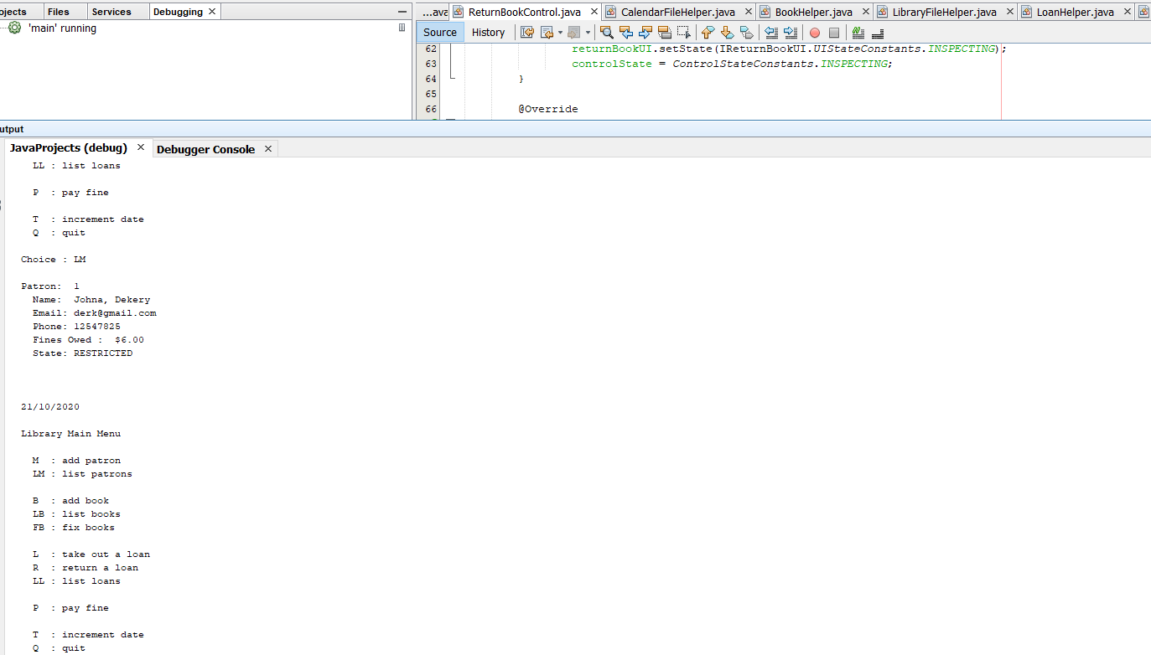

**Outcome of the Unit Examination:**

Such a bug emerges due to a mistake in the logical execution of assigning a small fine amount every day after the timeframe.

**Bug 2:** The state of the books is not accessible after penalty is paid for the books during the time of delivery.

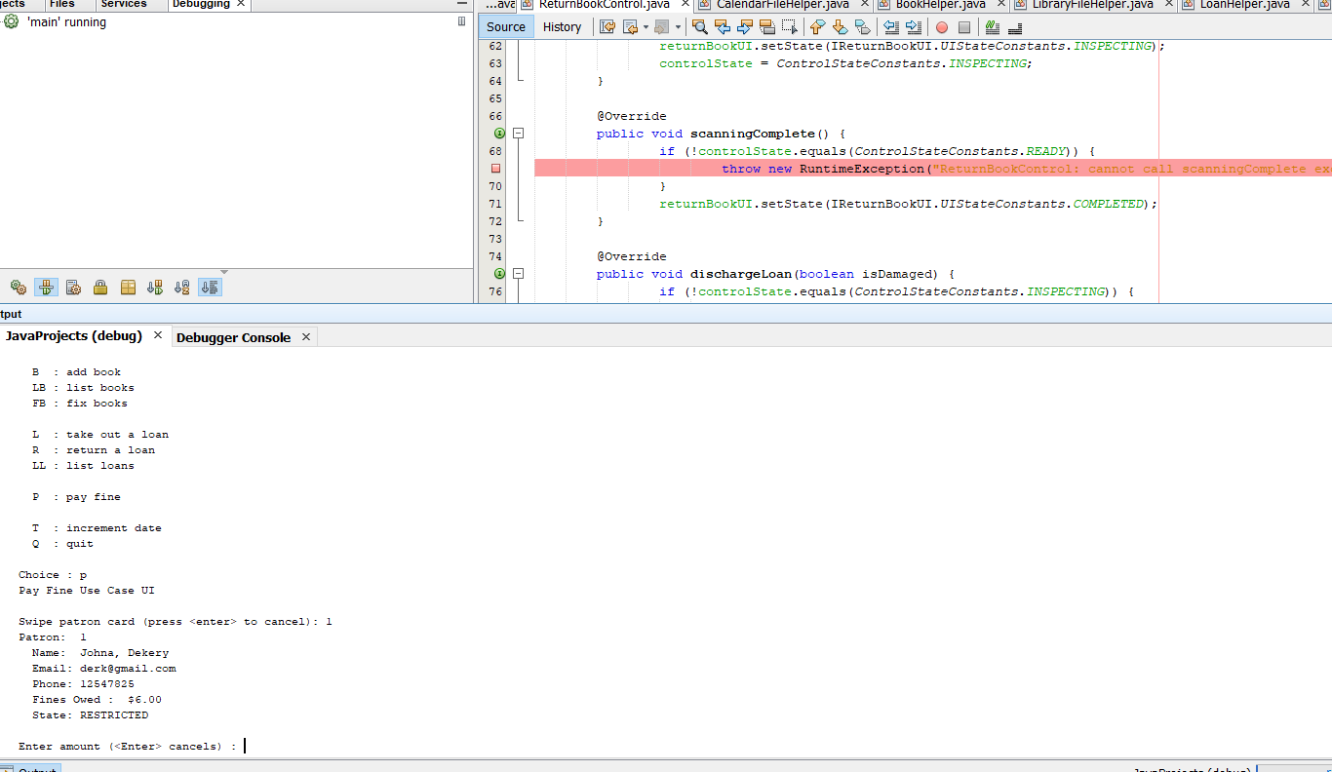

**Outcome of the Unit Examination**

Such a bug is presented due to a mistake in the implantation and modifications in the conditions of books

**Task 3: Tracking**

|  |  |  |  |  |  |
| --- | --- | --- | --- | --- | --- |
| Bug no | Description | Origin/ variables infected | Tracing Dependencies | Hypothesis | Screenshot # |
| 1 | All the penalties are noted as $0.00 while trying to give the penalty | Error:  **public void setState(UIStateConstants state) {**  **this.uiState = state;**  **}** |  | H0: var paymentAmount is noted inadequately | 1 |
| 2 | The books’ conditions are stated inaccessible. | public PayFineUI(IPayFineControl control) {  this.control = control;  input = new Scanner (System.in);  uiState = UIStateConstants.INITIALISED;  control.setUi(this);  } |  | H1: uiState reported inappropriately | 2 |

**Task 4: Resolution**

Bug 1: To address the issue, we must should be modify the penalty amount in the under mentioned function

The code after resolving the bug:

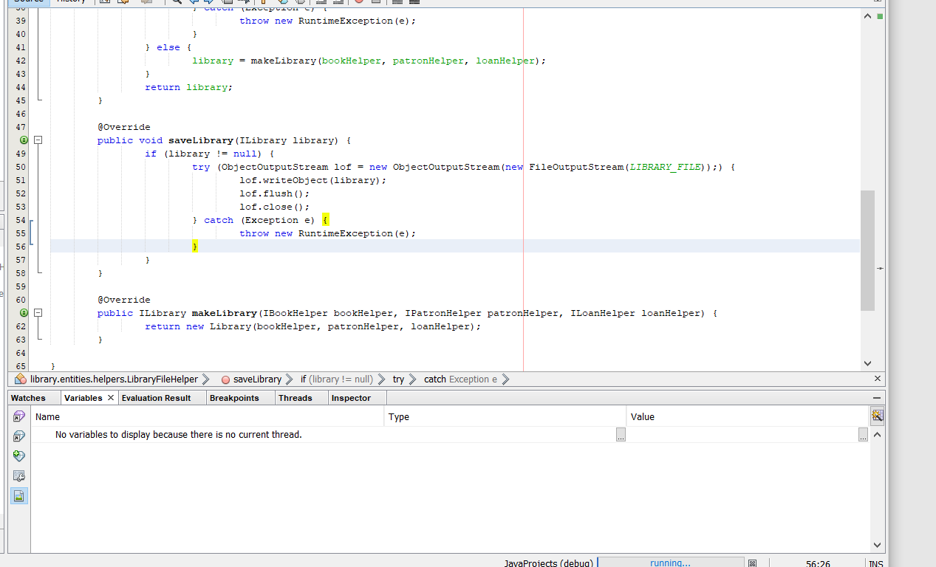

|  |  |  |  |
| --- | --- | --- | --- |
|  | **Phases of the Test** | **Estimated Outcome of the Test** | **Test status** |
| ***1*** | Chose Pay penalty from the primary menu | Prompt for client | PASS |
| 2 | Put client number: 1 | Penalty Charges: $15 | **PASS** |
|  |  |  |  |
|  |  |  |  |

**Outcome of the Unit Examination after Resolving the Bug 1: PASSED**

**Outcome of the Unit Examination after Resolving the Bug 2: PASSED**