**Asg 4 – Debugging / Sample Debugging Report**

**Version Control detail:**

|  |  |  |  |
| --- | --- | --- | --- |
| Author | Username | Password | Link |
| [NAME] |  |  |  |

**Task 1: Replication Test Case**

**UAT Test Script**

|  |  |
| --- | --- |
| **Script #1: Bug 1** | |
| **Script Name** | When a user loans a book and fine is levied at the time of return the Book state is not changed for the next user |
| **Use Case Tested:** | The state of the book should be changed at the time of return and fine for the extra days is levied. |
| **Test Description:** | When a user returns an overdue book after scheduled date then during their fine payment process the fine is recorded but the book is not made available. |
| **Pre-conditions** | Book return is over due  Fine is paid |
| **Post-conditions** | Fine paid is recorded |

**Bug 1 before fixing the bug:**

|  |  |  |  |
| --- | --- | --- | --- |
|  | **TEST STEPS** | **EXPECTED TEST RESULTS** | **Test status** |
| ***1*** | Select complete fine payment from menu | Prompt for fine amount | PASS |
| 2 | Scan the Book | Book state after fine levied: AVAILABLE | **Fail** |

|  |  |
| --- | --- |
| **Script #2: Bug 2** | |
| **Script Name** | When the days are incremented using the options twice the Fine amount remains Zero even after 3days overdue. |
| **Use Case Tested:** | The fine should be calculated from the next day of the scheduled return date |
| **Test Description:** | When ever some user does not return the book after the scheduled date certain amount of fine should be recorded for the late return |
| **Pre-conditions** | Book return is Overdue  The amount of Fine is calculated against the Patron |
| **Post-conditions** | Fine Paid and User can Borrow Books |

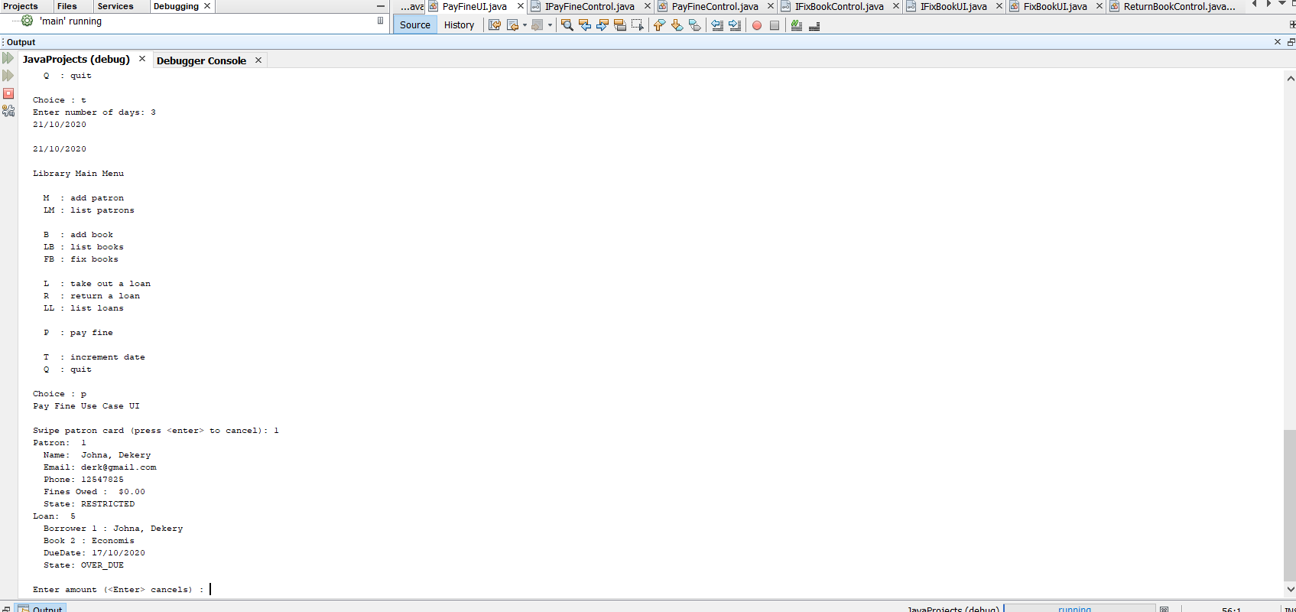

**Bug 2 before fixing the bug:**

|  |  |  |  |
| --- | --- | --- | --- |
|  | **TEST STEPS** | **EXPECTED TEST RESULTS** | **Test status** |
|  | Increase date by 5 days after the scheduled return date | Date is increased | PASS |
|  | Fine amount is clacluated and recorded for Patron | Fine amount recorded | **FAIL** |

**Task 2: Simplification**

**BUG 1:** **Late fine charges are reported as $0.00 even after scheduled date**

**Unit test screenshot:**

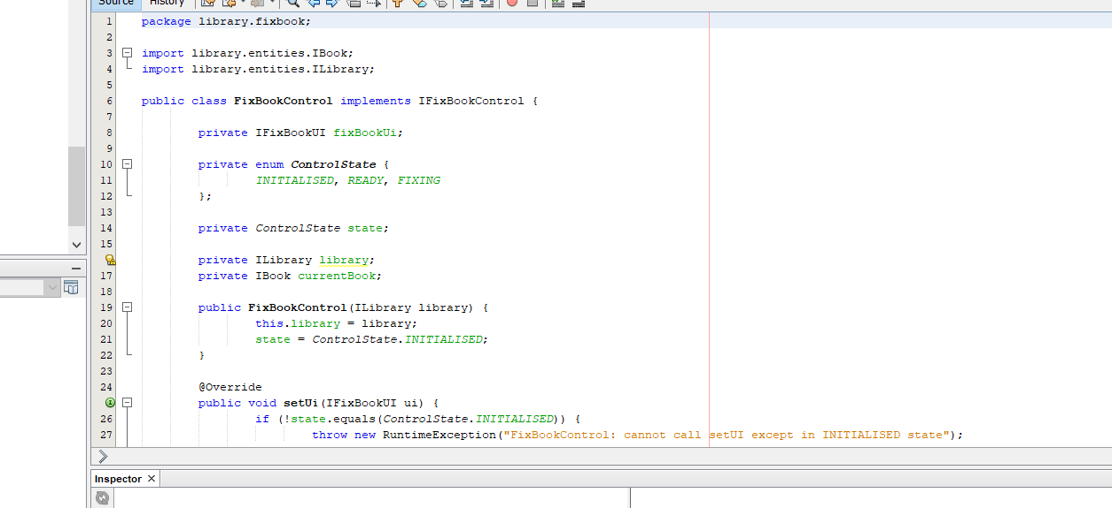

**Unit test result:**

This bug exists because of the error in the logic implementation of adding the specific fine value for every day after the dates.

**BUG 2: The Book state is not available after fine is paid for a book at the time of return**

**Unit test screenshot:**

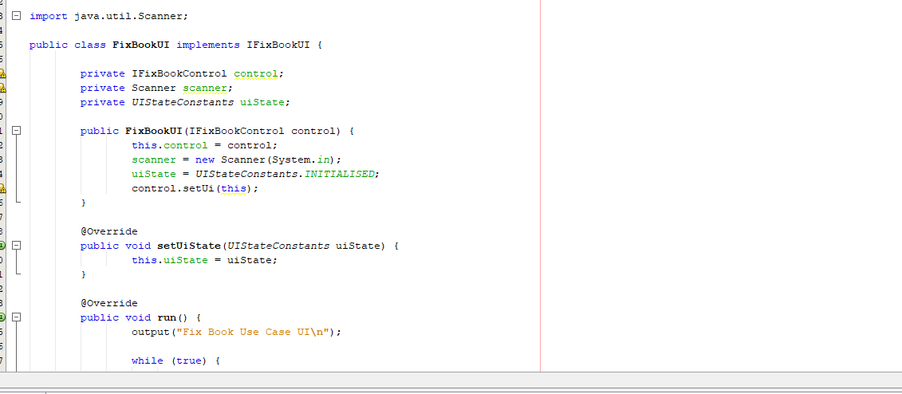

**Unit test result:**

This bug exists because of the error in the implementation and changes in the states of the Book

**Task 3: Tracing**

|  |  |  |  |  |  |
| --- | --- | --- | --- | --- | --- |
| Bug no | Description | Origin/ variables infected | Tracing Dependencies | Hypothesis | Screenshot # |
| 1 | All Fines are reported as $0.00 when trying to pay the fine | Error:  **public void setState(UIStateConstants state) {**  **this.uiState = state;**  **}** |  | H0: var paymentAmount is reported incorrectly | 1 |
| 2 | The book state is reported unavailable for the | public PayFineUI(IPayFineControl control) {  this.control = control;  input = new Scanner (System.in);  uiState = UIStateConstants.INITIALISED;  control.setUi(this);  } |  | H1: uiState reported incorrectly | 2 |

**Task 4: Resolution**

Bug 1:

To fix this problem we have to change the fine amount in the below function

**The code after fixing the bug:**

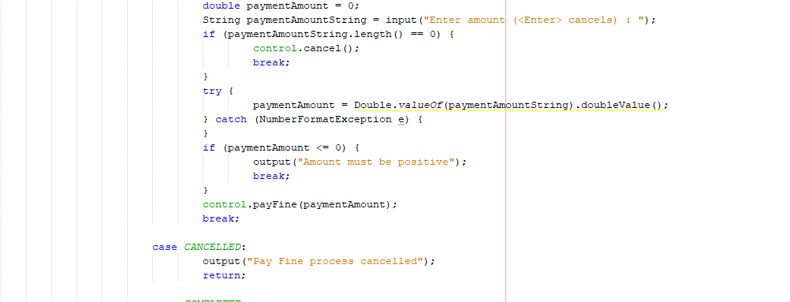

**UAT after fixing bug 1:**

|  |  |  |  |
| --- | --- | --- | --- |
|  | **TEST STEPS** | **EXPECTED TEST RESULTS** | **Test status** |
| ***1*** | Select Pay fine from the main menu | Prompt for patron | PASS |
| 2 | Enter Patron number: 1 | FineCharge: $15 | **PASS** |
|  |  |  |  |
|  |  |  |  |

**Unit test result UAT after fixing bug 1: Passed**

**Unit test result UAT after fixing bug 2: Passed**