Malaria Cell Image Classification Using Deep Learning
Short Title: Malaria Cell Classification Using CNN and MobileNetV2
Your Name: Sneha Ravindra Yadav
Student ID: 17286130
Project Coventry University GitHub Link:
(Paste your Coventry GitHub repository link here)

Introduction
One of the widespread infectious illnesses in the world is malaria, which remains a major challenge to global public health, particularly in developing countries. The illness results from infection with Plasmodium and is usually identified by examining blood smear images under a microscope. Nevertheless, such diagnosis is laborious and takes much time since it depends on the proficiency of medical experts. In addition, the interpretation process may lead to errors especially in cases where many blood smear images are examined.
The emergence of deep learning and computer vision techniques made the automatic analysis of medical images possible and facilitated the process of diagnosis. Medical image classifiers can identify complex visual features in microscopic blood cell images to assist medical practitioners in making a distinction between diseased and healthy cells.
The objective of this research is the development of an automatic classification system for malaria cells images based on the application of deep learning. Two types of models have been developed and analyzed: a CNN architecture created from scratch and a Transfer Learning MobileNetV2 model trained on ImageNet. The process of the creation of models has included preliminary processing of the dataset, splitting of the dataset into train, validation, and test parts and evaluation of models through accuracy, precision, recall, F1-score and confusion matrices metrics. The task is to choose the model which will be more accurate and efficient.

Dataset Preparation
The malaria cell image dataset comprises microscopic images of blood smears of two categories: Parasitised (infected cells) and Uninfected (healthy cells). To reduce computational time and keep a balanced dataset, a subset of 13,000 images (6,500 images per class) was selected. The data set was randomly divided into 80% training (10,400 images), 10% validation (1,300 images), and 10% testing (1,300 images). All the images were resized to 224 × 224 pixels and normalised prior to training. To improve model generalisation and reduce overfitting, data augmentation techniques such as random horizontal flipping and rotation were applied to the training dataset. Figure 1 shows representative sample images of the two classes used in this study.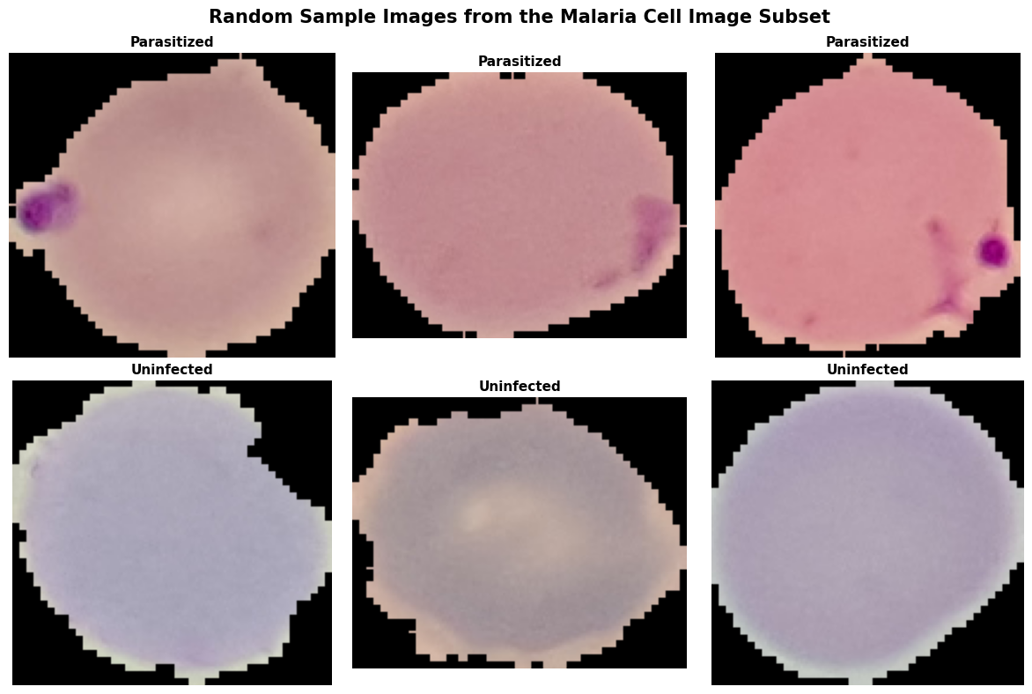
Figure 1:- Sample Images (Parasitized and Uninfected)
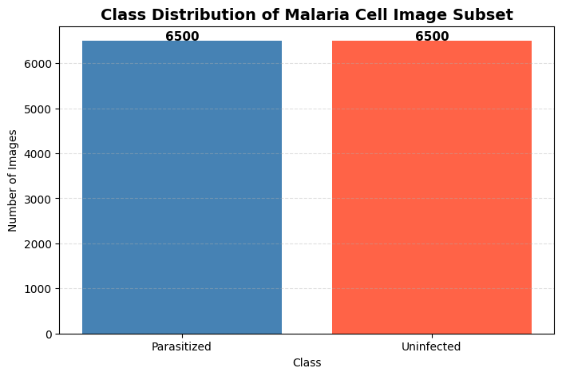
Figure 2: Class Distribution of the Dataset
Table 1 :- Dataset Split
Dataset | Images
Training | 10,400
Validation | 1,300
Testing | 1,300

Developed Deep Learning Models
Two different machine learning architectures have been designed and compared in terms of performance for automated malaria cell classification using images: the custom-built Convolutional Neural Network (CNN) and MobileNetV2 transfer learning. The idea is to compare the architecture, which was trained from scratch, to the pretrained deep learning architecture to find the best solution to this particular problem of binary medical image classification.
The first one was the custom CNN architecture that was designed specifically for malaria cell classification. It included three convolutional blocks that had a convolutional layer, Batch Normalization, ReLU activation function and MaxPooling layers in order to extract low-level and high-level features like edges, texture, and structure of cells. In order to save memory and computation, the Adaptive Average Pooling layer was added before the fully connected classifier that greatly reduced the number of trainable parameters. Moreover, the Dropout layer with a dropout rate of 0.5 was added in order to mitigate the problem of overfitting. The last layer of this CNN model had only two neurons representing Parasitized and Uninfected classes. The entire CNN model had 110,466 trainable parameters.
The second approach employed a MobileNetV2 architecture, which is a lightweight CNN model that was pretrained on ImageNet dataset. Rather than training the whole network from the beginning, transfer learning technique was used where the pretrained feature extraction layers of the CNN model were frozen while the classifier was replaced by a newly created fully connected network for binary classification. The new classifier included dropout, a fully connected layer with 128 neurons, Rectified Linear Unit (ReLU), and finally a two-neurons layer as an output. Only the classifier weights (164,226) were trained.
Training of both approaches was done using the Adam optimizer with a learning rate of 0.001 and CrossEntropyLoss as the objective function. Training was conducted for a maximum number of 15 epochs with early stopping and automatic model saving in case of having the best validation loss. Training and validation accuracies and losses were calculated after each epoch.
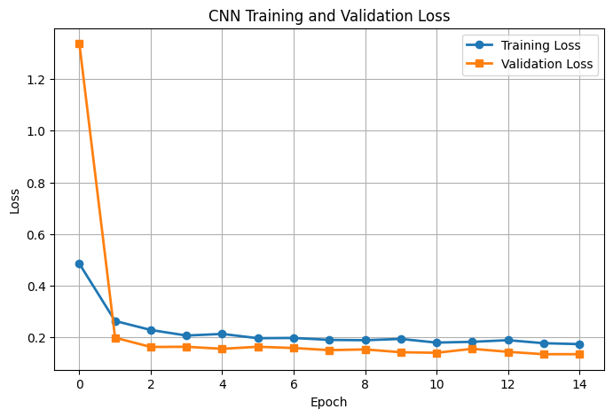
Figure 3:- CNN TRAINING & VALIDATION LOSS
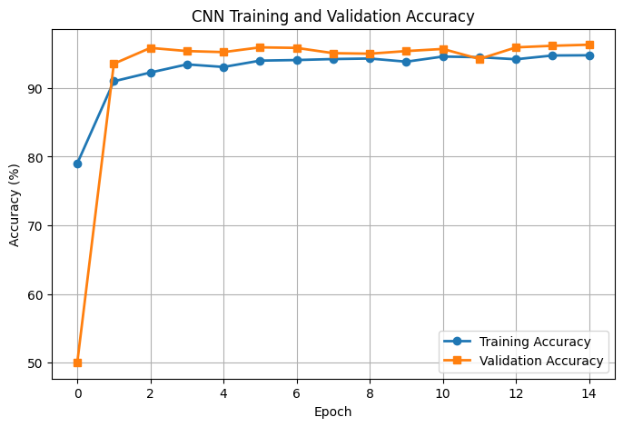
Figure 4:- CNN TRAINING & VALIDATION ACCURACY
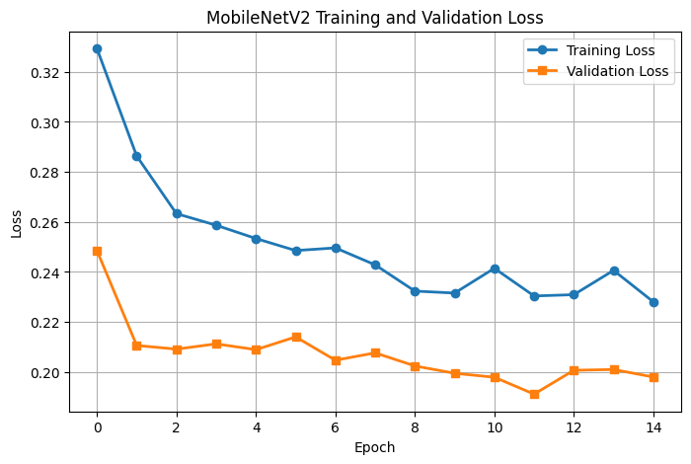
Figure 5:- MOBILENETV2 TRAINING & VALIDATION LOSS
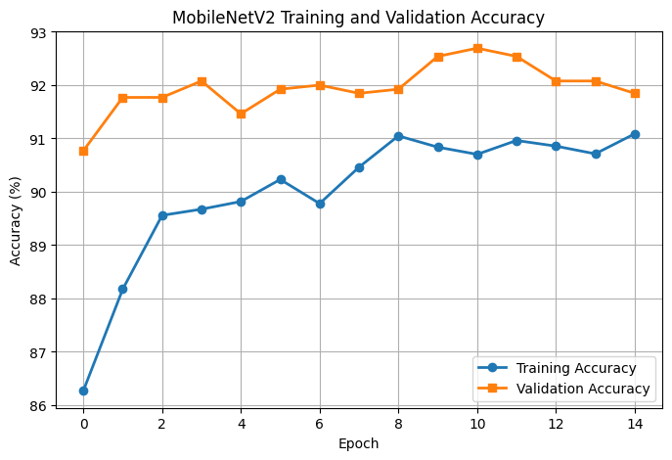
Figure 6:- MOBILENETV2 TRAINING & VALIDATION ACCURACY
Learning Curves of CNN are illustrated through Figures 3 and 4 below; these are indicative of stable convergence and prove the successful training of the CNN model without overfitting. Learning curves of MobileNetV2 were also plotted in similar manner for comparative analysis of training behavior in same experimental setup.

Results and Discussion
Model performances of the developed deep learning models were measured through an unseen testing set of data consisting of 1,300 microscopic images of blood cells. Metrics used for assessing model performances include accuracy, precision, recall, F1-score, confusion matrixes, and learning curves. The purpose is to find out which of the models can classify parasitized and unparasitized microscopic images of blood cells in the most accurate and computational efficient way possible.
Customized CNN performed impressively well when classifying during training sessions. There is consistent decrease in loss and increase in accuracy throughout the training process. Both training and validation curves (Figures 4 and 5) show that there is no overfitting since the two curves are very closely correlated to each other. Validation accuracy is approximately 96.31% while the final accuracy on the training phase is 94.77%.
As per the analysis based on the independent test data, the CNN had a test accuracy of 95.15%. The precision, recall, and F1-score values obtained from the classification report for the parasitized class were 0.96, 0.95, and 0.95 respectively. In addition, the values of precision, recall, and F1-score for the uninfected class were 0.95, 0.96, and 0.95 respectively. From the confusion matrix, the CNN was able to classify 616 images in the parasitized class and 621 images in the uninfected class whereas there were 63 incorrect classifications among 1,300 test images. This means that the CNN was able to learn discriminative features from the malaria cell images in a balanced manner.
The results obtained from the MobileNetV2 transfer learning model were also satisfactory. The learning curves (Figures 7 and 8) suggest stable training behaviour and steady improvements in both accuracy and loss. The highest validation accuracy obtained during the validation process is 92.69%. The test accuracy of MobileNetV2 on the test dataset is 92.85%. Precision, recall, and F1-score for both classes were approximately 0.93.

Table 2 – Model Comparison
Metric | CNN | MobileNetV2
Test Accuracy | 95.15% | 92.85%
Precision | 0.95 | 0.93
Recall | 0.95 | 0.93
F1-score | 0.95 | 0.93
Total Parameters | 110,466 | 2,388,098
Trainable Parameters | 110,466 | 164,226
Training Strategy | From Scratch | Transfer Learning

Table 2 provides the results of quantitative comparison of the two models. Even though the pre-trained ImageNet weights helped the MobileNetV2 model and it was necessary to train only the classification layer, the custom CNN still managed to outperform it in terms of all of the evaluation criteria. The custom CNN showed greater accuracy, precision, recall, and F1-score in comparison to MobileNetV2 model but also had much more compact architecture. The custom CNN has 110,466 trainable parameters, while the number of parameters in MobileNetV2 is equal to 2,388,098, including 164,226 trainable parameters after the feature extraction layers are frozen.
There are a few reasons that led to better performance of the CNN. First of all, there are specialized microscopic images in the malaria dataset, which are quite different from the natural images on which MobileNetV2 was pre-trained on ImageNet. Therefore, the feature representations learned from ImageNet were not perfectly matched with the image characteristics of blood cells. The second reason why the custom CNN performed better is that this network was developed for this particular binary classification task and could learn dataset-specific features from images.
In summary, both deep learning models performed well in classifying images of malaria cells with very good accuracy. The custom CNN, however, outperformed the other in that it had the highest test accuracy of 95.15%, in addition to having a small and well-balanced architecture in terms of classification.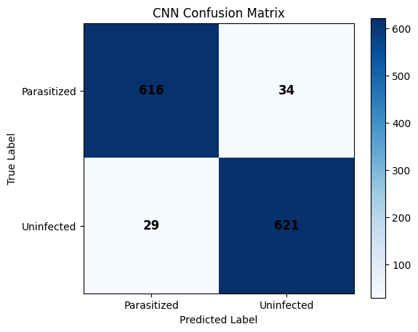
Figure 7: CNN Confusion Matrix
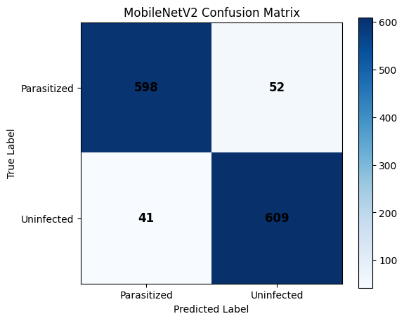
Figure 9: MobileNetV2 Confusion Matrix

Computational Aspects
The experiments were performed using Google Colab with a CPU runtime, which provides an easy-to-use cloud-based platform for building deep learning models. The custom CNN consisted of 110,466 parameters that could be optimized, making it less resource-intensive and well-suited for machines with limited hardware capabilities. In contrast, MobileNetV2 had a total number of 2,388,098 parameters, though only 164,226 parameters could be optimized due to the usage of the transfer learning approach and freezing of the feature extraction layers. The CNN needed less computational power but provided better classification accuracy than MobileNetV2.
Ethical Challenges
While there is substantial room for deep learning algorithms to facilitate the detection of malaria, various ethical concerns should be resolved prior to their implementation in practice. First, dataset bias can negatively impact the performance of the system if the training set images do not cover the diversity of populations, labs, and microscopy settings. The classification of infected blood cells in an erroneous manner can lead to misdiagnosis and the wrong treatment. Patient data should also be treated confidentially since the datasets of medical images should be kept secure. In addition, it should be noted that deep learning models are black-boxes whose predictions cannot be interpreted.
AI Tool Utilization Statement
AI Tool Utilization of this AI tool in this assignment
ChatGPT (OpenAI) Aided in the explanation of deep learning, suggested code format, code comment improvement, improved report writing skills and checked grammar. All generated contents were edited and validated prior to use.
Grammarly Grammar and spelling check.
References
- Deep Learning
Goodfellow, I., Bengio, Y. and Courville, A. (2016). Deep Learning. MIT Press.
- ImageNet Large Scale Visual Recognition Challenge
Russakovsky, O. et al. (2015). ImageNet Large Scale Visual Recognition Challenge. International Journal of Computer Vision, 115(3), 211–252.
- MobileNetV2: Inverted Residuals and Linear Bottlenecks
Sandler, M., Howard, A., Zhu, M., Zhmoginov, A. and Chen, L. (2018). MobileNetV2: Inverted Residuals and Linear Bottlenecks. Proceedings of the IEEE Conference on Computer Vision and Pattern Recognition (CVPR).
- Labeled Optical Microscope Images for Malaria Cell Classification
Rajaraman, S., Antani, S.K., Poostchi, M., Silamut, K., Hossain, M.A., Maude, R.J., Jaeger, S. and Thoma, G.R. (2018). Pre-trained convolutional neural networks as feature extractors toward improved malaria parasite detection in thin blood smear images. PeerJ, 6, e4568.

