Steps to procure Dataproc Cluster:

1. Get gcloud commandline windows offline installer: https://cloud.google.com/sdk/docs/downloads-interactive#windows
- Follow download steps and in cmd - gcloud init
- Do gcloud auth login and sign in to the account
- gcloud config set project <PROJECT_ID>
- To list all accounts: gcloud auth list

2. Externalize Hive metastore on Dataproc:
- Go to SQL and create MySQL instance. Set No password. Click on create instance.
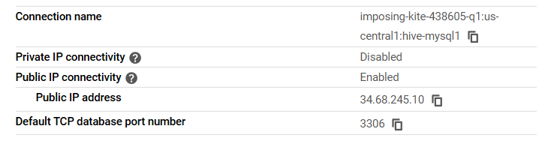
- While creating Dataproc cluster set below properties:
--enable cloud SQL admin API
--initialization-actions gs://goog-dataproc-initialization-actions-${REGION}/cloud-sql-proxy/cloud-sql-proxy.sh \
--properties hive:hive.metastore.warehouse.dir=gs://${HIVE_DATA_BUCKET}/hive-warehouse [set this in cluster property - this sets hive location as GCS location]
--metadata "hive-metastore-instance=${PROJECT_ID}:${REGION}:${INSTANCE_NAME}"
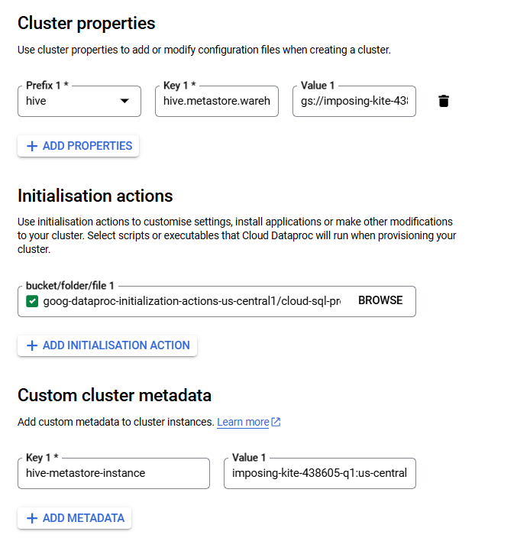

- For more details about initialization actions:
https://github.com/GoogleCloudDataproc/initialization-actions/tree/master

- Submit a job to create a Database in GCS location:
--Job type- hive, Query text - create database shared_gcs LOCATION 'gs://<BUCKET_NAME>/shared_gcs/'
- The above database can be used to store data in Hive.
- A dataproc cluster can be created without externalizing metastore, but this results in loss of metadata and data stored in Hive, since Hive resides in the same cluster only by default.

3. Run spark job on Dataproc using cloud console:
- On cmd: gsutil mb gs://<unique_bucket_name>
- Copy spark jar to the bucket: gsutil cp <JAR_PATH_ON_LOCAL> gs://<BUCKET>
- Submit Spark job on Dataproc - Give job id, cluster name, job type(spark), main class name, jar path, properties(spark.submit.deployMode - client).
- Submit Hive job on Dataproc - Give job id, cluster name, job type(hive), give text or hql file.

4. Run spark job on Dataproc using gcloud:
- https://cloud.google.com/sdk/gcloud/reference/dataproc/jobs/submit

5. Run spark job on Dataproc using SSH:
- Go to cluster -> VM instances -> SSH on master node.
- To know spark version and scala version to be used to make jar - Do "spark-submit -version".
- Run spark job here: spark-submit --master yarn --deploy-mode client gs://<JAR_PATH> //df.write.mode("overwrite").parquet(<GCS_LOCATION>)

