Steps to procure Kafka Cluster

1. Create 3 VM instances in GCP. 2 created in current scenario for testing.
2. Use Ubuntu or any OS as per your choice.
3. Make external IP of the VM as static IP. This will allow the IP not to change if the VM instance is stopped and resumed back again. The external IP will also allow connectivity to the VM or Kafka instance in VM from external places.
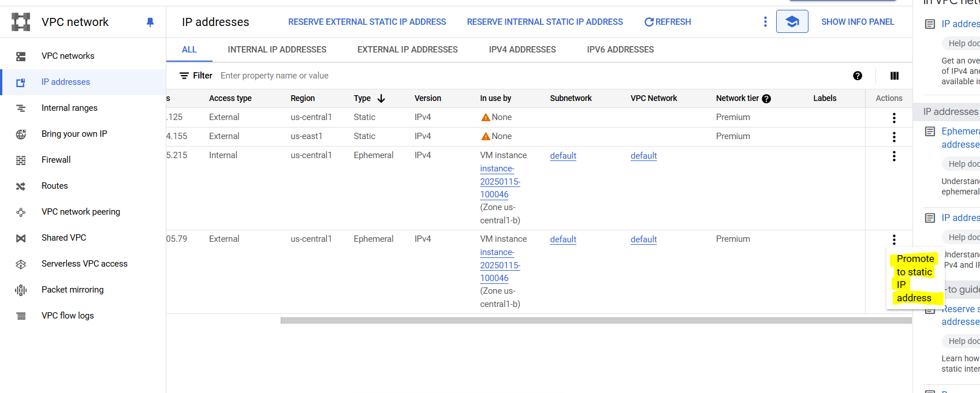
Write name as “staticip” and click on Reserve.
4. Do SSH on One VM and follow below steps for installing Kafka server:
- sudo apt update
- sudo apt install default-jdk
- Check java version: java -version
- sudo apt install wget
- mkdir kafka-home
- cd kafka-home
- wget https://downloads.apache.org/kafka/3.7.2/kafka_2.12-3.7.2.tgz
- Extract kafka package: tar -xvsf <kafka_folder_name>
5. Create firewall rule:
Give 9092 port TCP access to all instances in the network for all IPv4 ranges (0.0.0.0/0). Give ingress access only.

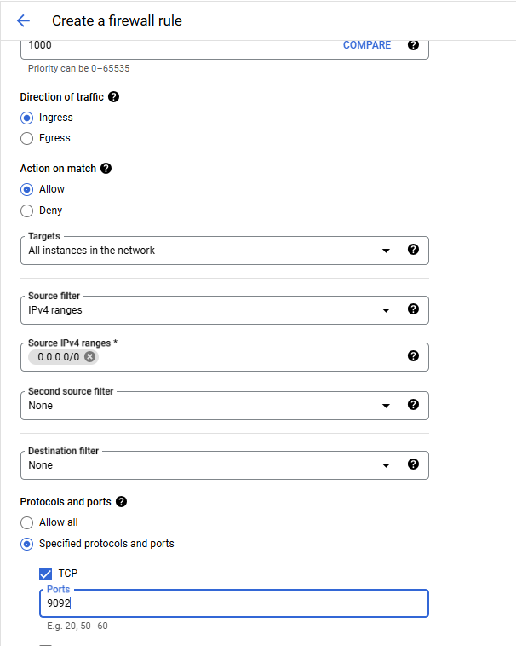

6. export KAFKA_HOME=<path_to_kafka_directory>
7. Commands for kafka server start:
- Start zookeeper: ${KAFKA_HOME}/bin/zookeeper-server-start.sh ${KAFKA_HOME}/config/zookeeper.properties
- Start kafka broker: ${KAFKA_HOME}/bin/kafka-server-start.sh ${KAFKA_HOME}/config/server.properties
- Create Kafka topic: ${KAFKA_HOME}/bin/kafka-topics.sh \
--create \
--topic FirstTopic \
--bootstrap-server <external_ip>:9092 \
--partitions 1 \
--replication-factor 1 \
--config "cleanup.policy=compact" \
--config "retention.ms=604800000" \
--config "segment.bytes=1073741824"

- List kafka-topic: ${KAFKA_HOME}/bin/kafka-topics.sh --list --bootstrap-server <external_ip>:9092
- Publish message to Kafka: ${KAFKA_HOME}/bin/kafka-console-producer.sh \ --topic FirstTopic \ --bootstrap-server <external_ip>:9092 \ --property "acks=all" \ --property "compression.type=gzip" \ --property "batch.size=16384" \ --property "parse.key=true" \ --property "key.separator=:"
- Consume Messages with Kafka Consumer: ${KAFKA_HOME}/bin/kafka-console-consumer.sh \ --topic FirstTopic \ --bootstrap-server <external_ip>:9092 \ --from-beginning \ --max-messages 100 \ --property "print.key=true" \ --property "print.value=true"

Use -daemon command to run servers on the background.

8. For multinode kafka cluster. Use above steps to have kafka cluster setup on both the VM instances. Edit zookeeper.properties and server.properties to allow connectivity of nodes between both the VM instances.
- zookeeper.properties:
tickTime=2000
initLimit=10
syncLimit=5
dataDir=/tmp/zookeeper
clientPort=2181
maxClientCnxns=60
4lw.commands.whitelist=*
server.1=<internal_ip>:2888:3888
server.2=<internal_ip>:2888:3888

-server.properties
broker.id=0 # Use 0 for VM1, 1 for VM2
log.dirs=/tmp/kafka-logs
zookeeper.connect=<internal-IP1>:2181,<internal-IP2>:2181
listeners=PLAINTEXT://0.0.0.0:9092
advertised.listeners=PLAINTEXT://<external-IP>:9092
num.network.threads=3
num.io.threads=8
log.retention.hours=168
log.segment.bytes=1073741824
log.retention.check.interval.ms=300000

Do the below in each server: (sets a unique id for each server)
echo 1 > /tmp/zookeeper/myid # For VM1
echo 2 > /tmp/zookeeper/myid # For VM2
echo 3 > /tmp/zookeeper/myid # For VM3

9. Important commands:
- To stop kafka server: ${KAFKA_HOME}/bin/kafka-server-stop.sh
- Verify Zk nodes are reachable from kafka server – telnet <Zk-IP> 2181
- Stop Zk server: ${KAFKA_HOME}/bin/zookeeper-server-stop.sh
- Verify broker registration:
${KAFKA_HOME}/bin/zookeeper-shell.sh <ZK-IP>:2181
ls /brokers/ids
- Verify partition assignment: /opt/kafka/bin/kafka-topics.sh --describe --topic __consumer_offsets --bootstrap-server <BROKER-IP>:9092
- Verify inter-broker communication: telnet <BROKER-IP> 9092
- Describe topic - ${KAFKA_HOME}/bin/kafka-topics.sh --describe --topic <topic-name> --bootstrap-server <BROKER-IP>:9092

