Cloud Composer setup:

1. For Cloud Composer – create a new service account, allowing Airflow to connect to different GCP components, like Dataproc, GCS, Bigquery etc.
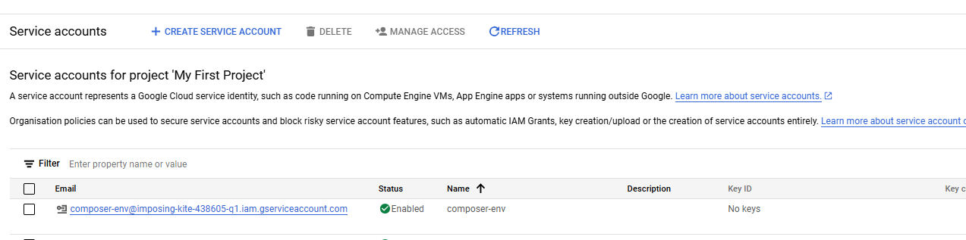
2. For current project, below are the roles assigned to the service account:
- Storage object admin
- Dataproc Editor
- Composer worker
- Cloud composer v2 API Service Agent Extension
- Bigquery Job user
- Bigquery Data Owner

3. For Airflow to access any external library in python:
- Goto PyPi packages section, add the library.
- For current project, kafka-python library was installed on Airflow.

