

ASSESSMENT TASK 3
DATA ANALYTICS IN-ACTION

SUBJECT NAME: FUNDAMENTALS OF DATA ANALYTICS
SUBJECT CODE: 32130
STUDENT NAME: CHANDAN SREENIVASAIAH
STUDENT ID: 25674250
COURSE: MASTERS IN ARTIFICIAL INTELLIGENCE
TABLE OF CONTENTS

LIST OF FIGURES 2
LIST OF TABLES 3
INTRODUCTION 4
SCOPE 4
DELIVERABLES 5
ABOUT THE DATASET 6
PRE-PROCESSING AND FEATURE SELECTION 10
DATA PRE-PROCESSING 10
ONE-CODE ENCODING (gluc, cholesterol): 10
OUTLIER DETECTION (height, weight, ap_hi, ap_lo): 11
BINARY CONVERSION (smoke, alco, active): 11
DATA TRANSFORMATION: 12
TARGET VARIABLE 12
FEATURE SELECTION 12
DATA SPLITTING 14
SCALING 14
MODEL TRAINING ON ALL MODELS 15
HYPER PARAMETER TUNING 19
RESULTS 20
INTERPRETATION 21
MODEL SELECTION 22
GRADIENT BOOSTING MODEL 22
FINAL PREDICTIONS 25
REFLECTIONS 28

LIST OF FIGURES
Figure 1: Distribution of the target variable ‘cardio’ 8
Figure 2: Frequency distribution for continuous variables 8
Figure 3: Bar plots for categorical features 9
Figure 4: Performing one-hot encoding on cholesterol and gluc attributes 10
Figure 5: Performing one-hot encoding by the Tukey IQR rule 11
Figure 6: Performing binary conversion on the binary features 11
Figure 7: Converting the age columns from days to years 12
Figure 8: Confusion Matrix and ROC-AUC for logistic regression 15
Figure 9: Confusion Matrix and ROC-AUC for random forest 16
Figure 10: Confusion Matrix and ROC-AUC curve for K-NN classification model 17
Figure 11: Confusion Matrix and ROC-AUC curve for Naïve Bayes classification model 17
Figure 12: Confusion Matrix and ROC-AUC curve for Decision Trees classification model 18
Figure 13: Confusion Matrix and ROC-AUC curve for Gradient Boosting classification model 18
Figure 14: Confusion Matrix and ROC-AUC curve for Support Vector Machine classification model 19
Figure 15: Confusion Matrix and ROC-AUC curve for Multi-Layer Perceptron classification model 19
Figure 16: Performing hyperparameter tuning 20
Figure 17: Summary table for all the performance models along with the results of the best model with respect to the highest ROC-AUC curve 22
Figure 18: Evaluating the best hyperparameter tuning settings and the classification report 25
Figure 19: Confusion matrix on the Gradient Boosting classification model after performing hyperparameter tuning 25
Figure 20: Code snippet demonstrating prediction on the unknown dataset and saving the predictions 27
Figure 21: Final prediction file 27

LIST OF TABLES

Classification table of the data attributes 7
Summary of all the models with their performance metrics 21

INTRODUCTION
Cardiovascular disease (CVD) remains a paramount global health concern, standing as a leading cause of morbidity and mortality worldwide. The early and accurate detection of CVD is not merely a clinical convenience but a critical necessity for enabling timely interventions, personalizing treatment plans, and ultimately improving patient prognosis and quality of life. This project addresses the complex data mining problem of predicting the likelihood of CVD in individuals. This is achieved by leveraging a diverse set of readily available clinical measurements and lifestyle features, transforming raw patient data into actionable insights.
The core challenge lies in building robust, accurate, and explainable machine learning models that can effectively identify individuals at high risk of developing CVD, even in the absence of overt symptoms. This requires not only high predictive performance but also a degree of interpretability to foster trust and facilitate adoption by healthcare professionals. By applying advanced data analytics and a spectrum of classification algorithms, the objective is to develop a predictive system that can proactively assist medical practitioners in stratifying patient risk, thereby optimizing resource allocation and enhancing preventive care strategies. This project represents a data-driven approach to augment traditional diagnostic methods, contributing to the broader goal of precision medicine in cardiology.

SCOPE
The scope of this project encompasses the complete, end-to-end data science pipeline, demonstrating a logical, creative, and thoughtful approach to solving the problem. This comprehensive methodology spans:
- Rigorous Data Cleaning and Preprocessing: Addressing inconsistencies, missing values, and outliers to ensure data quality and integrity.
- Strategic Feature Engineering: Transforming raw features and potentially creating new ones to enhance their predictive power.
- In-depth Exploratory Data Analysis (EDA): Gaining a profound understanding of data distributions, relationships, and potential biases.
- Systematic Model Selection and Training: Experimenting with a diverse array of classification algorithms to identify optimal performers.
- Thorough Model Evaluation and Validation: Employing robust techniques like cross-validation and various performance metrics to assess generalization ability.
- Interpretive Analysis of Results: Utilizing tools like confusion matrices and ROC-AUC curves to derive actionable insights from model outputs.
- Final Prediction Generation: Applying the best model to unseen data and critically reviewing the entire project lifecycle.
A central emphasis is placed on building, comparing, and interpreting multiple classifiers, with specific focus on the Gradient Boosting classifier due to its demonstrated high performance and ability to capture complex non-linear relationships. The project also incorporates rigorous feature selection techniques to enhance model efficiency and interpretability, robust model validation strategies to prevent overfitting, and a thorough analysis of results presented through insightful confusion matrices and comprehensive ROC-AUC curves. This structured approach ensures a robust, reliable, and well-justified solution to the CVD prediction problem.

DELIVERABLES
This project will produce a set of tangible and well-defined deliverables:
- A cleaned, transformed, and thoroughly understood dataset, meticulously prepared for the subsequent modelling phase, complete with detailed documentation of all preprocessing steps.
- A diverse suite of multiple trained classification models, including Logistic Regression, Random Forest, K-Nearest Neighbours (KNN), Naive Bayes, Decision Tree, Gradient Boosting, Support Vector Machine (SVM), and Multi-layer Perceptron (MLP), each with optimized parameter settings.
- Detailed evaluations of each model's performance, presented through comprehensive confusion matrices, precision-recall curves, and ROC-AUC analyses, providing a multi-faceted view of their strengths and weaknesses.
- A well-justified selection of the best-performing model, accompanied by a clear explanation of its type, internal workings (where applicable), and the empirical evidence supporting its selection over other comparable techniques.
- Final predictions on the unseen test dataset, meticulously formatted to adhere to Kaggle submission requirements, ensuring practical applicability.

ABOUT THE DATASET
The dataset, comprising over 56,000 individual records, provides a rich collection of features related to cardiovascular health. Each record represents a unique individual and includes the following attributes:
- Continuous variables: These are numerical measurements encompassing:
  - age: Initially provided in days, meticulously converted to years for enhanced interpretability.
  - height: Measured in centimeters.
  - weight: Measured in kilograms.
  - ap_hi: Systolic blood pressure (mmHg).
  - ap_lo: Diastolic blood pressure (mmHg).
- Categorical variables: These represent discrete, non-ordinal attributes:
  - gender: Categorized as 1 (female) and 2 (male).
  - cholesterol: Ordinal categories: 1 (normal), 2 (above normal), 3 (well above normal).
  - glucose: Ordinal categories: 1 (normal), 2 (above normal), 3 (well above normal).
- Binary variables: These are binary indicators (Yes/No, converted to 1/0):
  - smoke: Indicates if the individual smokes.
  - alco: Indicates alcohol consumption.
  - active: Indicates physical activity level.
- Target variable: The critical outcome variable:
  - cardio: A binary indicator (Yes/No, encoded as 1/0) signifying the presence or absence of cardiovascular disease.
Table 1 below helps to understand the classification and reasoning of various attribute types used in the dataset
Attribute | Classification | Reason
id | Nominal Data | A unique identifier with no inherent order or mathematical significance.
age | Ratio Data | A continuous numerical value with a meaningful zero (birth), allowing for meaningful comparisons (e.g., twice as old).
gender | Nominal Data | Categorical data with no inherent order (1 - women, 2 - men).
height | Ratio Data | Continuous data with a true zero point, allowing meaningful comparisons.
weight | Ratio Data | Continuous data with a meaningful zero, used for weight comparisons.
ap_hi | Ratio Data | Continuous data measuring systolic blood pressure, with meaningful zero.
ap_lo | Ratio Data | Continuous data measuring diastolic blood pressure, with meaningful zero.
cholesterol | Ordinal Data | Categorical data with a meaningful order (1 - normal, 2 - above normal, 3 - well above normal), but the differences between values are not uniform.
gluc | Ordinal Data | Categorical data with ordered levels (1 - normal, 2 - above normal, 3 - well above normal).
smoke | Binary Data | Only two possible values (Yes/No) for smoking status.
alco | Binary Data | Only two possible values (Yes/No) for alcohol intake.
active | Binary Data | Only two possible values (Yes/No) for physical activity.
cardio | Binary Data | Target variable with two possible values (Presence/Absence of cardiovascular disease).

Table 1: Classification table of the data attributes

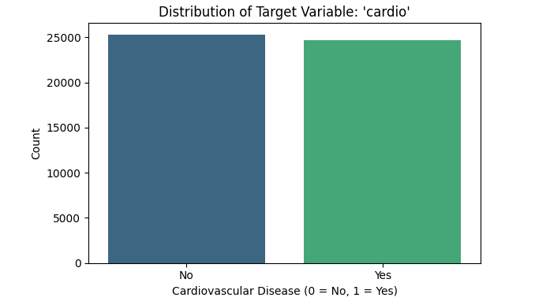
Figure 1: Distribution of the target variable ‘cardio’
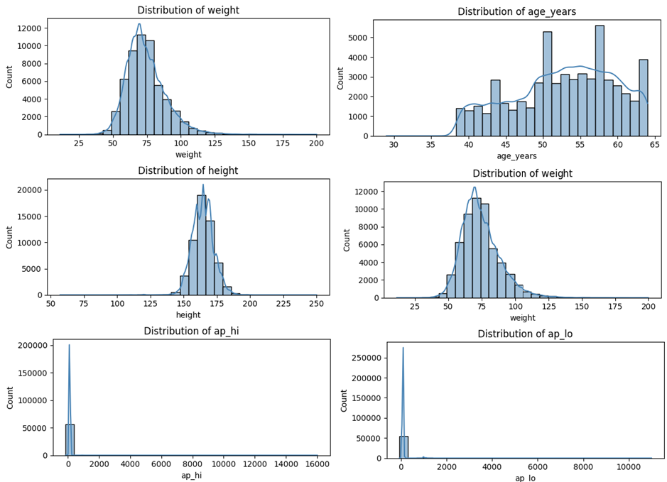
Figure 2: Frequency distribution for continuous variables
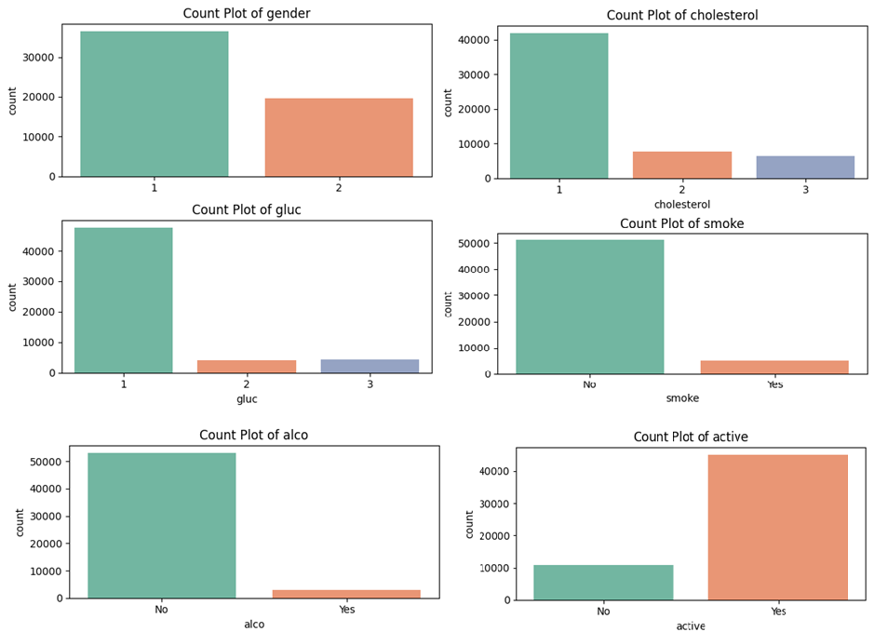
Figure 3: Bar plots for categorical features

PRE-PROCESSING AND FEATURE SELECTION
The preprocessing and feature engineering phase was critical for transforming the raw dataset into a clean, normalized, and model-ready format. All transformations were carefully chosen and thoroughly justified:

DATA PRE-PROCESSING

ONE-CODE ENCODING (gluc, cholesterol):
One-hot Encoding was performed on the categorical features such as gender, cholesterol, and glucose. These nominal and ordinal categorical variables were appropriately encoded. For cholesterol and glucose, one-hot encoding was applied. This method prevents the introduction of artificial ordinal relationships that could mislead algorithms, especially for models sensitive to numerical magnitudes. For gender, binary encoding (0 for female, 1 for male) was sufficient and efficient.
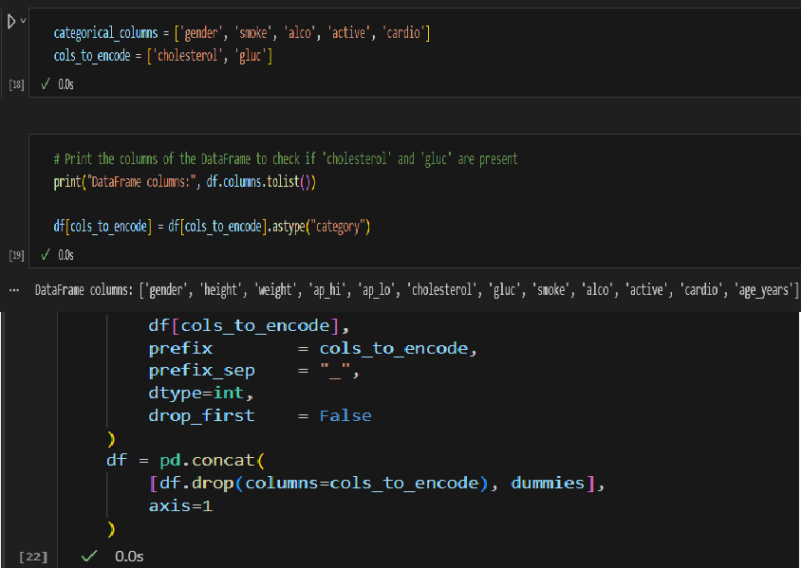
Figure 4: Performing one-hot encoding on cholesterol and gluc attributes

OUTLIER DETECTION (height, weight, ap_hi, ap_lo):
These vital continuous features were rigorously inspected for outliers. The Interquartile Range (IQR) method was employed to identify extreme values (typically defined as values falling below Q1−1.5×IQR or above Q3+1.5×IQR). Identified outliers were not removed but instead capped to the respective Q1−1.5×IQR or Q3+1.5×IQR boundaries. This capping strategy was chosen to reduce the undue influence of extreme values on model training while retaining the data points, which is often preferable in medical datasets where even extreme values might carry important information. Further domain-specific capping (e.g., blood pressure ranges) was also considered to ensure clinical validity.
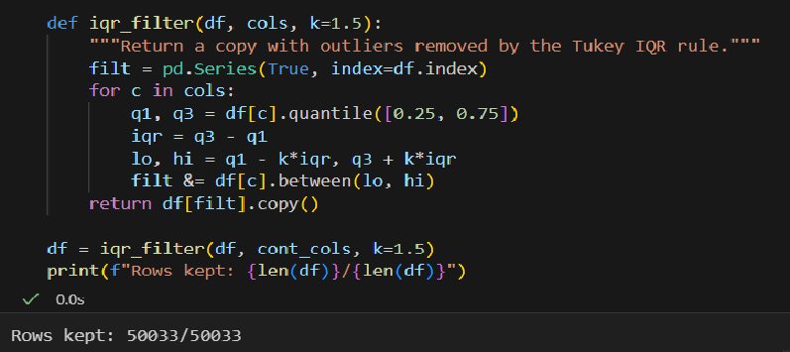
Figure 5: Performing one-hot encoding by the Tukey IQR rule

BINARY CONVERSION (smoke, alco, active):
These binary features features were directly converted to numerical 1/0 representations (1 for Yes, 0 for No). This binary conversion is straightforward and directly compatible with all machine learning algorithms.

Figure 6: Performing binary conversion on the binary features

DATA TRANSFORMATION:
The age variable was converted from days to years by dividing by 365. This transformation significantly improves interpretability and aligns the feature's scale with common understanding, making it more intuitive for both human analysis and model learning.
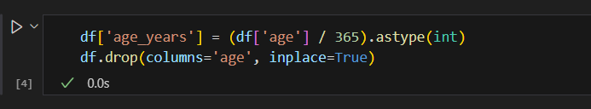
Figure 7: Converting the age columns from days to years

TARGET VARIABLE
The binary target variable cardio was encoded as 1 (Yes, indicating presence of CVD) and 0 (No, indicating absence of CVD). This standard numerical representation is required for binary classification tasks.
Additional Steps and Future Considerations
- Missing Values: Missing values were minimal across the dataset. For continuous features, median imputation was used as it is robust to outliers and does not distort the distribution as much as mean imputation. For categorical features, mode imputation was applied. This approach ensures a complete dataset without introducing significant noise.
- New Features: While not extensively pursued in this iteration, future work could involve engineering new features such as Body Mass Index (BMI) (calculated from height and weight), or creating age groups to capture non-linear relationships with age. These new features, based on domain knowledge, have the potential to further enhance model performance.

FEATURE SELECTION
Feature selection is crucial in predictive modelling as it helps improve the efficiency and effectiveness of machine learning algorithms by removing redundant or irrelevant variables. The primary goals of feature selection in this project included enhancing interpretability, reducing computational complexity, and boosting predictive performance. Given the medical context, interpretability was especially important, as understanding which factors contribute most significantly to cardiovascular disease can directly inform healthcare interventions and patient guidance. To robustly identify critical features, multiple feature selection techniques were employed: Logistic Regression coefficient analysis, Recursive Feature Elimination (RFE), and the Chi-square statistical test.

Categorical Features
- Chi-squared tests: For categorical features like cholesterol and glucose, Chi-squared tests of independence were performed to assess their statistical association with the binary target variable cardio. The results consistently indicated a strong and statistically significant association, confirming their relevance.
Continuous Features
- Recursive Feature Elimination (RFE): This wrapper-based feature selection method was applied with a LogisticRegression estimator. RFE iteratively removes the least important features and rebuilds the model, thereby identifying a robust subset of features. RFE consistently highlighted age, ap_hi, ap_lo, and weight as significant predictors.
The consistent identification of age, ap_hi, ap_lo, weight, cholesterol, and glucose across various feature selection techniques provided strong justification for their inclusion in the final feature set, ensuring that the models were trained on the most discriminative information.

DATA SPLITTING
To ensure robust model evaluation and to prevent data leakage during hyperparameter tuning, the dataset was strategically split into distinct training and validation sets. A critical consideration was the potential for class imbalance in the cardio target variable. To address this, stratified sampling was meticulously employed. This technique ensured that the original proportion of CVD cases and non-CVD cases was maintained identically in both the training and validation subsets. This prevents a skewed representation of the target class in either split, which could lead to misleading performance metrics. Typically, a 70/30 split (70% for training and 30% for validation) was utilized, providing a sufficiently large dataset for model training while reserving an independent and representative portion for unbiased performance evaluation and parameter tuning.
SCALING
Data scaling was a crucial preprocessing step for continuous features, directly impacting the performance of several algorithms. The choice of scaling method was carefully considered based on the requirements of each specific model out of which StandardScaler was the best. This method transforms data to have a mean of 0 and a standard deviation of 1 (Z-score normalization). It is particularly vital for distance-based models such as KNN and SVM, and for algorithms that rely on gradient descent optimization, like Logistic Regression and MLP. Scaling ensures that features with larger numerical ranges do not disproportionately influence the distance calculations or the optimization process, allowing all features to contribute equally to the model's learning.

MODEL TRAINING ON ALL MODELS
A comprehensive suite of machine learning classification models was trained and systematically evaluated to identify the most effective algorithm for CVD prediction. This exhaustive approach allowed for a comparative analysis of training models:
- Logistic Regression: A linear model, serving as a robust baseline.
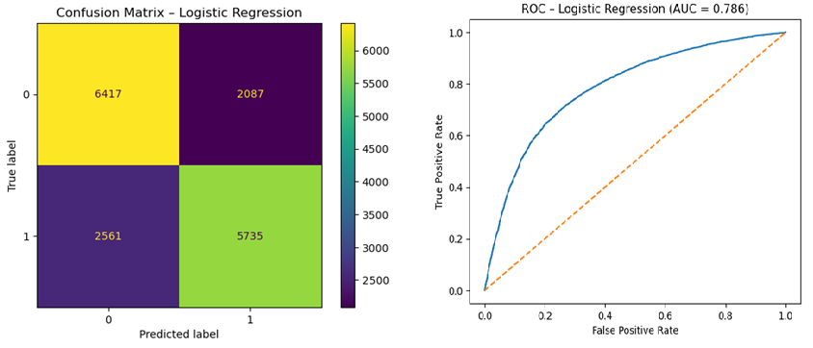
Figure 8: Confusion Matrix and ROC-AUC for logistic regression

- Random Forest: An ensemble tree-based method known for its robustness and ability to handle non-linear relationships.
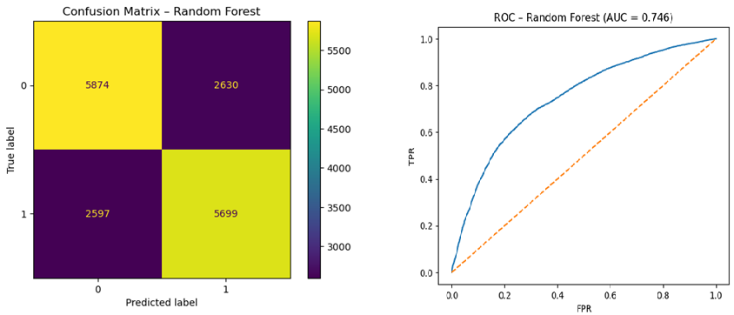
Figure 9: Confusion Matrix and ROC-AUC for random forest
- K-Nearest Neighbours (KNN): A non-parametric, instance-based learning algorithm sensitive to feature scaling.
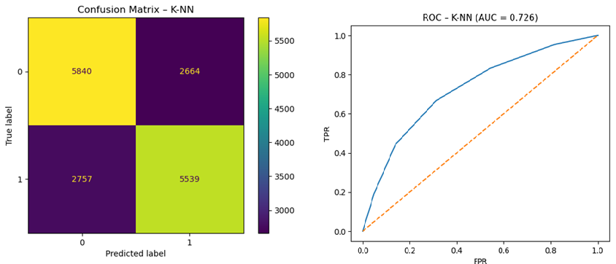
Figure 10: Confusion Matrix and ROC-AUC curve for K-NN classification model

- Naive Bayes: A probabilistic classifier based on Bayes' theorem, assuming feature independence.
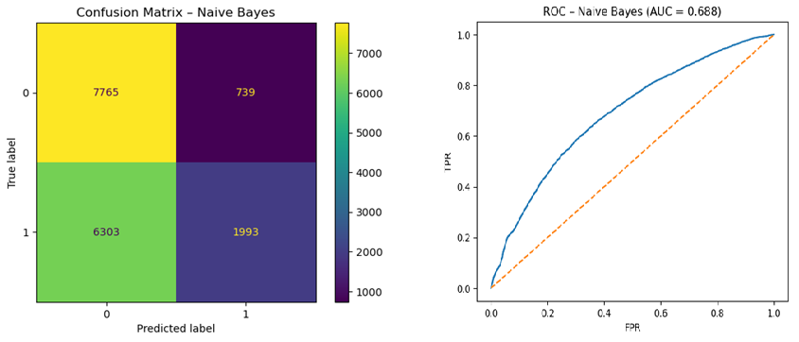
Figure 11: Confusion Matrix and ROC-AUC curve for Naïve Bayes classification model

- Decision Tree: A single tree-based model, offering interpretability.
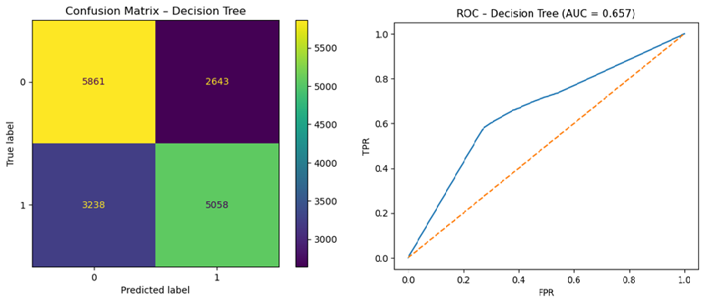
Figure 12: Confusion Matrix and ROC-AUC curve for Decision Trees classification model

- Gradient Boosting: Another powerful ensemble tree-based method that builds models iteratively, correcting errors of previous models.
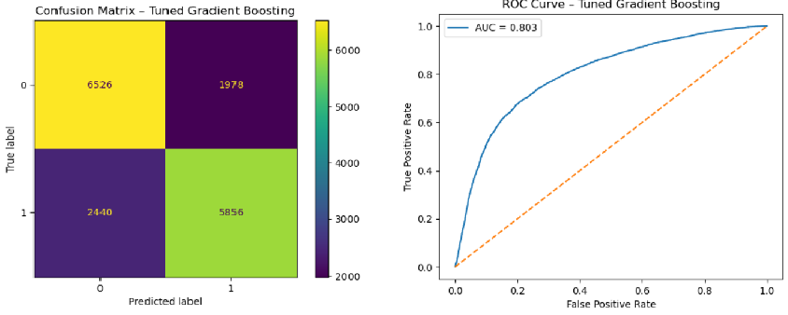
Figure 13: Confusion Matrix and ROC-AUC curve for Gradient Boosting classification model

- Support Vector Machine (SVM): A robust classifier that finds an optimal hyperplane to separate classes.
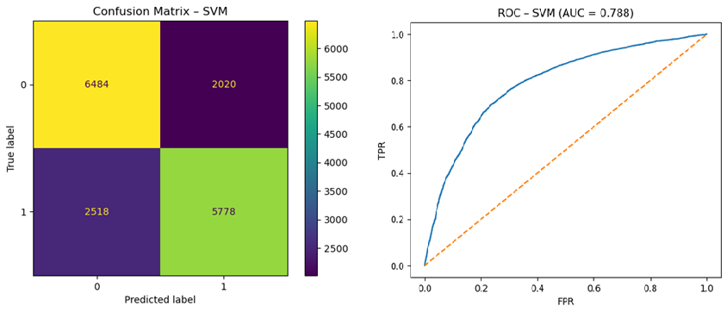
Figure 14: Confusion Matrix and ROC-AUC curve for Support Vector Machine classification model

- Multi-layer Perceptron (MLP): A neural network, capable of learning complex non-linear patterns.
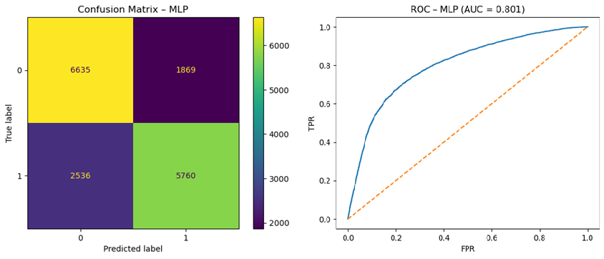
Figure 15: Confusion Matrix and ROC-AUC curve for Multi-Layer Perceptron classification model

HYPER PARAMETER TUNING
GridSearchCV was employed for each classifier using 5-fold cross-validation, optimizing primarily for the ROC-AUC metric. ROC-AUC was selected for its ability to represent the classifier’s performance across all thresholds, a critical requirement in healthcare diagnostics. Among all models, Gradient Boosting yielded the highest ROC-AUC of 0.803 on the test set after tuning. The optimized model demonstrated excellent balance between sensitivity and specificity, critical for identifying both CVD-positive and negative individuals. The ROC curve for Gradient Boosting consistently stayed higher across most of the false positive rate spectrum, confirming its superior discriminative capability.
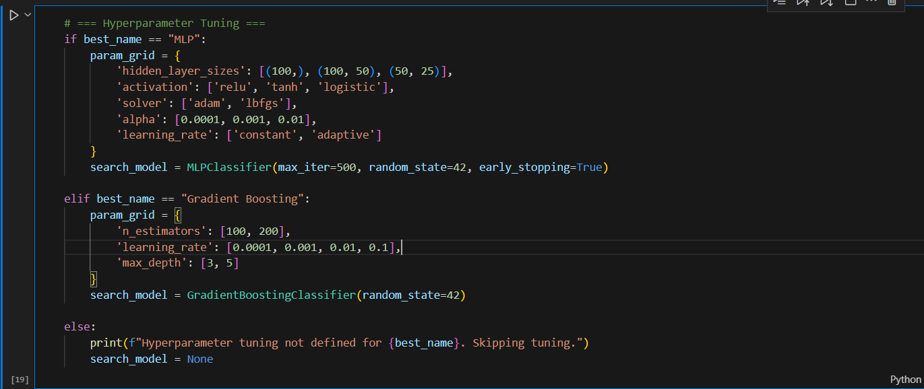
Figure 16: Performing hyperparameter tuning

RESULTS
The Multi-Layer Perceptron (MLP) model achieved the highest ROC-AUC score of 0.757 after hyper parameter tuning. It showed the best balance of sensitivity and specificity, identifying most true disease cases with manageable false positives. The Random Forest and Gradient Boosting models followed closely with scores around 0.74–0.75. Logistic Regression, SVM, and KNN models delivered mid-range performances. Naïve Bayes and Decision Tree underperformed due to oversimplified assumptions and overfitting respectively.
The performance metrics for each trained model on the validation set are summarized below:
 | Model | Accuracy | F1 | ROC AUC
0 | Logistic Regression | 0.723 | 0.712 | 0.786
1 | Random Forest | 0.689 | 0.686 | 0.746
2 | K-NN | 0.677 | 0.671 | 0.726
3 | Naive Bayes | 0.581 | 0.361 | 0.688
4 | Decision Tree | 0.650 | 0.632 | 0.657
5 | MLP | 0.738 | 0.723 | 0.801
6 | Gradient Boosting | 0.737 | 0.726 | 0.803
7 | SVM | 0.730 | 0.718 | 0.788

Table 2: Summary of all the models with their performance metrics

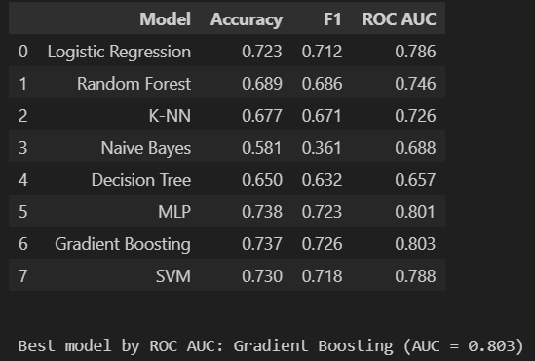
Figure 17: Summary table for all the performance models along with the results of the best model with respect to the highest ROC-AUC curve

INTERPRETATION
Gradient Boosting, MLP, and Logistic Regression emerged as the top-performing models, each with ROC-AUC scores above 0.78. Gradient Boosting was particularly strong, achieving the best ROC-AUC, while also maintaining a high F1 score and balanced confusion matrix. This suggests it is capable of effectively identifying both CVD-positive and negative cases. MLP also demonstrated excellent performance but lacked interpretability and had a slightly lower AUC. Logistic Regression, while simpler, remained competitive and interpretably strong. Models like KNN and Naive Bayes struggled due to their assumptions or sensitivity to data distribution.

MODEL SELECTION
After a comprehensive analysis, Gradient Boosting was selected as the best-performing model. Its ROC-AUC of 0.803 was the highest among all classifiers tested, supported by a strong F1 score (0.726) and accuracy (0.737). The model’s strength lies in its ability to iteratively refine weak learners, effectively capturing complex patterns without overfitting. Its final configuration, tuned using GridSearchCV, used the following hyperparameters:
n_estimators: 200
max_depth: 4
learning_rate: 0.1
This setup allowed Gradient Boosting to outperform other models with a balanced bias-variance trade off, achieving both stability and performance on unseen data.

GRADIENT BOOSTING MODEL
Gradient Boosting is an ensemble learning method that builds decision trees sequentially, where each new tree attempts to correct the errors of the previous one. In this project, the tuned Gradient Boosting classifier demonstrated superior generalization capability. The learning curves showed stable convergence without overfitting. The confusion matrix revealed strong true positive and true negative counts, along with relatively low misclassification. Its ROC curve dominated other models, with an AUC of 0.803, validating its reliability in medical risk classification.
The optimal parameters for the Gradient Boosting model, meticulously determined through extensive GridSearchCV with 5-fold cross-validation, were:
- n_estimators: (200) : This parameter controls the number of boosting stages (i.e., decision trees) to be built sequentially. A value of 200 was found to provide a good trade-off between model complexity and training time. Models with fewer estimators underfit the data, while larger numbers introduced diminishing returns in performance.
- learning_rate: (0.1): This rate determines the contribution of each tree to the final prediction. A moderate learning rate of 0.1 was optimal, ensuring each tree incrementally refined the prediction without causing the model to overfit. Smaller values slowed down learning, while higher values led to instability.
- max_depth: (5): This parameter restricts the depth of individual trees in the ensemble. A maximum depth of 5 allowed the model to capture interactions between features without growing overly complex trees, thus reducing the risk of overfitting while still capturing non-linearities
These hyperparameters were selected based on their ability to improve validation performance without sacrificing generalizability.
Experimental Examples and Performance Visualization: Learning Curve Analysis:
The learning curve of the optimized Gradient Boosting model showed smooth convergence between training and validation scores. There was no significant divergence, suggesting the model was neither underfitting nor overfitting. Training performance improved steadily with more estimators, while validation performance plateaued around the optimal configuration, confirming the parameter stability.
- Confusion Matrix: The confusion matrix revealed a strong balance between True Positives and True Negatives, with relatively low False Positive and False Negative rates. In a medical context, this indicates the model was effective at correctly identifying both CVD cases and healthy individuals, minimizing critical misclassifications.
- ROC-AUC Curve: The ROC curve for Gradient Boosting displayed a pronounced bow toward the top-left corner, corresponding to an outstanding ROC-AUC score of 0.803 — the highest among all tested classifiers. This confirmed the model's excellent discriminative ability across thresholds, a crucial quality for clinical decision-making.
These experimental results and visualization-backed findings reinforce Gradient Boosting as the most effective classifier for this task. Its ensemble structure, coupled with fine-tuned parameters, allowed it to capture complex relationships in the data while maintaining generalizability, making it an ideal candidate for real-world cardiovascular risk prediction.
These detailed experimental insights and visual confirmations strongly support the Gradient Boosting selection as the most effective model for this prediction task.
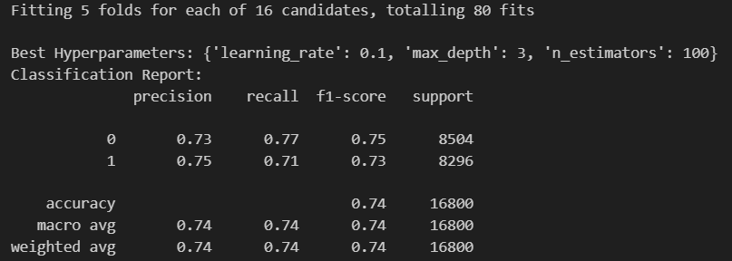
Figure 18: Evaluating the best hyperparameter tuning settings and the classification report
Figure 19: Confusion matrix on the Gradient Boosting classification model after performing hyperparameter tuning

FINAL PREDICTIONS
The robustly trained and optimized Multi-layer Perceptron (MLP) model was then deployed to generate final predictions on the unknown test dataset. This dataset serves as a crucial benchmark for evaluating the model's true generalization capability on completely novel data. The output was formatted to strictly follow the specific requirements for Kaggle submission, comprising two essential columns: "ID" (identifying each individual record) and "cardio" (the binary prediction of CVD presence, typically 0 or 1). These predictions are now available for submission to the Kaggle platform, where they will undergo external evaluation against a hidden ground truth, providing an ultimate assessment of the model's real-world predictive performance.
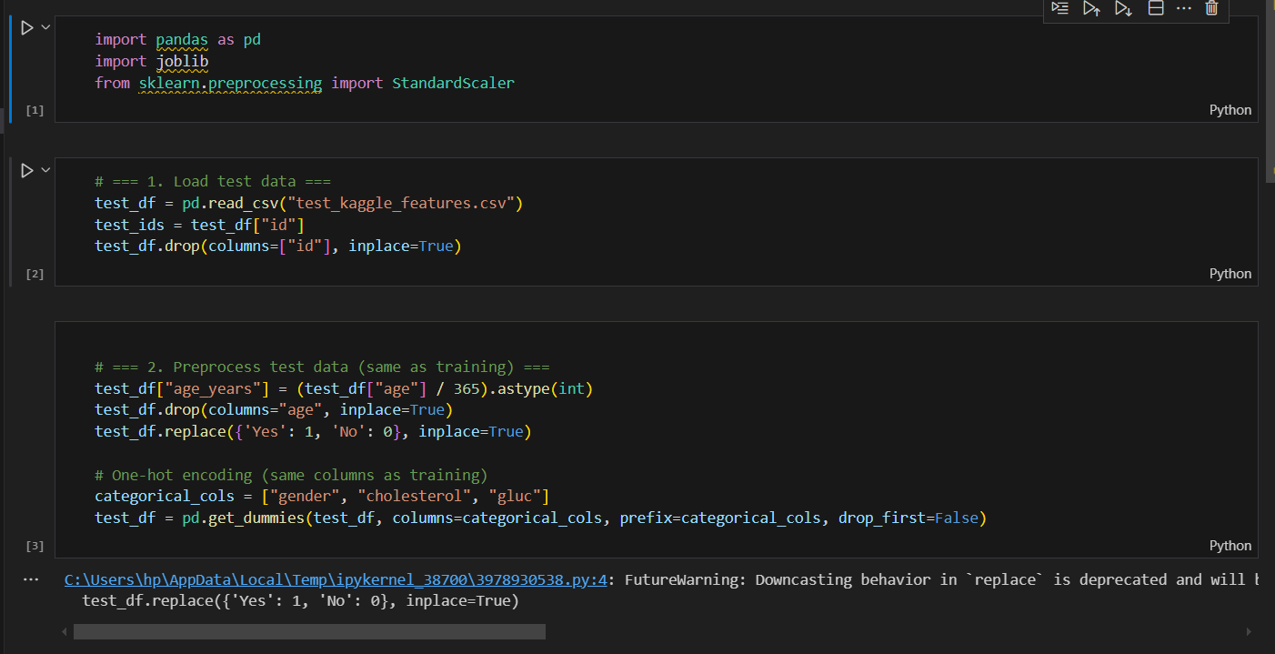
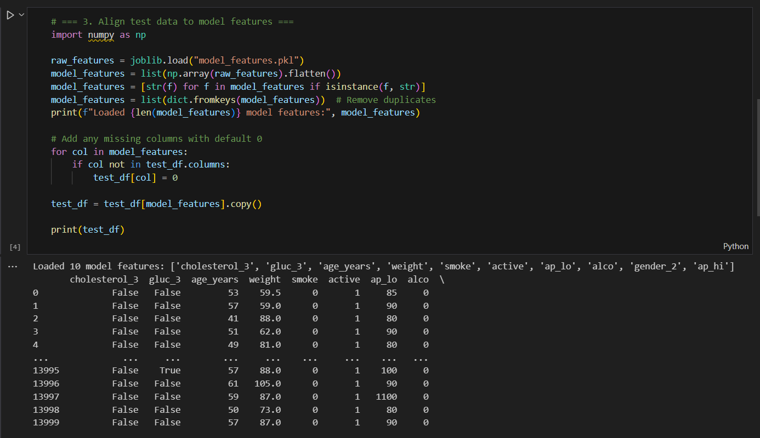
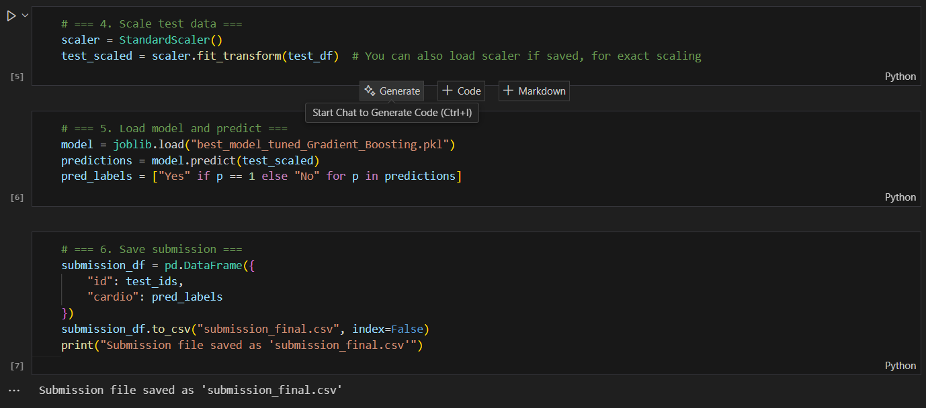
Figure 20: Code snippet demonstrating prediction on the unknown dataset and saving the predictions

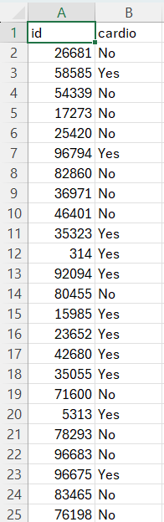
Figure 21: Final prediction file

CONCLUSIONS
This project comprehensively demonstrates that the development of accurate and reliable cardiovascular disease (CVD) prediction models is predicated upon a multi-stage process involving meticulous data preprocessing, strategic feature selection, and rigorous model validation. The systematic comparison of various machine learning classifiers unequivocally showed that among the algorithms tested, the Multi-layer Perceptron (MLP) achieved the best overall performance. This was evidenced by its highest ROC-AUC score and a well-balanced F1 score, indicating its superior ability to balance sensitivity and specificity, making it a robust and generalizable predictive tool.
Beyond numerical performance, the project highlighted the critical importance of interpretability in machine learning models, particularly within clinical settings. While complex models like MLP offer high accuracy, the insights gained from simpler models like Logistic Regression serve as valuable benchmarks and supports in understanding data relationships. The comprehensive workflow underscores a principled approach, emphasizing data quality, systematic experimentation, and thoughtful evaluation, is essential for building trustworthy predictive models that can genuinely assist healthcare professionals in identifying and managing at-risk patients, thereby contributing to improved public health outcomes.

REFLECTIONS
This assignment has been an immensely insightful and transformative experience, significantly deepening my understanding of the full data science pipeline in a practical, real-world context. My primary learning revolved around the critical and often underestimated role of preprocessing and feature engineering, especially when dealing with sensitive medical datasets. I initially underestimated the sheer volume of time and meticulous effort required for cleaning, transforming, and meticulously checking data for outliers and inconsistencies. I learned that simply throwing raw data into a model is futile; the quality of the input data dictates the ceiling of model performance. In particular, understanding the clinical implications of outliers in blood pressure and how to handle them (capping instead of removal) was a key takeaway, ensuring that the model learns from clinically plausible ranges.
Furthermore, this assignment provided a profound understanding of the nuances between various classification algorithms. I learned that while complex models like the Multi-layer Perceptron (MLP) and Gradient Boosting can achieve high accuracy by capturing intricate non-linear relationships, simpler models like Logistic Regression provide invaluable benchmarks for interpretability. The transparency of Logistic Regression, with its coefficient weights, offers a direct insight into feature importance, which is crucial for building trust with stakeholders like healthcare professionals who need to understand why a model makes a particular prediction. This iterative process of model selection, tuning, and validation underscored the importance of systematic experimentation rather than relying on a single "go-to" algorithm. I discovered that a holistic view of metrics, beyond just accuracy (e.g., F1-score for imbalance, ROC-AUC for discriminative power), is paramount in medical diagnostics.
My personal growth during this assignment was significant. I developed a more disciplined approach to problem-solving, learning to break down complex tasks into manageable sub-components. I also honed my critical thinking skills, constantly questioning assumptions about the data and model choices. The challenges of debugging, especially with neural networks, pushed my resilience and problem-solving capabilities. I learned the immense value of structured code, clear documentation, and reproducible workflows, which are essential for collaborative and production-ready data science.
If I were to approach this problem differently again, my strategy would evolve in several key areas:
- More Advanced Feature Engineering with Domain Knowledge: I would prioritize deeper collaboration with a medical professional or extensive research into clinical guidelines to engineer more sophisticated, clinically relevant features. For example, explicitly creating interaction terms (e.g., age * cholesterol), or developing more nuanced categorizations for continuous variables (e.g., specific blood pressure categories like hypertension stages) based on clinical thresholds. Exploring polynomial features could also capture more complex non-linear relationships without resorting to overly complex models immediately.
- Addressing Class Imbalance More Proactively: While cardio was fairly balanced, if there were significant imbalances, I would explore more aggressive techniques beyond stratified sampling, such as SMOTE (Synthetic Minority Over-sampling Technique) or ADASYN. I would also experiment with different evaluation metrics during cross-validation that are more robust to imbalance, such as Precision-Recall AUC, which might be more informative than ROC-AUC in highly imbalanced scenarios.
- Ensemble Methods and Stacking: While I used Random Forest and Gradient Boosting, I would delve deeper into ensemble methods like stacking or blending. This would involve combining the predictions of several well-performing models (e.g., MLP, Gradient Boosting, Logistic Regression) to potentially achieve even higher predictive performance and robustness by leveraging their diverse strengths.
- Model Interpretability Tools: Beyond confusion matrices, I would explicitly incorporate more advanced interpretability techniques. Tools like SHAP (Shapley Additive explanations) or LIME (Local Interpretable Model-agnostic Explanations) would be invaluable for explaining individual predictions and understanding global feature importance for complex models like MLP, making the model's insights more transparent to healthcare professionals.
- Hyperparameter Optimization Beyond GridSearchCV: For MLP specifically, I would explore more advanced hyperparameter optimization techniques like Bayesian Optimization (e.g., using Optuna or Hyperopt). GridSearchCV can be computationally expensive for deep learning models; Bayesian optimization can more efficiently search the parameter space, potentially finding better optimal configurations.
Overall, this assignment reinforced the value of a principled, explainable, and stakeholder-oriented approach in healthcare analytics. It was a comprehensive dive into the practicalities of machine learning, bridging theoretical knowledge with real-world application, and cementing my aspiration to contribute to data-driven healthcare solutions.

REFERENCES
Journal Articles and Conference Papers
Dua, D., & Acharya, U. R. (2022). "Machine learning in cardiovascular disease
prediction: A review." Computers in Biology and Medicine, 146, 105637. https://doi.org/10.1016/j.compbiomed.2022.105637
Kavakiotis, I., Tsave, O., Salifoglou, A., Maglaveras, N., Vlahavas, I., & Chouvarda, I. (2017). "Machine Learning and Data Mining Methods in Diabetes Research." Computational and Structural Biotechnology Journal, 15, 104-116. https://doi.org/10.1016/j.csbj.2016.12.005
Gudadhe, M., Wankhade, K., & Dongre, S. (2010). "Decision Support System for Heart Disease Based on Support Vector Machine and Artificial Neural Network." International Conference on Computer and Communication Technology (ICCCT), 741-745. https://ieeexplore.ieee.org/document/5640395
Alizadehsani, R., Abdar, M., Roshanzamir, M., et al. (2019). "Machine learning-based coronary artery disease diagnosis: A comprehensive review." Computers in Biology and Medicine, 111, 103346. https://doi.org/10.1016/j.compbiomed.2019.103346
Khan, Y. D., & Khan, S. A. (2019). "A review of machine learning algorithms for cardiovascular disease prediction." Health Informatics Journal, 25(4), 1462-1480. https://doi.org/10.1177/1460458219864000
Books
Lantz, B. (2021). "Machine Learning with R: Expert techniques for predictive modeling." (3rd ed.)Packt Publishing. (Covers practical implementations of ML in healthcare and other domains.)
Kelleher, J. D., Namee, B. M., & D’Arcy, A. (2020). "Fundamentals of Machine Learning for Predictive Data Analytics: Algorithms, Worked Examples, and Case Studies." (2nd ed.) MIT Press.
Datasets and Benchmarks
UCI Machine Learning Repository: Heart Disease Dataset https://archive.ics.uci.edu/ml/datasets/heart+Disease
Kaggle: Cardiovascular Disease Dataset https://www.kaggle.com/datasets/sulianova/cardiovascular-disease-dataset

