**--- Creation of database in MySQL Workbench: -**

We want to create “**games database**” to store Olympics data as a table in games database

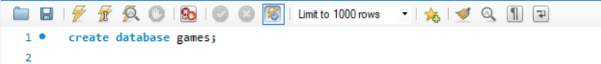

**--- Using the Created database: -**



**--- Creation of Olympics table: -**

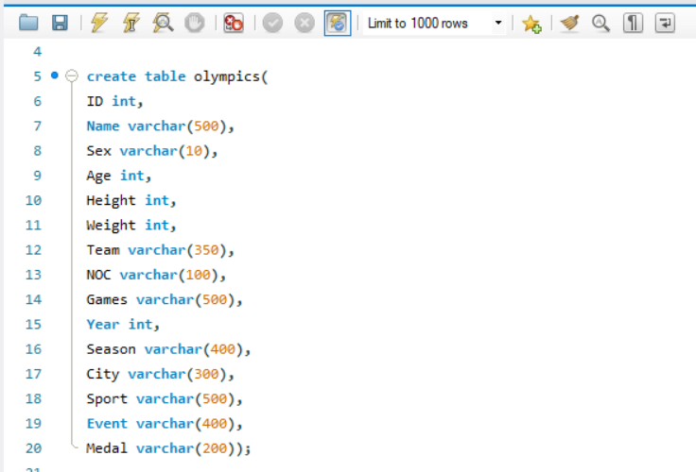

**--- Displaying the created table using SELECT: -**

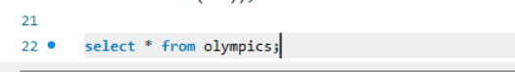

**--- Showing Variables: -**

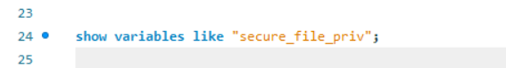

**“secure_file_priv”**: This MySQL system variable restricts file access for certain commands like LOAD DATA INFILE, SELECT INTO OUTFILE, etc. It ensures that these commands can only be used within a specific directory.

**--- Loading the Olympics Dataset externally using “Data infile ”: -**

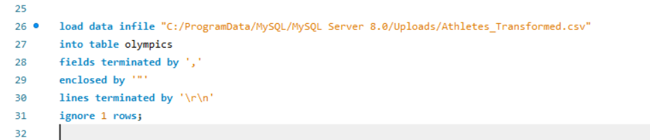

* **LOAD DATA INFILE**: This statement loads data from a file into a table.
* **INTO TABLE olympics**: Specifies the table into which the data will be loaded.
* **FIELDS TERMINATED BY ','**: Specifies that fields in the CSV file are separated by commas.
* **ENCLOSED BY '"'**: Indicates that fields in the file are enclosed by double quotes.
* **LINES TERMINATED BY '\r\n'**: Specifies that lines in the file end with \r\n (carriage return and line feed), which is typical for files created on Windows.
* **IGNORE 1 ROWS**: Skips the first row, often used to ignore the header row in a CSV file.

**--- Showing the data inserted into olympics table created: -**

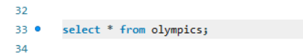

**OUTPUT: -**

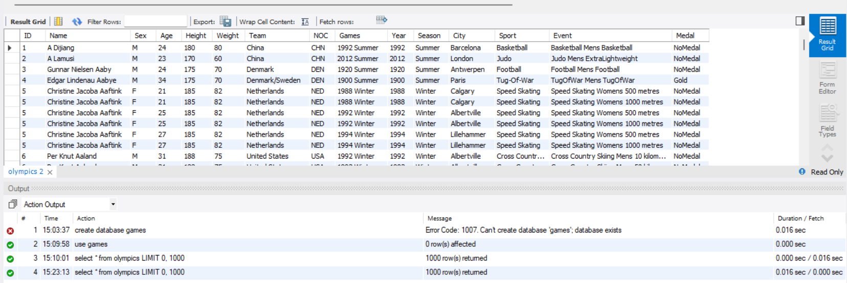

**-- SQL PROJECT**

**-- 1. Show how many medal counts present for entire data: -**

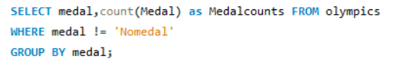

**OUTPUT: -**

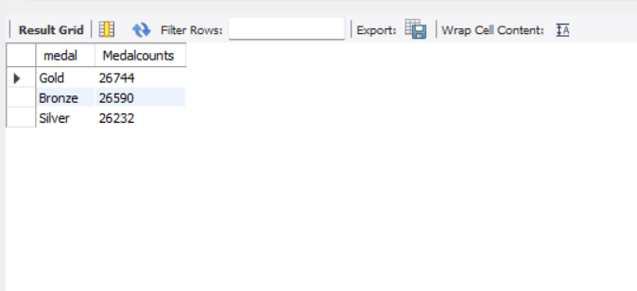

**-- 2. Show count of unique sports present in Olympics: -**

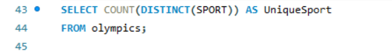

**OUTPUT: -**

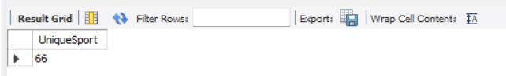

**-- 3. Show how many different medals won by team India: -**

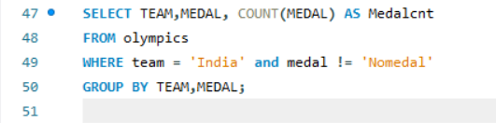

**OUTPUT: -**

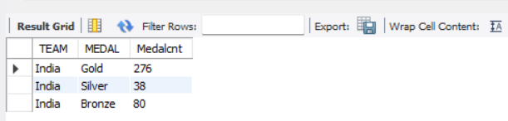

**-- 4. Show event wise medals won by India show from highest to lowest medals won in order: -**

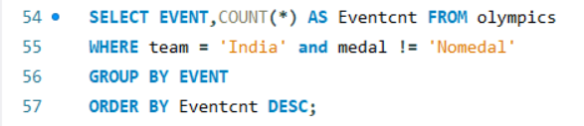

**OUTPUT**: -

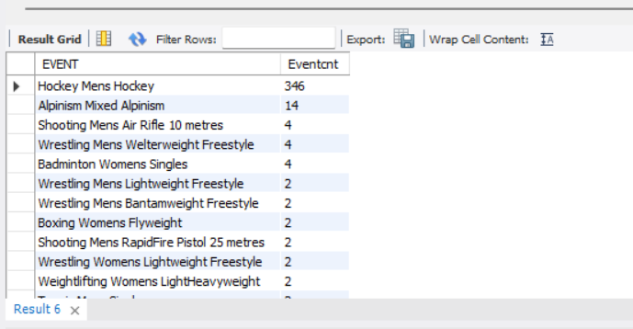

**-- 5. Show event wise medals won by India in order of year: -**

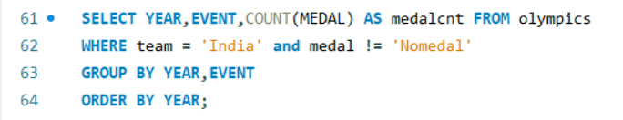

**OUTPUT**: -

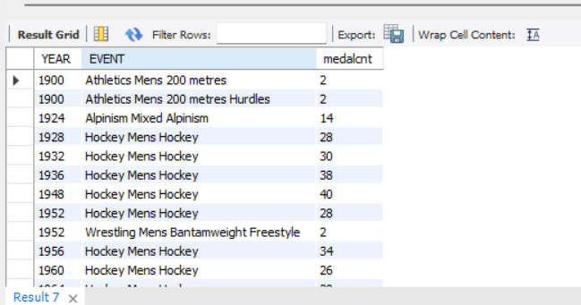

**-- 6. Show country who won maximum medals: -**

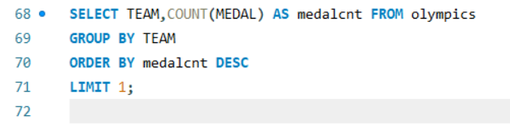

**OUTPUT**: -

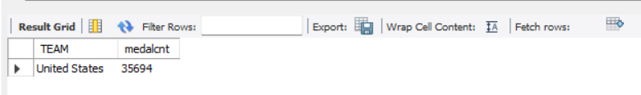

**-- 7. Show top 10 countries who won gold: -**

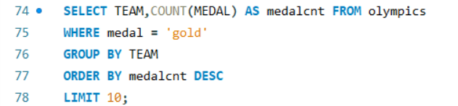

**OUTPUT: -**

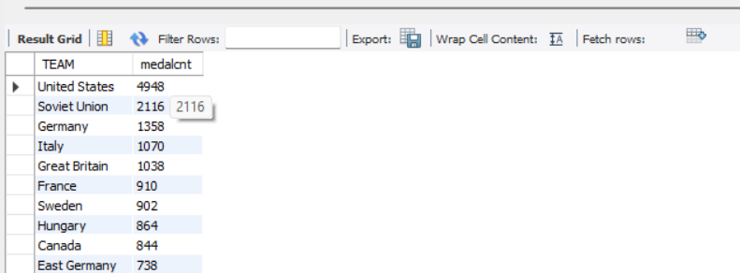

**-- 8. Show in which year did United states won most gold medal: -**

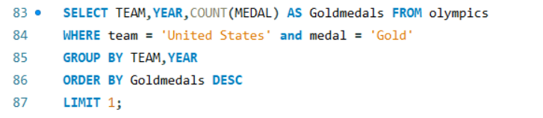

**OUTPUT:** -

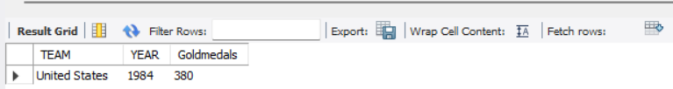

**-- 9. In which sports United States has most medals: -**

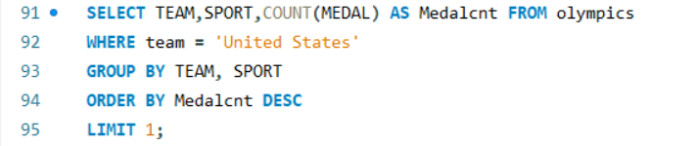

**OUTPUT**: -

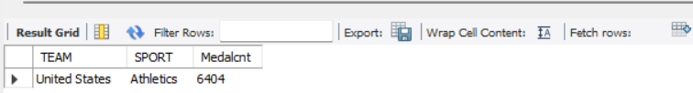

**-- 10. Find top three players who won most medals along with their sports and country: -**

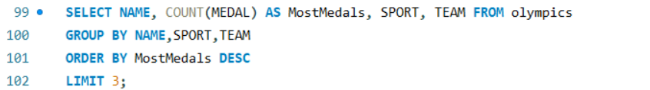

**OUTPUT: -**

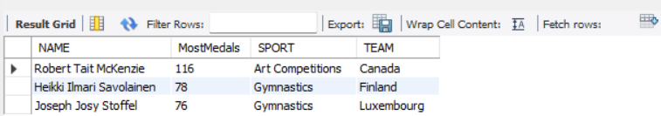

**-- 11. Find player with most gold medals in cycling along with his country: -**

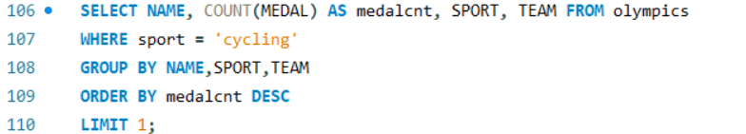

**OUTPUT: -**

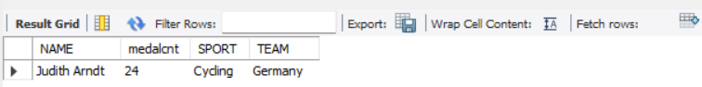

**-- 12. Find player with most medals (Gold+Silver+Bronze) in Basketball also show his country:**

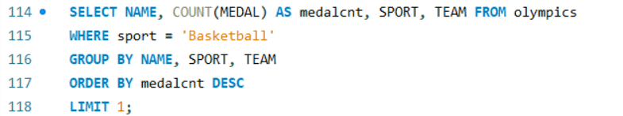

**OUTPUT: -**

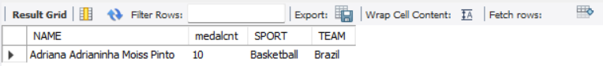

**-- 13. Find out the count of different medals of the top basketball player Teresa Edwards: -**

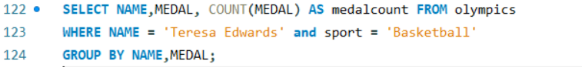

**OUTPUT**: -

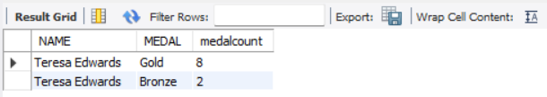

**-- 14. Find out medals won by male, female each year. Export this data and plot graph in excel: -**

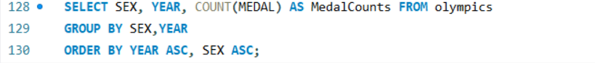

**OUTPUT: -**

