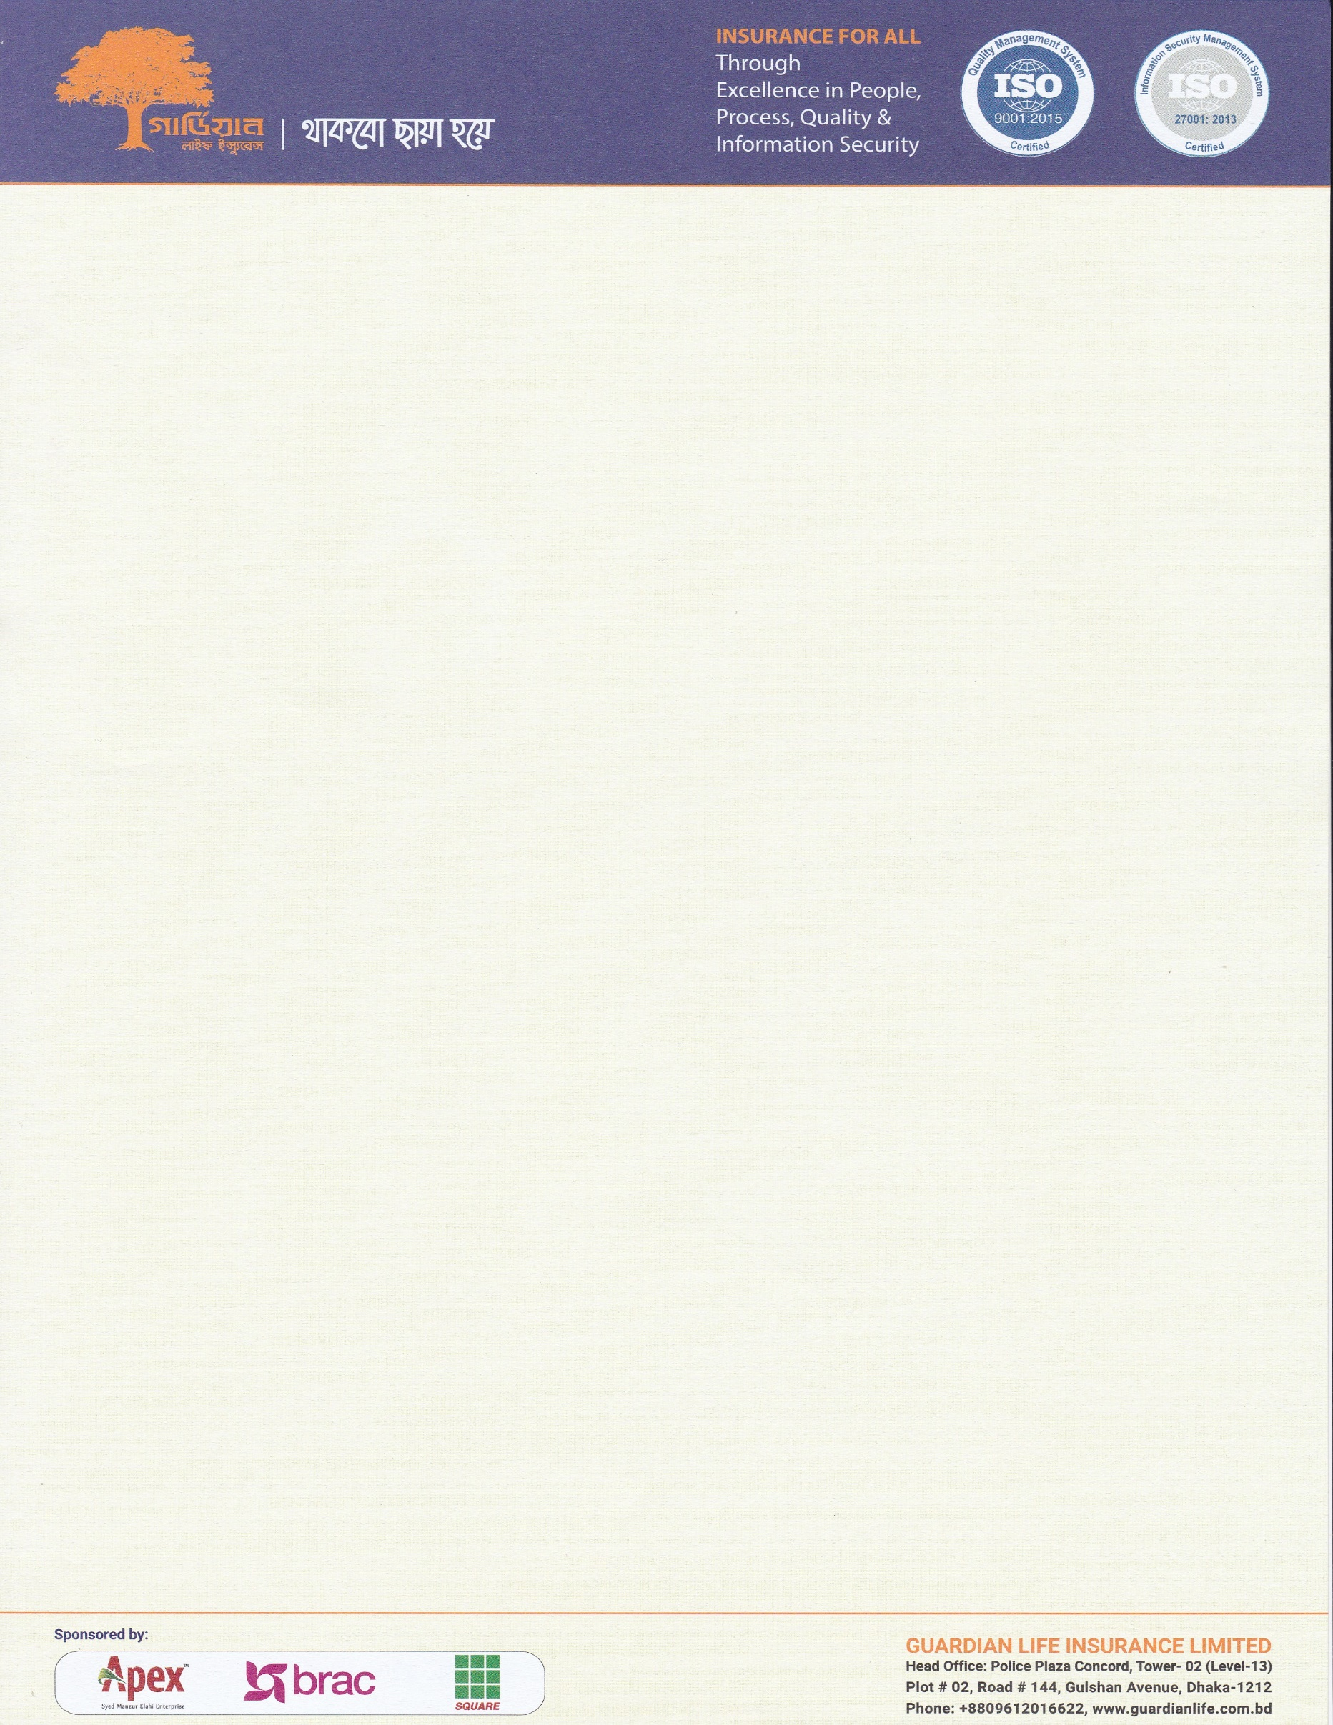

**Ref. GLIL/CD/WO/APRIL/XXXX/2021**

Date: 08/04/2021

The Managing Director,

**Orion Securities Services Limited**

House: #12, Road: 14/A, Sector: 4

Uttara, Dhaka-1230, Bangladesh

**Sub: Work order to investigate Death Claim of Late EXAMPLE**

Dear Sir, Appreciate if you take required step to initiate a broad-based inquiry on the bellow **Death** claims to find actual or original fact in details with maximum professional manner. Guardians always express optimum respect to valued insured.

|  |  |  |  |  |  |  |
| --- | --- | --- | --- | --- | --- | --- |
| **CASE ID** | **2021-0XXX** | **:** | **CLAIM AMOUNT** | **BDT 2,50,000** | | |
| **NAME OF ORG. AND PROJECT** | | **:** | **BRAC Microfinance, GBB** | | | |
| POLICY COMMENCEMENT DATE | | **:** | **28-12-2020** | | **DEATH DATE** | **02-02-2021** |
| **NAME OF DECEASED** | | **:** | Example | | | |
| **NAME OF BENIFICIARY** | | **:** | **Example** | | | |
| **CONTACT NUMBER** | | **:** | **01827009115** | | | |
| **ADDRESS** | | **:** | **Address………** | | | |
| **INSTRUCTIONS FOR INVESTIGATION** | | **:** | **Investigate this claim by following mutually agreed guideline under the Contract.** | | | |
| **SPECIAL NOTES** | | **:** | * **Give your maximum effort to collect Treatment / Medical records of Deceased Prior Policy Commencement and Death.** * **History sheets and treatment records from the Hospital from where she had been taking treatments.** * **Any other relevant document.** | | | |

**We shall be happy to get substantial evidence rich report from your end. We must have the complete investigation report within 05 working days from the date of receipt of this letter.**

Appreciate your prompt & devoted service.

Sincerely,

**Dr Shohan Ahmed**

**Senior Vice President & Head of Claims Department**

Guardian Life Insurance Limited

**Enclosed Documents:**

1. Loan Application Form
2. Death certificate of UPC / Doctor
3. NID both Deceased and Beneficiary -02