VLSI DESIGNING INTERNSHIP
TASK-5
Introduction:
1. RTL Design of Datapath
A datapath is a digital circuit that transfers and processes data between registers and functional units. It consists of registers, an ALU, and other components that perform operations based on control signals.
2. RTL Design of ALU
An Arithmetic Logic Unit (ALU) is a digital circuit that performs arithmetic and logical operations such as addition, subtraction, AND, OR, and XOR on binary data.
3. RTL Design of RAM
Random Access Memory (RAM) is used to store data temporarily. It supports reading and writing data at specific memory addresses and is commonly used in digital systems.
4. RTL Design of ROM
Read-Only Memory (ROM) stores predefined data or instructions. It reads data from a selected memory address and is commonly used for storing fixed information.
Objectives:
- To design and simulate a datapath using Verilog.
- To implement arithmetic and logical operations using an ALU.
- To design RAM for data storage and read/write operations.
- To design ROM for storing and retrieving predefined data.
- To verify the functionality of all designs using testbenches and waveform simulation.
Tools Used:
- Verilog HDL: To design the digital circuits.
- EDA Playground: To write and simulate Verilog code online.
- Icarus Verilog: To compile and execute the designs.
- EPWave: To view signal waveforms and verify circuit operation.
RTL DESIGNS AND SIMULATIONS:
1. Datapath
A datapath is a digital circuit that transfers and processes data. It consists of registers, an ALU, and other components. It helps move data between different parts of a system. Control signals determine the operations performed. Verilog HDL is used to design and simulate the datapath.
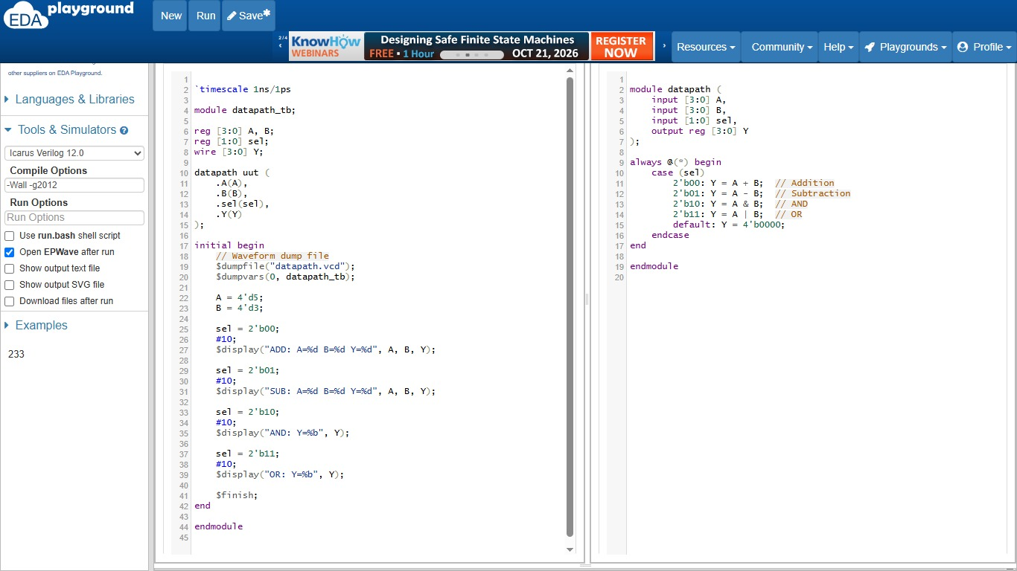
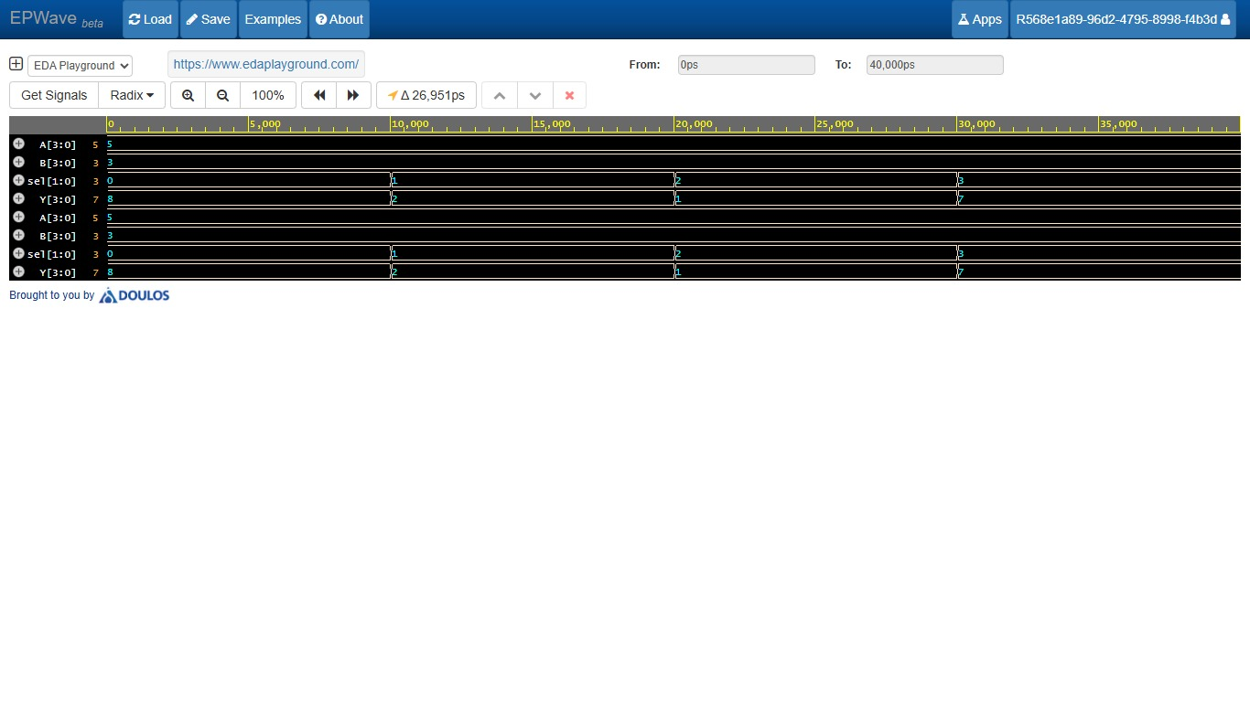
2. ALU
An Arithmetic Logic Unit (ALU) performs arithmetic and logical operations on binary data. It supports operations such as addition, subtraction, AND, OR, and XOR. The operation is selected using control signals. The ALU produces the result at its output. Verilog HDL is used to design and verify its functionality.
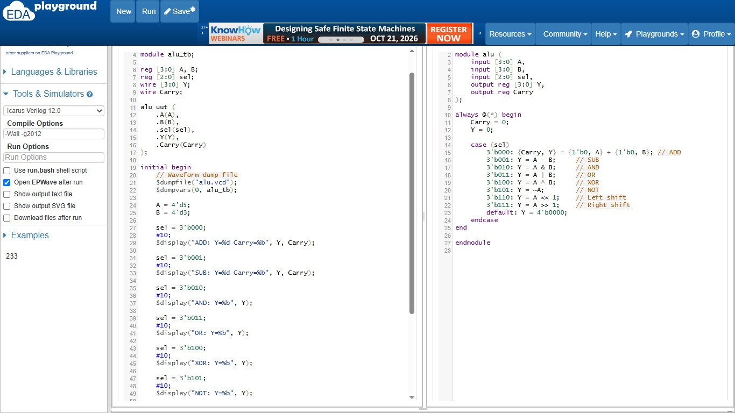

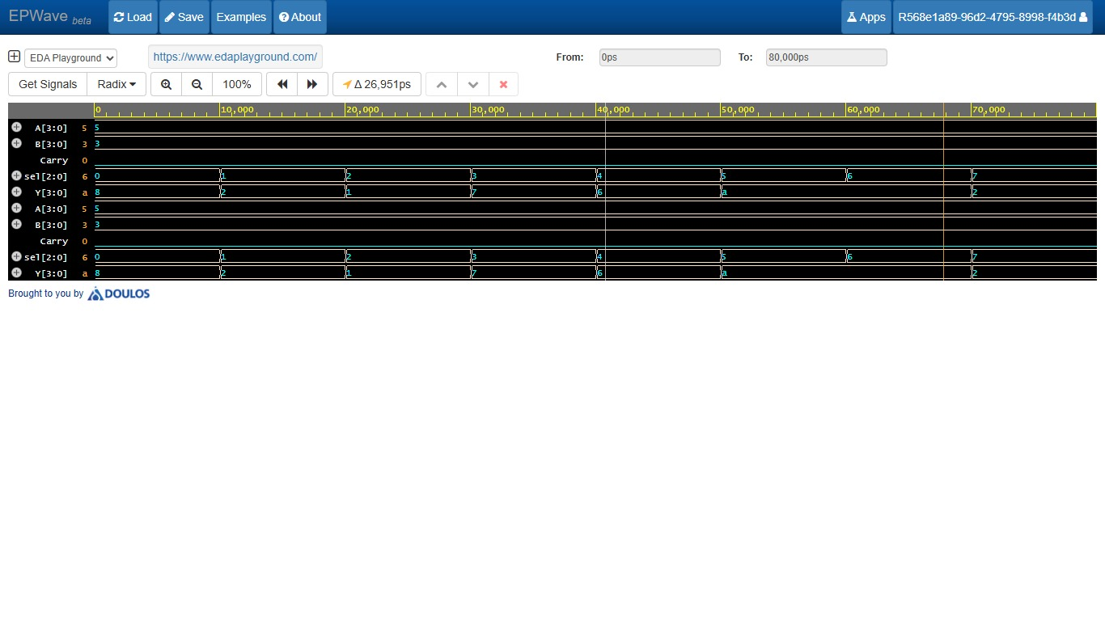
3. RAM
Random Access Memory (RAM) stores data temporarily in a digital system. It contains multiple memory locations, each identified by an address. Data can be written to and read from these locations. Control signals determine the read and write operations. Verilog HDL is used to design and simulate RAM.
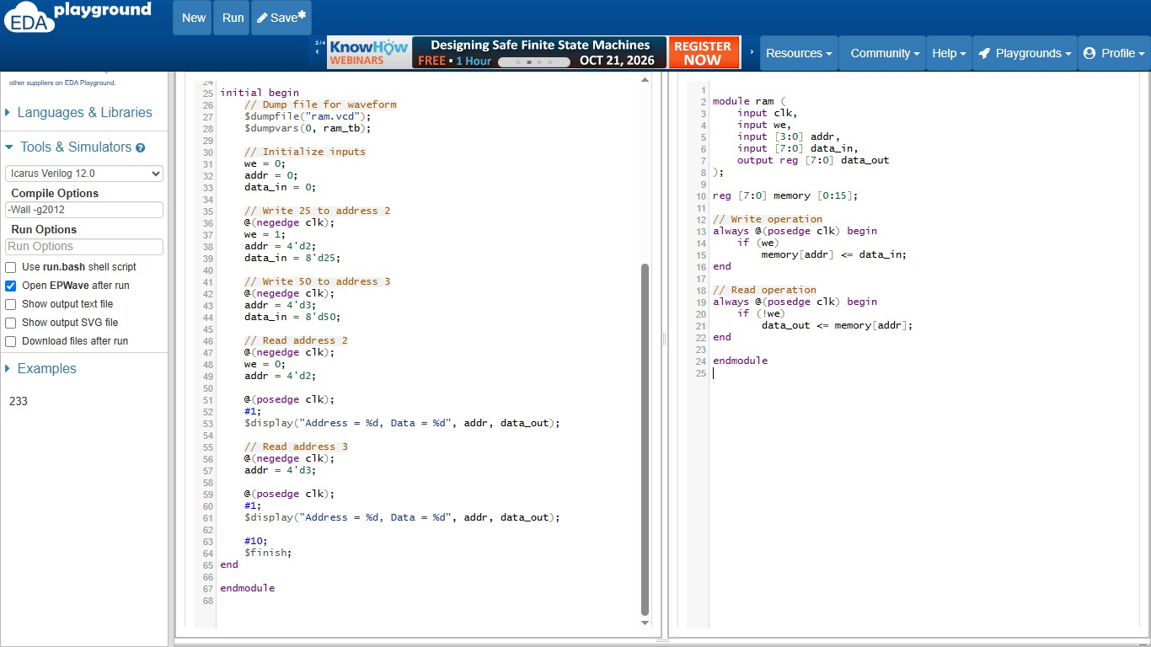

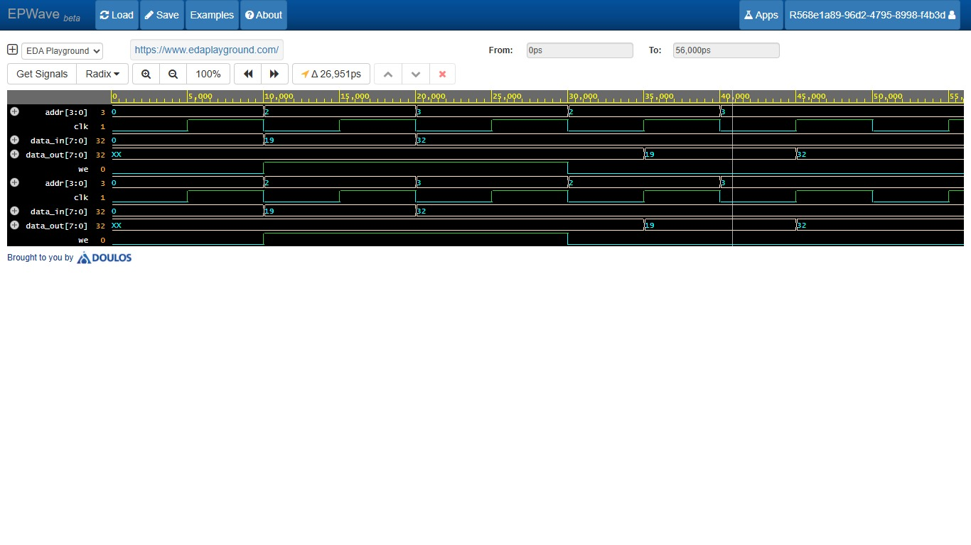
4. ROM
Read-Only Memory (ROM) stores predefined data or instructions. Each memory location has a unique address. When an address is selected, the corresponding data is provided at the output. ROM is commonly used to store fixed information. Verilog HDL is used to design and simulate ROM.
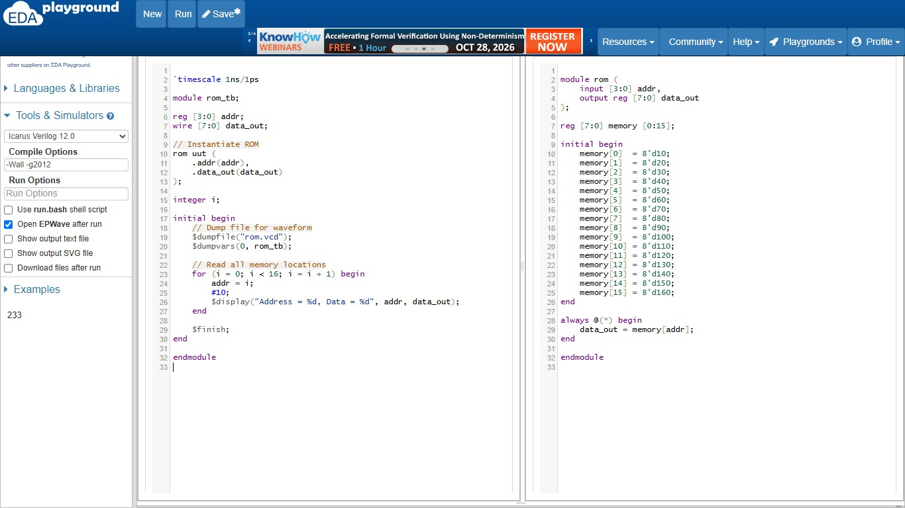

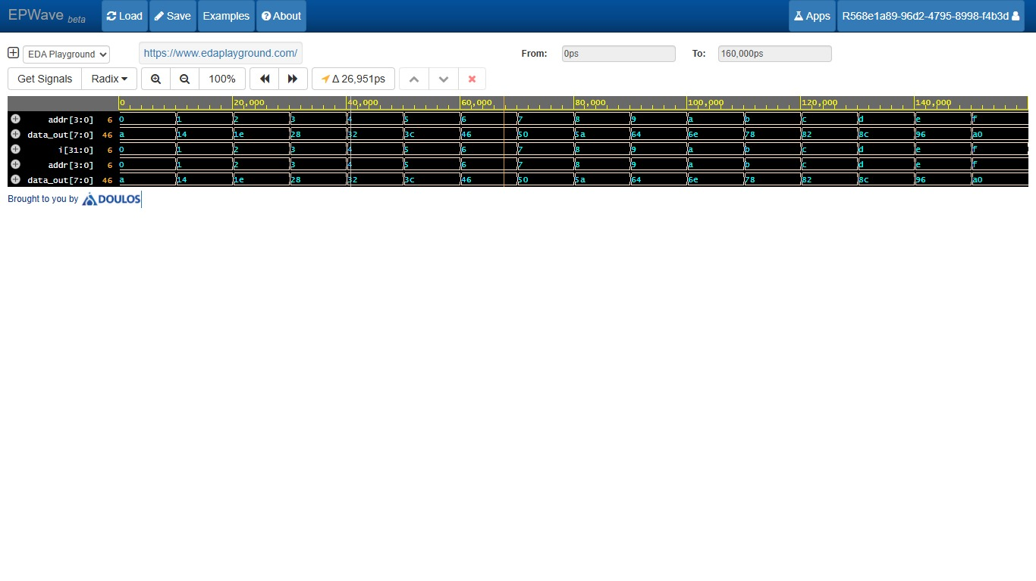
Conclusion:
The RTL design and simulation of datapath, ALU, RAM, and ROM were performed using Verilog HDL. The functionality of each design was verified using testbenches and waveform simulation. These designs helped in understanding data processing, arithmetic and logical operations, and memory organization. This work provides a basic understanding of digital system design and its applications.

