VLSI DESIGNING INTRNSHIP
TASK – 3
INTRODUCTION
Sequential digital circuits are important in digital system design because they can store and process information based on clock signals. Verilog HDL can be used to design and simulate these circuits efficiently. The circuits covered include D Flip-Flop, JK Flip-Flop, 4-bit Register, and 4-bit Counter. Their functionality can be verified using suitable testbenches and simulation waveforms.
OBJECTIVES
- To understand the basic concepts of sequential digital circuits.
- To design D Flip-Flop and JK Flip-Flop using Verilog HDL.
- To implement a 4-bit Register and 4-bit Counter.
- To develop testbenches for verifying the circuits.
- To simulate the designs and analyze their output waveforms.
- To gain practical experience in Verilog-based digital circuit design.
TOOLS USED
Verilog HDL – for designing the digital circuits.
Icarus Verilog – for compiling and simulating the Verilog code.
EDA Playground – for writing, running, and testing the designs.
EPWave – for viewing and analyzing simulation waveforms.
FLIPFLOPS – D FLIP FLOP
A flip-flop is a sequential circuit used to store one bit of binary data. It has two stable states, 0 and 1, and works with a clock signal. A D flip-flop is a type of flip-flop used to store data. It has a single data input called D, and at the active clock edge, the value of D is transferred to the output Q.
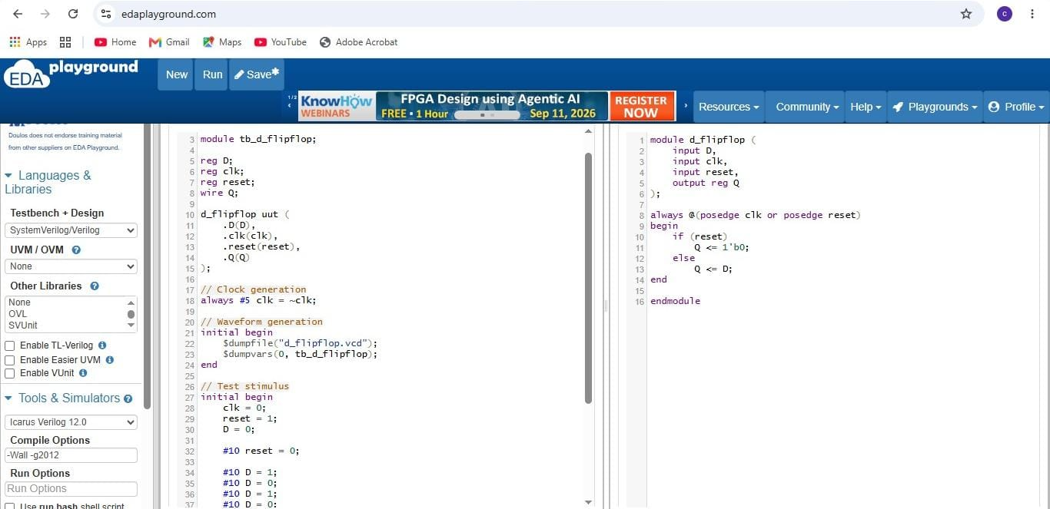

SIMULATION OUTPUT
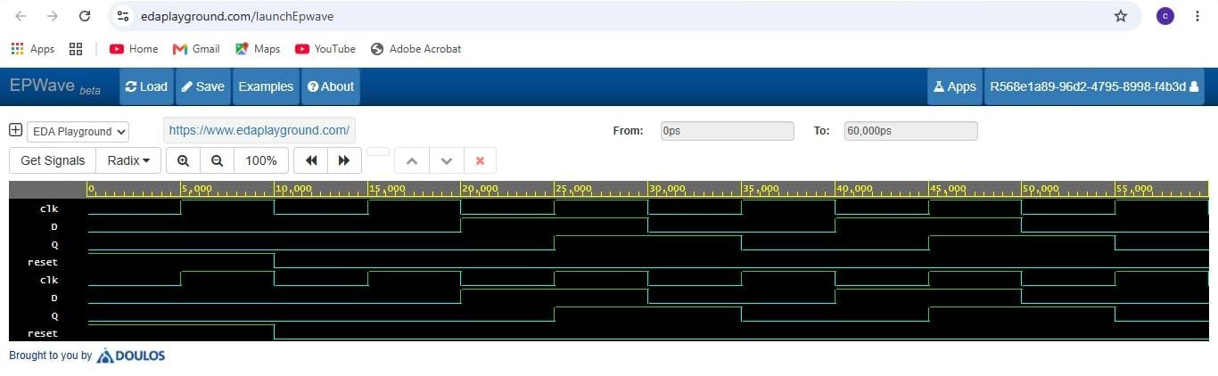
JK – FLIP FLOP
A JK flip-flop is a sequential circuit used to store one bit of data. It has two inputs, J and K, and works with a clock signal. When J = 0 and K = 0, the output remains unchanged; when J = 0 and K = 1, it resets; when J = 1 and K = 0, it sets; and when J = 1 and K = 1, the output toggles.
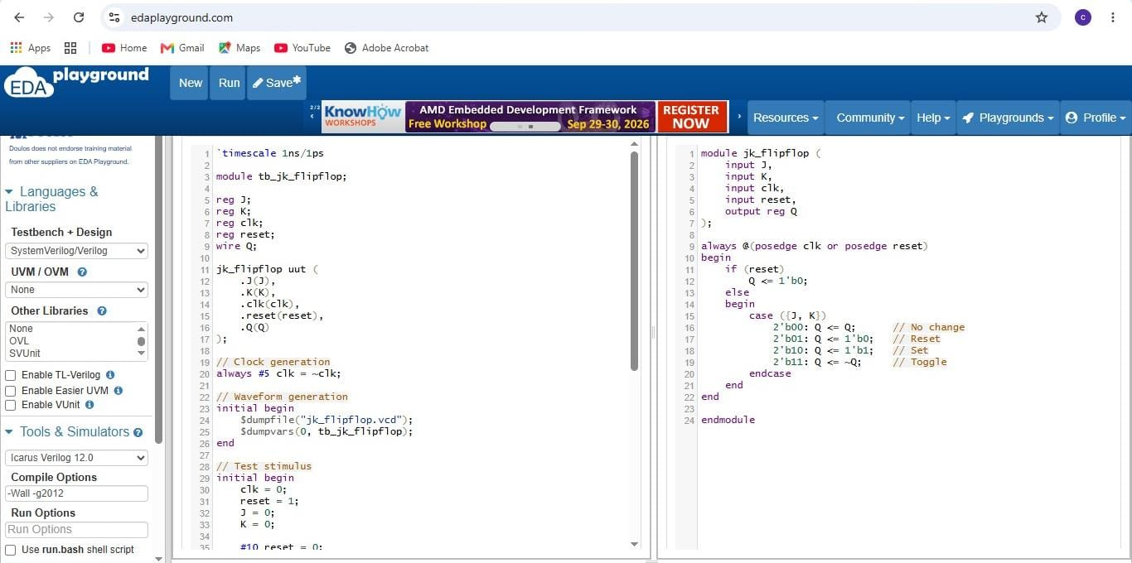
SIMULATION OUTPUT
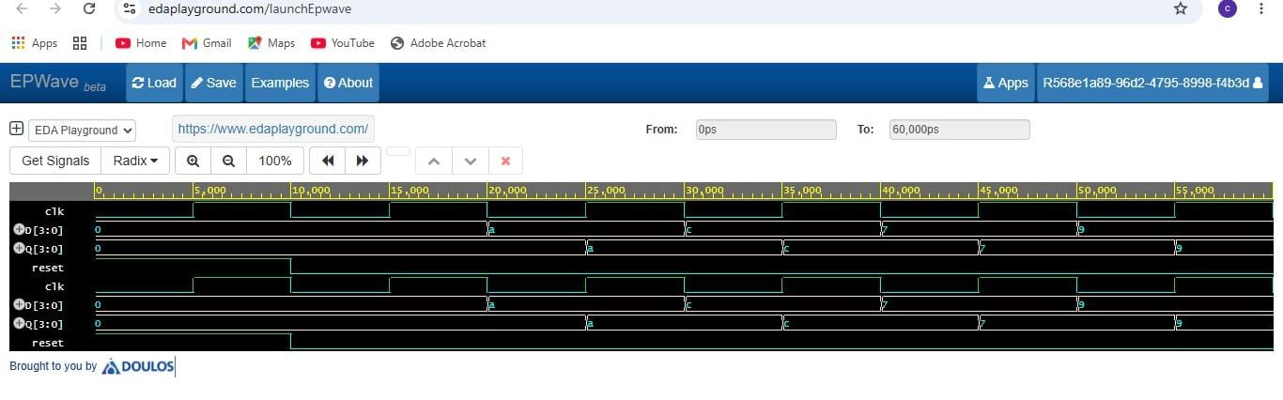
REGISTERS 4BIT
A 4-bit register is a sequential circuit used to store 4 bits of binary data. It is made using four flip-flops and stores the input data according to the clock signal. The stored data is available at the output until new data is loaded or the register is reset.
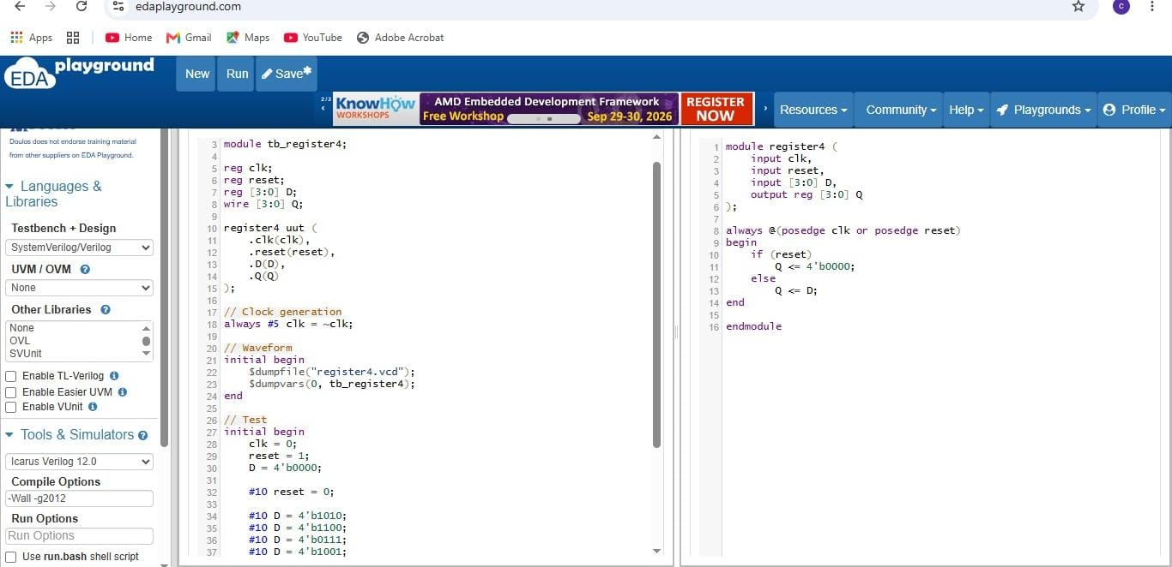
SIMULATION OUTPUT
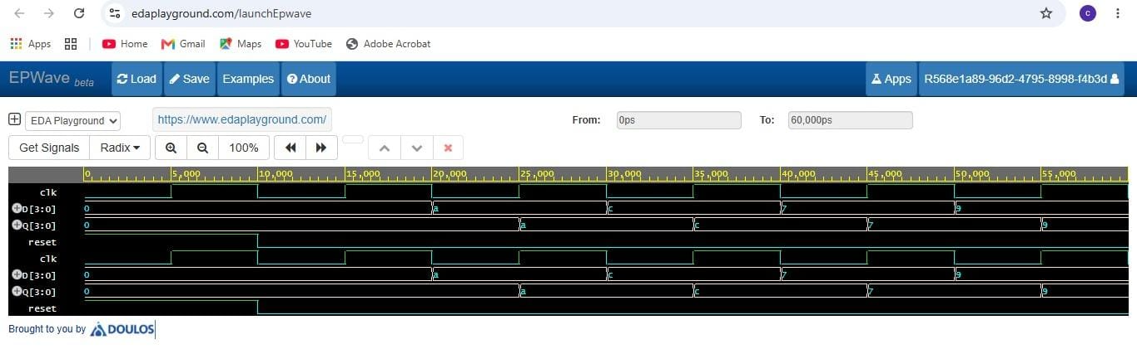
COUNTERS 4-BIT
A 4-bit counter is a sequential circuit used to count clock pulses. It uses four flip-flops and can count from 0000 to 1111, representing decimal values 0 to 15.
0000 → 0001 → 0010 → 0011 → 0100 → 0101 → 0110 → 0111 → 1000 → 1001 → 1010 → 1011 → 1100 → 1101 → 1110 → 1111 → 0000

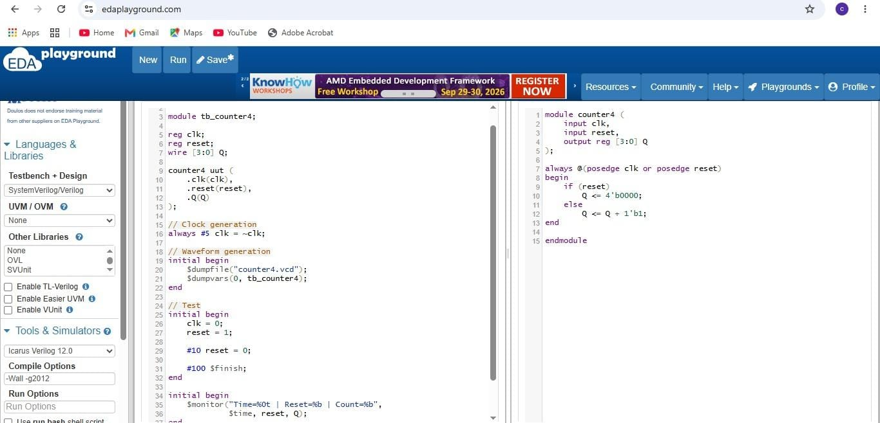
SIMULATION OUTPUT
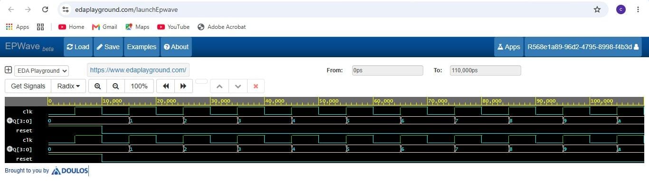

CONCLUSION
The D Flip-Flop, JK Flip-Flop, 4-bit Register, and 4-bit Counter were successfully designed and simulated using Verilog HDL. The working of each circuit was understood through simulation and testbench verification. The output waveforms were observed and matched with the expected results. This helped in gaining practical knowledge of sequential circuit design and Verilog-based simulation.

