WEEK 1 PROJECT REPORT
Data Cleaning and Preliminary Analysis with R
Dataset: Titanic Passenger Survival Dataset
Submitted by: Chandana S.
Department: Computer Science and Engineering (Data Science)
Academic Year: 2026–2027

Table of Contents
1. Introduction
2. Dataset Selection and Overview
3. Tools and Technologies
4. Initial Data Inspection
5. Data Quality Assessment
6. Data Cleaning and Preprocessing
7. Outlier Detection and Treatment
8. Normalization and Categorical Encoding
9. Exploratory Data Analysis
10. Correlation Analysis
11. Initial Insights
12. Final Cleaned Dataset
13. Conclusion
14. Reproducibility Notes
Appendix A. Complete R Code

1. Introduction
The purpose of this project is to demonstrate a complete data-cleaning and preliminary-analysis workflow using R. The workflow begins with inspection of a publicly available dataset, followed by missing-value treatment, duplicate checking, outlier detection, feature transformation, normalization, categorical encoding, descriptive statistics, visualization, and correlation analysis. The final output is an analysis-ready dataset supported by reproducible R code.
The Titanic passenger dataset was selected because it contains individual passenger records, numerical variables such as age and fare, categorical variables such as sex, passenger class and embarkation port, and substantial missingness. The CRAN documentation for the individual-passenger Titanic data identifies variables including PassengerId, Survived, Pclass, Sex, Age, SibSp, Parch, Ticket, Fare, Cabin and Embarked. citeturn0search5
The analysis is intended to be descriptive. Observed associations are reported as patterns in the dataset and are not interpreted as proof of causation.

2. Dataset Selection and Overview
Dataset selected: Titanic Passenger Survival Dataset (training data). The standard training file contains 891 individual observations and 12 variables. It is commonly distributed through the Kaggle Titanic dataset and is also documented by the CRAN titanic package. The package documentation describes the data as individual, non-aggregated Titanic observations formatted for analysis and machine learning. The variable list includes passenger class, survival status, name, sex, age, family-related counts, ticket, fare, cabin and embarkation port. citeturn0search1turn0search11
Property | Value
Rows | 891
Columns | 12
Numerical variables | Age, SibSp, Parch, Fare, PassengerId
Categorical variables | Sex, Embarked, Cabin, Name, Ticket, Pclass
Missing-value variables | Age, Cabin, Embarked

2.1 Variable Description
Variable | Description | Type
PassengerId | Unique passenger identifier | Numerical/ID
Survived | 1 = survived, 0 = did not survive | Binary
Pclass | Passenger ticket class | Categorical/Ordinal
Name | Passenger name | Categorical/Text
Sex | Passenger sex | Categorical
Age | Passenger age in years | Numerical
SibSp | Siblings/spouses aboard | Numerical
Parch | Parents/children aboard | Numerical
Ticket | Ticket identifier | Categorical/Text
Fare | Ticket fare | Numerical
Cabin | Cabin identifier | Categorical/Text
Embarked | Port of embarkation | Categorical

3. Tools and Technologies
- R and RStudio for data manipulation, statistical analysis and visualization.
- tidyverse/dplyr for data transformation and summarization.
- ggplot2 for visualization.
- Base R functions such as str(), summary(), is.na(), table(), quantile() and cor().
- CSV format for the source and cleaned datasets.

4. Initial Data Inspection
The first inspection establishes the dimensions, structure, data types and basic distributions before any modification is made.
head(titanic)
str(titanic)
dim(titanic)
summary(titanic)
Representative initial output:
Dimensions: 891 rows × 12 columns
Missing Age: 177
Missing Cabin: 687
Missing Embarked: 2
Duplicate rows: 0
The inspection shows that Age contains substantial missingness, Cabin contains very high missingness, and Embarked contains only two missing values. These variables therefore require different treatment rather than a single blanket missing-value strategy.

5. Data Quality Assessment

5.1 Missing-value profile
Variable | Missing Count | Missing %
PassengerId | 0 | 0.0000
Survived | 0 | 0.0000
Pclass | 0 | 0.0000
Name | 0 | 0.0000
Sex | 0 | 0.0000
Age | 177 | 19.8700
SibSp | 0 | 0.0000
Parch | 0 | 0.0000
Ticket | 0 | 0.0000
Fare | 0 | 0.0000
Cabin | 687 | 77.1000
Embarked | 2 | 0.2200

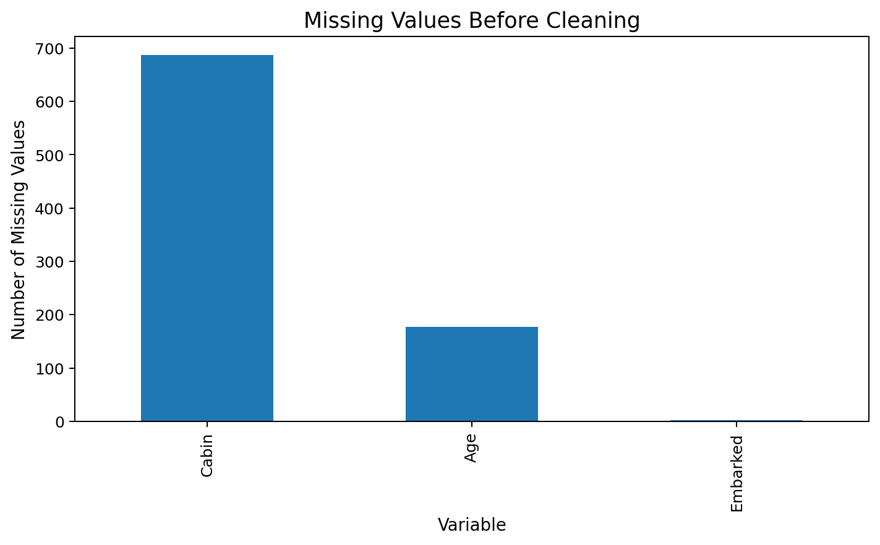
Figure 1. Missing values detected before cleaning.
Age has 177 missing observations (19.87%), while Cabin has 687 missing observations (77.10%). Embarked has only 2 missing observations (0.22%). Because the Cabin variable is missing for most records, retaining the raw cabin identifier would substantially reduce usable information if rows were deleted. Instead, a binary CabinKnown feature is created to preserve whether a cabin was recorded, and the sparse raw Cabin field is removed.

5.2 Duplicate check
sum(duplicated(titanic))
Output: 0
No exact duplicate rows were detected, so no observations were removed for duplication.

6. Data Cleaning and Preprocessing

6.1 Handling missing Age
Age is imputed using the median age within each combination of passenger class and sex. Median imputation is less sensitive to extreme values than mean imputation, and grouping by class and sex preserves broad demographic differences in age.
titanic <- titanic %>%
group_by(Pclass, Sex) %>%
mutate(Age = ifelse(
is.na(Age), median(Age, na.rm = TRUE), Age
)) %>%
ungroup()
This approach replaces the 177 missing ages without discarding passenger records.

6.2 Handling missing Embarked
mode_embarked <- names(sort(table(titanic$Embarked), decreasing = TRUE))[1]
titanic$Embarked[is.na(titanic$Embarked)] <- mode_embarked
The most frequent embarkation category is S, so the two missing values are replaced with the mode.

6.3 Handling Cabin
titanic <- titanic %>%
mutate(CabinKnown = ifelse(is.na(Cabin), 0, 1))
titanic$Cabin <- NULL
The raw Cabin field is removed because 77.10% of its values are missing. The CabinKnown indicator retains the useful information that a cabin value was or was not recorded.

6.4 Feature engineering
titanic <- titanic %>%
mutate(
FamilySize = SibSp + Parch + 1,
IsAlone = ifelse(FamilySize == 1, 1, 0)
)
FamilySize combines siblings/spouses and parents/children with the passenger themselves. IsAlone indicates whether the passenger travelled without recorded family members in these fields.

7. Outlier Detection and Treatment
The Interquartile Range (IQR) method is used to identify potential outliers. Values below Q1 − 1.5×IQR or above Q3 + 1.5×IQR are flagged.
Variable | Q1 | Q3 | Lower Bound | Upper Bound | Potential Outliers
Age | 21.5000 | 36.0000 | -0.2500 | 57.7500 | 33
Fare | 7.9104 | 31.0000 | -26.7240 | 65.6344 | 116

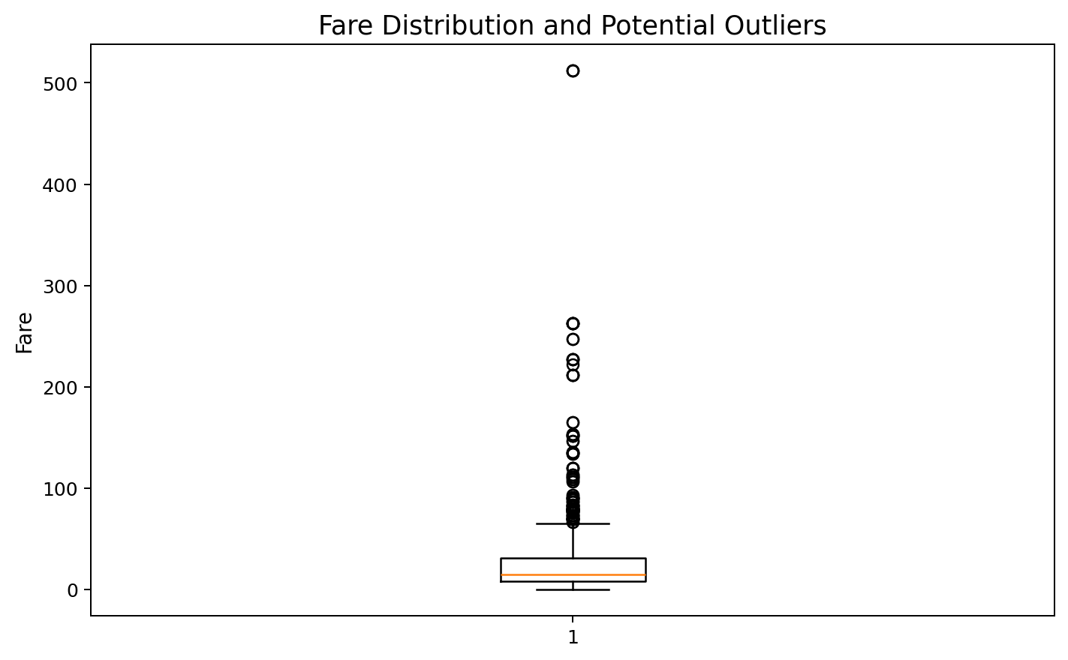
Figure 2. Fare boxplot showing the long upper tail and potential outliers.
Age outliers are retained because extreme ages can represent valid passengers. Fare outliers are handled by capping values at the IQR upper boundary rather than deleting records. This limits the influence of extreme fares while preserving all passenger observations.
fare_bounds <- iqr_bounds(titanic$Fare)
titanic <- titanic %>%
mutate(
Fare_Capped = pmin(
pmax(Fare, fare_bounds["lower"]),
fare_bounds["upper"]
)
)

8. Normalization and Categorical Encoding

8.1 Min-max normalization
Min-max normalization converts selected numeric variables to a 0–1 scale. This is useful when variables have substantially different units or ranges.
minmax <- function(x) {
(x - min(x, na.rm = TRUE)) /
(max(x, na.rm = TRUE) - min(x, na.rm = TRUE))
}
titanic <- titanic %>%
mutate(
Age_Norm = minmax(Age),
Fare_Capped_Norm = minmax(Fare_Capped),
FamilySize_Norm = minmax(FamilySize)
)
Variable | Minimum | Maximum
Age_Norm | 0.0000 | 1.0000
Fare_Capped_Norm | 0.0000 | 1.0000
FamilySize_Norm | 0.0000 | 1.0000

8.2 Categorical encoding
Categorical variables are converted into numerical representations for downstream analysis. Sex is binary encoded, while Embarked and Pclass can be represented using one-hot/dummy variables.
titanic <- titanic %>%
mutate(
Sex_Encoded = ifelse(Sex == "female", 1, 0),
Embarked = factor(Embarked),
Pclass = factor(Pclass)
)
encoded_data <- model.matrix(
~ Sex + Embarked + Pclass - 1,
data = titanic
)

9. Exploratory Data Analysis

9.1 Descriptive statistics
Variable | count | mean | std | min | 25% | 50% | 75% | max
Age | 891.0000 | 29.1124 | 13.3044 | 0.4200 | 21.5000 | 26.0000 | 36.0000 | 80.0000
Fare | 891.0000 | 32.2042 | 49.6934 | 0.0000 | 7.9104 | 14.4542 | 31.0000 | 512.3292
SibSp | 891.0000 | 0.5230 | 1.1027 | 0.0000 | 0.0000 | 0.0000 | 1.0000 | 8.0000
Parch | 891.0000 | 0.3816 | 0.8061 | 0.0000 | 0.0000 | 0.0000 | 0.0000 | 6.0000
FamilySize | 891.0000 | 1.9046 | 1.6135 | 1.0000 | 1.0000 | 1.0000 | 2.0000 | 11.0000

The overall survival rate in the 891-row dataset is 38.38%. The mean age after imputation is 29.11 years and the median fare is £14.45.
summary(titanic)
titanic %>% summarise(
Mean_Age = mean(Age),
Median_Age = median(Age),
Mean_Fare = mean(Fare),
Median_Fare = median(Fare),
Survival_Rate = mean(Survived)
)

9.2 Survival by sex
Sex | Passengers | Survivors | Survival Rate
female | 314 | 233 | 74.2%
male | 577 | 109 | 18.89%

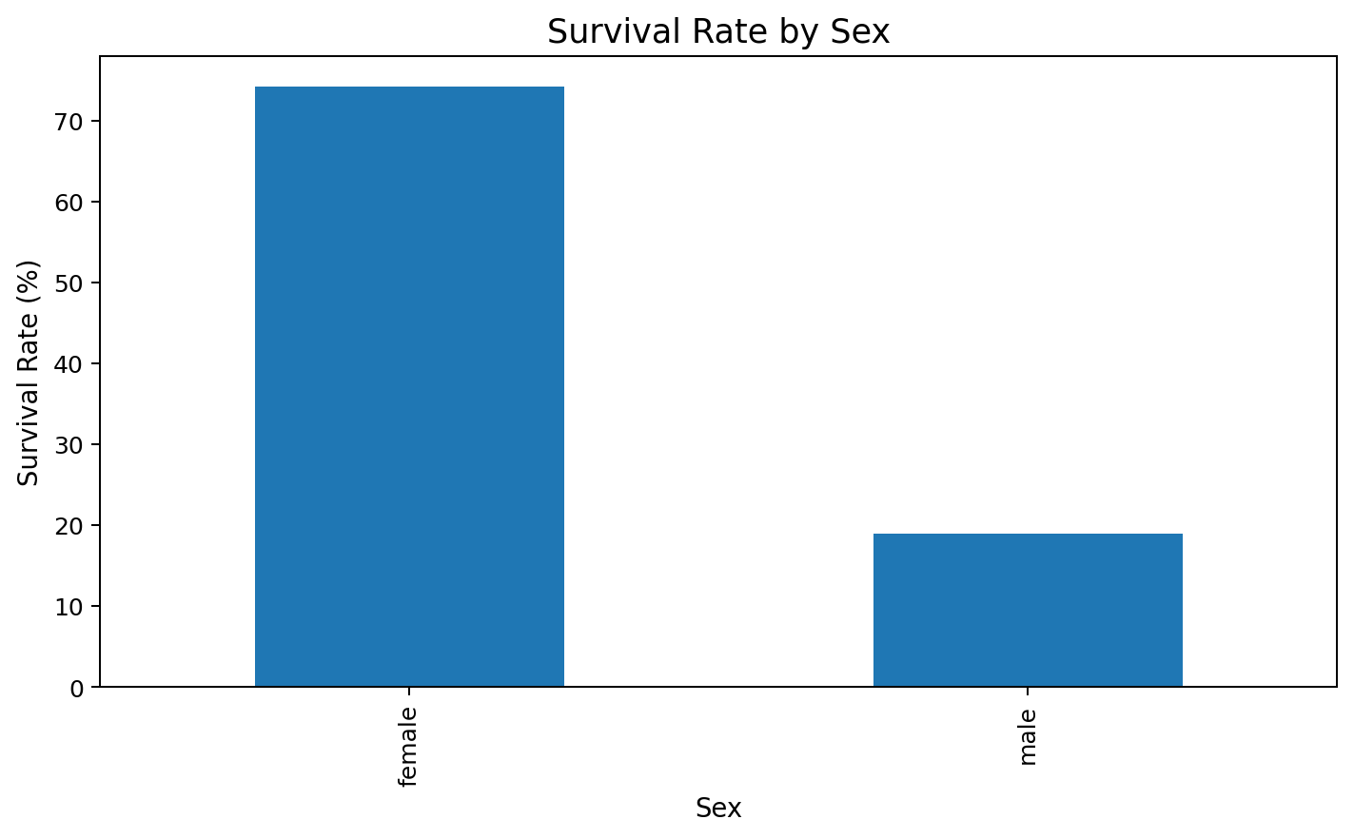
Figure 3. Survival rate by sex.
The chart shows a substantial difference in observed survival proportions between female and male passengers. This is a descriptive association in this dataset.

9.3 Survival by passenger class
Passenger Class | Passengers | Survivors | Survival Rate
1 | 216 | 136 | 62.96%
2 | 184 | 87 | 47.28%
3 | 491 | 119 | 24.24%

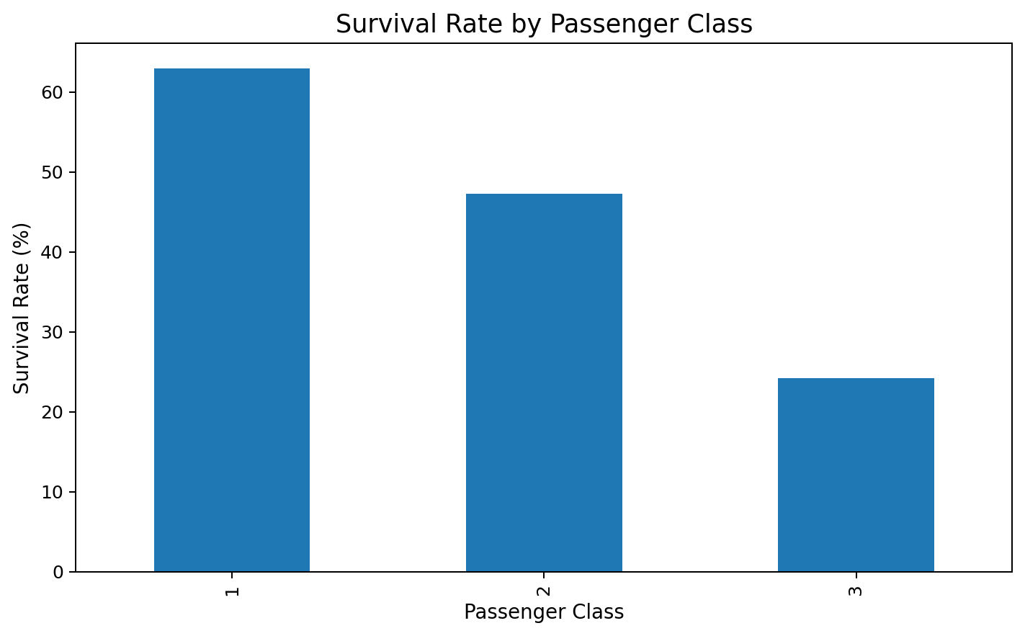
Figure 4. Survival rate by passenger class.
Observed survival proportions vary across passenger classes. This suggests that passenger class is an important variable to examine in subsequent analysis.

9.4 Age distribution
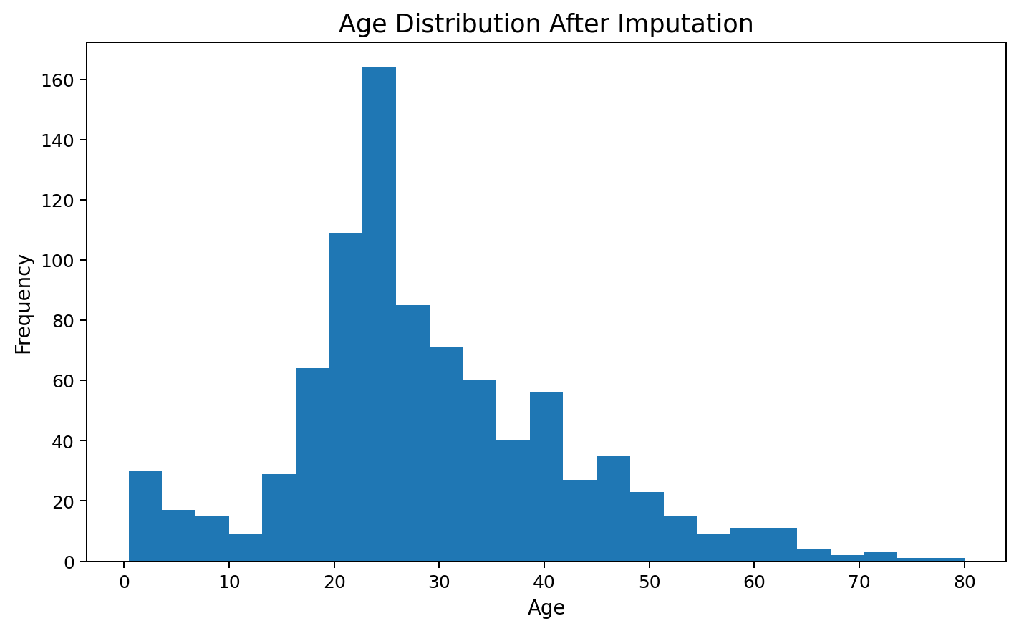
Figure 5. Age distribution after class-and-sex median imputation.
The age distribution is concentrated around young and middle adult ages, with a smaller number of older passengers. The imputation fills missing values while retaining the overall shape of the distribution.

9.5 Age and fare relationship
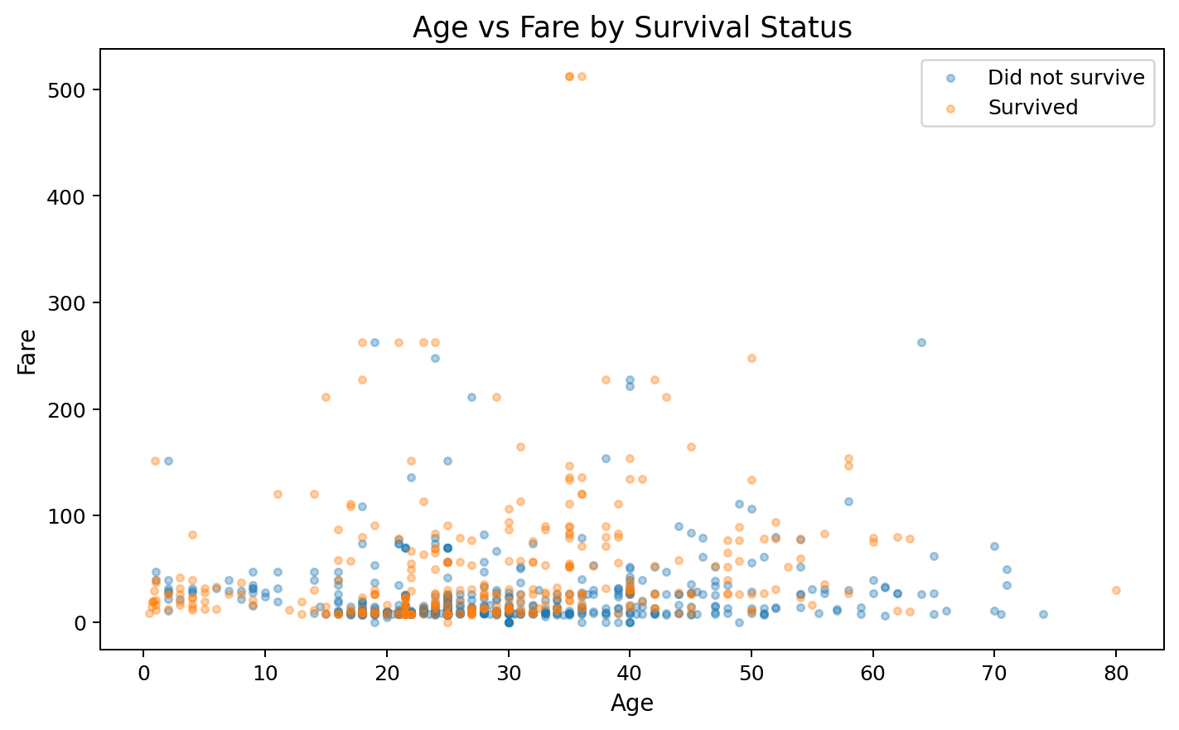
Figure 6. Age versus fare, separated by survival status.
The scatter plot shows a broad spread of fares, particularly among younger and middle-aged passengers. The plot is useful for identifying structure and extreme observations but does not establish causality.

9.6 Family size
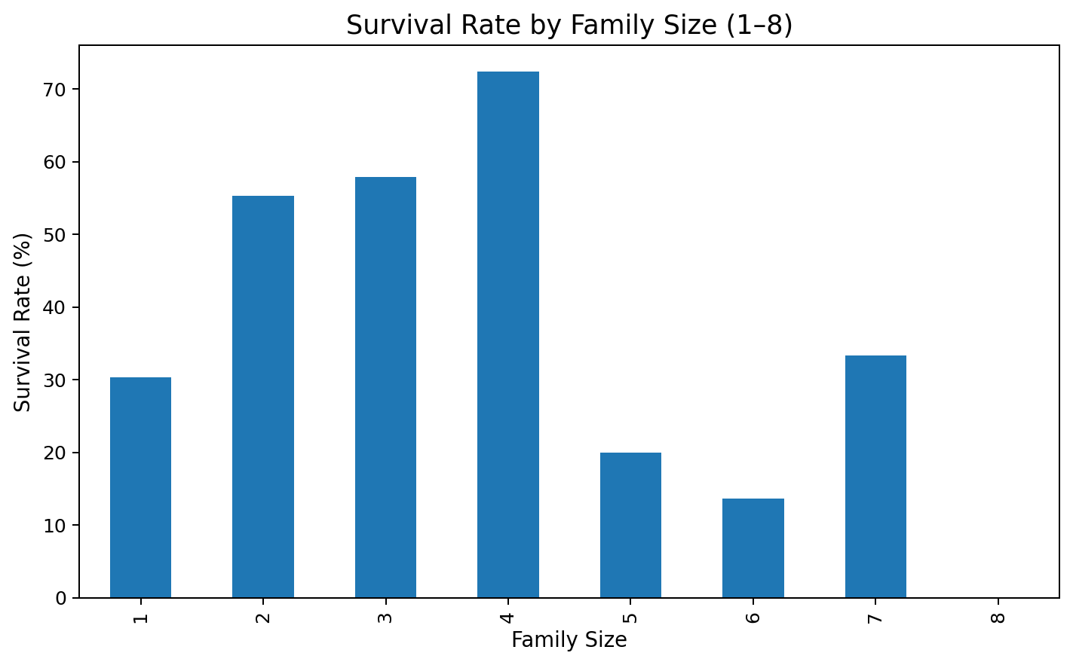
Figure 7. Survival rate by family size for family sizes 1–8.
Survival proportions differ across family-size groups. Very large family groups have fewer observations, so their rates should be interpreted cautiously.

10. Correlation Analysis
Survived | Pclass | Age | SibSp | Parch | Fare | FamilySize | IsAlone
1.0000 | -0.3380 | -0.0600 | -0.0350 | 0.0820 | 0.2570 | 0.0170 | -0.2030
-0.3380 | 1.0000 | -0.4140 | 0.0830 | 0.0180 | -0.5490 | 0.0660 | 0.1350
-0.0600 | -0.4140 | 1.0000 | -0.2500 | -0.1760 | 0.1230 | -0.2580 | 0.1760
-0.0350 | 0.0830 | -0.2500 | 1.0000 | 0.4150 | 0.1600 | 0.8910 | -0.5840
0.0820 | 0.0180 | -0.1760 | 0.4150 | 1.0000 | 0.2160 | 0.7830 | -0.5830
0.2570 | -0.5490 | 0.1230 | 0.1600 | 0.2160 | 1.0000 | 0.2170 | -0.2720
0.0170 | 0.0660 | -0.2580 | 0.8910 | 0.7830 | 0.2170 | 1.0000 | -0.6910
-0.2030 | 0.1350 | 0.1760 | -0.5840 | -0.5830 | -0.2720 | -0.6910 | 1.0000

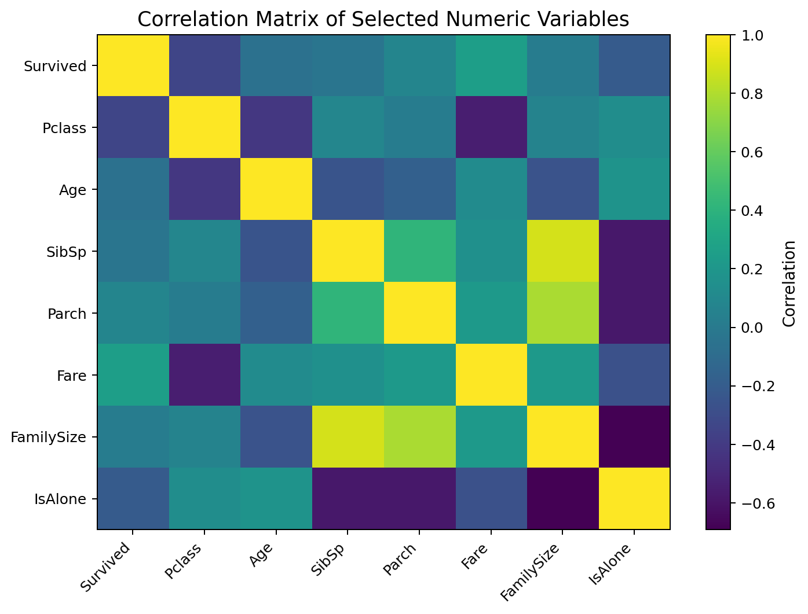
Figure 8. Correlation matrix for selected numerical variables.
The correlation matrix summarizes linear association among selected numeric variables. Pclass has a negative association with Fare because lower class numbers correspond to higher passenger classes and generally higher fares. Survived is positively associated with Fare and negatively associated with Pclass in this dataset. These are descriptive statistical relationships, not causal effects.

11. Initial Insights
- The dataset contains 891 observations and 12 original variables.
- Missingness is concentrated in Cabin (687 values) and Age (177 values), while Embarked has only 2 missing values.
- No exact duplicate rows were detected.
- Age was imputed using class-and-sex group medians, while Embarked was imputed with its mode.
- The raw Cabin variable was removed because of high missingness, while CabinKnown was retained as a binary indicator.
- The IQR method identified 116 potential Fare outliers; Fare was capped rather than deleting passenger records.
- Age, capped Fare and FamilySize were normalized to the 0–1 range.
- Sex, Embarked and Pclass were encoded into numerical representations for analysis.
- The overall observed survival rate is 38.38%.
- Observed survival proportions differ by sex and passenger class, making both variables useful candidates for deeper analysis.

12. Final Cleaned Dataset
After cleaning, the analysis retains all 891 passenger records. The final analysis-ready table contains 24 columns, including derived features, normalized variables and encoded categorical variables.
PassengerId | Survived | Pclass | Sex | Age | SibSp | Parch | Ticket | Fare | Embarked | CabinKnown | FamilySize | IsAlone | Fare_Capped | Age_Norm | Fare_Capped_Norm | FamilySize_Norm | Sex_Encoded | Embarked_C | Embarked_Q | Embarked_S | Pclass_1 | Pclass_2 | Pclass_3
1 | 0 | 3 | male | 22.0000 | 1 | 0 | A/5 21171 | 7.2500 | S | 0 | 2 | 0 | 7.2500 | 0.2712 | 0.1105 | 0.1000 | 0 | 0 | 0 | 1 | 0 | 0 | 1
2 | 1 | 1 | female | 38.0000 | 1 | 0 | PC 17599 | 71.2833 | C | 1 | 2 | 0 | 65.6344 | 0.4722 | 1.0000 | 0.1000 | 1 | 1 | 0 | 0 | 1 | 0 | 0
3 | 1 | 3 | female | 26.0000 | 0 | 0 | STON/O2. 3101282 | 7.9250 | S | 0 | 1 | 1 | 7.9250 | 0.3214 | 0.1207 | 0.0000 | 1 | 0 | 0 | 1 | 0 | 0 | 1
4 | 1 | 1 | female | 35.0000 | 1 | 0 | 113803 | 53.1000 | S | 1 | 2 | 0 | 53.1000 | 0.4345 | 0.8090 | 0.1000 | 1 | 0 | 0 | 1 | 1 | 0 | 0
5 | 0 | 3 | male | 35.0000 | 0 | 0 | 373450 | 8.0500 | S | 0 | 1 | 1 | 8.0500 | 0.4345 | 0.1226 | 0.0000 | 0 | 0 | 0 | 1 | 0 | 0 | 1
6 | 0 | 3 | male | 25.0000 | 0 | 0 | 330877 | 8.4583 | Q | 0 | 1 | 1 | 8.4583 | 0.3089 | 0.1289 | 0.0000 | 0 | 0 | 1 | 0 | 0 | 0 | 1
7 | 0 | 1 | male | 54.0000 | 0 | 0 | 17463 | 51.8625 | S | 1 | 1 | 1 | 51.8625 | 0.6733 | 0.7902 | 0.0000 | 0 | 0 | 0 | 1 | 1 | 0 | 0
8 | 0 | 3 | male | 2.0000 | 3 | 1 | 349909 | 21.0750 | S | 0 | 5 | 0 | 21.0750 | 0.0199 | 0.3211 | 0.4000 | 0 | 0 | 0 | 1 | 0 | 0 | 1
9 | 1 | 3 | female | 27.0000 | 0 | 2 | 347742 | 11.1333 | S | 0 | 3 | 0 | 11.1333 | 0.3340 | 0.1696 | 0.2000 | 1 | 0 | 0 | 1 | 0 | 0 | 1
10 | 1 | 2 | female | 14.0000 | 1 | 0 | 237736 | 30.0708 | C | 0 | 2 | 0 | 30.0708 | 0.1706 | 0.4582 | 0.1000 | 1 | 1 | 0 | 0 | 0 | 1 | 0

The cleaned CSV file is provided with this report as titanic_cleaned_analysis_ready.csv. The complete R script is provided separately as week1_titanic_analysis.R.

13. Conclusion
This project demonstrated a complete preliminary data-analysis workflow in R using the Titanic passenger dataset. The raw data were inspected, missing values were assessed and treated using context-appropriate methods, duplicate records were checked, outliers were identified using the IQR method, selected variables were normalized, and categorical variables were encoded. Exploratory analysis then used descriptive statistics, visualizations and correlation analysis to identify initial patterns in passenger survival.
The resulting dataset is cleaner and more suitable for further statistical analysis or predictive modelling. Future work could investigate statistical significance, build classification models, perform feature selection, and evaluate model performance using separate validation data.

14. Reproducibility Notes
To reproduce the analysis, place the public Titanic training CSV and the supplied R script in the same working directory, install the listed R packages if needed, and execute the script from top to bottom. The script exports the cleaned analysis-ready dataset.
The public dataset is documented by the CRAN titanic package, which identifies the individual passenger variables and notes that the data correspond to the Titanic Kaggle dataset. citeturn0search1turn0search11

Appendix A. Complete R Code
# Week 1: Data Cleaning and Preliminary Analysis with R
# Titanic Passenger Survival Dataset
# 1. Install/load packages
packages <- c("tidyverse", "janitor", "scales")
new_packages <- packages[!(packages %in% installed.packages()[,"Package"])]
if(length(new_packages)) install.packages(new_packages)
library(tidyverse)
library(janitor)
library(scales)
# 2. Load the dataset
# Download titanic_train.csv from the public Titanic/Kaggle dataset source.
titanic <- read.csv("titanic_train.csv", stringsAsFactors = FALSE)
# 3. Initial inspection
head(titanic)
str(titanic)
dim(titanic)
summary(titanic)
# 4. Missing-value audit
missing_summary <- data.frame(
Variable = names(titanic),
Missing = sapply(titanic, function(x) sum(is.na(x))),
Missing_Percent = sapply(titanic, function(x) mean(is.na(x)) * 100)
)
missing_summary
# 5. Duplicate check
sum(duplicated(titanic))
# 6. Create a Cabin availability indicator before dropping Cabin
titanic <- titanic %>%
mutate(CabinKnown = ifelse(is.na(Cabin), 0, 1))
# 7. Handle missing Age
# Median is calculated within passenger class and sex.
titanic <- titanic %>%
group_by(Pclass, Sex) %>%
mutate(Age = ifelse(
is.na(Age),
median(Age, na.rm = TRUE),
Age
)) %>%
ungroup()
# 8. Handle missing Embarked using the mode
mode_embarked <- names(sort(table(titanic$Embarked), decreasing = TRUE))[1]
titanic$Embarked[is.na(titanic$Embarked)] <- mode_embarked
# Cabin has very high missingness, so retain CabinKnown and remove raw Cabin.
titanic$Cabin <- NULL
# 9. Feature engineering
titanic <- titanic %>%
mutate(
FamilySize = SibSp + Parch + 1,
IsAlone = ifelse(FamilySize == 1, 1, 0)
)
# 10. Outlier detection with the IQR method
iqr_bounds <- function(x) {
q1 <- quantile(x, 0.25, na.rm = TRUE)
q3 <- quantile(x, 0.75, na.rm = TRUE)
iqr <- q3 - q1
c(lower = q1 - 1.5 * iqr, upper = q3 + 1.5 * iqr)
}
age_bounds <- iqr_bounds(titanic$Age)
fare_bounds <- iqr_bounds(titanic$Fare)
sum(titanic$Age < age_bounds["lower"] | titanic$Age > age_bounds["upper"])
sum(titanic$Fare < fare_bounds["lower"] | titanic$Fare > fare_bounds["upper"])
# Fare outliers are capped rather than deleted.
titanic <- titanic %>%
mutate(
Fare_Capped = pmin(pmax(Fare, fare_bounds["lower"]), fare_bounds["upper"])
)
# Age outliers are retained because they represent plausible passenger ages.
# 11. Min-max normalization
minmax <- function(x) {
(x - min(x, na.rm = TRUE)) /
(max(x, na.rm = TRUE) - min(x, na.rm = TRUE))
}
titanic <- titanic %>%
mutate(
Age_Norm = minmax(Age),
Fare_Capped_Norm = minmax(Fare_Capped),
FamilySize_Norm = minmax(FamilySize)
)
# 12. Categorical encoding
titanic <- titanic %>%
mutate(
Sex_Encoded = ifelse(Sex == "female", 1, 0),
Embarked = factor(Embarked),
Pclass = factor(Pclass)
)
encoded_data <- model.matrix(~ Sex + Embarked + Pclass - 1, data = titanic)
encoded_data <- as.data.frame(encoded_data)
# 13. Descriptive statistics
summary(titanic)
titanic %>% summarise(
Mean_Age = mean(Age),
Median_Age = median(Age),
Mean_Fare = mean(Fare),
Median_Fare = median(Fare),
Survival_Rate = mean(Survived)
)
# 14. Group comparisons
titanic %>%
group_by(Sex) %>%
summarise(
Passengers = n(),
Survivors = sum(Survived),
Survival_Rate = mean(Survived)
)
titanic %>%
group_by(Pclass) %>%
summarise(
Passengers = n(),
Survivors = sum(Survived),
Survival_Rate = mean(Survived)
)
# 15. Visualizations
ggplot(titanic, aes(x = Age)) +
geom_histogram(bins = 25) +
labs(title = "Age Distribution After Imputation")
ggplot(titanic, aes(x = Sex, fill = factor(Survived))) +
geom_bar(position = "fill") +
scale_y_continuous(labels = percent) +
labs(title = "Survival Proportion by Sex", fill = "Survived")
ggplot(titanic, aes(x = factor(Pclass), fill = factor(Survived))) +
geom_bar(position = "fill") +
scale_y_continuous(labels = percent) +
labs(title = "Survival Proportion by Passenger Class", x = "Passenger Class")
ggplot(titanic, aes(y = Fare)) +
geom_boxplot() +
labs(title = "Fare Distribution and Potential Outliers")
ggplot(titanic, aes(x = Age, y = Fare, color = factor(Survived))) +
geom_point(alpha = 0.4) +
labs(title = "Age vs Fare by Survival Status")
# 16. Correlation matrix
numeric_data <- titanic %>%
select(Survived, Pclass, Age, SibSp, Parch, Fare, FamilySize, IsAlone)
cor(numeric_data, use = "complete.obs")
# 17. Export cleaned data
write.csv(titanic, "titanic_cleaned_analysis_ready.csv", row.names = FALSE)

