WEEK 2 PROJECT REPORT
Data Visualization and Insight Communication using R
Dataset: Titanic Passenger Survival Dataset
Submitted by: Chandana S.
Department: Computer Science and Engineering (Data Science)
Week 2 – Visualization and Communication

Table of Contents
1. Introduction and Objective
2. Dataset Overview
3. Visualization Design Principles
4. Visualization 1 – Passenger Distribution by Class
5. Visualization 2 – Age Distribution
6. Visualization 3 – Age and Fare Scatter Plot
7. Visualization 4 – Survival Trend Across Age Groups
8. Visualization 5 – Survival by Class and Sex
9. Visualization 6 – Fare Distribution by Class
10. Visualization 7 – Survival by Family Size
11. Visualization 8 – Survival by Embarkation Port
12. Cross-Visualization Insights
13. Communication for a Non-Technical Audience
14. Conclusion
Appendix A – Complete R Code

1. Introduction and Objective
This Week 2 project extends the Week 1 Titanic data-cleaning project into visualization and insight communication. The objective is not only to create graphs, but to select a suitable visual form for each analytical question and explain the resulting pattern in language that a non-technical audience can understand.
The Titanic training dataset contains 891 passenger records with variables including survival outcome, passenger class, sex, age, family-related counts, fare, cabin and embarkation port. Kaggle describes the training set as the 891-passenger portion for which the survival outcome is available. citeturn0search0turn0search1

2. Dataset Overview
The same cleaned Titanic dataset from Week 1 is used to maintain continuity. The visualization dataset contains 891 passenger records. Age and other fields have already undergone the documented Week 1 cleaning process. New visualization-only variables, such as ordered age groups, are created for communication purposes.
Variable | Role in Week 2
Survived | Outcome used for comparison
Pclass | Passenger-group comparison
Sex | Group comparison
Age | Distribution and age-group trend
Fare | Numeric relationship and group spread
FamilySize | Ordered group trend
Embarked | Category comparison

Kaggle's data dictionary defines Survived as the binary survival outcome, Pclass as passenger ticket class, Age as age in years, Fare as passenger fare, and Embarked as the embarkation port. It also notes that Pclass acts as a proxy for socio-economic status in the dataset. citeturn0search0

3. Visualization Design Principles
- Use bar charts when the main task is comparing categories.
- Use histograms to communicate the distribution of a continuous numerical variable.
- Use scatter plots to examine relationships between two numerical variables.
- Use line charts only when the x-axis has a meaningful order; here they are used for ordered age groups and family size.
- Use boxplots to compare median, spread and potential outliers across groups.
- Use informative titles and axis labels so the chart can be understood without reading the code.
- Report sample sizes when a group is small, because a percentage based on very few observations can be unstable.

4. Visualization 1 – Passenger Distribution by Class
Why this visualization was selected: A bar chart was selected because passenger class is a discrete category and the question is a count comparison.
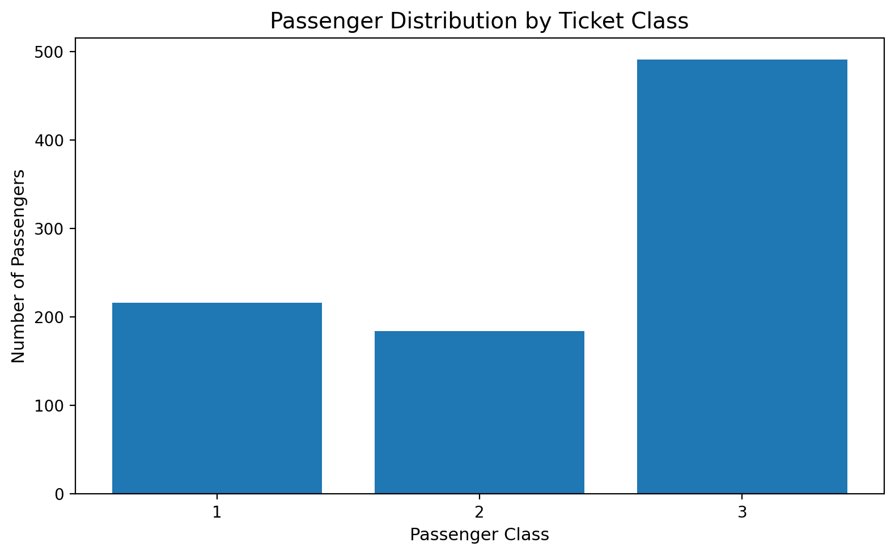
4. Visualization 1 – Passenger Distribution by Class
Interpretation: The chart shows how the 891 passengers are distributed across first, second and third class. Third class contains the largest group, while first class contains the smallest group. This matters because comparisons of survival rates should be interpreted together with the number of passengers represented in each class.

5. Visualization 2 – Age Distribution
Why this visualization was selected: A histogram was selected because Age is a continuous numerical variable and the main question is how passenger ages are distributed.
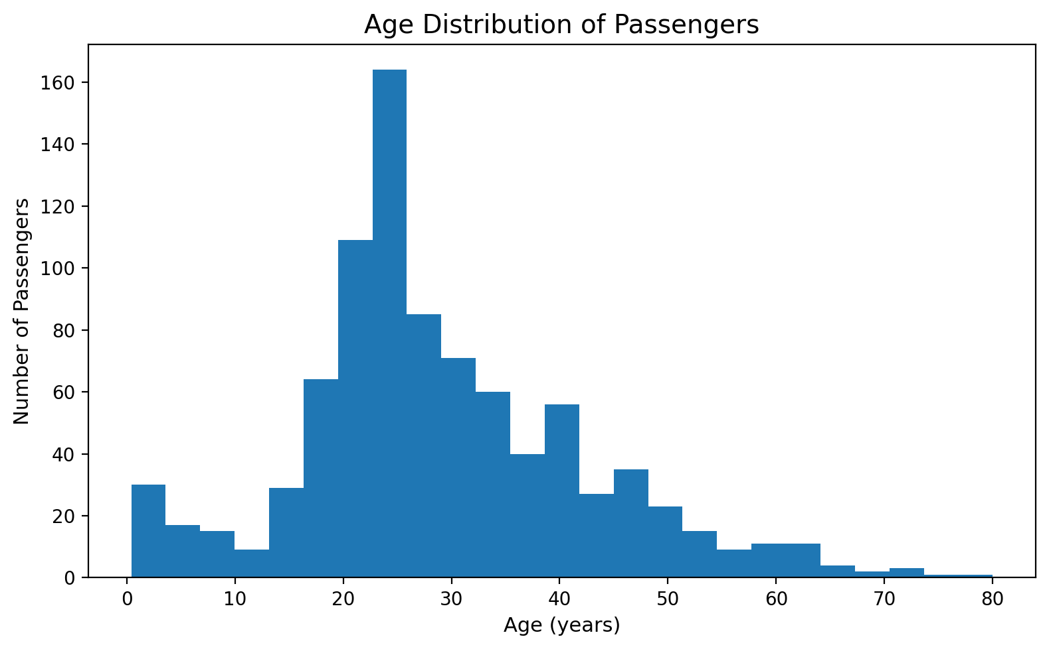
5. Visualization 2 – Age Distribution
Interpretation: Most passengers fall within the young-to-middle adult range, with fewer observations at older ages. The visualization makes the overall concentration and tail of the age distribution easier to understand than a table of summary statistics.

6. Visualization 3 – Age and Fare Scatter Plot
Why this visualization was selected: A scatter plot was selected because both Age and Fare are numerical variables. Survival status is used as a visual grouping variable.
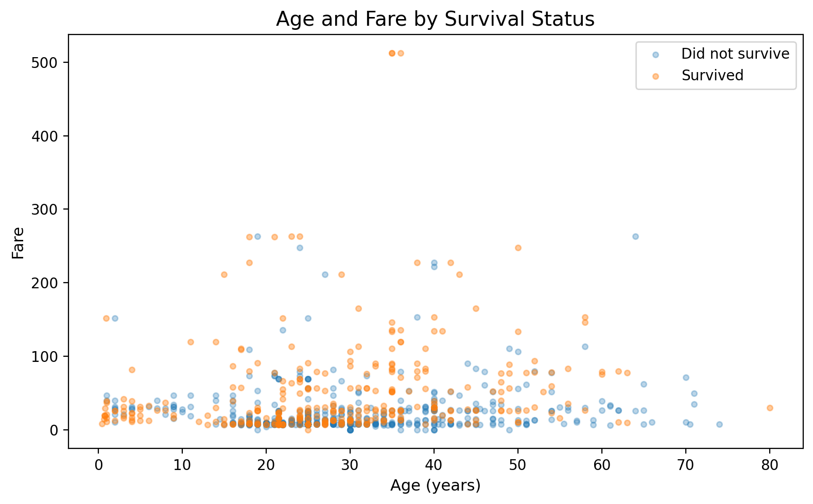
6. Visualization 3 – Age and Fare Scatter Plot
Interpretation: The plot shows a wide range of fares and a concentration of observations at lower fares. Higher fares occur more often among first-class passengers, while passengers across a broad age range appear at lower fares. The chart is useful for seeing joint patterns and unusual observations; it does not establish a causal relationship.

7. Visualization 4 – Survival Trend Across Age Groups
Why this visualization was selected: An ordered line chart was selected after grouping age into six meaningful bands. The age groups have a natural order, so the line emphasizes how the observed survival rate changes from younger to older groups.
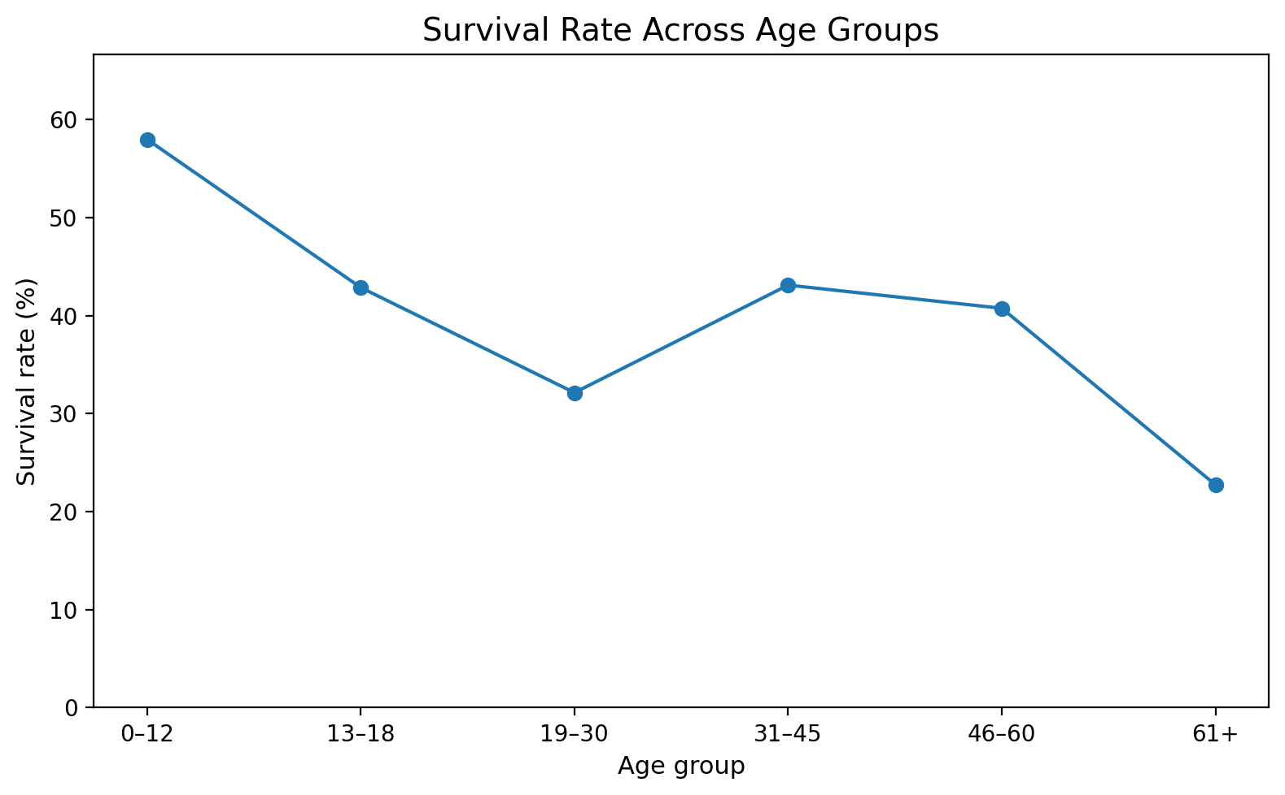
7. Visualization 4 – Survival Trend Across Age Groups
Interpretation: The survival rate varies across age bands rather than remaining constant. The youngest group and some adult groups show different observed proportions. Because the groups have different sample sizes, the rate should be read alongside the passenger counts rather than treated as equally precise across all ages.

8. Visualization 5 – Survival by Class and Sex
Why this visualization was selected: A grouped bar chart was selected because the analysis compares two categorical dimensions simultaneously: passenger class and sex.
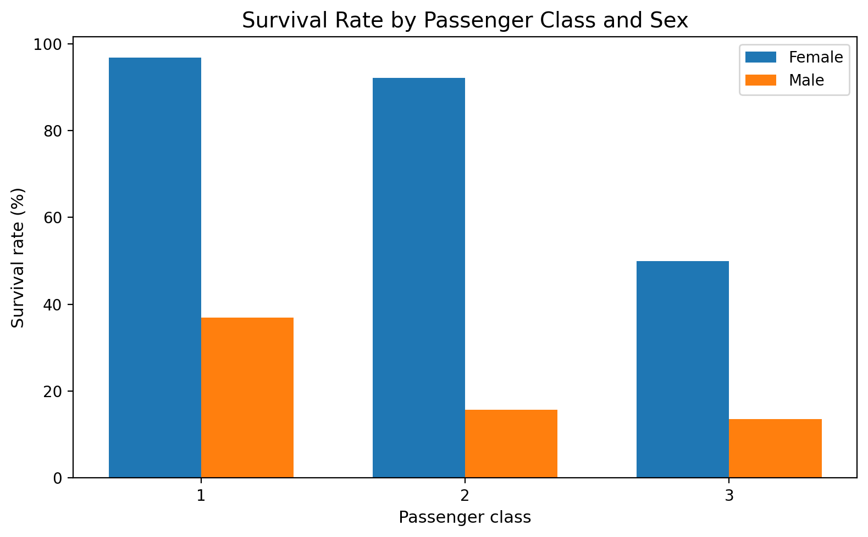
8. Visualization 5 – Survival by Class and Sex
Interpretation: The chart reveals a pronounced difference in observed survival rates between female and male passengers within passenger classes. It also shows that survival proportions differ across classes. This combined view is more informative than examining sex or class separately because it exposes how the two groupings intersect.

9. Visualization 6 – Fare Distribution by Class
Why this visualization was selected: A boxplot was selected because the goal is to compare the distribution of fares across passenger classes, including median, spread and potential extreme values.
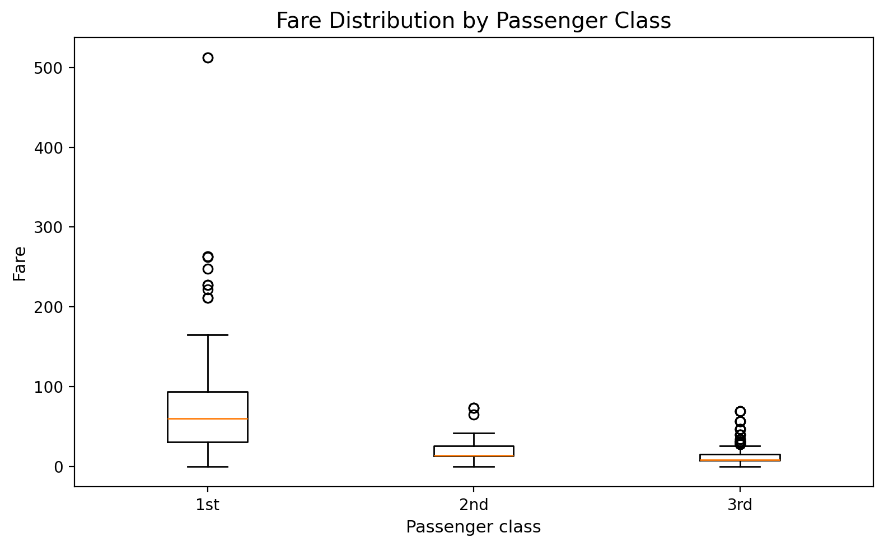
9. Visualization 6 – Fare Distribution by Class
Interpretation: First-class fares have a higher central tendency and wider upper range than second- and third-class fares. The boxplot also makes extreme fare observations visible without requiring every individual fare to be labelled.

10. Visualization 7 – Survival by Family Size
Why this visualization was selected: An ordered line chart was used to show how the observed survival proportion changes across family-size values from 1 through 8. Family sizes above 8 are excluded from this specific visualization because they contain fewer observations and can dominate the visual trend.
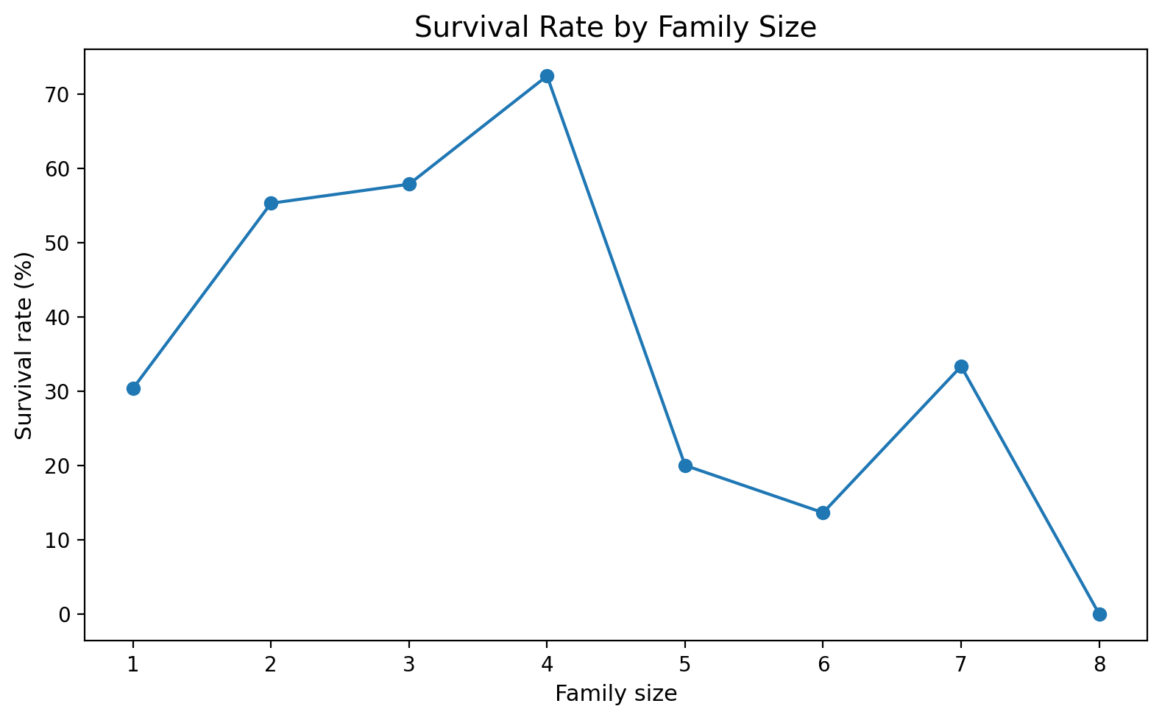
10. Visualization 7 – Survival by Family Size
Interpretation: The observed survival rate changes across family-size groups. The relationship is not a simple steadily increasing or decreasing pattern. Small groups should be interpreted carefully because a percentage based on a small number of passengers can change substantially with only a few observations.

11. Visualization 8 – Survival by Embarkation Port
Why this visualization was selected: A bar chart was selected to compare the observed survival proportion across the three embarkation categories.
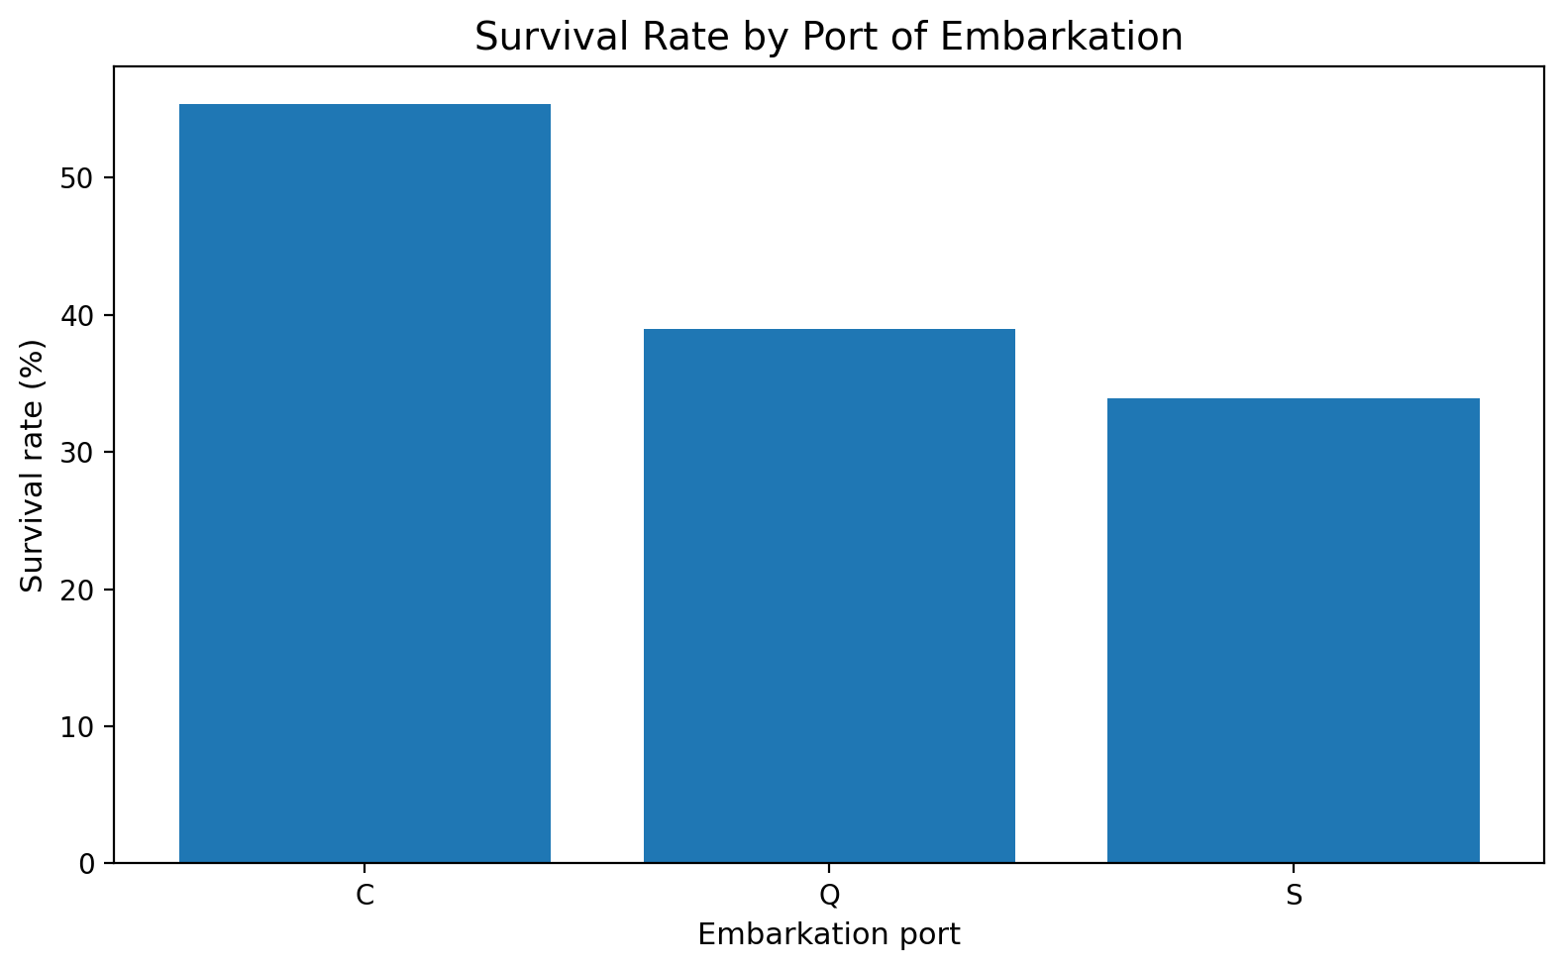
11. Visualization 8 – Survival by Embarkation Port
Interpretation: The survival rate differs across embarkation ports. However, embarkation is also related to passenger composition and class in the historical dataset, so this chart should be interpreted as a descriptive comparison rather than evidence that the port itself caused the difference.

Age-group summary used for Visualization 4
AgeGroup | Passengers | Survivors | Survival Rate (%)
0–12 | 69 | 40 | 57.97
13–18 | 70 | 30 | 42.86
19–30 | 417 | 134 | 32.13
31–45 | 232 | 100 | 43.10
46–60 | 81 | 33 | 40.74
61+ | 22 | 5 | 22.73

Class-and-sex summary used for Visualization 5
Passenger Class | Sex | Passengers | Survivors | Survival Rate (%)
1 | female | 94 | 91 | 96.81
1 | male | 122 | 45 | 36.89
2 | female | 76 | 70 | 92.11
2 | male | 108 | 17 | 15.74
3 | female | 144 | 72 | 50.00
3 | male | 347 | 47 | 13.54

12. Cross-Visualization Insights
- Passenger class is an important organizing variable: the dataset has different passenger volumes and different fare distributions across classes.
- Sex and passenger class together reveal stronger differences in observed survival proportions than either variable viewed in isolation.
- Fare is strongly structured by passenger class, so interpreting fare without considering class can be misleading.
- Age is distributed unevenly, with fewer older passengers; therefore age-group survival percentages should be read with their group counts.
- Family size shows a non-linear descriptive pattern, suggesting that grouping passengers only as 'alone' versus 'not alone' can hide additional structure.
- Embarkation-port differences are descriptive and may reflect differences in the types of passengers represented at each port.

13. Communication for a Non-Technical Audience
A non-technical reader does not need to understand R syntax to understand the main story. The visualizations therefore use direct titles, plain-language axis labels and short interpretations.
Question | Visual | Plain-language message
Question | Best visual | Plain-language message
How were passengers distributed? | Bar chart | The passenger groups were not equally sized.
What ages were common? | Histogram | Most passengers were young or middle-aged adults.
Do age and fare vary together? | Scatter plot | Fare varied widely, with high fares concentrated among some passengers.
Does survival vary across age? | Ordered line | Observed survival rates changed across age groups.
Do class and sex matter together descriptively? | Grouped bar | Survival proportions differed substantially across class-sex groups.
How did fares differ by class? | Boxplot | Higher-class passengers generally paid higher fares.
Does family size show a pattern? | Ordered line | Survival proportions changed across family-size groups, but small groups require caution.
Does embarkation show different rates? | Bar chart | Observed survival proportions differed across embarkation ports.

14. Conclusion
The Week 2 analysis transformed the cleaned Titanic dataset into a set of visual explanations rather than a collection of isolated charts. Bar charts were used for category comparisons, histograms for distributions, scatter plots for numerical relationships, boxplots for group spread, and ordered line charts for grouped trends. Each visualization was selected to match the analytical question.
The strongest communication value comes from combining visual evidence with context: survival differences are visible across sex and class, fares vary strongly by class, and age and family-size patterns require attention to group size. These findings provide a clear foundation for deeper statistical or predictive analysis in later work.

Appendix A – Complete R Code
# Week 2: Data Visualization and Insight Communication using R
# Titanic Passenger Survival Dataset
# This script uses the cleaned dataset produced in Week 1.
library(tidyverse)
library(scales)
# 1. Load the Week 1 cleaned dataset
titanic <- read.csv("titanic_cleaned_analysis_ready.csv")
# Convert key variables to factors for plotting
titanic <- titanic %>%
mutate(
Pclass = factor(Pclass, levels = c(1, 2, 3)),
Sex = factor(Sex),
Embarked = factor(Embarked),
SurvivedLabel = factor(Survived, levels = c(0, 1),
labels = c("Did not survive", "Survived"))
)
# ---------------------------------------------------------
# Visualization 1: Bar chart – passenger composition
# ---------------------------------------------------------
class_counts <- titanic %>%
count(Pclass)
ggplot(class_counts, aes(x = Pclass, y = n)) +
geom_col() +
labs(
title = "Passenger Distribution by Ticket Class",
x = "Passenger Class",
y = "Number of Passengers"
) +
theme_minimal()
# Why this chart?
# A bar chart is appropriate for comparing counts across discrete categories.
# ---------------------------------------------------------
# Visualization 2: Histogram – age distribution
# ---------------------------------------------------------
ggplot(titanic, aes(x = Age)) +
geom_histogram(bins = 25) +
labs(
title = "Age Distribution of Passengers",
x = "Age (years)",
y = "Number of Passengers"
) +
theme_minimal()
# Why this chart?
# A histogram shows the distribution and concentration of a continuous variable.
# ---------------------------------------------------------
# Visualization 3: Scatter plot – age and fare
# ---------------------------------------------------------
ggplot(titanic, aes(x = Age, y = Fare, color = SurvivedLabel)) +
geom_point(alpha = 0.55) +
labs(
title = "Age and Fare by Survival Status",
x = "Age (years)",
y = "Fare",
color = "Outcome"
) +
theme_minimal()
# Why this chart?
# A scatter plot is appropriate for examining the relationship between two numerical variables.
# ---------------------------------------------------------
# Visualization 4: Line chart – age-group trend
# ---------------------------------------------------------
titanic <- titanic %>%
mutate(
AgeGroup = cut(
Age,
breaks = c(0, 12, 18, 30, 45, 60, Inf),
labels = c("0–12", "13–18", "19–30", "31–45", "46–60", "61+"),
include.lowest = TRUE,
ordered_result = TRUE
)
)
age_summary <- titanic %>%
group_by(AgeGroup) %>%
summarise(
Passengers = n(),
SurvivalRate = mean(Survived),
.groups = "drop"
)
ggplot(age_summary, aes(x = AgeGroup, y = SurvivalRate, group = 1)) +
geom_line() +
geom_point(size = 3) +
scale_y_continuous(labels = percent) +
labs(
title = "Survival Rate Across Age Groups",
x = "Age group",
y = "Survival rate"
) +
theme_minimal()
# Why this chart?
# Age groups are ordered, so a line chart communicates how the rate changes across the ordered bands.
# The line should be interpreted as a visual trend between grouped observations, not as continuous-time data.
# ---------------------------------------------------------
# Visualization 5: Grouped bar – class and sex
# ---------------------------------------------------------
class_sex <- titanic %>%
group_by(Pclass, Sex) %>%
summarise(
SurvivalRate = mean(Survived),
Passengers = n(),
.groups = "drop"
)
ggplot(class_sex, aes(x = Pclass, y = SurvivalRate, fill = Sex)) +
geom_col(position = "dodge") +
scale_y_continuous(labels = percent) +
labs(
title = "Survival Rate by Passenger Class and Sex",
x = "Passenger class",
y = "Survival rate",
fill = "Sex"
) +
theme_minimal()
# Why this chart?
# A grouped bar chart makes it possible to compare two categorical dimensions simultaneously.
# ---------------------------------------------------------
# Visualization 6: Boxplot – fare by class
# ---------------------------------------------------------
ggplot(titanic, aes(x = Pclass, y = Fare)) +
geom_boxplot() +
labs(
title = "Fare Distribution by Passenger Class",
x = "Passenger class",
y = "Fare"
) +
theme_minimal()
# Why this chart?
# A boxplot compares median, spread and potential extreme values across groups.
# ---------------------------------------------------------
# Visualization 7: Line chart – family size
# ---------------------------------------------------------
family_summary <- titanic %>%
filter(FamilySize <= 8) %>%
group_by(FamilySize) %>%
summarise(
Passengers = n(),
SurvivalRate = mean(Survived),
.groups = "drop"
)
ggplot(family_summary, aes(x = FamilySize, y = SurvivalRate)) +
geom_line() +
geom_point(size = 3) +
scale_y_continuous(labels = percent) +
labs(
title = "Survival Rate by Family Size",
x = "Family size",
y = "Survival rate"
) +
theme_minimal()
# Why this chart?
# Family size is an ordered numeric feature. The chart communicates how the observed
# survival proportion changes as family size increases, while the passenger count
# should also be considered when interpreting small groups.
# ---------------------------------------------------------
# Visualization 8: Bar chart – embarkation
# ---------------------------------------------------------
embarked_summary <- titanic %>%
group_by(Embarked) %>%
summarise(
Passengers = n(),
SurvivalRate = mean(Survived),
.groups = "drop"
)
ggplot(embarked_summary, aes(x = Embarked, y = SurvivalRate)) +
geom_col() +
scale_y_continuous(labels = percent) +
labs(
title = "Survival Rate by Port of Embarkation",
x = "Embarkation port",
y = "Survival rate"
) +
theme_minimal()
# ---------------------------------------------------------
# Communication summary
# ---------------------------------------------------------
# Use titles that state the analytical question or finding.
# Label axes with meaningful units.
# Avoid decorative effects that do not add information.
# Keep comparisons consistent across charts.
# Always report sample size when small groups can distort interpretation.
# Export selected summaries if required
write.csv(age_summary, "week2_age_group_summary.csv", row.names = FALSE)
write.csv(class_sex, "week2_class_sex_summary.csv", row.names = FALSE)
write.csv(embarked_summary, "week2_embarked_summary.csv", row.names = FALSE)

