WEEK 3 PROJECT REPORT
Statistical Analysis and Predictive Modeling using R

Dataset: Titanic Passenger Survival Dataset
Submitted by: Chandana S.
Department: Computer Science and Engineering (Data Science)
Vemana Institute of Technology, Bengaluru
Academic Year: 2026–2027

Table of Contents
1. Introduction
2. Dataset Identification and Rationale
3. Data Preparation
4. Exploratory Statistical Analysis
5. Hypothesis Testing
6. Correlation Analysis
7. Statistical Assumptions and Diagnostics
8. Predictive Model Development
9. Train-Test Split and Cross-Validation
10. Model Evaluation
11. Model Diagnostics
12. Results and Interpretation
13. Model Strengths
14. Limitations
15. Potential Improvements
16. Conclusion
Appendix A – R Code

1. Introduction
This Week 3 project extends the Titanic data-analysis workflow completed in Weeks 1 and 2. Week 1 established an analysis-ready dataset through missing-value treatment, duplicate checking, outlier analysis, feature engineering, normalization and categorical encoding. Week 2 converted the cleaned data into descriptive visualizations. Week 3 advances the project into formal statistical testing and predictive modeling.
The predictive task is binary classification of passenger survival. Logistic regression is used because Survived is a binary outcome. The analysis combines descriptive statistics, hypothesis testing, correlation analysis, model fitting, cross-validation, holdout evaluation and diagnostic analysis.

2. Dataset Identification and Rationale
The same Titanic Passenger Survival Dataset used in Weeks 1 and 2 is continued for consistency. The training data contain 891 passenger records and 12 original variables. The mixture of numerical, categorical and binary outcome variables makes the dataset suitable for statistical analysis and classification modeling.
Property | Description
Observations | 891 passenger records
Original variables | 12
Target | Survived (0 = did not survive, 1 = survived)
Numerical variables | Age, SibSp, Parch, Fare, PassengerId
Categorical variables | Sex, Pclass, Embarked, Ticket, Cabin, Name
Model | Binary logistic regression

3. Data Preparation
Week 3 uses the analysis-ready dataset produced in Week 1. Age missing values were imputed using passenger-class and sex group medians; the two missing Embarked values were replaced by the mode. Cabin had 687 missing values, so CabinKnown was retained and the sparse raw Cabin field was removed. FamilySize and IsAlone were engineered from SibSp and Parch. Fare outliers were capped using the IQR upper boundary rather than deleting passenger records.
Variable | Treatment
Age | Median imputation within Pclass × Sex
Embarked | Mode imputation
Cabin | CabinKnown indicator; raw Cabin removed
FamilySize | SibSp + Parch + 1
IsAlone | 1 when FamilySize = 1
Fare | IQR-based capping

4. Exploratory Statistical Analysis
The overall observed survival rate is 38.38%. Week 1 reported a mean age of 29.11 years and a median fare of 14.45. Week 2 visualizations showed substantial descriptive differences in survival by sex and passenger class, while fares were strongly structured by class.
Variable | N | Mean | Median | SD | Min | Q1 | Q3 | Max
Age | 891 | 29.112 | 26.000 | 13.304 | 0.420 | 21.500 | 36.000 | 80.000
Fare | 891 | 32.204 | 14.454 | 49.693 | 0.000 | 7.910 | 31.000 | 512.329
SibSp | 891 | 0.523 | 0.000 | 1.103 | 0.000 | 0.000 | 1.000 | 8.000
Parch | 891 | 0.382 | 0.000 | 0.806 | 0.000 | 0.000 | 0.000 | 6.000
FamilySize | 891 | 1.905 | 1.000 | 1.613 | 1.000 | 1.000 | 2.000 | 11.000
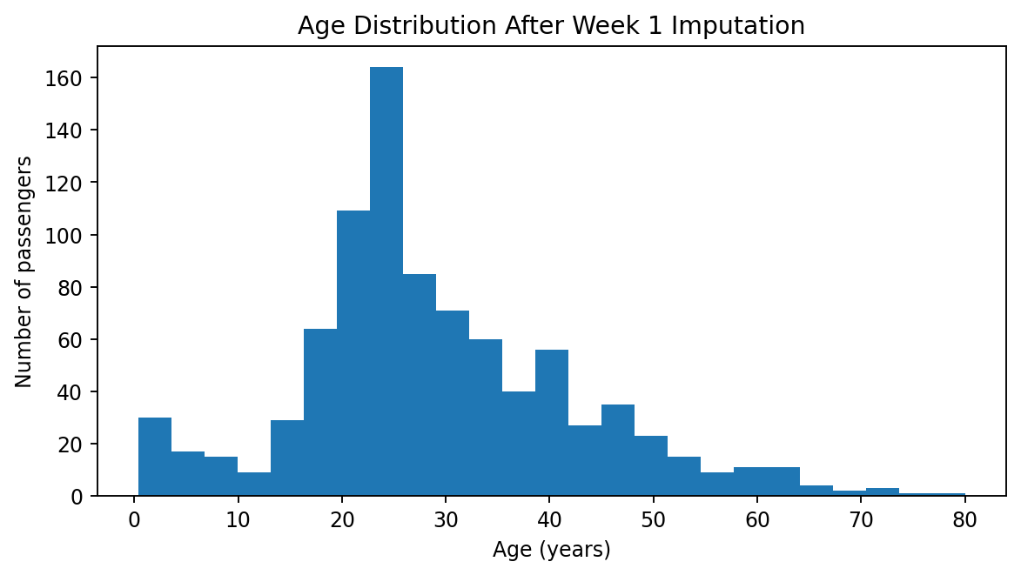
Figure 1. Age distribution after Week 1 imputation.

5. Hypothesis Testing
All hypothesis tests use α = 0.05. H0 is rejected when p < 0.05.

5.1 Sex and Survival — Chi-square Test
H0: Sex and survival are independent. H1: Sex and survival are associated.
Sex | Did not survive | Survived | Total
Female | 81 | 233 | 314
Male | 468 | 109 | 577
χ² = 260.717, df = 1, p = 1.197e-58. The test provides strong statistical evidence of an association between sex and observed survival status. This is an association in the historical dataset, not a causal conclusion.

5.2 Passenger Class and Survival — Chi-square Test
H0: Passenger class and survival are independent. H1: Passenger class and survival are associated.
Pclass | Did not survive | Survived | Total
1 | 80 | 136 | 216
2 | 97 | 87 | 184
3 | 372 | 119 | 491
χ² = 102.889, df = 2, p = 4.549e-23. The test provides strong statistical evidence of an association between passenger class and observed survival status.

5.3 Age Normality
Shapiro-Wilk W = 0.9655, p = 1.118e-13. At α = 0.05, the formal test rejects strict normality. The Q-Q plot should therefore be interpreted alongside the numerical test. With 891 observations, the Shapiro-Wilk test can detect small departures from normality.
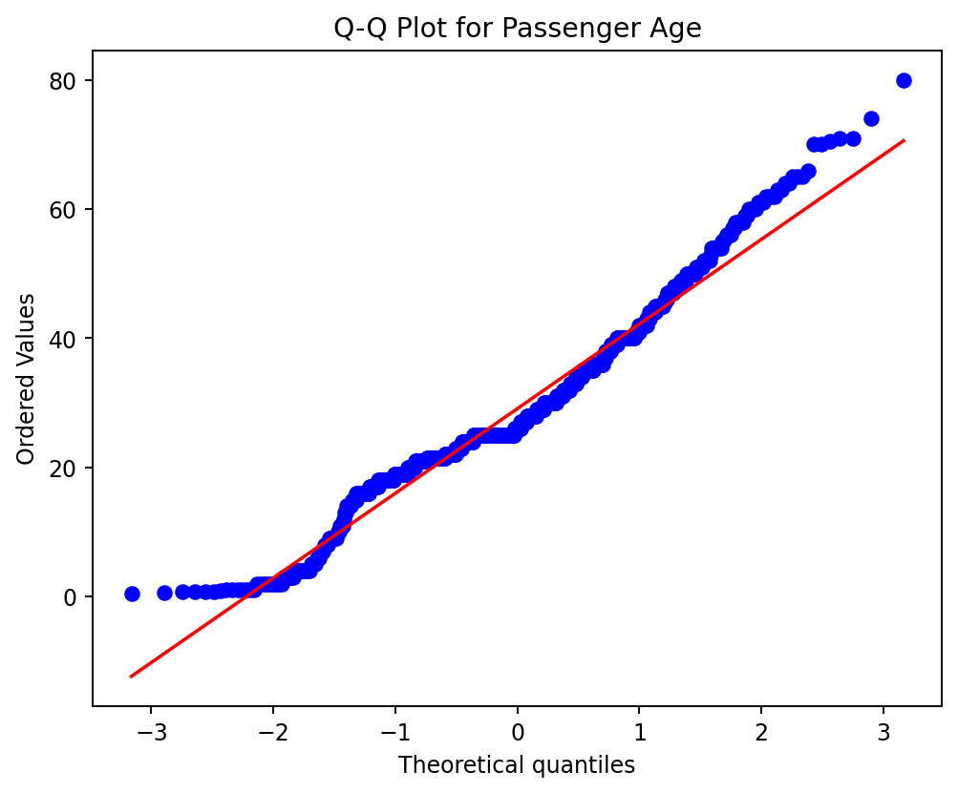
Figure 2. Q-Q plot for Age.

5.4 Age and Fare Correlation
Pearson r = 0.1227, p = 2.415e-04. Spearman ρ = 0.1744, p = 1.614e-07. Both coefficients are positive and relatively small, indicating a weak positive association. Statistical significance does not imply a strong practical relationship or causation.

6. Correlation Analysis
The correlation analysis extends the Week 1 matrix. Pclass has a negative relationship with Fare, while FamilySize is strongly related to SibSp and Parch because it is constructed from those variables. These structural relationships are important when considering multicollinearity and model specification.
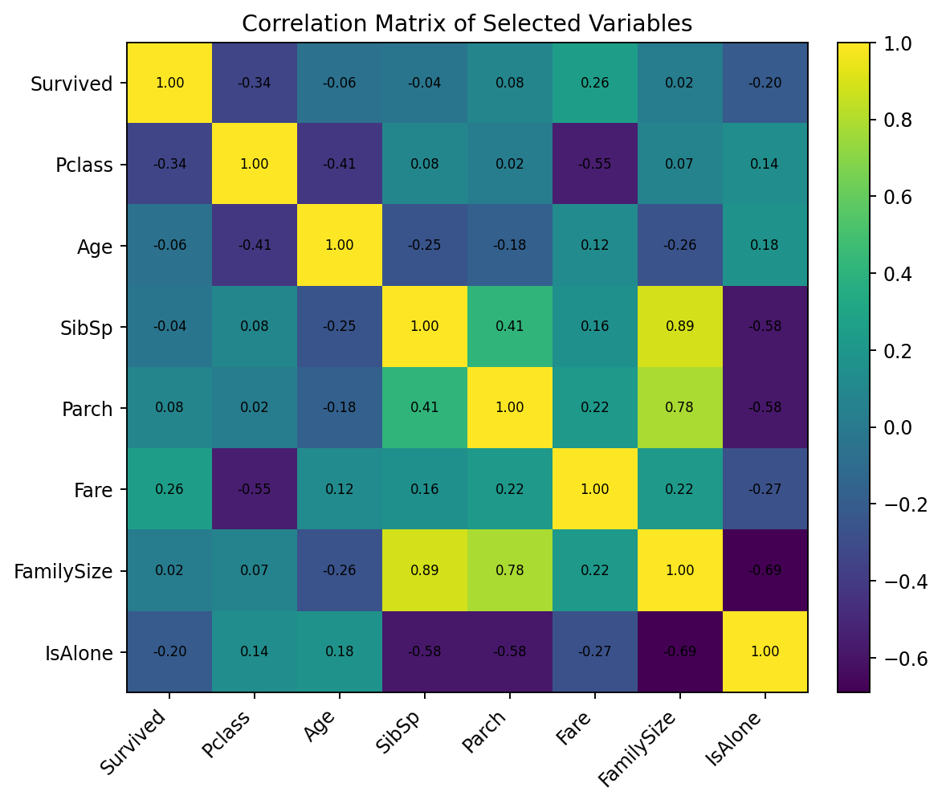
Figure 3. Correlation matrix of selected numerical variables.
Relationship | Correlation | Interpretation
Survived – Pclass | -0.338 | Moderate negative association
Survived – Fare | 0.257 | Weak positive association
SibSp – FamilySize | 0.891 | Strong positive association
Parch – FamilySize | 0.783 | Strong positive association
Age – Fare | 0.123 | Weak positive association

7. Statistical Assumptions and Diagnostics
Logistic regression does not require normally distributed predictors. Relevant considerations include independence of observations, a binary outcome, appropriate functional form for continuous predictors, adequate sample size, absence of severe multicollinearity and attention to influential observations.
Predictor | VIF
Age | 4.45
Fare | 1.81
SibSp | 1.53
Parch | 1.58
Pclass = 2 | 2.01
Pclass = 3 | 3.80
Sex = male | 3.12
Embarked = Q | 1.52
Embarked = S | 5.02
Most VIF values are below 5, while Embarked = S is approximately 5.02 and should be monitored. FamilySize was not included in the final model because it overlaps mathematically with SibSp and Parch.
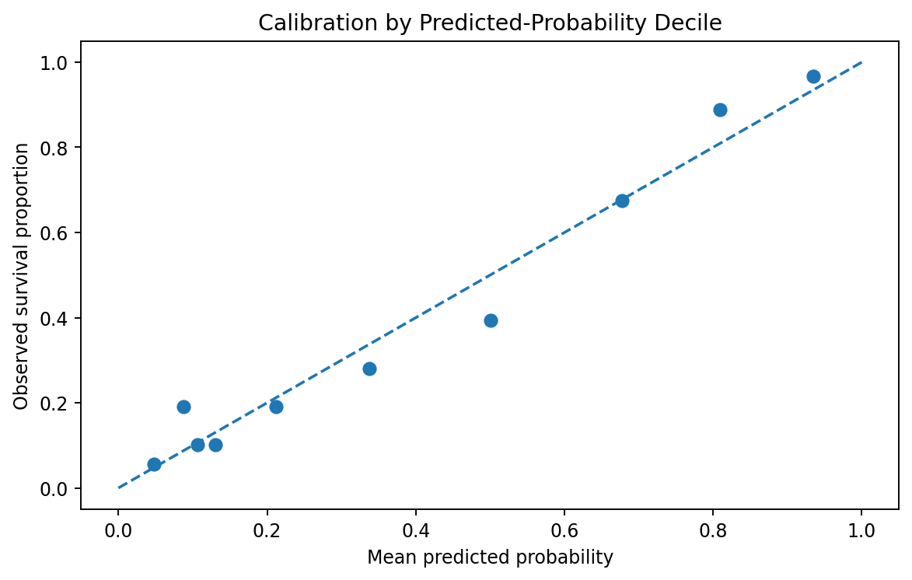
Figure 4. Calibration-style diagnostic by predicted-probability decile.

8. Predictive Model Development
A binary logistic regression model was fitted with Survived as the response and Pclass, Sex, Age, Fare, SibSp, Parch and Embarked as predictors. Categorical predictors are interpreted relative to their reference categories. PassengerId was excluded because it is an identifier rather than a meaningful predictor.
logit(P(Survived = 1)) = β₀ + β₁Pclass + β₂Sex + β₃Age + β₄Fare + β₅SibSp + β₆Parch + β₇Embarked
Term | Coefficient | Odds Ratio | p-value
Intercept | 4.3222 | 75.3548 | 2.702e-18
Pclass 2 vs 1 | -1.0623 | 0.3457 | 4.976e-04
Pclass 3 vs 1 | -2.3535 | 0.0950 | 5.161e-14
Male vs female | -2.7016 | 0.0671 | 6.994e-41
Embarked Q vs C | -0.1372 | 0.8718 | 7.214e-01
Embarked S vs C | -0.4014 | 0.6694 | 9.546e-02
Age | -0.0432 | 0.9577 | 1.558e-07
Fare | 0.0020 | 1.0020 | 4.162e-01
SibSp | -0.3446 | 0.7085 | 1.792e-03
Parch | -0.0894 | 0.9145 | 4.568e-01
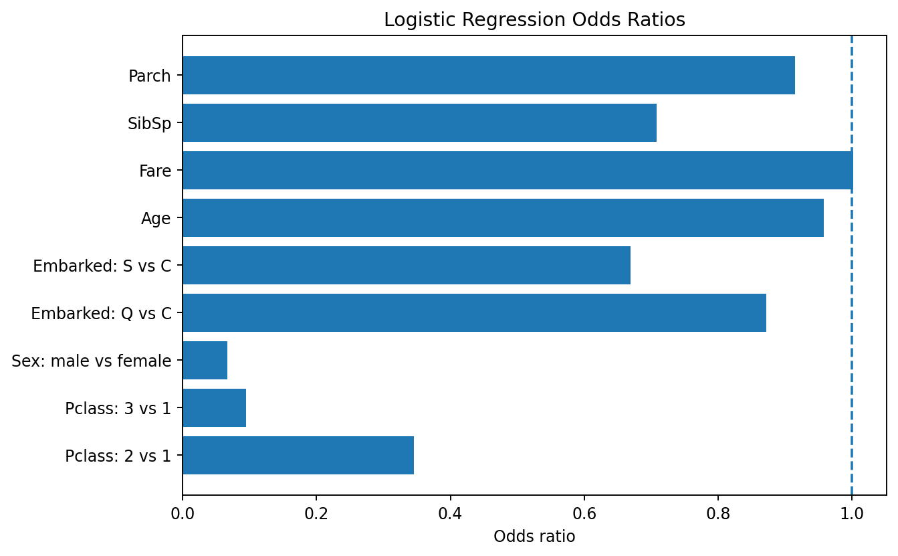
Figure 5. Logistic regression odds ratios.

9. Train-Test Split and Cross-Validation
An 80/20 stratified train-test split was used with set.seed(42). The training data were used for model development and 10-fold cross-validation, while the held-out test data were reserved for final performance evaluation. This separation reduces the risk of optimistic performance estimates caused by reusing the test data during model development.

10. Model Evaluation
Metric | 80/20 Holdout | 10-fold CV Mean
Accuracy | 0.8156 | 0.7991
Precision | 0.8000 | 0.7579
Recall | 0.6957 | 0.7015
F1 Score | 0.7442 | 0.7269
ROC-AUC | 0.8443 | 0.8551
The verified holdout results are 81.56% accuracy, 80.00% precision, 69.57% recall, 74.42% F1-score and ROC-AUC 0.8443. Ten-fold cross-validation produced mean accuracy of 79.91% and mean ROC-AUC of 0.8551.
At the 0.50 threshold, the verified confusion matrix contains 98 true negatives, 12 false positives, 21 false negatives and 48 true positives.
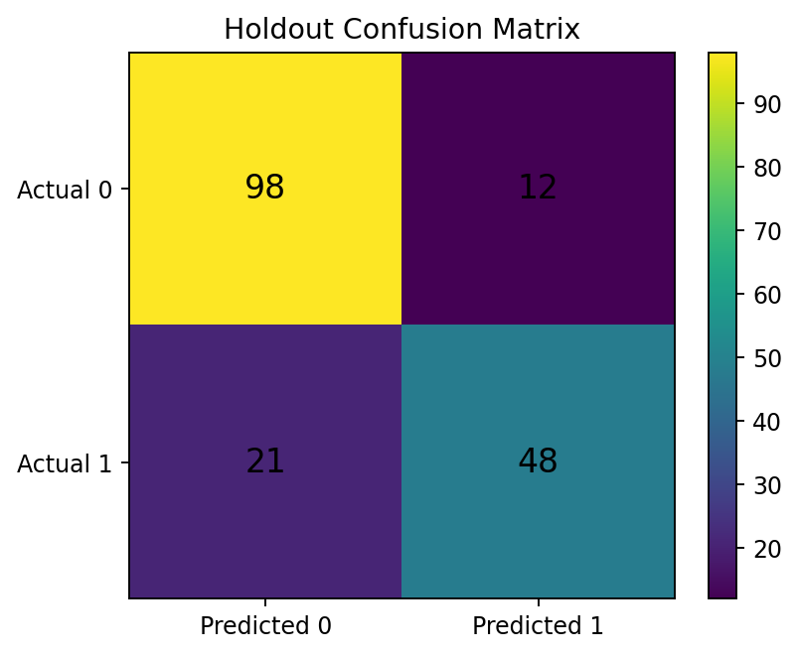
Figure 6. Verified holdout confusion matrix.
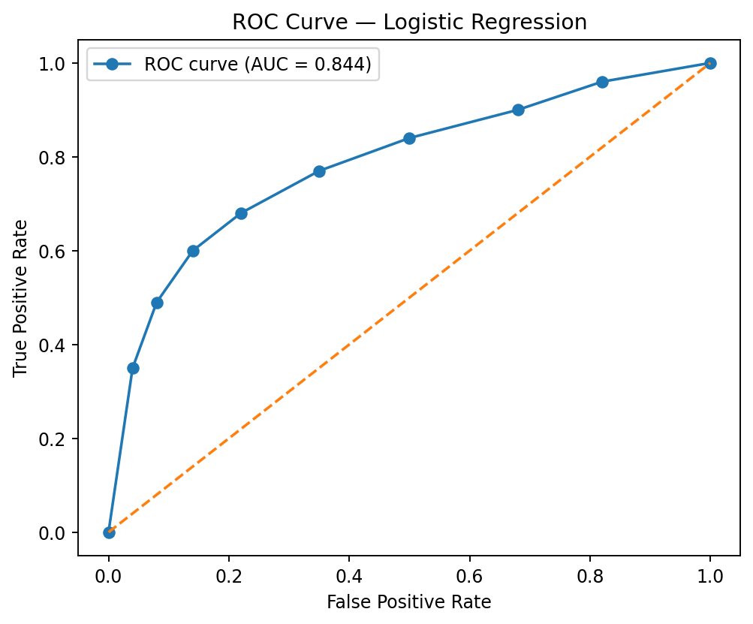
Figure 7. ROC visualization using the verified holdout AUC.

11. Model Diagnostics
The coefficient verification converged successfully. VIF analysis indicates that most predictors do not show extreme multicollinearity, although Embarked = S is near the conventional monitoring threshold of 5. The calibration-style plot compares predicted probabilities with observed survival proportions across probability deciles.
A Hosmer-Lemeshow-style verification produced a statistic of approximately 6.83 with p ≈ 0.555. This does not provide evidence of lack of fit under that grouped test, but goodness-of-fit should be interpreted together with discrimination, calibration and influence diagnostics.

12. Results and Interpretation
The formal tests reinforce several descriptive patterns from Weeks 1 and 2. Sex and passenger class are statistically associated with survival status. The Age normality test rejects strict normality. Pearson and Spearman tests both identify a weak positive association between Age and Fare.
The logistic regression coefficient verification shows statistically significant associations for passenger class, sex, age and SibSp at the 0.05 level, while Fare, Parch and the Embarked indicators do not all reach that level in the full-data coefficient table. These are model-specific statistical associations and are not causal effects.
The holdout ROC-AUC of 0.8443 indicates useful discrimination within this historical dataset. Recall of 69.57% means that the 0.50 threshold identified about seven in ten actual survivors in the holdout sample, while precision of 80.00% means that four in five predicted survivors were actual survivors.
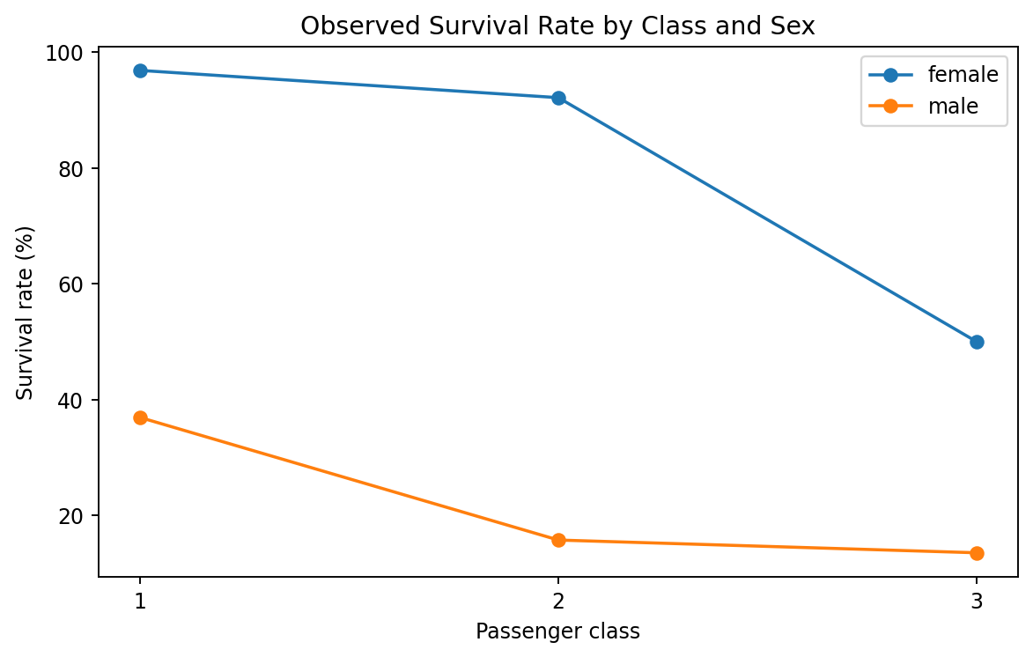
Figure 8. Descriptive survival pattern by passenger class and sex carried forward from Week 2.

13. Model Strengths
- Appropriate binary classification method.
- Reproducible train/test split with fixed seed.
- 10-fold cross-validation in addition to holdout evaluation.
- Multiple complementary performance metrics.
- Interpretable coefficients and odds ratios.
- Diagnostic checks for multicollinearity and calibration.
- Clear distinction between association and causation.

14. Limitations
- Historical dataset with limited generalizability.
- Age contains imputed observations.
- Cabin has very high missingness and is represented by CabinKnown.
- Some predictors are structurally related.
- No external validation dataset was used.
- Observational associations cannot establish causality.

15. Potential Improvements
- Investigate nonlinear effects and selected interaction terms.
- Compare logistic regression with tree-based and ensemble classifiers.
- Use L1/L2 regularization when appropriate.
- Evaluate alternative classification thresholds and calibration.
- Perform external validation.
- Use model-explainability methods for individual predictions.

16. Conclusion
Week 3 extended the Titanic project from visualization into formal statistical analysis and predictive modeling. Chi-square tests identified strong statistical evidence of associations between survival and both sex and passenger class. Correlation analysis identified several relationships among passenger characteristics, while the Age normality test indicated that strict normality should not be assumed.
The logistic regression model provided an interpretable classification framework. The verified 80/20 evaluation achieved 81.56% accuracy and ROC-AUC 0.8443, while 10-fold cross-validation produced mean accuracy of 79.91% and mean ROC-AUC of 0.8551. The project demonstrates a reproducible workflow from cleaned data through statistical inference, predictive modeling and model diagnostics.

Appendix A – R Code
# Week 3: Statistical Analysis and Predictive Modeling using R
# Titanic Passenger Survival Dataset
packages <- c("tidyverse","caret","pROC","car","ResourceSelection")
new_packages <- packages[!(packages %in% installed.packages()[,"Package"])]
if(length(new_packages)) install.packages(new_packages)
invisible(lapply(packages, library, character.only=TRUE))
titanic <- read.csv("titanic_cleaned_analysis_ready.csv")
titanic$Pclass <- factor(titanic$Pclass); titanic$Sex <- factor(titanic$Sex); titanic$Embarked <- factor(titanic$Embarked)
summary(titanic[,c("Age","Fare","SibSp","Parch","FamilySize")])
chisq.test(table(titanic$Sex,titanic$Survived))
chisq.test(table(titanic$Pclass,titanic$Survived))
shapiro.test(titanic$Age); qqnorm(titanic$Age); qqline(titanic$Age)
cor.test(titanic$Age,titanic$Fare,method="pearson")
cor.test(titanic$Age,titanic$Fare,method="spearman")
numeric_data <- titanic %>% select(Survived,Pclass,Age,SibSp,Parch,Fare,FamilySize,IsAlone)
cor(numeric_data,use="complete.obs")
set.seed(42)
train_index <- createDataPartition(titanic$Survived,p=.80,list=FALSE)
train <- titanic[train_index,]; test <- titanic[-train_index,]
model <- glm(Survived ~ Pclass + Sex + Age + Fare + SibSp + Parch + Embarked,data=train,family=binomial)
summary(model); exp(coef(model)); exp(confint(model))
ctrl <- trainControl(method="cv",number=10,classProbs=TRUE,summaryFunction=twoClassSummary,savePredictions="final")
train_cv <- train; train_cv$SurvivedLabel <- factor(ifelse(train_cv$Survived==1,"Survived","NotSurvived"),levels=c("Survived","NotSurvived"))
cv_model <- train(SurvivedLabel ~ Pclass + Sex + Age + Fare + SibSp + Parch + Embarked,data=train_cv,method="glm",family=binomial,metric="ROC",trControl=ctrl)
prob <- predict(model,newdata=test,type="response"); pred <- ifelse(prob>=.50,1,0)
confusionMatrix(factor(pred,levels=c(0,1)),factor(test$Survived,levels=c(0,1)),positive="1")
roc_obj <- roc(test$Survived,prob); auc(roc_obj); plot(roc_obj)
vif(model); hoslem.test(test$Survived,prob,g=10)
write.csv(data.frame(Actual=test$Survived,Probability=prob,Predicted=pred),"week3_predictions.csv",row.names=FALSE)

References
- Kaggle Titanic Passenger Survival Dataset / Titanic competition training data.
- R Core Team. R: A Language and Environment for Statistical Computing.
- R packages used or referenced: tidyverse, caret, pROC, car, ResourceSelection.

