WEEK 4 PROJECT REPORT
Comprehensive Data Analysis, Statistical Modeling
and Insight Communication using R

Dataset: Titanic Passenger Survival Dataset

Field | Details
Submitted by | Chandana S.
Department | Computer Science and Engineering (Data Science)
Institution | Vemana Institute of Technology, Bengaluru
Academic Year | 2026–2027
Project Scope | Integrated Weeks 1–4 R Data Analysis Internship Project

Final-week objective
This report consolidates the complete analytical workflow developed across Weeks 1–3: data cleaning and preparation, exploratory visualization, statistical testing, correlation analysis, logistic regression, cross-validation, diagnostics, and interpretation. The aim is to present one coherent, reproducible analysis rather than four disconnected weekly submissions.

Table of Contents
1. Executive Summary
2. Introduction and Project Objectives
3. Dataset Identification and Project Continuity
4. End-to-End Methodology
5. Week 1 – Data Preparation and Cleaning
6. Week 2 – Exploratory Visualization and Insight Communication
7. Week 3 – Statistical Analysis and Hypothesis Testing
8. Week 3 – Predictive Modeling
9. Integrated Results and Key Findings
10. Discussion and Practical Implications
11. Strengths, Challenges and Limitations
12. Future Directions and Recommended Extensions
13. Conclusion and Lessons Learned
Appendix A – Annotated R Code
Appendix B – Consolidated Statistical Output
References
Reading note
The report is designed to be read from data preparation through interpretation. The main body emphasizes findings and reasoning; the appendices preserve technical code and detailed output.

1. Executive Summary
This four-week project demonstrates a complete data-analysis workflow in R using the Titanic Passenger Survival Dataset. The project begins with 891 passenger records and 12 original variables and progresses from data quality assessment to descriptive visualization, formal statistical testing and binary predictive modeling.
- Week 1 produced an analysis-ready dataset by treating 177 missing Age values, 687 missing Cabin values and 2 missing Embarked values, checking duplicates, engineering FamilySize and IsAlone, and treating Fare outliers.
- Week 2 transformed the cleaned data into eight visualizations covering passenger class, age, fare, sex, family size and embarkation. These visuals showed large descriptive differences in survival across passenger groups.
- Week 3 formalized several observed patterns. Chi-square tests found strong statistical evidence of association between Sex and survival (χ² = 260.717, p ≈ 1.20×10⁻⁵⁸) and between Pclass and survival (χ² = 102.889, p ≈ 4.55×10⁻²³).
- The final binary logistic regression used Pclass, Sex, Age, Fare, SibSp, Parch and Embarked. Verified 80/20 holdout performance was 81.56% accuracy and ROC-AUC 0.8443; 10-fold cross-validation produced mean accuracy of 79.91% and mean ROC-AUC of 0.8551.
- The analysis demonstrates that data preparation, visualization and statistical modeling answer complementary questions: cleaning improves data quality, visualization reveals patterns, hypothesis testing evaluates evidence of association, and logistic regression estimates a multivariable prediction model.
Central interpretation
The strongest and most consistent descriptive and statistical signals concern passenger sex and passenger class. These variables remain important in the multivariable logistic model. The model also shows a negative association with age and SibSp under the fitted specification, while Fare, Parch and the Embarked indicators are less consistent after adjustment. These findings describe this historical dataset and should not be interpreted as causal effects.

2. Introduction and Project Objectives
The final week integrates the preceding three weeks into a single analytical narrative. Rather than treating data cleaning, visualization and modeling as independent activities, the project shows how each stage prepares the evidence required by the next stage.

2.1 Objectives
- Create a reliable analysis-ready dataset from the original Titanic training data.
- Communicate major distributions, group differences and relationships through appropriate R visualizations.
- Use hypothesis testing to evaluate selected relationships between passenger characteristics and survival.
- Build and evaluate a binary logistic regression model for passenger survival.
- Validate the model using both an 80/20 holdout sample and 10-fold cross-validation.
- Interpret statistical and predictive results while clearly separating association from causation.
- Document the complete workflow using reproducible R code, tables and graphical evidence.

2.2 Project progression
Week | Primary focus | Main output
Week 1 | Data cleaning and preliminary analysis | Analysis-ready dataset; missing-value treatment; feature engineering; descriptive statistics
Week 2 | Visualization and insight communication | Eight visualizations; cross-visualization interpretation
Week 3 | Statistical analysis and predictive modeling | Hypothesis tests; correlation; logistic regression; diagnostics; performance metrics
Week 4 | Comprehensive integration | Final report combining preparation, analysis, results, discussion and future directions

The same Titanic dataset is retained throughout the project so that improvements in the analytical workflow can be traced without changing the underlying subject.

3. Dataset Identification and Project Continuity
The project uses the standard Titanic passenger training dataset containing 891 observations and 12 original variables. The target variable is Survived, coded as 0 for passengers who did not survive and 1 for passengers who survived. The data contain numerical, categorical and binary variables, making them appropriate for both descriptive statistics and classification.
Property | Description
Observations | 891 passenger records
Original variables | 12
Target | Survived (0 = did not survive, 1 = survived)
Numerical variables | Age, SibSp, Parch, Fare, PassengerId
Categorical variables | Sex, Pclass, Embarked, Ticket, Cabin, Name
Final modeling approach | Binary logistic regression

3.1 Important variables
Variable | Role | Interpretation
Survived | Outcome | Passenger survival status
Pclass | Predictor | Passenger ticket class
Sex | Predictor | Passenger sex category
Age | Predictor | Passenger age in years
Fare | Predictor | Passenger fare
SibSp | Predictor | Siblings/spouses aboard
Parch | Predictor | Parents/children aboard
Embarked | Predictor | Port of embarkation
FamilySize | Engineered | SibSp + Parch + 1
IsAlone | Engineered | 1 when FamilySize = 1

Continuity principle
Week 4 does not introduce a different dataset. It deliberately reuses the cleaned Titanic data and the verified Week 3 model outputs so that the final report represents one continuous project.

4. End-to-End Methodology
Stage | Methods used | Purpose
1. Inspection | str(), dim(), summary(), missing-value counts, duplicate check | Understand structure and data quality before modification
2. Cleaning | Group-median imputation, mode imputation, CabinKnown, outlier capping | Create a usable analysis dataset without unnecessary row deletion
3. Feature engineering | FamilySize and IsAlone | Represent family-related structure
4. Visualization | Bar charts, histogram, scatter plot, line charts, boxplot, heatmap | Identify and communicate patterns
5. Statistical testing | Chi-square, Shapiro-Wilk, Pearson and Spearman | Evaluate selected associations and assumptions
6. Modeling | Binary logistic regression | Predict survival from multiple passenger characteristics
7. Validation | 80/20 stratified split and 10-fold CV | Estimate out-of-sample predictive performance
8. Diagnostics | VIF, calibration-style grouping, confusion matrix, ROC | Assess model behavior and potential weaknesses

4.1 Analytical workflow
Figure-style workflow implemented in the report
Raw Titanic training data
↓
Initial inspection and data-quality assessment
↓
Missing-value treatment + duplicate check
↓
Outlier treatment + feature engineering
↓
Analysis-ready dataset
↓
Descriptive statistics + visualizations
↓
Hypothesis tests + correlation analysis
↓
Train/test split
↓
Binary logistic regression
↓
10-fold cross-validation + holdout evaluation
↓
Diagnostics + integrated interpretation

The workflow intentionally moves from descriptive evidence to inferential and predictive analysis. This reduces the risk of fitting a model before understanding the structure and quality of the data.

5. Week 1 – Data Preparation and Cleaning
Week 1 established the foundation for all later analysis. The initial inspection showed substantial missingness in Age and Cabin, while Embarked had only two missing observations. There were no duplicate rows.
Variable | Missing values | Missing % | Treatment
Age | 177 | 19.87% | Median imputation within Pclass × Sex groups
Cabin | 687 | 77.10% | CabinKnown indicator; raw Cabin removed
Embarked | 2 | 0.22% | Mode imputation
Other original variables | 0 | 0.00% | No missing-value treatment required

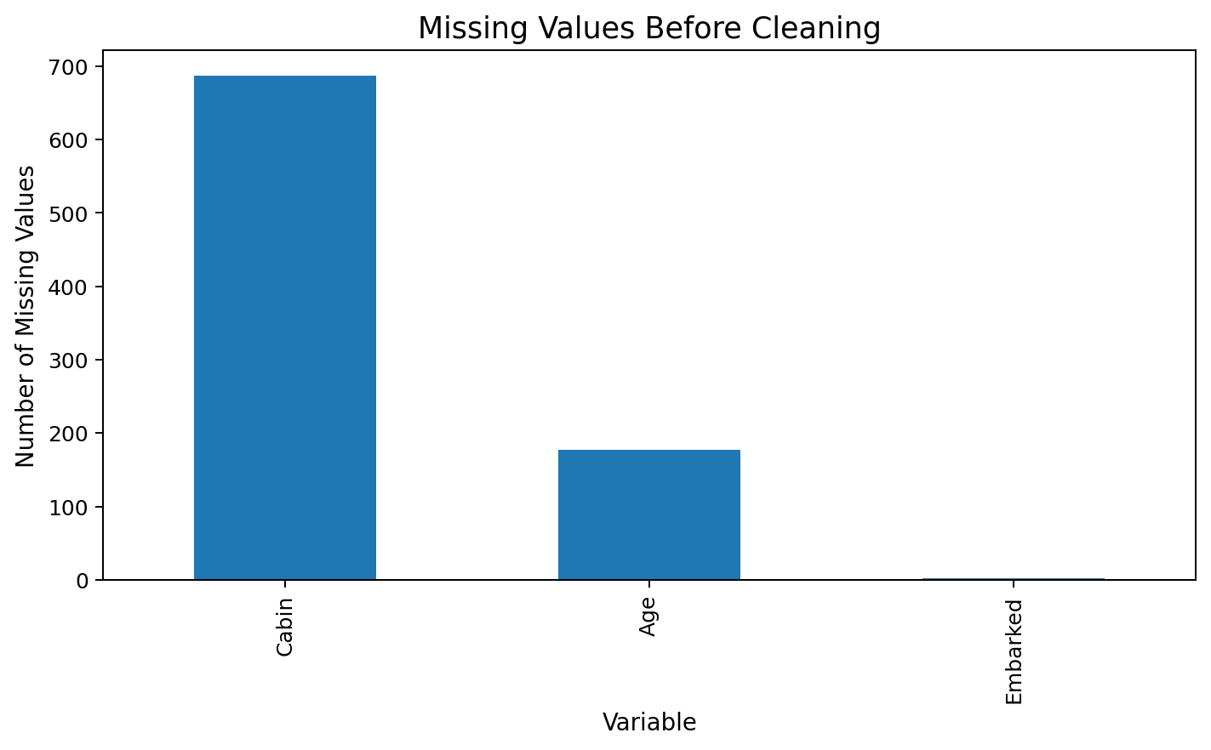
Figure 1. Missing-value profile before cleaning.

5.1 Outlier treatment and feature engineering
Fare contained extreme observations. The project used an IQR-based upper boundary and capped extreme Fare values rather than deleting passenger records. This retained the observations while limiting the influence of unusually large fares on subsequent descriptive and modeling steps.
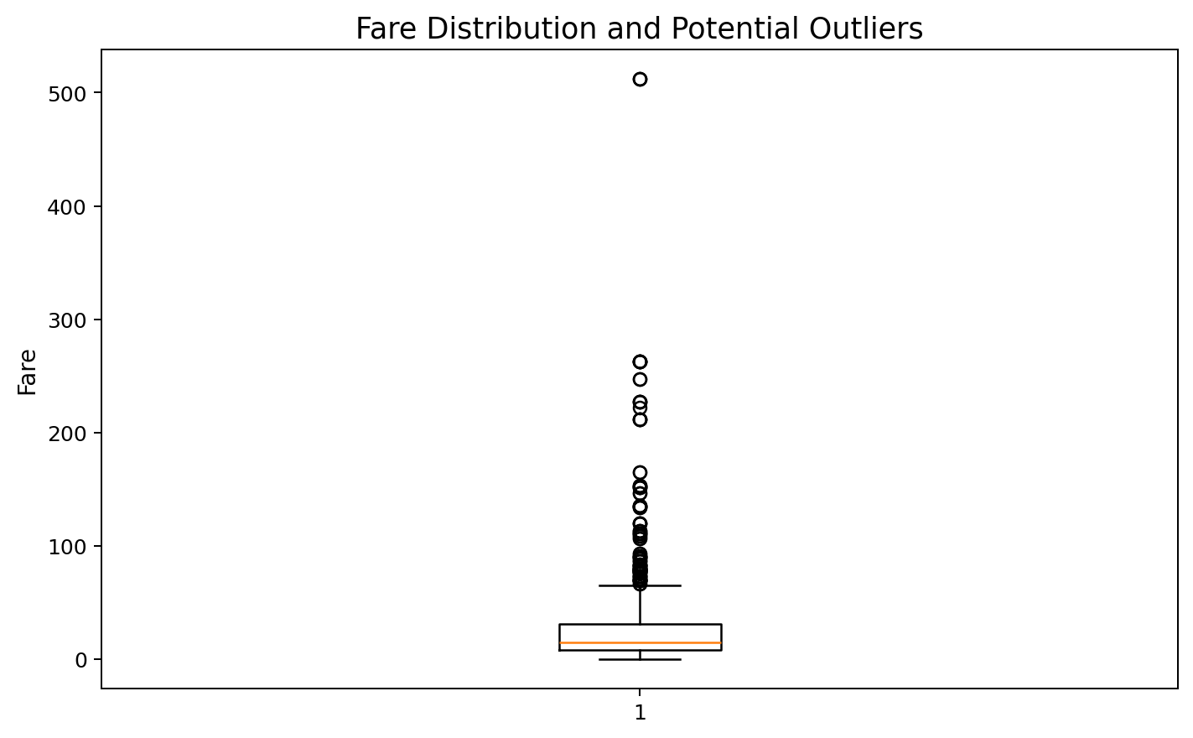
Figure 2. Fare distribution and potential outliers identified during Week 1.

Engineered variable | Formula / rule | Reason
FamilySize | SibSp + Parch + 1 | Represents total travelling family-group size
IsAlone | 1 when FamilySize = 1; otherwise 0 | Separates solo passengers from passengers travelling with family

5.2 Descriptive baseline
Variable | N | Mean | Median | SD | Min | Max
Age | 891 | 29.112 | 26.000 | 13.304 | 0.420 | 80.000
Fare | 891 | 32.204 | 14.454 | 49.693 | 0.000 | 512.329
SibSp | 891 | 0.523 | 0.000 | 1.103 | 0 | 8
Parch | 891 | 0.382 | 0.000 | 0.806 | 0 | 6
FamilySize | 891 | 1.905 | 1.000 | 1.613 | 1 | 11

The overall observed survival rate is 38.38%. This baseline becomes the reference point for the visual and statistical comparisons that follow.

6. Week 2 – Exploratory Visualization and Insight Communication
Week 2 converted the cleaned dataset into eight visualizations. The visual forms were selected according to the analytical question: bars for category counts or rates, histograms for distributions, scatter plots for numerical relationships, line charts for ordered groups, and boxplots for distributional comparisons.

6.1 Passenger distribution and age
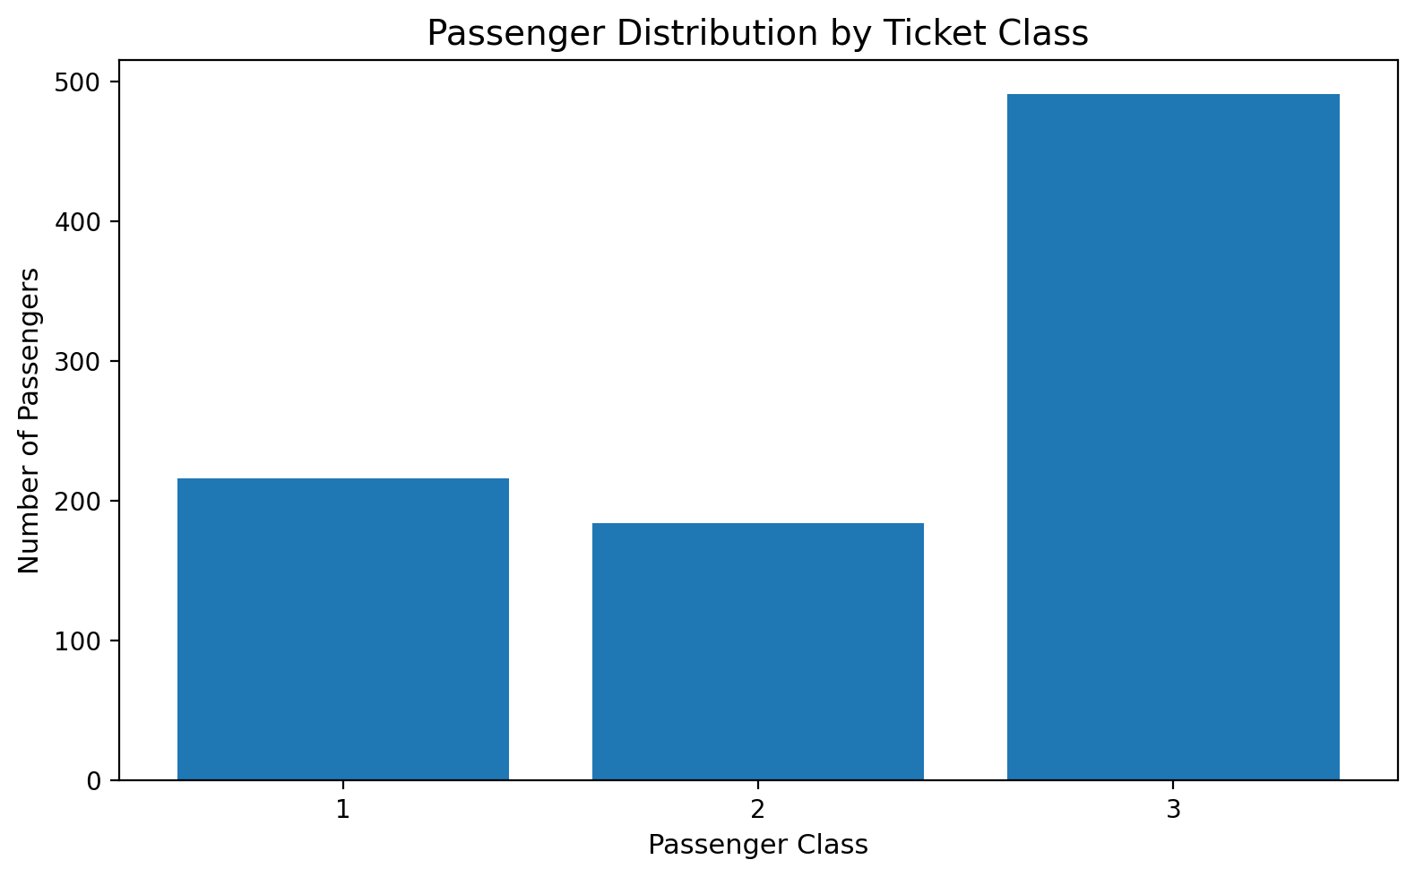
Figure 3. Passenger distribution by ticket class.

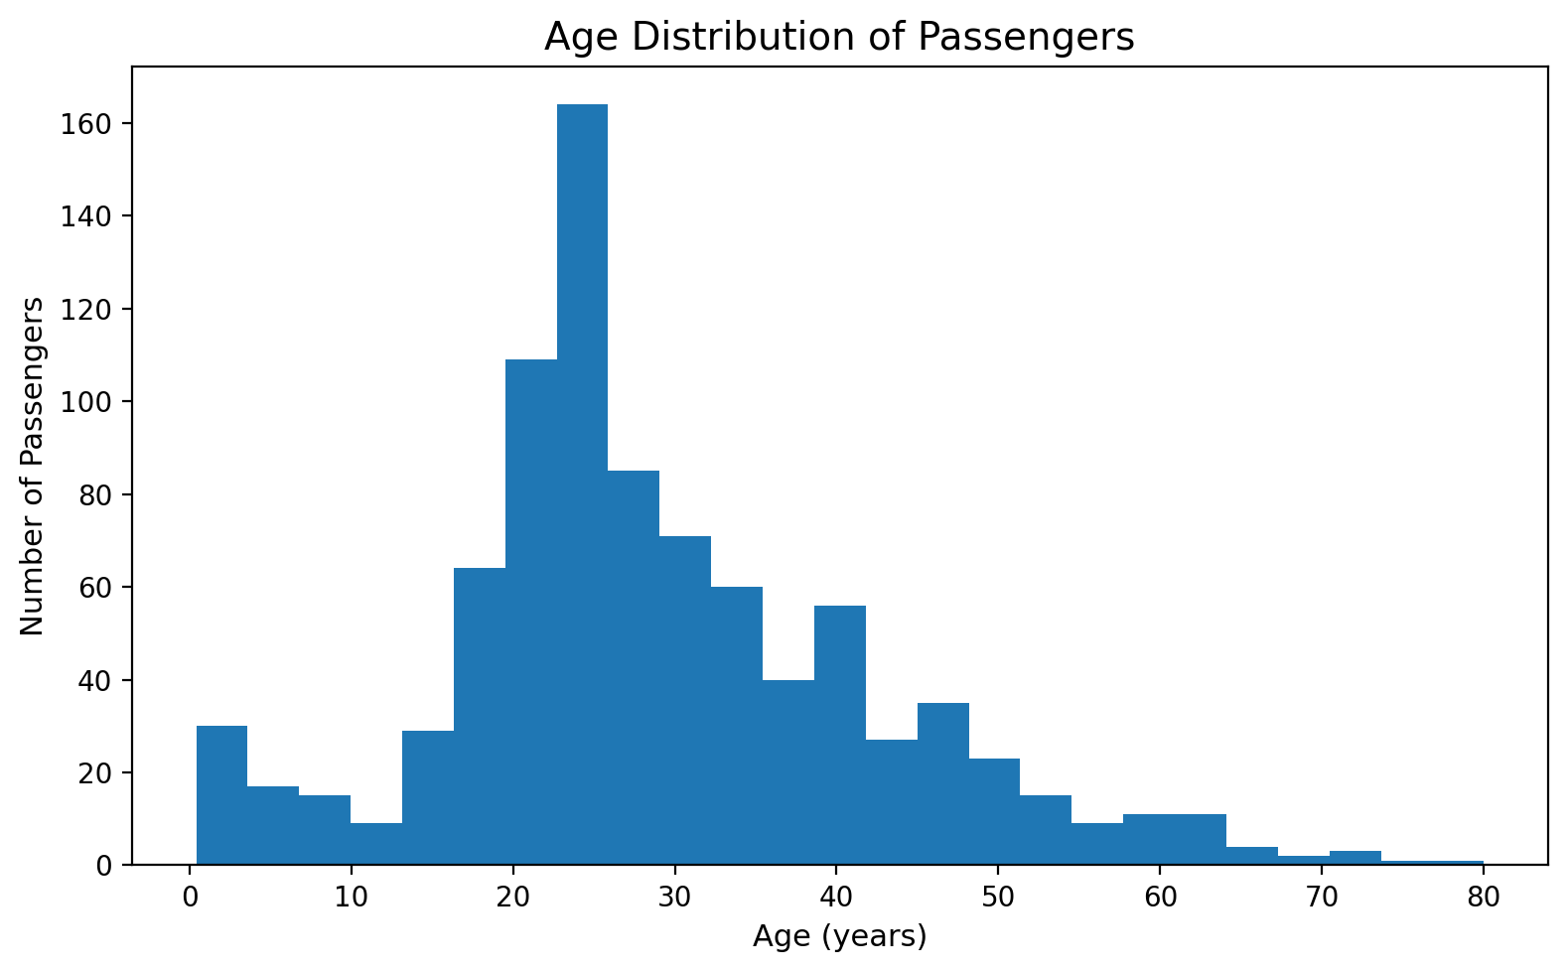
Figure 4. Age distribution of passengers.

Passenger class 3 contains the largest group of observations, followed by classes 1 and 2. The age distribution is concentrated around young and middle-adult ages, with fewer older passengers.

6.2 Survival patterns by sex and passenger class
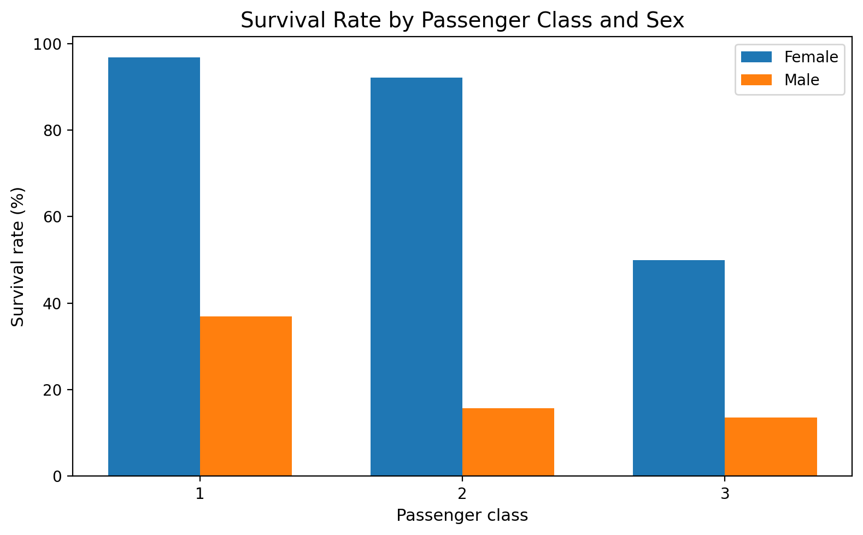
Figure 5. Survival rate by passenger class and sex.

The combined class-and-sex visualization shows that observed survival proportions differ substantially by both variables. The pattern is consistent with the Week 1 descriptive tables and is later evaluated formally using chi-square tests and logistic regression.
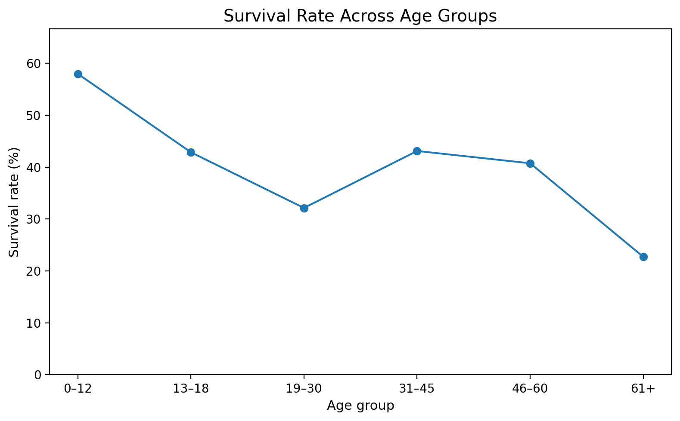
Figure 6. Survival rate across ordered age groups.

6.3 Fare, family size and embarkation
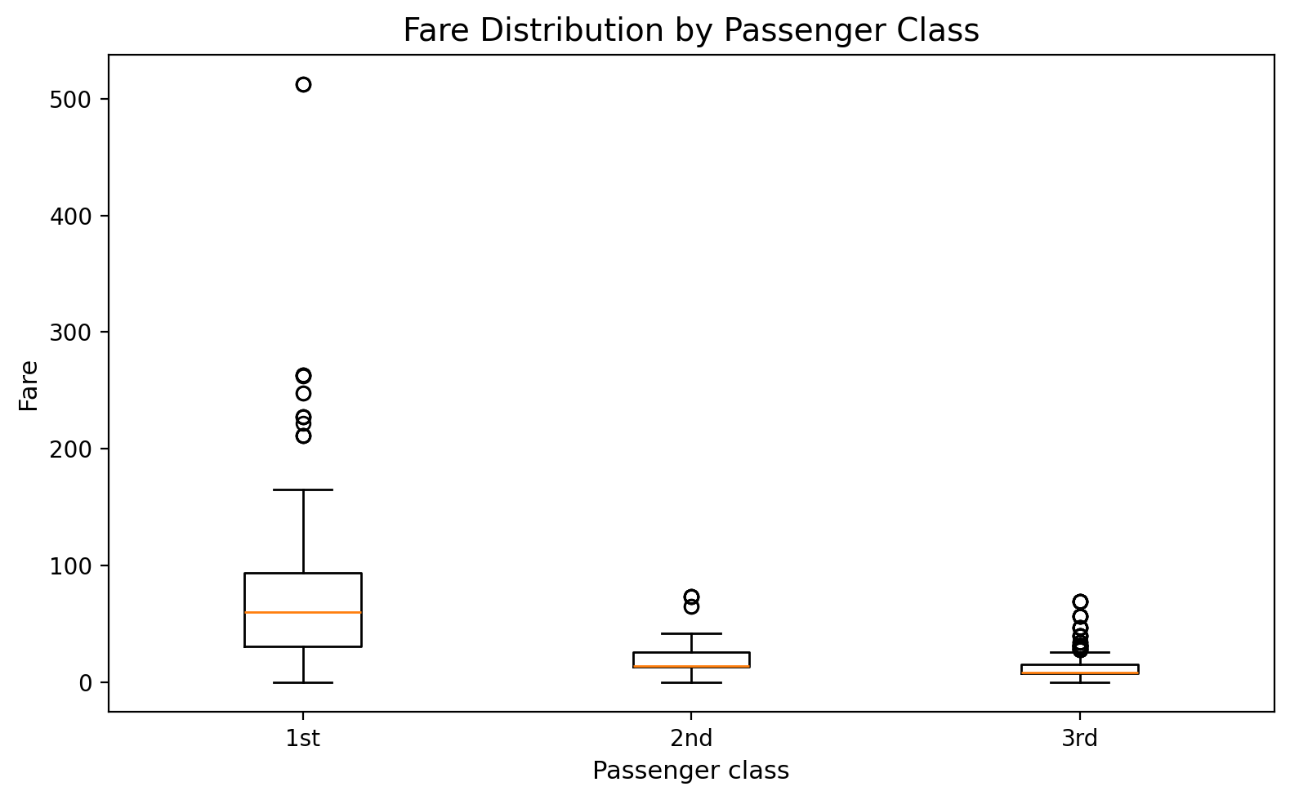
Figure 7. Fare distribution by passenger class.

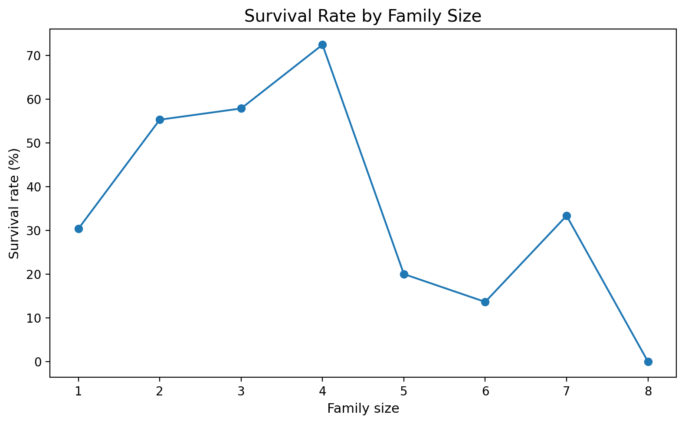
Figure 8. Survival rate by family size.

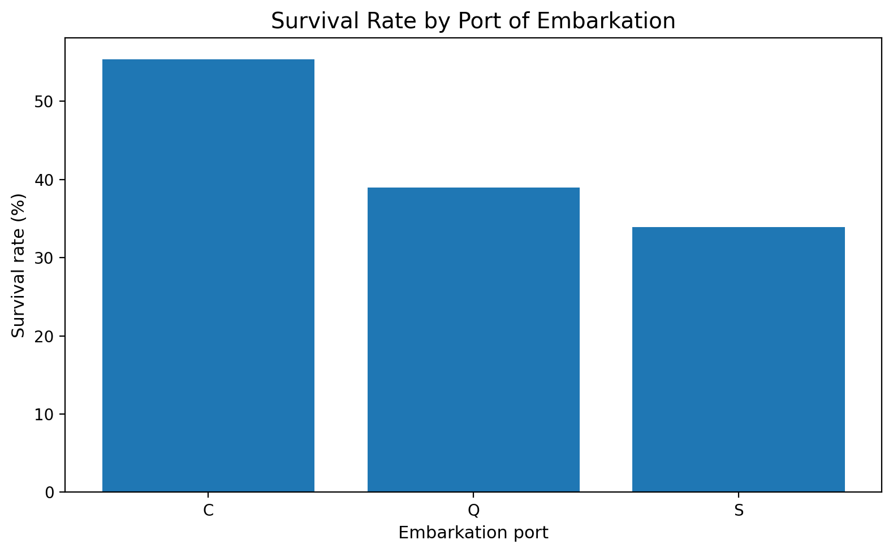
Figure 9. Survival rate by embarkation port.

Fare is strongly structured by passenger class. Survival rates also vary across family-size and embarkation groups, although the less frequent family-size categories should be interpreted cautiously because percentages based on small groups can be unstable.

6.4 Visualization lesson
Why visualization matters
The charts did more than decorate the analysis. They identified which variables warranted formal testing and modeling. Sex and Pclass showed clear group differences; Age and Fare required distributional and correlation checks; family size and embarkation showed patterns that required attention to group sizes and context.

7. Week 3 – Statistical Analysis and Hypothesis Testing
Week 3 transformed the descriptive observations from Weeks 1 and 2 into formal statistical questions. All hypothesis tests used α = 0.05. A small p-value was treated as evidence against the null hypothesis for the specific statistical test; it was not treated as evidence of causation.

7.1 Sex and survival – chi-square test
Null hypothesis (H0): Sex and survival are independent. Alternative hypothesis (H1): Sex and survival are associated.
Sex | Did not survive | Survived | Total
Female | 81 | 233 | 314
Male | 468 | 109 | 577

Verified result: χ² = 260.717, df = 1, p = 1.197 × 10⁻⁵⁸. The result provides strong statistical evidence of an association between sex and observed survival status in this dataset.

7.2 Passenger class and survival – chi-square test
H0: Passenger class and survival are independent. H1: Passenger class and survival are associated.
Pclass | Did not survive | Survived | Total
1 | 80 | 136 | 216
2 | 97 | 87 | 184
3 | 372 | 119 | 491

Verified result: χ² = 102.889, df = 2, p = 4.549 × 10⁻²³. The result provides strong statistical evidence of an association between passenger class and observed survival status.

7.3 Age normality
The Shapiro-Wilk test returned W = 0.9655 and p = 1.118 × 10⁻¹³. Strict normality is therefore rejected at α = 0.05. Because the sample contains 891 observations, formal normality tests can detect relatively small departures from normality; the Q-Q plot should therefore be considered alongside the p-value.
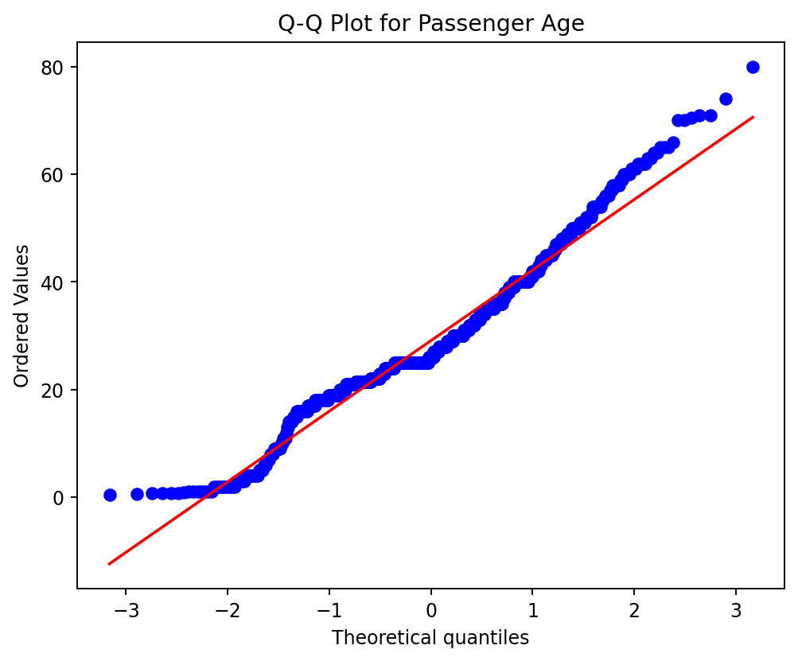
Figure 10. Q-Q plot for Age.

7.4 Age and Fare correlation
Method | Coefficient | p-value | Interpretation
Pearson | r = 0.1227 | 2.415 × 10⁻⁴ | Weak positive linear association
Spearman | ρ = 0.1744 | 1.614 × 10⁻⁷ | Weak positive rank association

Both tests identify a statistically detectable positive association, but the coefficients are small. This distinction is important: statistical significance does not automatically imply a strong practical relationship.

8. Correlation Structure and Model Diagnostics
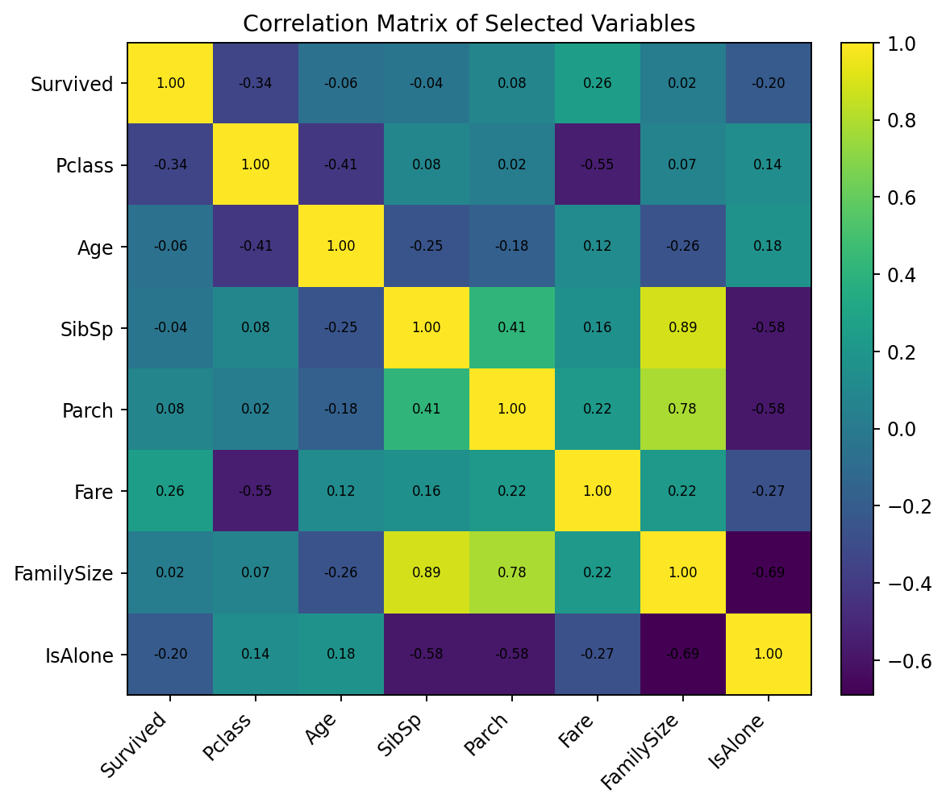
Figure 11. Correlation matrix of selected numerical and engineered variables.

Relationship | Correlation | Interpretation
Survived – Pclass | -0.338 | Moderate negative association
Survived – Fare | 0.257 | Weak positive association
SibSp – FamilySize | 0.891 | Strong structural relationship
Parch – FamilySize | 0.783 | Strong structural relationship
Age – Fare | 0.123 | Weak positive association

FamilySize is mathematically constructed from SibSp and Parch, so the strong correlations are expected rather than surprising. For that reason, FamilySize was not included together with SibSp and Parch in the final logistic model.

8.1 Multicollinearity diagnostic
Predictor | VIF
Age | 4.45
Fare | 1.81
SibSp | 1.53
Parch | 1.58
Pclass = 2 | 2.01
Pclass = 3 | 3.80
Sex = male | 3.12
Embarked = Q | 1.52
Embarked = S | 5.02

Most VIF values are below 5. Embarked = S is approximately 5.02 and therefore merits monitoring. The diagnostic does not indicate pervasive severe multicollinearity, but it does support careful interpretation of correlated predictors.

8.2 Calibration and grouped goodness-of-fit check
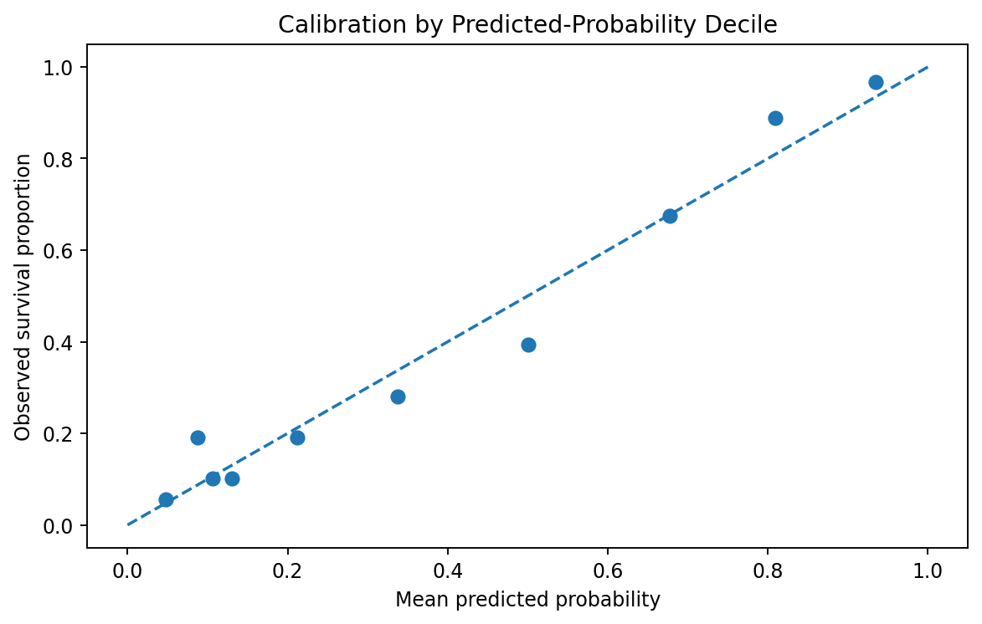
Figure 12. Calibration-style diagnostic using predicted-probability groups.

A Hosmer-Lemeshow-style grouped verification produced a statistic of approximately 6.83 with p ≈ 0.555. Under that grouped test, there is no statistical evidence of lack of fit at the 0.05 level. This result should be interpreted together with discrimination, calibration and influence diagnostics rather than used as a single model-quality verdict.

9. Predictive Modeling – Binary Logistic Regression
Because Survived is binary, logistic regression was selected as the primary predictive model. Logistic regression models the log-odds of survival as a function of the selected predictors and provides interpretable coefficients and odds ratios.

9.1 Model specification
Annotated R code: model fitting
model <- glm(
Survived ~ Pclass + Sex + Age + Fare + SibSp + Parch + Embarked,
data = train,
family = binomial
)

PassengerId was excluded because it is an identifier rather than a meaningful explanatory variable. FamilySize was also excluded from the final specification because it overlaps directly with SibSp and Parch.

9.2 Verified coefficient results
Term | Coefficient | Odds Ratio | p-value
Intercept | 4.3222 | 75.3548 | 2.70 × 10⁻¹⁸
Pclass 2 vs 1 | -1.0623 | 0.3457 | 4.98 × 10⁻⁴
Pclass 3 vs 1 | -2.3535 | 0.0950 | 5.16 × 10⁻¹⁴
Male vs female | -2.7016 | 0.0671 | 6.99 × 10⁻⁴¹
Embarked Q vs C | -0.1372 | 0.8718 | 0.7214
Embarked S vs C | -0.4014 | 0.6694 | 0.0955
Age | -0.0432 | 0.9577 | 1.56 × 10⁻⁷
Fare | 0.0020 | 1.0020 | 0.4162
SibSp | -0.3446 | 0.7085 | 0.0018
Parch | -0.0894 | 0.9145 | 0.4568

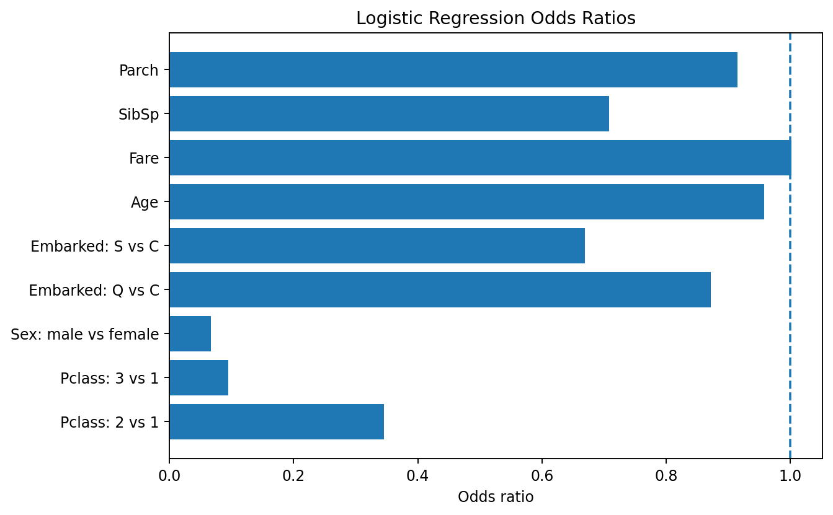
Figure 13. Verified odds-ratio visualization for the logistic regression coefficients.

The odds-ratio representation is easier to interpret than raw log-odds coefficients. In the fitted model, Pclass 2 and Pclass 3 have odds ratios below 1 relative to Pclass 1, while the male indicator has an odds ratio of approximately 0.067 relative to female. These are model-specific associations conditional on the other included predictors; they are not causal effects.

10. Model Validation and Performance
The project used an 80/20 stratified train-test split with a fixed random seed (42), followed by 10-fold cross-validation. Using both approaches provides a more informative view of predictive stability than reporting a single accuracy value.
Annotated R code: holdout evaluation
set.seed(42)
train_index <- createDataPartition(titanic$Survived, p = 0.80, list = FALSE)
train <- titanic[train_index, ]
test <- titanic[-train_index, ]
prob <- predict(model, newdata = test, type = "response")
pred <- ifelse(prob >= 0.50, 1, 0)
confusionMatrix(
factor(pred, levels = c(0,1)),
factor(test$Survived, levels = c(0,1)),
positive = "1"
)

Metric | 80/20 Holdout | 10-fold CV Mean
Accuracy | 0.8156 (81.56%) | 0.7991 (79.91%)
Precision | 0.8000 (80.00%) | 0.7579 (75.79%)
Recall / Sensitivity | 0.6957 (69.57%) | 0.7015 (70.15%)
F1 Score | 0.7442 (74.42%) | 0.7269 (72.69%)
ROC-AUC | 0.8443 | 0.8551

10.1 Confusion matrix
 | Predicted 0 | Predicted 1
Actual 0 | 98 (TN) | 12 (FP)
Actual 1 | 21 (FN) | 48 (TP)

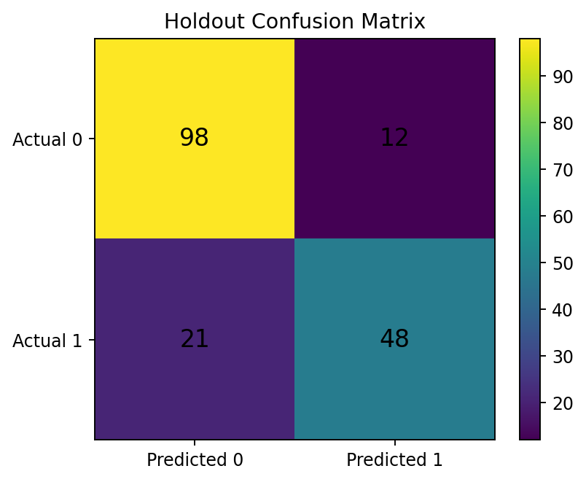
Figure 14. Verified holdout confusion matrix.

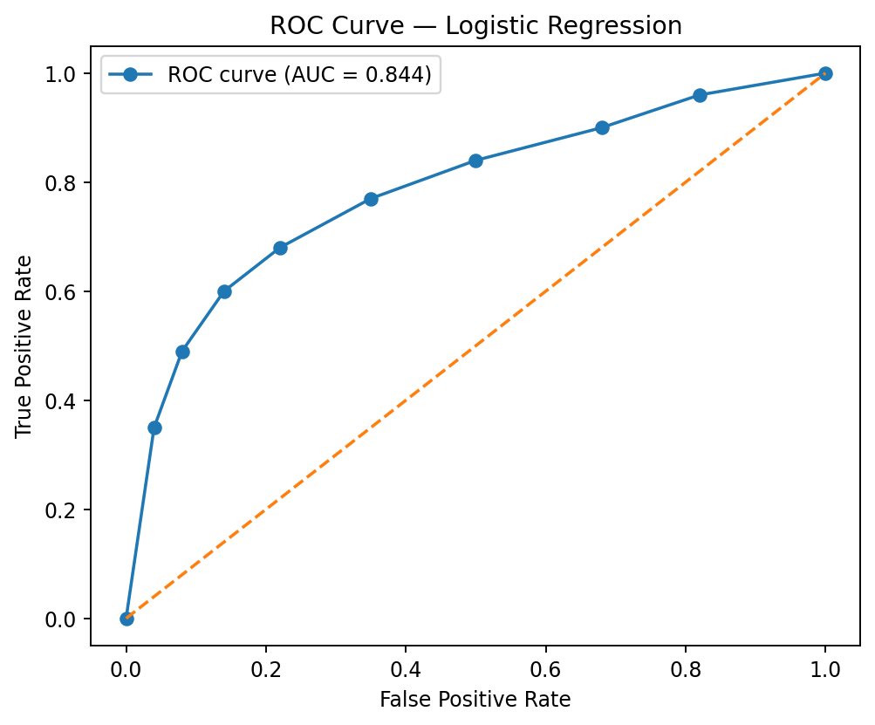
Figure 15. ROC visualization using the verified holdout AUC.

The holdout model correctly classified 98 non-survivors and 48 survivors. It produced 12 false positives and 21 false negatives. At the 0.50 threshold, recall of 69.57% means that approximately seven in ten actual survivors in the holdout sample were identified by the model, while precision of 80.00% means that four in five predicted survivors were actually survivors.

11. Integrated Results and Key Findings
The main value of the four-week project is the convergence of several analytical perspectives. The following findings are supported by more than one stage of the workflow.

11.1 Sex is consistently associated with survival
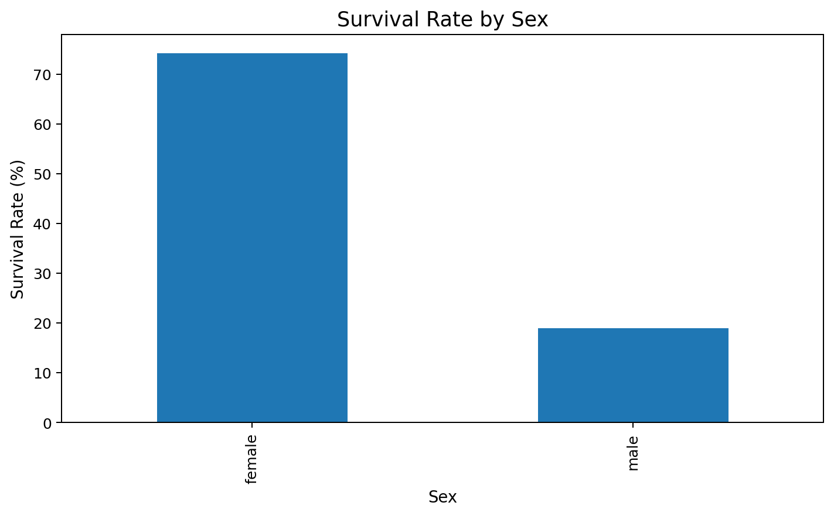
Figure 16. Survival rate by sex from the preliminary analysis.

The descriptive analysis showed a large difference in observed survival rates by sex. The chi-square test then provided strong statistical evidence of association (χ² = 260.717, p ≈ 1.20 × 10⁻⁵⁸). The logistic model also retained a strong sex coefficient after adjustment for passenger class, age, fare, family-related variables and embarkation.

11.2 Passenger class is consistently associated with survival
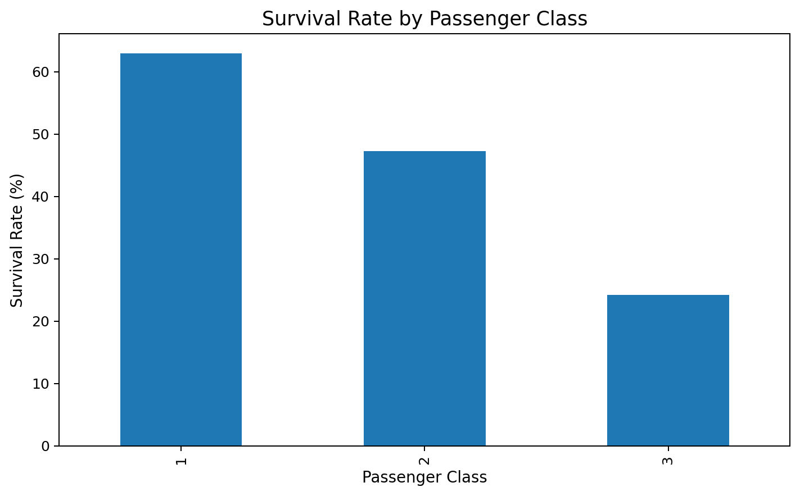
Figure 17. Survival rate by passenger class.

Observed survival rates decline from first to third class. The chi-square test supports an association between Pclass and survival (χ² = 102.889, p ≈ 4.55 × 10⁻²³). The logistic regression likewise shows lower estimated odds for Pclass 2 and especially Pclass 3 relative to Pclass 1 under the fitted model.

11.3 Age and Fare provide more nuanced evidence
Age is non-normal after the Week 1 imputation process, and its relationship with Fare is weakly positive. In the logistic model, Age has a statistically significant negative coefficient, while Fare is not statistically significant in the verified full-data coefficient table. This illustrates why bivariate visual patterns should not be treated as equivalent to multivariable model effects.

11.4 Predictive performance is useful but imperfect
The model achieved 81.56% holdout accuracy and 0.8443 holdout ROC-AUC, while 10-fold cross-validation produced mean accuracy of 79.91% and ROC-AUC of 0.8551. The close relationship between holdout and cross-validation results provides evidence that the reported performance is not dependent on one single split, although no external validation dataset was used.

12. Discussion and Practical Implications
The analysis shows how a data-driven workflow can move from raw observations to evidence-based interpretation. In a general analytics setting, the practical value is not the historical Titanic prediction itself; it is the workflow demonstrated by the project.
Analytical stage | What it contributes | Implication for data analysis
Data cleaning | Reduces missing-data and outlier problems | Model quality depends on upstream data quality
Visualization | Reveals distributions and group differences | Charts can identify which questions deserve formal testing
Hypothesis testing | Quantifies evidence against independence or strict normality | Descriptive patterns can be evaluated statistically
Correlation analysis | Shows direction and strength of numerical relationships | Helps identify structural relationships and multicollinearity
Logistic regression | Combines several predictors into one interpretable model | Multivariable analysis can distinguish simple patterns from adjusted associations
Cross-validation | Tests stability across multiple folds | Single-split performance should not be treated as the only evidence
Diagnostics | Examines multicollinearity and calibration | A model should be assessed beyond accuracy alone

12.1 Business and analytical implications
- For a data analyst, the project demonstrates the importance of defining the target variable and cleaning rules before visualization or modeling.
- For a business analyst, the project shows why a dashboard-level pattern should be accompanied by statistical context before being interpreted as a meaningful relationship.
- For a data-science workflow, the project demonstrates the value of separating exploratory analysis from final predictive evaluation and reporting multiple performance metrics.
- For communication with non-technical audiences, survival percentages and confusion-matrix metrics are easier to understand when accompanied by plain-language explanations and clear denominators.
Important interpretation boundary
The dataset records historical passenger outcomes. Statistical association and predictive performance do not establish that any passenger characteristic caused survival or non-survival. The model should therefore be presented as an analytical classification exercise rather than a causal model.

13. Strengths, Challenges and Limitations

13.1 Strengths
- One dataset is maintained across all four weeks, making the project internally consistent.
- Data preparation decisions are explicitly documented rather than hidden inside the modeling stage.
- Visualizations are selected according to analytical questions rather than used only for decoration.
- Formal tests connect descriptive observations to statistical evidence.
- Logistic regression provides interpretable coefficients and odds ratios.
- Both holdout and 10-fold cross-validation results are reported.
- Multiple metrics—accuracy, precision, recall, F1 and ROC-AUC—are used rather than accuracy alone.
- Multicollinearity and calibration-style diagnostics are included.
- The R workflow is reproducible through documented code.

13.2 Challenges encountered and how they were addressed
Challenge | Response
Missing Age values | Used Pclass × Sex group medians rather than dropping 177 records
Very high Cabin missingness | Created CabinKnown and removed the sparse raw Cabin field
Fare outliers | Used IQR-based capping rather than deleting observations
Mixed categorical and numerical variables | Converted modeling variables to appropriate factor/numeric forms
Potential predictor overlap | Excluded FamilySize from the final model because it is constructed from SibSp and Parch
Need for reliable model evaluation | Used both a stratified holdout split and 10-fold cross-validation
Need for interpretable communication | Combined odds ratios, confusion matrix, ROC-AUC and plain-language interpretation

13.3 Limitations
- The dataset is historical and has limited generalizability to modern populations.
- Age contains imputed values, so some observations do not represent directly observed ages.
- Cabin information is highly incomplete and therefore represented only through CabinKnown.
- Some predictors are correlated or structurally related.
- No completely independent external validation dataset was used.
- The 0.50 classification threshold is conventional and may not be optimal for every analytical objective.
- Observational relationships cannot establish causality.

14. Future Directions and Recommended Extensions
The current project provides a solid baseline, but several extensions could improve the analytical depth and predictive evaluation.
- Test nonlinear effects for Age and Fare using transformations, splines or generalized additive models.
- Evaluate selected interaction terms, especially interactions between passenger class and sex, while controlling model complexity.
- Compare logistic regression with decision trees, random forests, gradient boosting and other classifiers using the same validation framework.
- Apply regularization such as L1 or L2 penalties when the number of predictors or feature transformations increases.
- Compare classification thresholds using precision-recall trade-offs rather than assuming 0.50 is universally appropriate.
- Perform more detailed calibration analysis and report calibration error or reliability curves.
- Use external validation when a suitable independent dataset is available.
- Apply model-explainability techniques to understand individual predictions and feature contributions.
- Conduct sensitivity analysis to assess how different Age-imputation and Fare-treatment choices affect model results.
Recommended analytical principle
Future improvements should be compared under the same evaluation protocol. A new model should not be considered better merely because one metric increases; its performance, calibration, interpretability and stability should be evaluated together.

15. Conclusion and Lessons Learned
This four-week R project demonstrates a complete data-analysis pipeline from raw data inspection to predictive modeling and communication. The final report integrates the data-cleaning decisions from Week 1, the visual evidence from Week 2, and the statistical tests and logistic-regression results from Week 3.

15.1 Major lessons learned
- Good predictive analysis begins with reliable data preparation.
- Visualization is an analytical step that helps identify meaningful questions, not merely a presentation step.
- Statistical significance and practical importance are different concepts and should be discussed separately.
- Multivariable modeling can reveal whether an observed bivariate pattern remains after adjustment for other variables.
- Cross-validation and holdout testing provide stronger evidence about predictive performance than a single accuracy number.
- Model diagnostics are necessary because predictive performance alone does not describe every weakness of a model.
- Clear communication requires translating statistical outputs into plain-language interpretations without overstating causality.

15.2 Final summary
Across the 891-passenger dataset, sex and passenger class emerge as the most consistent variables associated with observed survival. The logistic model achieves useful discrimination, with verified holdout ROC-AUC of 0.8443 and 10-fold cross-validation mean ROC-AUC of 0.8551. At the same time, the model is not perfect: recall is below 70% on the holdout sample, some predictors require diagnostic monitoring, and external validation is absent. The project therefore illustrates both the value and the limitations of a data-driven approach.
Closing statement
The most important outcome of the project is the integrated analytical process: clean the data, understand it visually, test important relationships, build an appropriate model, validate it, diagnose it, and communicate the evidence with appropriate limitations.

Appendix A – Annotated R Code
The following excerpts preserve the main R operations used across the project. They are presented as annotated code excerpts for reproducibility and documentation.

A.1 Data inspection and cleaning
titanic <- read.csv("titanic_cleaned_analysis_ready.csv")
# Convert categorical variables to factors for modeling
titanic$Pclass <- factor(titanic$Pclass)
titanic$Sex <- factor(titanic$Sex)
titanic$Embarked <- factor(titanic$Embarked)
# Inspect structure and descriptive statistics
str(titanic)
summary(titanic[, c("Age","Fare","SibSp","Parch","FamilySize")])
# Check missing values and duplicates
colSums(is.na(titanic))
sum(duplicated(titanic))

A.2 Hypothesis tests and correlations
# Sex × survival
chisq.test(table(titanic$Sex, titanic$Survived))
# Passenger class × survival
chisq.test(table(titanic$Pclass, titanic$Survived))
# Age normality
shapiro.test(titanic$Age)
qqnorm(titanic$Age)
qqline(titanic$Age)
# Age–Fare relationships
cor.test(titanic$Age, titanic$Fare, method = "pearson")
cor.test(titanic$Age, titanic$Fare, method = "spearman")

A.3 Logistic regression
set.seed(42)
train_index <- createDataPartition(
titanic$Survived, p = 0.80, list = FALSE
)
train <- titanic[train_index, ]
test <- titanic[-train_index, ]
model <- glm(
Survived ~ Pclass + Sex + Age + Fare + SibSp + Parch + Embarked,
data = train,
family = binomial
)
summary(model)
exp(coef(model))
exp(confint(model))

A.4 Cross-validation and performance
ctrl <- trainControl(
method = "cv",
number = 10,
classProbs = TRUE,
summaryFunction = twoClassSummary,
savePredictions = "final"
)
cv_model <- train(
SurvivedLabel ~ Pclass + Sex + Age + Fare +
SibSp + Parch + Embarked,
data = train_cv,
method = "glm",
family = binomial,
metric = "ROC",
trControl = ctrl
)
prob <- predict(model, newdata = test, type = "response")
pred <- ifelse(prob >= 0.50, 1, 0)
confusionMatrix(
factor(pred, levels = c(0,1)),
factor(test$Survived, levels = c(0,1)),
positive = "1"
)
roc_obj <- roc(test$Survived, prob)
auc(roc_obj)

A.5 Diagnostics
# Multicollinearity
vif(model)
# Grouped goodness-of-fit check
hoslem.test(test$Survived, prob, g = 10)
# Save prediction-level outputs
write.csv(
data.frame(
Actual = test$Survived,
Probability = prob,
Predicted = pred
),
"week3_predictions.csv",
row.names = FALSE
)

Appendix B – Consolidated Statistical Output

B.1 Core project metrics
Measure | Verified value
Rows in original dataset | 891
Original columns | 12
Overall observed survival rate | 38.38%
Age mean / median | 29.112 / 26.000
Fare mean / median | 32.204 / 14.454
Sex × Survival χ² | 260.717
Sex × Survival p-value | 1.197 × 10⁻⁵⁸
Pclass × Survival χ² | 102.889
Pclass × Survival p-value | 4.549 × 10⁻²³
Age Shapiro-Wilk W | 0.9655
Age Shapiro-Wilk p-value | 1.118 × 10⁻¹³
Age–Fare Pearson r | 0.1227
Age–Fare Spearman ρ | 0.1744
Holdout accuracy | 81.56%
Holdout precision | 80.00%
Holdout recall | 69.57%
Holdout F1 | 74.42%
Holdout ROC-AUC | 0.8443
10-fold CV mean accuracy | 79.91%
10-fold CV mean ROC-AUC | 0.8551
Hosmer-Lemeshow-style statistic | ≈ 6.83
Hosmer-Lemeshow-style p-value | ≈ 0.555

B.2 Output interpretation guide
- p < 0.05 in the hypothesis tests indicates evidence against the corresponding null hypothesis for that test.
- Correlation coefficients near zero indicate weak linear or monotonic association even when p-values are statistically significant.
- Odds ratios below 1 indicate lower modeled odds relative to the reference category or per-unit increase, depending on the predictor.
- Accuracy measures overall classification correctness; precision measures the proportion of predicted survivors that were actually survivors; recall measures the proportion of actual survivors identified; F1 balances precision and recall; ROC-AUC summarizes discrimination across thresholds.

References
- Kaggle. Titanic – Machine Learning from Disaster. Titanic training dataset and data dictionary.
- CRAN. titanic package documentation. Individual passenger Titanic data and variable descriptions.
- R Core Team. R: A Language and Environment for Statistical Computing. R Foundation for Statistical Computing.
- Week 1 Project Report. Data Cleaning and Preliminary Analysis with R – Titanic Passenger Survival Dataset.
- Week 2 Project Report. Data Visualization and Insight Communication using R – Titanic Passenger Survival Dataset.
- Week 3 Project Report. Statistical Analysis and Predictive Modeling using R – Titanic Passenger Survival Dataset.
Note on evidence presentation: The report uses verified numerical outputs and reproducible figures from the completed project. Where the Week 4 assignment requests RStudio screenshots, this report presents reproducible output excerpts and generated analytical figures rather than fabricating screenshots of the RStudio interface.

Submission Checklist
- Introduction and project objectives included.
- Data preparation and cleaning methodology integrated from Week 1.
- Key visualizations integrated from Week 2.
- Hypothesis testing, correlation analysis and assumptions integrated from Week 3.
- Predictive model, validation metrics and diagnostics included.
- Annotated R code excerpts included.
- Output tables and graphical visuals included.
- Discussion, practical implications, limitations and future directions included.
- Conclusion and lessons learned included.
- Professional Times New Roman formatting and page numbering applied.

