Name:- Matli Chandana

Reg no:192111221

SET 1: (Q1)EXPERIMENT 1:

NMAP TOOLS

1:SPECIFY PORT OR PORT RANGE

2:SCAN ALL PORTS

3: FAST PORT SCAN

STEP 1: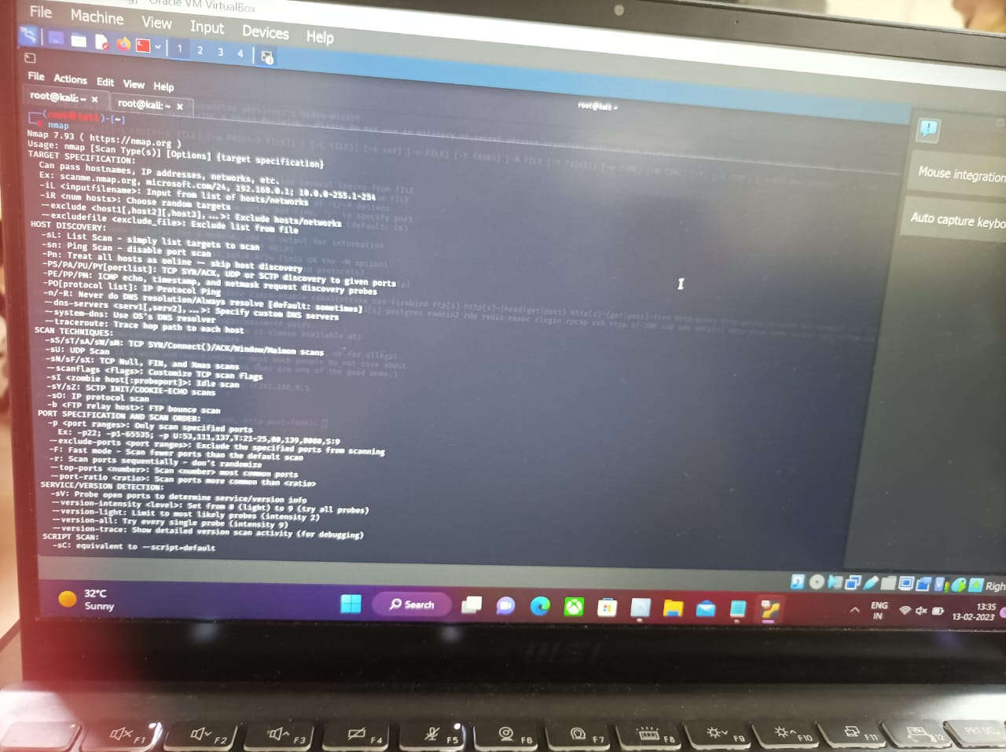

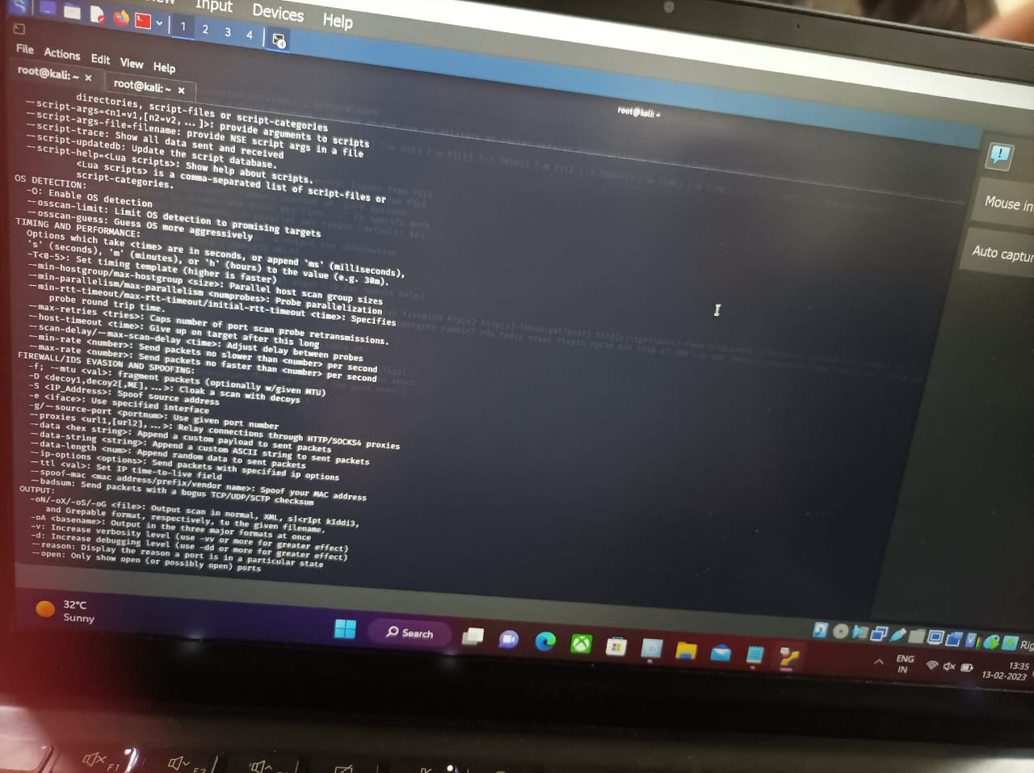

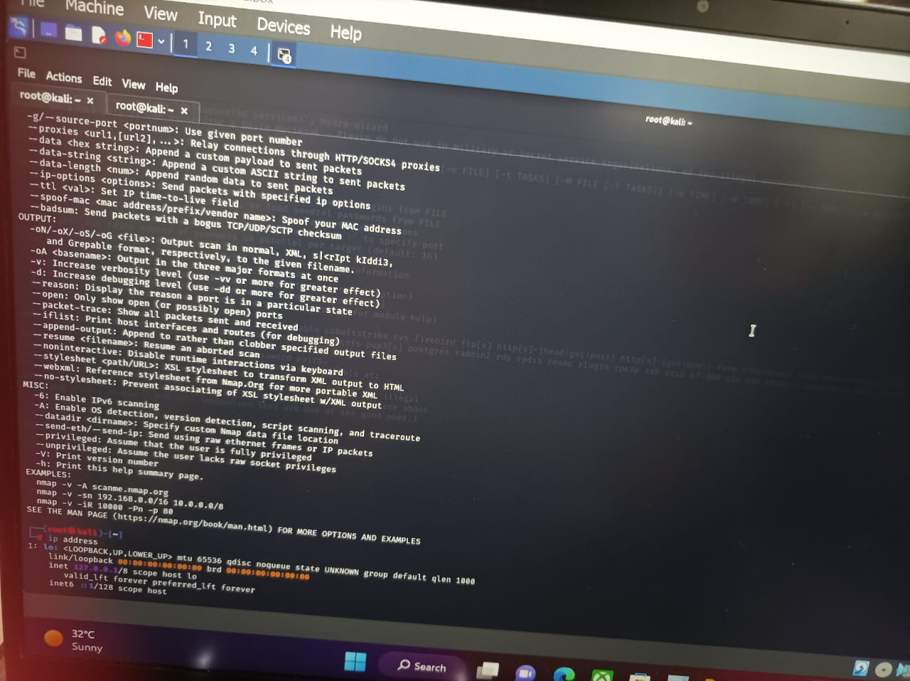

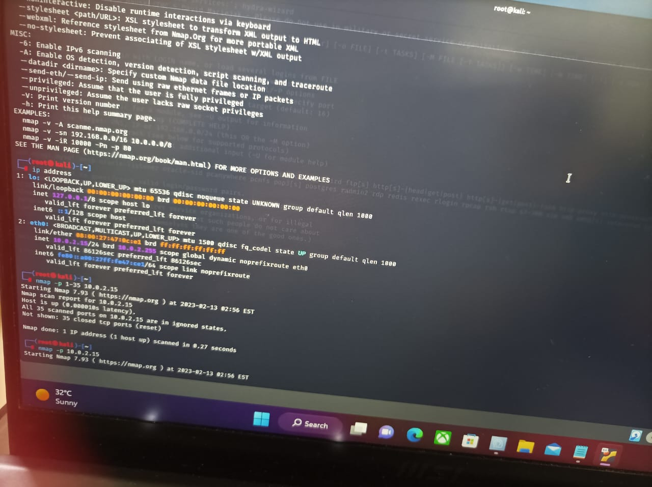

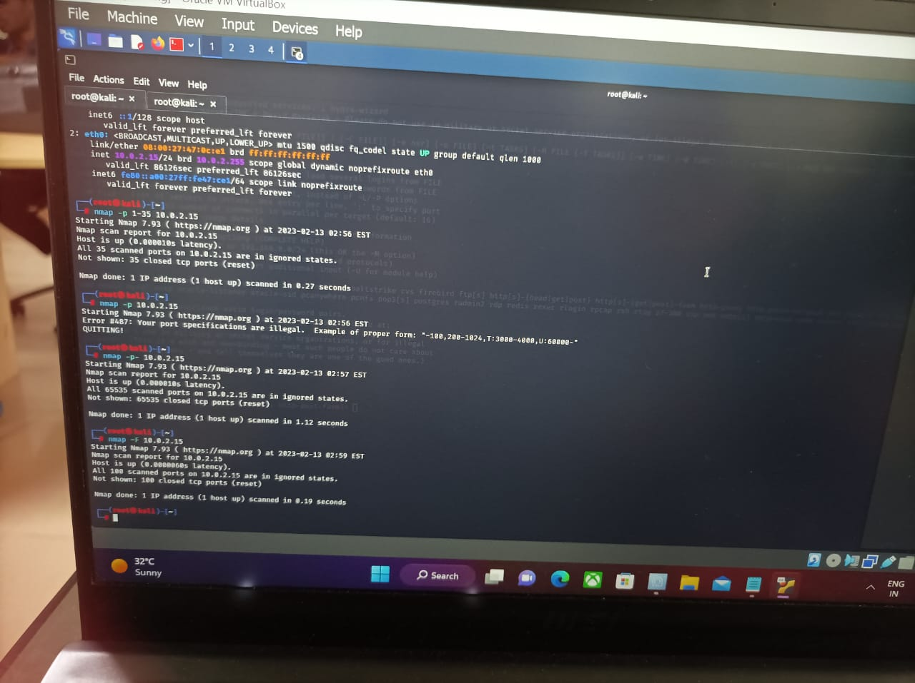

SET 1:(Q2):EXPERIMENT 2- PASSWORD CRACKING

STEP:1

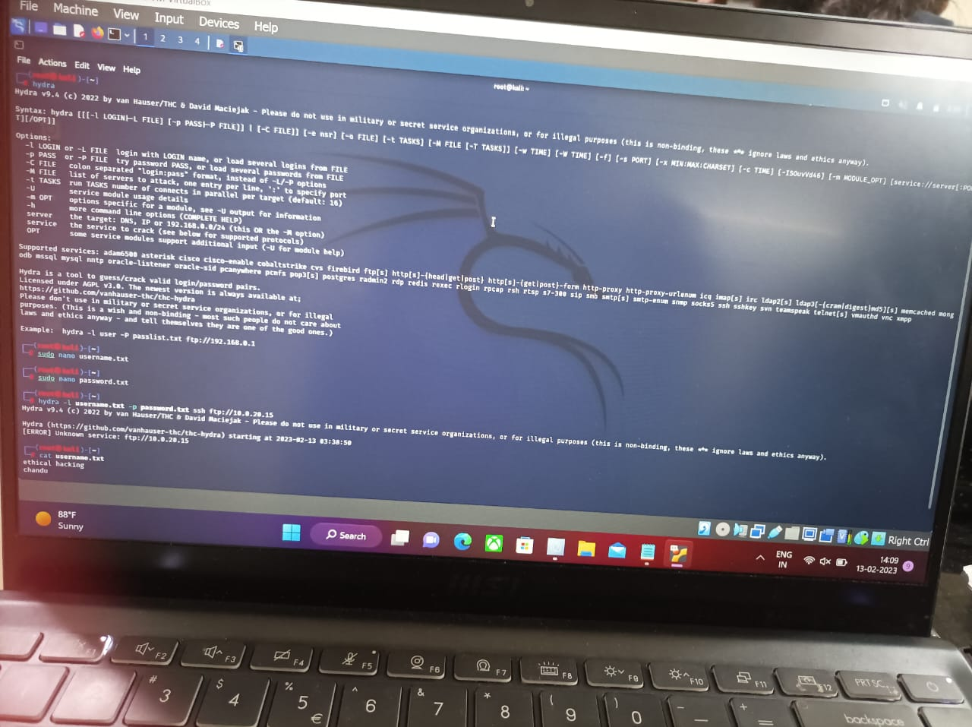

STEP :2

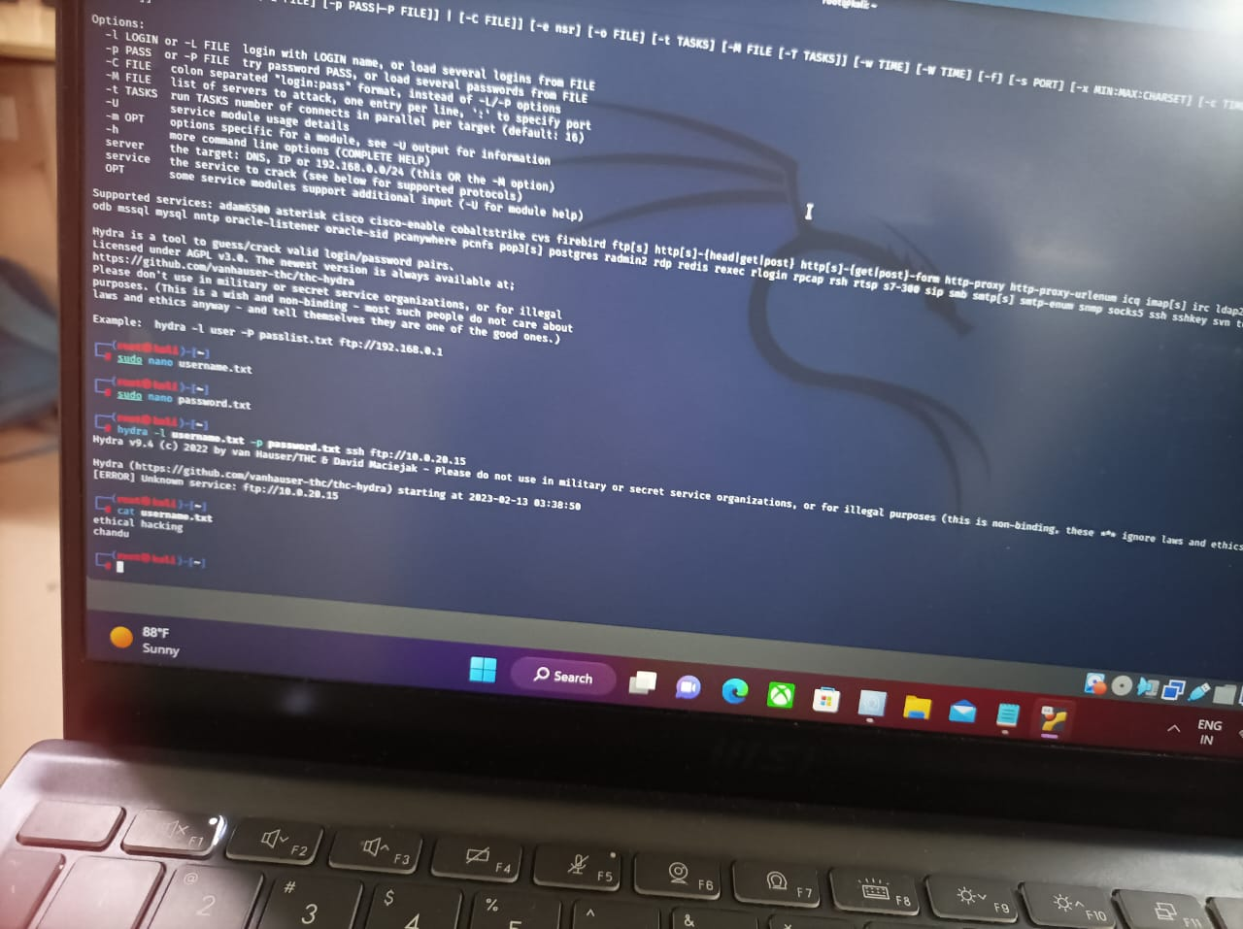

SET 1:(Q3) EXPERIMENT 3:WIRESHARK

STEP 1:

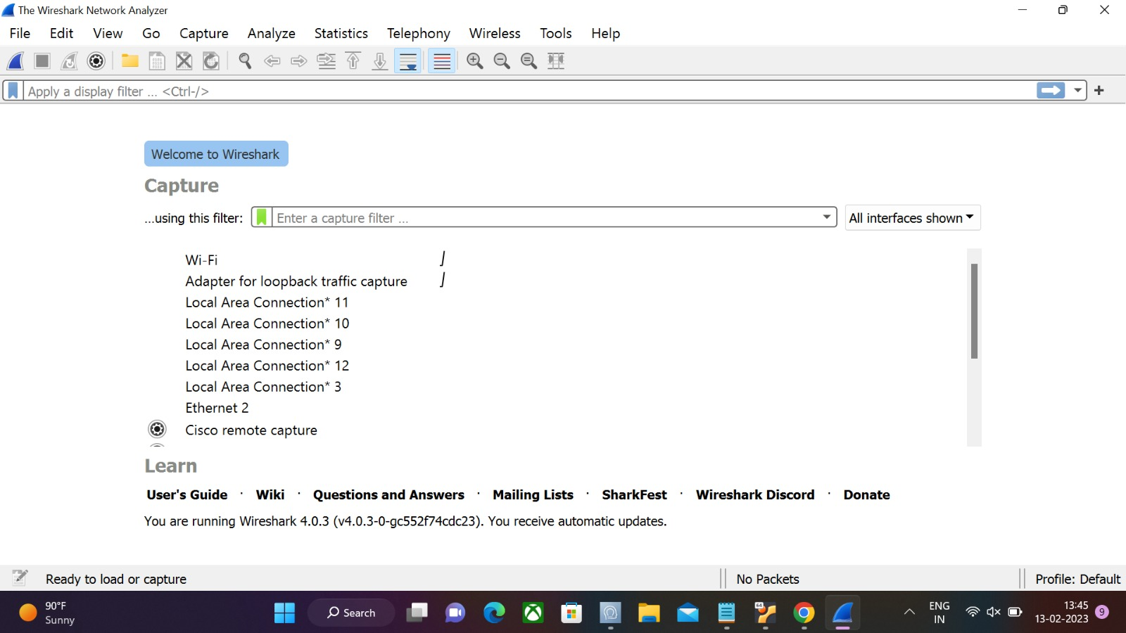

STEP 2:

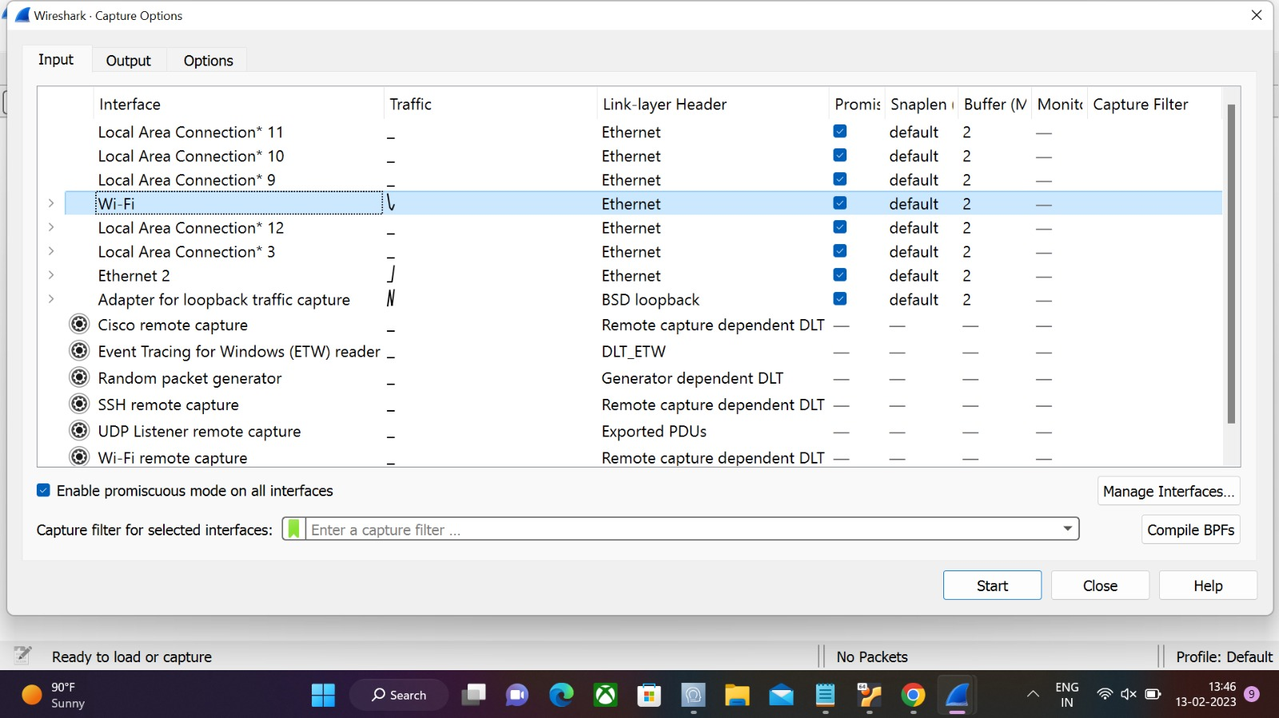

STEP 3:



STEP 4:

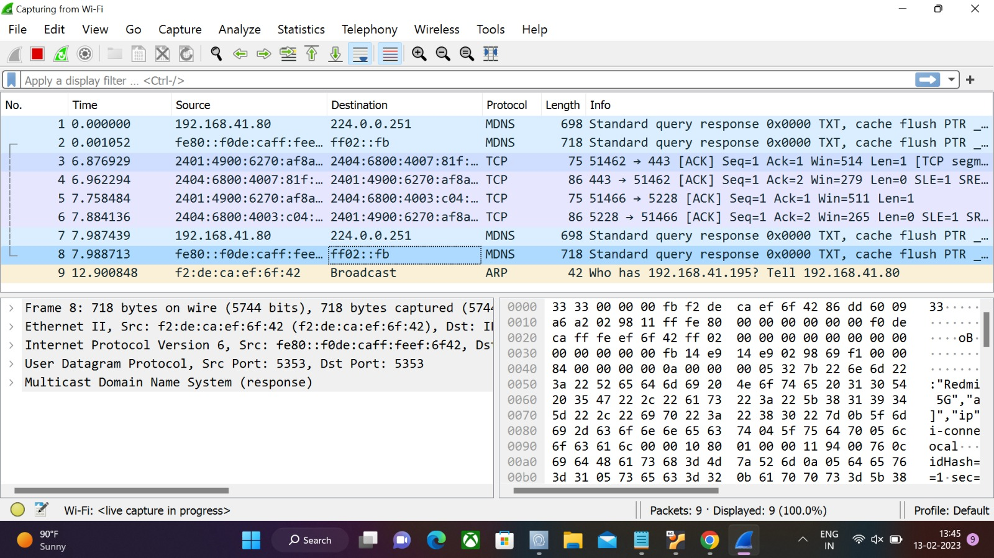

STEP 5:

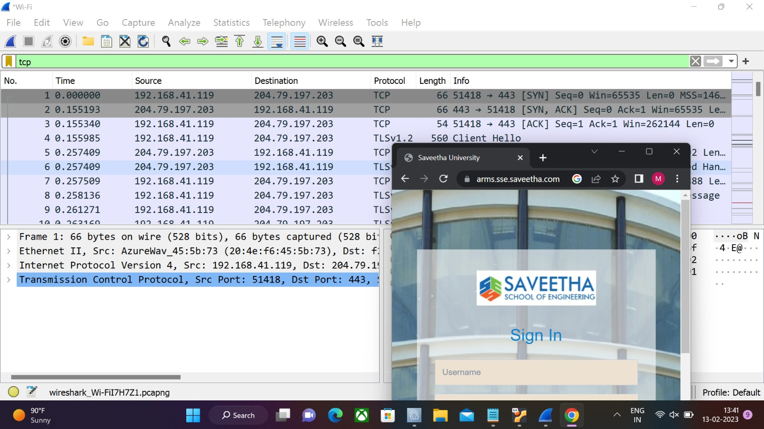

SET 1:(Q4):EXPERIMENT 4:

EXECUTING LS,CAT,MKDIR COMMANDS IN KALI

STEP 1:

LS COMMAND

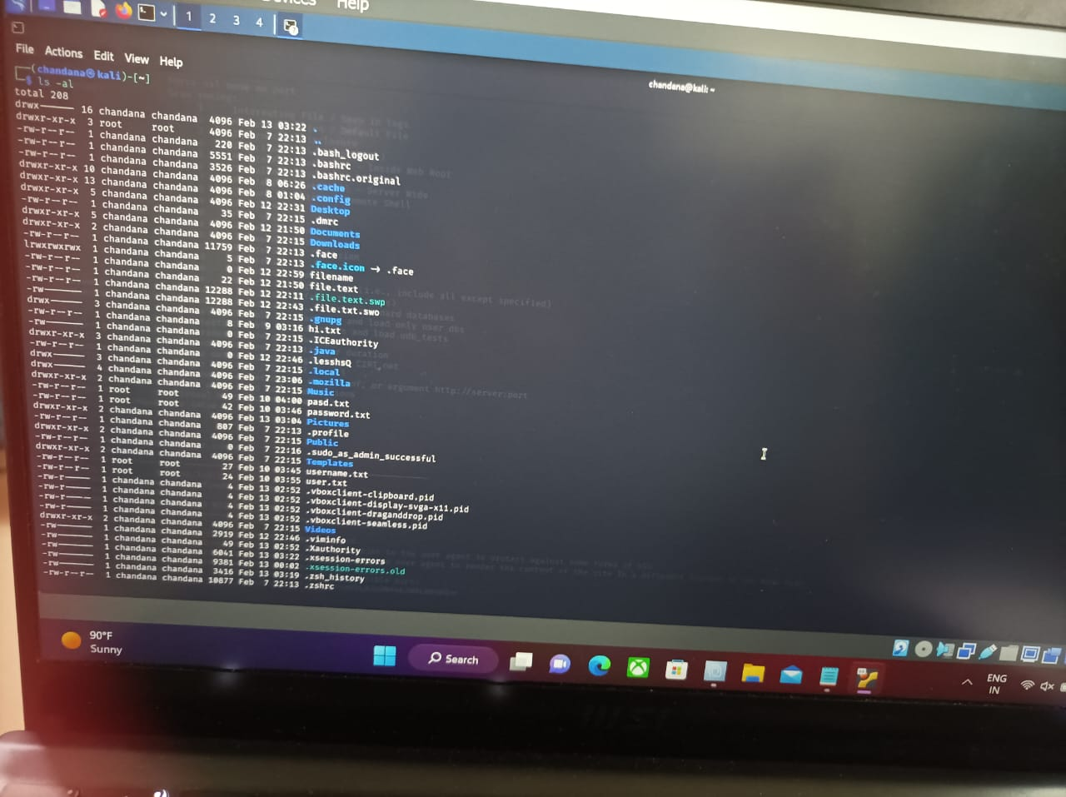

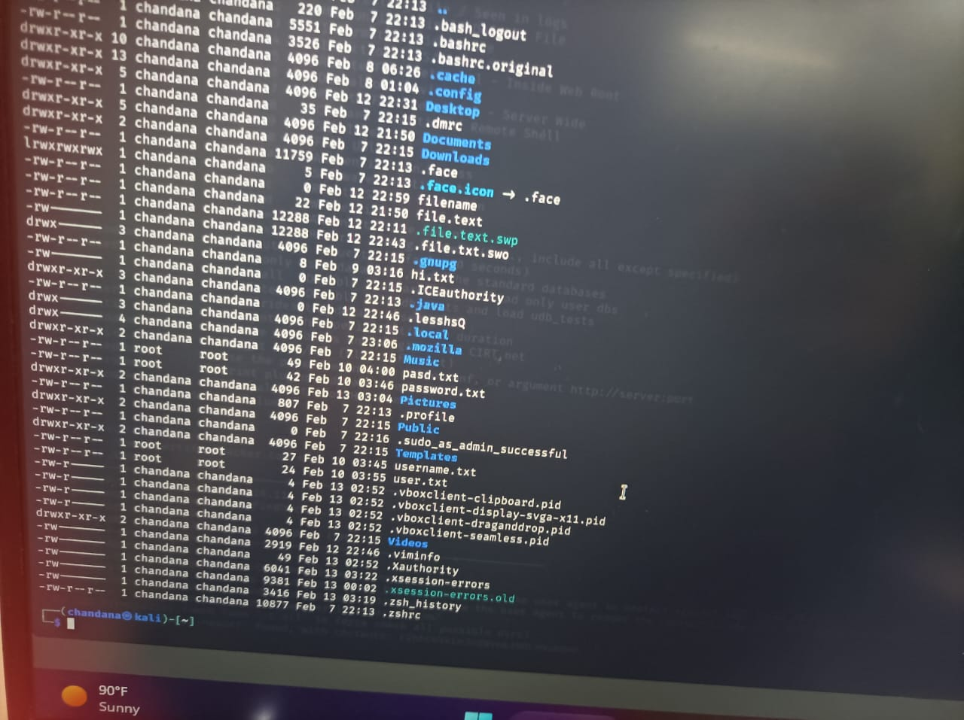

STEP :2

CAT COMMAND

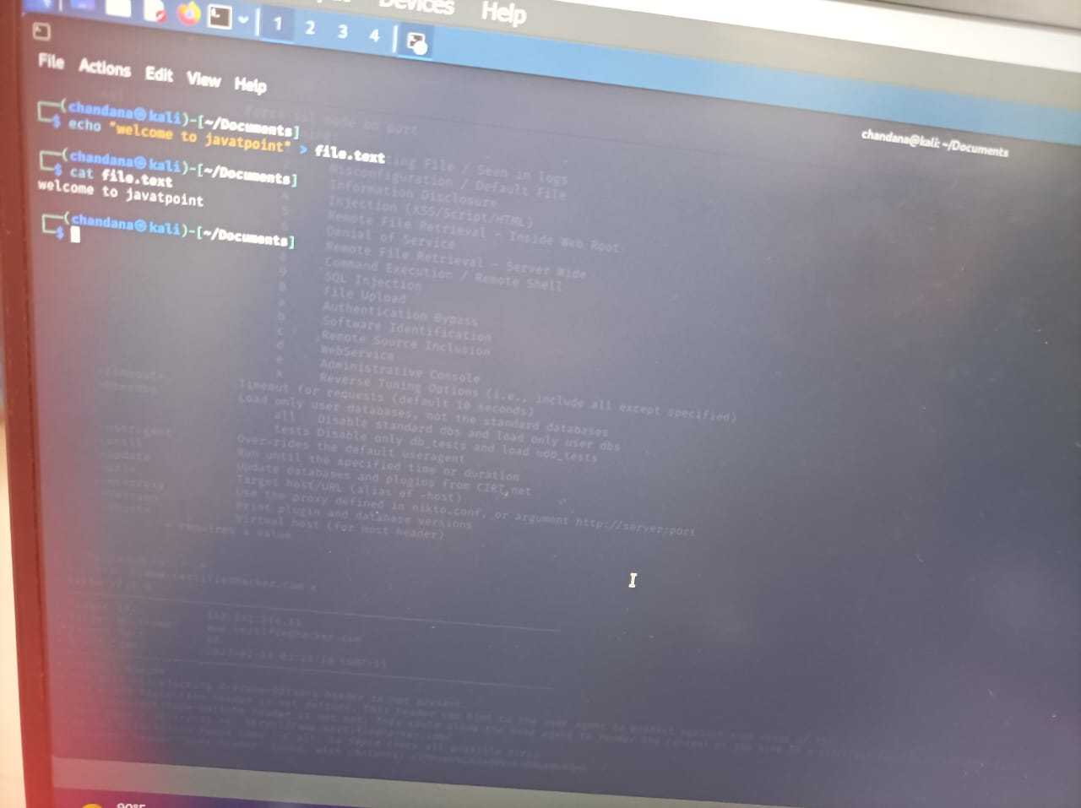

STEP 3:

MKDIR COMMAND

