
PES UNIVERSITY
100 feet Ring Road, BSK 3rd Stage, Bengaluru 560085
Department of Computer Science and Engineering
(AI & ML)
B. Tech. CSE - 5th Semester
Aug – Dec 2026
UE23CS351A
DATABASE MANAGEMENT SYSTEMS (DBMS)
PROJECT REPORT on
Software Supply-Chain Vulnerability Management Database
Submitted by:
SRN | Name | Section
PES1UG24AM352 | Bhumika Patil | 5 [Sec]
PES1UG24AM353 | Chandana O N | 5 [Sec]
Class of Prof. [NAME]
[Lab Faculty]

Abstract
Modern software is assembled from hundreds of third-party packages, and each package depends on further packages. A single vulnerable library deep in that chain can expose every application that uses it, often without the team knowing. This project builds a database system that records projects, packages, package versions, the dependency relationships between them, published vulnerabilities (CVEs), the versions that fix them, and the remediation work done by the team.
The relational design in MySQL 8 has eleven tables in Third Normal Form, protected by primary, foreign, unique, NOT NULL and CHECK constraints. Recursive common table expressions trace each vulnerability through direct and indirect dependencies and report the exact path, with protection against circular dependencies. Triggers derive severity from the CVSS score, open remediation items automatically and keep an audit trail, while stored procedures wrap multi-step changes in transactions. Role-based access is enforced inside the database using MySQL roles, table-level grants and one service account per application role.
A MongoDB copy of the data stores the dependency graph as embedded arrays and answers the same exposure question with $graphLookup, and it also holds free-form analyst notes validated with $jsonSchema. A Next.js 16 web application provides login with bcrypt-hashed passwords and JWT sessions, and separate views for developers, security analysts and administrators. The system is verified by 9 SQL feature tests, 15 database permission tests and 30 end-to-end API tests, all of which pass.

Table of Contents
Sl. No | Topic | Page No.
1. | Introduction  a) Problem Statement | 4
2. | User Requirements Specification - Tech Stack | 5
3. | E-R Model  a) List of Entities [labeling Weak ones]  b) List non-simple Attributes  c) ER Diagram Snapshot  d) ERD from a tool (Graphviz) | 7
4. | Relational Model  a) List of Relations that are not Entities in ER Model  b) Schema Diagram | 10
5. | SQL DDL Statements | 12
6. | SQL DML Statements | 18
7. | NoSQL Database Commands | 24
8. | Results  a) Resulting Tables' Screenshots | 27
9. | Next.js Project Tree Structure | 33
10. | Sample Screenshots of Application Code and Demo | 34
11. | Evaluation Rubrics - Completion Status | 43

1. Introduction

1.1 Problem Statement
Software teams rarely know their full dependency tree. When a vulnerability such as Log4Shell (CVE-2021-44228) is published, the urgent questions are: which of our projects use the affected package, directly or through another package; through which chain of packages does it arrive; is there a fixed version; and who is fixing it. Answering these by hand across many projects is slow and error prone.

Short Description
The Software Supply-Chain Vulnerability Management Database stores projects and their owners, packages from three ecosystems (npm, PyPI and Maven), every package version, which versions each project uses directly, which versions depend on which other versions, the CVEs that affect particular versions, the patches that fix them, and one remediation record per exposed project and CVE. From this data the system answers, for example, that CVE-2022-24999 in qs@6.5.2 reaches the WebShop project three levels deep through express@4.16.0 -> body-parser@1.18.3 -> qs@6.5.2, that the fix is qs@6.11.0, and who is assigned to the work.
The seed data contains 4 users, 6 projects, 15 packages, 26 package versions, 7 real-world CVEs and 6 patches. It deliberately includes a circular dependency (lib-a and lib-b depend on each other) to prove that the recursive queries terminate, and one CVE with no patch.

2. User Requirements Specification

2.1 Users and roles
Role | Who | What they can do
Developer | Asha Nair, Ravi Kumar | See only the projects they own, see how each CVE reaches them, update the status of their own remediation items
Security analyst | Meera Iyer | See all projects and CVEs, trace any CVE, run reports, update and take ownership of remediation items, write analyst notes in MongoDB
Admin | Admin User | Everything an analyst can do, plus register and delete CVEs, view users and the audit log

2.2 Functional requirements
- Register projects, packages, package versions and users.
- Record direct dependencies of projects and dependencies between package versions.
- Register vulnerabilities and the package versions they affect.
- Derive severity automatically from the CVSS score.
- Record patches (fixed versions) for vulnerabilities.
- Create remediation records automatically for every exposed project, including indirect exposure.
- Track remediation status (OPEN, IN_PROGRESS, RESOLVED, IGNORED) and assignee.
- Apply a patch by upgrading a dependency and closing the related remediation, as one transaction.
- Log every change to key tables in an audit log with old and new values and the user who made it.
- Authenticate users and restrict both pages and database access by role.

2.3 Questions the database must answer
- Which projects are affected by a given CVE, directly or indirectly, and through which path?
- Which CRITICAL or HIGH vulnerabilities are still unresolved, and who owns them?
- Which packages in use are outdated, and which CVEs have no patch?
- Which fixed version should each project upgrade to?
- Which projects carry the highest total risk?
- Who changed a vulnerability or remediation record, and when?

2.4 Non-functional requirements
- Integrity: foreign keys, unique keys, NOT NULL and CHECK constraints reject bad data in the database itself.
- Consistency: multi-step changes run inside transactions with rollback on error.
- Safety: circular dependencies must never cause infinite recursion.
- Security: least privilege. The login route can run only one procedure, and developers cannot read the vulnerability tables directly.
- Auditability: old and new values are stored for every change.

2.5 Tech stack and justification
Layer | Choice | Why it fits this problem
Relational database | MySQL 8.0.16+ | Remediation and audit data must stay correct, so we need foreign keys, CHECK constraints, triggers and transactions. WITH RECURSIVE traces dependency chains and returns the full path. MySQL roles and GRANTs let us enforce role-based access inside the database.
NoSQL database | MongoDB | See section 2.6.
Web framework | Next.js 16 (React 19) | Pages and backend API (route handlers) live in one project. Database credentials stay on the server. The built-in proxy (formerly middleware) guards pages by role before they load.
Database drivers | mysql2, mongodb (Node.js) | Official, promise-based drivers with parameterised queries, which prevent SQL injection.
Authentication | bcryptjs, jose (JWT) | Passwords are stored only as bcrypt hashes. The session is a signed JWT in an httpOnly cookie that page scripts cannot read, and it expires after 2 hours.
Styling | Tailwind CSS 4 | Consistent, responsive UI without a separate stylesheet codebase.
Data migration | Python 3, pymongo, mysql-connector | Copies the MySQL data into MongoDB documents in one script.

2.6 Why MongoDB as the NoSQL database
- The dependency graph is read far more often than it is written. Each component document embeds a depends_on array, and each project embeds direct_deps, so a project's whole tree is one $graphLookup stage instead of a long recursive query.
- Cycle protection is built in. $graphLookup remembers visited documents, so the lib-a / lib-b cycle needs no manual path check.
- Analyst notes have no fixed shape. Some notes carry tags and some do not. A document store holds this naturally, and $jsonSchema still enforces the required fields.
- Different ecosystems carry different metadata (npm, PyPI and Maven). Documents can grow new fields without schema changes.
- MySQL remains the system of record because it enforces integrity and roles. MongoDB is a read-optimised copy plus the notes store. Section 7 shows the commands.

3. E-R Model

3.1 List of Entities
Weak entities are highlighted. PACKAGE_VERSION cannot be identified on its own: version 2.0.0 means nothing without knowing the package. It is identified by its owner PACKAGE through the identifying relationship HAS_VERSION, with version_no as its partial key. In the relational design it receives a surrogate key version_id plus UNIQUE (package_id, version_no).
Entity | Type | Key | Description
APP_USER | Strong | user_id | A person who logs in: developer, security analyst or admin
PROJECT | Strong | project_id | An application owned by a user, with a business criticality
PACKAGE | Strong | package_id | A third-party library in an ecosystem (npm, PyPI, Maven)
PACKAGE_VERSION | Weak (owner: PACKAGE) | partial key: version_no | One released version of a package
VULNERABILITY | Strong | vuln_id (cve_id unique) | A published CVE with CVSS score and severity
PATCH | Strong | patch_id | A package version that fixes a vulnerability
REMEDIATION | Strong | remediation_id | The work item for one project and one CVE: status, assignee, dates
AUDIT_LOG | Strong | log_id | One recorded change to a key table. Stand-alone by design: filled by triggers

3.2 Relationships
Relationship | Between | Cardinality | Participation | Maps to
OWNS | APP_USER – PROJECT | 1 : N | PROJECT total | project.owner_id
HAS_VERSION (identifying) | PACKAGE – PACKAGE_VERSION | 1 : N | PACKAGE_VERSION total | package_version.package_id
DEPENDS_ON (attr: added_at) | PROJECT – PACKAGE_VERSION | M : N | partial | table project_dependency
REQUIRES (recursive) | PACKAGE_VERSION (parent) – PACKAGE_VERSION (child) | M : N | partial | table package_dependency
AFFECTS | VULNERABILITY – PACKAGE_VERSION | M : N | VULNERABILITY total | table vulnerability_affected
FIXES | VULNERABILITY – PATCH | 1 : N | PATCH total | patch.vuln_id
FIXED_IN | PACKAGE_VERSION – PATCH | 1 : N | PATCH total | patch.fixed_version_id
FOR_PROJECT | PROJECT – REMEDIATION | 1 : N | REMEDIATION total | remediation.project_id
FOR_CVE | VULNERABILITY – REMEDIATION | 1 : N | REMEDIATION total | remediation.vuln_id
ASSIGNED_TO | APP_USER – REMEDIATION | 1 : N | partial (may be unassigned) | remediation.assigned_to

3.3 List of non-simple Attributes
Attribute | Kind | Explanation
VULNERABILITY.severity | Derived | Computed from cvss_score (≥9 CRITICAL, ≥7 HIGH, ≥4 MEDIUM, else LOW). Stored for fast filtering and kept correct by BEFORE INSERT/UPDATE triggers.
PROJECT.risk_score | Derived | Not stored. Computed by the function calculate_risk_score() and the view v_project_risk_summary from the CVEs that reach the project.
PACKAGE_VERSION.version_no | Partial key | Identifies a version only together with its owning PACKAGE.
AUDIT_LOG.old_data, new_data | Complex (JSON) | Structured values holding the changed columns before and after the change.
Multivalued attributes | None in SQL | Lists such as a project's dependencies are M:N relationships stored in their own tables. In MongoDB they become arrays: direct_deps, depends_on, affected, patches, tags.

3.4 ER Diagram
Notation: rectangles are entities (double rectangle = weak), diamonds are relationships (double diamond = identifying), ellipses are attributes (underlined = key, dashed = derived), double lines show total participation and the red labels give cardinality.

3.5 ERD from a tool
The ER diagram on the next page was produced with Graphviz from a script kept in the repository (docs/diagrams/make_er_diagram.py), so it always matches the implemented schema and can be regenerated after any change. An SVG version (docs/diagrams/ER_Diagram.svg) can be opened and edited in draw.io.

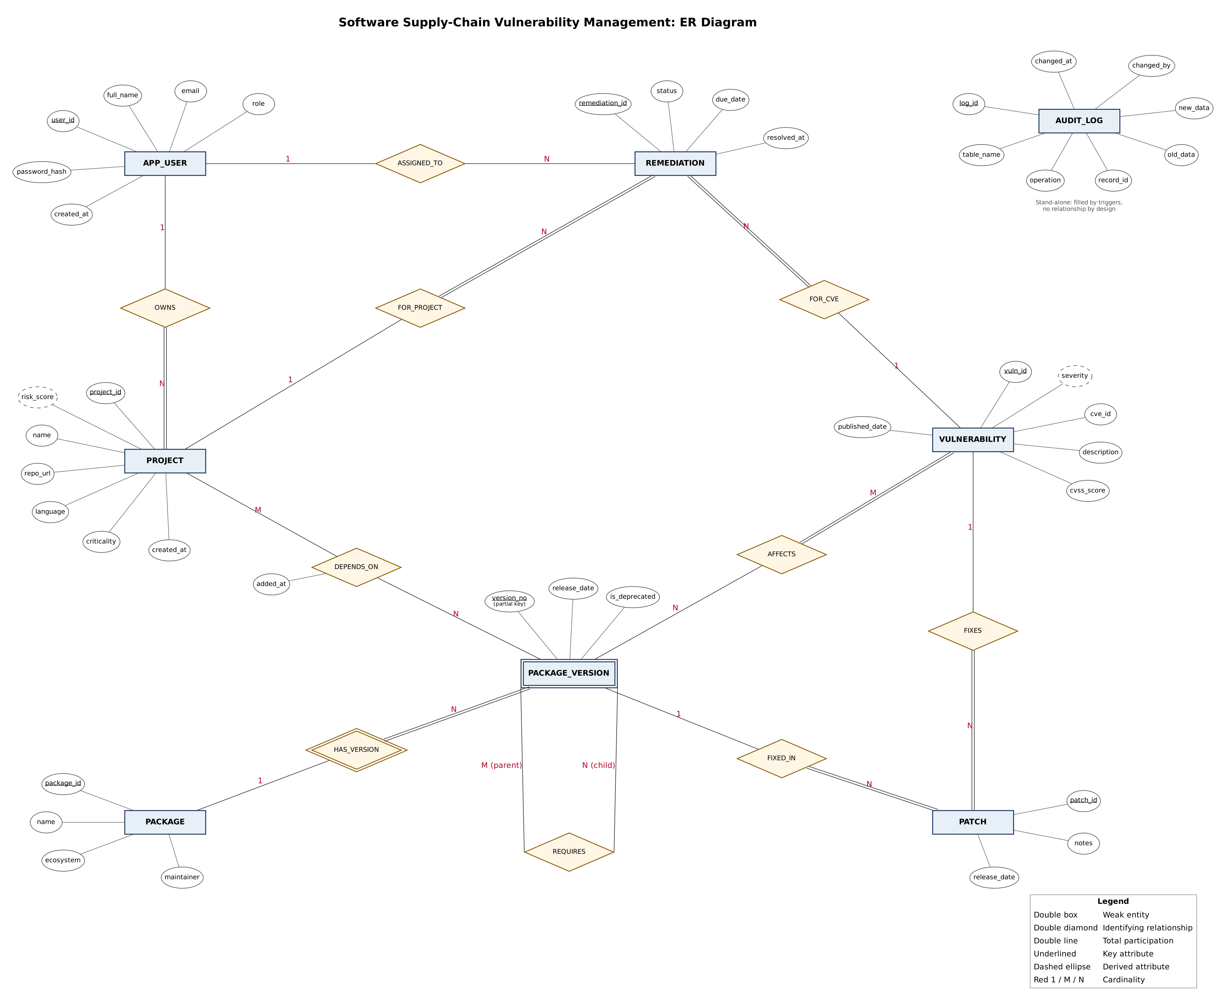
Figure 1: ER diagram (Chen notation), drawn with Graphviz

4. Relational Model

4.1 List of Relations
Highlighted rows are relations that are not entities in the ER model. They come from the three many-to-many relationships, and their primary key is the combination of the two foreign keys.
Relation | Primary key | Foreign keys | From ER
app_user | user_id | – | Entity APP_USER
project | project_id | owner_id → app_user | Entity PROJECT (+ OWNS)
package | package_id | – | Entity PACKAGE
package_version | version_id | package_id → package | Weak entity PACKAGE_VERSION (+ HAS_VERSION)
project_dependency | (project_id, version_id) | project, package_version | Relationship DEPENDS_ON (not an entity)
package_dependency | (parent_version_id, child_version_id) | package_version (twice) | Relationship REQUIRES (not an entity)
vulnerability | vuln_id | – | Entity VULNERABILITY
vulnerability_affected | (vuln_id, version_id) | vulnerability, package_version | Relationship AFFECTS (not an entity)
patch | patch_id | vuln_id, fixed_version_id | Entity PATCH (+ FIXES, FIXED_IN)
remediation | remediation_id | project_id, vuln_id, assigned_to | Entity REMEDIATION (+ 3 relationships)
audit_log | log_id | – (by design) | Entity AUDIT_LOG

4.2 Normalisation
The starting point was one wide sheet (project, owner, owner email, package, ecosystem, version, CVE, CVSS, severity, fix). It suffered update, insertion and deletion anomalies. 1NF: every cell atomic, one row per (project, package, version, CVE). 2NF: attributes depending on part of the key moved out (project → owner, criticality; package → ecosystem; CVE → description, CVSS). 3NF: project → owner → owner_email became the app_user table. The one deliberate exception is vulnerability.severity, which depends on cvss_score. It is kept for query speed and the triggers guarantee it can never drift. Full reasoning is in docs/normalization.md.

4.3 Schema Diagram
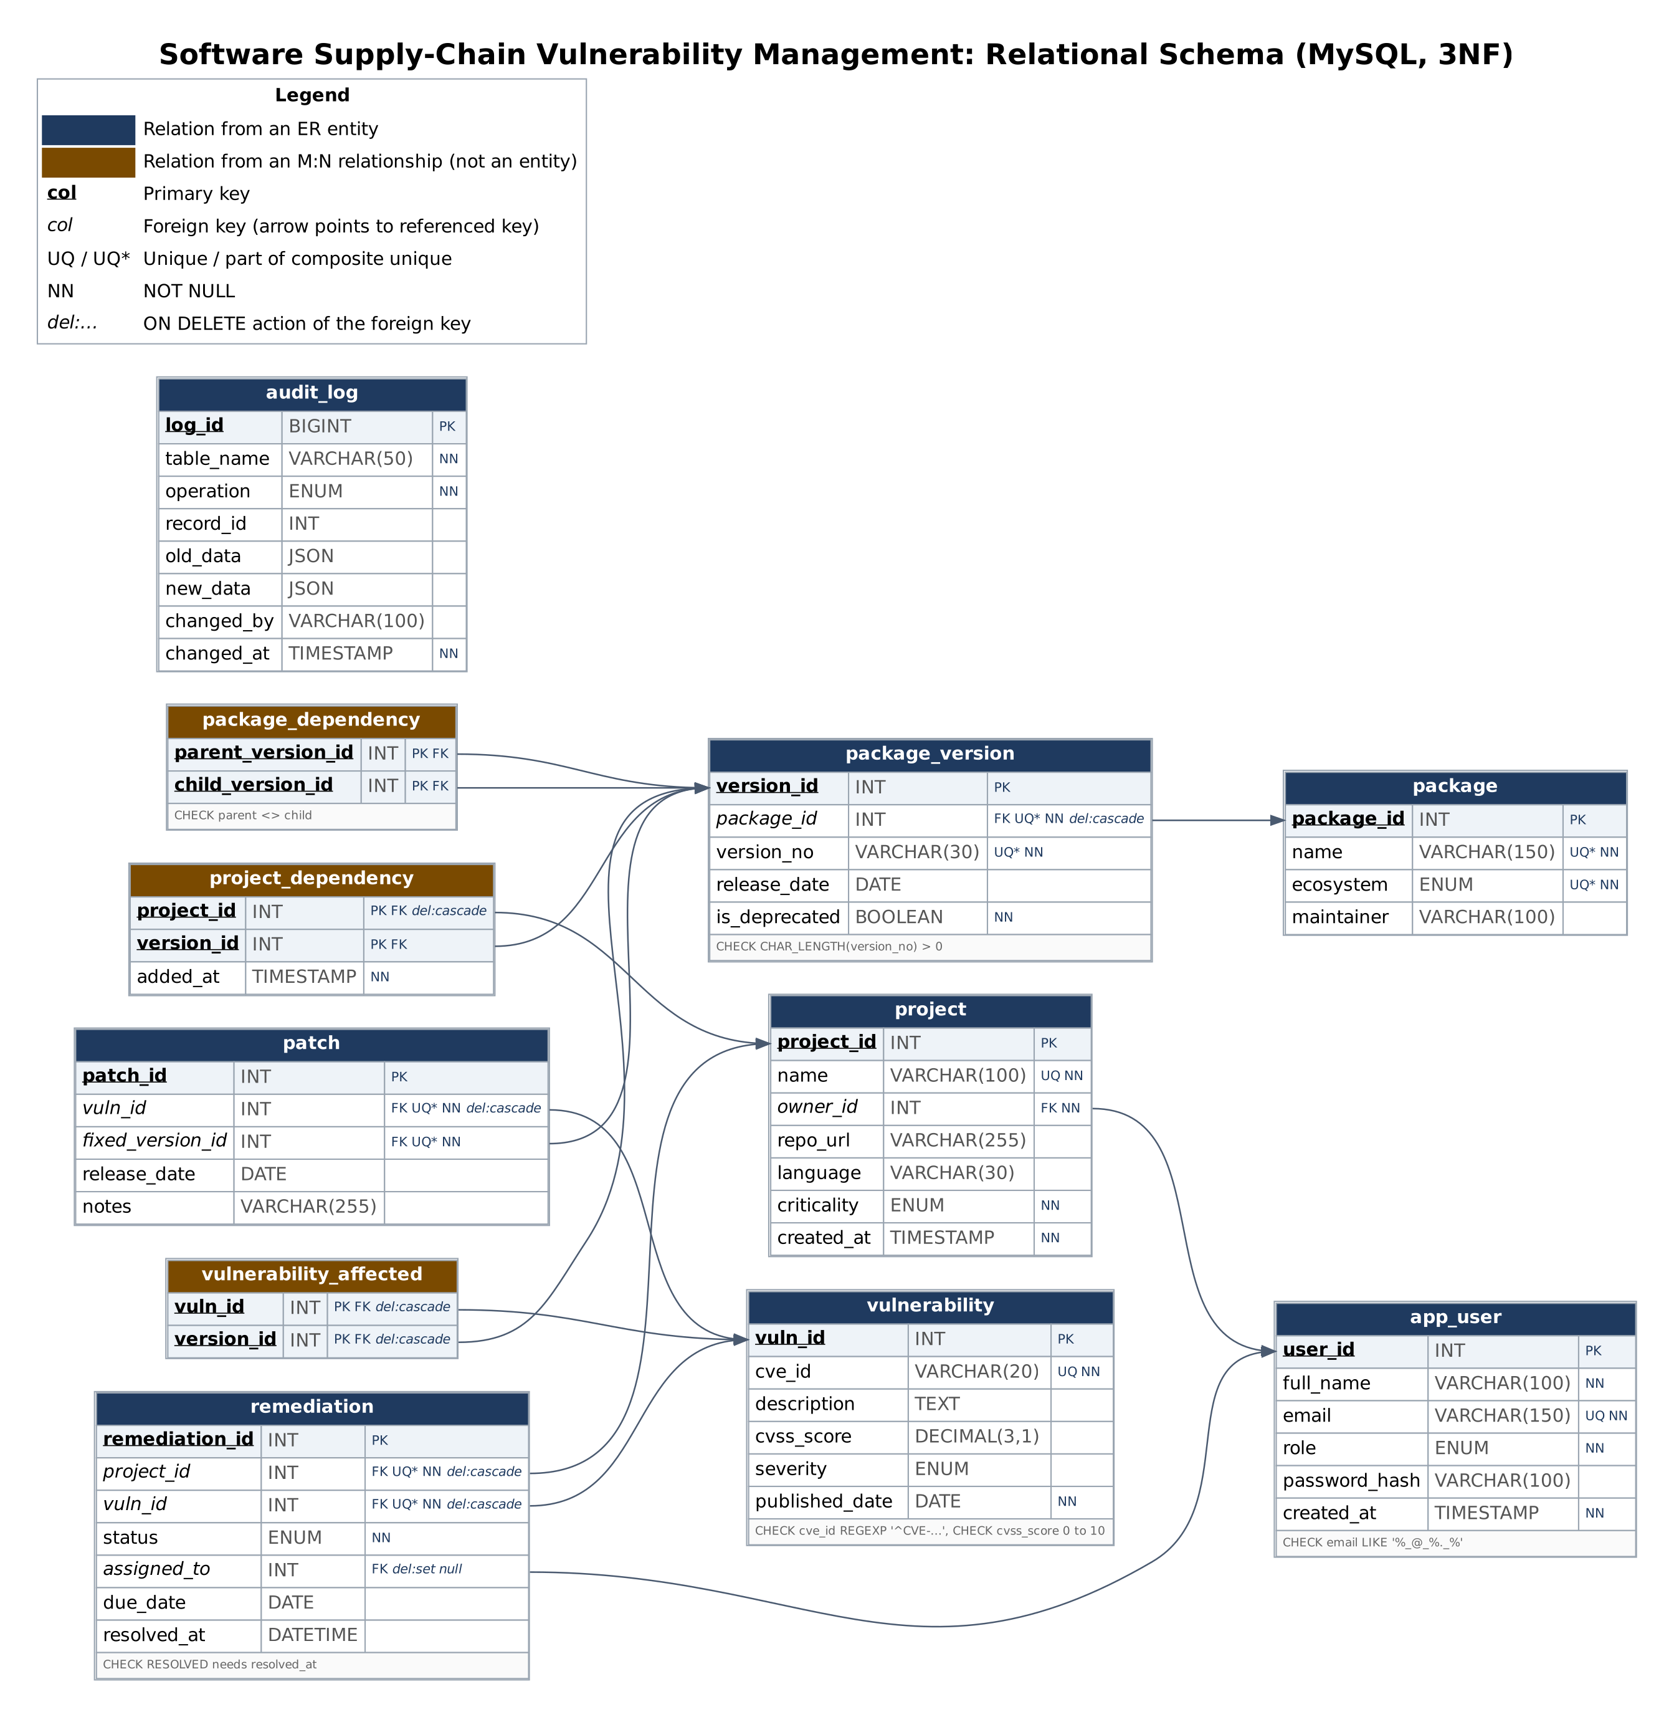
Figure 2: Relational schema with keys, types, constraints and foreign keys

5. SQL DDL Statements
All DDL is in the sql/ folder and runs in order through sql/00_setup_all.sql. The complete table definitions and constraints are below, followed by the key views, routines, triggers and roles.

5.1 Tables (01_schema.sql)
-- 01_schema.sql | Requires MySQL 8.0.16+
DROP DATABASE IF EXISTS supply_chain_db;
CREATE DATABASE supply_chain_db CHARACTER SET utf8mb4;
USE supply_chain_db;

-- ========== PART A: core tables ==========

CREATE TABLE app_user (
user_id INT AUTO_INCREMENT PRIMARY KEY,
full_name VARCHAR(100) NOT NULL,
email VARCHAR(150) NOT NULL UNIQUE,
role ENUM('DEVELOPER','SECURITY_ANALYST','ADMIN') NOT NULL DEFAULT 'DEVELOPER',
password_hash VARCHAR(100) NULL, -- bcrypt hash, filled by webapp/scripts/seed-passwords.mjs
created_at TIMESTAMP NOT NULL DEFAULT CURRENT_TIMESTAMP
) ENGINE=InnoDB;

CREATE TABLE project (
project_id INT AUTO_INCREMENT PRIMARY KEY,
name VARCHAR(100) NOT NULL UNIQUE,
owner_id INT NOT NULL,
repo_url VARCHAR(255),
language VARCHAR(30),
criticality ENUM('LOW','MEDIUM','HIGH','CRITICAL') NOT NULL DEFAULT 'MEDIUM',
created_at TIMESTAMP NOT NULL DEFAULT CURRENT_TIMESTAMP,
CONSTRAINT fk_project_owner FOREIGN KEY (owner_id) REFERENCES app_user(user_id)
) ENGINE=InnoDB;

CREATE TABLE package (
package_id INT AUTO_INCREMENT PRIMARY KEY,
name VARCHAR(150) NOT NULL,
ecosystem ENUM('npm','PyPI','Maven') NOT NULL,
maintainer VARCHAR(100),
CONSTRAINT uq_package UNIQUE (name, ecosystem)
) ENGINE=InnoDB;

CREATE TABLE package_version (
version_id INT AUTO_INCREMENT PRIMARY KEY,
package_id INT NOT NULL,
version_no VARCHAR(30) NOT NULL,
release_date DATE,
is_deprecated BOOLEAN NOT NULL DEFAULT FALSE,
CONSTRAINT uq_pkg_version UNIQUE (package_id, version_no),
CONSTRAINT fk_pv_package FOREIGN KEY (package_id) REFERENCES package(package_id)
ON DELETE CASCADE
) ENGINE=InnoDB;

-- A project's DIRECT dependencies
CREATE TABLE project_dependency (
project_id INT NOT NULL,
version_id INT NOT NULL,
added_at TIMESTAMP NOT NULL DEFAULT CURRENT_TIMESTAMP,
PRIMARY KEY (project_id, version_id),
CONSTRAINT fk_pd_project FOREIGN KEY (project_id) REFERENCES project(project_id)
ON DELETE CASCADE,
CONSTRAINT fk_pd_version FOREIGN KEY (version_id) REFERENCES package_version(version_id)
) ENGINE=InnoDB;

-- Package-to-package edges (parent version REQUIRES child version).
-- No ON DELETE CASCADE here: columns used in a CHECK (added in file 02)
-- cannot have cascading referential actions in MySQL.
CREATE TABLE package_dependency (
parent_version_id INT NOT NULL,
child_version_id INT NOT NULL,
PRIMARY KEY (parent_version_id, child_version_id),
CONSTRAINT fk_pkgdep_parent FOREIGN KEY (parent_version_id) REFERENCES package_version(version_id),
CONSTRAINT fk_pkgdep_child FOREIGN KEY (child_version_id) REFERENCES package_version(version_id)
) ENGINE=InnoDB;
-- ========== PART B: vulnerability side ==========

CREATE TABLE vulnerability (
vuln_id INT AUTO_INCREMENT PRIMARY KEY,
cve_id VARCHAR(20) NOT NULL UNIQUE,
description TEXT,
cvss_score DECIMAL(3,1),
severity ENUM('LOW','MEDIUM','HIGH','CRITICAL'),
published_date DATE NOT NULL
) ENGINE=InnoDB;

-- Which package versions are affected by which vulnerability
CREATE TABLE vulnerability_affected (
vuln_id INT NOT NULL,
version_id INT NOT NULL,
PRIMARY KEY (vuln_id, version_id),
CONSTRAINT fk_va_vuln FOREIGN KEY (vuln_id) REFERENCES vulnerability(vuln_id) ON DELETE CASCADE,
CONSTRAINT fk_va_version FOREIGN KEY (version_id) REFERENCES package_version(version_id) ON DELETE CASCADE
) ENGINE=InnoDB;

CREATE TABLE patch (
patch_id INT AUTO_INCREMENT PRIMARY KEY,
vuln_id INT NOT NULL,
fixed_version_id INT NOT NULL,
release_date DATE,
notes VARCHAR(255),
CONSTRAINT uq_patch UNIQUE (vuln_id, fixed_version_id),
CONSTRAINT fk_patch_vuln FOREIGN KEY (vuln_id) REFERENCES vulnerability(vuln_id) ON DELETE CASCADE,
CONSTRAINT fk_patch_version FOREIGN KEY (fixed_version_id) REFERENCES package_version(version_id)
) ENGINE=InnoDB;

CREATE TABLE remediation (
remediation_id INT AUTO_INCREMENT PRIMARY KEY,
project_id INT NOT NULL,
vuln_id INT NOT NULL,
status ENUM('OPEN','IN_PROGRESS','RESOLVED','IGNORED') NOT NULL DEFAULT 'OPEN',
assigned_to INT NULL,
due_date DATE,
resolved_at DATETIME NULL,
CONSTRAINT uq_remediation UNIQUE (project_id, vuln_id),
CONSTRAINT fk_rem_project FOREIGN KEY (project_id) REFERENCES project(project_id) ON DELETE CASCADE,
CONSTRAINT fk_rem_vuln FOREIGN KEY (vuln_id) REFERENCES vulnerability(vuln_id) ON DELETE CASCADE,
CONSTRAINT fk_rem_assignee FOREIGN KEY (assigned_to) REFERENCES app_user(user_id) ON DELETE SET NULL
) ENGINE=InnoDB;

CREATE TABLE audit_log (
log_id BIGINT AUTO_INCREMENT PRIMARY KEY,
table_name VARCHAR(50) NOT NULL,
operation ENUM('INSERT','UPDATE','DELETE') NOT NULL,
record_id INT,
old_data JSON,
new_data JSON,
changed_by VARCHAR(100),
changed_at TIMESTAMP NOT NULL DEFAULT CURRENT_TIMESTAMP
) ENGINE=InnoDB;

5.2 CHECK constraints and indexes (02_constraints_indexes.sql)
USE supply_chain_db;

-- ===== CHECK constraints =====
ALTER TABLE app_user
ADD CONSTRAINT chk_user_email CHECK (email LIKE '%_@_%._%');

ALTER TABLE package_version
ADD CONSTRAINT chk_version_not_empty CHECK (CHAR_LENGTH(version_no) > 0);

ALTER TABLE package_dependency
ADD CONSTRAINT chk_no_self_dep CHECK (parent_version_id <> child_version_id);

ALTER TABLE vulnerability
ADD CONSTRAINT chk_cve_format CHECK (cve_id REGEXP '^CVE-[0-9]{4}-[0-9]{4,}$'),
ADD CONSTRAINT chk_cvss_range CHECK (cvss_score IS NULL OR cvss_score BETWEEN 0 AND 10);

ALTER TABLE remediation
ADD CONSTRAINT chk_resolved_has_date
CHECK (status <> 'RESOLVED' OR resolved_at IS NOT NULL);

-- ===== Indexes =====
-- InnoDB automatically indexes foreign key columns, so only add the rest.
CREATE INDEX idx_vuln_severity ON vulnerability(severity);
CREATE INDEX idx_vuln_published ON vulnerability(published_date);
CREATE INDEX idx_rem_status ON remediation(status);
CREATE INDEX idx_pv_release ON package_version(release_date);

5.3 Views (excerpt of 06_views.sql)
CREATE OR REPLACE VIEW v_vulnerable_projects AS
SELECT p.project_id, p.name AS project, v.vuln_id, v.cve_id, v.severity, v.cvss_score,
pk.name AS vulnerable_package, pv.version_no AS vulnerable_version,
c.depth, IF(c.depth = 1, 'DIRECT', 'INDIRECT') AS exposure,
c.name_path AS dependency_path
FROM v_dependency_chain c
JOIN vulnerability_affected va ON va.version_id = c.version_id
JOIN vulnerability v ON v.vuln_id = va.vuln_id
JOIN package_version pv ON pv.version_id = c.version_id
JOIN package pk ON pk.package_id = pv.package_id
JOIN project p ON p.project_id = c.project_id;

CREATE OR REPLACE VIEW v_project_risk_summary AS
SELECT t.*, (t.critical_cnt * 10 + t.high_cnt * 5 + t.medium_cnt * 2 + t.low_cnt) AS risk_score
FROM (
SELECT p.project_id, p.name AS project, p.criticality,
COUNT(DISTINCT CASE WHEN vp.severity = 'CRITICAL' THEN vp.vuln_id END) AS critical_cnt,
COUNT(DISTINCT CASE WHEN vp.severity = 'HIGH' THEN vp.vuln_id END) AS high_cnt,
COUNT(DISTINCT CASE WHEN vp.severity = 'MEDIUM' THEN vp.vuln_id END) AS medium_cnt,
COUNT(DISTINCT CASE WHEN vp.severity = 'LOW' THEN vp.vuln_id END) AS low_cnt
FROM project p
LEFT JOIN v_vulnerable_projects vp ON vp.project_id = p.project_id
GROUP BY p.project_id, p.name, p.criticality
) t;

5.4 Function and procedure (excerpt of 07_functions_procedures.sql)
CREATE FUNCTION calculate_risk_score(p_project INT) RETURNS DECIMAL(8,2)
READS SQL DATA
BEGIN
DECLARE v_score DECIMAL(8,2);
SELECT COALESCE(SUM(CASE severity WHEN 'CRITICAL' THEN 10 WHEN 'HIGH' THEN 5
WHEN 'MEDIUM' THEN 2 ELSE 1 END), 0)
INTO v_score
FROM (SELECT DISTINCT vuln_id, severity
FROM v_vulnerable_projects WHERE project_id = p_project) t;
RETURN v_score;
END //

-- Registers a CVE and the affected version in ONE transaction.
-- The triggers from file 08 set the severity and create remediation rows.
CREATE PROCEDURE register_vulnerability(
IN p_cve VARCHAR(20), IN p_desc TEXT, IN p_cvss DECIMAL(3,1),
IN p_published DATE, IN p_affected_version INT)
BEGIN
DECLARE v_id INT;
DECLARE EXIT HANDLER FOR SQLEXCEPTION
BEGIN
ROLLBACK;
RESIGNAL;
END;

START TRANSACTION;
INSERT INTO vulnerability (cve_id, description, cvss_score, published_date)
VALUES (p_cve, p_desc, p_cvss, p_published);
SET v_id = LAST_INSERT_ID();
INSERT INTO vulnerability_affected (vuln_id, version_id) VALUES (v_id, p_affected_version);
COMMIT;

SELECT v_id AS new_vuln_id;
END //

5.5 Triggers (excerpt of 08_triggers_audit.sql)
-- ===== Auto-severity from CVSS =====
CREATE TRIGGER trg_vuln_severity_ins BEFORE INSERT ON vulnerability
FOR EACH ROW
BEGIN
SET NEW.severity = CASE WHEN NEW.cvss_score >= 9 THEN 'CRITICAL'
WHEN NEW.cvss_score >= 7 THEN 'HIGH'
WHEN NEW.cvss_score >= 4 THEN 'MEDIUM'
ELSE 'LOW' END;
END //

-- ===== Auto-create remediation for every exposed project (direct or indirect) =====
CREATE TRIGGER trg_affected_create_remediation AFTER INSERT ON vulnerability_affected
FOR EACH ROW
BEGIN
INSERT IGNORE INTO remediation (project_id, vuln_id, status)
WITH RECURSIVE up AS (
SELECT NEW.version_id AS version_id
UNION
SELECT d.parent_version_id FROM package_dependency d JOIN up ON d.child_version_id = up.version_id
)
SELECT DISTINCT pd.project_id, NEW.vuln_id, 'OPEN'
FROM project_dependency pd JOIN up ON pd.version_id = up.version_id;
END //

CREATE TRIGGER trg_rem_audit_upd AFTER UPDATE ON remediation
FOR EACH ROW
INSERT INTO audit_log (table_name, operation, record_id, old_data, new_data, changed_by)
VALUES ('remediation','UPDATE',NEW.remediation_id,
JSON_OBJECT('status',OLD.status,'assigned_to',OLD.assigned_to),
JSON_OBJECT('status',NEW.status,'assigned_to',NEW.assigned_to), COALESCE(@app_user, USER())) //

5.6 Roles and privileges (excerpt of 10_roles_security.sql and 12_auth_setup.sql)
DROP ROLE IF EXISTS 'admin_role', 'analyst_role', 'developer_role';
CREATE ROLE 'admin_role', 'analyst_role', 'developer_role';

-- ----- ADMIN -----
GRANT ALL PRIVILEGES ON supply_chain_db.* TO 'admin_role';

-- ----- SECURITY ANALYST (table-level grants, so audit_log/app_user stay hidden) -----
GRANT SELECT ON supply_chain_db.project TO 'analyst_role';
GRANT SELECT ON supply_chain_db.package TO 'analyst_role';
GRANT SELECT ON supply_chain_db.package_version TO 'analyst_role';
GRANT SELECT ON supply_chain_db.project_dependency TO 'analyst_role';
GRANT SELECT ON supply_chain_db.package_dependency TO 'analyst_role';
GRANT SELECT ON supply_chain_db.vulnerability TO 'analyst_role';
GRANT SELECT ON supply_chain_db.vulnerability_affected TO 'analyst_role';
GRANT SELECT ON supply_chain_db.patch TO 'analyst_role';
GRANT SELECT, UPDATE ON supply_chain_db.remediation TO 'analyst_role';
GRANT SELECT ON supply_chain_db.v_dependency_chain TO 'analyst_role';
GRANT SELECT ON supply_chain_db.v_vulnerable_projects TO 'analyst_role';
GRANT SELECT ON supply_chain_db.v_critical_open_issues TO 'analyst_role';
GRANT SELECT ON supply_chain_db.v_outdated_packages TO 'analyst_role';
GRANT SELECT ON supply_chain_db.v_unpatched_vulnerabilities TO 'analyst_role';
GRANT SELECT ON supply_chain_db.v_fix_recommendations TO 'analyst_role';
GRANT SELECT ON supply_chain_db.v_project_risk_summary TO 'analyst_role';
GRANT SELECT ON supply_chain_db.v_remediation_board TO 'analyst_role';
GRANT EXECUTE ON PROCEDURE supply_chain_db.get_affected_projects TO 'analyst_role';
GRANT EXECUTE ON PROCEDURE supply_chain_db.apply_patch TO 'analyst_role';
GRANT EXECUTE ON FUNCTION supply_chain_db.calculate_risk_score TO 'analyst_role';

-- ----- DEVELOPER -----
GRANT SELECT ON supply_chain_db.v_my_remediation TO 'developer_role';
GRANT SELECT ON supply_chain_db.v_project_risk_summary TO 'developer_role';

-- Service accounts used by the web app (one per role).
-- The app picks the account from the logged-in user's role, so MySQL itself
-- enforces what each role can do.
DROP USER IF EXISTS 'app_admin'@'localhost', 'app_analyst'@'localhost', 'app_developer'@'localhost';
CREATE USER 'app_admin'@'localhost' IDENTIFIED BY 'AdminSvc#2026';
CREATE USER 'app_analyst'@'localhost' IDENTIFIED BY 'AnalystSvc#2026';
CREATE USER 'app_developer'@'localhost' IDENTIFIED BY 'DevSvc#2026';
GRANT 'admin_role' TO 'app_admin'@'localhost';
GRANT 'analyst_role' TO 'app_analyst'@'localhost';
GRANT 'developer_role' TO 'app_developer'@'localhost';
SET DEFAULT ROLE ALL TO 'app_admin'@'localhost', 'app_analyst'@'localhost', 'app_developer'@'localhost';

6. SQL DML Statements

6.1 INSERT (excerpt of 03_seed_data.sql)
INSERT INTO app_user (user_id, full_name, email, role) VALUES
(1,'Asha Nair', 'asha@example.com', 'DEVELOPER'),
(2,'Ravi Kumar', 'ravi@example.com', 'DEVELOPER'),
(3,'Meera Iyer', 'meera@example.com', 'SECURITY_ANALYST'),
(4,'Admin User', 'admin@example.com', 'ADMIN');

INSERT INTO project (project_id, name, owner_id, repo_url, language, criticality) VALUES
(1,'WebShop', 1,'https://github.com/demo/webshop', 'JavaScript','HIGH'),
(2,'AdminPortal', 2,'https://github.com/demo/adminportal', 'JavaScript','MEDIUM'),
(3,'PaymentService', 1,'https://github.com/demo/paymentservice', 'Java', 'CRITICAL'),
(4,'DataPipeline', 2,'https://github.com/demo/datapipeline', 'Python', 'MEDIUM'),
(5,'BlogEngine', 1,'https://github.com/demo/blogengine', 'Python', 'LOW'),
(6,'InternalTools', 2,'https://github.com/demo/internaltools', 'JavaScript','LOW');

-- Package-to-package (transitive) edges
INSERT INTO package_dependency (parent_version_id, child_version_id) VALUES
(1,3),(3,5), -- express -> body-parser -> qs
(9,11), -- axios -> follow-redirects
(17,13),(13,15), -- spring-boot -> log4j-core -> log4j-api
(19,21), -- requests -> urllib3
(23,24), -- flask -> werkzeug
(25,26),(26,25); -- CYCLE: lib-a <-> lib-b (tests cycle protection)

6.2 INSERT, UPDATE and DELETE with triggers (11_dml_nested_demo.sql)
-- ===== DML: INSERT
INSERT INTO package (name, ecosystem, maintainer) VALUES ('moment','npm','moment');
SET @pid = LAST_INSERT_ID();
INSERT INTO package_version (package_id, version_no, release_date)
VALUES (@pid, '2.29.0', '2020-09-22');
SELECT pk.name, pv.version_no FROM package pk
JOIN package_version pv USING (package_id) WHERE pk.package_id = @pid;

-- ===== DML: UPDATE (fires the audit trigger)
UPDATE remediation SET status = 'IN_PROGRESS', assigned_to = 3 WHERE remediation_id = 1;
SELECT table_name, operation, old_data, new_data, changed_by
FROM audit_log ORDER BY log_id DESC LIMIT 1;

-- put the row back
UPDATE remediation SET status = 'OPEN', assigned_to = NULL WHERE remediation_id = 1;

-- ===== DML: DELETE (ON DELETE CASCADE removes the version too)
DELETE FROM package WHERE package_id = @pid;
SELECT COUNT(*) AS versions_left FROM package_version WHERE package_id = @pid; -- 0

6.3 Nested and correlated sub-queries (11_dml_nested_demo.sql)
-- ===== NESTED subqueries (3 levels): projects that directly use a version
-- affected by a CRITICAL or HIGH CVE. Expect WebShop, AdminPortal.
SELECT name FROM project WHERE project_id IN (
SELECT project_id FROM project_dependency WHERE version_id IN (
SELECT version_id FROM vulnerability_affected WHERE vuln_id IN (
SELECT vuln_id FROM vulnerability WHERE severity IN ('CRITICAL','HIGH'))));

-- ===== CORRELATED subquery with EXISTS: projects with unresolved remediation
SELECT p.name FROM project p
WHERE EXISTS (SELECT 1 FROM remediation r
WHERE r.project_id = p.project_id
AND r.status IN ('OPEN','IN_PROGRESS'));

-- ===== CORRELATED scalar subquery: open items per project
SELECT p.name,
(SELECT COUNT(*) FROM remediation r
WHERE r.project_id = p.project_id AND r.status <> 'RESOLVED') AS open_items
FROM project p ORDER BY open_items DESC;

6.4 Join queries (04_queries_basic.sql)
-- Q1: JOIN - direct dependencies that are vulnerable
SELECT p.name AS project, pk.name AS package, pv.version_no, v.cve_id, v.severity
FROM project p
JOIN project_dependency pd ON pd.project_id = p.project_id
JOIN package_version pv ON pv.version_id = pd.version_id
JOIN package pk ON pk.package_id = pv.package_id
JOIN vulnerability_affected va ON va.version_id = pv.version_id
JOIN vulnerability v ON v.vuln_id = va.vuln_id
ORDER BY v.cvss_score DESC;

-- Q4: Anti-join - vulnerabilities with no patch (expect only CVE-2023-25577)
SELECT v.cve_id, v.severity, v.description
FROM vulnerability v
LEFT JOIN patch pt ON pt.vuln_id = v.vuln_id
WHERE pt.patch_id IS NULL;

-- Q6: Fix recommendation for direct dependencies
SELECT p.name AS project, v.cve_id,
CONCAT(pk.name,'@',pv.version_no) AS current_version,
CONCAT(fk.name,'@',fv.version_no) AS upgrade_to
FROM project_dependency pd
JOIN project p ON p.project_id = pd.project_id
JOIN package_version pv ON pv.version_id = pd.version_id
JOIN package pk ON pk.package_id = pv.package_id
JOIN vulnerability_affected va ON va.version_id = pv.version_id
JOIN vulnerability v ON v.vuln_id = va.vuln_id
JOIN patch pt ON pt.vuln_id = v.vuln_id
JOIN package_version fv ON fv.version_id = pt.fixed_version_id
JOIN package fk ON fk.package_id = fv.package_id;

6.5 Recursive query with cycle protection (05_recursive_queries.sql)
-- R2: Everything exposed to ONE vulnerability, with the path that introduces it
WITH RECURSIVE chain AS (
SELECT pd.project_id, pd.version_id, 1 AS depth,
CAST(CONCAT(',', pd.version_id, ',') AS CHAR(500)) AS id_path,
CAST(CONCAT(pk.name,'@',pv.version_no) AS CHAR(1000)) AS name_path
FROM project_dependency pd
JOIN package_version pv ON pv.version_id = pd.version_id
JOIN package pk ON pk.package_id = pv.package_id
UNION ALL
SELECT c.project_id, d.child_version_id, c.depth + 1,
CONCAT(c.id_path, d.child_version_id, ','),
CONCAT(c.name_path, ' -> ', pk.name, '@', pv.version_no)
FROM chain c
JOIN package_dependency d ON d.parent_version_id = c.version_id
JOIN package_version pv ON pv.version_id = d.child_version_id
JOIN package pk ON pk.package_id = pv.package_id
WHERE LOCATE(CONCAT(',', d.child_version_id, ','), c.id_path) = 0
)
SELECT p.name AS project, v.cve_id, c.depth, c.name_path
FROM chain c
JOIN vulnerability_affected va ON va.version_id = c.version_id
JOIN vulnerability v ON v.vuln_id = va.vuln_id
JOIN project p ON p.project_id = c.project_id
WHERE v.cve_id = 'CVE-2022-24999';

6.6 Transactions and savepoints (09_transactions_demo.sql)
-- Demo 1: SAVEPOINT and partial rollback
START TRANSACTION;
UPDATE remediation SET status = 'IN_PROGRESS', assigned_to = 3 WHERE remediation_id = 1;
SAVEPOINT after_first;
UPDATE remediation SET status = 'IGNORED' WHERE remediation_id = 2;
SELECT remediation_id, status FROM remediation WHERE remediation_id IN (1,2);
ROLLBACK TO SAVEPOINT after_first; -- undoes only the second update
SELECT remediation_id, status FROM remediation WHERE remediation_id IN (1,2);
COMMIT;

-- Demo 2: a failing procedure rolls back completely (no patch exists for version 999)
CALL apply_patch(2, 4, 9, 999); -- expect error: No registered patch...
SELECT * FROM project_dependency WHERE project_id = 2; -- unchanged

-- Demo 3: successful patch (AdminPortal: axios 0.21.0 -> 1.6.0)
CALL apply_patch(2, 4, 9, 10);
SELECT * FROM project_dependency WHERE project_id = 2;
SELECT project_id, vuln_id, status FROM remediation WHERE project_id = 2;
SELECT * FROM audit_log WHERE table_name = 'project_dependency';

6.7 Output of the demo queries
Outputs captured from MySQL 8.0 (full logs in docs/results/).
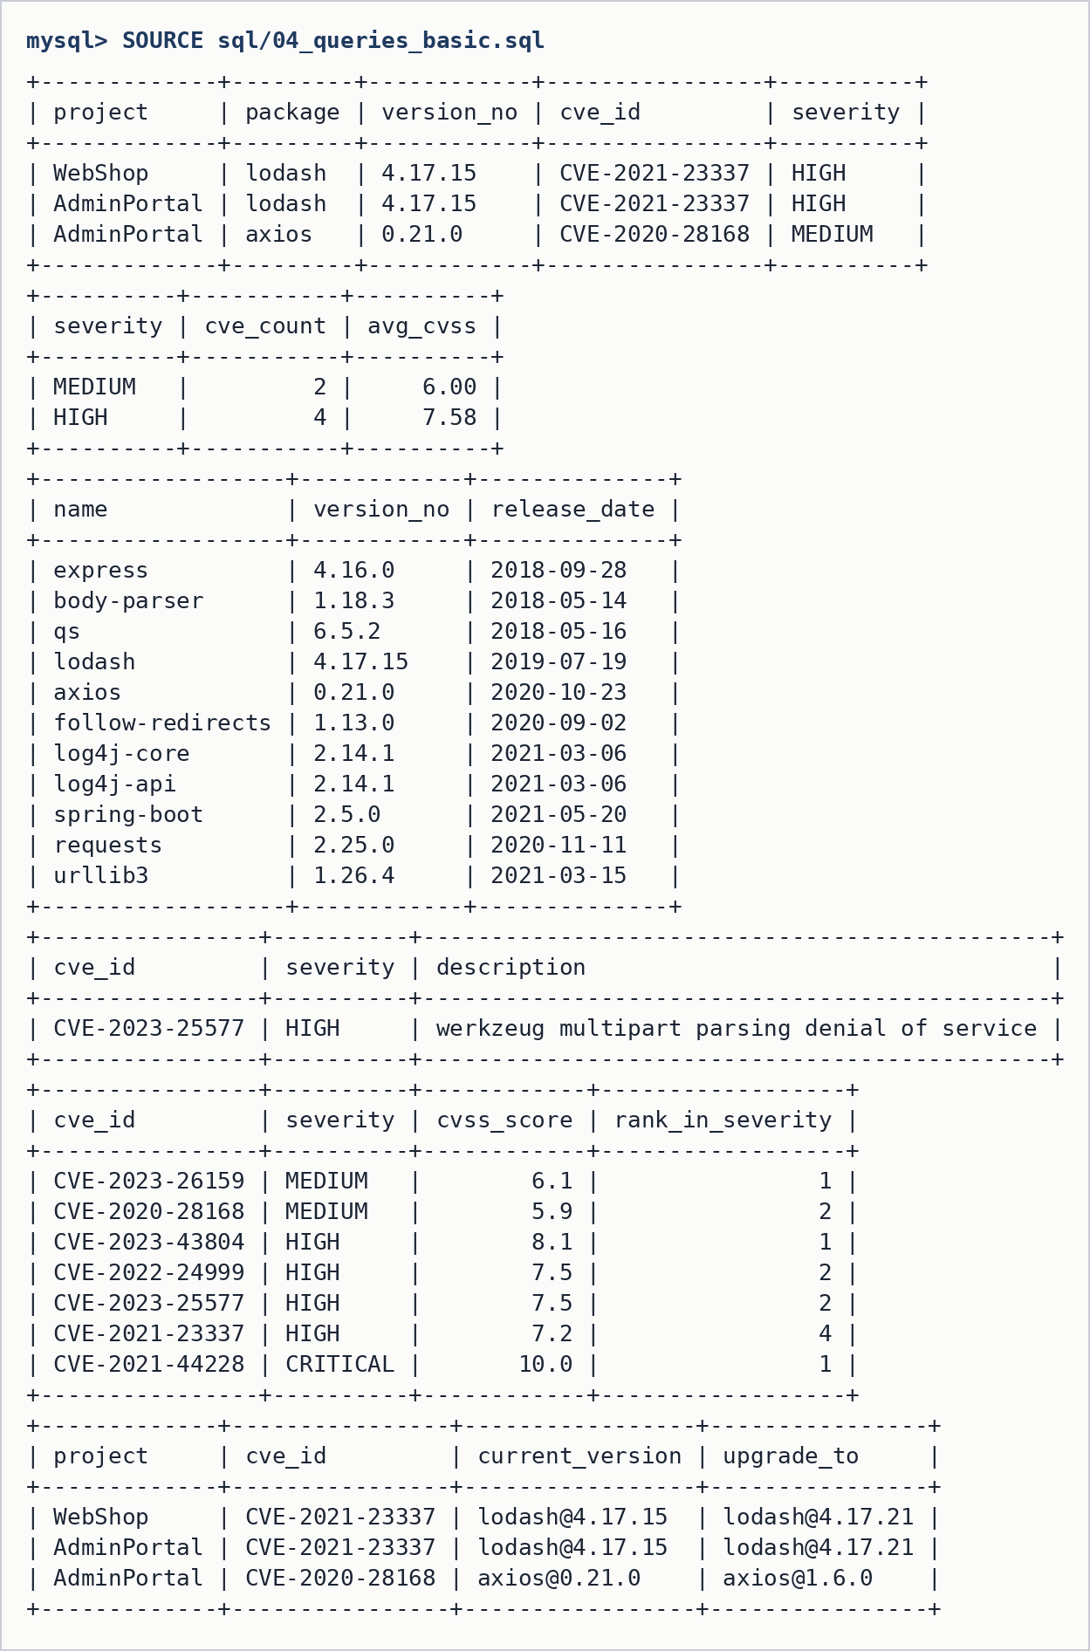
Figure 3: Output of 04_queries_basic.sql (joins, GROUP BY/HAVING, sub-query, anti-join, window function)
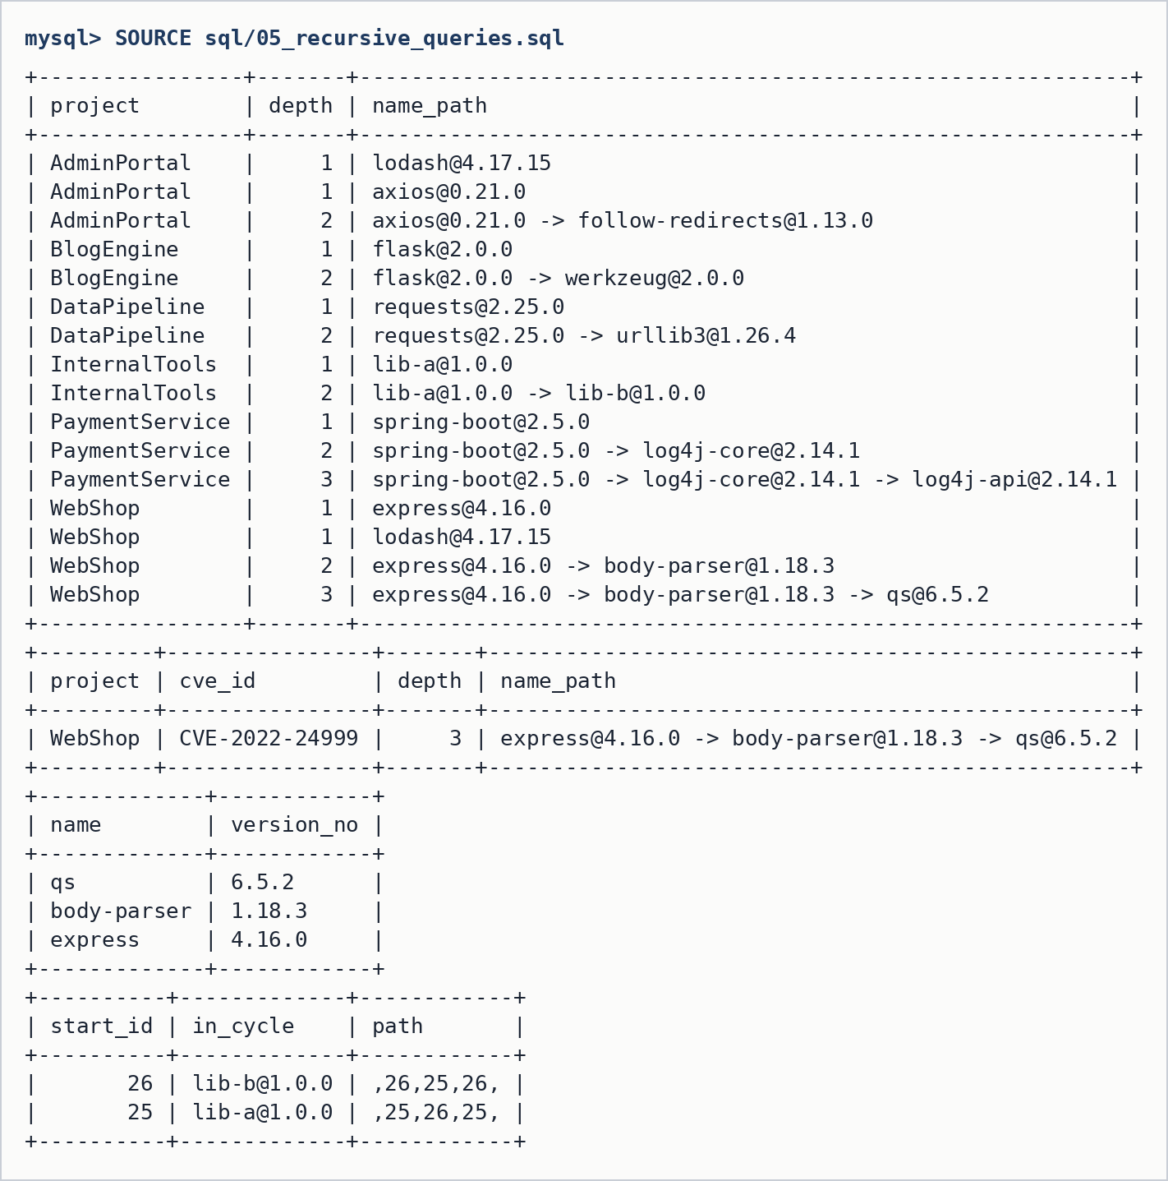
Figure 4: Output of 05_recursive_queries.sql (dependency chains, exposure path, reverse lookup, cycle detection)
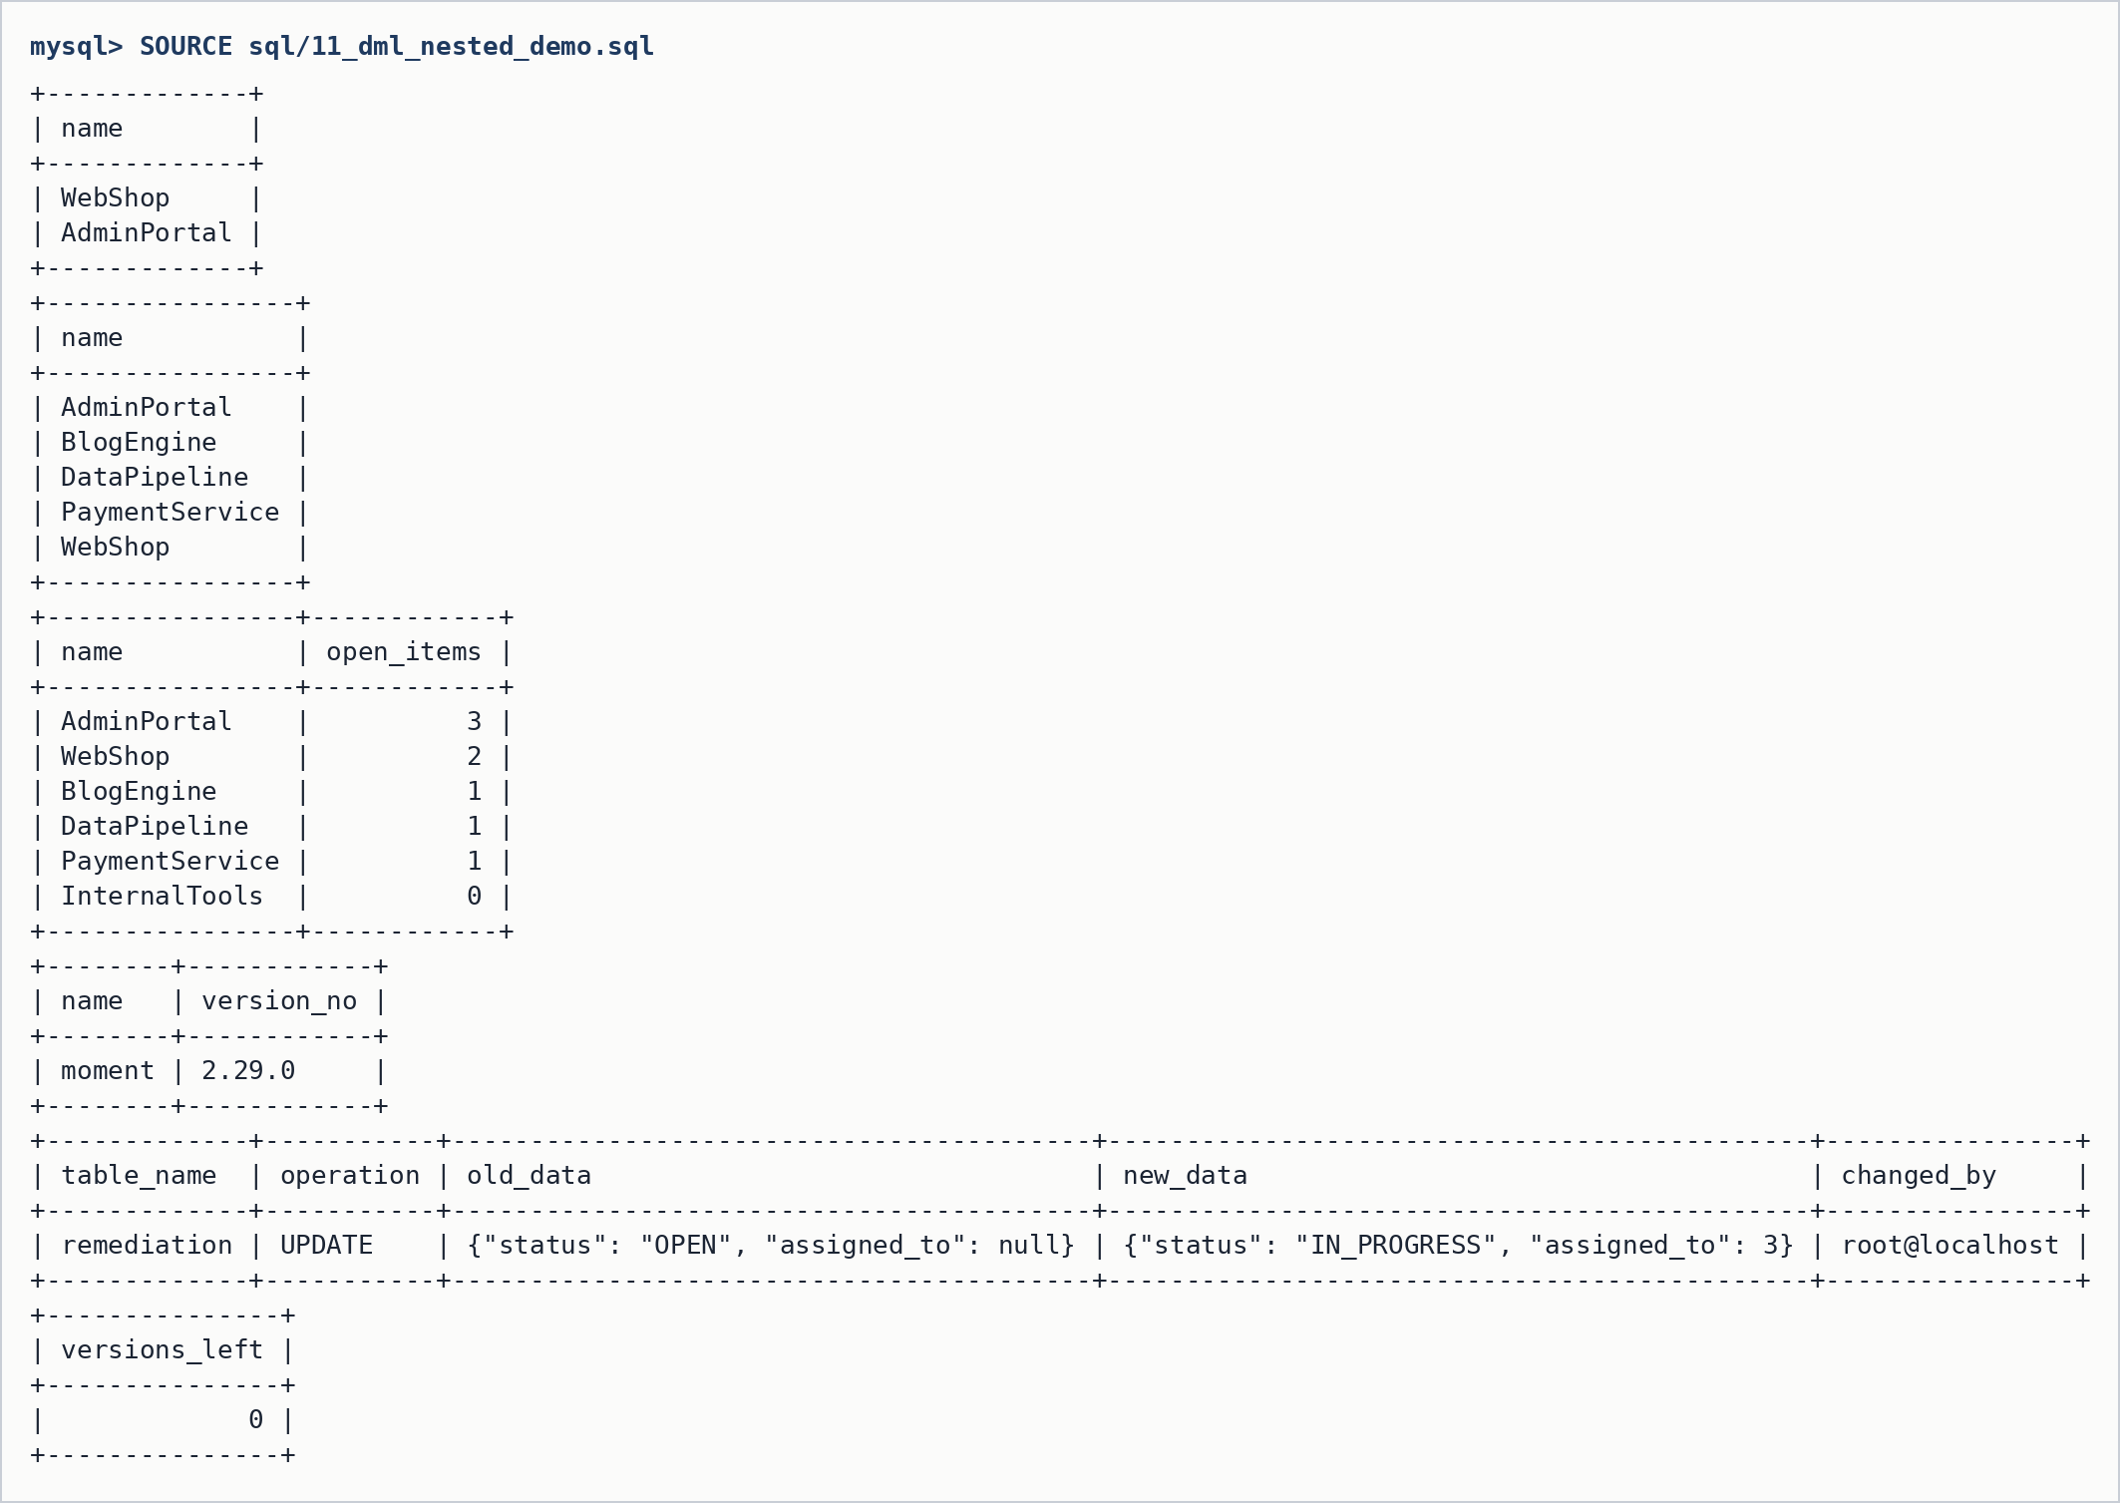
Figure 5: Output of 11_dml_nested_demo.sql (nested and correlated queries, INSERT, UPDATE with audit, DELETE with cascade)
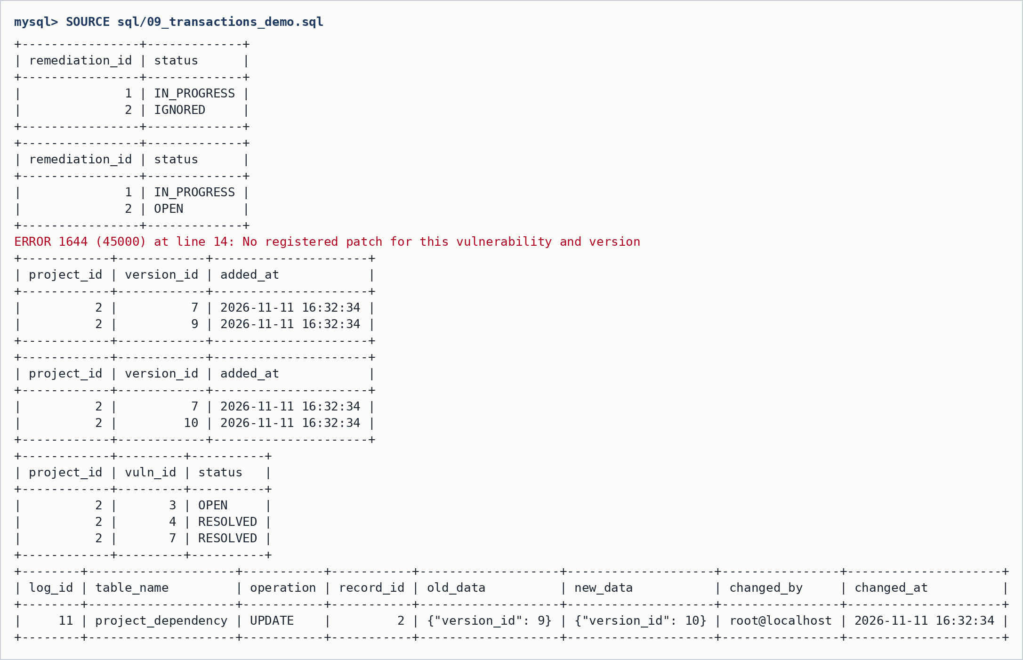
Figure 6: Output of 09_transactions_demo.sql (savepoint rollback, failed and successful apply_patch)

7. NoSQL Database Commands
Database supply_chain_nosql is built from MySQL by nosql/migrate_mysql_to_mongo.py. It has six collections: components, projects, vulnerabilities, remediation, analyst_notes and audit_log.

7.1 Collection creation with schema validation
db.create_collection("vulnerabilities", validator={"$jsonSchema": {
"bsonType": "object",
"required": ["cve_id", "severity", "published", "affected", "patches"],
"properties": {
"cve_id": {"bsonType": "string", "pattern": "^CVE-[0-9]{4}-[0-9]{4,}$"},
"cvss": {"bsonType": ["double", "int", "null"], "minimum": 0, "maximum": 10},
"severity": {"enum": ["LOW", "MEDIUM", "HIGH", "CRITICAL"]},
"affected": {"bsonType": "array", "items": {"bsonType": "string"}},
"patches": {"bsonType": "array"},
}}})

db.create_collection("analyst_notes", validator={"$jsonSchema": {
"bsonType": "object",
"required": ["cve_id", "text", "author", "created_at"],
"properties": {
"cve_id": {"bsonType": "string"},
"text": {"bsonType": "string", "minLength": 1, "maxLength": 1000},
"author": {"bsonType": "string"},
"tags": {"bsonType": "array", "items": {"bsonType": "string"}},
"created_at": {"bsonType": "date"},
"updated_at": {"bsonType": "date"},
}}})

7.2 Document shape
// projects
{ _id: "WebShop", owner: "Asha Nair", owner_email: "asha@example.com",
language: "JavaScript", criticality: "HIGH",
direct_deps: ["express@4.16.0", "lodash@4.17.15"] }
// components
{ _id: "express@4.16.0", package: "express", ecosystem: "npm", version: "4.16.0",
release_date: "2018-09-28", depends_on: ["body-parser@1.18.3"] }
// vulnerabilities
{ _id: "CVE-2022-24999", cve_id: "CVE-2022-24999", cvss: 7.5, severity: "HIGH",
published: "2022-11-26", affected: ["qs@6.5.2"],
patches: [ { fixed_in: "qs@6.11.0", notes: "Upgrade qs to 6.11.0" } ] }

7.3 Read, Update, Delete and transaction commands (nosql/queries.js)
// N3: projects exposed to one CVE (direct or indirect), with depth
var affected = db.vulnerabilities.findOne({ _id: "CVE-2022-24999" }).affected;
printjson(db.projects.aggregate([
{ $graphLookup: { from: "components", startWith: "$direct_deps",
connectFromField: "depends_on", connectToField: "_id",
as: "closure", depthField: "depth" } },
{ $project: { hits: { $filter: { input: "$closure", as: "c",
cond: { $in: ["$$c._id", affected] } } } } },
{ $match: { "hits.0": { $exists: true } } },
{ $project: { exposure_depth: { $add: [{ $min: "$hits.depth" }, 1] },
vulnerable_component: "$hits._id" } }
]).toArray());

// N6: open critical/high issues (join with $lookup)
printjson(db.remediation.aggregate([
{ $match: { status: { $in: ["OPEN", "IN_PROGRESS"] } } },
{ $lookup: { from: "vulnerabilities", localField: "cve_id", foreignField: "_id", as: "v" } },
{ $unwind: "$v" },
{ $match: { "v.severity": { $in: ["CRITICAL", "HIGH"] } } },
{ $project: { project: 1, cve_id: 1, severity: "$v.severity", status: 1 } }
]).toArray());

// N7: notes for one CVE, newest first
printjson(db.analyst_notes.find({ cve_id: "CVE-2021-44228" }).sort({ created_at: -1 }).toArray());

// ======================= UPDATE =======================

// U1: change a remediation status and write an audit entry
db.remediation.updateOne({ project: "WebShop", cve_id: "CVE-2022-24999" },
{ $set: { status: "IN_PROGRESS" } });
db.audit_log.insertOne({ collection: "remediation", op: "UPDATE",
key: "WebShop/CVE-2022-24999", new: { status: "IN_PROGRESS" }, by: "mongosh", at: new Date() });

// U2: add a tag to every note on a CVE ($addToSet avoids duplicates)
db.analyst_notes.updateMany({ cve_id: "CVE-2021-44228" }, { $addToSet: { tags: "reviewed" } });

// U3: edit one note's text
var note = db.analyst_notes.findOne({ cve_id: "CVE-2023-25577" });
db.analyst_notes.updateOne({ _id: note._id },
{ $set: { text: "No upstream patch. Workaround: cap multipart size at 1 MB.", updated_at: new Date() } });

// U4: schema validation in action - this update is REJECTED (severity not in the enum)
try {
db.vulnerabilities.updateOne({ _id: "CVE-2023-25577" }, { $set: { severity: "SUPER_HIGH" } });
} catch (e) { print("Rejected by $jsonSchema: " + e.message); }

// ======================= DELETE =======================

// D1: insert a temporary note, then delete it by _id
var tmp = db.analyst_notes.insertOne({ cve_id: "CVE-2023-26159", text: "temporary note",
author: "mongosh", created_at: new Date() });
printjson(db.analyst_notes.deleteOne({ _id: tmp.insertedId })); // { deletedCount: 1 }

// D2: delete the audit entries written from mongosh in this demo
printjson(db.audit_log.deleteMany({ by: "mongosh" }));

// D3: remove one field from a document ($unset is a "partial delete")
db.vulnerabilities.updateOne({ _id: "CVE-2023-26159" }, { $unset: { description: "" } });

// ======================= TRANSACTION =======================
// N8: multi-document transaction. MongoDB needs a REPLICA SET for this.
// To try it locally: mongod --replSet rs0 then in mongosh: rs.initiate()
try {
const session = db.getMongo().startSession();
const s = session.getDatabase("supply_chain_nosql");
session.startTransaction();
s.remediation.updateOne({ project: "WebShop", cve_id: "CVE-2021-23337" }, { $set: { status: "RESOLVED" } });
s.audit_log.insertOne({ collection: "remediation", op: "UPDATE",
key: "WebShop/CVE-2021-23337", new: { status: "RESOLVED" }, by: "mongosh", at: new Date() });
session.commitTransaction(); // both writes, or neither
session.endSession();
print("Transaction committed");
} catch (e) {
print("Transaction skipped (standalone server, not a replica set): " + e.message);
}

7.4 Output (mongosh, MongoDB 8)
// N3: projects exposed to CVE-2022-24999
[
{
_id: 'WebShop',
exposure_depth: Long('3'),
vulnerable_component: [
'qs@6.5.2'
]
}
]
[
{
_id: 'CVE-2023-25577',
// N4: unpatched vulnerabilities
cve_id: 'CVE-2023-25577',
severity: 'HIGH'
}
]
[
{
_id: 'HIGH',
// U4, D1, D2, N8
Rejected by $jsonSchema: Plan executor error during update :: caused by :: Document failed validation
{
acknowledged: true,
deletedCount: 1
}
{
acknowledged: true,
deletedCount: 1
}
Transaction skipped (standalone server, not a replica set): This MongoDB deployment does not support retryable writes. Please add retryWrites=false to your connection string.

8. Results

8.1 Resulting Tables' Screenshots
Contents of every table after running sql/00_setup_all.sql (seed data plus the remediation rows and audit entries created by the triggers).
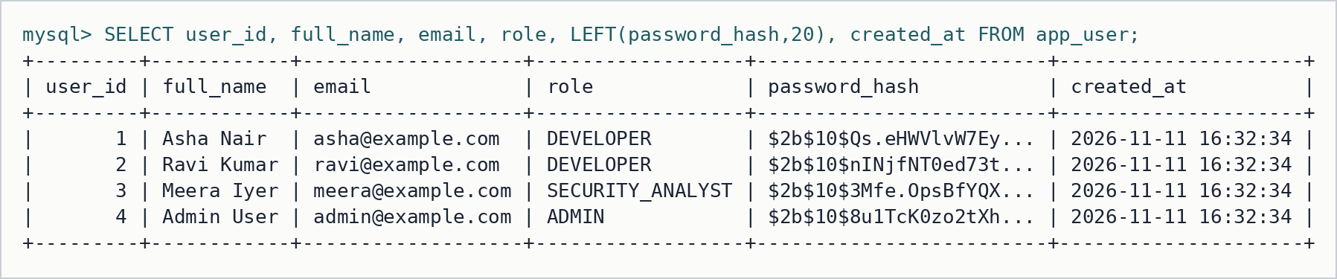
Figure 7: Table app_user
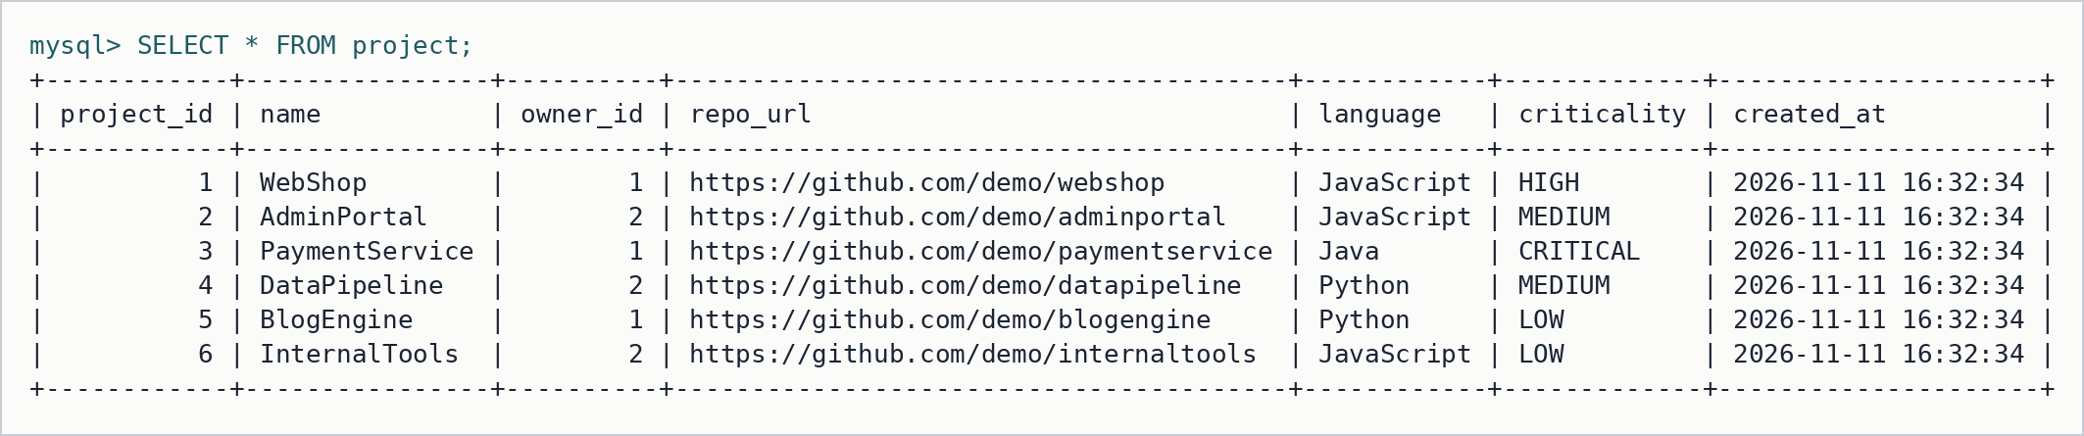
Figure 8: Table project
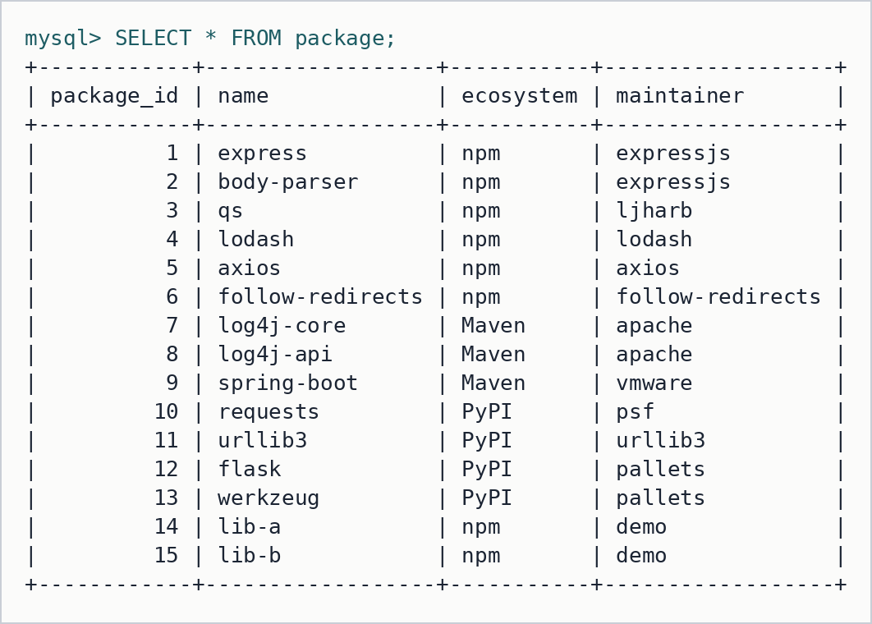
Figure 9: Table package
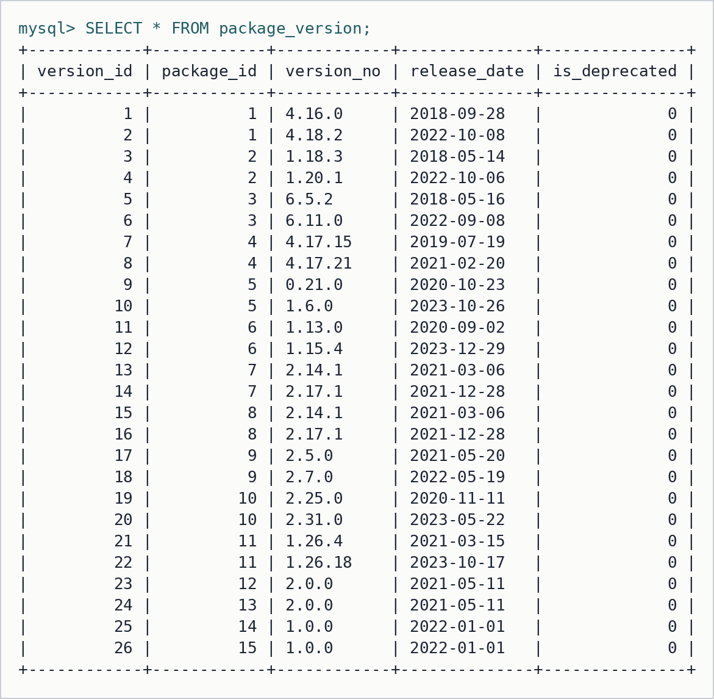
Figure 10: Table package_version
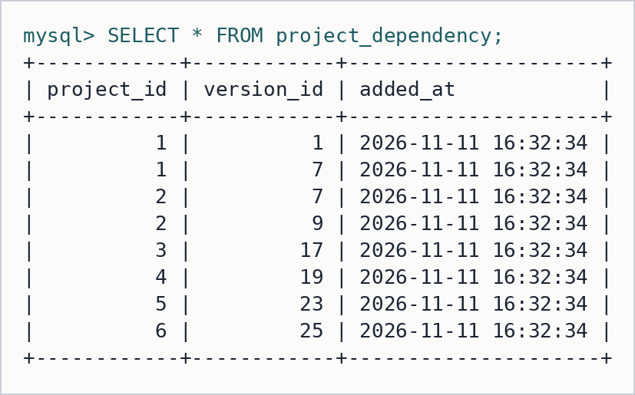
Figure 11: Table project_dependency
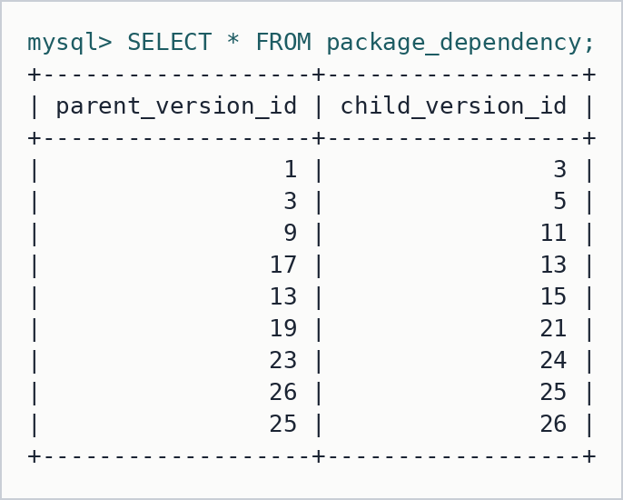
Figure 12: Table package_dependency
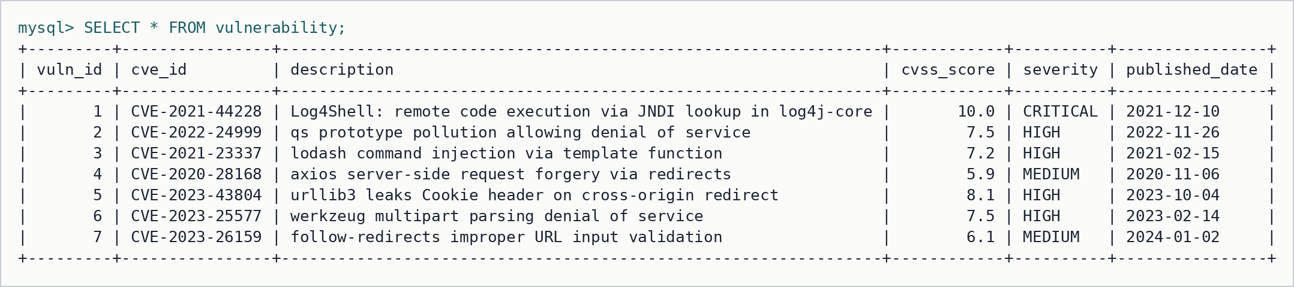
Figure 13: Table vulnerability
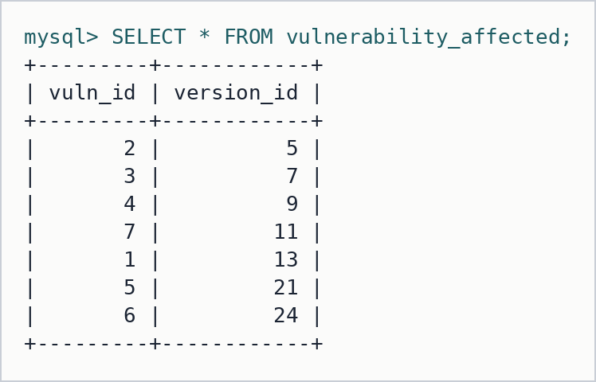
Figure 14: Table vulnerability_affected
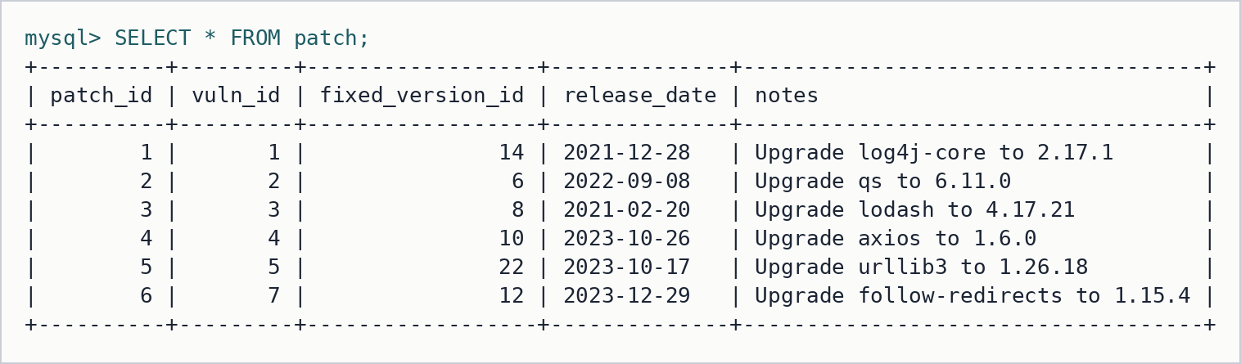
Figure 15: Table patch
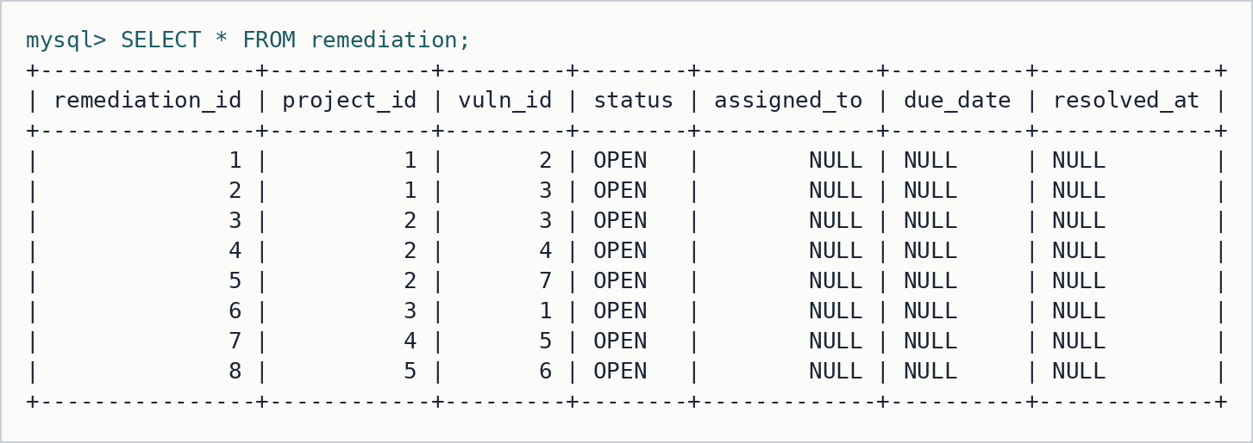
Figure 16: Table remediation
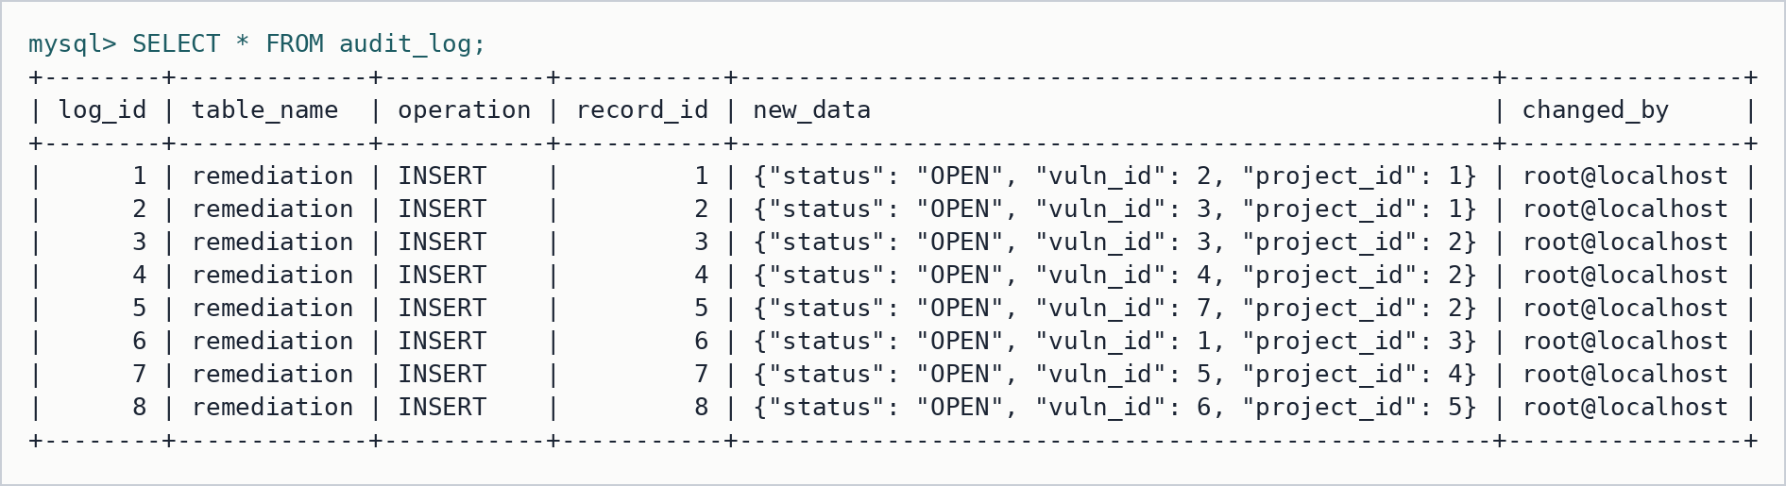
Figure 17: Table audit_log

8.2 Test results
SQL feature tests (tests/test_cases.sql): recursion, cycle safety, risk function, severity trigger with audit, validation triggers, automatic remediation, CHECK constraint and ownership check. The four ERROR lines are the expected rejections.
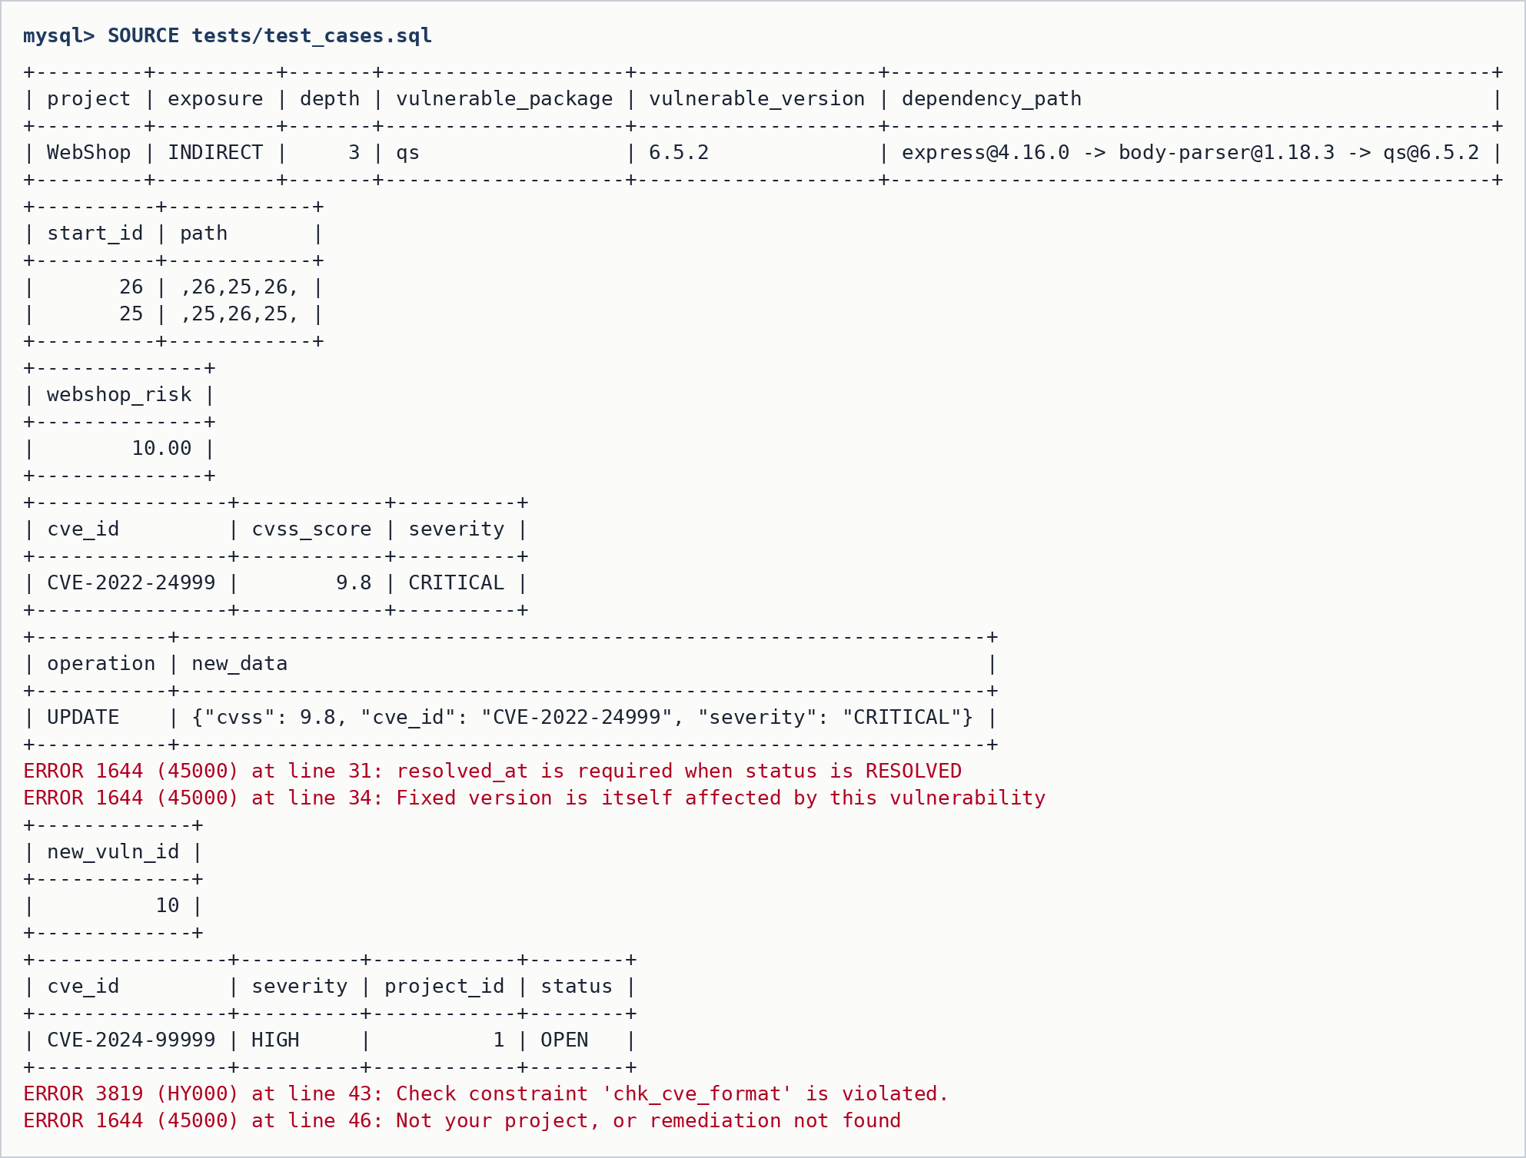
Figure 18: SQL feature tests
Database permission tests (tests/test_rbac.sh): each line logs in as one of the web app's MySQL accounts and MySQL itself allows or denies the statement.
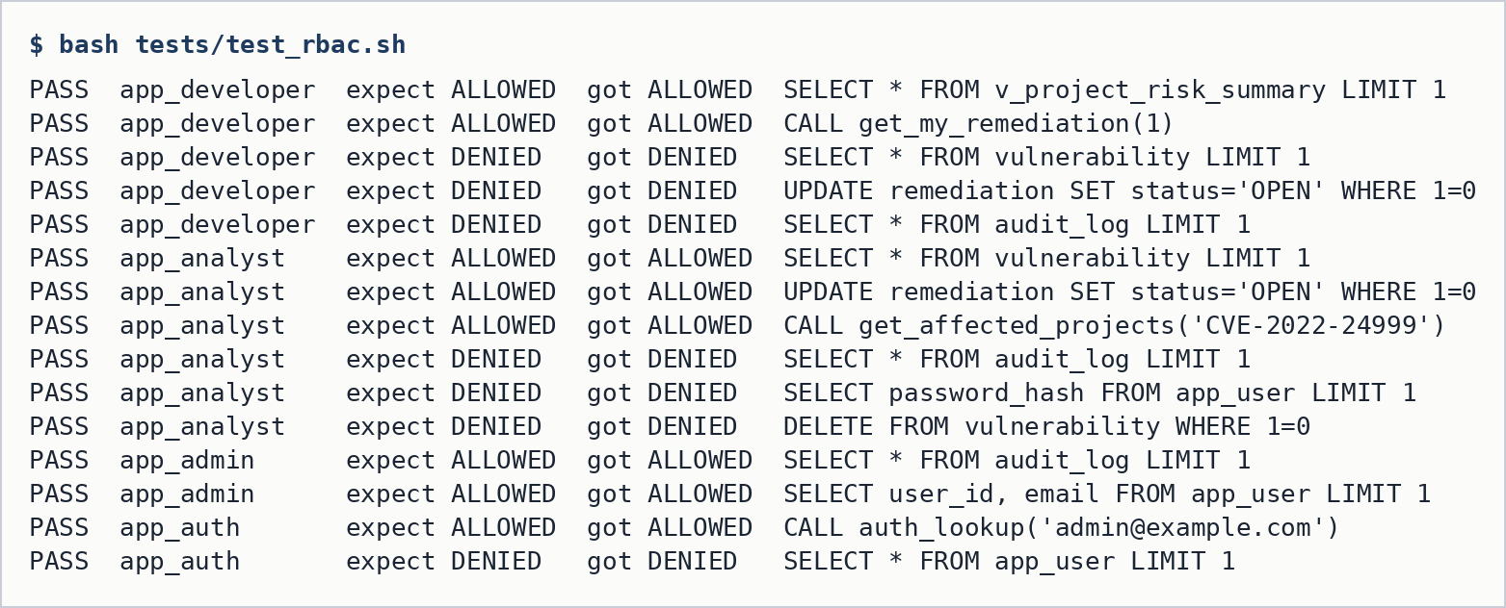
Figure 19: Role-based access control enforced by MySQL
End-to-end API tests (webapp/tests/api-smoke.mjs): login, page guards, API guards, database-level denial, and CRUD on MongoDB through the app.
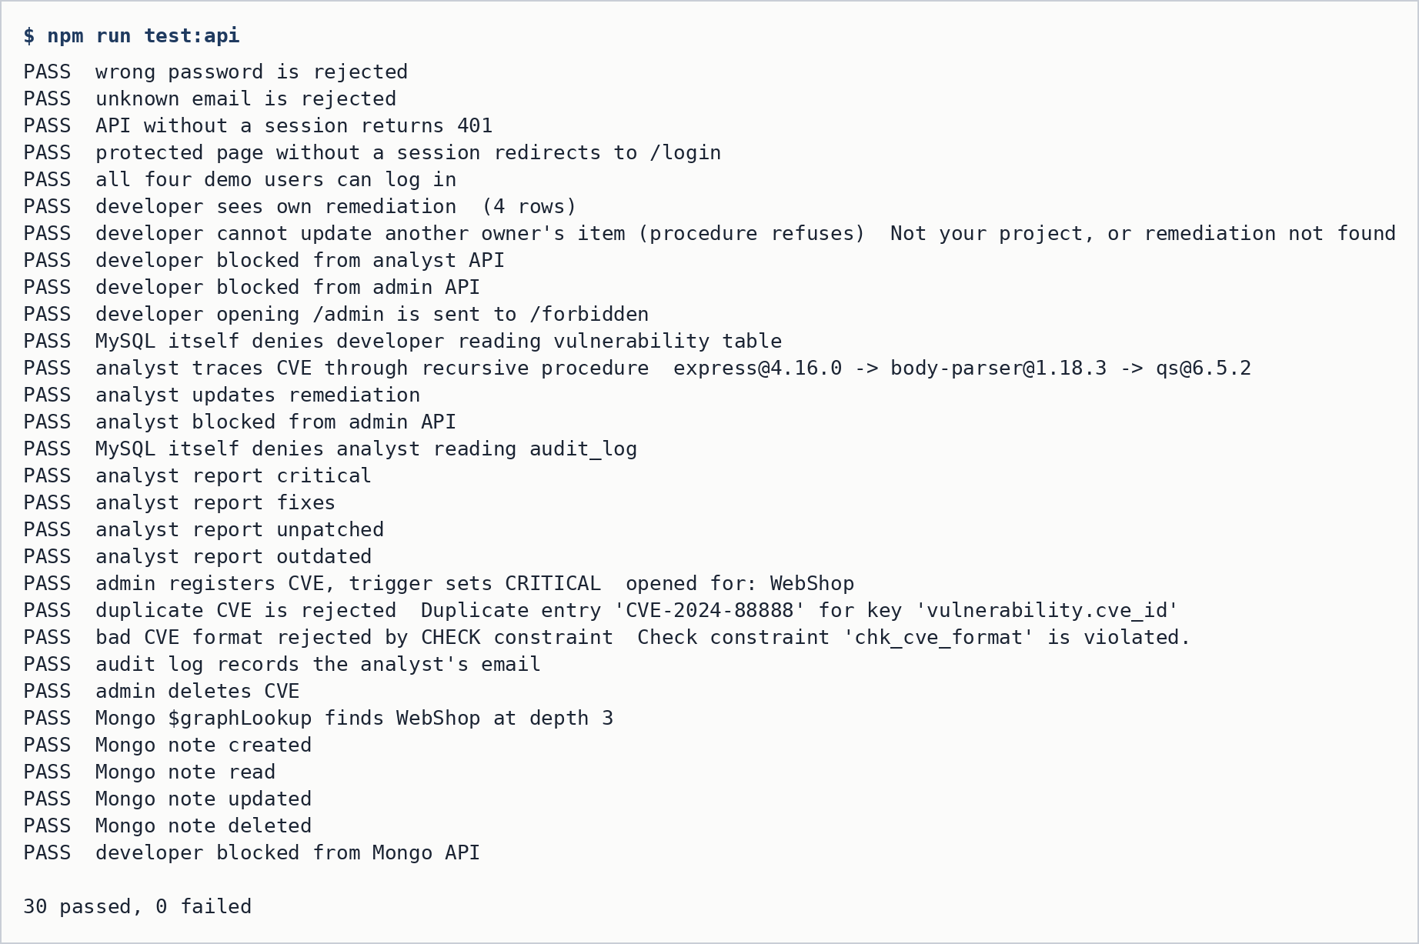
Figure 20: API tests against the running Next.js app

9. Next.js Project Tree Structure
DBMS_Mini_project/
├── ER_Diagram.png, Relational_schema.png
├── README.md, requirements.txt
├── docs/ requirements.md, normalization.md, sql_vs_nosql.md,
│ diagrams/ (generator scripts, SVG), results/ (outputs), screenshots/
├── sql/ 00_setup_all.sql, 01_schema.sql ... 13_auth_login.sql
├── nosql/ migrate_mysql_to_mongo.py, queries.js
├── tests/ test_cases.sql, test_rbac.sh
└── webapp/
├── proxy.js page guard: login + role (Next 16 proxy)
├── next.config.ts, package.json, .env.example
├── lib/
│ ├── auth.js JWT sign / verify, getSession()
│ ├── db.js one MySQL pool per role, withDb() sets @app_user
│ ├── mongo.js MongoDB client, audit helper
│ └── api.js guard(roles), error mapping
├── components/
│ ├── Shell.js layout, role-based navigation, logout
│ └── ui.js tables, severity badges, dependency-path chips
├── app/
│ ├── layout.tsx, globals.css, page.js
│ ├── login/page.js all roles
│ ├── dashboard/page.js all roles: risk ranking, live DB permission check
│ ├── my-projects/page.js DEVELOPER
│ ├── analyst/page.js SECURITY_ANALYST, ADMIN
│ ├── nosql/page.js SECURITY_ANALYST, ADMIN (MongoDB)
│ ├── admin/page.js ADMIN
│ ├── forbidden/page.js
│ └── api/
│ ├── login, logout, me, risk-summary, db-check
│ ├── my/remediation, my/exposure DEVELOPER
│ ├── analyst/exposure, affected, remediation, reports ANALYST, ADMIN
│ ├── nosql/cves, closure, exposure, notes ANALYST, ADMIN
│ └── admin/vulnerabilities, users, audit, versions ADMIN
├── scripts/seed-passwords.mjs
└── tests/api-smoke.mjs

10. Application Code and Demo

10.1 Sample application code
Choosing the MySQL account from the logged-in role (lib/db.js). The @app_user variable lets the audit triggers record the real person.
// One MySQL account per application role, so MySQL's own GRANTs decide what
// each role may do. role comes from the verified session.
export function poolForRole(role) {
const accounts = {
ADMIN: [process.env.ADMIN_DB_USER, process.env.ADMIN_DB_PASS],
SECURITY_ANALYST: [process.env.ANALYST_DB_USER, process.env.ANALYST_DB_PASS],
DEVELOPER: [process.env.DEV_DB_USER, process.env.DEV_DB_PASS],
};
if (!accounts[role]) throw new Error("Unknown role");
if (!g._pools[role]) g._pools[role] = make(...accounts[role]);
return g._pools[role];
}

// used only by the login route; can run one stored procedure
export function authPool() {
if (!g._pools.AUTH) {
g._pools.AUTH = make(process.env.AUTH_DB_USER, process.env.AUTH_DB_PASS);
}
return g._pools.AUTH;
}

// Runs fn(conn) on the session's role connection. Sets @app_user first so the
// audit triggers in 08_triggers_audit.sql record WHO made the change.
export async function withDb(session, fn) {
const conn = await poolForRole(session.role).getConnection();
try {
await conn.query("SET @app_user = ?", [session.email || session.name]);
return await fn(conn);
} finally {
await conn.query("SET @app_user = NULL").catch(() => {});
conn.release();
}
}

Role check used by every API route (lib/api.js).
// Application-level authorization for API routes.
// Returns { session } when allowed, or { res } holding a 401/403 response.
export async function guard(roles) {
const session = await getSession();
if (!session) return { res: json({ error: "Not logged in" }, 401) };
if (roles && !roles.includes(session.role)) {
return {
res: json({ error: `Your role (${session.role}) cannot use this feature` }, 403),
};
}
return { session };
}

Login (app/api/login/route.js): the login account can run only auth_lookup, and the password is checked against the bcrypt hash.
export async function POST(req) {
const { email, password } = await req.json();
const bad = () =>
NextResponse.json({ error: "Wrong email or password" }, { status: 401 });

if (!email || !password) return bad();

// app_auth can run ONLY this procedure (sql/13_auth_login.sql)
const [result] = await authPool().query("CALL auth_lookup(?)", [email.trim().toLowerCase()]);
const user = result[0]?.[0];
if (!user || !user.password_hash) return bad();

const ok = await bcrypt.compare(password, user.password_hash);
if (!ok) return bad();

const token = await signToken(user);
const res = NextResponse.json({ name: user.full_name, role: user.role });
res.cookies.set("session", token, {
httpOnly: true,
sameSite: "lax",
path: "/",
maxAge: 60 * 60 * 2,
secure: process.env.NODE_ENV === "production",
});
return res;
}

A developer update goes through a procedure that refuses rows of projects the user does not own (app/api/my/remediation/route.js).
// The procedure itself refuses rows of projects the user does not own
export async function PATCH(req) {
const { session, res } = await guard(["DEVELOPER"]);
if (res) return res;
const { remediation_id, status } = await req.json();
if (!Number.isInteger(remediation_id) || !STATUSES.includes(status)) {
return json({ error: "remediation_id and a valid status are required" }, 400);
}
try {
await withDb(session, (c) =>
c.query("CALL update_my_remediation(?, ?, ?)", [session.uid, remediation_id, status])
);
return json({ ok: true });
} catch (e) {
return dbError(e);
}
}

10.2 Demo screenshots
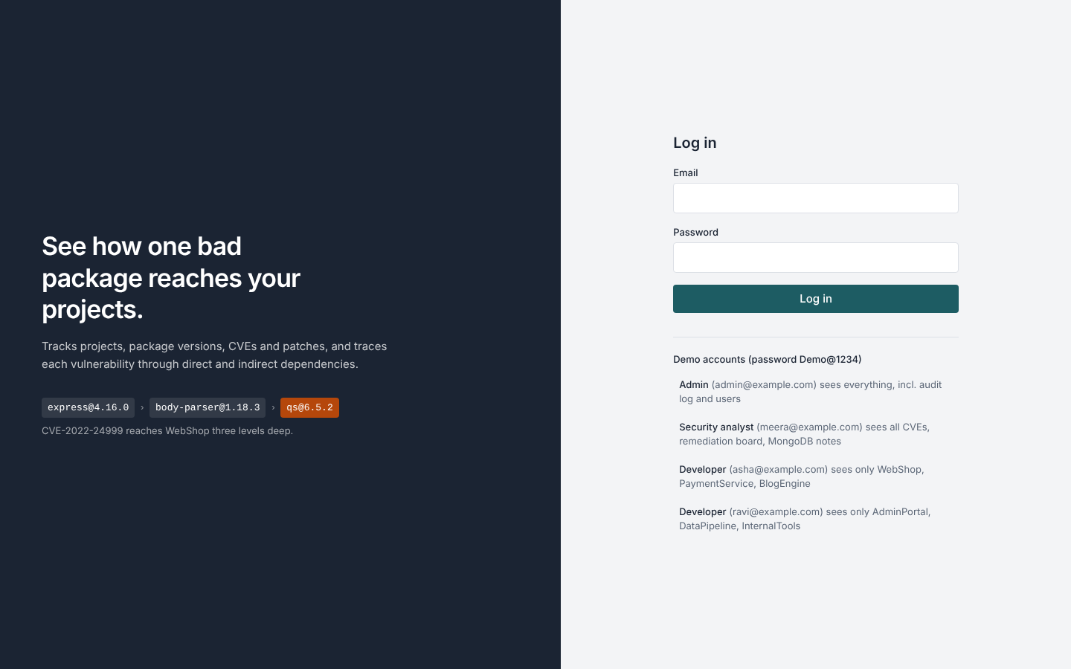
Figure 21: Login page with the four demo accounts
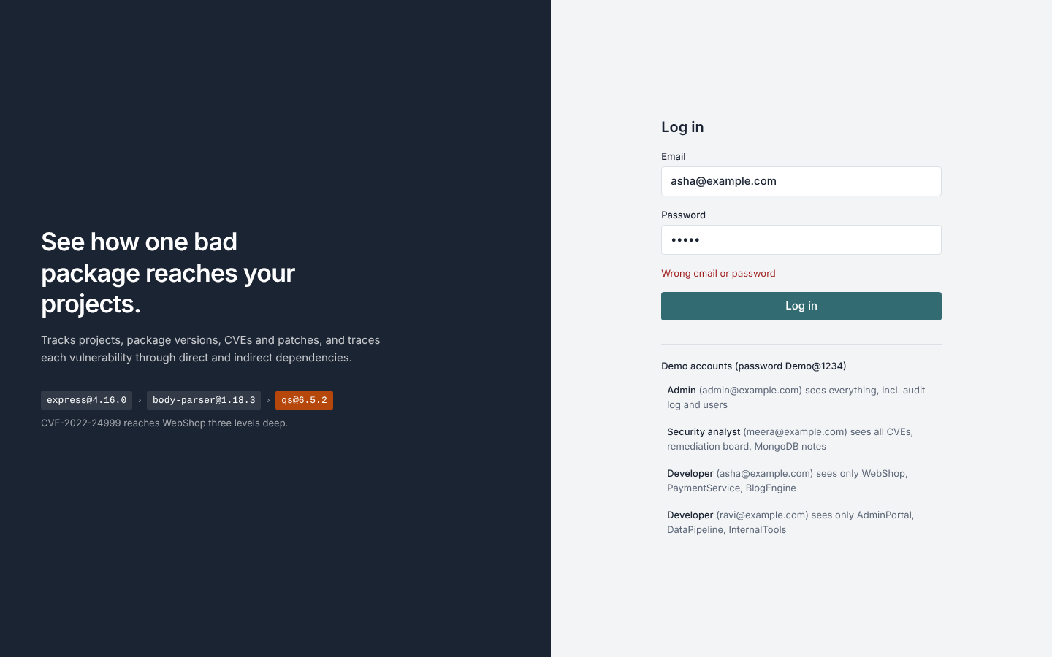
Figure 22: Wrong password is rejected
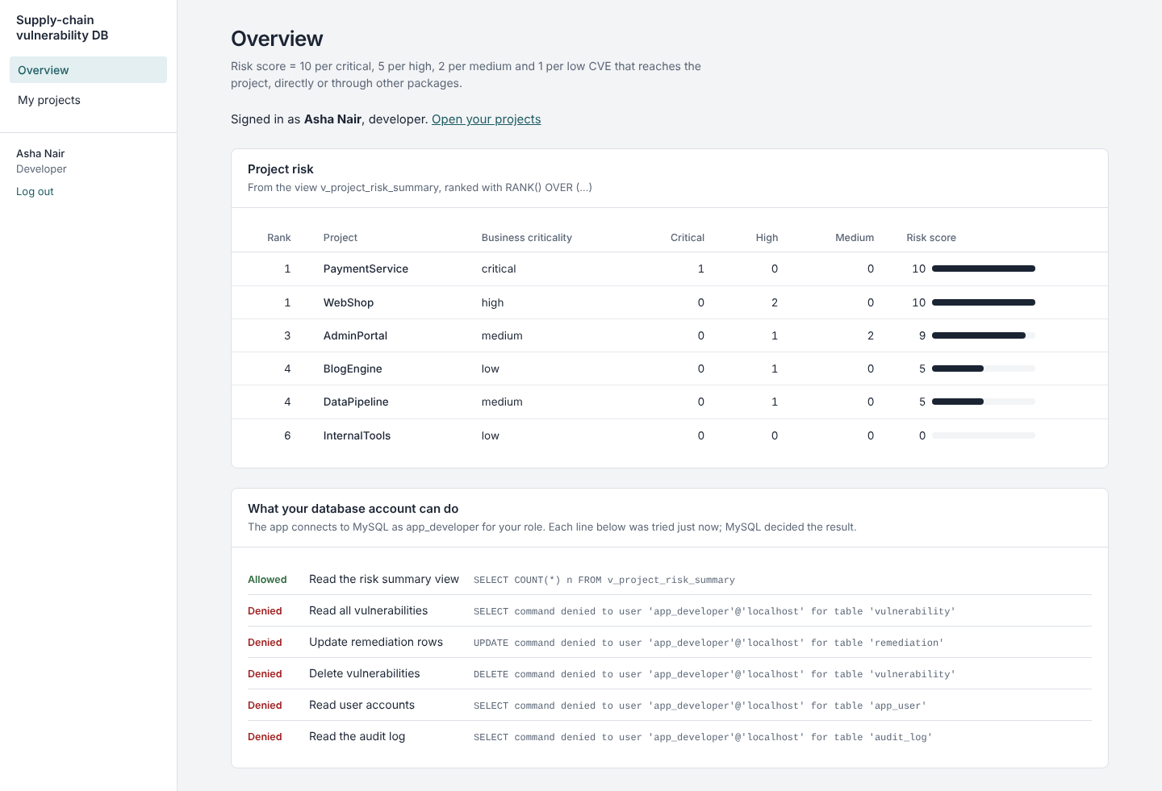
Figure 23: Developer dashboard: risk ranking and live MySQL permission check (vulnerability, audit log and users are denied)
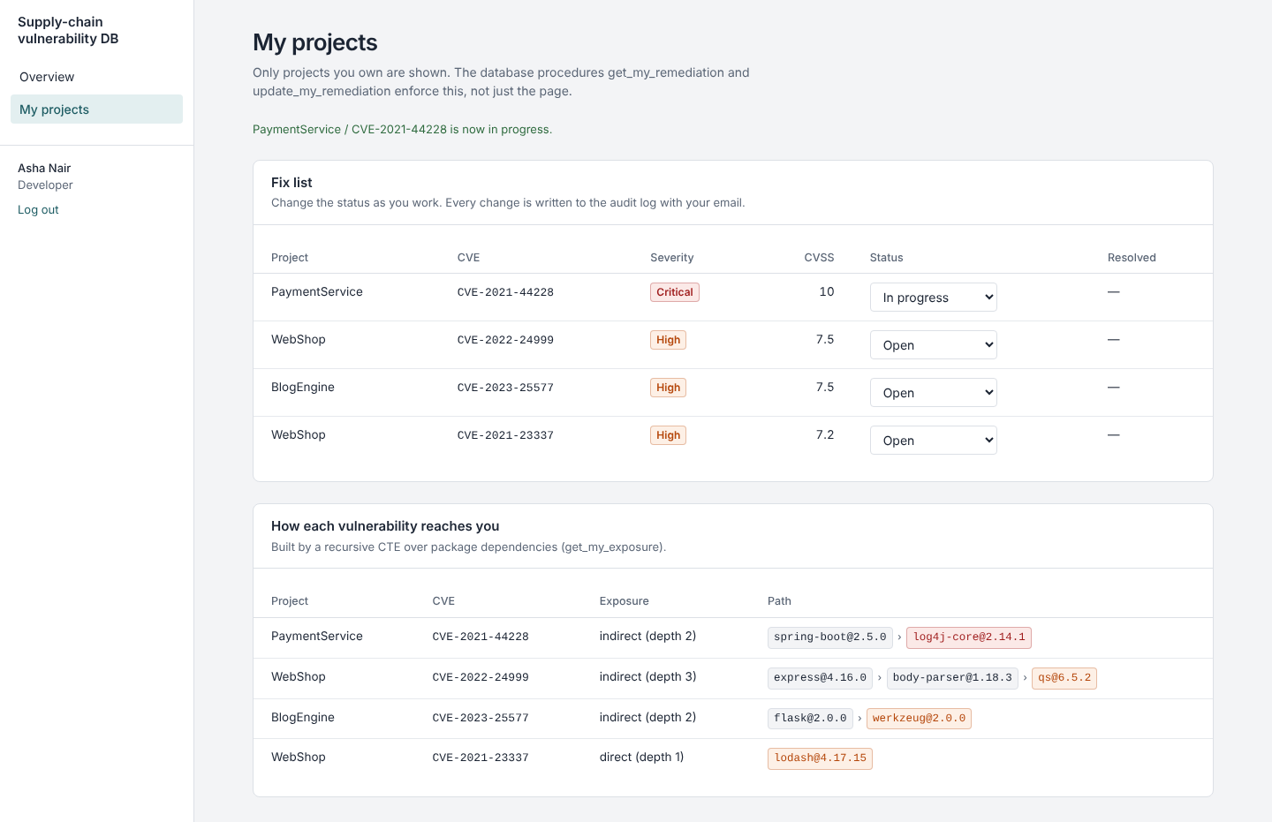
Figure 24: Developer sees only her own projects and the path each CVE takes
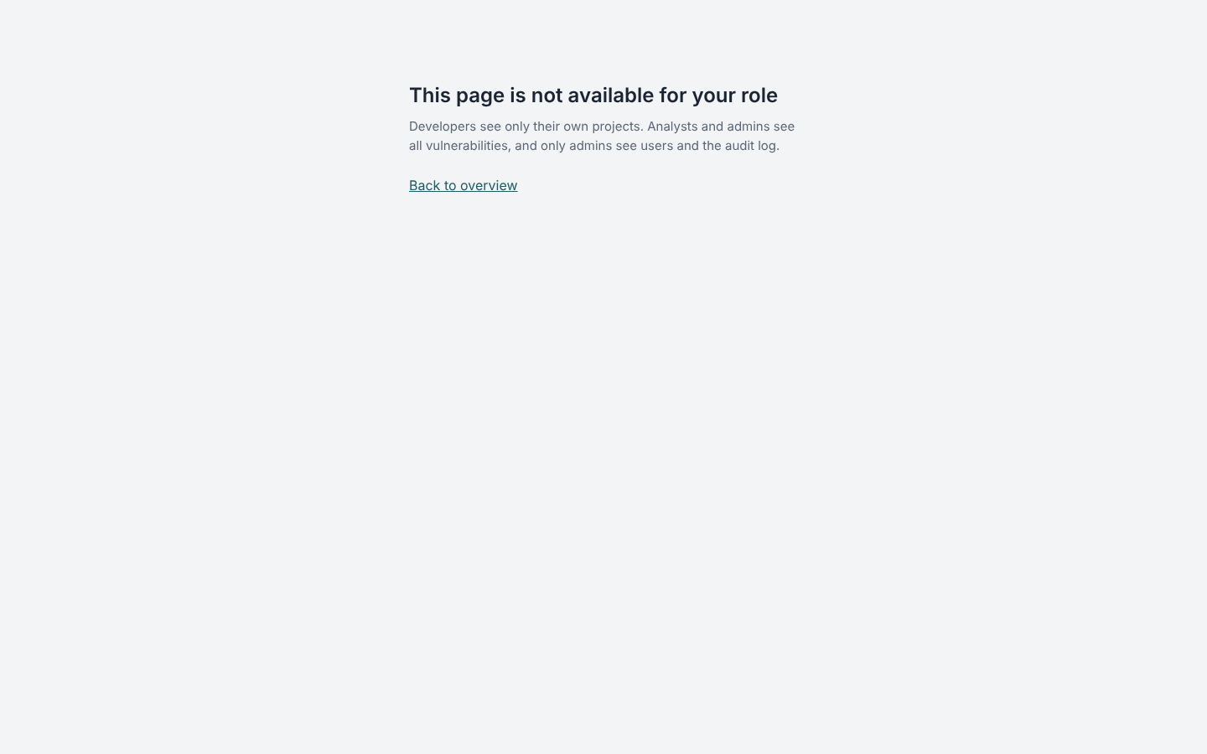
Figure 25: Developer opening /admin is redirected to /forbidden
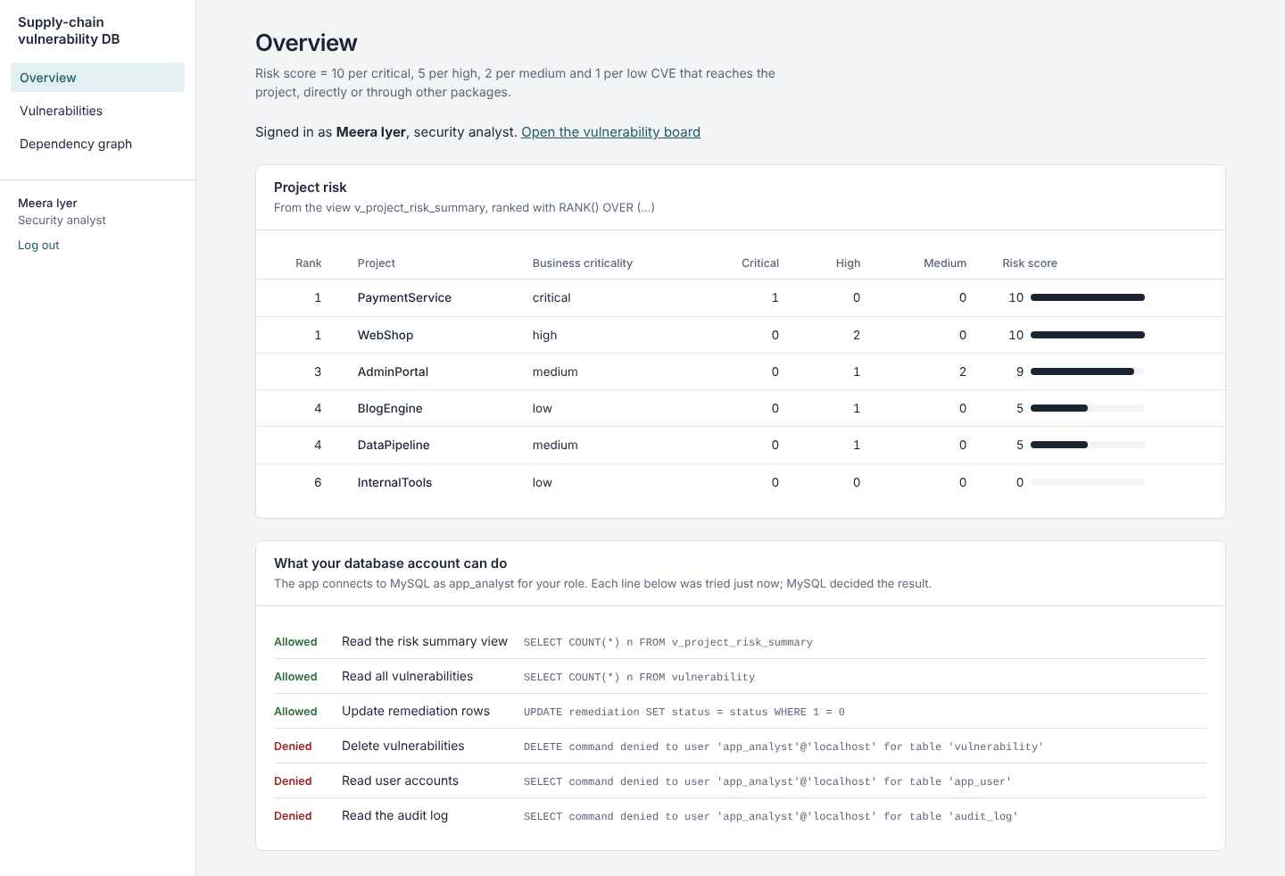
Figure 26: Analyst dashboard: more permissions allowed, audit log and users still denied
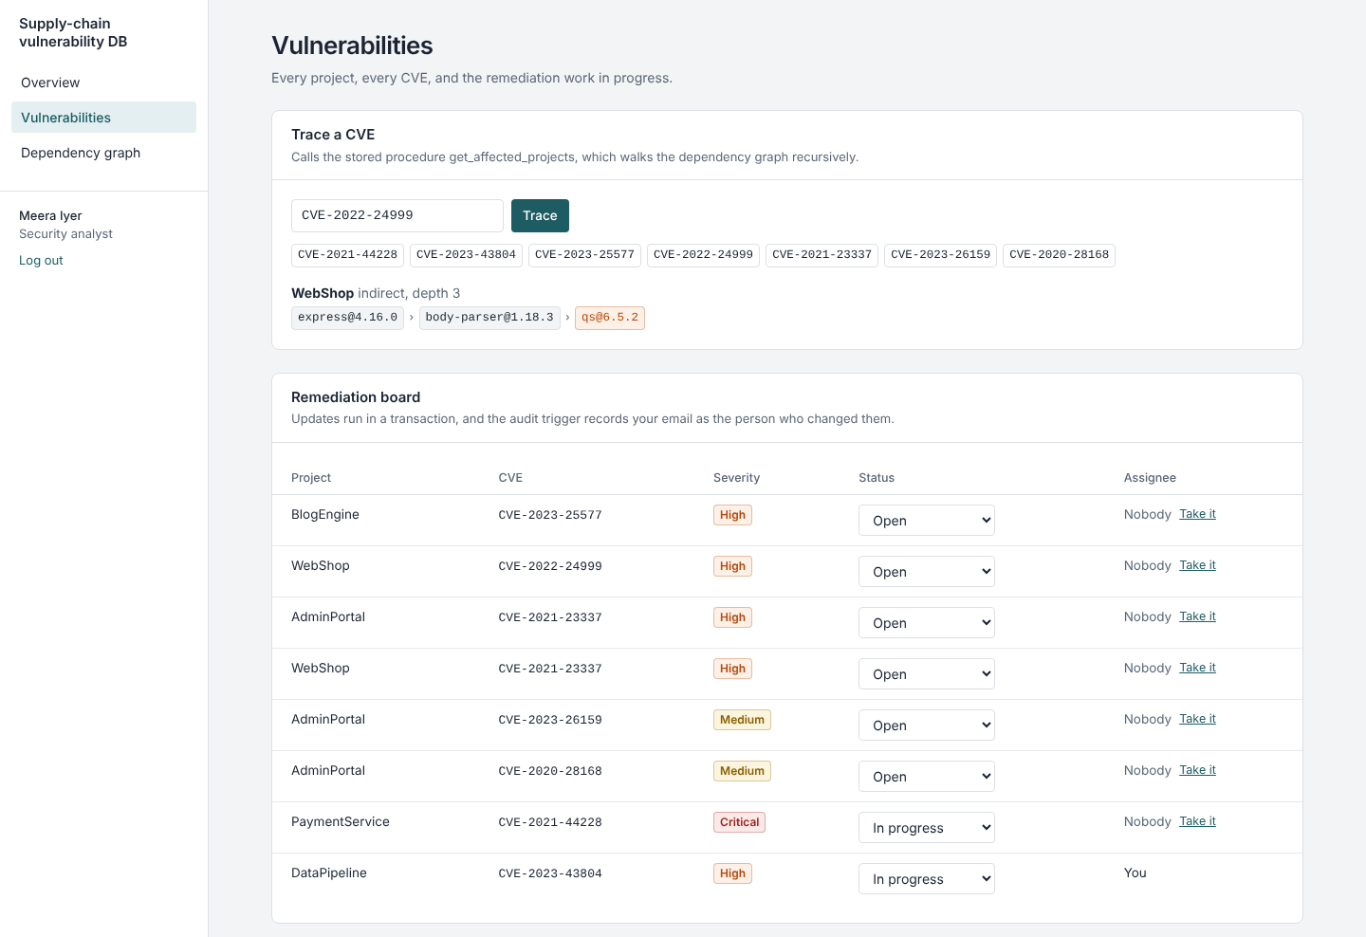
Figure 27: Analyst: CVE trace through the stored procedure and the remediation board
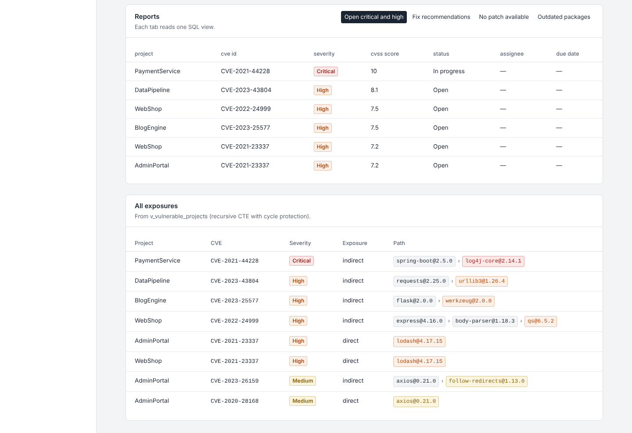
Figure 28: Analyst: report views and all exposures
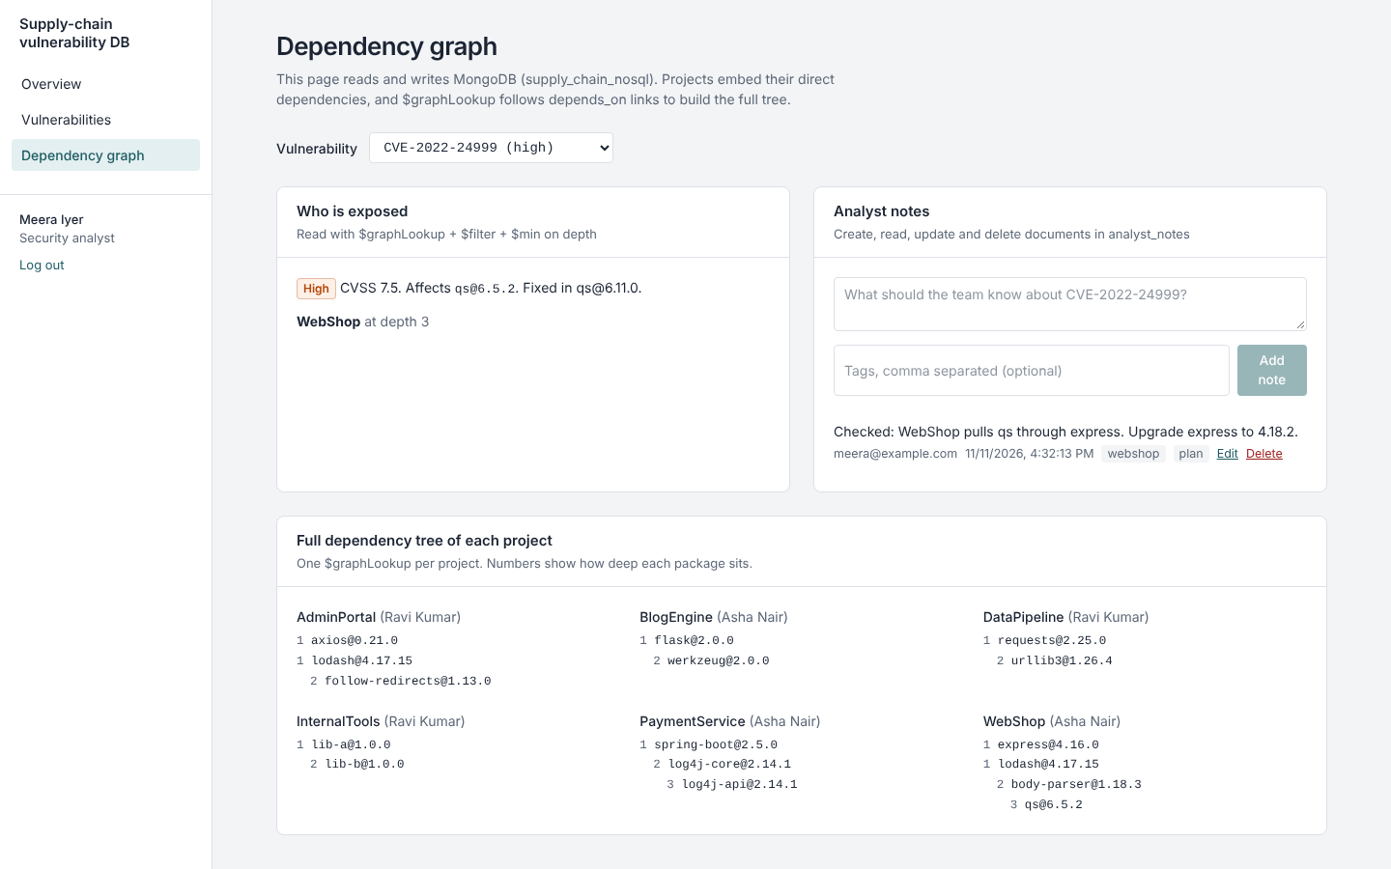
Figure 29: MongoDB page: $graphLookup exposure, analyst notes (CRUD) and dependency trees
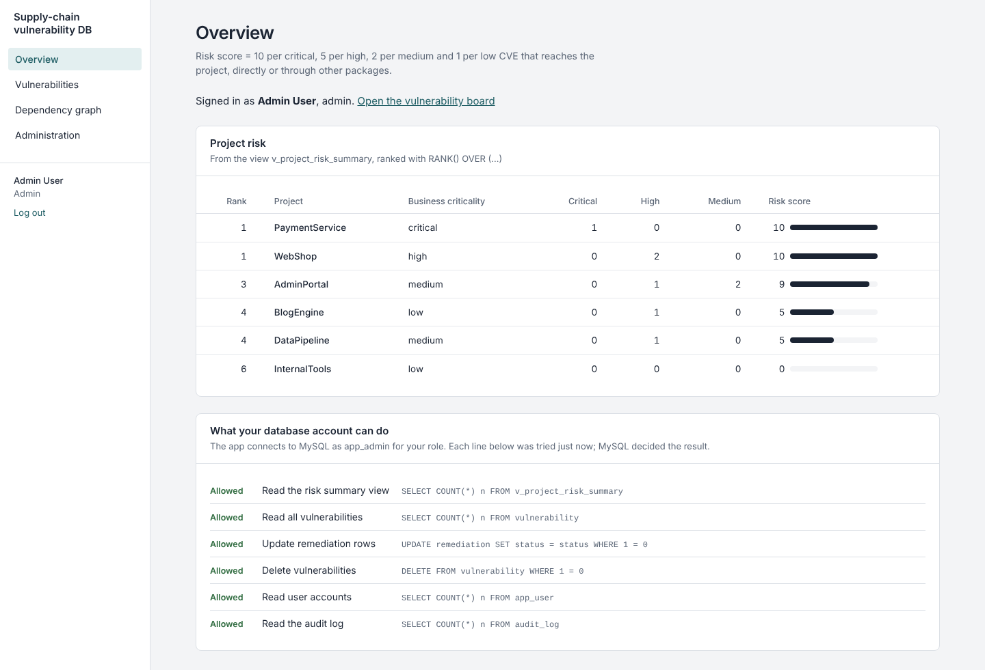
Figure 30: Admin dashboard: every permission allowed
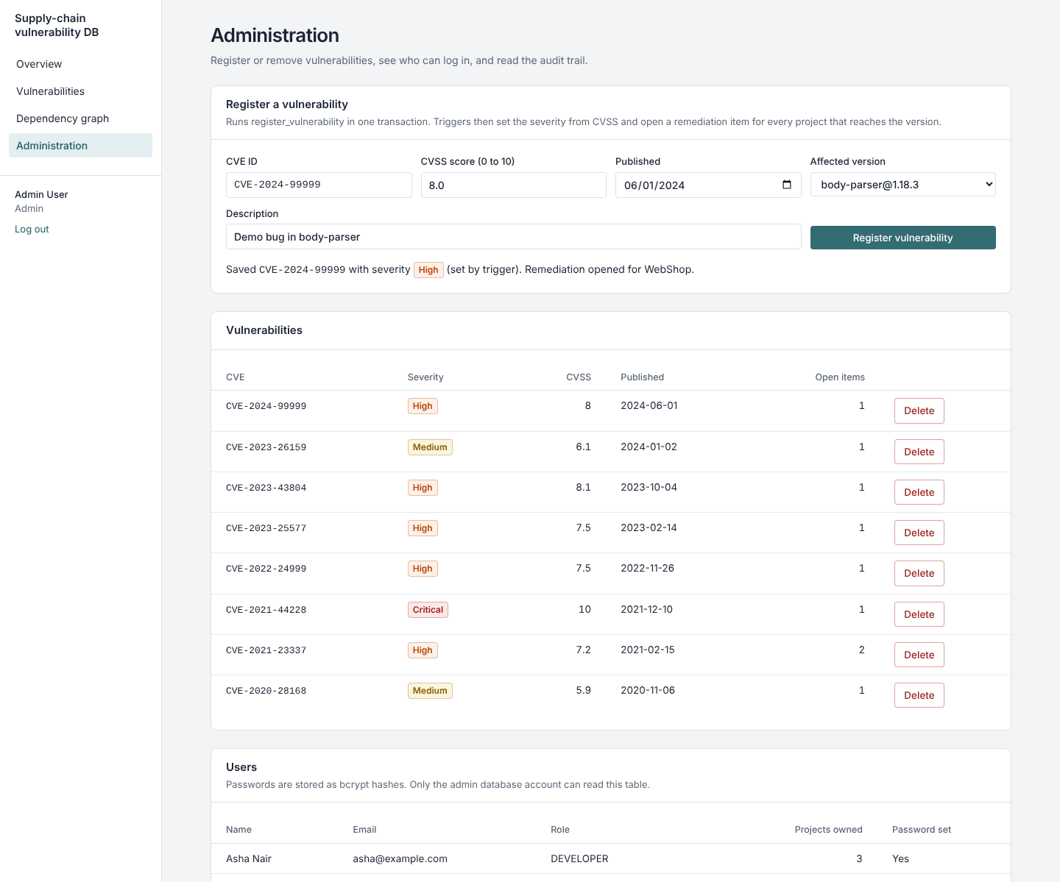
Figure 31: Admin registers a CVE; the trigger sets severity and opens remediation for WebShop
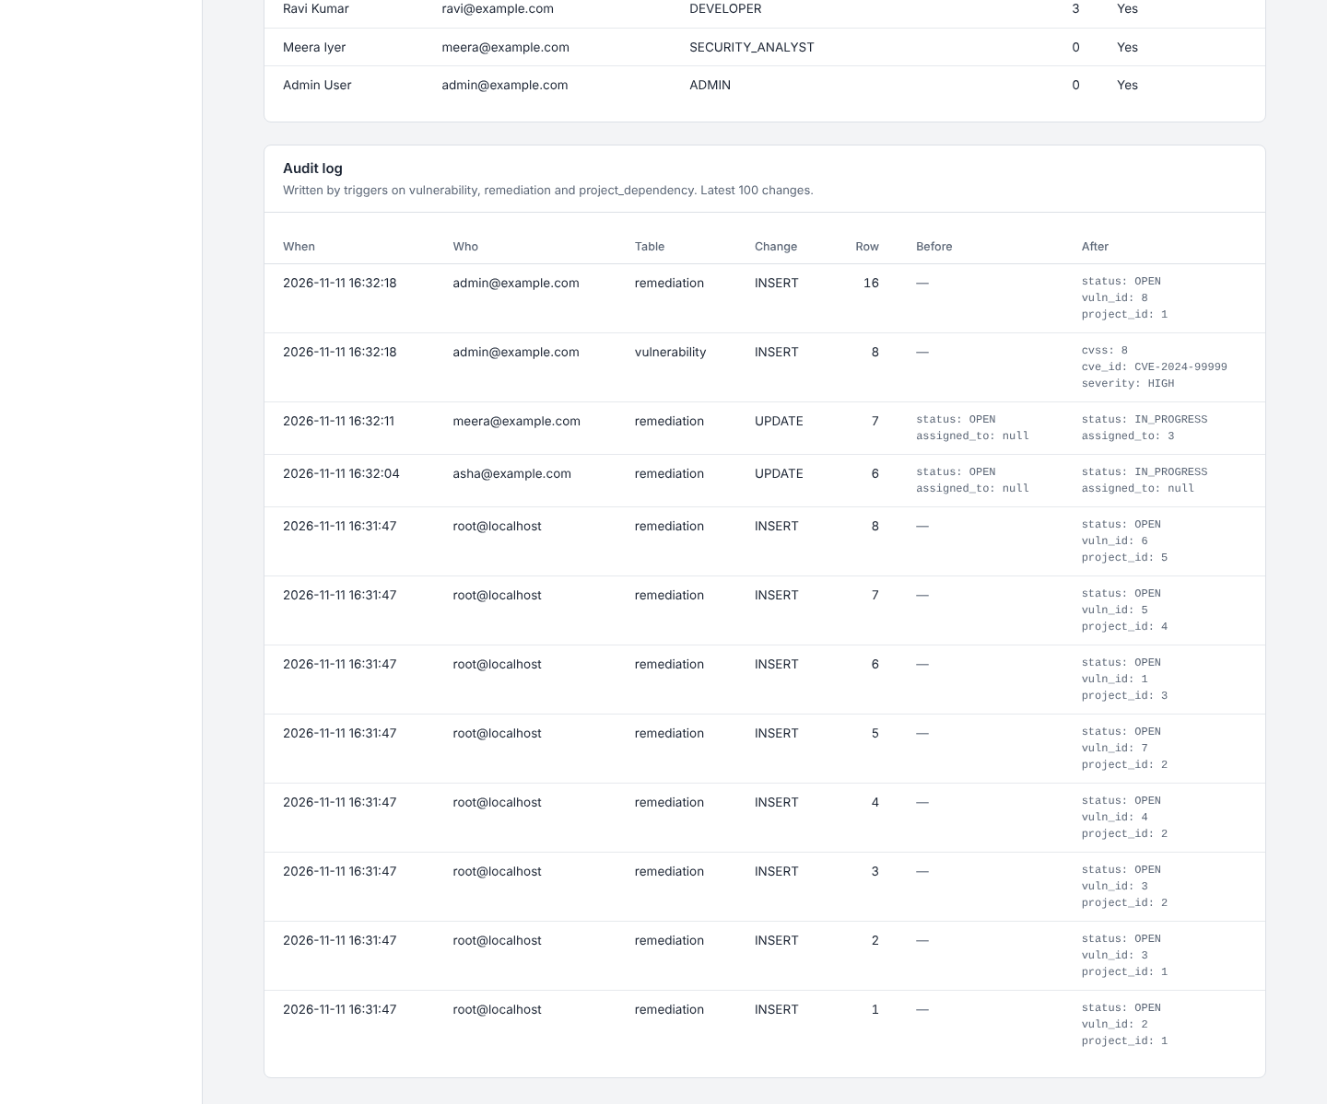
Figure 32: Admin: users and the audit log, with the analyst's email recorded by the trigger

11. Evaluation Rubrics
# | Criteria | Distribution | Status
1 | Database Design | ER diagram, relational schema with keys, relationships, and constraints | Completed. Sections 3 and 4: Chen ER with weak entity, cardinality and participation; schema with PK, FK, UNIQUE, NOT NULL, CHECK and ON DELETE actions.
2 | Database Creation | SQL database implementation - DDL with constraints, NoSQL/Vector database creation, Technology justification | Completed. 11 tables with 5 CHECK constraints (5.1, 5.2); MongoDB collections with $jsonSchema validation (7.1); justification in 2.5 and 2.6.
3 | SQL Operations and Queries | DML operations, Nested/correlated/Recursive SQL queries, Join SQL queries | Completed. INSERT/UPDATE/DELETE (6.1, 6.2), nested and correlated (6.3), joins and anti-join (6.4), recursive CTE (6.5), transactions (6.6).
4 | Advanced Database Concepts | Advanced database concepts (Procedure/function, trigger, CTE), NoSQL/Vector feature RUD | Completed. 1 function and 7 procedures, 14 triggers, recursive CTEs and 9 views (5.3–5.5); MongoDB Read, Update, Delete and transaction (7.3), also used from the app.
5 | Web Application and Database Integration | Next.js interface, Backend/API and database integration | Completed. 7 pages and 19 API route files reading and writing both MySQL and MongoDB (sections 9, 10).
6 | Authentication and Authorization | Authentication implementation (front end and backend) and minimum two roles and role-based access control in database | Completed. bcrypt + JWT login (10.1); 3 roles enforced at page, API and database level with MySQL roles and GRANTs (5.6, 8.2).
7 | Documentation, Git/GitHub, Demonstration, Testing, and Originality | Documentation, Git/GitHub, Originality and individual contribution | Completed: README, docs, this report, 54 automated tests. Repository: github.com/chandana1202/DBMS_Mini_project. Contribution split is listed in README.md.

