ASSIGNMENT

1. Write a python program to return a set of elements present in set A or B, but not both.

Set1={10,20,30,40,50}

Set2={30,40,50,60,70}

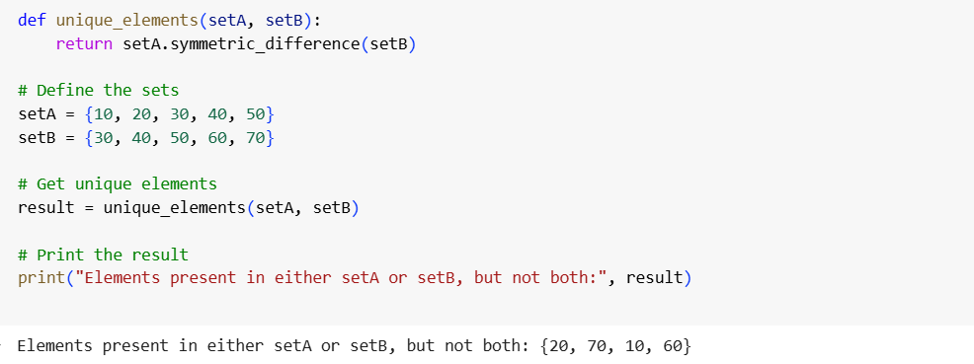

1. Write a python program to check if two sets have any elements in common if yes, display the common elements

Set1={10,20,30,40,50}

Set2={60,70,80,90,10}

