ASSIGNMENT

1. Write a python program to handle a ZeroDivisionError exception when dividing a number by zero.

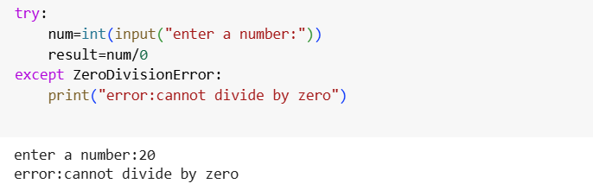

1. Write a python program that prompts the user to input an integer and raises a ValueError exception if the input is not a valid integer.

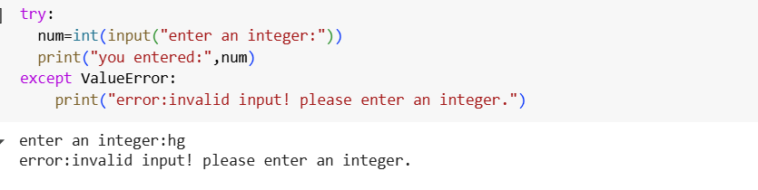

1. Write a python program that opens a file and handles a FileNotFoundError exception if the file does not exit.

