IIi - ASSIGNMENT

1. Python program to check leap year.

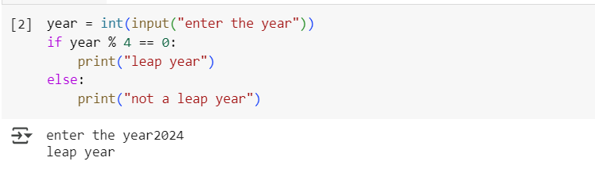

Output

Enter the year 2024

Leap year

1. Python program to find the largest among three numbers.

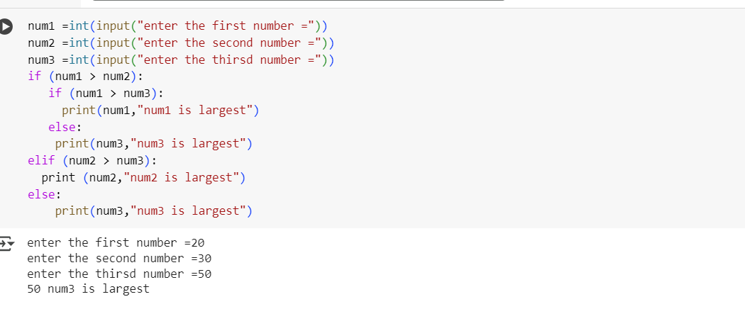

Output

Enter the first number=20

Enter the second number=30

Enter the third numb=50

50 num3 is largest

1. Python program to check if a number is Positive, Negative or 0.

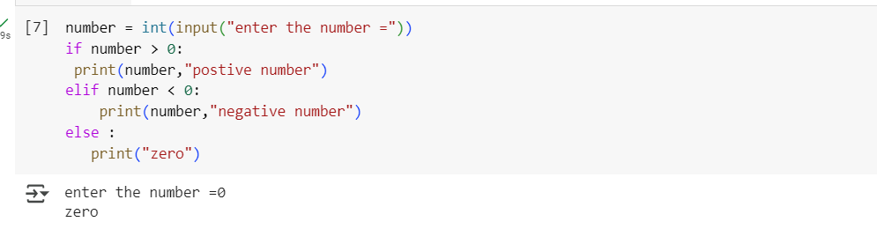

Output

Enter the number=0

Zero

1. A toy vendor supplies three types of toys: Battery based toys, Key-based toys, and Electrical

Charging- based toys. The vendor gives a discount of 10% on orders for battery-based toys if the order is for more than Rs.1000. On orders of more than Rs.100 for key-based toys, a discount of 5% is given, and a discount of 10% is given on orders for electrical charging -based toys of value more than Rs.500. Assume that the numeric codes 1,2 and 3

are used for battery- based toys, key-based toys, and electrical charging -based toys respectively. Write a program that reads the product code and the order amount and prints out the net amount that the customer is required to pay after the discount.

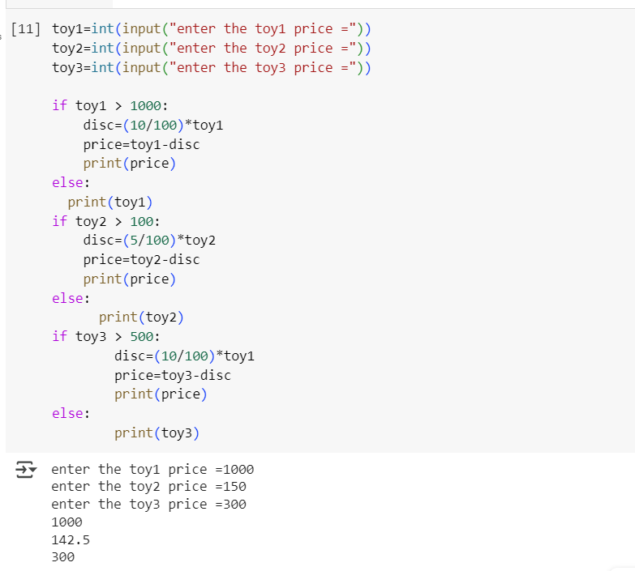

Output

enter the toy1 price =1000

enter the toy2 price=150

enter the toy3 price =300

1000

142.5

300

1. A transport company charges the fare according to following table:

|  |  |
| --- | --- |
| Distance | Charges |
| 1-50 | 8 Rs/km |
| 51-100 | 10 Rs/km |
| >100 | 12 Rs/km |

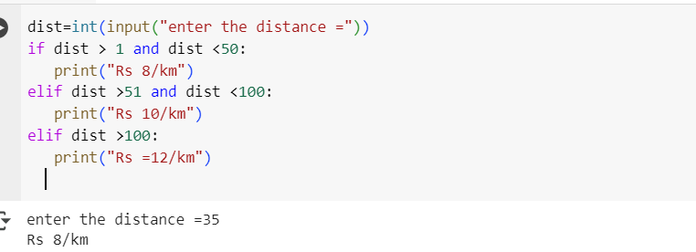

Output

Enter the distance =35

Rs 8/km