I - ASSIGNMENT

1. Calculate the multiplication and sum of two numbers.

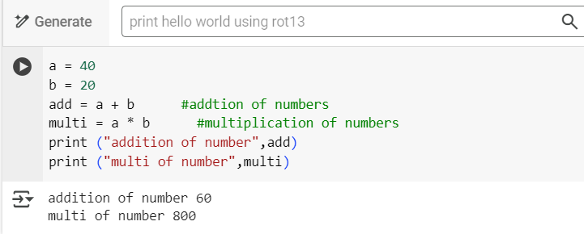

OUTPUT

Addition of 2 number 60

Multi of 2 number 800

1. Declare two variable and print that which variable is

Largest using ternary operators.

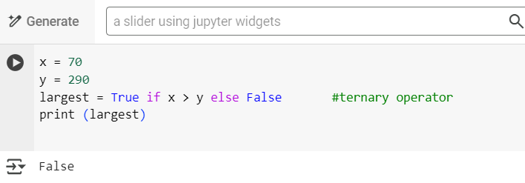

OUTPUT

FALSE

1. Python program to convert the temperature in degree centigrade to Fahrenheit.

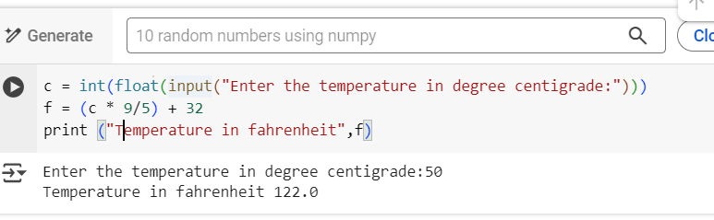

OUTPUT

Enter the temperature in degree centigrade:50

Temperature in Fahrenheit 122.0

1. Python program to find the area of a triangle whose sides are given.

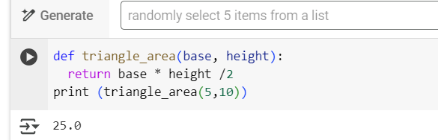

OUTPUT

25.0