Microsoft Word Author Guidelines for CVPR Proceedings

Anonymous CVPR submission
Paper ID ****< replace **** here and in header with paperID>

Abstract

The ABSTRACT is to be in fully-justified italicized text, at the top of the left-hand column, below the author and affiliation information. Use the word “Abstract” as the title, in 12-point Times, boldface type, centered relative to the column, initially capitalized. The abstract is to be in 10-point, single-spaced type. The abstract may be up to 3 inches (7.62 cm) long. Leave two blank lines after the Abstract, then begin the main text.

Introduction
A scene can include various details about objects, regions, geometry, location, activities, and even nonvisual attributes and can be described in many ways. For example, a typical urban scene can be described by specifying the location of the foreground animal object and background grass, sky, and road regions. Alternatively, the image could be summarized as a street scene. We would like a computer to be able to detect about all these aspects of the scene and provide both coarse image-level tags and detailed pixel level annotations describing the semantics and geometry of the scene.

Object classification is assigning semantic labels to an object. It can be used as a building block for many other tasks such as localization, detection, and scene parsing. Current approaches typically adopt one of the two classification models: multiclass classification, which predicts one label out of a set of mutually exclusive labels or binary classifications, which make binary decisions for each label independently. The classification model used in carrying out our work is the multiclass classification model.

Related work
Gould, Fulton and Koller addressed the problem of decomposing a scene into geometrically and semantically coherent regions. They reasoned over both pixels and regions through a unified energy function. They also proposed an effective inference technique for optimizing this energy function and showed how it could be learned from data. We have done a major part of our work inspired by them.

P.Kontschieder, S. Rota Bul`o, H. Bischof and M.Pelillo_presented a simple and effective way to integrate ideas from structured learning into the popular random forest framework for the task of semantic image labelling. In particular, they incorporated the topology of the local label neighborhood in the training process and therefore intuitively learned valid labelling transitions among adjacent object categories. Also, they provided several experiments on the challenging CamVid and MSRCv2 databases and found superior results when compared to standard random forest or conditional random field (using pairwise potentials) classification results

D. Baby and S. Raju addressed the problem of task-specific image partitioning by supervised training and a region based image retrieval by creating a database of partitioned images and inputting a query image. The correlation clustering model aimed to merge superpixels into regions of homogeneity with respect to the solution of any particular image labeling problem. The used LP relaxation to approximately solve the correlation clustering over a superpixel graph where a rich pair wise feature vector was defined based on several visual cues. They used S-SVM for supervised training of parameters in correlation clustering, and the cutting plane algorithm with LP-relaxed inference was applied to solve the optimization problem of S-SVM.

D. Depalov and B. Gandhi presented a new approach for semantic classification that utilizes perceptual models for image segmentation and classification. The main innovations of the proposed apprach are the use of an algorithm that produces perceptually uniform segments and the selection of perceptually-motivated region-wide color and texture features. The features of these regions are used as medium level descriptors and are the key to bridging the gap between low-level image primitives and high-level image semantics. Their results indicate that the proposed approach offers significant performance improvements over the existing literature.

X. Yu and Hong Liu put forward a method to classify image regions based on their semantics. It can reduce the gap between human’s perception and description of image content. Because the pre-defined semantic class hierarchy reflects in the semantics by human’s subject, so it is flexible and intuitive query by novice. The use of the binary SVM classifiers that classify image regions using different features at different levels in the hierarchy were the main reasons behind the high classification precision that we achieved in our experiments. Currently, we are looking adding more feature extraction methods to get high precision and put more classifiers to include more classes into the system.

Approach
3.1 Superpixels
Our model decomposes a scene into and semantically consistent regions using a classifier over pixels and regions. In the work carried out, we have labelled the images using a fixed number of labels. One approach that could be used to assign these labels to an image is pixel wise but there are some disadvantages of doing so such as
classifying large regions rather than individual pixels we can compute more robust features and reduce inference complexity. Also, the use of individual pixels makes it difficult to utilize more global cues, including both robust statistics about the appearance of larger regions, which can help average out the random variations of individual pixels, and relationships between regions, which are hard to “transmit” by using local interactions at the pixel level.
Instead of performing pixel wise labelling we have adopted a more improved approach which is superpixels based labelling. Superpixels correspond to small, nearly-uniform regions in the image They are constructed in advance using simple procedures. Superpixel preserve boundary. Also, they can significantly reduce computational cost and allow feature extraction to be conducted from a larger homogeneous region.

3.2. Features
Features can also be used for segment classification.

One of the features we have used is color and we have used two different color spaces namely RGB color space and HSV color space. Color is not a strong clue for image classes, and few object categories are associable to a single color. On the other side, color can provide strong information on object boundaries: a sharp color change between two parts gives a strong clue that those patches can belong to different objects. Additionally,up to a certain extent, objects instances tend to be color homogeneous. The color composition feature exploits the fact that the HSV cannot simultaneously perceive a large number of colors. In addition, it accounts for the varying image characteristics and the adaptive nature of the HSV. The RGB color space is not as informative as the HSV color space.

Another feature used is the texture component. In texture we use LMFilters to give us useful information and we take the mean and max of these reponses returned. The segmentation algorithm combines the color composition and texture features to obtain segments of uniform texture. We use texture to determine the major structural composition of the image and combines it with color, first to estimate the major segments, and then to obtain accurate
and precise localization of the border between regions.

We also use the position descriptor to label our images. Normalised y coordinate is used to detect elements such as sky which normally tend to be at a higher height than road. The cues given by this position descriptor are quite helpful while labelling images.

3.3 Supoort Vector Machine
In our study, the label of an object is not known initially. Only the label of a set of objects is known, which is called the training data. We map an object to its label according to the information learned from the training data.

The way of constructing a hyperplane to get binary classifiers done that can separate members of one class from others, but most real data hardly separate because the hyperplane that can successfully separate the members of the two classes in most case does not exist. One measure to solve this problem is to map the data into a higher dimensional space, where the members of the two classes can separate by a hyperplane. However, the traditional classifier is not good at in high dimensional vector. It is extremely expensive in terms of memory and time.

The way of constructing a hyperplane to get binary classifiers done that can separate members of one class from others, but most real data hardly separate because the hyperplane that can successfully separate the members of the two classes in most case does not exist. One measure to solve this problem is to map the data into a higher dimensional space, where the members of the two classes can separate by a hyperplane. However, the traditional classifier is not good at in high dimensional vector. It is

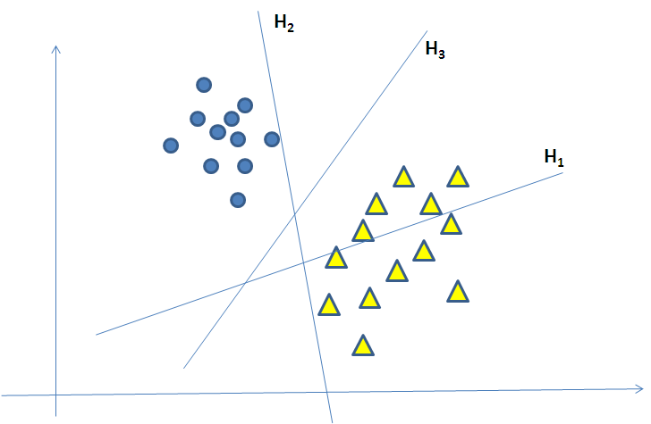

Figure 1. Separation hyperplanes. H1 does not separate the two classes; H2 separates but with a very tinny margin between the classes and H3 separates the ..

extremely expensive in terms of memory and time. Support Vector Machines can solve this problem. SVM avoid overfitting the data by choosing a hyperplane from the many that can separate the data. That maximizes the minimum distance from the hyperplane to the closest training point. Such a hyperplane call the maximum margin hyperplane. Another advantage of the SVM is the compact representation of the decision boundary, so the number of support vectors is small as compared to the number of points in the training set.

Learning the semantics for each class through using SVM based on different features of training sample regions of each class.After training the SVM, binary classifiers that can classify image regions based on their semantics create. Then, we use these classifiers to classify our database of image regions leading to the classification to determine the class of an input image region and this image region map into its class in the semantic class hierarchy.

Experimental analysis
Below are the results of the conducted work. We first performed the 5-fold cross validation for 10000 super pixels. We can see that we have obtained an average accuracy of 13. In some folds class 3 seems to have the most accuracy and in some class 6 seems to have the most accuracy.

We have performed these experiments on MATLAB 2013a using libsvm. One of the main reasons for a low accuracy is the use of the above mentioned version of MATLAB. Using MATLAB 2014b which uses fitcsvm we can obtain an accuracy of above 40.

Also, tried implementing SIFT features but it did not show any improvement in the accuracy.
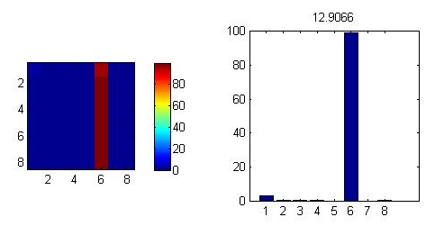

Fig 3. Fold 1 of the 5-Fold cross validation for 10000 superpixels
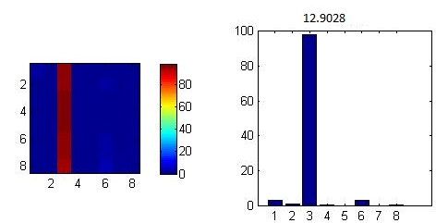

Fig 4. Fold 2 of the 5-Fold cross validation for 10000 superpixels

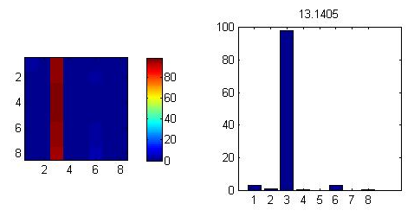
Fig 5. Fold 3 of the 5-Fold cross validation for 10000 superpixels
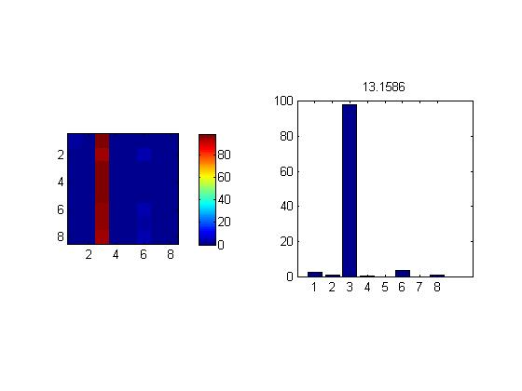
Fig 6. Fold 4 of the 5-Fold cross validation for 10000 superpixels
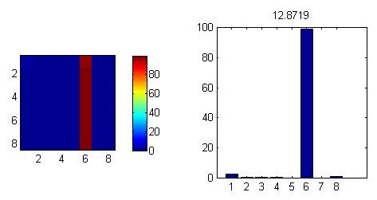
Fig 7. Fold 5 of the 5-Fold cross validation for 10000 superpixels

Below are the results by varying the number of superpixels.

Fig 8. Accuracy for 1000 superpixels

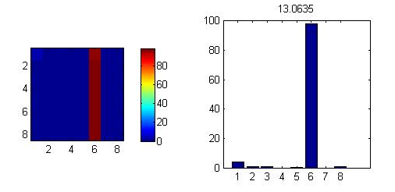
Fig 9. Accuracy for 10000 super pixels
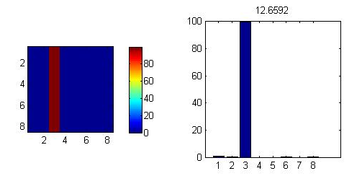
Fig 10. Accuracy for 25000 super pixels

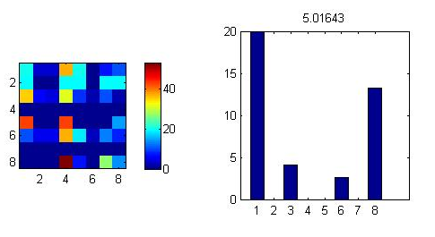
Fig 11Accuracy for 10000 super pixels for linear.

Conclusion

References
- A. Alpher, , and J. P. N. Fotheringham-Smythe. Frobnication revisited. Journal of Foo, 13(1):234–778, 2003.
- A. Alpher, , J. P. N. Fotheringham-Smythe, and G. Gamow. Can a machine frobnicate? Journal of Foo, 14(1):234–778, 2004.
- A. Alpher. Frobnication. Journal of Foo, 12(1):234–778, 2002.
- Authors. The frobnicatable foo filter, 2014. Face and Gesture 2014 submission ID 324. Supplied as additional material efg324.pdf.
- Authors. Frobnication tutorial, 2014. Supplied as additional material tr.pdf.

