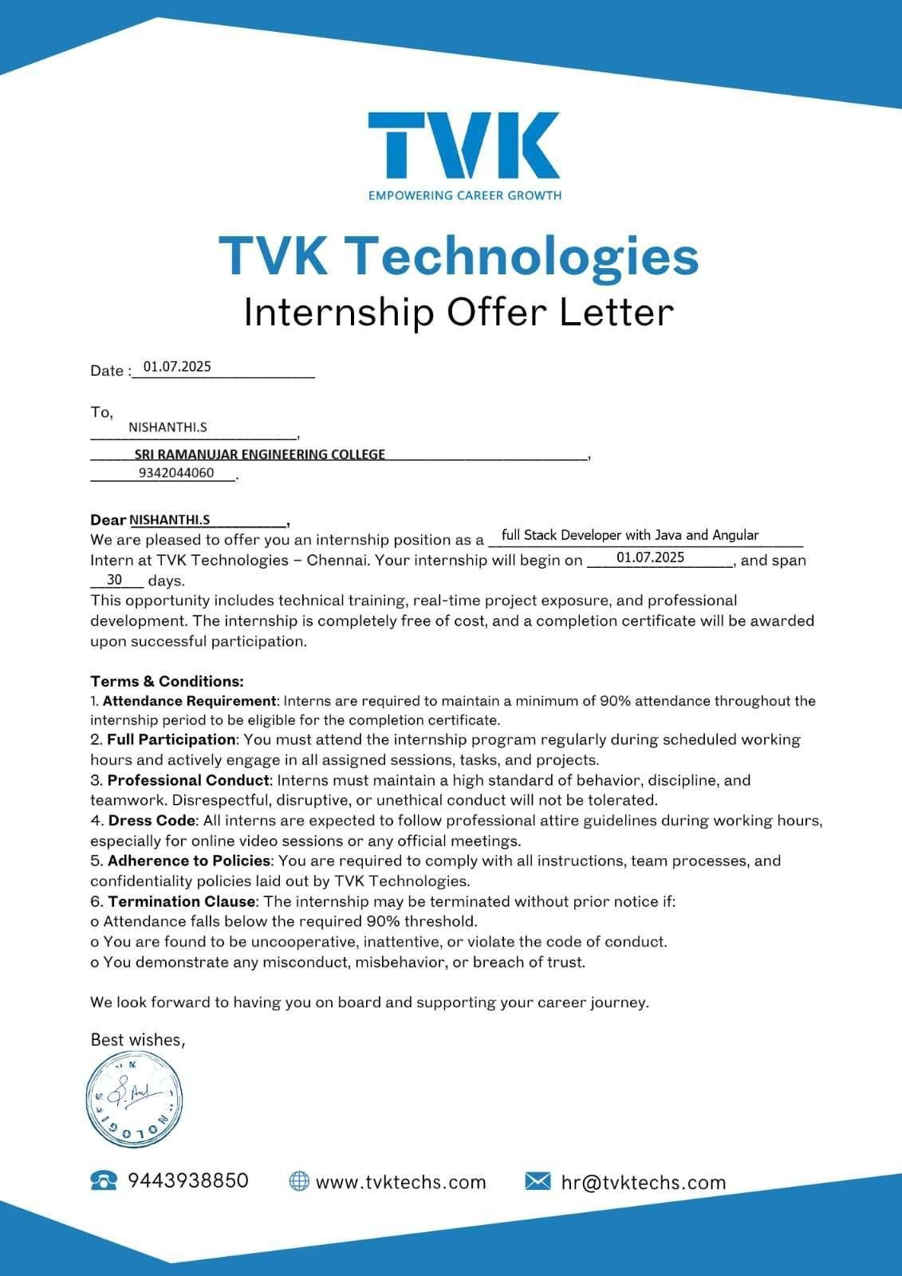


TVK Technologies

Internship Offer Letter

Date : {date}
Dear {studentName} ({studentId}),
We are pleased to offer you an internship position as {role} Intern at TVK Technologies - Chennai. Your internship will begin on {startDate}, and span {duration}. This opportunity includes technical training, real-time project exposure, and professional development. The internship is completely free of cost, and a completion certificate will be awarded upon successful participation.

Terms & Conditions:
- Attendance Requirement: Interns are required to maintain a minimum of 90% attendance throughout the internship period to be eligible for the completion certificate.
- Full Participation: You must attend the internship program regularly during scheduled working hours and actively engage in all assigned sessions, tasks, and projects.
- Dress Code: All interns are expected to follow professional attire guidelines during working hours, especially for online video sessions or any official meetings.
- Adherence to Policies: You are required to comply with all instructions, team processes, and confidentiality policies laid out by TVK Technologies.
We look forward to having you on board and supporting your career journey.

Best wishes,


phone: 9443938850 website: www.tvktechs.com Email: hr@tvktechs.com

