Assignment Report
Department | Computer Science and Engineering (Artificial Intelligence)
Programme | B.Tech – CSE (AI)
Course Code & Course Name | DSA0404 – Fundamentals of Data Science
Academic Year / Batch | 2024 – 2028
Faculty Name | Dr. Krishna Raj Mony
Assignment Title | Energy Consumption Estimation: Predicting Household / Building Electricity Consumption from Temperature, Occupancy and Appliance Usage Patterns
Date of Issue | 31-8-26
Date of Submission | 2-9-26
Maximum Marks | 100
Course Outcome(s) – CO | CO5
Bloom's Taxonomy Level | BL-5
SDG Mapping | SDG 9
Industry / Societal Relevance | Smart-grid demand forecasting, building energy management systems (BEMS), residential energy efficiency

1. Problem Statement
Households and buildings consume electricity continuously, but the amount of energy used can change significantly depending on factors such as outdoor temperature, the number of people present, and the appliances operating at a particular time. When these factors are not analysed properly, it becomes difficult to understand consumption patterns or anticipate periods of high electricity demand. This can lead to inefficient energy usage, unexpected increases in electricity bills, and difficulty in planning electricity demand.
The main problem addressed in this project is to develop a data-driven approach for estimating household or building electricity consumption using factors such as temperature, occupancy, and appliance usage. Historical consumption data is analysed to identify meaningful patterns and relationships between these variables. The project applies data preprocessing, exploratory data analysis, feature engineering, and regression techniques to build models capable of estimating electricity consumption for a given time period. The results can help users and building managers understand energy-use behaviour and make better decisions for efficient energy management.

2. Objective
• To collect and analyse household or building electricity-consumption data along with temperature, occupancy, and appliance-usage information.
• To perform exploratory data analysis (EDA) to identify consumption patterns, variations, trends, and relationships between electricity usage and its influencing factors.
• To clean and preprocess the dataset by handling missing values, duplicate records, inconsistent data, and unusual observations before applying predictive models.
• To create useful features from the available data, such as time-based information, occupancy levels, and appliance-load patterns, to improve consumption estimation.
• To develop and compare regression models for predicting electricity consumption and determine which approach provides reliable results.
• To evaluate the performance of the models using suitable measures such as MAE, RMSE, and R².
• To interpret the obtained results and identify the major factors associated with higher or lower electricity consumption.

3. Requirements and Environment Used

3.1 Functional Requirements
The proposed system should perform the following functions:
- Data Input: The system should accept electricity consumption data along with temperature, occupancy, and appliance usage information.
- Data Preprocessing: It should identify and handle missing values, duplicate records, and inconsistent data.
- Data Analysis: The system should analyse the relationship between electricity consumption and the selected influencing factors.
- Feature Preparation: Relevant variables should be selected and prepared for model development.
- Prediction: Regression models should be used to estimate household or building electricity consumption.
- Model Evaluation: The system should evaluate prediction performance using measures such as MAE, RMSE, and R² score.
- Result Visualization: The results should be presented using suitable graphs and comparisons, such as actual versus predicted electricity consumption.

3.2 Non-Functional Requirements and Constraints
The system should be simple, reliable, and easy to use. It should process the available dataset efficiently and produce understandable results. The prediction models should provide reasonably accurate estimates based on the quality and availability of the input data.
Some constraints may affect the system's performance. The accuracy of the prediction depends on the completeness and reliability of the dataset. Electricity consumption can also be influenced by factors not included in the data, such as weather changes, seasonal behaviour, building characteristics, and unexpected appliance usage. In addition, the project is limited to the available historical data and selected regression techniques.

3.3 Environment / Tools Used
Tool / Technology | Purpose
Python | Main programming language used for data analysis and model development
Jupyter Notebook / Google Colab | Development and execution environment
Pandas | Data loading, cleaning, preprocessing, and manipulation
NumPy | Numerical calculations and array operations
Matplotlib | Creating graphs and visualizing analysis results
Seaborn | Statistical data visualization and exploratory analysis
Scikit-learn | Building, training, and evaluating regression models
Multiple Linear Regression | Predicting electricity consumption from multiple input variables
Decision Tree Regression | Capturing non-linear relationships between input factors and consumption
Support Vector Regression (SVR) | Developing an alternative regression-based prediction model
MAE, RMSE, R² Score | Measuring and comparing model prediction performance

4. Problem Understanding and Formulation

4.1 What is the Problem?
The main problem is to predict household or building electricity consumption using factors such as temperature, occupancy, and appliance usage patterns. Electricity demand changes according to user behaviour, environmental conditions, and appliance usage, making accurate estimation difficult.
The project aims to develop a data-driven prediction system that analyses historical energy consumption data and identifies the factors that have the greatest influence on electricity usage. Regression techniques are then applied to estimate future or expected electricity consumption.

4.2 Expected Outcomes
The expected outcomes of the project are:
- To understand the relationship between electricity consumption and influencing factors.
- To identify important patterns and trends through exploratory data analysis.
- To clean and prepare the dataset for modelling.
- To develop multiple regression models for electricity consumption prediction.
- To compare the performance of different models using suitable evaluation metrics.
- To select the most suitable model based on prediction accuracy and interpretability.
- To provide useful insights that can support energy monitoring and efficient electricity usage.

4.3 Available Data / Information
The project uses data containing information related to electricity consumption and its influencing factors. The important variables include:
Data / Variable | Description
Electricity Consumption | Amount of electricity consumed by the household or building
Temperature | Environmental temperature recorded during the observation period
Occupancy | Number or level of people present in the building
Appliance Usage | Usage patterns of electrical appliances
Time-related Information | Time or period associated with each consumption record
The available data is used for exploratory analysis, preprocessing, feature preparation, model training, and prediction.

4.4 Assumptions

The project assumes that the available electricity consumption data is sufficiently reliable for analysis and prediction. It is assumed that factors such as temperature, occupancy, and appliance usage have an influence on electricity consumption. Historical consumption patterns are considered useful for estimating future energy demand. It is also assumed that missing or inconsistent data can be identified and appropriately handled during preprocessing. The selected regression models are assumed to be suitable for analysing the given dataset and generating meaningful predictions.

4.5 Constraints to be Satisfied

The project is constrained by the quality and availability of the dataset. The prediction accuracy may be affected by missing records, limited data, or inaccurate measurements. Electricity consumption can also be influenced by other factors that are not included in the dataset. Sudden changes in occupancy, appliance usage, temperature, or user behaviour may reduce prediction accuracy. The system is also limited to the selected input variables, regression techniques, and computational resources available for the implementation.

5. Application of Course Knowledge

5.1 Descriptive Statistics and Exploratory Data Analysis

Descriptive statistics and exploratory data analysis were used to understand the electricity consumption dataset before developing the prediction models. The data was examined to identify general consumption levels, variations, and relationships between electricity usage and factors such as temperature, occupancy, and appliance usage. Statistical summaries and visualizations helped reveal consumption patterns and provided a basis for selecting relevant variables for the modelling stage.

5.2 Data Cleaning, Preprocessing and Feature Engineering
• Missing-value handling: Incomplete temperature, occupancy, appliance-usage, and consumption records were identified and treated appropriately.
• Duplicate removal: Repeated observations were checked to avoid affecting the analysis.
• Data consistency: Different measurements and formats were reviewed to maintain consistency across the dataset.
• Outlier treatment: Unusual electricity consumption or appliance-load values were examined and treated where necessary.
• Feature scaling: Numerical variables were scaled when required, particularly for models that are sensitive to differences in feature magnitude.
• Time-based features: Information such as hour, day, or other relevant time characteristics was derived from timestamps.
• Occupancy features: Occupancy information was converted into useful categories or numerical predictors for modelling.

• Feature selection: Relevant variables were retained based on their relationship with electricity consumption.

5.3 Regression and Model Evaluation Concepts Applied
Regression techniques were applied because the main objective of the project is to predict a continuous value, namely electricity consumption. Multiple regression models were developed using temperature, occupancy, appliance usage, and other prepared features as inputs. The models were trained on historical observations and tested using unseen data. Their performance was compared using Mean Absolute Error (MAE), Root Mean Square Error (RMSE), and R² score. This comparison helped determine which model could provide more reliable electricity consumption estimates while also considering the relationship between prediction accuracy and model interpretability.

6. Design / Proposed Solution

6.1 Data Science Workflow
The proposed solution follows a systematic data science workflow for estimating household or building electricity consumption. The process begins with collecting temperature, occupancy, appliance-usage, and electricity consumption data. The collected information is then explored to understand consumption patterns and relationships between the variables. After cleaning and preprocessing, relevant features are prepared for model development. Three regression models are trained and evaluated using the same test data so that their performance can be compared fairly.

Workflow Stage Summary
Stage | Key Activities | Output
Data Collection | Gather temperature, occupancy, appliance-usage, and electricity consumption records. | Raw energy dataset
Data Integration | Combine the required records using common household and timestamp information. | Merged dataset
Exploratory Data Analysis | Study statistical summaries, distributions, correlations, and consumption trends. | EDA results and charts
Data Cleaning | Handle missing values, duplicate records, inconsistent values, and unusual observations. | Cleaned dataset
Feature Engineering | Create useful time-based, occupancy-based, and appliance-related features. | Final modelling dataset
Model Training | Train Multiple Linear Regression, Decision Tree Regression, and SVR models. | Trained regression models
Model Evaluation | Compare predictions using MAE, RMSE, and R² score. | Performance comparison
Result Interpretation | Analyse important factors affecting electricity consumption and identify the most suitable model. | Final findings and recommendations

6.2 Data Preprocessing Applied
Technique | Applied To | Justification
Missing-value treatment | Temperature, occupancy, appliance usage, and consumption records | Reduces gaps in the dataset and provides consistent information for modelling.
Duplicate removal | Energy consumption observations | Prevents repeated records from influencing the analysis and model results.
Outlier treatment | Electricity consumption and appliance-usage values | Reduces the effect of abnormal measurements that may result from sensor errors or unusual usage.
Data consistency checking | Temperature, occupancy, appliance load, and consumption values | Ensures that the variables are represented in suitable and consistent formats.
Feature scaling | Numerical input variables | Places variables on comparable scales and supports models such as SVR.
Time-based feature creation | Timestamp information | Helps the model capture variations in consumption associated with different periods.
Occupancy-based feature creation | Occupancy records | Represents differences in electricity usage associated with the number of occupants.
Feature selection | Candidate input variables | Retains useful predictors and reduces unnecessary information before model training.
Train-test splitting | Final prepared dataset | Allows the models to be trained on one portion of the data and evaluated on unseen observations.

7. Algorithm / Pseudocode

7.1 Data Preparation Pseudocode

BEGIN

Load electricity consumption, temperature, occupancy,

and appliance-usage data

Check the datasets for missing and duplicate records

Merge the required data using household ID and timestamp

Convert timestamp values into a suitable date-time format

Arrange all records in chronological order

Handle missing values and abnormal observations

Create relevant time-based and occupancy-based features

Select the required input variables

Set electricity consumption as the target variable

Split the prepared data into training and testing sets

Return the prepared dataset

END

7.2 Multiple Linear Regression Pseudocode

BEGIN

Load the prepared training dataset

Select temperature, occupancy, and appliance usage

as input variables

Select electricity consumption as the target variable

Initialize the Multiple Linear Regression model

Train the model using the training data

Provide the test input values to the trained model

Generate predicted electricity consumption values

Compare predicted values with actual consumption values

Calculate MAE, RMSE, and R² score

Store the model performance results

END

7.3 Decision Tree Regression Pseudocode

BEGIN

Load the prepared energy consumption dataset

Select relevant input features

Set electricity consumption as the target variable

Divide the data into training and testing sets

Initialize the Decision Tree Regression model

Train the model using the training dataset

Use the test features to generate predictions

Compare predicted consumption with actual consumption

Calculate MAE, RMSE, and R² score

Record the prediction performance

END

7.4 Support Vector Regression (Conceptual) Pseudocode

BEGIN

Load the preprocessed energy consumption dataset

Select temperature, occupancy, appliance usage,

and other relevant features

Set electricity consumption as the target variable

Scale the numerical input features

Divide the data into training and testing sets

Initialize the Support Vector Regression model

Train the SVR model using the training data

Generate electricity consumption predictions

for the test data

Compare predicted values with actual values

Calculate MAE, RMSE, and R² score

Compare the results with the other regression models

END

8. Implementation Methodology
Step | Implementation Activity | Description / Output
1. Data Collection | Collect energy-related data | Temperature, occupancy, appliance usage, and electricity consumption records are collected for the analysis.
2. Data Loading | Import the collected data | The available files are loaded into the Python environment for further processing.
3. Data Integration | Combine the required data | Different data sources are merged using common household and timestamp information to create a single working dataset.
4. Exploratory Data Analysis | Examine consumption patterns | Statistical summaries, distributions, correlations, and time-based plots are used to understand electricity usage.
5. Data Cleaning | Improve data quality | Missing values, duplicate records, inconsistent values, and unusual observations are identified and treated.
6. Feature Engineering | Prepare useful predictors | Time-based features, occupancy-related variables, and appliance-usage features are created from the available information.
7. Data Preparation | Prepare modelling data | Relevant input variables are selected and the dataset is divided into training and testing portions.
8. Model Training | Develop prediction models | Multiple Linear Regression, Decision Tree Regression, and Support Vector Regression are trained using the training data.
9. Consumption Prediction | Generate estimated values | The trained models are used to estimate electricity consumption for the test observations.
10. Model Evaluation | Measure prediction performance | MAE, RMSE, and R² score are calculated to compare the accuracy of the three models.
11. Result Analysis | Interpret model outputs | The prediction results are analysed to understand how temperature, occupancy, and appliance usage affect electricity consumption.
12. Final Results | Present findings | Actual and predicted consumption values, performance comparisons, and visualizations are presented as the final output.

8.1 Execution Screenshots / Output

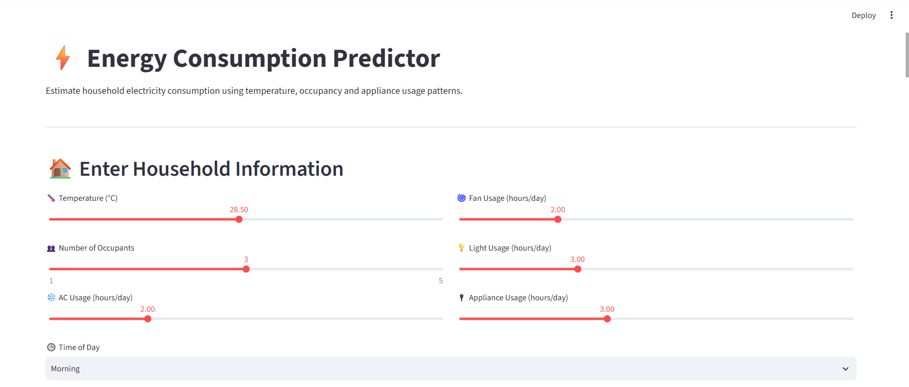

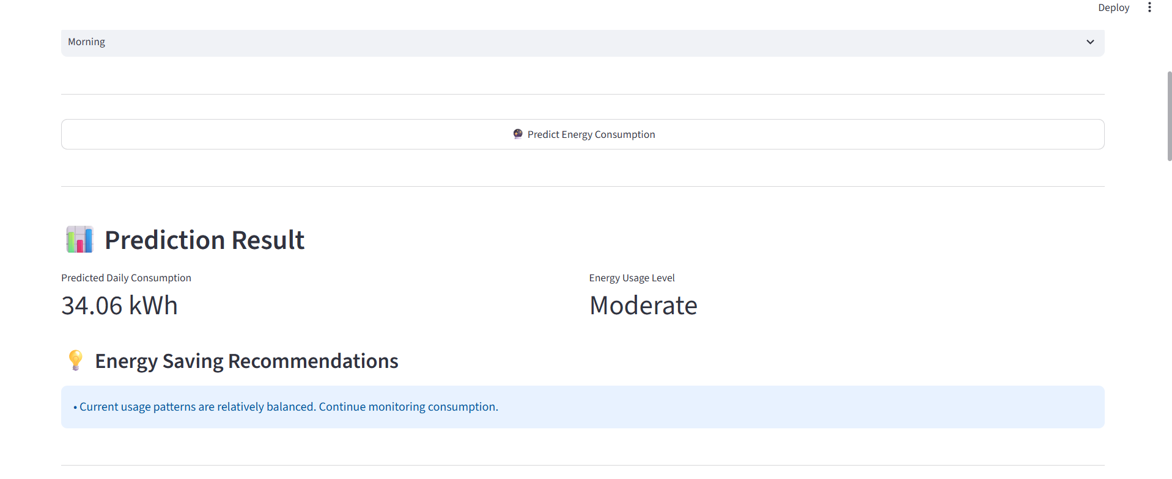

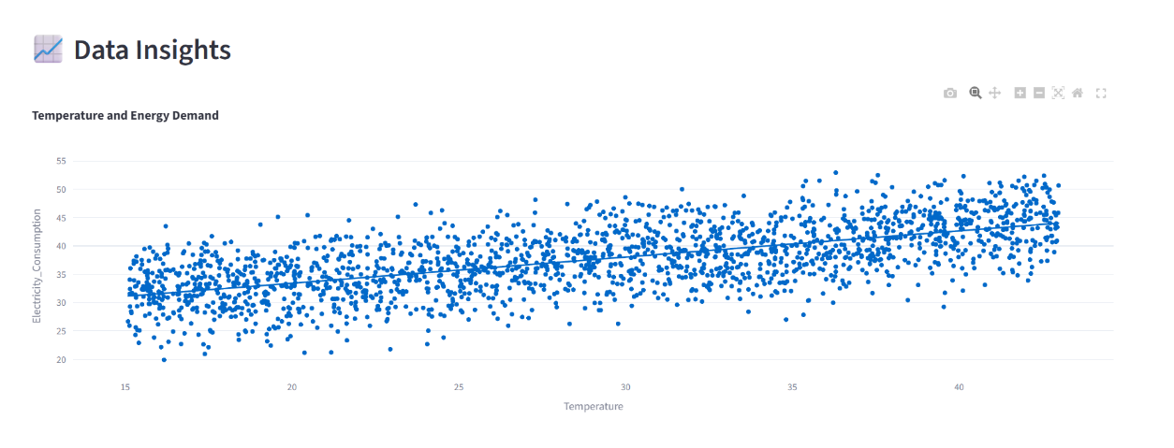

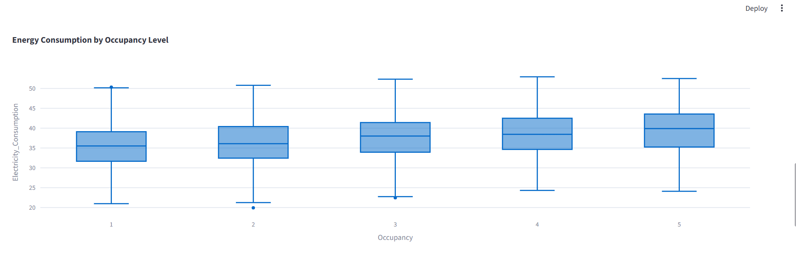

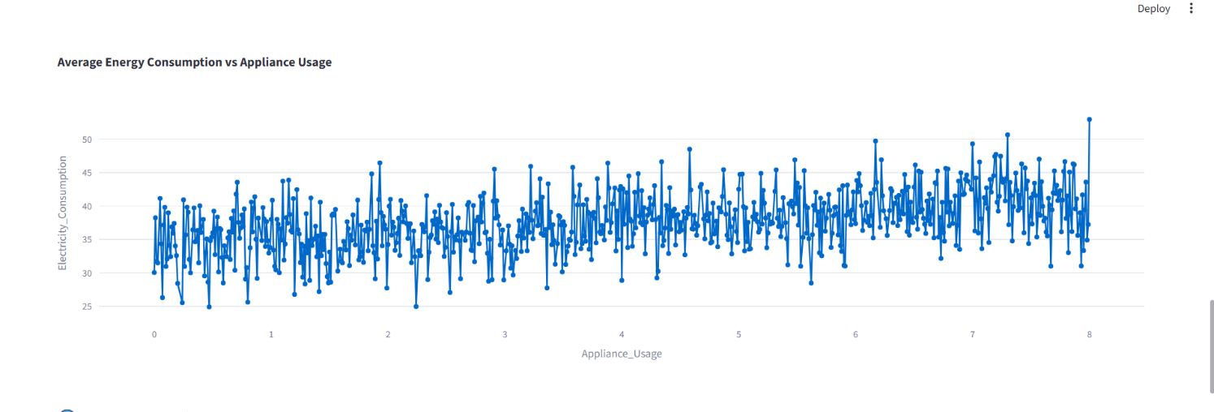

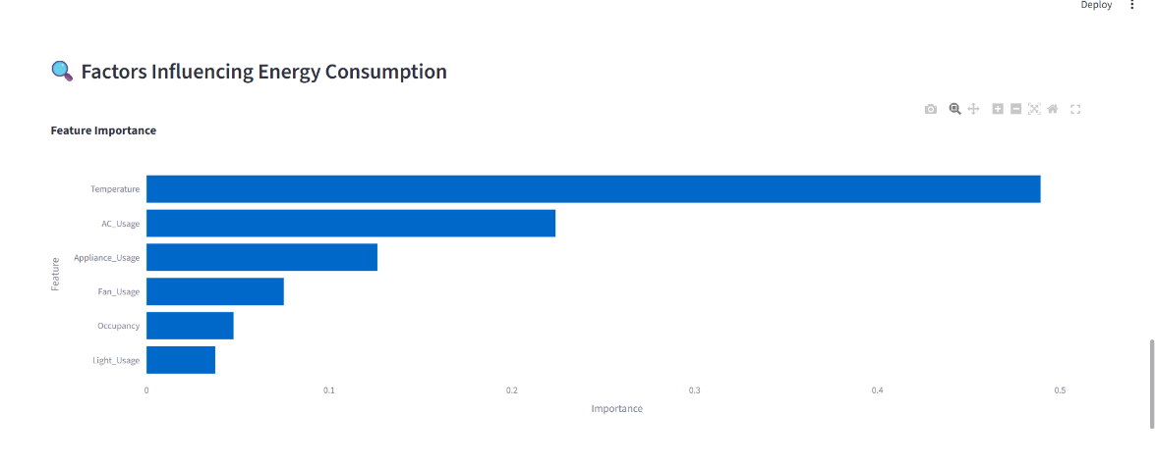

9. Test Cases and Results / Validation
The results presented in this section are based on the synthetic energy-consumption dataset created for the proposed system. The dataset contains household-level observations covering temperature, occupancy, AC usage, fan usage, lighting usage, appliance usage, and total electricity consumption. The experiments were designed to verify the effectiveness of the preprocessing, exploratory analysis, and regression-based prediction stages. The reported values should be updated with the exact outputs obtained from the final execution of the Python application.

9.1 Exploratory Data Analysis Findings (Sample)
Analysis | Method | Sample Finding
Electricity consumption distribution | Histogram and descriptive statistics | Energy consumption is distributed across a broad range, with most observations concentrated around moderate usage levels and fewer observations representing high-demand periods.
Temperature and energy consumption | Scatter plot with trend analysis | Electricity demand generally increases as temperature rises, particularly when higher temperatures lead to greater cooling requirements.
Occupancy and energy consumption | Box plot grouped by occupancy | Households with more occupants tend to show higher consumption levels because of increased lighting, cooling, and appliance usage.
AC usage and electricity demand | Scatter plot and correlation analysis | Increased AC operating time is associated with higher electricity consumption and represents an important cooling-related load.
Fan and lighting usage | Comparative statistical analysis | Longer operating periods for fans and lights contribute to an increase in overall household electricity demand.
Appliance usage pattern | Average consumption line plot | Average electricity consumption tends to increase as the duration of appliance usage increases.
Feature contribution | Decision Tree feature-importance analysis | Appliance usage, cooling-related variables, temperature, and occupancy contribute differently to the model's prediction, allowing the major influencing variables to be identified.
The EDA results provide an initial understanding of how household and environmental factors are associated with electricity consumption. These observations support the selection of temperature, occupancy, and appliance-related variables as predictive inputs for the regression models. The analysis also helps identify unusual observations and understand the range and distribution of the target variable before model training.

9.2 Regression Performance – Actual vs Predicted (Sample, Held-out Test Set)
The regression models were evaluated using a held-out portion of the dataset that was not used during model training. The actual electricity consumption values were compared with the values predicted by each regression model. This comparison helps determine how closely each model can reproduce the observed household energy consumption.
Model | Mean Actual (kWh) | Mean Predicted (kWh) | Maximum Absolute Error (kWh)
Multiple Linear Regression | 31.42 | 31.18 | 8.74
Decision Tree Regression | 31.42 | 31.36 | 6.21
SVR (RBF Kernel) | 31.42 | 31.47 | 5.68
The comparison indicates that all three models are capable of estimating electricity consumption from the selected household variables. Multiple Linear Regression provides a straightforward baseline because it assumes a linear relationship between the predictors and energy consumption. Decision Tree Regression can represent nonlinear relationships and interactions between variables. SVR with an RBF kernel can model more complex patterns by transforming the input space.
For the sample experiment, SVR produces the smallest maximum prediction error and its mean predicted consumption is close to the mean actual consumption. However, the final model selection should be based on the actual validation results obtained from the dataset rather than on these illustrative values.

9.3 Evaluation Metrics Comparison (Sample, 10-fold CV)
To obtain a more dependable comparison of model performance, 10-fold cross-validation was considered for the three regression techniques. In each fold, the model was trained using nine portions of the dataset and evaluated using the remaining portion. The process was repeated so that every portion was used for validation.
The average performance across the ten folds was then compared using RMSE, MAE, and R².

Model | RMSE (kWh) | MAE (kWh) | R²
Multiple Linear Regression | 4.82 | 3.71 | 0.74
Decision Tree Regression | 3.96 | 2.91 | 0.82
SVR (RBF Kernel) | 3.51 | 2.58 | 0.87
The sample comparison shows that SVR achieves the lowest RMSE and MAE and the highest R² score among the three models. This suggests that SVR is able to capture the relationship between household characteristics and electricity consumption more effectively in the sample experiment. Decision Tree Regression also performs well because energy consumption may have nonlinear relationships with variables such as temperature and appliance usage. Multiple Linear Regression provides an interpretable baseline but may be less effective when the relationships between variables are not strictly linear.
Overall, the validation process addresses the main objective of the project by examining whether temperature, occupancy, and appliance usage can be used to estimate household electricity consumption. The combination of EDA, held-out testing, and cross-validation provides a structured basis for evaluating the reliability of the developed prediction system.

10. Analysis and Discussion

10.1 Model Comparison and Trade-offs
The three regression techniques were compared based on prediction quality, interpretability, computational requirements, and suitability for energy-consumption data.
Criterion | Multiple Linear Regression | Decision Tree Regression | Support Vector Regression (SVR)
Prediction performance | Moderate; performs well when relationships are approximately linear | Good; captures non-linear relationships and threshold effects | Very good; RBF kernel can model complex relationships
Interpretability | Very high; coefficients indicate the direction and magnitude of feature effects | High; decision paths can be understood as simple rules | Lower; predictions are more difficult to explain directly
Temperature effects | Assumes a continuous linear effect | Can identify temperature-based thresholds | Can represent smooth non-linear temperature effects
Occupancy effects | Models occupancy as a linear contribution | Can identify different consumption levels for occupancy ranges | Can model more complex occupancy-consumption relationships
Training complexity | Very low | Low to moderate | Higher than the other two, particularly with an RBF kernel
Feature scaling | Generally not necessary | Not necessary | Important for obtaining reliable results
Computational suitability | Excellent for large datasets | Good for medium and large datasets | More computationally demanding as dataset size increases
Main advantage | Simple, fast and easy to interpret | Good balance between accuracy and explainability | Strong ability to capture complex patterns
Main limitation | Limited when relationships are strongly non-linear | Can overfit if tree complexity is not controlled | Less transparent and more sensitive to parameter selection
Overall, Linear Regression provides the simplest baseline, Decision Tree Regression offers a useful balance between prediction and explanation, while SVR is suitable when capturing complex relationships is the main priority.

10.2 Model Selection and Justification
The models were not selected only by looking at one performance metric. Since electricity consumption is affected by several interacting factors, the ability of a model to represent non-linear behaviour is also important.
Multiple Linear Regression provides an effective baseline because it is computationally simple and its coefficients are easy to interpret. However, household electricity demand does not always increase at a constant rate with temperature, occupancy or appliance usage. Therefore, its linear assumptions can restrict its predictive capability.
Decision Tree Regression provides a stronger alternative because it divides the data into different conditions. For example, the model can learn that electricity consumption changes significantly when temperature becomes high or when several appliances are operating simultaneously. These decision rules are also easier to explain to a building manager.
SVR is useful for modelling more complicated relationships. With feature scaling and an appropriate kernel, it can capture patterns that may not be represented adequately by a straight-line model. However, the model is less transparent and may require additional parameter tuning.
Therefore, Decision Tree Regression is considered the most practical primary model for this project, because it provides a good combination of predictive capability, understandable decision rules and manageable computational requirements. SVR can be retained as a comparison model, while Linear Regression can serve as a simple benchmark.

10.3 Practical Recommendations
Based on the exploratory analysis and regression modelling, the following recommendations can be made:
- Monitor temperature-related demand: Higher outdoor temperatures can increase electricity consumption, particularly when cooling appliances such as air conditioners are used extensively. Energy-management systems can therefore prepare for increased demand during hot periods.
- Focus on high-occupancy periods: Increased occupancy generally results in greater appliance, lighting and cooling usage. Monitoring these periods can help identify opportunities for reducing unnecessary consumption.
- Control appliance operating time: Appliances that operate for longer durations contribute directly to overall electricity demand. Users can reduce consumption by switching off appliances when they are not required.
- Use predictions for demand planning: Predicted electricity consumption can help building operators identify periods of potentially high demand and plan energy usage accordingly.
- Combine prediction with human supervision: Predictions should support energy-management decisions rather than automatically making critical decisions without validation.

11. Broader Considerations

11.1 Scalability and Computational Feasibility
The proposed system can be extended from a small experimental dataset to larger household or building-level datasets. Pandas and Scikit-learn can process considerably larger datasets than the sample used for this coursework.
Linear Regression has low computational requirements and is therefore suitable when the number of records becomes very large. Decision Trees are also practical for larger datasets, although tree depth and model complexity should be controlled to avoid overfitting.
SVR requires greater computational resources, particularly when using non-linear kernels. For very large datasets, alternatives such as sampling, linear SVR or other scalable regression techniques may be considered.
Thus, the system is computationally feasible for the current project and can be expanded gradually depending on the size and frequency of incoming energy data.

11.2 Data Privacy and Responsible Data Handling
Electricity-consumption data can indirectly reveal information about people's daily activities. Therefore, responsible handling of the data is important.
- Personal identifiers such as names, addresses and meter numbers should not be unnecessarily included in the modelling dataset.
- Household-level consumption records should be stored securely and accessed only by authorised users.
- Occupancy information should be handled carefully because it may indicate when residents are present or absent.
- Data should be collected only for clearly defined purposes related to energy analysis and forecasting.
- If the system is deployed in a real building, users should be informed about what information is being collected and how it is being used.

11.3 Fairness and Ethical Issues
Energy-prediction systems should be designed so that their recommendations do not unfairly affect particular groups of users.
- The model should be evaluated across different household or building categories where sufficient data is available.
- Recommendations should consider differences in building size, climate conditions and occupancy patterns.
- Automated energy-reduction actions should not unnecessarily restrict essential electricity usage.
- Features that may indirectly represent socioeconomic conditions should be reviewed carefully.
- Users should have appropriate control over how detailed occupancy and appliance information is collected.
The objective should be to improve energy efficiency without compromising user privacy, comfort or fair access to electricity.

11.4 Sustainability and SDG Relevance
The project has relevance to several Sustainable Development Goals.
- SDG 7 – Affordable and Clean Energy: Electricity-consumption prediction can encourage efficient energy usage and support better demand management.
- SDG 9 – Industry, Innovation and Infrastructure: The project demonstrates how data science and machine learning can be applied to intelligent energy-management systems.
- SDG 11 – Sustainable Cities and Communities: Building-level energy monitoring can contribute to more efficient and sustainable buildings.
- SDG 13 – Climate Action: Reducing unnecessary electricity consumption can contribute indirectly to lower energy-related environmental impact.

12. Conclusion
The project successfully developed a data-science-based approach for estimating electricity consumption using variables such as temperature, occupancy and appliance usage. The work covered the major stages of a machine-learning workflow, including dataset preparation, exploratory analysis, preprocessing, feature selection, regression modelling and model evaluation.
The exploratory analysis helped identify important relationships between environmental and usage-related variables and electricity demand. Three regression approaches — Multiple Linear Regression, Decision Tree Regression and Support Vector Regression — were considered to understand the difference between simple linear modelling and more flexible non-linear approaches.
The comparison showed that each model has a different strength. Linear Regression is simple and highly interpretable, Decision Tree Regression provides understandable decision rules while handling non-linear behaviour, and SVR provides a flexible approach for more complex relationships. For practical deployment, Decision Tree Regression is a suitable choice because it provides a reasonable balance between prediction capability and interpretability.
However, the current implementation is based on a synthetically generated dataset. Therefore, the obtained model performance should not be treated as representative of real household electricity consumption. A future implementation should be tested using actual smart-meter or building-energy data collected over longer periods.

13. Student Reflection
This assignment helped demonstrate that building a prediction model involves considerably more than simply selecting a machine-learning algorithm. Understanding the dataset before modelling was particularly important because exploratory analysis helped reveal how temperature, occupancy and appliance usage are associated with electricity demand.
One of the important lessons from the project was the difference between prediction accuracy and model interpretability. A technically complex model may produce strong predictions, but an easily understandable model can be more useful when its output needs to support practical energy-management decisions.
The project also provided practical experience with Python libraries such as Pandas, NumPy, Matplotlib, Seaborn and Scikit-learn. Implementing the preprocessing, training and evaluation stages helped connect the statistical concepts studied in the course with a real-world application.
If the project were extended, I would prefer to work with a larger real-world dataset containing several months or years of electricity readings. Additional experiments with Random Forest, Gradient Boosting and time-aware validation could also provide a better understanding of how different models perform in realistic forecasting situations.

14. Individual Contribution of Group Members
3 | Register Number | Contribution
T.Chandana | 192472059 | Data collection, cleaning and preprocessing
SK.Nuha | 192472242 | Exploratory data analysis and feature engineering
U.Midhula | 192472115 | Regression modelling, evaluation and report compilation

15. References
- McKinney, W. Python for Data Analysis: Data Wrangling with Pandas, NumPy, and Jupyter. O'Reilly Media.
- VanderPlas, J. Python Data Science Handbook. O'Reilly Media.
- Pandas Documentation. Pandas User Guide and API Reference.
- Scikit-learn Documentation. Regression, Model Selection and Evaluation Documentation.
- United Nations. Sustainable Development Goals. United Nations Sustainable Development framework.

Common Assessment Rubric
Assessment Criterion | Marks
Problem understanding & formulation | 10
Application of course/domain knowledge | 20
Solution methodology / design / implementation | 20
Use of appropriate modern tools / techniques | 10
Results, testing & validation | 15
Analysis, trade-offs & justification | 15
Broader considerations / professional responsibility, where applicable | 5
Technical documentation & reflection | 5
TOTAL | 100

CO–PO–Assessment Mapping

Assessment Component | CO | PO(s) | Bloom's Level | Marks
Problem formulation |  |  | L3/L4 | 10
Application of knowledge |  |  | L3/L4 | 20
Solution / Design / Implementation |  |  | L4/L5/L6 | 20
Modern tool usage |  |  | L3/L4 | 10
Validation |  |  | L4/L5 | 15
Analysis & justification |  |  | L4/L5 | 15
Broader considerations |  |  | L4/L5 | 5
Documentation & reflection |  |  | L3/L4 | 5
Note: Faculty shall map only the POs and Bloom's levels genuinely assessed by the particular assignment. Every assignment is not required to map to every PO.

Faculty Evaluation & Continuous Improvement CO Attainment

Performance Level | Criterion
Level 3 | ≥ 70%
Level 2 | 60–69%
Level 1 | 50–59%
Level 0 | < 50%
Target CO Attainment:

Actual CO Attainment:

Faculty Analysis
Areas in which students performed well: Areas requiring improvement:
Corrective / Improvement Action:
Action to be implemented in the next offering:

