



Your Financial Plan
[NAME][VALUE][NAME]


Prepared by Roshan Tamil
Chartered Financial Planner
[NUMBER]^{[VALUE]}[VALUE][NAME][DATE]
AAI Is Authorised and Regulated by the Financial Conduct Authority

Contents
1) Your Annual Financial Review 1
2) Recommendation Summary 2
3) Your Objectives 3
4) Your Risk Profile 4
5) Your Plans 6
6) Planning Ahead 7
7) Recommendations 14
8) What Are The Charges 17
9) Other Areas of Planning 19
10) Next Steps 20
Appendix - Risk Profile Assessment 21
Appendix - Your Existing Plans 23
Appendix - Product Information 26
Appendix - LIFT-Invest Additional Information 28

Your Annual Financial Review

Introduction
It is important we regularly review your financial affairs to ensure you remain on track to meet your financial objectives and we can continue to act in your best interests.

This report provides an update on your current circumstances, and a review of your objectives and existing plans that are managed by my company to ensure they remain suitable for your needs, objectives and risk profile.

Circumstances
I note the following changes have taken place with regards to your circumstances since our last review:

[INFO][INFO][INFO][DETAILS]
[DETAILS][INFO][DETAILS][NUMBER]

Understanding You
The advice we provide is based on the information you have provided about your personal and financial circumstances. If this report does not accord with your view of the situation or you require further clarification, please contact me immediately. We retain full details of this information and notes of our conversations on file.

LIFT-Financial Contacts
At LIFT-Financial, each client has access to a team of individuals who will support them. The team that will be looking after you is:

Chartered Financial Planner | [INFO][VALUE]
Technical Support Analyst | [NAME][NAME]
Head of Group Risk | [INFO]
Senior Client Support | [INFO]
Client Support | [INFO]

As you know, I am your direct point of contact for any queries. However, in the event that you are unable to reach me please do not hesitate to contact my Client Support in the first instance on 0161 929 2626.

Recommendation Summary
I would advise that you read the full ‘Recommendations’ section later in this report to understand the reasoning behind my recommendations. However, these can be summarised as follows:
Owner | Plan | Recommendation
[NAME][VALUE][NAME] | [INFO][NAME][VALUE][VALUE] | - [NUMBER]  - [NOTES]  - [NOTES]  - [INFO][NAME][NUMBER]  - [NOTES][DETAILED_NOTES]
[NAME][VALUE][NAME] | [INFO][NAME][VALUE][VALUE] | - [DETAILS]
[NAME][VALUE][NAME] | [INFO][NAME][VALUE] | - [DETAILS]
[NAME][VALUE][NAME] | [DETAILS] | - [DETAILS]

Your Objectives

Background
This report is further to our recent meeting on [NUMBER]^{[VALUE]}[DATE] where we discussed your financial goals and objectives. I agreed to provide a report which summarises your financial position and highlights areas that may require further attention.

Objectives
We discussed your personal and financial circumstances and explored what you were trying to achieve. We then helped you to form these into the prioritised objectives outlined below:

[NUMBER]
[NUMBER][DETAILED_NOTES][NAME][NAME]

[RETIREMENT_INFO]
[DETAILS][DETAILED_NOTES][INFO][RETIREMENT_INFO]

[DETAILS][INFO][VALUE][ADDRESS][INFO][INFO][VALUE]
[ADDRESS][RETIREMENT_INFO][VALUE][DATE]

My recommendations outlined later in this report are based on these objectives. Therefore, if you do not feel that these accurately reflect your goals and needs, please contact me at your first convenience prior to proceeding with any recommendations made.

Other Needs & Shortfalls
As holistic financial planners, we believe it is important to review all areas of your finances in order to identify any shortfalls or areas for improvement. This is a vital component of the financial planning process as it highlights areas that, if not addressed, could have a serious impact on your lifestyle and financial wellbeing.

Consequently, we identified the following other areas that you have a need or shortfall, although they have not been addressed in this report for the reasons outlined below:

Need or shortfall | Reason not being addressed now
[DETAILS] | [DETAILED_NOTES][NUMBER][NOTES][VALUE][VALUE][RETIREMENT_INFO]

If you decide you require advice in relation to any of these areas before our next annual review meeting, or on any other matter, please get in touch.

Your Risk Profile
[DETAILED_NOTES]

[INFO][VALUE][VALUE][VALUE][INFO][VALUE][DATE][VALUE][NAME][VALUE][NOTES]

[DETAILED_NOTES][DETAILED_NOTES][VALUE][VALUE][INFO][NOTES][INFO][VALUE]

[RETIREMENT_INFO][DETAILED_NOTES]

[PERCENTAGE][DETAILED_NOTES][DETAILS][NOTES]

[DETAILED_NOTES][DETAILS][VALUE]

Risk Scale

Low Risk |  |  |  | High Risk
Cautious | Moderately Cautious | Moderate | Moderately Adventurous | Adventurous

Please see ‘Appendix – Risk Profile Assessment’ at the end of this report for more details of the assessment we undertook and the definitions for each risk profile.

 | When investing your capital is at risk. Past performance is not an indicator of future results and future returns are not guaranteed.

Cash Reserves
[DETAILED_NOTES]

Existing Amount | Amount Post-Recommendation
[AMOUNT] | [VALUE][NUMBER]

We agreed this is sufficient given your circumstances and objectives. I confirm my recommendations are therefore affordable for you both now and for the foreseeable future.

Please note, the Financial Services Compensation Scheme (FSCS) only protects up to £85,000 of holdings with any one banking organisation. This means that if you were to hold more than £85,000 with any one banking organisation, and that organisation was then to get into financial difficulty, you may not be able to recover all of your holdings. You should therefore consider spreading your cash savings across multiple banking organisations.

See the Product Information Appendix for more information.

Your Plans
Please see the table below for a summary of the plans that we manage for you. We have discussed these plans and the table below shows their position before my recommendations are implemented.

Owner | Plan | Investment/Portfolio | Values*
[NAME][VALUE][NAME] | [INFO][NAME][INFO] | [DETAILS] | [AMOUNT]
[NAME][VALUE][NAME] | [INFO][NAME][INFO] | [DETAILS] | [AMOUNT]
[NAME][VALUE][NAME] | [INFO][NAME][DETAILS] | [VALUE] | [AMOUNT]
[NAME] |  |  | [AMOUNT]
*As at 18/01/2023

A full breakdown of these portfolios can be found in ‘Appendix – Your Existing Plans’ at the end of this report. My recommendations regarding these plans can be found in the ‘Recommendations’ section of this report.

 | The next section of my report provides cashflow charts to help illustrate whether you are on track to meet your goals and objectives.

Planning Ahead
[DETAILED_NOTES]

[DETAILED_NOTES]

[INFO][RETIREMENT_INFO][VALUE]

Key Assumptions
It is important to note that we have used what we believe to be cautious assumptions for our cashflow models. We believe that this is a better approach than making ambitious assumptions that have a higher potential of creating shortfalls if used as a guide for your planning needs.

One such assumption would be your life expectancy. In our cashflows we have forecast that you will live to 100. Whilst national statistics may suggest that this is unlikely, we would much rather establish a plan that has the flexibility to assume greater longevity without exhausting your finances.

The assumptions I have used in this report are therefore as follows:

Assumption | Description
Income & Expenditure | [DETAILS]  [DETAILS][NUMBER][NUMBER][VALUE]  [DETAILS][NUMBER][VALUE]
Life Expectancy | [DETAILS]
Inflation | [PERCENTAGE]
Investment Returns | [NOTES][NUMBER][PERCENTAGE]
Cash Interest Rate | [PERCENTAGE]
State Pension | [DETAILS][VALUE][AGE][VALUE][DETAILS]^{[VALUE]}[INFO]
Debts | [AMOUNT][VALUE]  [DATE]
Slowing Down Assumption | [DETAILED_NOTES][AGE][VALUE][NUMBER][RETIREMENT_INFO]
Property Liquidation | [NOTES][INFO][INFO][ADDRESS][INFO][AGE][DETAILS][NUMBER][VALUE]

Scenario 1 – Current Situation - Cashflow
[DETAILED_NOTES][VALUE][DETAILED_NOTES]

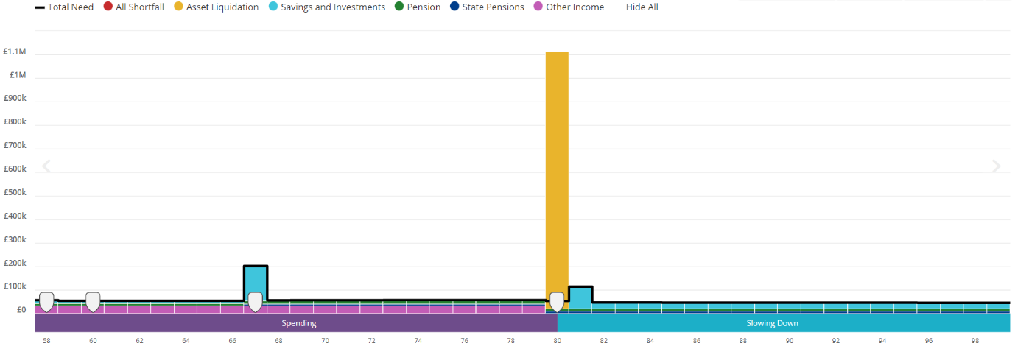

Scenario 1 – Current Situation – Liquid Assets
[DETAILED_NOTES]
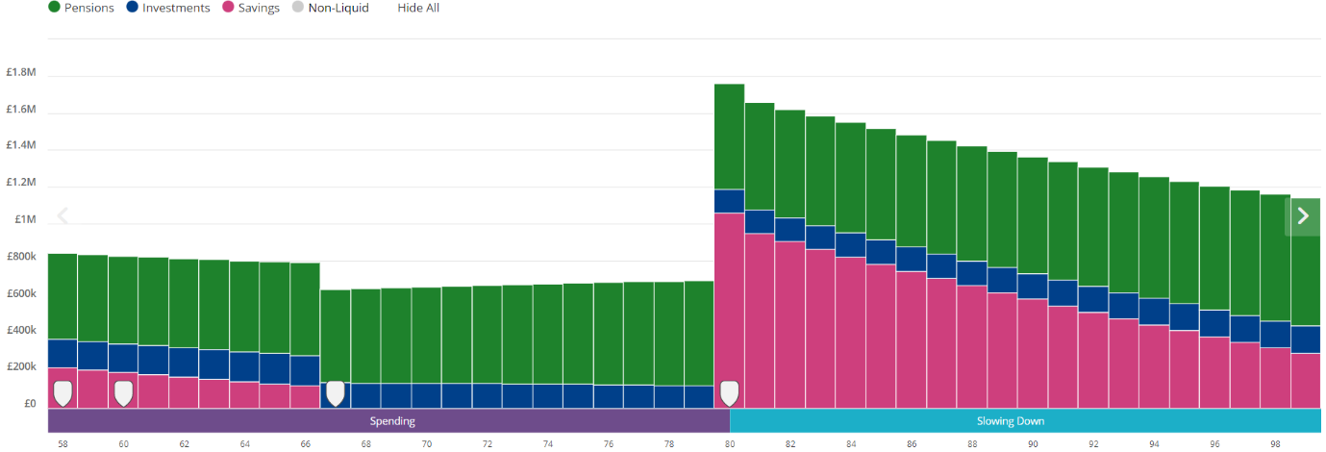

Scenario 2 – Sell Buy-to-Let Flat and Invest Proceeds - Cashflow
[NOTES][VALUE][INFO][DATE][DETAILS][NUMBER][DETAILED_NOTES]

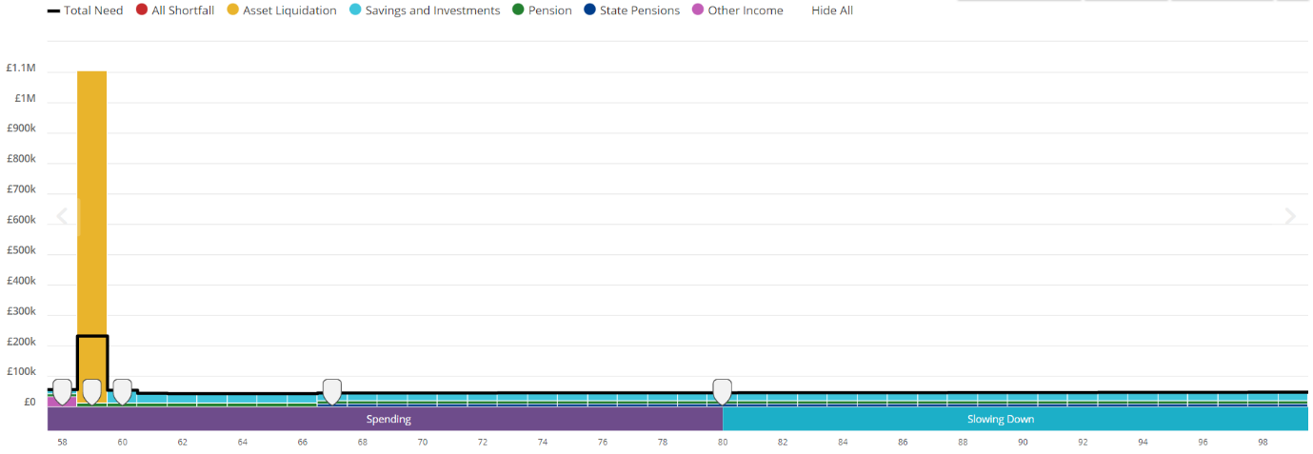

Scenario 2 – Sell Buy-to-Let Flat and Invest Proceeds – Liquid Assets

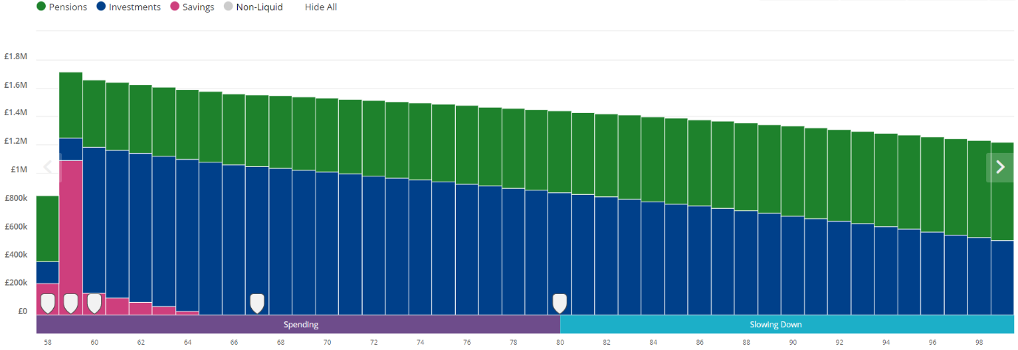

Scenario 3 – Sell Buy-to-Let Flat, Invest Proceeds & Extra Spending on ‘Wild Living’ - Cashflow
[NOTES][INFO][NUMBER][INFO][VALUE][DETAILED_NOTES]
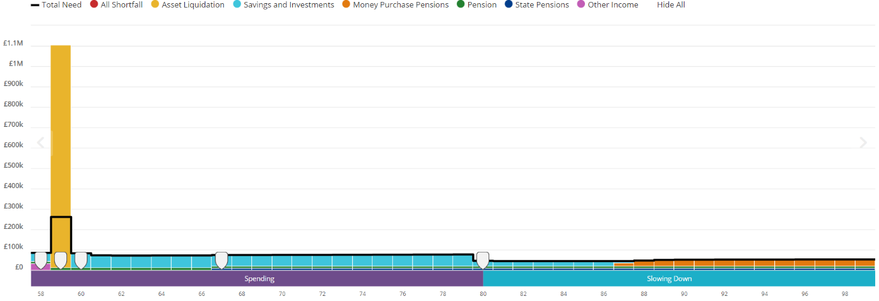

Scenario 3 – Sell Buy-to-Let Flat, Invest Proceeds & Extra Spending on ‘Wild Living’– Liquid Assets
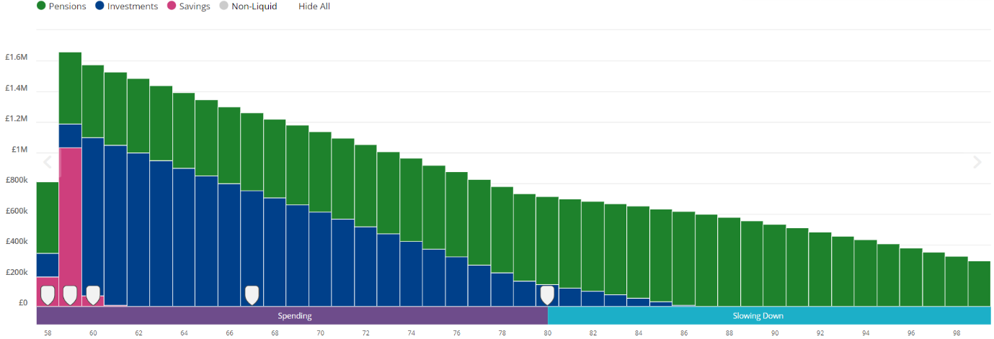

Scenario 4 – Major Loss, Followed by Selling BTL Flat and Investing Proceeds - Cashflow
[NOTES][AGE][PERCENTAGE][DATE][DETAILED_NOTES]

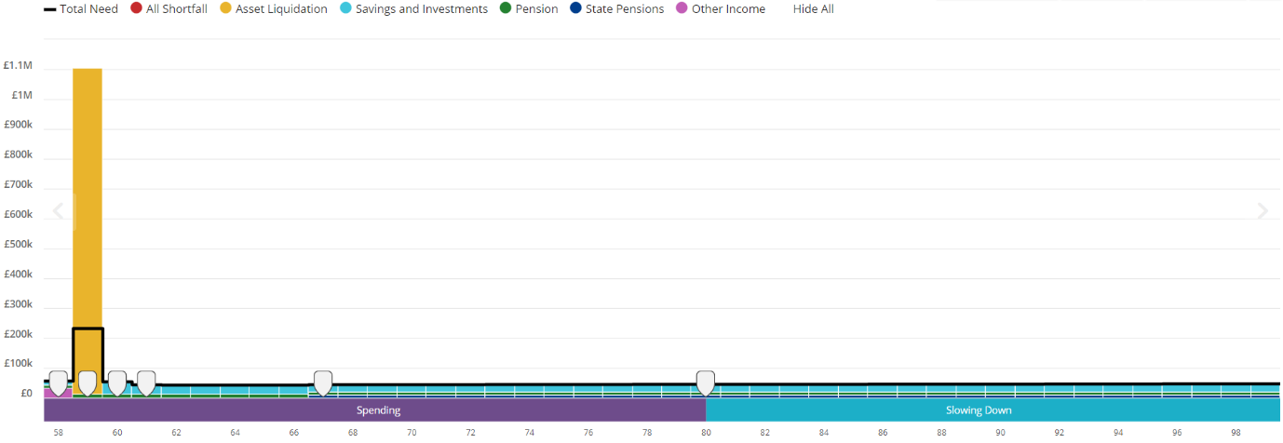

Scenario 4 – Major Loss, Followed by Selling BTL Flat and Investing Proceeds – Liquid Assets

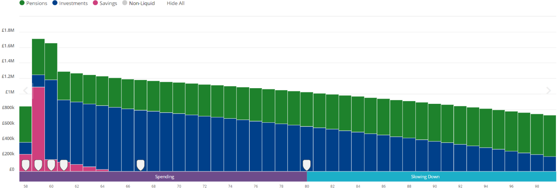

Key Observations
I have detailed the key observations which can be seen from these charts below:

Current Situation
[NUMBER]
[VALUE][DETAILS][INFO][NOTES][DETAILS][NUMBER][DETAILS]
[NUMBER]

[DETAILS]
[DATE]
[NUMBER]
[RETIREMENT_INFO][INFO][DETAILS][DETAILS][VALUE]
[DETAILS][DETAILS][DETAILS][NUMBER][VALUE][AGE][DETAILS][VALUE]

[NOTES]
[INFO][DETAILS][NUMBER]
[DETAILS][DETAILS][RETIREMENT_INFO][INFO][VALUE][NUMBER][DETAILS][DETAILS][INFO]
[NUMBER]

[DETAILS][INFO][DETAILS]
[PERCENTAGE]
[DETAILS][INFO][DATE]
[PERCENTAGE]
[NUMBER]

Conclusion
In summary, I feel the main conclusions of our cashflow planning exercise are as follows:

- [DETAILS][NUMBER]

- [INFO][PERCENTAGE][VALUE][DETAILS][VALUE]

It is important to understand that the cashflow forecasts are based on various assumptions we believe to be reasonable based on your current circumstances and currently available evidence. The projected figures are therefore not a guarantee of future outcomes.

The next section of my report sets out a review of your existing plans and confirms whether they remain suitable to meet your objectives and risk profile, as set out above.

Recommendations
I have reviewed the following plans to ensure they remain suitable for your objectives and risk profile. I refer you to the original suitability report that was issued at the time the plans were first set up for further information as to why they were initially recommended.

Recommendation Summary
[DETAILED_NOTES]

Recommendations
Following a review of your plans my recommendations are set out below together with the reasons behind these:

[INFO][INFO][NAME][VALUE][VALUE][NUMBER]
[DETAILS][NUMBER][DETAILS][INFO][NAME][VALUE][DATE][DETAILS][DETAILS][NOTES][VALUE]

[INFO][NAME][NUMBER]

[NOTES]
[DETAILED_NOTES]

[DETAILS][NAME][DETAILS][VALUE]
[NUMBER]

[NUMBER]

[DETAILED_NOTES][DETAILS]

[DETAILS][VALUE][AMOUNT]

[NUMBER][INFO][AMOUNT][INFO][DETAILS][NUMBER][VALUE][DETAILS][NUMBER][VALUE][DETAILS]

Reasons Why
The reasons why these recommendations meet your objectives:

- [DETAILS][NOTES]
[RETIREMENT_INFO][RETIREMENT_INFO]
[DETAILED_NOTES]

Disadvantages
The main disadvantages associated with these recommendations are:

- [NOTES]
[DETAILED_NOTES]

[DETAILS]
[DETAILED_NOTES]

What are the risks associated with your plans and/or our recommendations?

[NOTES]
[NOTES]
[NOTES]
[DETAILED_NOTES][VALUE]
[NOTES]
[DETAILED_NOTES]
[NOTES]
[INFO][INFO][DETAILED_NOTES]
[DETAILED_NOTES]
[DETAILED_NOTES]

Cash Account Minimum Balance
I recommend that you leave the following cash balances to provide for the fees associated with your plans:

[PERCENTAGE]
[PERCENTAGE][NUMBER][INFO]

An annual fee of 0.30% plus VAT will be levied against your account. The charge will be calculated and deducted from your account at the end of each calendar quarter and paid in arrears. This fee has been benchmarked against similar managed portfolio services available through AJ Bell and is competitive. This will be kept under review to ensure that we remain in line with our peers.

What Are The Charges

What are the costs associated with my recommendations?
The table below summarises the cost associated with your plans after the recommendations have been implemented. Some plans remain unchanged and so the table simply outlines the existing charge that applies.

 | Initial |  | Ongoing (per annum)
Adviser Fees | £ | % | £ | %
Fees paid direct from client | £0 | 0.00% | £0 | 0.00%
AJ Bell Investcentre SIPP | £0 | 0.00% | £3,200 | 0.68%
AJ Bell Investcentre ISA | £0 | 0.00% | £1,000 | 0.66%
AJ Bell Investcentre GIA | £0 | 0.00% | £0 | 0.00%
Subtotal | £0 | 0.00% | £4,200 | 0.68%
Platform Fees
AJ Bell Investcentre SIPP | £0 | 0.00% | £702 | 0.15%
AJ Bell Investcentre ISA | £0 | 0.00% | £226 | 0.15%
AJ Bell Investcentre GIA | £0 | 0.00% | £2 | 0.15%
Subtotal | £0 | 0.00% | £930 | 0.15%
Investment Fees
AJ Bell Investcentre SIPP | £0 | 0.00% | £4,982 | 1.06%
AJ Bell Investcentre ISA | £0 | 0.00% | £1,601 | 1.06%
AJ Bell Investcentre GIA | £0 | 0.00% | £0 | 0.00%
Subtotal | £0 | 0.00% | £6,583 | 1.06%
Grand Total | £0 | 0.00% | £11,713 | 1.89%

[NUMBER][INFO][NUMBER]

[NUMBER]

Please note that this is only a projection and not a guarantee of the charges to be levied. This does not account for any withdrawals or contributions that you make over the upcoming year.

[INFO] will send you an annual Costs and Charges Statement around April/May each year. This will confirm the actual costs and charges deducted within each of your accounts held on the [DETAILS] for the previous calendar year, broken down between platform, investment and adviser costs.

Please note the figures in the above table are as at 18th January 2023 and due to the timing of the valuations used these may differ to the figures elsewhere in the report. Furthermore, due to rounding, the amounts and percentages may not add up precisely or reflect the absolute figures.

The effect of costs and charges on your returns
The above illustration is based on the amount you have invested and the charges that apply to the products and services today. The investment performance is not guaranteed, and the value of your investments can go down as well as up.

These figures are only examples and are not guaranteed - they are not minimum or maximum amounts. What you get back depends on how your investments grow, the tax treatment of the fund and your own tax position. You could get back more or less than the figures shown. You may get back less than the amount you have paid in.

Review of our service
As you know, AAI is a fee-based practice. We set our charges by looking at the amount of time it will take us to provide the advice and service, the complexity of the work and the risk associated with the advice that we are giving.

You have already signed our Service and Fee Agreement which confirms the fees we will charge and the service we provide, but for clarity, our ongoing fee as is as follows:

Ongoing Advice Fees | [VALUE][NUMBER][VALUE][VALUE] | [AMOUNT]

Other Areas of Planning

Wills
The main purpose of writing a will is to ensure that, upon death, your estate is passed to the people you want to benefit from it. It also makes the distribution of your assets simpler, reducing the stress and financial hardship that may fall upon your family and loved ones.

[DETAILS][INFO][DETAILED_NOTES]

Lasting Power of Attorney
A Lasting Power of Attorney (LPA) ensures your health and financial affairs will be looked after by someone you trust if you cannot manage this yourself.

[DETAILS][INFO][DETAILS][DETAILED_NOTES][NOTES]

Inheritance Tax Planning
Inheritance Tax (IHT) is payable on death at a rate of 40% by those whose personal estates exceed £325,000. There is also a ‘Residence’ Nil Rate Band, which applies when you gift your main residence to direct descendants, and this will draw a further £175,000 (for 2022/23) out of the calculation if your estate is under £2m. Above this amount, the allowance tapers down at £1 for every £2 of net estate.

[DETAILS][INFO][DETAILED_NOTES]

Long Term Care Planning (2022/23)
The average cost of a care home place in the UK is about £36,608 a year, rising to £46,176 if nursing care is required. This is likely to be significantly more if you live in the South East of England.

[DETAILED_NOTES]

[DETAILED_NOTES]

Next Steps
The next steps and actions required are as follows:

- Please review this report and come back to me with any questions or comments.

- The following documents are referred to elsewhere in the report and should be kept for your records:

Appendix - Risk Profile Assessment

Your understanding of the risks involved in investing
It is important that when making decisions in relation to your financial planning you are aware of and fully understand the potential risks involved. The three key risks associated with investing are:

Capital risk – not getting back as much of your money you originally invested or losing some of the return already achieved.
Income risk – where you are investing for income, the risk that the income level achieved is less than you had expected.
Liquidity risk – not being able to get your money back when you need or want it.

When making an investment and during the time you hold it you need to take account of these risks and the consequences they may have on the achievement of your objectives. To determine an appropriate investment strategy for you, we consider the following five points in relation to your risk profile:

1. Risk required
We have talked with you to understand your goals, current and anticipated income and expenses, and current and anticipated assets and liabilities. We have discussed the return needed to meet your future cash flow needs.

2. Risk capacity
Your risk capacity (or capacity for loss) refers to your ability to manage financially if a loss occurs. This was considered during our discussions and our assessment of your financial position (including a review of your income, expenditure, assets and liabilities). We discussed the effect the loss of any invested capital would have in relation to your standard of living and/or your future objectives.

3. Risk tolerance
Unlike risk required and risk capacity, which are financial calculations, risk tolerance is psychological. Risk tolerance is how you feel about taking risk. For example, you may say that it is very important that your investments maintain their purchasing power or that any fall in the value of your investments would make you feel uncomfortable. We asked you to complete a questionnaire as a starting point to assess your risk tolerance, and discussed any inconsistences in the answers you gave to establish your natural inclination to take investment risk

4. Time Horizon
The level of risk you take is dependent on how long you are able to invest your money for. Generally speaking, the longer you can invest for, the more time you have to recover any capital losses. It is therefore important that the chosen risk profile reflects the timeframe for investment.

5. Your knowledge & experience of financial products
Knowledge and experience is about assessing what your previous experience has been in respect of financial products and investments. For example, we consider what financial products you have previously purchased and whether you have done this having received advice or whether you acted on your own. This helps us to assess your understanding of financial products and investments and the risks involved in any proposed recommendations.

Risk Descriptions
We use five different descriptions to categorise your risk profile once assessed. I have noted these below for reference:

Cautious - You are prepared to take only a small amount of investment risk and it is important to you that your capital is protected. This means that your portfolio will concentrate on investments which provide low returns in the long term but present less risk to your capital. Only a small proportion of riskier assets will be included in your portfolio in order to increase the chance of obtaining better long term returns. A typical Cautious investor will be invested mostly in fixed interest type investments, with a small element (up to about one third) in equities and property which can boost longer term returns but are associated with more risk. The range of assets provides diversification benefits which also help to reduce the overall risk.

Moderately Cautious - You are prepared to take a limited investment risk in order to increase the chances of achieving a positive return but you only want to risk a small part of your capital to achieve this. A typical Moderately Cautious portfolio will have up to half invested in fixed interest products which are low risk but have low returns. The remainder of the portfolio will be invested in equities and property which can boost longer term returns but are associated with more risk. The range of assets provides diversification benefits which also help to reduce the overall risk.

Moderate - You are prepared to take a moderate amount of investment risk in order to increase the chance of achieving a positive return. Capital protection is less important to you than achieving a better long term return on the investment. A typical moderate investor will usually invest in a variety of assets to obtain diversification. There would typically be a higher proportion of equities and property assets compared to fixed interest. The range of asset types helps reduce the overall risks as well as increasing the chance of better returns.

Moderately Adventurous - You are prepared to take an above average degree of risk with your investments in return for the prospect of improving longer term investment performance. Short term capital protection is not important to you and you are willing to sacrifice some long-term protection for the likelihood of greater returns. A typical Moderately Adventurous investor will be invested mainly in equities but with other assets included to provide some diversification. There will be a higher proportion of overseas equity within the portfolio.

Adventurous - You are prepared to take a substantial degree of risk with your investments in return for the prospect of the highest possible longer term performance. You appreciate that over some periods of time there can be significant falls, as well as rises, in the value of your investment and you may get back less than you invest. This strategy holds significant risk in the shorter term. A typical Adventurous investor will be invested almost entirely in equities, both in the UK and overseas, with a small core holding in property assets to provide some limited diversification. There may be a significant proportion of the investment in overseas and specialised equities.

Appendix - Your Existing Plans
The tables below provide a summary of your existing plans. These were discussed in our Annual Review meeting in terms of their performance and whether they meet your preferences and needs.

Stacey Shipman AJ Bell Investcentre
Account Type | [VALUE]
Plan Number | [INFO]

Fund | Holding | Value
[INFO][DETAILS][VALUE] | [PERCENTAGE] | [AMOUNT]
[NAME][NAME][VALUE] | [PERCENTAGE] | [AMOUNT]
[DETAILS][VALUE][VALUE] | [PERCENTAGE] | [AMOUNT]
[NAME][NAME][VALUE][VALUE] | [PERCENTAGE] | [AMOUNT]
[DETAILS][VALUE] | [PERCENTAGE] | [AMOUNT]
[VALUE][NAME][VALUE][VALUE] | [PERCENTAGE] | [AMOUNT]
[INFO][VALUE] | [PERCENTAGE] | [AMOUNT]
[DETAILS][VALUE] | [PERCENTAGE] | [AMOUNT]
[DETAILS] | [PERCENTAGE] | [AMOUNT]
[NAME][INFO][VALUE] | [PERCENTAGE] | [AMOUNT]
[INFO][NAME][VALUE][INFO] | [PERCENTAGE] | [AMOUNT]
[INFO][VALUE][VALUE][VALUE] | [PERCENTAGE] | [AMOUNT]
[DETAILS][VALUE] | [PERCENTAGE] | [AMOUNT]
[DETAILS][VALUE] | [PERCENTAGE] | [AMOUNT]
[DETAILS] | [PERCENTAGE] | [AMOUNT]
[VALUE][VALUE][VALUE][VALUE][INFO][VALUE][VALUE][VALUE] | [PERCENTAGE] | [AMOUNT]
[DETAILS][VALUE] | [PERCENTAGE] | [AMOUNT]
[DETAILS] | [PERCENTAGE] | [AMOUNT]
[NAME][NAME][VALUE][NAME][VALUE] | [PERCENTAGE] | [AMOUNT]
[NAME][NAME][VALUE][NAME][VALUE] | [PERCENTAGE] | [AMOUNT]
[DETAILS][VALUE][VALUE] | [PERCENTAGE] | [AMOUNT]
[NAME][DETAILS][VALUE][VALUE] | [PERCENTAGE] | [AMOUNT]
[DETAILS] | [PERCENTAGE] | [AMOUNT]
[NAME][NAME][VALUE] | [PERCENTAGE] | [AMOUNT]
[NAME] | [PERCENTAGE] | [AMOUNT]
Fund values as at 10/03/2023.

[NAME][VALUE][NAME][INFO][NAME]
Account Type | [VALUE]
Plan Number | [INFO]

Fund | Holding | Value
[INFO][DETAILS][VALUE] | [PERCENTAGE] | [AMOUNT]
[NAME][NAME][VALUE] | [PERCENTAGE] | [AMOUNT]
[DETAILS][VALUE][VALUE] | [PERCENTAGE] | [AMOUNT]
[NAME][NAME][VALUE][VALUE] | [PERCENTAGE] | [AMOUNT]
[DETAILS][VALUE] | [PERCENTAGE] | [AMOUNT]
[VALUE][NAME][VALUE][VALUE] | [PERCENTAGE] | [AMOUNT]
[INFO][VALUE] | [PERCENTAGE] | [AMOUNT]
[DETAILS][VALUE] | [PERCENTAGE] | [AMOUNT]
[DETAILS] | [PERCENTAGE] | [AMOUNT]
[NAME][INFO][VALUE] | [PERCENTAGE] | [AMOUNT]
[NAME][DETAILS] | [PERCENTAGE] | [AMOUNT]
[INFO][NAME][VALUE][INFO] | [PERCENTAGE] | [AMOUNT]
[INFO][VALUE][VALUE][VALUE] | [PERCENTAGE] | [AMOUNT]
[DETAILS][VALUE] | [PERCENTAGE] | [AMOUNT]
[DETAILS][VALUE] | [PERCENTAGE] | [AMOUNT]
[DETAILS] | [PERCENTAGE] | [AMOUNT]
[VALUE][VALUE][VALUE][VALUE][INFO][VALUE][VALUE][VALUE] | [PERCENTAGE] | [AMOUNT]
[DETAILS][VALUE] | [PERCENTAGE] | [AMOUNT]
[DETAILS] | [PERCENTAGE] | [AMOUNT]
[NAME][NAME][VALUE][NAME][VALUE] | [PERCENTAGE] | [AMOUNT]
[NAME][NAME][VALUE][NAME][VALUE] | [PERCENTAGE] | [AMOUNT]
[DETAILS][VALUE][VALUE] | [PERCENTAGE] | [AMOUNT]
[NAME][DETAILS][VALUE][VALUE] | [PERCENTAGE] | [AMOUNT]
[DETAILS] | [PERCENTAGE] | [AMOUNT]
[NAME][NAME][VALUE] | [PERCENTAGE] | [AMOUNT]
[NAME] | [PERCENTAGE] | [AMOUNT]
Fund values as at 10/03/2023.

[NAME][VALUE][NAME][INFO][NAME]
Account Type | [DETAILS]
Plan Number | [INFO]

Fund | Holding | Value
Funds&SharesCash | [PERCENTAGE] | [AMOUNT]
Total: | [PERCENTAGE] | [AMOUNT]
Fund values as at 10/03/2023.

Expression of Wish
Since the 6th April 2015, the flexibility and tax treatment of death benefits from UK-registered pension schemes has evolved for the better making it essential for the nomination of beneficiaries to be considered closely in conjunction with the new regime.

In summary, the tax treatment is as follows:

- On death before age 75, benefits can now be paid as a lump-sum or as a drawdown pension to any beneficiary tax-free, irrespective of whether these benefits derived from uncrystallised or crystallised funds.

- On death after age 75, the benefits can be drawn as an income or a lump sum at the beneficiary’s marginal rate of Income Tax.

The rules allow for any beneficiary to elect for either income or a lump sum; an obvious advantage being that any remaining funds following the death of the first beneficiary may be passed on to further nominated beneficiaries. Theoretically, this allows for the fund to be continually preserved through multiple generations until exhausted.

The decision regarding who you would like to benefit can be changed at any time with a subsequent expression of wish form, superseding any previous nomination.

Appendix - Product Information
We have selected tax wrappers or financial products based on your tax position and unused allowances, and objectives including timescales. Our choice of product and provider on your behalf is based on independent research which we maintain centrally and is kept on file.

Financial Services Compensation Scheme (‘FSCS’)
Any UK regulated savings or current account (including Cash ISAs) held in banks, building societies or credit unions are covered by the Government backed Financial Services Compensations Scheme (FSCS). If the organisation holding your cash savings should fail, each individual would be entitled to £85,000 compensation per person, per financial institution. It is, therefore, advisable not to hold more than this amount with one banking institution.

You should also bear in mind that some banking institutions may have a number of banks within their organisation with only one licence covering all banks.

The FSCS will also provide a £1 million protection limit for temporary high balances held with your bank, building society or credit union if it fails. Further details can be found at www.fscs.org.uk.

Investments
If you need to grow your money over the medium to long term, and once you’ve got an adequate emergency cash reserve in place, you will probably need to consider some type of investment. Investments differ from cash savings in that they provide higher returns in exchange for the risk of capital loss.

Recommended Product – What is an Individual Savings Account (ISA)?
The Individual Savings Account (ISA) is a tax-free savings account which means there is no liability to Income or Capital Gains Tax within the wrapper or upon encashment.

ISA savers will be able to subscribe the full amount to a cash account and will be able to transfer their investment from a ‘Stocks & Shares’ wrapper to a ‘Cash’ wrapper and vice versa.

Recommended Product – What is a General Investment Account (GIA)?
A GIA operates in a similar way to an ISA, but without the tax-free environment. It is simply an investment account which holds unit trusts/OEICs directly, rather than within an ISA wrapper.

Any withdrawals of capital from the account are potentially liable to capital gains tax. However, each individual has an annual allowance of £12,300 (for the 2022/23 tax year), meaning a gain of £12,300 can be made before any potential tax liability. This is an important annual allowance. Any natural income received from a GIA would be chargeable to income tax in the normal way.

An advantage of a GIA is that the fund can easily be transferred into an ISA by way of a Bed & ISA transaction in future years. As a result, any gains within the portfolio are likely to be within the capital gains allowance should the gains are realised on an annual basis.

Pensions
What is a Self-Invested Personal Pension?
A SIPP is a tax efficient investment vehicle used to provide benefits in retirement. A SIPP is a personal pension plan set up by an insurance company or specialist SIPP operator where the member has greater control over the investments. Anyone can take out a SIPP providing they meet the provider's eligibility requirements. These are usually based on a minimum fund size because of the higher costs involved in running a SIPP compared to a standard personal pension. Other features include:

The option to invest in both non-insured assets such as unit trusts and commercial property and insured assets such as a trustee investment plan.
The member's employer can contribute to the plan and may operate payroll deduction on the member's behalf.
The ability to lend to a company where members are directors or shareholders.
The ability to invest in any commercial property including one held by the SIPP member.
The ability to borrow up to 50% of its net assets to fund a property purchase.
The ability to invest up to 70% of the pension fund in any company if acceptable to the SIPP provider. However, tax charges may be applied if the company is controlled by a member or an associated person.

Retirement Options
When you start to take any benefits from your pension you typically have a number of options. The main ones are summarised below:

[DETAILS][INFO][NAME]
[PERCENTAGE]

[DETAILS]
[DETAILED_NOTES]

[DETAILS]
[DETAILED_NOTES]

[DETAILS]
[PERCENTAGE]

