About the conference
The National Conference on Advances in Plant and Environmental Interactions (APEI–2025) aims to provide a dynamic platform for researchers, academicians, and students to share recent insights into how plants perceive, respond, and adapt to their ever-changing environment. The conference will focus on the multifaceted interactions between plants and environmental factors—including biotic and abiotic stresses, climate change, soil–plant–microbe dynamics, and sustainable agricultural practices. By integrating perspectives from plant physiology, molecular biology, ecology, and biotechnology, the event seeks to foster interdisciplinary discussions that can inform future strategies for enhancing crop productivity and ecosystem resilience. The program will feature keynote lectures by eminent scientists, invited talks, oral and poster presentations, and interactive sessions to encourage collaboration and idea exchange among participants from diverse domains of plant and environmental sciences.

Thematic areas:
- Plant-environment interactions
- Developmental biology
- Genomics and Epigenetics
- Metabolomics and metabolic engineering
- Microbiology and phycology
- Molecular Breeding and Physiology
Focus points
- Keynote lectures
- Invited research presentations
- Poster session
- interactive discussions
Through these various activities the conference aims to deepen our understanding on how plants and environment interact with each other and shape the life on the planet.

About the department

The department of plant Sciences, university of Hyderabad is globally known for imparting high-quality teaching and research in the frontier areas of plant sciences and microbiology. It been supported under UGC Special Assistance Programme and the DST-Funds for Infrastructure in Science and Technology (FIST) Level-II and is marching towards achieving the status of the UGC Centre for Advanced Studies. The foundations for the rapid growth of the Department over the years have been laid with its philosophy to provide a well-balanced training to the students in modern Plant Sciences to enable them to choose careers in both advanced teaching and high quality research. The Department offers Masters in Plant Biology and Biology and Biotechnology and Molecular Biology (in collaboration with sister Departments) and Ph.D. in Plant Sciences besides being actively associated with teaching of Masters in Biotechnology, Integrated Masters of Science in Systems Biology, and M.Tech Bioinformatics programmes of the School of Life Sciences. One of the regular features of the Department is to host distinguished scholars from abroad for short duration under the international exchange programmes. The individual research laboratories are well equipped, apart from the availability of major equipment in central facilities of the Department, sister Departments in the School, and also at Central Instrumentation Lab of the University.

About the University of Hyderabad

The University of Hyderabad (UoH), also known as Hyderabad Central University, is a premier public central university located in Gachibowli, Hyderabad, and Telangana. Established in 1974 by an Act of Parliament, UoH is recognized as an Institution of Eminence (IoE) by the Government of India in 2019.
For further information, please visit our webpage: www.uohyd.ac.in
For the School of Life Sciences: www.sls.uohyd.ac.in

Chief Patron Patrons
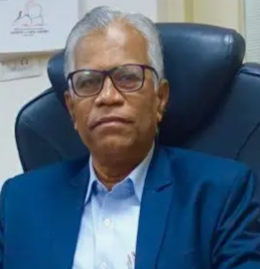


Prof. B. J. Rao Prof. Anand Kumar Kondapi
Dean, School of Life Sciences
University of Hyderabad
Vice Chancellor
University of Hyderabad Convener



Prof.Ragiba Makandar
Head, Department of Plant Sciences

Advisory Board


Ch. Venkataramana Appa Rao Podile AS Raghavendra

Speakers

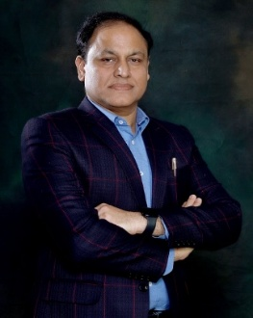
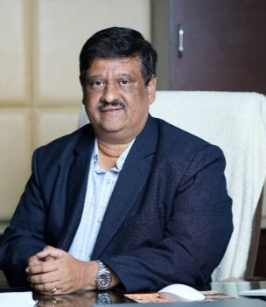
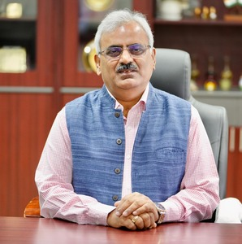

S. Venkata Mohan Prabodh Kumar Trivedi Ashwani Pareek

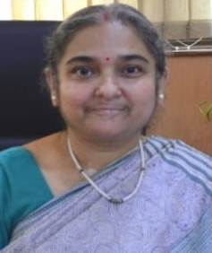


Subhra Chakraborty

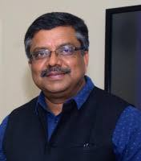
Alok Kr Sinha Anjan Banerjee Manjula Reddy
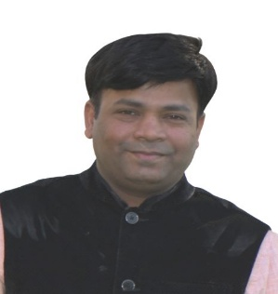

Jagadish Gupta Kapuganti

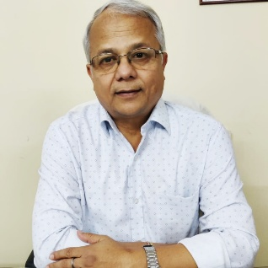
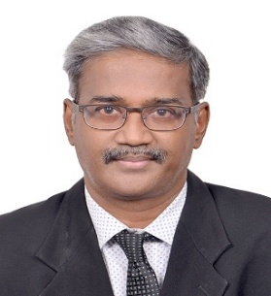
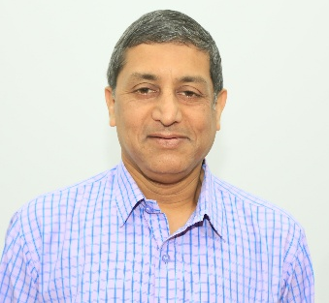

Bidyut Sarmah A.P. Sane Amalraj Ramesh Sundar


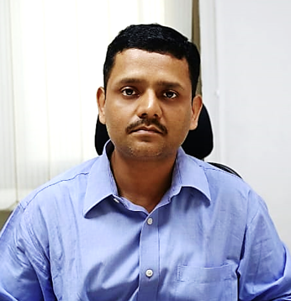
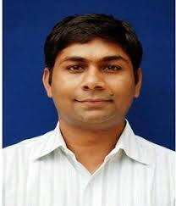

Samir V sawant Satendra Mangrauthia Swaroop K. Parida

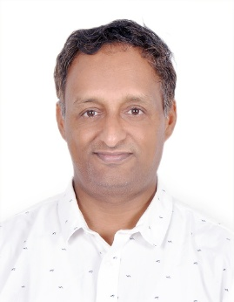
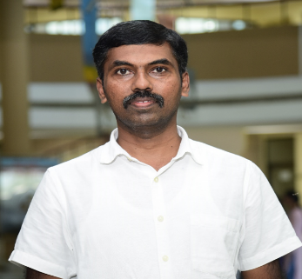

Senthil Kumar-Muthappa Nataraja Karaba Nalkur Vinita Gowda

Important Dates
- Registration opens: December 7, 2025
- Abstract submission opens: December 7, 2025
- Abstract submission closes: January 31, 2026
- Abstract results: February 15, 2026
- Registration closes: January 31, 2026
- Payment gateway opens: December 1, 2025

Registration Fees
- Students : 3000 INR
- Faculties : 4000 INR
- Industry Persons : 6000 INR

Note: GST (18%) is applicable as per Govt norms.

What's Included in Your Registration
- Conference materials and welcome kit
- Access to all conference sessions
- Conference dinner
- Food and drinks during coffee breaks
- Lunches for all conference days

Click here for registration and abstract submission ( Ihave sent you separate file)

Payment link and guidelines :--------------------( see separate file attached))
Abstract submission:
Guide lines:
- The abstract of the paper should be between 300-400 words with Times New Roman, Size 12, Regular and Single Line Spacing
- The abstract must indicate: Title of paper, name(s) of author(s), affiliation(s), and contact details, purpose of study, research methodology, results, conclusion, key words
- The presenting author name should be underlined and email of both presenting author and corresponding author should be provided
- Abstract must be submitting online only
Accommodation: Limited guest house/hostel accommodation for students available on payment basis on first come first service. Contact person: Prof. Rahul Kumar, email id: rksl@uohyd.ac.in
Space for abstract submission needs to be given

ORGANIZING TEAM

Padmaja Gudipalli

Rajagopal Subramanyam

Sreenivasulu Yelam

Santosh R Kanade

Irfan Ahmad Ghazi

Y. Sreelakshmi

Rahul Kumar

Gopinath Kodetham

Jogi Madhuprakash

M Muthamilarasan

Siddharthan S

Organizing Secretaries

Sribash Roy

Vadivelmurugan Irulappan

Venue
SLS Auditorium
Department of Plant Science, School of Life Sciences
University of Hyderabad
Telangana Hyderabad
500046

