

End Semester Examinations - 2024-2025-JD24_REGULAR Hall Ticket

Student Name | DONTHULA NAVEEN | 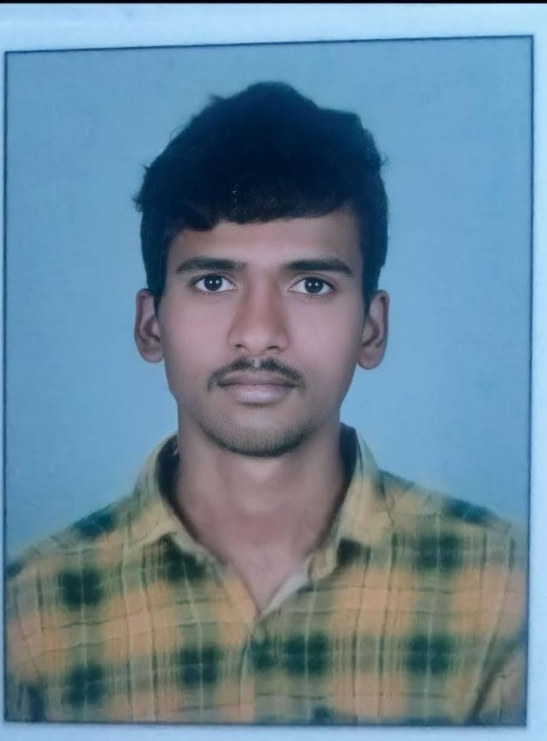
Enrolment Number | 23LPMS10
Programme | MSPB : Master of Science (Plant Biology and Biotechnology)
Semester | 3 | 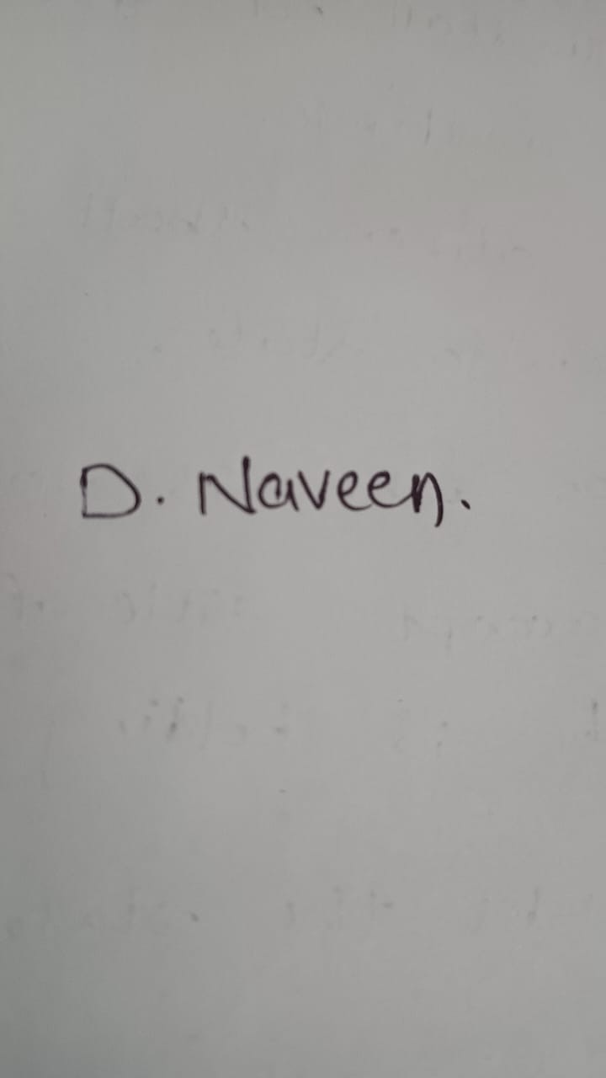

The Student is advised to refer to the Exam Time Table issued by the School/ Department /Centre to know the Date, Time & Venue of the Exam.

Sl.No. | COURSE CODE | COURSE NAME | TERM
1 | PB501 | GENOMICS | 3
2 | PB502 | PROTEOMICS | 3
3 | PB503 | Plant Physiology | 3
4 | PB504 | PLANT SYSTAMATICS | 3
5 | PB505 | PRACTICALS | 3
6 | PB506 | SECONDARY PLANT PRODUCTS AND METABOLIC ENGINEERING | 3

7 | PB521 | Molecular Plant Breeding | 3
8 | PB527 | CONSERVATION BIOLOGY | 3

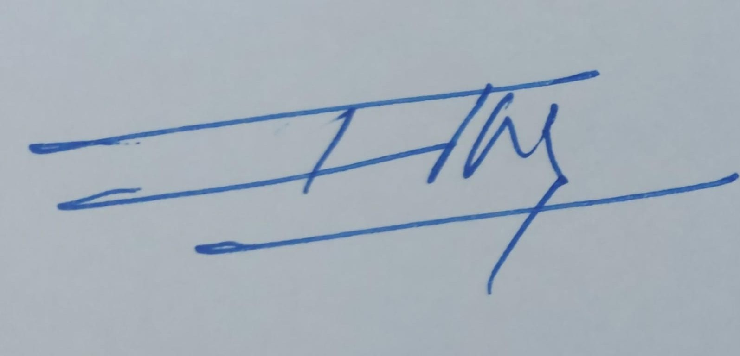
Controller of Examinations I/c
Instructions:
- This candidate has registered for the Semester.
- Admission to examination hall is subject to student fulﬁlling prescribed percentage of attendance.
- The candidate shall not pssess in the examination hall, any paper, note book, programmable calculators, cell phones, pager, palm computers or any other form of material (in any forma) concerned with or related to the subject of the examination (theory or practical) in which he is appearing but has not made us of (material shall include any marks in any format diagrams, clues, writing) on the body of the candidate which can be used as an aid in the subject of examination.
- The Candidate shall not give assistance or guidance or receive it from any other candidate orally or by any body language methods or communicate through any means with any candidate or persons in or outside the exams hall in respect of any matter.
- The candidate shall not impersonate any other candidate in connection with the examination.

The Student shall abide to the malpracties (Prevention and disciplinary action) rules made available in the website of the University of Hyderabad : acad.uohyd.ac.in

22-11-2024 12:00:48

