ASSIGNMENT
NAME – RIYA KUMARI
TOPIC- CRISPR CAS SYSTEM
ROLL N0- 21/4611, 21081564033
SUBJECT- ADVANCES IN MICROBIOLOGY
COURSE- BSc (H) Microbiology ,
3rd year , VI SEMESTER
SUBMITTED TO- DR SUNIL KUMAR SRIVASTAVA
GENERAL INTRODUCTION

CRISPR refers to clustered regulatory Interspaced short palindromic repeats.
An CRISPR array consists of 30 palindromic repeats separated by spacer of 36 bases.
RNA transcribed by CRISPR array is called cr RNA which along with Cas protein can be used for genome editing which nowdays is widely used.
CRISPR CAS SYSTEM

HISTORY

- The discovery of clustered DNA repeats took place independently in three parts of the world. The first description of what would later be called CRISPR is from Osaka University researcher Yoshizumi Ishino and his colleagues in 1987. They accidentally cloned part of a CRISPR sequence together with the "iap" gene (isozyme conversion of alkaline phosphatase) from the genome of Escherichia coli which was their target. The organization of the repeats was unusual. Repeated sequences are typically arranged consecutively, without interspersing different sequences.

- Francisco Mojica at the University of Alicante in Spain studied repeats observed in the archaeal organisms of Haloferax and Haloarcula species and their function.

- In 2001, Mojica and Ruud Jansen, who were searching for an additional interrupted repeats, proposed the acronym CRISPR (Clustered Regularly Interspaced Short Palindromic Repeats) to alleviate the confusion stemming from the numerous acronyms used to describe the sequences in the scientific literature.

- In 2002, Tang, et al. showed evidence that CRISPR repeat regions from the genome of Archaeoglobus fulgidus were transcribed into the long RNA molecules that were subsequently processed into unit-length small RNAs, plus some longer forms of 2, 3, or more spacer-repeat units.

- In 2005, yogurt researcher Rodolphe Barrangou discovered that Streptococcus thermophilus, after iterative phage challenges, develops increased phage resistance, and this enhanced resistance is due to the incorporation of additional CRISPR spacer sequences. The Danish food company Danisco, which at that time Barrangou worked for, then developed phage-resistant S. thermophilus strains for use in yogurt production. Danisco was later bought out by DuPont, which "owns about 50 percent of the global dairy culture market" and the technology went mainstream.

- In 2007, the first experimental evidence that CRISPR was an adaptive immune system was published. A CRISPR region in Streptococcus thermophilus acquired spacers from the DNA of an infecting bacteriophage. The researchers manipulated the resistance of S. thermophilus to different types of phages by adding and deleting spacers whose sequence matched those found in the tested phages.

- In 2008, Brouns and Van der Oost identified a complex of Cas proteins (called Cascade) that in E. coli cut the CRISPR RNA precursor within the repeats into mature spacer-containing RNA molecules called CRISPR RNA (crRNA), which remained bound to the protein complex.

- A 2010 study showed that CRISPR-Cas cuts both strands of phage and plasmid DNA in S. thermophilus.

- In 2012, Jennifer Doudna and Emmanuelle Charpentier re-engineered the Cas9 endonuclease into a more manageable two-component system by fusing the two RNA molecules into a "single-guide RNA" that, when combined with Cas9, could find and cut the DNA target specified by the guide RNA. This contribution was so significant that it was recognized by the Nobel Prize in Chemistry in 2020.

- Another group of collaborators comprising Virginijus Šikšnys together with Gasiūnas, Barrangou, and Horvath showed that Cas9 from the S. thermophilus CRISPR system can also be reprogrammed to target a site of their choosing by changing the sequence of its crRNA.

- Groups led by Feng Zhang and George Church simultaneously published descriptions of genome editing in human cell cultures using CRISPR-Cas9 for the first time. It has since been used in a wide range of organisms, including baker's yeast (Saccharomyces cerevisiae), the opportunistic pathogen Candida albicans, zebrafish (Danio rerio), fruit flies (Drosophila melanogaster), ants (Harpegnathos saltator^{[54]} and Ooceraea biroi), mosquitoes (Aedes aegypti), nematodes (Caenorhabditis elegans), plants, mice (Mus musculus domesticus), monkeys and human embryos.

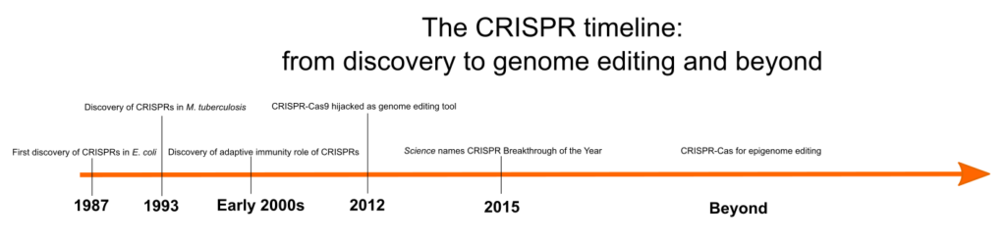

A timeline of key CRISPR developments. (Image Credit: Laura Grassie.)

TYPES

The CRISPR-Cas system can be classified into two main categories according to the effectors: first, where all functionalities in the effector complexes are carried out using a protein, and second, the multi-unit effector complexes. These two classes are further divided into six types of CRISPR-Cas systems
according to the presence of the signature genes. In type I systems, the signature protein is Cas3, in which the cleavage of the external DNA is carried out by the
nuclease and helicase domains, and the recognition of the target sequence is made by the multi-protein-crRNA complex Cascade.
In type II systems, the unique protein required for the interference is Cas9 (signature protein).
In type III systems, the signature gene is cas10, a gene encoding a multidomain protein (Cas10) that is
assembled into an interference complex needed for the identification and cleavage of the target sequence.
Type IV systems are usually not linked to a CRISPR array.
The effector complex is represented by Csf1 (csf1 being considered the signature gene) and the other two proteins by cas genes.

Type V systems comprise a unique Cas9-like nuclease, which can be Cpf1, C2c1, or C2c3 according to the subtype of the CRISPR/Cas type V system.

In type VI systems, the protein C2c2 with two
HEPN RNase domains is the signature protein . All these systems are classified as either Class1 systems (Type I, III, IV) as they have a multi-subunit effector or as Class 2 systems (Type II, V, VI) as they are characterized by
a single-subunit effector. Table illustrates a brief classification and characterization of the CSISPR/Cas systems.
Class | System type |  | Target for cleavage |  | Effector |  | Nuclease domain
I | I III IV |  | DNA DNA/RNA DNA |  | Cas proteins – Cas3, Cas5-Cas8, Cas10, and Cas11 |  | HD fused to Cas3 HD fused to Cas10 Unknown
II | II |  | DNA |  | Cas9 |  | RuvC and HNH
 |  | V DNA |  | Cas12a/b/c |  | RuvC and Nuc
 |  | VI RNA |  | Cas13a/b/c |  | HEPN domains

HD – Histidine-aspartate domain; HEPN – Higher eukaryotes and prokaryotes nucleotide binding domain

Table 1. Overview of classification and characteristics of CRISPR/Cas systems (Shmakov et al. 2017, Pyzocha and Chen 2018, Makarova et al. 2020, Perez Rojo et al. 2018, Tamulaitis et al. 2017)

MECHANISM OF ACTION

The defense response generated by the CRISPR-Cas system consists of three points, which are as follows: adaptation, expression and maturation, and interference.
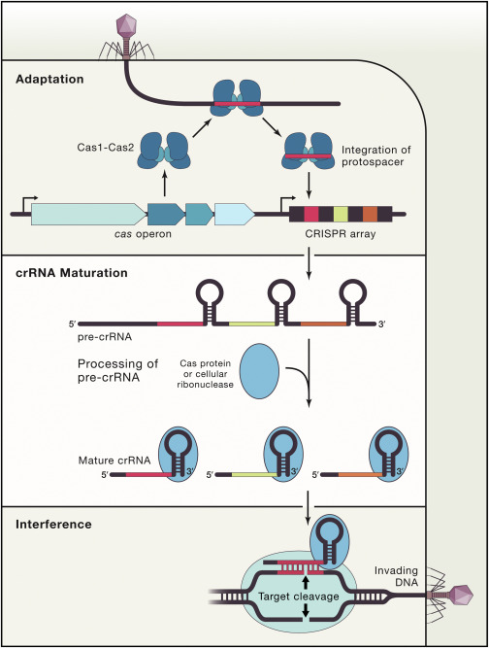
https://www.google.com/url?sa=i&url=https%3A%2F%2Fwww.sciencedirect.com%2Fscience%2Farticle%2Fpii%2FS0092867417313831&psig=AOvVaw0OUbaU1HxROoOKwKmgZKsn&ust=1714597045479000&source=images&cd=vfe&opi=89978449&ved=0CBIQjRxqFwoTCJDF4vHp6oUDFQAAAAAdAAAAABAJ
In the adaptation step, a complex of Cas proteins is responsible for the identification of the target sequence in the DNA (protospacer-adjacent motif – PAM), binding, and the generation of double-strand breaks in this sequence. This target DNA releases a short sequence that will be acquired by the CRISPR array as a ‘spacer’.

The expression step consists of the transcription of the CRISPR array into a precursor RNA that is further processed by the Cas proteins and other accessory factors into smaller entities of RNA – CRISPR RNAs (crRNAs) that, together with the Cas proteins, form the Cas-crRNA complex.

The last step – the interference – includes the action of the Cas-crRNA complex to recognize and cleave the invading nucleic acid.

-Depending on the type of CRISPR-Cas system, there are particular stages of expression and interference. In the type I system, the Cas complex acts by cleaving at the junction of the ss RNA (single-stranded RNA) and the dsRNA (double-stranded RNA) formed by the hairpin loops. -In type II CRISPR-Cas systems, the double break in the target DNA is induced by the Cas9 protein (guided by the tracr RNA:cr RNA complex). Specifically, each DNA strand is cleaved by two different Cas9 endonuclease domain. -In type III systems, there are two main nucleases – one sequence-specific ribonuclease to degrade the ssRNA, and one deoxyribonuclease to target and degrade the ssDNA. The mechanism is based on the DNA sequence recognition, and does not require hairpin loops .
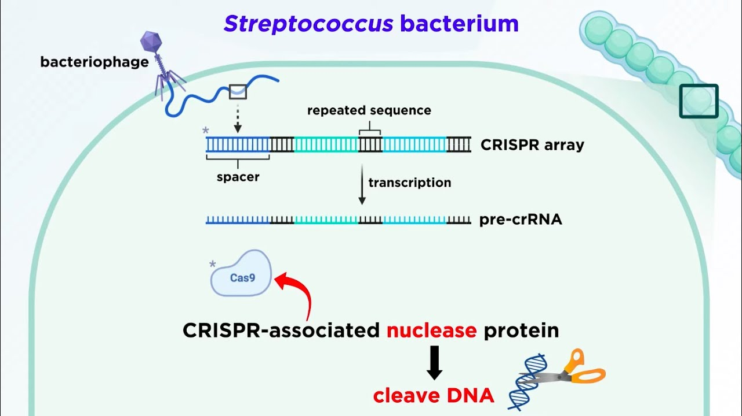

https://www.google.com/url?sa=i&url=https%3A%2F%2Fm.youtube.com%2Fwatch%3Fv%3DIiPL5HgPehs&psig=AOvVaw3AtnQc18sf_VCHYKtC10Mo&ust=1714596174801000&source=images&cd=vfe&opi=89978449&ved=0CBIQjRxqFwoTCPC5gNPm6oUDFQAAAAAdAAAAABAJ
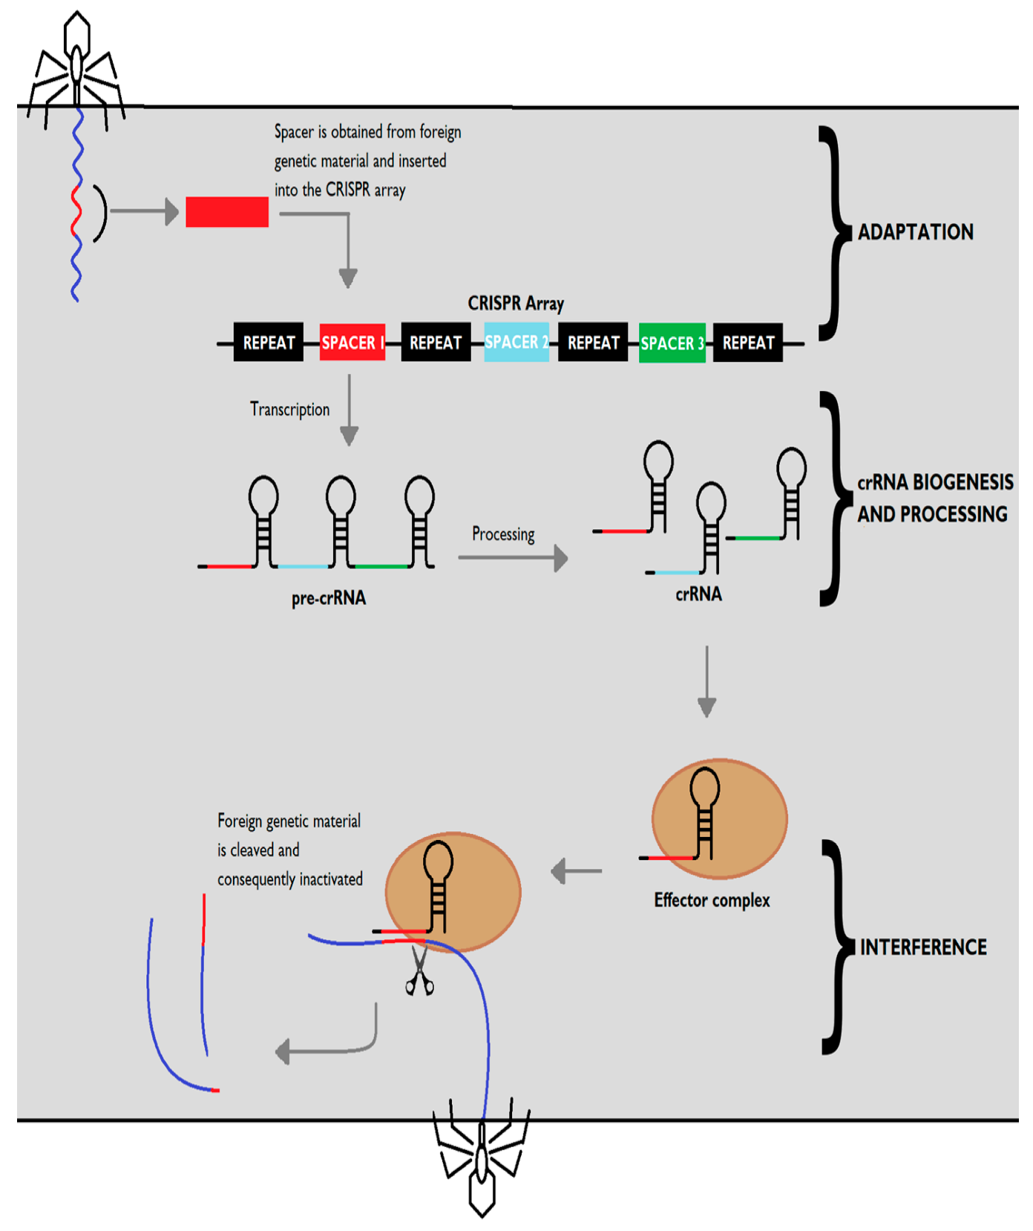
https://www.mdpi.com/antibiotics/antibiotics-08-00018/article_deploy/html/images/antibiotics-08-00018-g001.png
MOLECULAR MECHANISM OF CRISPR CAS 9 FOR GENOME EDITING

-The use of CRISPR-Cas9 system in gene editing is based on the development of guide RNA (gRNA) sequences, which, in turn, compel for a unit fusion molecule – such as
single-guide RNA (sgRNA) – or a specific crRNA with the trans-activating CRISPR RNA (tracrRNA) required .
-Specifically, to target and cleave a
double-stranded DNA (dsDNA) sequence, this system is based on the formation of the complex of sgRNA and the Cas protein
-CRISPR/Cas9 employs Cas9 endonuclease to recognize and cleave the DNA strands using one of the two domains (RuvC and HNH) responsible for the cleavage of the target and non-target DNA strands.
-During this stage, the tracrRNA – a small noncoding RNA – directs the maturation of crRNAs by pairing with the repeat sequence and forming a dual-RNA hybrid structure meant to guide the Cas9 at the target sequence (usually a 20 nucleotide sequence) adjacent to the PAM.
-Combining the tracrRNA and the crRNA into a chimeric sgRNA would simplify the system and maintain Cas9 function for DNA cleavage at a specific target.

NOTE-RNase III after binding to complementary region of invading genome cleaves loop that joins tracr RNA and cr RNA.
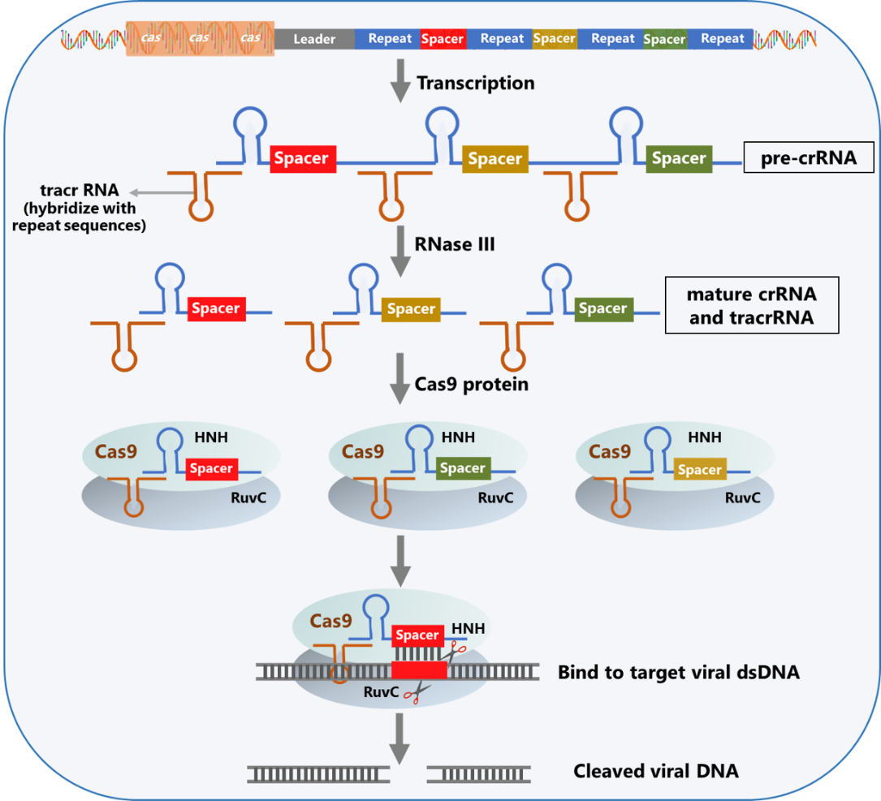
https://miro.medium.com/v2/resize:fit:1400/1*mQ5Zqlj_IIk1ega5-QFzTA.png
DOUBLE STRANDED BREAK REPAIR METHODS
NHEJ REPAIR
The generated double-strand breaks (DSB) are then restored either by error-prone nonhomologous end joining (NHEJ) – this repair generates small random indels at
the DSB site .

Knockout disrupt gene.

No template is required for repairing DSB.

Causes loss of function mutations.

Size of repaired gene either increases or decreases as indels are formed.

Repair of the DSB through NHEJ can result in the introduction of indels and the generation of frameshift mutations and premature stop codons, producing the nonsense-mediated decay of the transcript.

Various studies focused on the use of RNA-mediated programmed Cas9 on genome-scale knockout in mammalian cell cultures highlighted the fact that this approach offers promising phenotypic effects, high reagent consistency, and significant validation rate of the knockout efficiency.

In addition to the knockout function for genes, deactivated Cas9 (dCas9) or other complexes using Cas9 or sgRNAs fused with transcriptional repressors, activators, or recruitment domains are used to regulate gene expression at a specific site. This approach provides the possibility of gene-editing without introducing irreversible changes in the DNA sequence.
For this purpose, CRISPRi and CRISPRa are dCas9 systems employed for the activation and inhibition of transcription at a specific target site . CRISPRi system to induce the repression of gene expression in HEK293 human
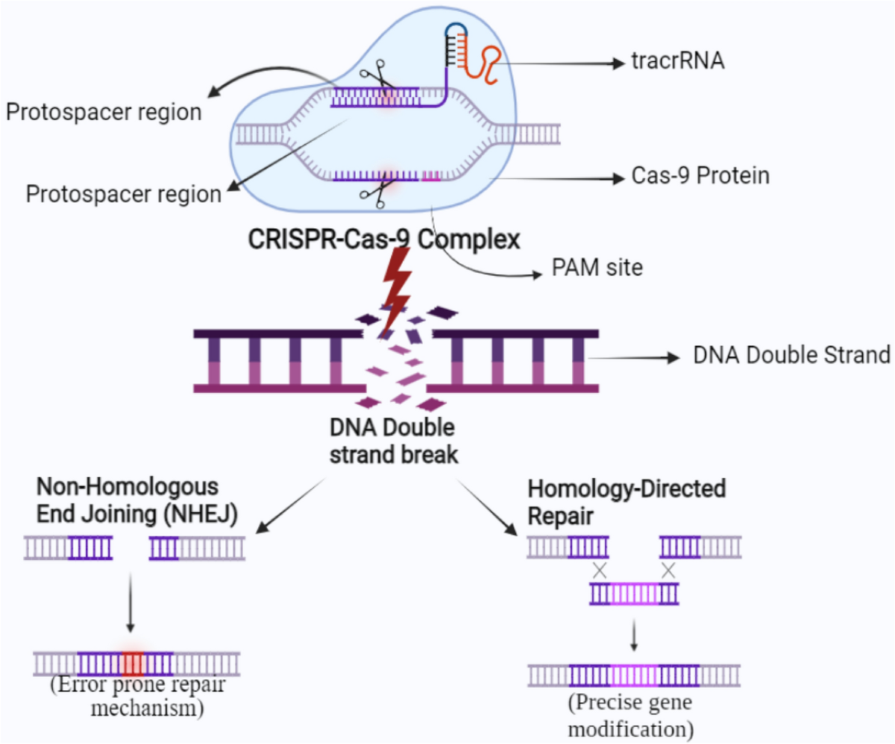
https://media.springernature.com/lw1200/springer-static/image/art%3A10.1007%2Fs11033-022-07880-6/MediaObjects/11033_2022_7880_Fig1_HTML.png
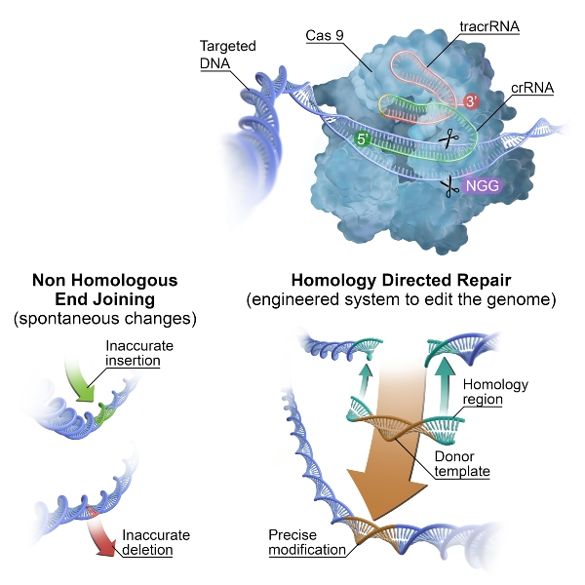
https://assets-global.website-files.com/655dd3c88278aa64954052d4/657ac2491153816efeaad557_illu-crispcas9-final-resized-15.jpeg
cells. Their system uses dCas9 and can be employed for effective gene modulation
(repression/activation). Another study demonstrated that the binding of dCas9 at the promoter region inhibits transcription, most likely by preventing RNA polymerase from binding.
The insertion of frameshift mutations leading to the impairment of the protein function makes NHEJ less reliable and, therefore, makes its use restricted.

HDR(HOMOLOGY DIRECTED REPAIR)
High-fidelity homology directed repair (HDR) – this type of
repair is based on the use of a homologous template that produces precise genome
modification at the cleavage site.
Sequence is altered to change the function as homologous recombination occurs.
Template used has sequence of homology with the regions at the end of double standed breaks.
HDR is the mechanism preferred in the CRISPR technology as the long stretches of homologous sequences used to repair the DNA lesions do not cause mutations.

APPLICATIONS

1-BASE EDITING- Refers to alternation of single base within sequence.
Used to treat disease caused by point mutation such as sickle cell anaemia and progeria.

There are two types of base editings:
Cytidine base editor is a novel therapy in which the cytidine (C) changes to thymidine (T).
Adenine base editor (ABE), in this there is a change in base complements from adenine (A) to Guanine (G).
Base editors are generated by coupling two separate proteins capable of very specific functions. The components of a typical base editor include:
- Cas9 nickase (nCas9): This is a version of Cas9 that has been modified through mutations in one of the two main amino acid residues responsible for the DNA cleavage activity of Cas9. Thus, nCas9 is still able to pair with a gRNA and find the DNA sequence complementary to the gRNA spacer, but is only able to nick one strand of the DNA.
- Nucleoside deaminase: This is an enzyme capable of removing an amino group from a specific type of nucleoside. The deaminase fused to the nickase – be it a cytosine deaminase (e.g. APOBEC) or an adenosine deaminase (e.g. engineered TadA) – will dictate whether the base editor is a CBE or an ABE. CBEs contain cytosine deaminases, while ABEs typically contain adenine deaminases (though several groups have recently engineered CBEs from the conventional TadA adenosine deaminase domain (6-8)).
The Cas9-deaminase fusion protein complex is targeted to a specific DNA locus by a guide RNA (gRNA). Once the base editor has bound to its target sequence, the deaminase can modify bases within the exposed non-target strand (NTS) of the target site R-loop. The area of the target locus in which bases can be modified is called the base editing window (see Figure 2). Depending on the specific intended modification, other factors may be included in the base editor complex to increase efficiency or alter the outcome of the base substitution.
Once the base-editing complex recognises the target DNA sequence complementary to the gRNA spacer, Cas9 mediates the denaturing of the double-stranded DNA (dsDNA) to form a structure known as an R-loop, which exposes a short stretch of single-stranded DNA (ssDNA) in the non-complementary strand to the activity of the deaminase (see Figure 3; also called the non-target strand). This allows the deaminase to chemically modify bases inside the base editing window, which is normally 5-10bp long depending on the deaminase, and somewhat distal from the protospacer adjacent motif (PAM) within the target site.
The first generation of base editors encountered severe efficiency issues that had to be solved. For example, CBEs mediate the deamination of cytosines, generating a uracil (U) base, which can then be read by the cell’s DNA polymerases as thymine. However, human cells are very efficient at DNA repair, and especially at dealing with deaminated bases via the base-excision repair (BER) pathway. Thus, uracil can be recognised and eliminated by the enzyme uracil DNA N-glycosylase (UNG) during the initiation of BER. This drastically limits the efficiency of C-to-T edits and can lead to reduced C-to-T purity (and increased C-to-A or C-to-G edits). To overcome this issue, second-generation CBEs included a third component, namely a uracil glycosylase inhibitor (UGI) fused together with Cas9 and the cytosine deaminase. UGI inhibits the action of UNG on the edited DNA, thus conserving the uracil base and achieving 3-fold higher editing efficiency and purity
In addition to the above, the DNA mismatch repair mechanisms of the cell are tasked with detecting and resolving any incorrect nucleotide pairings into correct pairings (A-T and C-G). Since the deamination of a cytosine, which will be paired with a guanine, will lead to an incorrect T-G pairing, this will be repaired by the cell, either by substituting the U for a C (C-G pairing) or by substituting the G for an A (T-A pairing). Considering that the cell does not know which of the two bases is correct, the probabilities of each repair outcome are equal. To increase editing efficiency, the catalytically-dead version of Cas9 (dCas9) that was used in the first-generation CBEs was substituted with the Cas9 nickase (nCas9) version that we find nowadays in nearly all base editors, which is only able to nick the complementary strand of the DNA. This cut in the complementary (=unedited) strand, directs the mismatch repair machinery to utilise the base-edited strand as a template for repair, thus biasing the repair towards the introduced edit, and further improving efficiency.
ABEs work in a very similar way. In this case, the deamination of adenine generates an inosine residue, which is interpreted by the DNA polymerases as a guanosine. Thus, an A-to-G edit is achieved (Ref. 3, and see Figure 4). However, no UGI or equivalent inhibitor is necessary since inosine residues are not excised like uracil residues.
One step that was very important for the generation of ABEs was making an adenine deaminase that could edit the DNA, since naturally occurring adenine deaminases only edit RNA. Directed mutagenesis efforts were successful in generating a version of the E.coli tRNA adenosine deaminase (TadA) that can edit the DNA. Interestingly, editing efficiency was higher when the ABEs included one mutated TadA (TadA*) and one wildtype enzyme (3). ABEs are very important because G-C to A-T mutations represent the most frequently reported pathogenic point mutations, thus this type of base editing has the greatest potential for clinical applications. More recent ABEs have been developed that have improved editing efficiencies
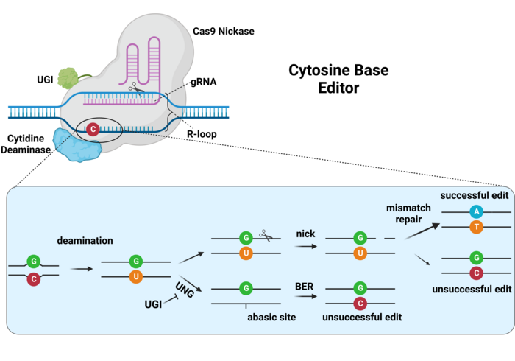
https://d2qa4785ekzzy0.cloudfront.net/typo3temp/assets/images/csm_Figure_3_-_CBE_in_detail_81aafb4ce1_1ec4c251dc.png
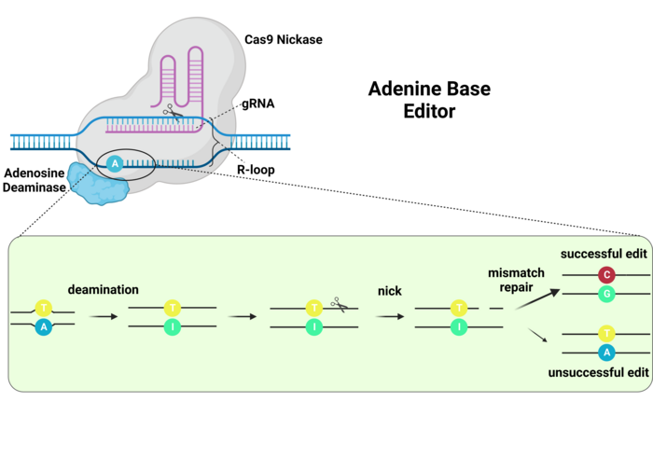
https://d2qa4785ekzzy0.cloudfront.net/typo3temp/assets/images/csm_Figure_4_-_ABE_in_detail_7c0f083561_6bfbaf8ef4.png

PRIME EDITING
Prime editing (or base editing) is a CRISPR refinement to accurately insert or delete sections of DNA. The CRISPR edits are not always perfect and the cuts can end up in the wrong place. Both issues are a problem for using the technology in medicine. Prime editing does not cut the double-stranded DNA but instead uses the CRISPR targeting apparatus to shuttle an additional enzyme to a desired sequence, where it converts a single nucleotide into another. The new guide, called a pegRNA, contains an RNA template for a new DNA sequence to be added to the genome at the target location. That requires a second protein, attached to Cas9: a reverse transcriptase enzyme, which can make a new DNA strand from the RNA template and insert it at the nicked site. Those three independent pairing events each provide an opportunity to prevent off-target sequences, which significantly increases targeting flexibility and editing precision. Prime editing was developed by researchers at the Broad Institute of MIT and Harvard in Massachusetts.

2- CRISPR/Cas9 as a tool for biomarkers discovery
3- Used in Gene therapy.
1-In monogenic diseases, CRISPR/Cas9 system for genome editing is preferred because it can achieve permanent removal of the genetic defect, while other gene therapy methods work by adding a functional copy of the gene to the cells, but do not eliminate the dysfunctional copy of the gene.
2-Used in the treatment of disease caused by HIV. Malignancies can be treated and it succeded in the treatment of solid tumours.
3-Extensive research has been done in cells and animals using CRISPR-Cas9 to attempt to correct genetic mutations which cause genetic diseases such as Down syndrome, spina bifida, anencephaly, and Turner and Klinefelter syndromes.
4-The first clinical use of TALEN-based genome editing was in the treatment of CD19+ acute lymphoblastic leukemia in an 11-month old child in 2015. Modified donor T cells were engineered to attack the leukemia cells, to be resistant to Alemtuzumab, and to evade detection by the host immune system after introduction
5-Used in the treatment of cancer, diabetes, haemoglobinopathy and numerous neurological diseases.
4- Used in plant sciences.
5- Used in epigenome editing-Epigenome editing or epigenome engineering is a type of genetic engineering in which the epigenome is modified at specific sites using engineered molecules targeted to those sites (as opposed to whole-genome modifications).

The CRISPR/Cas9 Genome-editing System: Principles and Applications

Challenges of CRISPR/Cas9
One major challenge in CRISPR/Cas9 mediated genome editing is represented by the off-target mutations, especially in human cells, which may result in cell death or cell transformation.
The presence of multiple identical or highly homologous DNA sequences is usually a characteristic of large genomes, thus creating the possibility for CRISPR/Cas9 to cleave and modify other sequences besides the desired ones.
In order to overcome this threat, efforts are made by the research community to reduce and/or remove off-target mutations that occur in the process of genome-editing with the CRISPR/Cas9 systems.

REFERENCES

1-Barrangou, R., Fremaux, C., Deveau, H., Richards, M., Boyaval, P., Moineau, S., et al. 2007.
CRISPR provides acquired resistance against viruses in prokaryotes. Science, 315 (5819):
1709-1712.
2-Barrangou, R. and Marraffini, L. A. 2014. CRISPR-Cas systems: Prokaryotes upgrade to adaptive immunity. Molecular Cell, 54(2): 234-244.
3-Berindan-Neagoe, I., Monroig Pdel, C., Pasculli, B. and Calin, G. A. 2014. MicroRNAome genome: A treasure for cancer diagnosis and therapy. CA: A Cancer Journal for Clinicians, 64(5): 311-336.4-Brouns, S. J., Jore, M. M., Lundgren, M., Westra, E. R., Slijkhuis, R. J., Snijders, A. P., et al. 2008. Small CRISPR RNAs guide antiviral defense in prokaryotes. Science, 321(5891): 960-964.
5-Charpentier, E. and Doudna, J. A. 2013. Biotechnology: Rewriting a genome. Nature, 495(7439): 50-51.
6-Chen, B., Gilbert, L. A., Cimini, B. A., Schnitzbauer, J., Zhang, W., Li, G. W., et al. 2013. Dynamic imaging of genomic loci in living human cells by an optimized CRISPR/Cas system. Cell, 155(7): 1479-1491’ 7- Bak RO, Gomez-Ospina N, Porteus MH (August 2018). "Gene Editing on Center Stage". Trends in Genetics. 34 (8): 600–611. doi:10.1016/j.tig.2018.05.004. PMID 29908711. S2CID 49269023.
8-^ "The Nobel Prize in Chemistry 2020". The Nobel Prize. Retrieved 2020-12-10. 9-^ Cohen J (October 7, 2020). "CRISPR, the revolutionary genetic "scissors," honored by Chemistry Nobel". Science. doi:10.1126/science.abf0540. S2CID 225116732.

10-wikipedia

11- Explainer: What Are Base Editors and How Do They Work? By: Manel Llado - Jun. 8, 2023

12- CRISPR-/Cas9 Based Genome Editing for Treating Genetic Disorders and Diseases Luis María Vaschetto Oncativo, Córdoba Argentin

