LAKSHMI RG

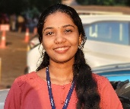
POST GRADUATE IN NANOBIOTECHNOLOGY
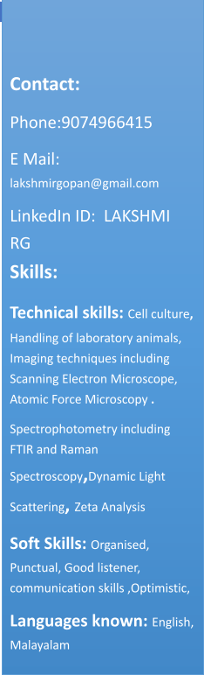

Career Objective: Seeking a stimulating role in targeted drug delivery research and biomaterials within the realm of nanobiotechnology where i can apply my post graduate expertise to innovate and optimize drug delivery systems. Committed to contributing the forefront of biomedical research by harnessing nanotechnology to create innovative solutions for precise and personalized medicine.
Educational Qualifications:
Name of  examination | Year of passing | Name of  University | Name of  School/College | Grades
Masters in nanobiotechnolog y | Pursuing | Amrita Vishwa  Vidyapeetham | Amrita School of nanoscience and molecular medicine | 8.7  [SGPA] for  Second semester
Bachelors in Chemistry | 2023 | Kerala  University | Sree Narayana  College for Women,  Kollam, Kerala, India. | 7.3 [CGPA]
Board of Higher  Secondary  Examintion | 2020 |  | St. Joseph’s Convent GHSS, Kollam | 85%
Indian Certificate  Of Secondary  Education[ICSE] | 2018 |  | Trinity Lyceum,  Fatima Road, Kollam. | 72%
Project:
Bachelors in chemistry:-
Tittle:- Determination Of Total Carbohydrate Content in Nuts by Anthrone Method
Objective:- To determine the total carbohydrate content in Nuts like Almonds, Cashews and Peanuts by Anthrone method.
Description :- Nuts are nutrient dense foods with complex matrices rich in unsaturated fatty and other bioactive compounds: high quality vegetable protein, fiber, minerals, tocopherols, phytosterols, and phenolic compounds. Nuts are nutrient rich foods with wide-ranging cardiovascular and metabolic benefits, which can be readily incorporated into healthy diets. In the experiment, we collected nuts like cashews, peanuts and almonds, grinded to a powdered manner into which we added 2.5 N HCL and anthrone reagent. The experiment is followed by grinding, hydrolysing , Neutralising, centrifuging, and after a series of making up we added anthrone reagent and using the absorption spectroscopy we analyzed data from which we concluded that Almond has the highest carbohydrate content.
Skills Learnt:- Research skills like searching scientific literature, Gained hands on experience with laboratory equipments, techniques, protocols in sample preparation and data interpretation, Time Management
Document and reporting
Understanding different analytical techniques like spectrophotometer, chromatograph
Additional Qualifications:
Completed a course in Energy Physcis
Recieved a certificate in KGTE (lower) in typewriting.
Awards and achievements:
Participated in dance competitions in kerala university kalolsavam
Workshops or seminars attended/conducted
- Attended a symposium hosted by Amrita School of Nanosciences and molecular medicine on February 17, 2024, on “Current Trends in Tissue Engineering & Regenerative Medicine”, featuring speakers Dr. Kyoung Ha So ( Seoul National
University), Dr. Binulal (Amrita Centre for Nanosciences), Nathaniel S. Hwang (Seoul National University), Thadi Mohan (Amrita Institute of Medical Sciences) and Dr.
Jayakumar (Amrita Centre for Nanosciences).
- Participated in an in- person session hosted by Amrita School of Nanosciences and Molecular Medicine on February 9, 2024, with Professor Brain Rodrigues (University College Dublin), discussing “ Recent Advancements in Nanotechnology”.
- Participated in an in-person seminar organized by Amrita School of Nanosciences and
Molecular Medicine on February 5,2024, with Dr. M. S. Narayanan (IITM), Amit Dinda
(Amrita Hospital, Faridabad), Dr. Manzoor Koyakutty (Amrita Centre for
Nanosciences ) and Aleena Cheriyan (Entrepreneur), discussing “ Research Translation and Entrepreneurship.”
Events organized
- Worked as active member in organizing committee for Arts Fest held in (2023), co ordinating with students and faculties as well as scheduling the events.
Personal details:
- Contact address: Mallezhathu House, sakthikulangara, p.o. Kollam. PIN :691581
Nationality: Indian Mother tongue: Malayalam References:
Name of the faculty : Dr. Manzoor. K
Designation :- Professor at Amrita School of Nanosciences and Molecular Medicine, Kochi, Kerala.

