5.Building and Training the Model:

Sequential model is created with 3 layers, First layer has 160 neurons and second layer has 80 neurons. Both first and second layer uses relu activation function. Rectified Linear activation function(ReLU) is a linear function that will output the input directly if positive otherwise it will give output as zero. For the last layer, number of neurons will be equal to number of intents of predicted output with a softmax activation function.

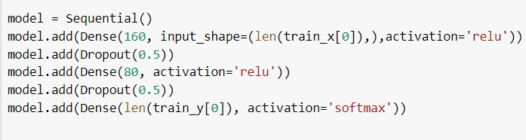

For the created model, Stochastic Gradient Descent optimization technique is used to find the minimum possible cost function. Starting from an initial value, Gradient Descent runs iteratively to find the optimal values of the parameters to find the minimum possible value of the given cost function.SGD is preferred as it is easy to implement and efficient.



The training data is fit to the model and using 1000 epochs best accuracy of 93.84 and minimum loss of 11.38 is obtained.



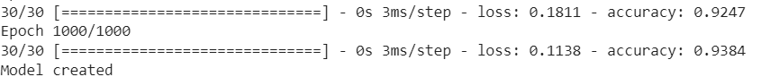

5.1. Conversational Chatbot using Speech Recognition:

Speech enabled chatbots provide higher level of interactivity and usability. User can either give their input using text or speech and similarly chatbot is able to give its response by either text or voice. In our project, this process of conversion between text and speech is done by using speech_recognition and pyttsx3 python modules.

a) Voice Input by User (Speech to Text):

Using systems inbuilt microphone live audio input can be transcribed using Google’s Web Speech API (recognize_google()).By using adjust_for_ambient_noise function we can set the engine to listen to ambient noise for some time period(here 2 seconds) and adjust energy threshold accordingly. If speech Recognizer unable to detect the speech correctly, respective error messages will be given as response.

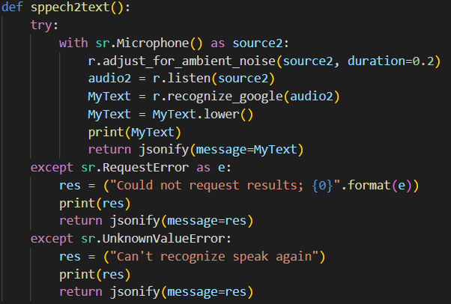

b) Voice Output by Bot (Text to Speech):

Pyttsx3 is a Text to Speech Conversion Python Library. Using pyttsx3.init() an engine instance will be created for which we can set various properties like voice rate, volume level and also voices(male or female).We can directly pass the text that need to be converted to voice to this engine and output will be voice saying the text accordingly.

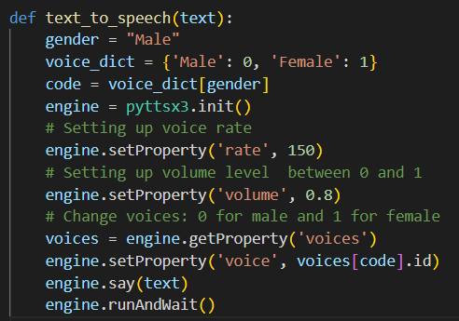

7.Conclusion and Future Work:

The main objective of our hospital management system chatbot is to automate repeated tasks in a user-friendly manner such that it will provide hospital employees to focus on important tasks and also to enable fast response for customer instead of waiting for employee to solve their queries as user can interact with bot anytime. Enabling Speech recognition in our chatbot also helps customers to have a simple and fast conversation.

We can incorporate more department specific data to make the chatbot more diverse, as of now disease diagnosis, appointment booking, viewing user appointment details and test costs are included. More refined data will give more scope for user to resolve their queries. The application can be integrated with any hospital website to make it more reachable for users.