DAY-5 Assignment

Postman: REST API implementation

Different requests

* Create -post
* Change-put
* Delete
* Get

**post**

**put**

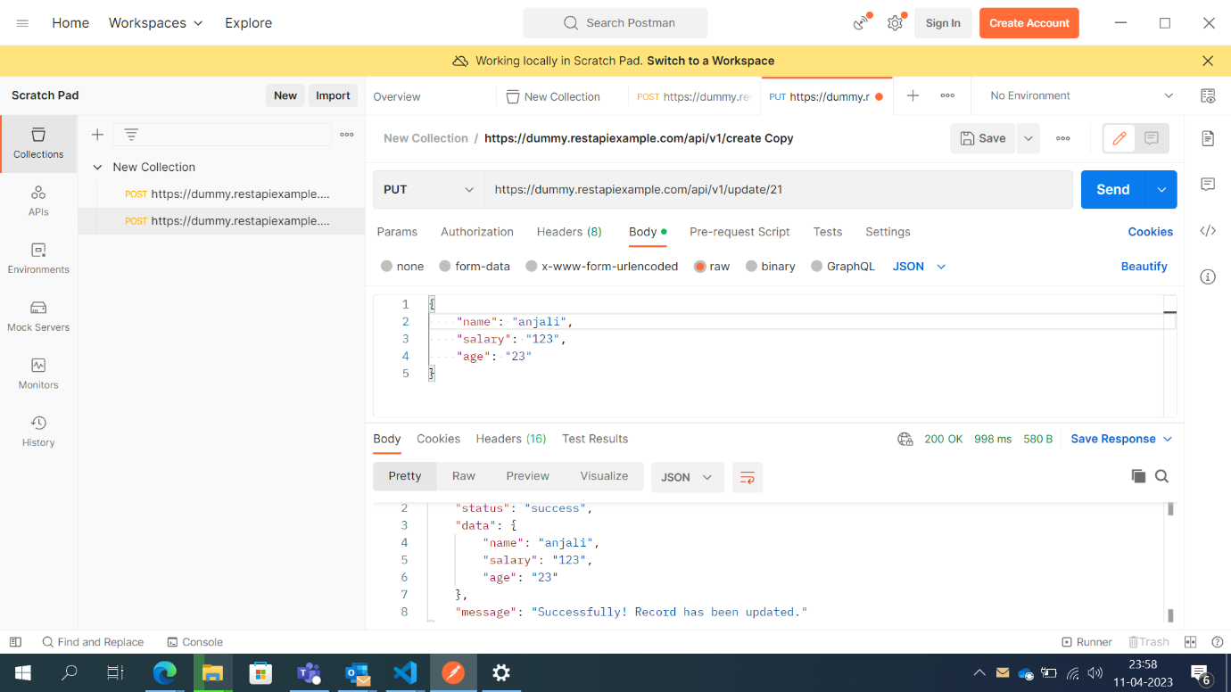

**Get**

**delete**

