**SIDDAGANGA INSTITUTE OF TECHNOLOGY, TUMAKURU- 3**

(An Autonomous institution affiliated to Visvesvaraya Technological University- Belagavi, Approved by AICTE,

Accredited by NAAC with ‘A’ Grade, Awarded Diamond College Rating by QS I-GAUGE & ISO 9001:2015 certified )



**ASSIGNMENT-03**

**ON**

**“MATLAB CODE FOR FLANGING”**

**SUBMITTED BY:**

**1.CHANDANA K (1SI20ET011)**

**2.CHINMAY B S (1SI20ET053)**

**3.DEEPAK H A (1SI20ET013)**

**4.POOJA P V (1SI20ET033)**

**FACULTY:H M CHANDRASHEKAR**

**Department of Electronics And Telecommunication Engineering**

**SIDDAGANGA INSTITUTE OF TECHNOLOGY**

(An Autonomous institution affiliated to Visvesvaraya Technological University- Belagavi)

**Academic Year: 2022-23**

**FLANGING:**

There are a number of special sound effects that are often used in the mix-down process. One such effect is called flanging

Flanging is an audio effect produced by mixing two identical signals together, one signal delayed by a small and usually changing period, usually smaller than 20 milliseconds.

The same signal is passed through two tape recorder then the finished music track is recorded simultaneously to two matching tap

machines, then replayed with both decks in sync. The output from the two recorders is mixed to a third recorder.

The engineer slows down one playback recorder by lightly pressing a finger on the flange (rim) of the supply reel. Varying the time delay causes these to sweep up and down the frequency spectrum. A flanger is an effects unit that creates this effect. This produces a swept **comb filter effect**

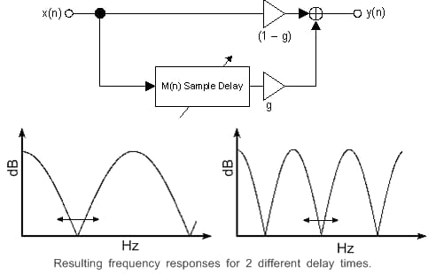

Direct form diagram of flanging

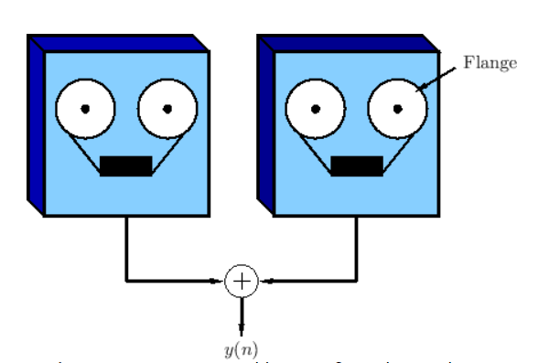

Two tape machines configured to produce a *flanging effect*

**CALCULATION:**

**CODE:**

clc;close;clear all;

[x, fs] = audioread('input_audio.wav'); % read the input audio

d = 0.05; % set the delay in seconds

m = 0.5; % set the modulation depth

f = 0.1; % set the modulation frequency in Hz

% calculate the modulated delay

n = round(d * fs);

mod_delay = n + m * sin(2 * pi * f * (1:length(x)) / fs);

% apply the flanging effect

y = zeros(length(x), 1);

for i = 1:length(x)

if i > n

y(i) = x(i) + x(i - n) * (1 - m * sin(2 * pi * f * i / fs));

else

y(i) = x(i);

end

end

audiowrite('output_audio.wav', y, fs); % write

**OUTPUT:**

the output audio