create table TeamDetails(sl_no int,Team_Name varchar(20),Captain varchar(20),owner varchar(20),home_ground varchar(20) primary key)
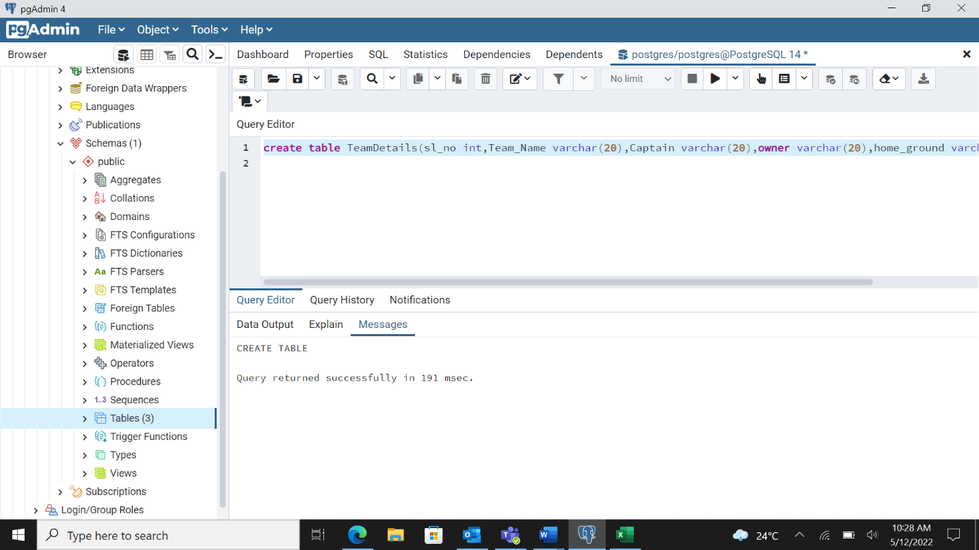

create table fixtures(match_no int primary key,home_team varchar(20),away_team varchar(20),venue varchar(20),team_won varchar(20),team_lost varchar(20),foreign key(venue) references teamdetails(home_ground) )
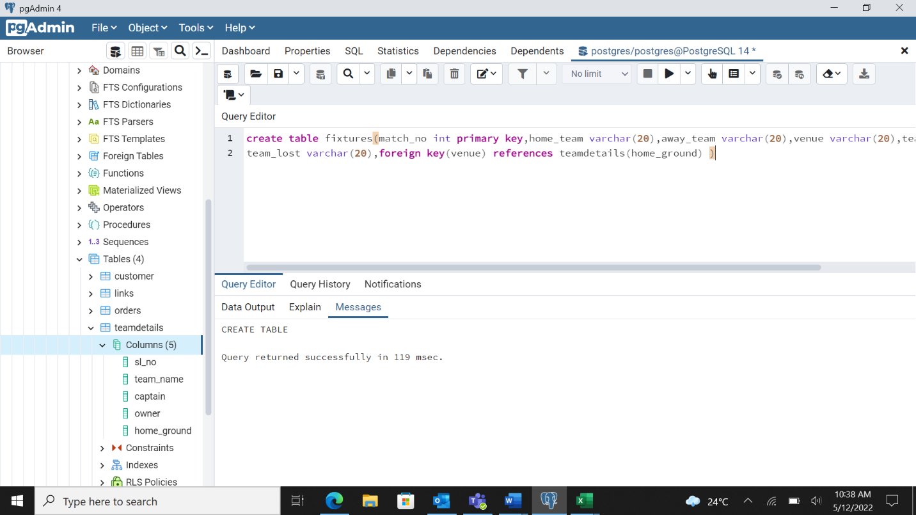
create table points(teamname varchar(20) primary key,wins int,losses int,points int)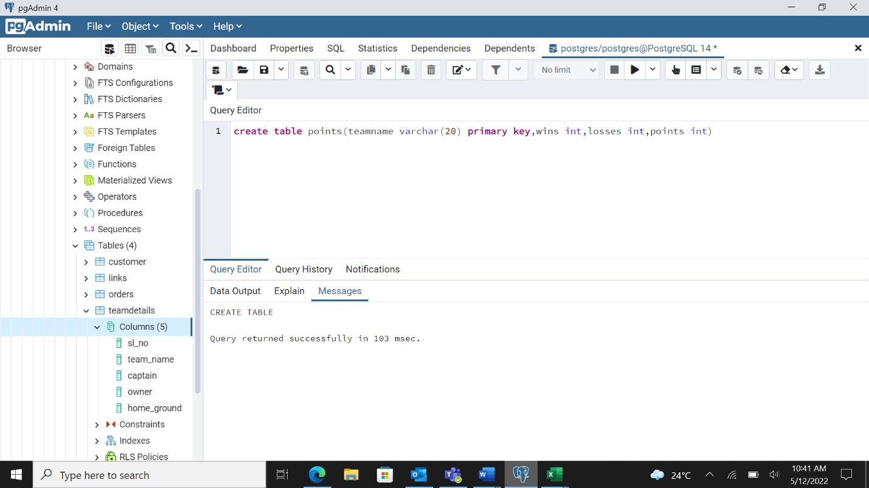
milestone 2
copy public."teamdetails" from 'C:\Fixtures.csv' DELIMITER ',' CSV HEADER

select * from team details
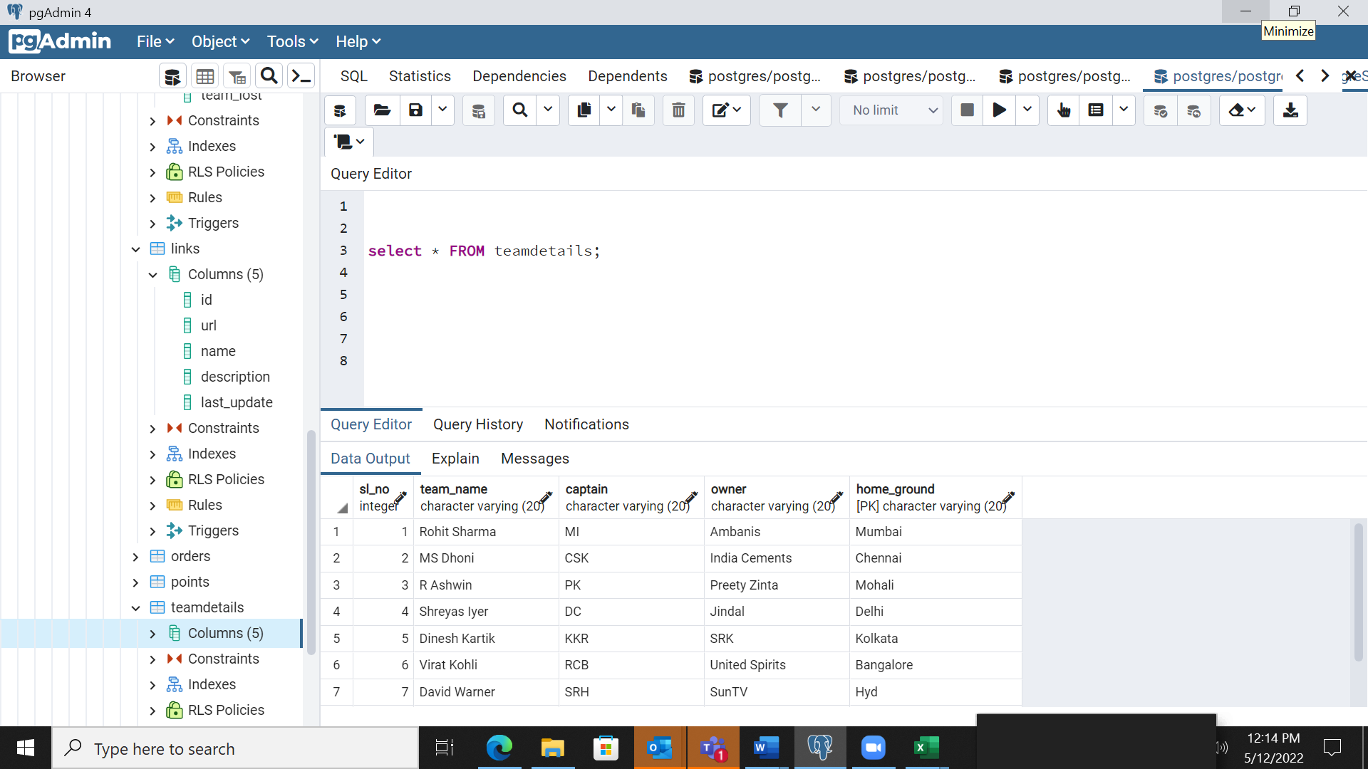
select count(team_name) from team_details

milestone 3
copy public."Fixtures" from 'C:\Fixtures.csv' DELIMITER ',' CSV HEADER

MILESTONE 4

Select count(f.home_team) from fixtures f,teamdetails t where home_ground=banglore and venu=banglore

Select team_lost from fixature where venue=Kolkata;

Milestone 7
Insert into points select * fixtature where count(team_won>=8) group by teamwon
Insert into points select * fixtature where count(team_lost) group by teamwon

