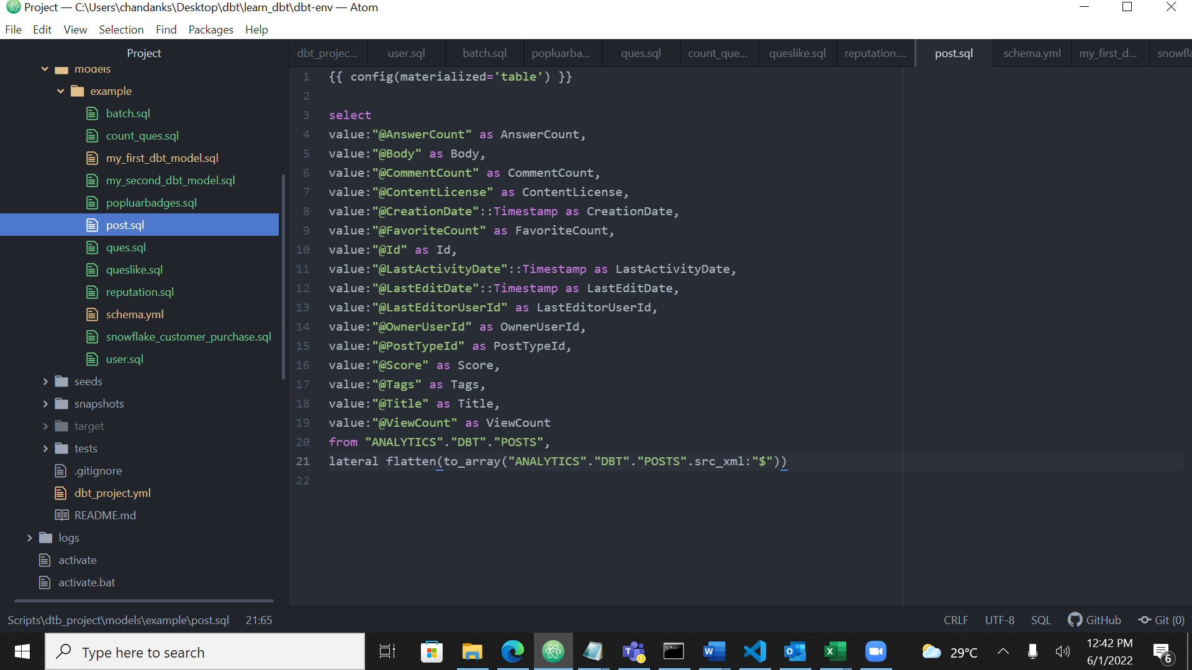

These are the screen shorts of the queries after loading xml and converting to table format

Question 1

Find top 10 users with the highest reputation. Print their id, displayname and reputation. Sort by highest reputation first.

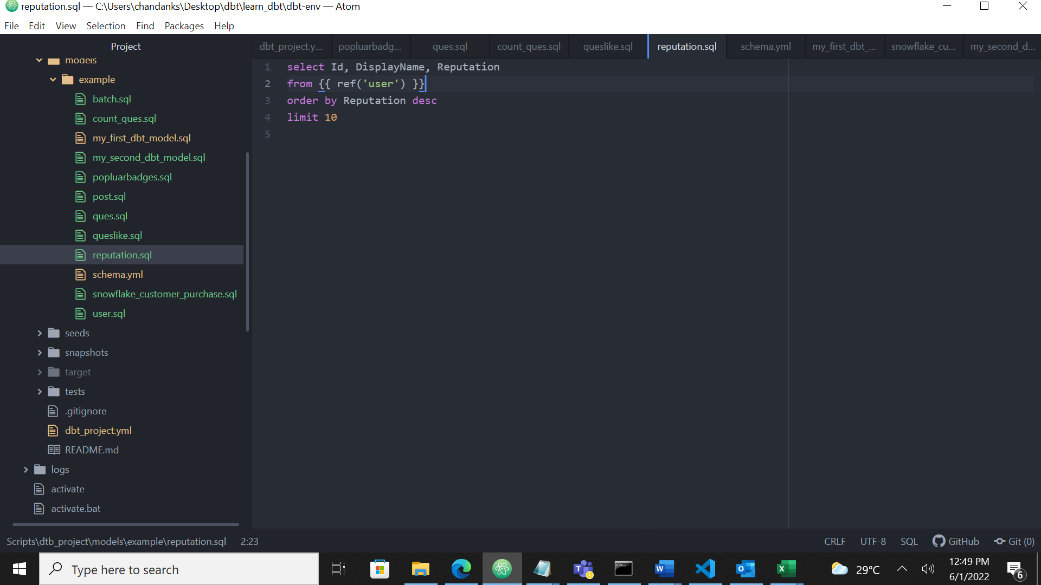

This is the sql query

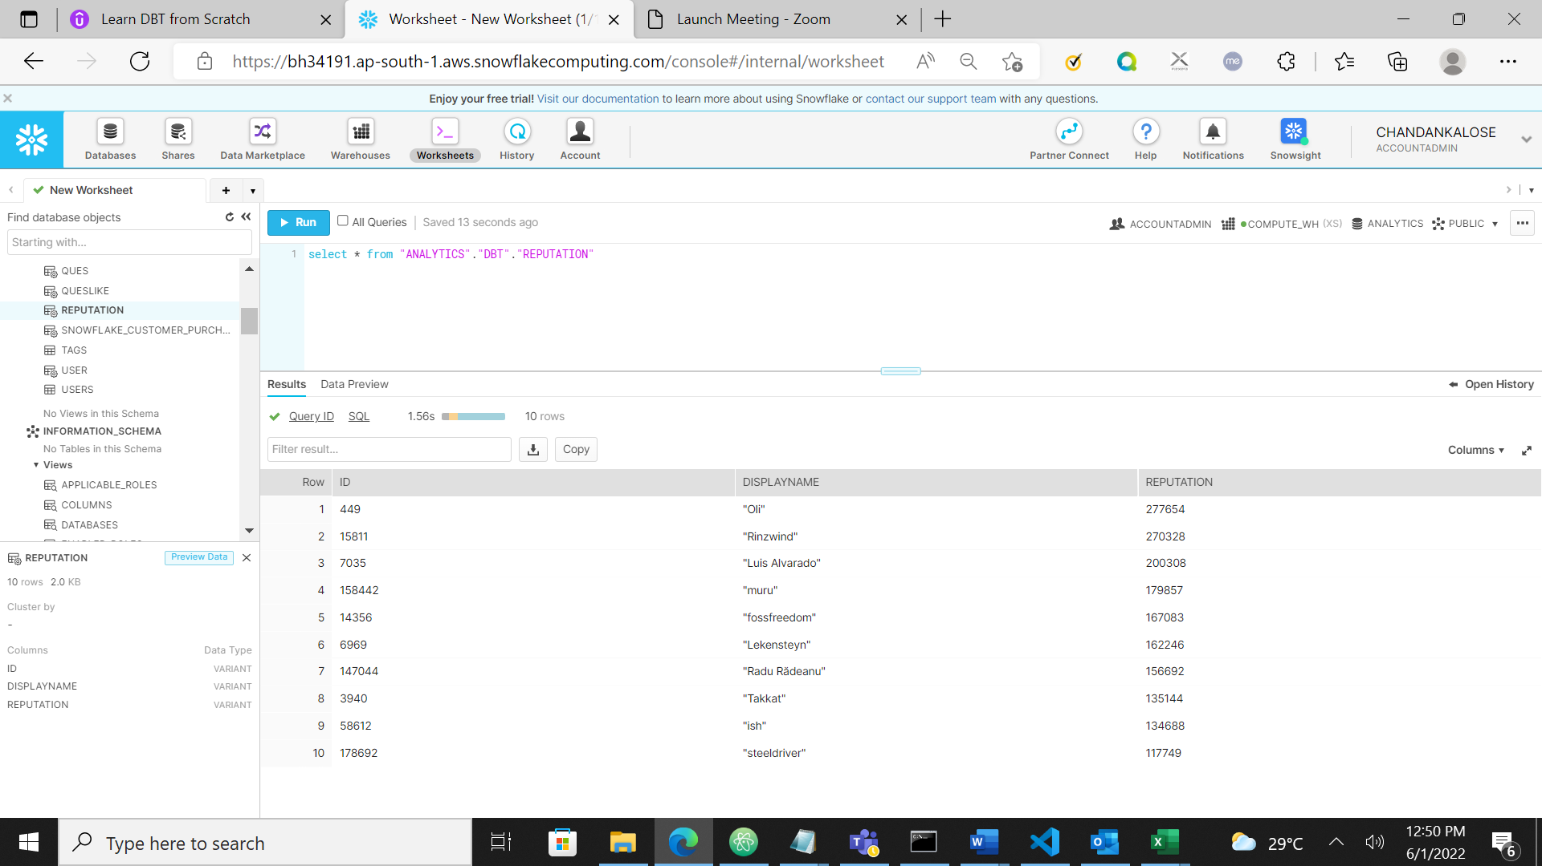

According to above query table is created and these are the contents

Question

Print the text of questions asked by user whose display name contains the string “nau”

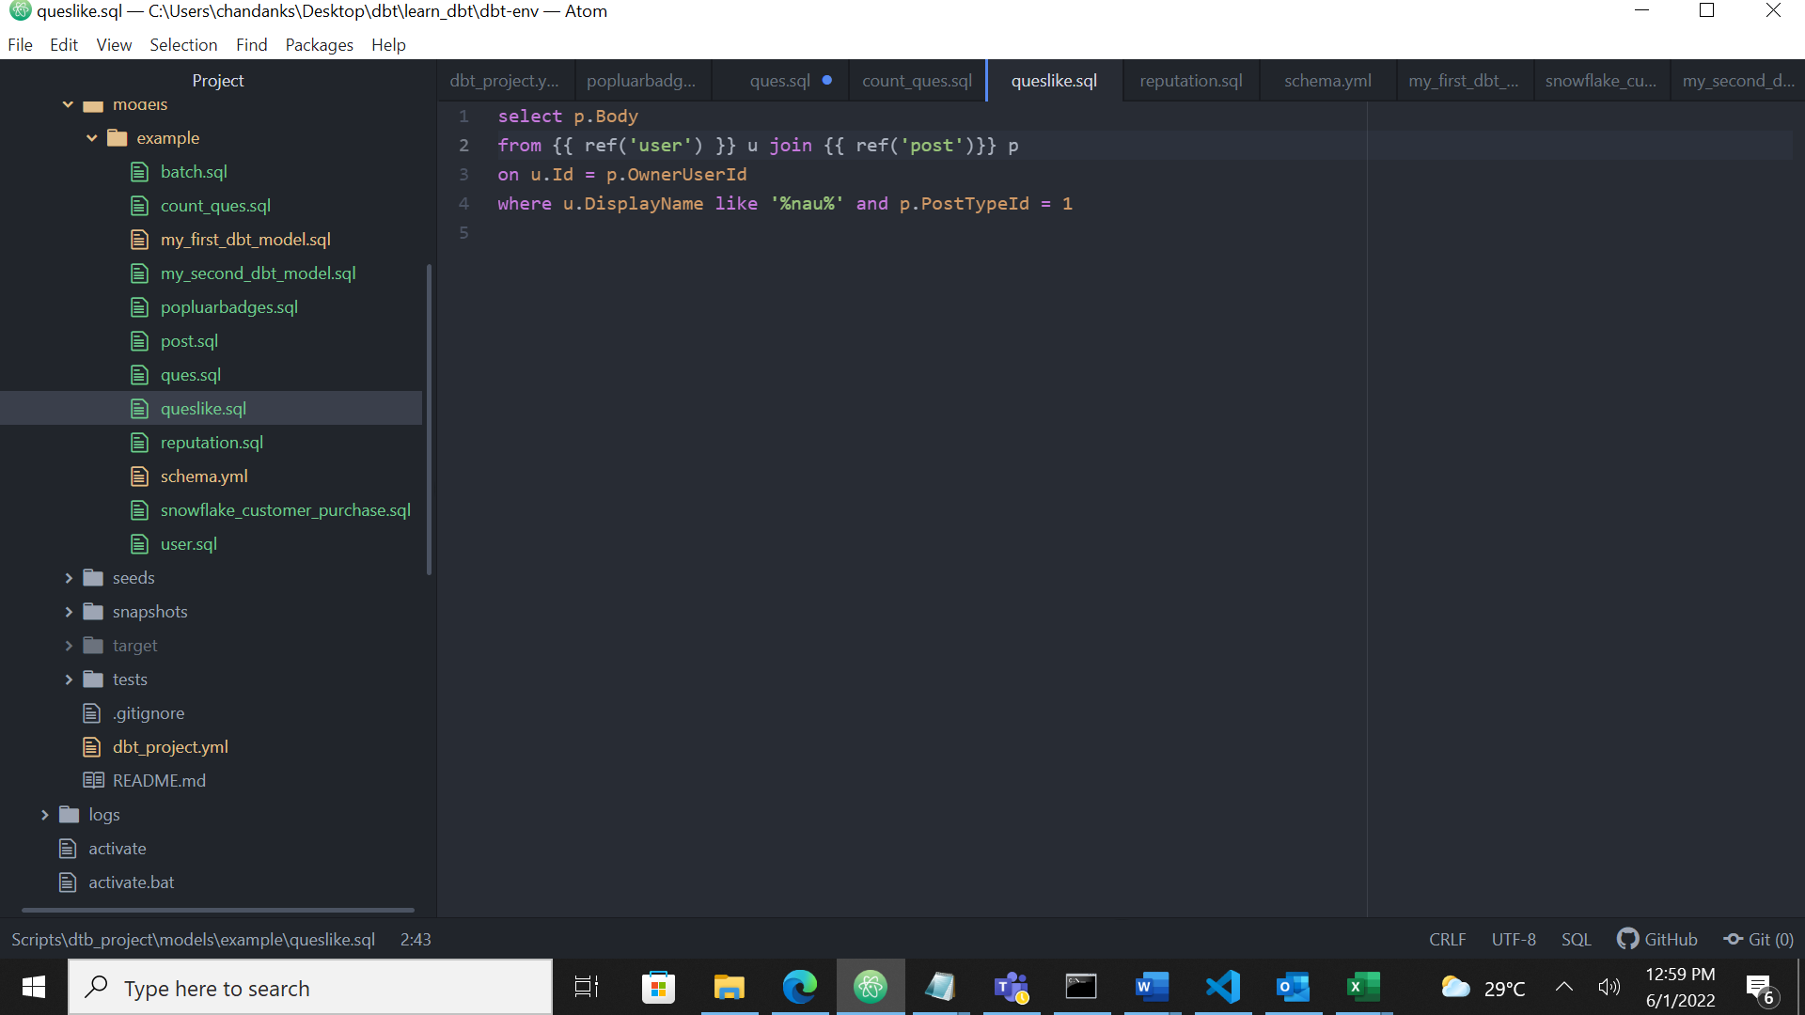This is sql query

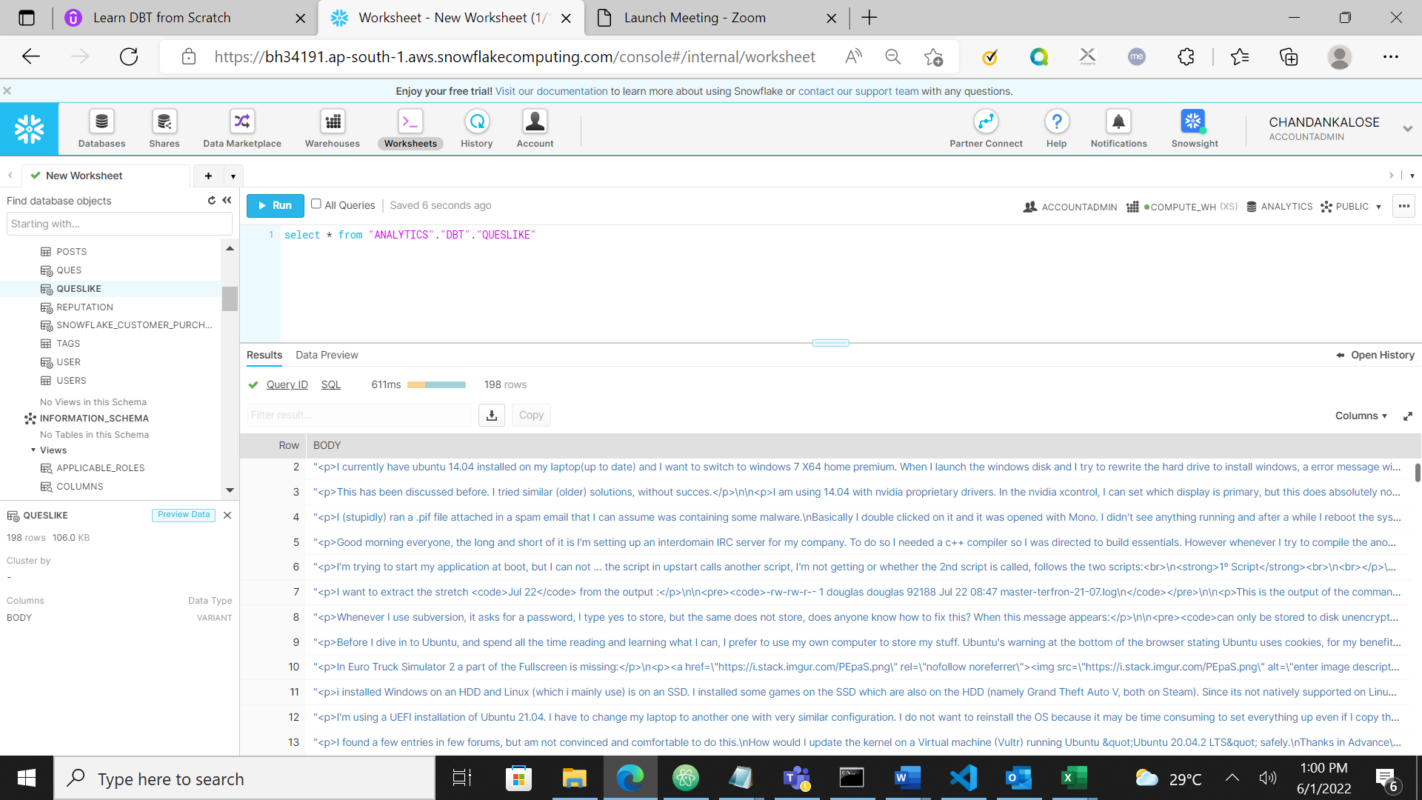

According to above query table is created and these are the contents

Question

Print the 10 most popular badges, sorted by the number of users who have these badges.

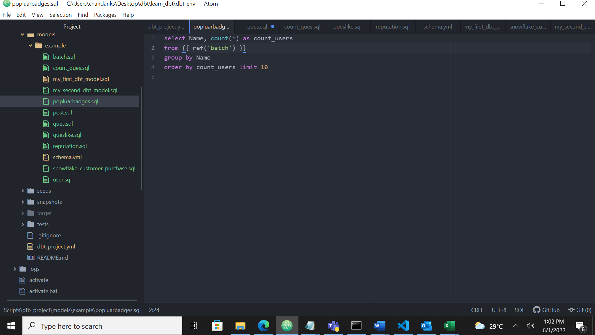

The sql query

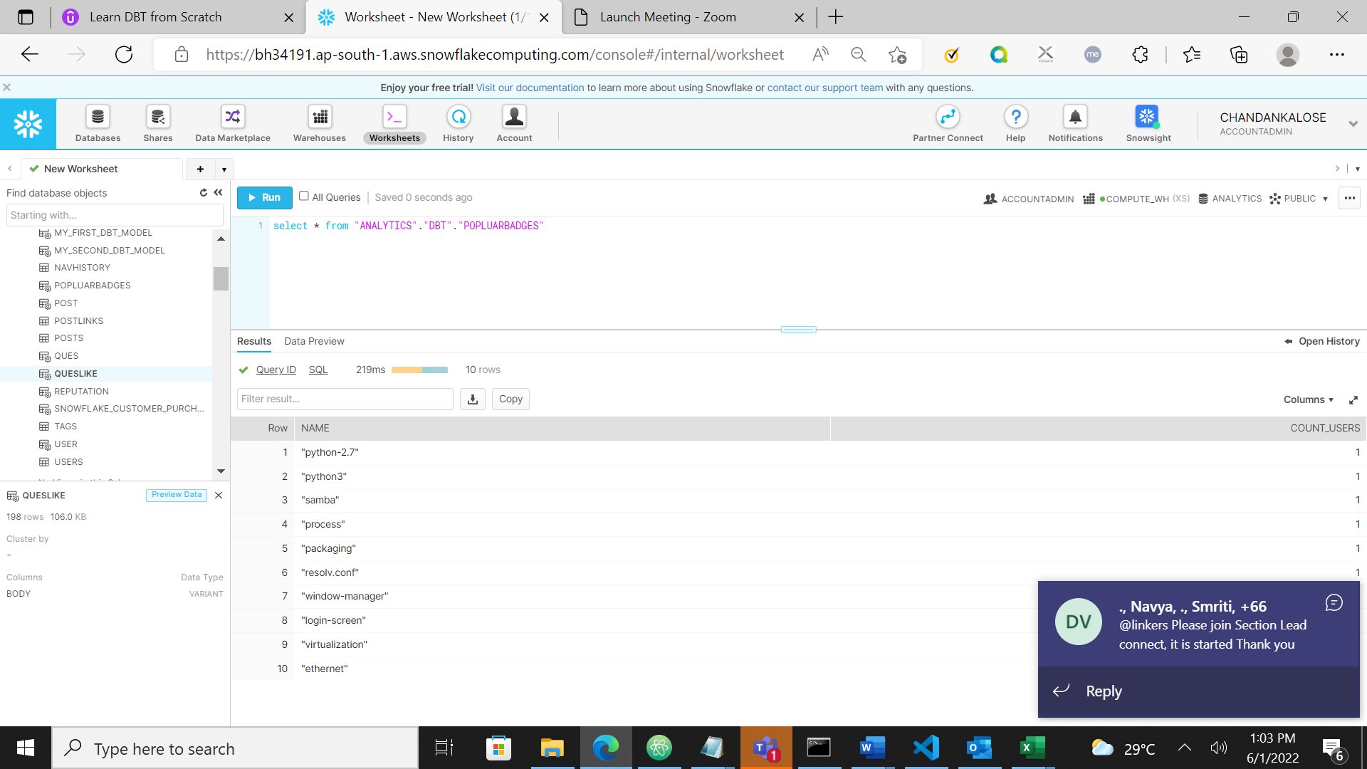

The table is created and its output

Question

For users who have a reputation greater than 75000, print their userid, displayname, reputation and the total number of questions they have asked.

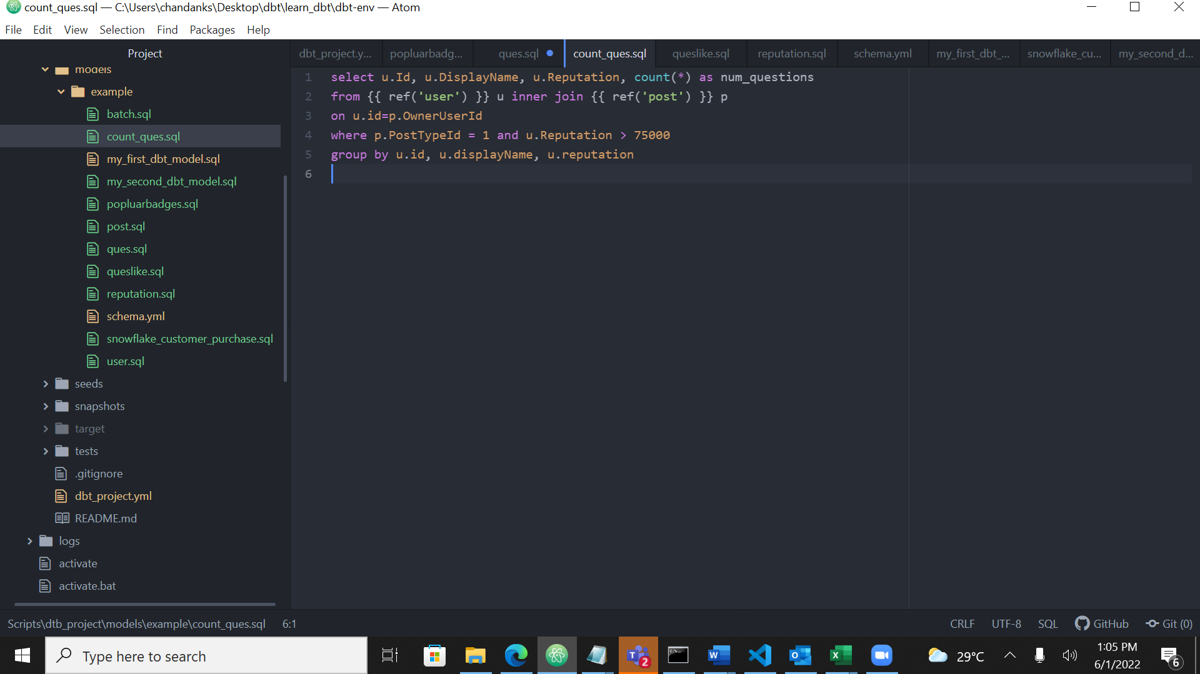

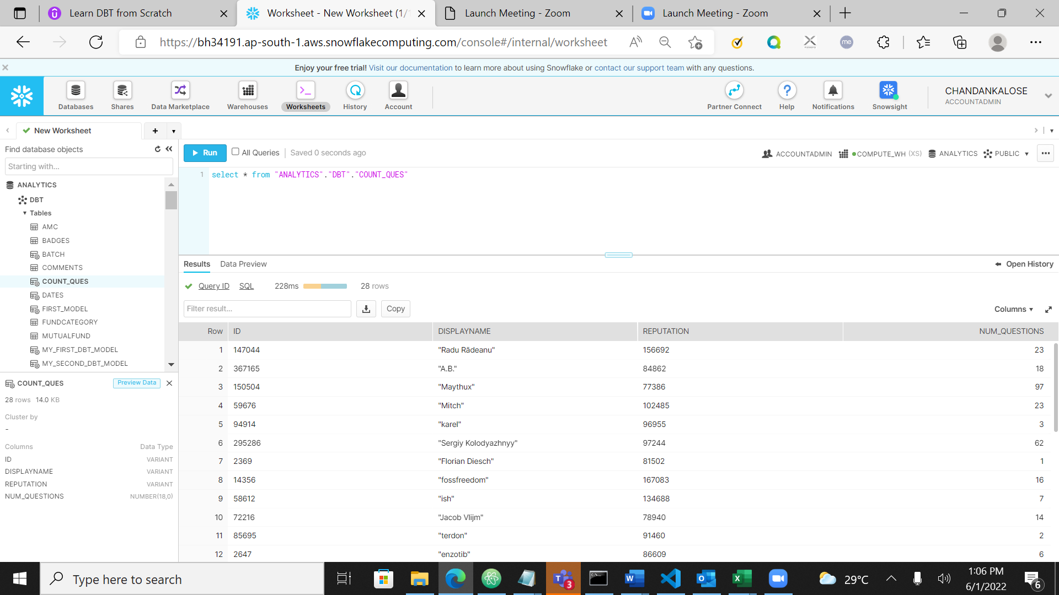

The sql and output

Question

Print the text of questions asked by user whose display name is alexandrul.

